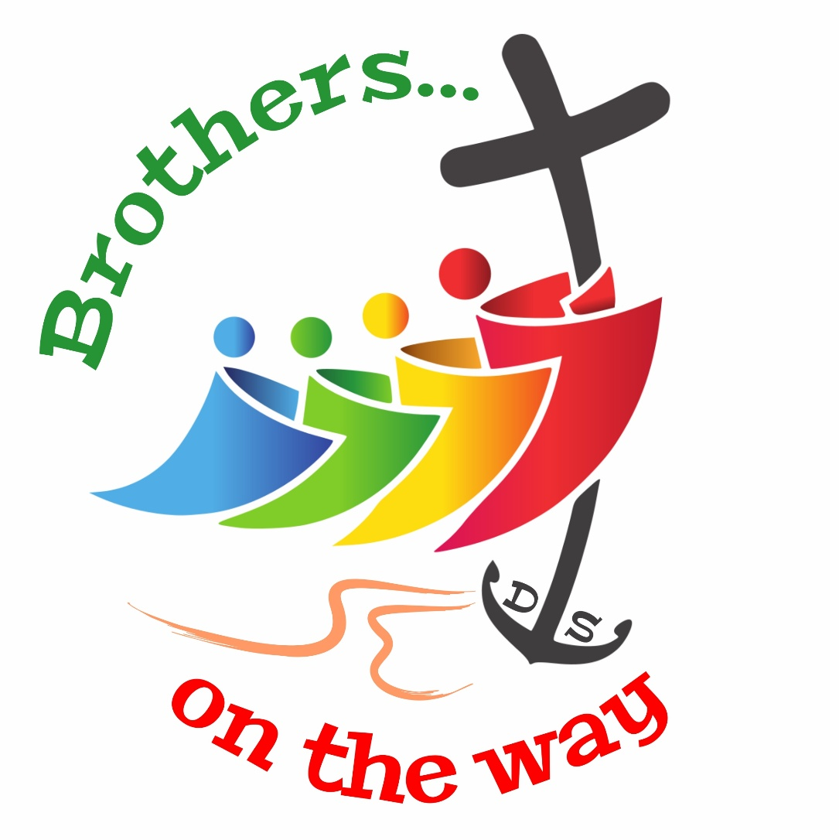

Pilgrims

On the Way

Of the Fraternal Life

**Year 2025 - 2026**

**Notebook I**

Presentation of the animation booklet

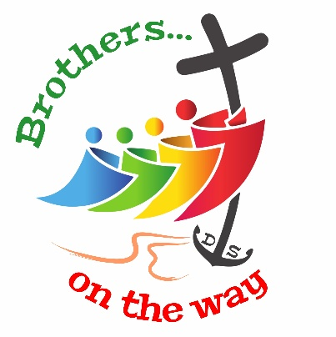This animation booklet has a simple objective: to accompany Major Superiors in their mission of animation of their Province and District based on this year's theme: Pilgrims on the path of fraternal life: Brothers on the way.

This booklet is addressed to them first. Together with their council members, they are invited to discern how they intend to use it to meet the specific needs of their sector while remaining in communion with the entire Body formed by the Institute.

This booklet aims to help the Brothers and Lay people of the Mennaisian Family to become aware of the theme and begin to live it at the beginning of the pastoral year. It includes:

1. **Introduction to the year theme** (p. 3)

This part only aims to introduce the theme, with the long and short forms of its title. The link with the Rule of Life, and for this year, with chapter 6 on the Fraternal Community, is essential.

1. **Biblical Icon: The Washing of the Feet** (p. 4-5)

The text chosen as a "biblical icon" should allow us to enter more deeply into the theme, in the light of the Word of God, also giving it a visual and concrete dimension, as the term "icon" indicates.

1. **Guide for preparing the community project** (p. 6-8)

At the heart of this booklet are guidelines for launching the year, through a community meeting day or meetings, with the aim of drafting the community project.

1. **Drafting of the community project** (p. 9)

A sheet that complements the guide in the previous section, to help write the community project, following the Rule of Life and taking into account the different dimensions of community life.

1. **To write and live your personal project** (p. 10)

The process of writing the personal project is in itself independent of what precedes it. However, it should take into account the theme of the year and also be based on the community project, as indicated in the Rule of Life (n°63.2).

1. **Celebrate and pray (**p. 11-12)

This part of the booklet particularly requires adaptation by the Provinces and Districts to take into account cultural and ecclesial diversity.

***Brothers on the Way*: 2 animation notebooks for 2025-2026:**

**Notebook I** (May 2025). This first notebook focuses on discovering the year's theme, writing the community project, and writing the personal project. It is primarily intended for the launch of the year.  
  
**Notebook II** (October 2025). The second notebook will present tools for ongoing formation at the personal and community level. It can be used in particular for community meetings, times of community or personal spiritual reading.

Introduction to the year theme

**“Pilgrims on the path of fraternal life”** Our theme for the year is an extension of the previous one, which invited us to be "Pilgrims on the path of prayer." We thus remain in the dynamic of pilgrimage driven by the Jubilee Year 2025. We are also continuing the progressive deepening of our new Rule of Life. After the theme of prayer, which corresponded to chapter 7 of this Rule, here is the fraternal community that will take us forward with chapter 6. All this rich content of our theme for the year can be expressed in a few words: **“Brothers on the way»**.

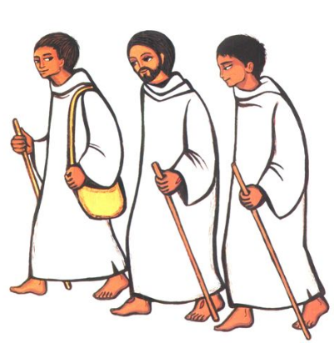**"Brothers"**, because fraternal life in community is an essential element of our consecrated life which is deeply rooted in the Word of God. The Gospel shows us **Jesus surrounded by his disciples.** They have this community experience with him throughout his public life, from the initial call, to the moment of the washing of the feet and the Last Supper, which will be followed by the crisis of the passion. The fraternity between the disciples will resume and grow after the resurrection, through the encounters with the living Jesus. After Pentecost, the Acts of the Apostles show us the **first Christian community** which will remain the unsurpassed model of fraternal life. The apostles and all those who had welcomed the Word "were assiduously in the teaching of the Apostles and fellowship, the breaking of bread and prayers… All who believed lived together and had all things in common” (Acts 2:42.44).

To live out the theme of the year, we will allow ourselves to be guided and stimulated by the **Rule of Life**. It invites us first to contemplate fraternity as a **gift received from God**. To live fraternity is to enter into the mystery of the Trinity, the mystery of communion that is the very life of God. It also means unfolding and manifesting this mystery in history, in humanity today. The Rule then calls us **to live and celebrate this gift** in a very concrete way through community prayer and fraternal relationships that build community through encounters, sharing, and exchanges. Finally, the community is the place of mission, of course through the apostolic action it supports, but also through the witness it gives to the life of a Brother. Fraternity is therefore also **a gift to offer** to those around us and to the world today. It is particularly in the Mennaisian Family that we are called to develop this spirit of communion and these bonds of fraternity (RV 2024, 9).

**"On the Way"**. It is about **living fraternity** by truly engaging with our Brothers. The Gospel shows us the very concrete action of Jesus washing the feet of his disciples and thus highlights the inseparable bond that unites the love of God and the love of neighbor. Paul's letters also strongly emphasize fraternal relationships in Christian communities, linked to the heart of faith and Christian commitment. Jean-Marie de la Mennais is steeped in these texts; he emphasizes fraternal life in community, not in a theoretical way, but **in the concrete of life**, with the brothers that God places on their path. We see this in his writings, especially the first editions of the Rule. Thus, the Rule of 1823 deals with relationships "toward other Brothers":

*“The spirit of the Congregation is a spirit of peace and charity; the Brothers will live together in the most perfect union, loving and helping one another.”*

Today the Church continues to encourage us to be "Brothers on the Way." "Pilgrims on the path of fraternal life," throughout the year we can refer to the beautiful text, **Fraternal Life in Community*[1],***as well as the first ecclesiastical text on the life of a brother: **Identity and Mission of the Religious Brother in the Church**[2]**.**Let us set out, resolutely and together.

Biblical Icon: The Washing of the Feet

To help us enter into our theme of the year and live it, we can consider the episode of the **washing of the feet (**Jn 13:1-17). This text is well known to us, but we also know that we can never exhaust its richness of content and meaning. The following few reflections are therefore intended only to highlight certain aspects that are particularly illuminating for our theme of the year.

**John 13, 1-17:**

*Before the feast of Passover, Jesus knew that his hour had come to pass from this world to the Father. He loved his own in the world and he loved them to the end.* *The devil had already induced Judas, son of Simon the Iscariot, to hand him over. So, during supper,* *fully aware that the Father had put everything into his power and that he had come from God and was returning to God,* *he rose from supper and took off his outer garments. He took a towel and tied it around his waist.* *Then he poured water into a basin and began to wash the disciples’ feet and dry them with the towel around his waist.*

*He came to Simon Peter, who said to him, “Master, are you going to wash my feet?”* *Jesus answered and said to him, “What I am doing, you do not understand now, but you will understand later.”* *Peter said to him, “You will never wash my feet.” Jesus answered him, “Unless I wash you, you will have no inheritance with me.”* *Simon Peter said to him, “Master, then not only my feet, but my hands and head as well.”* *Jesus said to him, “Whoever has bathed- has no need except to have his feet washed, for he is clean all over; so you are clean, but not all.”*

*For he knew who would betray him; for this reason, he said, “Not all of you are clean.”* *So when he had washed their feet [and] put his garments back on and reclined at table again, he said to them, “Do you realize what I have done for you?* *You call me ‘teacher’ and ‘master,’ and rightly so, for indeed I am.* *If I, therefore, the master and teacher, have washed your feet, you ought to wash one another’s feet.* *I have given you a model to follow, so that as I have done for you, you should also do.* *Amen, amen, I say to you, no slave is greater than his master nor any messenger greater than the one who sent him.* *If you understand this, blessed are you if you do it.*

**Jesus began to wash the disciples' feet**

Jesus' gesture is not common for us, outside of our frequenting the Gospel. In Jesus' time, it was a common gesture; both a sign of welcome and hospitality when receiving someone and a necessity after walking dusty roads. The Bible often mentions this gesture, for example, when Abraham asks for water to be brought to wash the feet of the three men who come to visit him (Gen 18:4).

Typically, this gesture is performed by a servant or slave. It is therefore considered a humiliating task. This explains Peter's violent reaction, as he refuses to see his master take the position of the lowest of servants in front of his own disciples.

Compared to the usual sense of service rendered by the slave to his master, Jesus reverses the roles. From now on, the master is the first of the servants. This is the case for this community of disciples gathered around Jesus, as it will be in the communities that will refer to Jesus.

**The gesture of Jesus**

However, Jesus' gesture cannot be considered a simple service of which he would set an example. The text is almost overloaded with indications that draw our attention to a very particular context. It mentions "the feast of the Passover," here as the moment when Jesus will "pass from this world to his Father" because he will have been "delivered up." The meal in question is therefore not just any meal, it is the last meal of Jesus with his disciples, in the context of his "Passover." His attitude and his gestures therefore take on a symbolic and prophetic value.

Thus Jesus appears as the Servant. He strips himself of his garments, takes a towel and ties it around his waist. It is the abasement of Jesus at the moment of his passion that is represented, his kenosis. He truly takes on the habit of the servant who not only washes the disciples' feet, but gives his life for them, loving them to the end. In this sense, the washing of the feet joins the Last Supper, which is not reported by John in his Gospel. By his Eucharistic gesture at the Last Supper, Jesus gives his body and blood, as an anticipation of his Passion for the salvation of men. This is also what he does by washing the disciples' feet, and this is why it is necessary for Peter to accept this gesture.

**Brothers on the Way. Pilgrims on the Path of Fraternal Life**

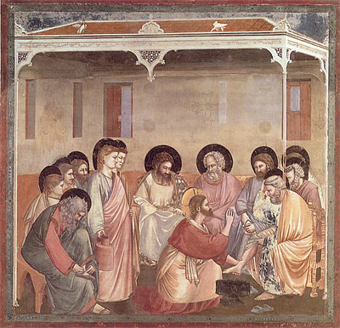The washing of the feet comes at an essential moment in the life of the community of disciples around Jesus, and it is therefore a passage from the Gospel which can enlighten us on our path of fraternal life.

**The community of disciples is gathered around Jesus.**

It is Jesus who gathers the disciples for this last meal. When his time has come, he loves them to the end. He makes a symbolic gesture that indicates the meaning of what he will experience in his passion by giving his life to the end on the Cross. It is an invitation for the life of the disciples, up to us today. This gesture, which could have been that of a slave, Jesus makes it a gesture of fraternity, of closeness with his disciples. He, the Lord and Master, becomes their friend and brother.

**The gift of fraternal life**

In this context of the Last Supper, Jesus' gesture symbolizes the gift of his life to the disciples and to humanity. Just as when he shared his body and blood, that is, his entire being given up for humanity. The fruit of this gift, fraternal life cannot be primarily a conquest of our will and our efforts. It is a grace to be received. Like Peter and the apostles, we must allow ourselves to be loved by Jesus, who loves us first. It is he who draws close to us and "washes" us so that we can participate in his life. It is he who gives us the example of true fraternity.

**The call to live as Brothers**

“***You must wash one another’s feet***”: Jesus calls us to serve one another, in humility, without considering ourselves superior to others or better than him.

***“I have given you an example so that you also should do as I have done to you.”***: taking the path of fraternal life is to put ourselves in the school of Jesus. Beyond this scene of the washing of the feet, other words of Jesus can challenge us: "learn from me, for I am gentle and humble of heart." We can also think of other gestures and attitudes of Jesus, when he meets the poor, the sick, children...

"***A servant is not greater than his master, nor one who is sent greater than the one who sent him. Knowing this, happy are you if you do it***." A call to truly live as brothers, to truly set out on the journey, in humility. Words are not enough; we need attitudes, gestures, concrete commitments. Jesus uses the verb "to do" to express the need to take concrete action towards our brothers.

Guide for preparing

the community project

**Each community is invited to plan a meeting** for the preparation of the Community Project.

1. In some Provinces or Districts, a day is taken in a place far from the daily concerns of the community. This day constitutes a time of reflection that prepares for the new year.
2. But if this is not possible, one to two hours should be allowed for the first time. After the meeting, based on the sharing that has taken place, the Superior drafts the community project. This will be presented to the community at a second meeting, one or two weeks after the first. The Brothers can still make changes. Then the Superior completes the drafting, presents the final text to the community, and requests the validation of the Provincial or Visitor.
3. Only afterward does the community reread the community plan during a time of prayer. The Brothers then sign it to signify their commitment to living what has been written.

**Our community life project for this year**

We are "***Pilgrims on the path of fraternal life in community***," "***Brothers on the Way***," Brothers who have decided to ***walk together on the paths of holiness and mission*** among children and young people. We are missionary disciples, called, ***not alone but with brothers***, to be like Christ, ***the Master and Servant, the One who washes the feet of his disciples and invites them to do the same***. It is He whom we must serve, and whom we must imitate. It is therefore with Him that we are called to wash the feet of our brothers. Behind Him, we journey, and we bring his Word to the little ones to whom he sends us. But we must do this in community, never alone. This is what our theme for the year reminds us. ***The first we are called to serve are our brothers.***

Before sharing among brothers to build our community project, let us take a moment to celebrate the One who makes us unified, ***the One who invites us to respond together to his call.***

**Time for prayer.**

At the beginning of the meeting, the leader schedules a time for prayer. Its duration depends on the time allotted for the entire meeting. Here are some suggestions.

**It is good to plan a song to open the prayer:**

It is good to take a song to the Holy Spirit.

**Then, one or two psalms can be prayed. For example:**

**Psalm 22**which evokes the individual relationship with God, but also the presence of God among his people; **Psalm 99** which is a call to collective praise; **Psalm 121** which expresses the joy of going to the house of God, where the people gather; **Psalm 132** which is a hymn to fraternal unity. It describes the joy and blessing that come from life in community. But there are many others.

**Finally, we listen to the Word of God**

It may be good to rely on the text proposed as an icon for the theme of the year, the **washing of the feet**: Jn 13, 1-17

But we can also choose the one that describes the **first community of believers**: Acts 2:41-47.

Or, remember **St. Paul's advice to the first communities**. We find them, for example, in the following references: Eph 4:1-6; Phil 2:1-11.

**Then we say a final prayer together.**

After a time of silence during which it is possible to ask the Brothers to share what they remember from the text listened to, we end with the prayer of the Our Father, or any other prayer.

**The development of the community project.**

For the rest, everyone has ***Chapter 6 of our Rule of Life*** (see appendix 1).

**A time of silence and personal listening to the Spirit.**

* We read personally and in a sufficiently long time of silence, the numbers of **chapter 6 of the Rule of Life** on the fraternal community.
* Each person then chooses three excerpts from this chapter. They choose them because they believe they represent attitudes and dispositions that they themselves are ready to commit to this year.
* He writes these three extracts on three separate sheets of paper, prepared in advance.

**A moment of listening and sharing.**

* **Everyone presents their choice** and places his three leaves on a table.
* Then we take the time, **in silence, to read** all the sheets.
* Now comes the time to define, based on the excerpts chosen by the Brothers, **three or four areas to which the community decides** to pay greater attention during this new year. These points will constitute the heart of our community project.
* **Everyone clarifies and shares their personal opinion.**, while listening very carefully to the opinions of others.
* After this time of listening and sharing, **the community chooses the three or four extracts** from the Rule of Life that it will retain for its Community Project.

**The time of developing the Community Project.**

**The community specifies, as clearly as possible, the means** which she will use to implement the extracts from the Rule of Life that she previously chose for this new year.

Then, **she continues to develop the Community Project** by reviewing all the elements of the community's life and mission. If necessary, one can draw inspiration from a few questions such as these:

**The prayer:**

* Following last year's theme, is our place of prayer (oratory or chapel) a central place for the community? How do we see it? Do all the brothers meet there for morning and evening prayer? Is the Eucharist celebrated there periodically in the presence of the entire community?
* Do our prayer time-tables allow for all Brothers to be present? If not, the community must decide whether to change them. What do we decide?
* Do all the Brothers participate in leading prayers? How?
* Is the time of morning prayer a community time as the Rule requires?
* Do the Brothers have the opportunity, from time to time, to share a text from the Word of God, living a lectio divina in community? If not, do we agree to do so?

**Fraternal relationships:**

* Does the community have times to relax together?
* How does she mark Sunday?
* Has the community taken steps toward reconciliation? How could it attempt to achieve one?
* How does the community care for the young brothers who join it? Can we discuss how we support them? What role do we give them? Do we listen to them? Do we take their suggestions into account?

**Community meetings:**

* How important is the organization of community meetings in our community? Are they not too far apart? How are they prepared? What is their content? Do we have times for spiritual reading together?

**Mennaisian Family:**

* How does the community welcome members of the Mennaisian Family: times of prayer, sharing, and conviviality? What mission projects can it undertake with these people?
* Is there a time planned with some of these most committed people to develop a mission plan for the year?

**Reception:**

* How is the community a place of welcome and a bond of fraternity for the people around it, the young, the poorest, the local Church?
* Do outsiders like to come and meet the Brothers? What place is given to them?
* How does the community promote the use of new communication technologies in an apostolic spirit of welcome and evangelization?

**Daily organization and year planning.**

* After examining these various aspects, the community reviews in detail the organization of a day, a week, and plans the highlights of the year for the community, the school, the Province or the District.

Drafting the community project

What we share and decide together for our community project this year:

|  |  |  |  |  |
| --- | --- | --- | --- | --- |
| **Our community** | | | | |
| **Name of the Brothers** | | 1- | | |
| 2- | | |
| 3- | | |
| 4- | | |
| 5- | | |
| **Assignment** | |  | | |
| **Pilgrims on the path of fraternal life in community** | | | | |
| **1- The calls of our Rule of Life.** | | | | |
|  | **2- Concrete means to live them (see the questions asked above?)** | | | |
|  | | | |
|  | **3- Our commitment in life: young people and those around us** (What commitments are we called to make to young people and to those around us?) | | | |
|  | | | |
|  | **4- Pastoral care of vocations in the Mennaisian Family**(How do we bear witness to the vocation of Brother? Do we call young people to become Mennaisians? How do we engage in the pastoral care of vocations in the Province or District?) | | | |
|  | | | |
|  | **5- Continuing education**(How do we organize community meetings, times of shared spiritual reading?) | | | |
|  | | | |
| **Review and evaluation of our community project**(Plan the two or three dates of the year when we will carry out an evaluation of this community life project?) | | | | |
|  |  | | | |
| **Approval of the Provincial Brother or Visitor** | | | |  |
| **Signature of community members** | | |  | |

Write and live your personal project

The following can help the Brother or a lay member of the Mennaisian Family to reflect on and write their personal project. Retreat, or recollection, is a favorable time to write this project, integrating into it what is stated in the community project.

**My response to the Lord's call**

The personal project is a means to enable each person to advance towards "the full stature in Christ" (Eph 4:13). It is therefore an original translation of the availability of each person to respond to God's initiative of love.

*"In the spirit of the community project and with a view to unifying his life, each Brother develops his personal project. He specifies the means and attitudes he intends to adopt to implement it in a dynamic of human and spiritual growth, ongoing formation and apostolic commitment" (Rule of Life, Ch. 6, 63.2)*.

**Preparation**

A personal project is prepared and written in the light of the Word of God, the Rule of Life and the guidelines of the Congregation, the Province or the District, and also the community project, in connection with the theme of the year: Pilgrims on the path of fraternal life. Brothers on the way. In a climate of prayer and availability, each person strives to discern the most pressing personal calls of the Lord, to identify the needs and challenges present in their own life or in that of the community, and to take the fundamental direction that their heart dictates.

**A fundamental orientation**

Choose a fundamental direction that encompasses an important dimension of concrete life, which will gradually transform the person. "Brothers on the journey": each person specifies what this means for them? What they want to experience more deeply this year? Points of attention, according to chapter 6 of the Rule:

* A fraternal life based on the Word of God, the Eucharist and prayer;
* The quality of fraternal relationships: attention, listening, dialogue, service, forgiveness, peace and joy;
* Sharing: “the Brothers share what they are, what they do and what they have”;
* The community “for the mission”, “sign” of evangelical fraternity, in the Mennaisian Family.

**Concrete means**

To provide oneself with the concrete means to implement the chosen orientation in one's daily life, by specifying, with regard to the points mentioned above, how one wishes to live one's vocation as a consecrated person or as a lay person committed to following Christ, in community or in fraternity, as a witness guided by fraternal life: actions, times of the day and of the week, attitudes to adopt or to work on...

**Periodic evaluation**

For your personal project to be successful, it is important to periodically and honestly evaluate its implementation. To do this:

* Write it down (personal notebook, printed sheet, reminder posted in your room)
* Reread it or critique it periodically, for example, when looking back on the day, at evening prayer or when visiting the Blessed Sacrament...
* If you wish, share your personal project with the Major Superior, the spiritual guide, or perhaps even with a colleague of your choice...

If it is well lived, the personal project contributes effectively to the human and spiritual growth of the person. It also has positive effects on fraternal life, on the apostolic mission of the community and of the entire Congregation.

Celebrate and Pray

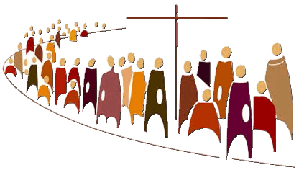

**BUILDING BONDS THE IN THE WAY OF JESUS**

Lord Jesus, on this day we offer you our whole life.

May fraternal love reign among all of us who form a community.

May each of us be happy in the joy of others and suffer in their sorrows.

May we all practice mutual help to go to God and do his work each day.

May there never be among us quarrels, rivalries, secret jealousies, or unkind words.

Remove from us, Lord, everything that hurts, everything that divides, everything that harms charity.

Do so, Lord, that today and always we try to help one another.

May we pass this day with gentleness, patience, humility and fidelity to our commitments.

*Based on the writings of Jean-Marie de La Mennais*

**PRAYER FOR BROTHERHOOD**

O God, Trinity of love, from the profound communion of your divine life,

pour out upon us a torrent of fraternal love.

Grant us the love reflected in the actions of Jesus, in his family of Nazareth,

and in the early Christian community.

Grant that we Christians may live the Gospel,

discovering Christ in each human being, recognizing him crucified

in the sufferings of the abandoned and forgotten of our world,

and risen in each brother or sister who makes a new start.

Come, Holy Spirit, show us your beauty, reflected in all the peoples of the earth,

so that we may discover anew that all are important and all are necessary,

different faces of the one humanity that God so loves. Amen. *Pope Francis, Fratelli Tutti, Rome 2020, n°287*

**PRAYER TO LOVE AND SERVE**

I ask our Lord Jesus Christ to grant that his Sacred Heart may continue to pour forth the streams of living water that can heal the hurt we have caused, strengthen our ability to love and serve others, and inspire us to journey together towards a just, solidary and fraternal world. Until that day when we will rejoice in celebrating together the banquet of the heavenly kingdom in the presence of the risen Lord, who harmonizes all our differences in the light that radiates perpetually from his open heart. May he be blessed forever.

*Pope Francis, Dilexit nos. He loved us, Rome 2024, no. 220*

SONGS:

**I HAVE CALLED YOU MY COMPANIONS**

[**https://www.youtube.com/watch?v=MiWIOZLxRdI**](https://www.youtube.com/watch?v=MiWIOZLxRdI)

I’'ve called you my companions.  
My friends, I’ve chosen you  
to show my Heart’s compassion,  
for all life to be renewed.

Now, do as I have shown you—  
my Spirit will break through—  
humbly serving one another,  
loving as I’ve loved you.

**REFRAIN**  
**I will wash your feet, cleanse away the stain.  
I will fill you with my peace, make my love remain.**

**WE ARE ONE IN THE SPIRIT**

**https://www.youtube.com/watch?v=TJGE7r6I9Og**

1. we are one in the Lord,  
   we are one in the Spirit,  
   we are one in the Lord,  
   and we pray that all unity  
   will one day be restored  
     
   Refrain:  
   **and they'll know we are Christians  
   by our love, by our love,  
   and they'll know we are Christians  
   by our love.**  
     
   2. We will walk with each other,  
   we will walk hand in hand,  
   we will walk with each other,  
   we will walk hand in hand,  
   and together we'll spread the news   
   that God is in our land.  
   (Refrain)

I will wash your feet, cleanse away the pain.  
Your heart, I will hold and heal.  
Make my mercy reign.

I leave you with this mission, a sacrifice of love,  
a life to be surrendered so all sinners may be free.

Now, take your cross and follow.  
Go forth, proclaim my Word.  
Find the lost, console the weary,  
bear the light so all may see

3. We will work with each other,  
we will work side by side,  
we will work with each other,  
we will work side by side,  
and we'll guard each one's dignity  
and save each one's pride.  
  
(Refrain)  
  
4. All praise to the Father,  
from whom all things come,  
and all praise to Christ Jesus,  
who is God's only Son,  
and all praise to the Spirit,  
who makes us one,  
  
(Refrain)

1. CICLSAL, Fraternal life in community, Rome 1994.
2. CICLSAL, Identity and Mission of the Religious Brother in the Church, Rome 2015.