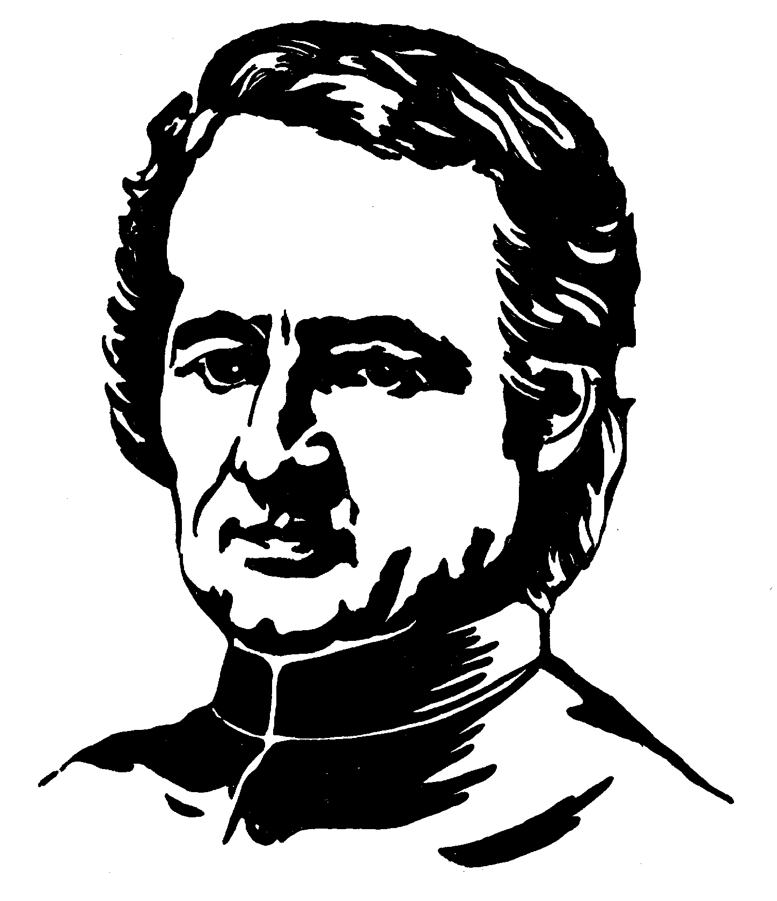**A spirit of charity and unity**

**Sermon by Jean-Marie de la Mennais[1] :**

The spirit of the Congregation must be a spirit of charity and of union. It will happen, no doubt, that among us there will be some, and me the first one, who will be in need of indulgence. Well then! We shall bear in a spirit of charity one another’s burden: *« Bear one another’s burdens, and so you will fulfill the law of Christ[2] »* Far from being irritated by the defects of our confreres, as it happens too often, we shall think of humbling ourselves for ours, and we shall have, if I may say so, for our spiritual ills, the most attentive and the tenderest care.

It would be absurd to expect that in a big gathering of people there would not be any sick ones. It would not be less absurd to suppose that in a Congregation, there would not be any troublesome characters, whatever precautions we may take in the choice of the subjects we receive. Moreover, the characters sometimes change with the positions and with the years. And who among us can affirm that his present dispositions will be invariable? Thus, we are perhaps speaking of and for ourselves at this moment. Following the example of St John the Apostle, I will tell you unceasingly: “Love one another; be full of indulgence and mercy for one another. Do not judge others severely for fear of being judged yourselves”.

When we shall be united, we shall be strong and we shall be happy. Yes, this holy union will be the charm, the grace and the strength of our Society. *« How good and how pleasant it is, when brothers dwell together as one![3] ! » “together in one”*, does not mean in the same house, but of the same sentiments, but of the same charity. So much so that if one of our confreres suffers, we would suffer with him, that if he rejoices, we would rejoice with him, taking for motto these beautiful and touching words: *« one heart and mind* [4]*».* This is more necessary as we are habitually together and always so near one another. The smallest frictions of character, if I may say so, repeating themselves at every hour, soon cause heartbreaks. It is necessary then that the oil of charity softens them, and heals these little wounds, apparently so light, but very dangerous in reality, and which soon make matters worse. Yes, my children, let us love one another as brothers, *« with the affection of Christ Jesus*[5]*»,* following the Apostle’s advice that nothing could ever change our peace, our union. This holy union will not be broken by death; it will be eternal as God himself.

1. S II, 603. Esprit de la Congrégation (St-Méen), Anthology 172-173
2. Ga, 6, 2.
3. Ps, 133, 1+
4. Ac, 4, 32.
5. Ph, 1, 8.