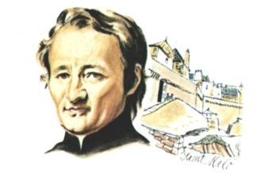
MENNAISIAN NOVENA PRAYER
(CHILDREN AND PRE-TEENAGERS)

JEAN-MARIE DE LA MENNAIS: A FATHER'S HEART
- A CHRISTIAN FAMILY'S GIFT
- SINGING
- STORY OF HIS LIFE:
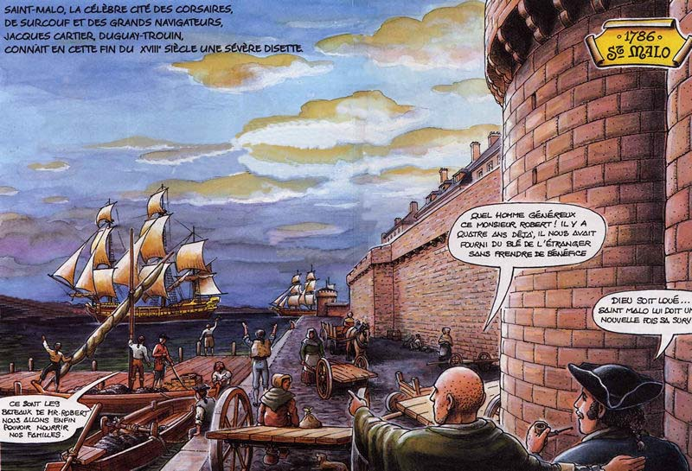
Jean-Marie was born in Saint-Malo, France, a town of sailors, fishermen, and former privateers. His family was well-off, but very Christian and generous. His father, Pierre, a shipowner, maintained trade with Europe and America. He often came to the aid of the local population during times of famine, selling wheat, corn, and other products at very low prices, or even for free. His mother, Gratienne, was very religious: she gently taught catechism and prayers to her six children. Jean-Marie listened to her obediently.
Sadly, his mother became gravely ill and died, leaving her family in deep sorrow. Jean-Marie, barely seven years old, suffered greatly, but he cherished his mother's words and would follow her teachings throughout his life. He already dreamed of dedicating his life to helping lonely or abandoned children.
PRAYER
- We give you thanks, O Father in Heaven, for the family you have given us: may it always be a place of love, giving and peace, let us pray.
LISTEN TO US, O FATHER
- We pray to you, O Father in Heaven, for families in difficulty because of illness, poverty, and lack of communion, that they may find hope in the gospel of love and forgiveness. Let us pray.
- We pray for parents who have a beautiful but difficult mission, that they may find the time, patience, and firmness with their children and allow themselves to be guided by faith in the God of love. Let us pray.
- We pray for us, sons and brothers, that we may be grateful and open with our parents and with our brothers and sisters, forming a joyful community of affection and mutual support. Let us pray.
SINGING
GESTURE: Before supper, pray together as a family to ask for a favor through the intercession of Father de la Mennais

- THE REVOLUTION: JOHN-MARY CHOOSES TO SIDE WITH JESUS
- SINGING
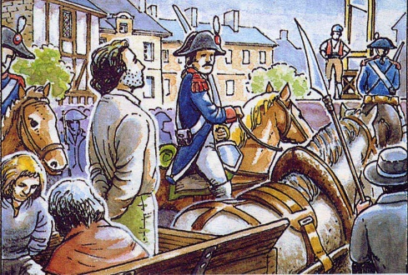
- STORY OF HIS LIFE:
Jean-Marie was nine years old when the French Revolution broke out. According to the revolutionaries, authority came from the people and law from human reason. God was no longer needed; on the contrary, he, along with his priests and commandments, had to be eliminated. Churches had to be destroyed, and religion abolished. Little Jean-Marie saw priests condemned to death and killed in the public squares. But he admired them and chose to stand, like them, beside Jesus. He secretly helped priests disguised as sailors or merchants; he took them to his home so they could celebrate Holy Mass in the attic. He attended as an altar boy. He promised himself: “When I grow up, I too will become a priest and dedicate myself to the service of God and the Church that they want to destroy.” Every day he went to the port. He had a special instinct for recognizing priests in disguise. Risking his life—if he were discovered—he spoke with them and supported them. He befriends priests, who instruct him in the faith and encourage him to follow Jesus.
PRAYER
- Jesus, help me to have the strength and joy to follow you on the path of the Gospel, prayer, and kindness. LET US PRAY
LISTEN TO US, JESUS
- Jesus, help me to serve everyone, especially those who are alone, weak, or marginalized. Let us pray.
- Jesus, help me to always follow you, even when I am mocked for praying, attending church, and following your word. LET US PRAY
- Jesus, help all children to follow you with joy and courage as Jean-Marie did. Let us pray.
GESTURE: I am willing to deepen my faith through catechesis and religious instruction, at school or in the parish

- JEAN-MARIE CULTIVATES A PROJECT THAT COMES FROM GOD
- SINGING
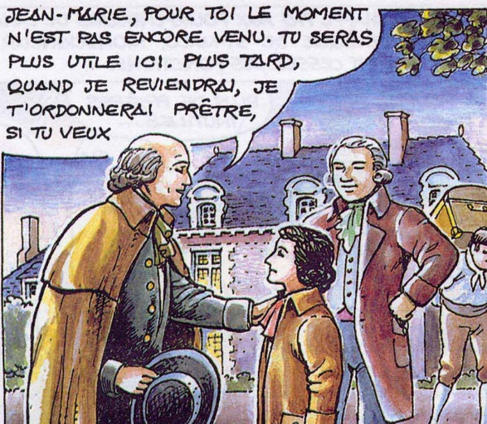
- STORY OF HIS LIFE
In the turmoil of the Revolution, even the Bishop of Saint-Malo was forced into exile. As he was a close friend of the de la Mennais family, he visited their country house for a final farewell. He celebrated Mass, assisted by young Jean-Marie. Only ten years old, he was already mature in his heart. He spoke to the bishop: “I want to become a priest and will come with you to England, because you will help me prepare.” Seeing young Jean-Marie's resolve and his religious preparation, the bishop gave him First Communion and Confirmation. The child received both Sacraments with fervor and simplicity: he was not interested in celebrations or gifts, but now, with Jesus, he received a strength and joy that no one could take from him. He had made his decision: “I will follow Jesus, whatever the cost, even the cost of death!”

PRAYER
- Thanks to you, Jesus, who loves us and gave your life for us. Let us pray.
WE GIVE YOU THANKS, JESUS
- Thanks be to you, Jesus, who gave us the Sacraments through which you make us children of God and your brothers and sisters, and fill us with love. Let us pray.
- Thanks be to you, Jesus, who calls us into your Family of the Church: may no one remain alone, but may we all be in communion with one another. Let us pray.
- Thanks to you, Jesus, who calls each of us to follow you in a great adventure of generosity: I want to prepare myself for great horizons by faithfully fulfilling my duties. LET US PRAY

SINGING
GESTURE: I want to commit myself to Christian initiation, either through the Catechumenate or through frequenting the Sacraments of the Eucharist and Confirmation.

- JEAN-MARIE: A YOUNG MAN FULL OF ENTHUSIASM AND COURAGE
SINGING
STORY OF HIS LIFE
We are in the midst of revolutionary turmoil: churches destroyed, priests killed, Christians persecuted. France is going through a period of bloodshed and terror. With courage, Jean-Marie bears witness to his faith. He refuses the invitation to participate in a military parade in uniform, organized by the revolutionaries. He goes out onto the ramparts and remains fasting all day. He returns home hungry in the evening, but his conscience is clear.
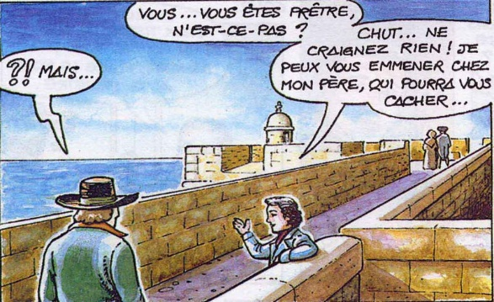
He defies danger. He attends Mass celebrated by an elderly priest very early in the morning. Once, deceived by the full moon, he ventures out at night and encounters a patrol of gendarmes who ask him, “Where are you going?” “What time is it, citizens? It’s getting a bit late!” And he quickly runs home. He had a narrow escape! He takes another risk when, on the ramparts, he meets some men posing as sailors. The question, “Are you a priest?” could lead to him being accused of being a cleric and condemned. When the days become calmer, he remains faithful to his faith: he advises his sister not to participate in the festivities, after such dramatic times.

PRAYER
1- Jesus, help us to be courageous and not to give up at the first sign of difficulty. LET US PRAY.
GIVE US YOUR STRENGTH
2. Jesus, grant us to be generous towards others, without calculating if it suits us. Let us pray.
3. Jesus, help us not to be ashamed of you and your gospel, but to be proud of the gift of faith. Let us pray.
4. Jesus, give us the courage to serve others, the strength to forgive, enthusiasm for our schoolwork, and joy in all our lives. Let us pray.
SINGING
GESTURE: I am committing to a solidarity or friendship initiative with young people in difficulty.

- JEAN-MARIE: A LIFE DEDICATED TO BRINGING JESUS ​​INTO THE WORLD
SINGING
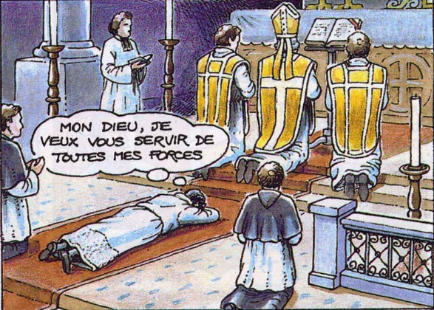
STORY OF HIS LIFE
Jean-Marie had grown into a young man: well-educated, intelligent, and from a wealthy family. He could have had a successful and prosperous career. But he remained faithful to God's call and his plan: to become a priest. He went to Paris to meet his elderly bishop and fulfill his dream. The bishop took him to a church where the walls were still stained with the blood of priests killed by revolutionaries. The bishop said to him, “Those who killed these priests are still alive, and they could do it again. Are you still willing to become a priest?” Jean-Marie replied, “They could do it again. I want to dedicate my life to the service of the religion that they want to destroy. I have seen so many priests killed because they wanted to remain faithful to Jesus, and I too am ready to do the same!” With these words, Jean-Marie was ordained a priest. From then on, all his moments would be devoted to Jesus and the Church, especially to children and young people.
PRAYER
- Jesus, I want to say yes to your call. I am willing to do what you desire of me. LET US PRAY
HERE I AM AT YOUR SERVICE
- Jesus, I say yes to your words, which show me the path of goodness. LET US PRAY
- Jesus, help me to say yes to my parents, my teachers, to all those who represent you. LET US PRAY
- Jesus, help me to take steps each day toward the vocation to which you are calling me. LET US PRAY
SINGING
GESTURE: I want to be helped by some spiritual guide to understand my vocation

- JEAN-MARIE, FOUNDER OF CHRISTIAN SCHOOLS TO MAKE JESUS ​​KNOWN AND LOVED
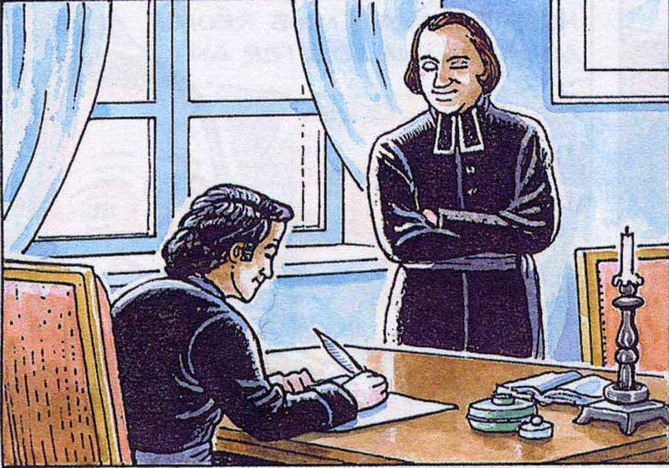
In his life, Jean-Marie accomplished many things, but his most important work was the founding of numerous schools for children and young people. With his friend, Father Gabriel, he saw abandoned children on the roads, often without parents, exploited in farm work or factories, without any education or preparation for life.
The state wanted to educate children, but without God and without respect for individuals, as in the days of the Revolution. Jean-Marie and Gabriel envisioned a school founded on faith to make Jesus known and loved, and consequently to raise children to be free, respectful, honest, and compassionate. There was a need for a Christian school, where education and religion were taught while simultaneously nurturing the mind and heart, faith and knowledge, and respect for society and the Church. To establish these schools, Jean-Marie founded two religious orders: the Daughters of Providence and the Brothers of Christian Instruction. Schools multiplied in villages and towns: primary schools and specialized schools focusing on mechanics, agriculture, and navigation. Everything was learned with joy; children played and prayed together. The school was a large family, and the teacher, an older brother, leading the children to Jesus.
SINGING
PRAYER
- Jesus, I want to say “Yes” to your call: I am willing to do what you ask of me, LET US PRAY
JESUS, I WANT TO FOLLOW IN YOUR FOOTSTEPS
- Jesus, I want to know and follow your gospel better. LET US PRAY
- Jesus, help me to say Yes to those who help me grow in wisdom and grace, LET US PRAY
- Jesus, help me to be docile to the promptings of the Holy Spirit so that I may grow in holiness. Let us pray.
SINGING
GESTURE: I want to be involved in my school as a house of faith, friendship, and projects.

7- THE MISSIONS AND THE MISSION OF JOHN-MARIE
SINGING
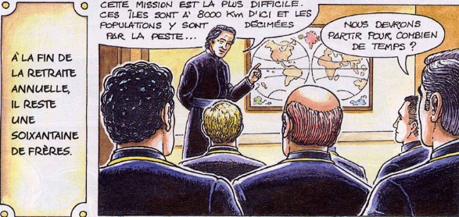
STORY OF HIS LIFE
Jean-Marie did not limit himself to opening schools in his region of France, Brittany. He sent his Brothers and Sisters all over the world. He opened schools in the West Indies, where slaves still lived. Other schools were founded in Africa, South America, and the islands of the North Atlantic and Pacific Oceans. Hundreds of Brothers left to dedicate themselves to children and adults, free people and slaves. Everywhere they went, they brought the Gospel and education, often amidst terrible living conditions and diseases that claimed dozens of young lives. And yet, they left by the hundreds with enthusiasm and courage, which Jean-Marie, called “Father” by all, instilled in them.
Today, the Mennaisian family is still alive, spread across all continents. It works to provide Christian instruction and education to hundreds of thousands of young people, always with the same spirit, the same love, the same faith of John Mary. So let us also follow in the footsteps of our Father. Let us pray that his holiness may receive official recognition from the Church and that, following in his footsteps, many young people may dedicate themselves to this magnificent project of renewing the world through the Christian education of children and young people.

PRAYER: JOHN-MARY, PRAY FOR US
- You who loved Jesus so much
- You who have worked so hard for the Church
- You, a father to children and young people
- You, founder of numerous schools to make Jesus known and loved
- You who founded two religious institutes
- You who are our Father in faith
SINGING
GESTURE: How could Jean-Marie's dream help me achieve my dream?

Prayer for the Beatification of Jean-Marie de la Mennais
[-Songs and prayers on:https://www.lamennais.org/audio-chants-songs-cantos/
- Images and locations: “Le Foyer Mennaisien”]

