NOVENA September 18- 26 26, 2026
To Evangelize: to Make Jesus Christ Known
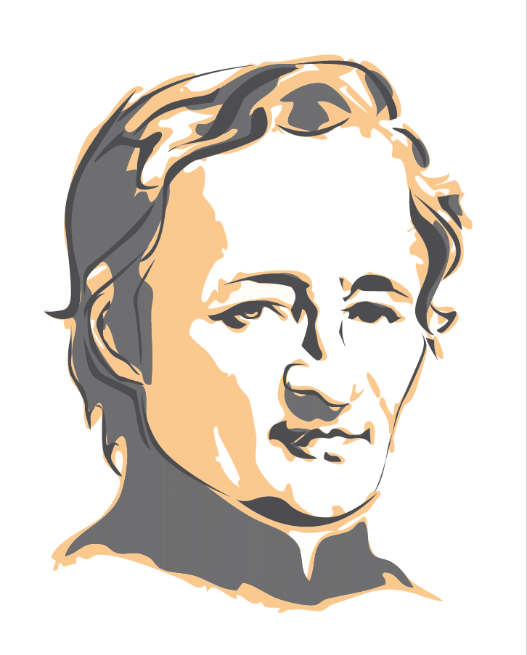
In many Sectors of the Congregation, September coincides with the Start of the School Year and Apostolic Activities. For all of us, Mennaisian Brothers and Lay People engaged in the Mission, it could be good to allow Ourselves to be challenged again on Our Commitment to serving Young People: Consecration to God is inseparable from the Mission with which it forms a Single Unit: To be consecrated to God implies being sent into the World. "Rule of Life #19"
That Service takes many Forms: Teachers, Catechists, Leaders of Prayer Groups or Apostolic Movements, Leaders of Groups preparing for the Sacraments of Christian Initiation, Various Services to Young People in difficulty, Service to Migrants through Literacy, Language Learning, or Administrative Assistance, Service of Prayer and Offering one's Sufferings, etc. Whatever form Our Commitment takes, the Heart of Our Mission remains the same:
"The Brothers seek, in the midst of the Children and Young People to whom they are sent, to reproduce the Gospel face of Jesus the Master who 'loved the Children whom he wished to be surrounded by and whom He deigned to Bless'"
Through their Vocation as Educators, the Brothers have as their First Mission to make Jesus Christ and His Gospel known and loved… Rule of Life No. 2
"There could be no more Beautiful and Simpler Program of Evangelization and Mission: to reveal to each Person the Tender and Special Love that Jesus has for them, to the point of transforming their life." Leo XIV
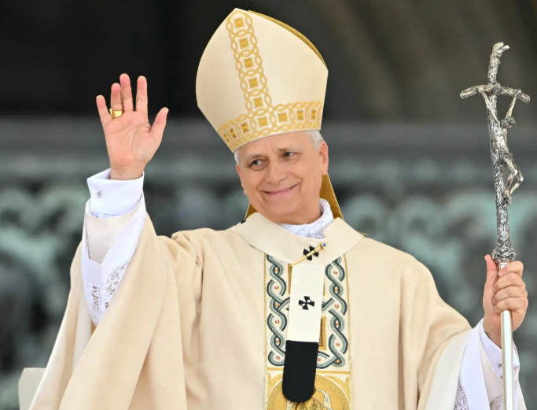
Together for the Mission
"The Evangelizing Mission that Christ entrusted to the Disciples requires above all reconciled Hearts, eager for Communion. The more united we are in Christ, the more we could accomplish together the Mission He entrusts to us." Leo XIV
In Rule 91, we find that same emphasis on the Indispensable Unity necessary for the Mission to bear Fruit: “Like the First Disciples of Christ, the Brothers form One Body for the Mission: It is together that they are called and sent as a Body. Fraternal Communion is both the Source and the Fruit of their Mission.” (RV 91) “Shared Mission is a call of the Spirit addressed to the Brothers and the Laity to live the Mennaisian Charism in Communion.” (RV 92)
In Conclusion, let us listen to Father de la Mennais tell us again:
"I hope that you will all faithfully fulfill the Mission entrusted to you. For that, Perfect Unity is necessary, as well as sincere Charity…" (To Brother Arthur, April 3rd, 1842)
"Love one another; live together in Perfect Unity; have but one Heart and one Soul."(To Bro. Étienne-Marie, January 9th, 1853)
News from the POSTULATION: Bro. Dino
2016, Rome: The Enzo Carollo Case is reopened: the Consulta Medica (Medical Commission) met to Examine the File. The Argument of Scientific Inexplicability was rejected by a vote of 5 to 2. Reasoning: the Doctors successfully treated the Immunosuppressive Mechanisms with Corticosteroids and Immunoglobulins.
2017: Postulator Bro. Dino De Carolis, acting on the Dicastery's Instructions, took up the Cause of Josette Poulain, a young girl from Combourg (Rennes), who had fallen and hit her head, falling into a coma with Paralysis. The Diocesan Inquiry was completed with the help of Bro. Michel Bouvais, Vice-Postulator. The Case was taken to Rome and examined in 2022. The Consulta declared that there was insufficient Evidence to determine whether the Healing was either Explainable or Inexplicable: a lack of reliable X-rays and the Sole Diagnosis of the Doctor. Final judgment: Suspensive, meaning: Case postponed.
2023-2026: The Postulator, under the Mandate of the Superiors, took up the Case of Enzo Carollo again. He gathered Testimonies from other Doctors and considered the Expertise of Four Italian Specialists, one Argentinian (who was present at Enzo's First Hospitalization), and the Testimony of young Enzo's current situation (he is 25 years old), as well as that of his Mother and a Friend. The Steps taken in Argentina were carried out by the Brothers of the South American Province.
Prayer Intentions
- The Brothers of the Mission of Timor Leste: Bro. Stéphane, Bro. Philippe, Bro. Festo.
- Recommended Patients:
  - Brother Jean Herbinière, Brother George Kamanda,Dominic S Kahangire, Onesmus Mutakirwa
  - Brother Dufreine Auguste (Cap-Haïtien) recently suffered a Stroke
  - Dario Leukemia), Gioacchino (Cancer), Dionisio (Circulation Problems),
  - Sandrine (Charcot's Disease)
  - For Bruno, who is very fragile Psychologically, so that he could find a Job and stability in his life.
- Vocations in the Institute and the Perseverance of the Professed Brothers.

Novena Prayer:
God Our Father, you gave Jean-Marie de la Mennais,
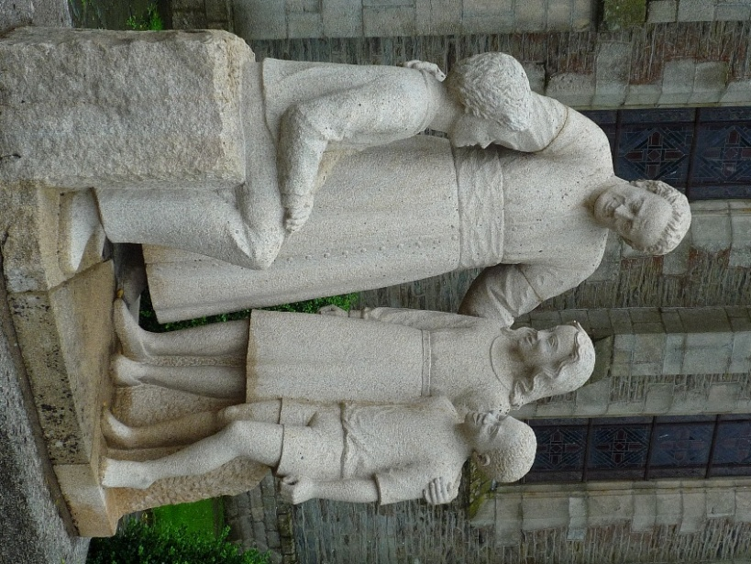
a Generous Heart and an Unwavering Zeal
to make known and loved your Son Jesus and His Gospel.
Grant us to follow his example.
Give us the courage to build united and Fraternal Communities.
Help us to proclaim Your Gospel to the youth of today.
For the Glory of your Name,
Grant that the Holiness of Jean-Marie de la Mennais
may soon be recognised and proclaimed by the Church.

Deign to grant us, O Lord, through his Intercession,
the healing of the persons recommended ...
Through Jesus Christ, Our Lord. Amen.
O Lord Jesus, Glorify your Servant, Venerable Jean-Marie de la Mennais.

