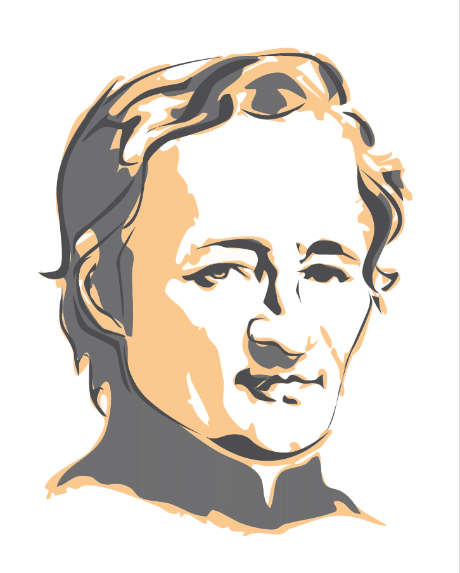
Novena from July 18th to 26th , 2026

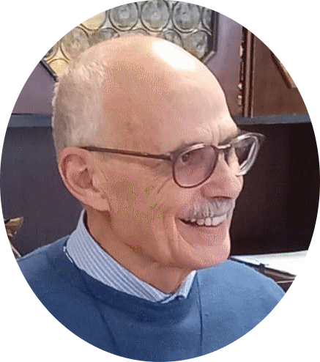
As I began that New Mission, I noted that the Postulator Brothers had Published Extensively to encourage the Brothers and the Entire Mennaisian Family to persevere in Prayer. Over the past few years, we could only commend the Interventions of Brother Dino, who has consistently reminded us of Our Progress in the "Cause of Our Venerable Father." I have witnessed his Immense Work in the Case of Enzo Carollo. Being Italian, Brother Dino has Many Connections both within the Dicasteries and with Medical Authorities. He has skillfully used his Networks to bring us to where we are today. We are deeply grateful to him!
"APPLICATION UPDATES (JULY 2026)"
The Investigation into the alleged Inexplicable Healing of E. Carollo has reached a New Stage. The Postulator had formally requested the Reopening of the Investigation into Enzo Carollo's Healing, which had not been deemed Inexplicable by an Initial Consulta Medica (Medical Commission) in 2016. That Request was supported by a Series of New Private Expert Opinions that favored the Inexplicable Nature of the Healing.
The Dicastery accepted the Postulator's Request on January 17th, 2026. It mandated Two Ex Officio Experts (Officers chosen by the Dicastery) to study the Additional Dossier prepared by the Postulator. The Result: One of the Two, Dr. Gandolfini M., asserts that there are serious grounds for a New Examination by the Consulta Medica; the other, Dr. Valentini, states that there could be Scientifically Justifiable Reasons.
Thanks to the Favorable Vote of one of the two Doctors, the Prefect of the Dicastery, Cardinal Semeraro, Officially authorized a New Examination by a Second Medical Consultant on June 17th. The Written Reports from the Expert Assessments arrived on June 30th.
Now, the Study Materials for each Specialist and for the Dicastery need to be printed. Those Materials consist of the Frst Summarium (File) from 2016, supplemented with New Expert Reports. All those Files would be ready by the end of July. They would be distributed to those concerned after the Summer Break, at the beginning of September, for In-depth Study. The Consulta Medica Meeting is scheduled for approximately a Thursday in November.
For the Next Step, IF THE RESULT OF THE CONSULTA IS FAVORABLE, WE WOULD MOVE ON TO THE CONSULTA TEOLOGICA (to testify that the “Miracle” was obtained through the Intercession of Father de la Mennais) and, as the Final Canonical Step, SIGNATURE OF THE POPE FOR THE BEATIFICATION!
To achieve that Result, we must WATCH, PRAY, AND FOLLOW OUR FATHER!!!” F. DINO
Pray and pray again with confidence “Whatever you ask the Father in my name, he will give it to you.”(John 16:23) Jesus tells us.
I borrow the following lines from Bro. Vincent Guillerm: “The ‘Official’ Prayer (Annual or Monthly Novena, etc.) was obviously recommended, but without forgetting that it must always be a truly Personal Prayer. And it is also to the humble, trusting prayer of each person (the Sick themselves and their Families, their Friends, their Colleagues) that the Lord delights in responding generously.”
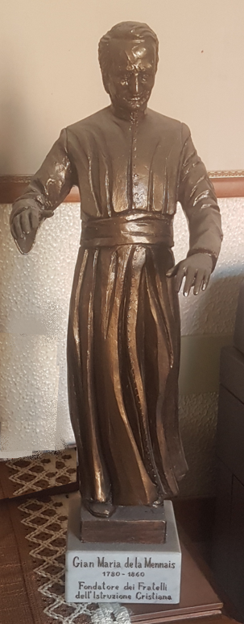
The Intentions of the Month:
- The Brothers, the Communities and the Entire Mennaisian Family in Countries affected by Wars, Epidemics, Insecurity: Congo DRC, Haiti, and South Sudan.
- Young People who participate in Vocational Camps during School Holidays.
- Novices preparing for their First Commitment and Brothers Renewing their Temporary Vows,
- The Brothers are in Session in Ploërmel in preparation for their Final Commitment.
- Recommended Patients:
  - Brother Jean Herbinière and Brother George Kamanda, Dominic S Kahangire,and Onesmus Mutakirwa
  - Dario (Leukemia), Gioacchino (Cancer), Dionisio (Circulatory Problems),
  - Sandrine (Charcot's Disease)
- The Intentions placed on the Father's Tomb in Ploërmel.
- Brothers Stéphane, Philippe and Festo from the Community of Manatuto, Timor Leste.

Novena Prayer
God Our Father, you gave Jean-Marie de la Mennais,
a Generous Heart and an Unwavering Zeal
to make known and loved your Son Jesus and His Gospel.
Grant us to follow his example.
Give us the courage to build united and fraternal Communities.
Help us to proclaim Your Gospel to the youth of today.
For the Glory of your Name,
grant that the holiness of Jean-Marie de la Mennais
may soon be recognised and proclaimed by the Church.

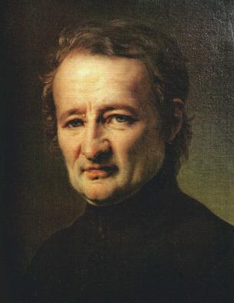
Deign to grant us, O Lord, through his Intercession,
the healing of the persons recommended ...
Through Jesus Christ, Our Lord. Amen.
O Lord Jesus, Glorify your Servant, Venerable Jean-Marie de la Mennais

