The Virgin Mary at the Heart of
NOVENA October 18-26, 2026
our Religious Life

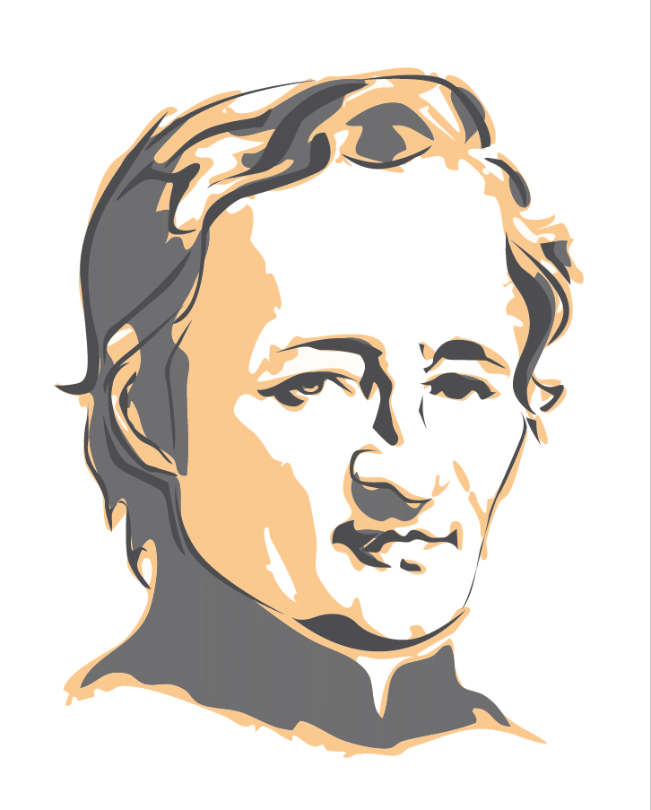
Throughout his life, Jean Marie de la Mennais lived a profound devotion to the Virgin Mary. "We know that until the end of his life, Father de la Mennais recited the rosary every day, sometimes at very late hours… He never went to sleep without having paid homage to his sweet Sovereign."
To the various individuals and groups he addresses, he strongly recommends devotion to Mary. "In Mary, you will find a powerful advocate, a mother full of gentleness and kindness, and the most perfect model of all virtues: could Jesus possibly reject the prayers she addresses to him for the beloved children he himself gave her and of whom he wanted her to be the mother, just as she was his?"
To the Brothers, he recommends the daily recitation of the rosary: ​​"the most powerful weapon to touch the heart of God" Leo XIII, "a summary of the whole gospel" Pius XII, "the gospel in short" Paul VI, "a channel of graces" JMdlM. As early as 1823, Jean-Marie de la Mennais made it a point of the Rule.
In later editions, we find the same advice and recommendation. In number 75 of our Rule of Life, we read: The Brothers express their love and veneration for the Blessed Virgin Mary, model of listening to the Word. Through Scripture, they meditate on her role in the plan of salvation and, through the liturgy, experience with her the mysteries of her Son. They entrust their religious and apostolic life to her maternal care. They do this especially through the daily Rosary, a traditional prayer in the Congregation. "In the chapter on formation, at number 121, the recommendation made to young people in formation also applies to each of us: 'Like her, the Brother allows himself to be transformed and celebrates in his life the wonders of God; following her example, he listens to the Word and meditates on it in his heart, in order to put it into practice.'"
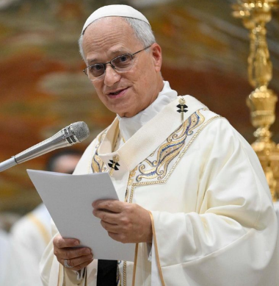
For Pope Leo XIV, Marian devotion is part of the life of all Christians, not just consecrated persons, because “Marian spirituality is at the service of the Gospel: it reveals its simplicity. Affection for Mary of Nazareth makes us, with her, disciples of Jesus; it teaches us to return to Him, to meditate on and connect the events of life in which the Risen One still visits us and calls us… Mary’s path follows Jesus, and Jesus’ path leads to every human being, especially to those who are poor, wounded, and sinners.” (Homily of October 12, 2025)
"The Rosary is one of the most powerful devotions entrusted to us by Our Lady, and in these turbulent times, it remains a sure path to peace, conversion, and a deeper love of Christ."
On October 1, 2025, during the general audience, the Holy Father noted: "As we begin October, the month dedicated to the Holy Rosary, I invite you to pray the Rosary every day for peace in the world."
I borrow the conclusion from Bro. Bernard Gaudeul in circular no. 282:
"Pray to her. Imitate her."
"Welcome her into your home," doors wide open.
Spread the word!
Prayer intentions
- The Brothers of the mission of Timor Leste: Bro. Stéphane, Bro. Philippe, Bro. Festo.
- Recommended patients:
  - Brother Jean Herbinière, Brother George Kamanda, Brother Dufreine Auguste,
  - Emma, ​​7 years old, brain cancer (Lourdes).
  - Dario (leukemia), Gioacchino (cancer), Dionisio (circulation problems),
  - Sandrine (Charcot's disease)
  - For Bruno, who is very fragile psychologically, so that he can find a job and stability in his life.
  - Conchi Gonzalez and Rosa Gonzalez (Reinosa)
  - Maribel Vejo (Reinosa)
  - Carlos de la Fuente (Zamora)
  - Encarna Fernandez (Prádanos de Ojeda)
  - Israel Fernández (Miravalles)
  - Milton Jadier Moraga González. (Alumno del colegio San José de Reinosa)
- The intentions recommended in the districts and provinces as well as those placed on the tomb of the Father.
- Vocations in the Institute and the perseverance of the professed Brothers.
- The members of the medical commission that is to examine the case of Enzo Carollo's recovery.

Novena prayer:

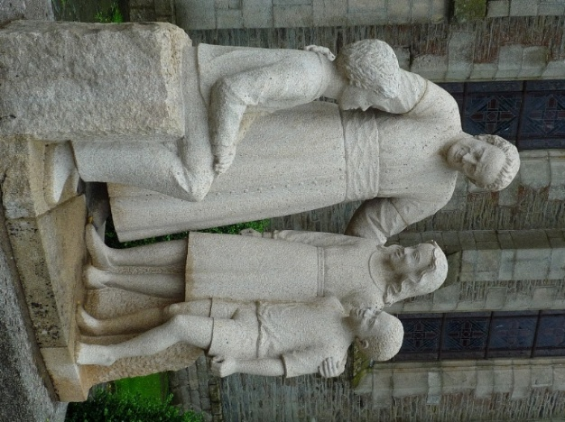
God Our Father, you gave Jean-Marie de la Mennais,
a Generous Heart and an Unwavering Zeal
to make known and loved your Son Jesus and His Gospel.
Grant us to follow his example.
Give us the courage to build united and Fraternal Communities.
Help us to proclaim Your Gospel to the youth of today.
For the Glory of your Name,
Grant that the Holiness of Jean-Marie de la Mennais
may soon be recognised and proclaimed by the Church.

Deign to grant us, O Lord, through his Intercession,
the healing of the persons recommended ...
Through Jesus Christ, Our Lord. Amen.

O Lord Jesus, Glorify your Servant, Venerable Jean-Marie de la Mennais.

