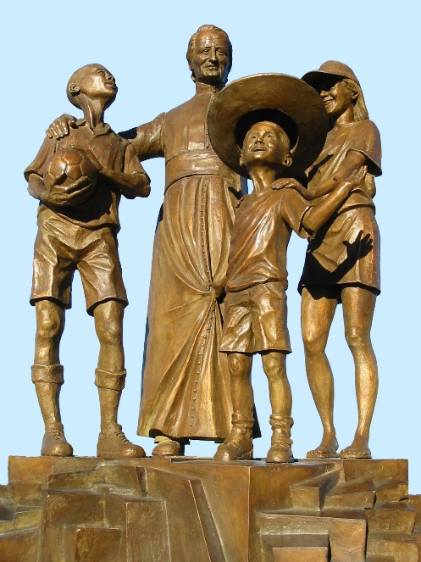
MENNAISIAN NOVENA
MARCH 2026

- News from the Postulation
On January 15th, the Postulator of the Brothers of Christian Instruction and the Daughters of Providence presented to the Dicastery for the Causes of Saints the Official Request for a Review of the Examination of the Healing of the child Enzo Carollo, which took place in Buenos Aires in 2006. [It should be noted that it had been examined in 2016 by the Medical Commission and had a Negative Result].
In early February, the Under-Secretary of the Dicastery, Father Boguslaw Turek, Appointed Two Physicians to investigate that Healing. If either of them declares that the Healing showed Signs of Scientific Inexplicability and, therefore, warrants further Investigation, it would be referred to the Consulta Medica (Medical Commission) for a New Examination. We know that Canonical Processes are rather Lengthy, and a Little Patience was required: we entrusted ourselves to Divine Providence and continue Our Prayer for the Beatification of Our Father Jean-Marie de la Mennais.

- Prayer Intentions through the Intercession of Father de la Mennais
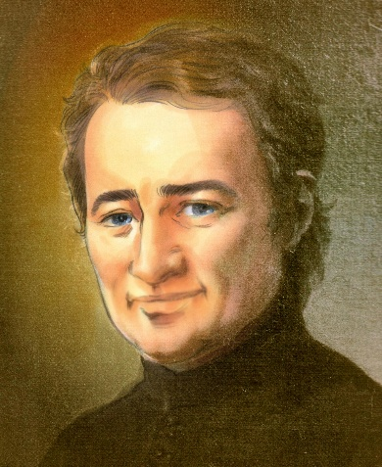
- Let us pray for the Beatification of Father de la Mennais and for a New Impetus in Vocations.
- We join with the Uganda Province in giving Thanks to God for their First Centenary; let us pray that God would bless their Present and Future Fields of Apostolate, in Uganda and throughout the World.
- In that rather Unstable Period, let us also pray for the Needs of the More Exposed Provinces: Haiti, Democratic Republic of Congo, South Sudan, and Tanzania; to support also the First Steps of the New Mission in Timor-Leste.
- For Our Recommended Patients: Bro. George Kamanda, Bro. Jean Herbinière, Bro. Dominic Kahangire and the Brothers in difficulty, the Patients indicated by the Local Leaders.

- Favors attributed to the Intercession of Father de la Mennais

INDICATIONS:
Each Member of the Mennaisian Congregations has undoubtedly received Personal Favors through the Intercession of Our Founder: often those are Healings from Illnesses of Varying Severity, Unexpected Solutions to Troubling Problems, Improvements in Our Spiritual Lives, or even True Conversions. Recognizing those Graces would be a way to praise the Lord and encourage us, as Mennaisians, to Pray and Ask without Ceasing. The Postulation invites those who have received those Favors to send a Brief Report to the Local Leaders or the Postulator, so that those Testimonies may be shared.
The Source of Favors has not run Dry, and Our Father continues to watch over his Children. Recently, Several Graces, both Small and Great, received through the Intercession of the Father have been transmitted: to Brothers Joseph Tinkasimire, Jean-Paul Peuzé, and Sergio Musitano, among others. The Prayers offered for their Intentions have certainly brought about Surprising Improvements. To that end, we also encourage the Dissemination of Prayers for the Beatification and the distribution of Relic Images for the Healing of Illnesses, as well as for Favors in General.
- Beatification of Our Brothers who have left Traces of Sanctity
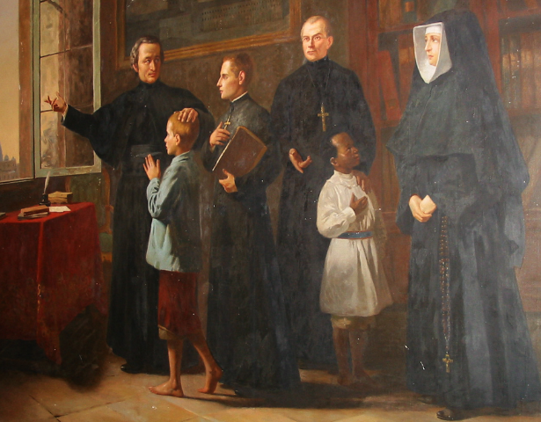
We have Treasures of Holiness in the Ancient and Recent History of the Institute. It was a Great Gratification to explore their Stories for Our Own Edification. It was also a Duty that to faithfully preserve their Memory as a Treasure not to be squandered. There are several ways to preserve that Memory: caring for the Tomb, preserving Writings and Images, disseminating Information through Appropriate Publications, marking Anniversaries, Interviewing Witnesses… The Important Thing was to maintain all of that with a Certain Regularity: the Memory must be kept Alive. The First Condition required to open a Cause for Sainthood is a “Reputation for Holiness”: it must be Continuous, Vibrant, Spontaneous, and Present at Least in the Places where the Servant of God lived, and always Alive among the people of God. Heroic Virtues, the offering of One's Own Life, and Martyrdom attract the admiration of the Faithful, which leads to Imitation and Invocation. That was what was called “Fama Sanctitatis.” A Cause for Beatification could not begin without that Proven Reputation for Holiness. (See Motu Proprio “The Offering of Life in the Causes of Saints”, Pope Francis, Commentary from the Dicastery for the Causes of Saints, pp. 61-63).
Table of the Venerability of JM de La Mennais
In particular, we have Fairly Well-Developed Biographies of several Brothers (written by the Postulation Committee). Building on that Work and also using the Short Illustrated Biographies of the same Brothers (available on the Lamennais.org website), we could explore that Aspect of their Reputation for Holiness in Greater Depth. The First Candidates might be:
  - Bro. Zoël Hamon, 1819-1851: Plouvorn, Province of France and Diocese of Quimper.
  - Bro. Francis Cardinal, 1942-1992: Provinces of Canada and Rwanda, Diocese of Nyundo.
  - Bro. Hyacinthe, 1813-1860: Province of France (and Haiti?), Diocese of Vannes and Guadeloupe and Martinique.
  - Bro. Lucien Séveno, 1929-1962: Province of France and Diocese of Rennes.
  - Other Brothers. They certainly lived Lives of Holiness comparable to those who are most well-known. Research must be undertaken, Biographical Material gathered, a thorough Biography produced, and their reputation for Holiness demonstrated. It was a Work of Patience, but one that would surely bear Fruit.

- TRACES OF SAINTINESS IN THE HISTORY OF THE INSTITUTE:
THE CENTENARY OF UGANDA PROVINCE (1926-2026)

THE CENTENARY OF UGANDA PROVINCE (1926-2026)
- THE BEGINNINGS: THE FOUNDATION BY THE NEW CANADIAN PROVINCE


SITUATION OF THE INSTITUTE IN 1926
In 1926, the Institute of the Brothers of Christian Instruction was still subject to the Laws Secularizing Schools in France (and in the French Colonies), which stipulated the exclusion of the Brothers from Teaching. Membership had declined sharply, as the Brothers were forced to operate clandestinely. The Institute's Authorities had found refuge in England, where Recruitment had also begun to be reorganized. Fortunately, before the Turmoil, the Superiors had considered immigrating to New Countries where they could freely live their Religious Life: Canada 1886, Spain 1903, England 1903, Egypt 1903, Turkey 1904, Bulgaria 1904, and the United States 1903.
The Most Favorable Region for a New Establishment was undoubtedly Canada. That Country shared the same Language as the Brothers' Homeland and was experiencing Rapid Population Growth: a young Country on the rise. Furthermore, the Christian Faith was well-established there, and the Bishops strongly supported the Work of Christian Schools. Soon, the French-Speaking Part of Canada proved very receptive to the Establishment of the Mennaisian Work. Having arrived in Canada in 1886, by 1903 the Brothers already had 119 Brothers working in 22 Schools, with 10 Novices in Formation. By 1914, the Number of FIC Schools had reached 32, and by 1924, it had reached 40: Steady Growth, thanks either to the influx of Brothers from France, forced underground by the Combes Laws of Secularization, or to Local Recruitment: many young people embraced the Mennaisian Vocation.

THE ORIGINS OF THE MISSION IN UGANDA
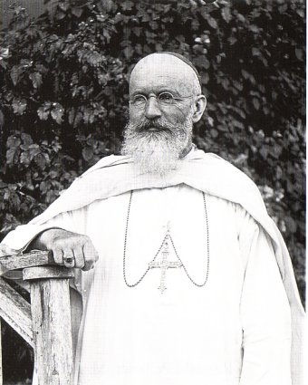
After the Founding Period and the Initial Phase of Development, the young District had reached the point of Expansion, the Time of the Mission ad Gentes, into the Lands of the New Christendom. The (providential) Choice fell upon the Countries of East and Central Africa, particularly Uganda. In 1924, Bishop Forbes of the White Fathers (Missionaries of Africa), Coadjutor to Bishop Streicher, Apostolic Vicar of Uganda, traveled to Jersey, where the Superiors of the Institute were located. He came to urgently request Brothers for the Schools of his Vast Vicariate. In particular, it was necessary to open and support the Catholic Secondary Schools, which were to train the Country's New Leaders and which lacked Professional Teachers. The Congregation, which was experiencing a Period of Persecution in France and Financial Insecurity in other Regions, could not directly send Brothers. The only Province that could respond positively to that request was Canada. Hence the General Council's Response: "If Canada agreed to take Charge of the Mission, the General Council also agree."
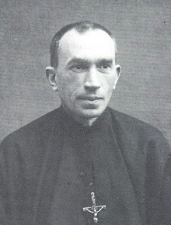
During his Travels in Canada, Bishop Forbes, who was Canadian, enjoyed visiting La Prairie, the Canadian Mother House of the BCI (Brothers of Christian Instruction) to illustrate the Needs and Resources of the Ugandan Church. During his stay, he shared his Missionary Adventures with the Young Men in Formation. He always inspired a wave of Enthusiasm and Generosity. On January 26th, 1924, the Canadian Provincial Council, presided over by Brother Célestin-Auguste Cavaleau, decided to take over the Mission, postponing the dispatch of the First Contingent for Two Years to allow for the Necessary Preparation.

THE FIRST MISSIONARY TEAM
It was time to begin preparing the First Contingent of Missionaries. The Superiors appointed Brother Charles-Jules Poitras as Director of that Missionary Team. Even at Home, a Climate of Faith permeated the Air: Daily Prayer, Work, and Care for the Poor. Young Jules-Henri attended the Brothers' School and naturally returned to the Junior Seminary of his Teachers. He would become a Mennaisian Brother, taking the name Brother Charles-Jules. “He was a Most Active Man, full of Fire and Enthusiasm, very Zealous for the Advancement of the Reign of Christ. Director of the Largest School in the Province in Grand'Mère, he led his School with Great Energy, which had 24 Brothers, a Few Lay Teachers, and 800 Students. To become Proficient in English, he was to spend the 1925-26 School Year in Plattsburgh (USA) with Our Brothers.”
He was presented in those Terms by the Provincial, Brother Célestin-Auguste: “Brother Charles-Jules Poitras, Director, would go there to carry the Flame of Apostolic Zeal that animates him. His Good Humor, his Devotion, his Contagious Enthusiasm, as well as Robust Health and Tireless Generosity, made him a True Leader in a Mission Country.” (Chronicle 75, Sept. 1926, pp. 34 ff.)
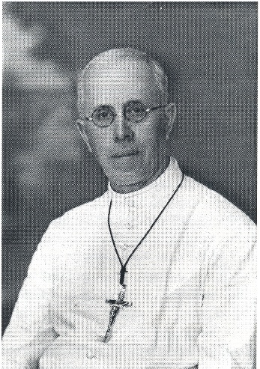
Brother Joachim-Léon Collerette, 41, originally from Mascouche, “was Very Good and Very Kind, Very Calm and Never Impulsive.” He spoke English well, having lived for a few years in England with the Superiors. He would return at an advanced age and ill in Canada, after a life completely spent at the Ugandan Mission. The Provincial added: “He was the Type of a Man of Duty, always at his Post, an Enemy of Ostentation, but ready for all Sacrifices; he would be the Most Valuable Assistant to the Brother Director"
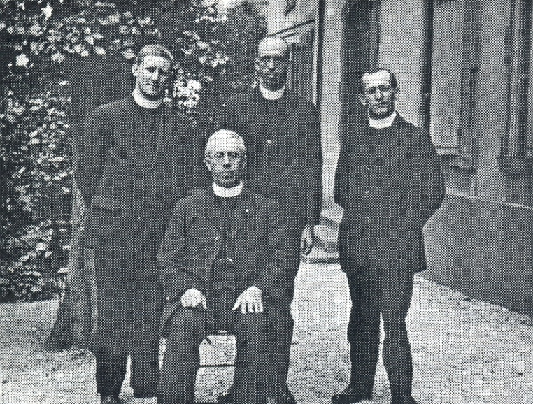
Brother Eugène-Marie Paquette, born near Lake
Bro Charles Jules Poitras
Mégantic, was only 26 years old. “He seemed very kind and was always Friendly and Smiling. He would effectively assist Brother Charles, especially in Recruiting Indigenous Vocations. He would exhaust himself in the Mission, until he fell ill and gave his life at the age of 50.” The Provincial added: “His Good Character, his Joviality, and his Willingness to help, not to mention his Devotion and Good Spirit, would be a Most Valuable Worker for the Fledgling Mission.”
Finally, there was Brother Stanislas-Joseph Taillefer, 21 years old: “Full of Energy, he was always on the go, ready to throw himself wholeheartedly into any Good Work that came his way, always Active, Cheerful, a Real Live Wire, and Slightly Eccentric.” (Brother Hubert Libert) In addition to his Practical Skills, he was the Mission's Chronicler. “He was the Type of Young Man who didn't Count the Cost, who gave his All and spared No Effort. His Ardent and Impulsive Nature would be very well suited to the Missionary Life.” (Célestin-Auguste)
The First Four Missionaries, in Jersey in 1926: Brothers Eugène-Marie, Charles-Jules, Joachim-Léon, Stanislas-Joseph

THE DEPARTURE CEREMONY
The Departure of the Four Brothers for the Ugandan Mission was marked by a Solemn and Moving Ceremony: it was the True First Missionary Sending of the Young Canadian Province of St. John the Baptist.
“How Beautiful are the Feet of those who proclaim the Gospel!” The Four Missionaries are in the Sanctuary. Twelve Brothers, representing the Community, led by Brother Xavier-Joseph, aged 78, prostrate themselves before them to kiss their Feet. The Four Missionaries would go to take the Good News of Jesus to Children in Distant Lands.
The ‘Te Deum’ was Sung, while that Missionary Zeal deeply touched the Young People: “Those Four Brothers were from my Country, they have Families like me, they were going to leave everything to go and teach Children in Africa: why shouldn’t I do the same?”
In the Evening, the Community gathered again for the Farewell Wishes, Addressed to the departing Members by the Provincial Brother. Here were some Excerpts: “After the Small Branch in England, we are establishing another destination for the African Continent. To those who would accuse us of imprudence, we would reply that, in 1837, only Twenty Years after the Founding of the Institute, Our Venerable Founder did not hesitate to send Our Brothers to Guadeloupe… We are following the Views of Our Superior General, responding to the calls of the Sovereign Pontiff, and rejoicing in the Heart of Jesus, who shed his Blood for the Salvation of those far away. It must be added that the News of a Foundation in Uganda has awakened the Apostolic Spirit in Our Brothers: I have received numerous requests to leave for the Missions… Trials await you: a difficult acclimatization, a New Language, Competition with State Institutions… But we already see the Kisubi College as the Teacher Training College for Teachers and Catechists: and among those Teachers, we are already sensing the emergence of Vocations for African Brothers.” [Here the Provincial Superior presented Statistics on the Large Number of African Nuns, prepared by Brother Amans-Alexis.] Why should Our Brothers not be able to achieve among Men what the White Sisters have so successfully achieved among Women?” Finally, Brother Célestin-Auguste called upon the Entire Province to collaborate closely, both Spiritually and Materially, with the New Mission. He concluded with a Wish: “May you live Many Long Years in Uganda, see Your Work flourish, and die there Happy, laden with Labors and Merits!”
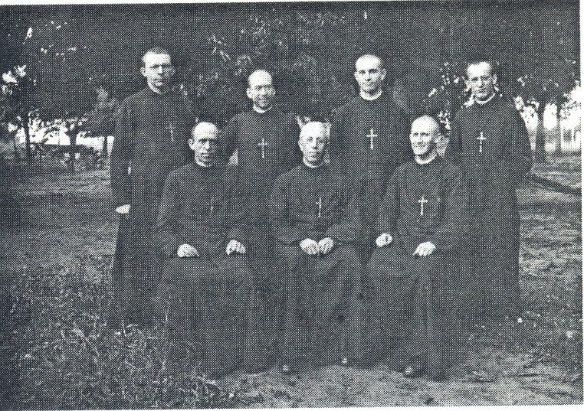
On behalf of the 4 Missionaries, Brother Charles-Jules spoke to thank the Institute and ask for its Spiritual Support; “That Foundation perfectly matched the Traditions of Our Institute which, from the earliest years, established its Missions… What a Joy for the Sons of the Venerable de la Mennais to see a New Branch of the Institute developing on the Shores of Lake Victoria!
1927- 2nd Group of Missionaries: in the 2nd row: Brothers Edgar, Lucien and Donat.
We rely on the Prayers of the Province and especially the Formation Houses… Allow me to thank you for choosing us to be the Founders of Our Mission in Uganda.”(Chron. cit. p. 37-38)
For the Province of Saint John the Baptist, that Historic Moment was certainly Solemn and Momentous. It was an Important Date in its History, the Starting Point of a Hopeful Development. “What would the Future hold for that Undertaking? God alone knows. In any case, the Institute rejoiced in the Event, and Everyone's Best Wishes accompanied the Four Canadian Brothers entrusted with such an Honorable Mission.” (Fr. Célestin-Auguste Cavaleau) Today, a Century later, we could see that that sending forth was Prophetic in Scope. The Small Seed sprouted and became a Great Tree. In turn, the Tree extended its Branches to other Lands. Currently, the Brothers are working to spread the Kingdom of Jesus in Uganda through a Dense Network of Schools for Children and Young People. God blessed their Efforts and Assured them of Precious Mennaisian Vocations. Even though the Mother Province, Canada, was going through a Difficult Time, the Seeds that her Sons have so Generously Sown in the World would providentially bear Fruit in the Times and Places that God knows.

SOURCES.
TWO MENNAISIAN CONGREGATIONS pp.71-72/ 150 YEARS OF MISSIONARY ACTION OF THE FIC 1838-1988 pp.71-82/ FIC MISSIONS (Journal directed by FJC Bertrand, 1969-1990), Several Articles/ CHRONICLE OF THE FIC BROTHERS, years 1926-1927, in particular September 1926, pp. 31-38)

