MENNAISIAN MONTHLY NOVENA
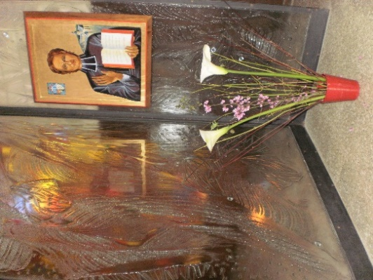
AUGUST 2023
1-NEWS OF POSTULATION
We have received the response from the Congregation for the Causes of Saints on the healing of little Josette Poulain. The research work on this distant cure, begun by Br. Hippolyte-Victor Géreux, had been long and serious. He had been supported by very Competent Specialists, in order to respond to any objections that might have arisen from the Medical Commission. However, it gave a “suspensive” judgment in these terms: “The absence of instrumental Neuroradiological Examinations and the presence of inconsistent Clinical Data do not allow the certain diagnosis of Epidural Hematoma [its healing would then have been inexplicable]. Because of this, the Commission does not believe [“non ritiene”] that it can express a judgment of the Scientific explainability or inexplicability of the cure”.
Now we are taking up the case of Enzo Carollo, already presented in his time. We began to request other Expertise from important Specialists, called to work on the very abundant and precise Documentation, very well prepared by the Postulators of the time: Bro. Gil Rozas and Bro. Delfín Lopez. We continue to pray to the Lord that the time will come for the recognition of the holiness of our Father Jean-Marie. Do not be discouraged: God knows the day of Providence!

2-PRAYER INTENTIONS
- As we have already said, we entrust the Prayer Intentions to the indications of the Mennaisian Animators in each Region of the Congregation. Let us entrust to the intercession of our Father those who are confronted with an illness or a serious situation. Let us not be afraid to entrust ourselves to the Paternal Protection of Fr. de la Mennais.

- In Italy, we follow Giuseppe, a 14-year-old boy who has suffered from Leukemia for years and who had Transfusions several times a year. He fights against his illness with great courage: this year, in June, he brilliantly passed School Exams and wanted to receive the Sacrament of Confirmation with fervor. We continue to pray for him, with all his Family: his Parents, his Little sister and his Grandparents.

3- FAVORS RECEIVED
TWO IMPORTANT NOTICES
1- We would be happy to receive Reports on the favors received. It is not necessary that these favors be extraordinary and dazzling: it is enough that they be a Providential gift, an unexpected solution, an improvement that relieves, an opening of a New path, a Vocation that germinates, a small Conversion, the healing of a Troublesome illness, averted Danger… The graces obtained through the Father's Intercession must become a stream of benefits. So, Mennaisian Animators, we are waiting for the Communication of the favors received!

2- Another Invitation for you: do not be afraid to distribute the Relic-images (with a piece of cloth that touched the tomb of the Father) to the Mennaisian Institutions, to the Communities, to the Laity of the Mennaisian Family. If you don't have enough, don't hesitate to ask for them.

FAVOR STORY: Healing of Tonsillitis in St-Alexandre de Kamouraska, Canada
Little Bruno B., 2.5 years old, had suffered badly from Tonsillitis for more than a week, despite the Medication prescribed by the Doctor. The latter, faced with the ineffectiveness of his remedies, brought a new prescription which he declared marvelous; then he promised to return in two days. But the child did not take these drugs.
Informed by the family, the Brother Director of the School began with the pupils a Novena to Father de la Mennais; he gave each of the two brothers of the little patient, pupils at School, a Relic-image which they brought home. Seeing these Relic images, the mother felt her confidence grow. She put the image in a bag which she attached to the neck of her sick child. The following night, around 11 a.m., the child began to cry, complaining that his throat was hurting him a lot. As a result of great efforts, as if to vomit, he spat out his Diseased Tonsils. When the Doctor returned two days later, he could not hide his satisfaction at the radical effect of his famous remedy:
- I told you that my remedy was wonderful!
- The child did not touch it - replied the mother - I will tell you later what happened!
- How is it then that he is cured? I don't understand a thing - replied the Doctor.

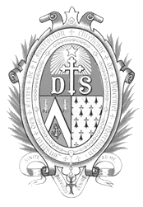
Since that day, the child no longer felt any discomfort… The healing was complete.

4- A SHORT HISTORY OF MENNAISIAN DEVOTION
THE FIRST FRUITS OF DEVOTION TO THE FATHER (7) - (1930-1940):
HEALINGS
The Recommendation to entrust the healing of sick members of the family to the Intercession of the Father was launched by a New confidence in his protection. Healings could also provide new “miracles” for the Beatification. We received the report of brilliant cases, but also of simpler favors. Here are a few by way of example, reported in the Chronicles of 1937 and 1938:
- A lady in Ste-Scholastique (Canada) was cured of a Severe Migraine.
- A seriously ill 8-year-old child was cured following a Novena celebrated by all the students of the School in Aguilar de Campoo.
- Br. Eugène-Marie in Kitovu (Uganda) thanked Father for an important healing. He sent the report to the Chronicle.
- In Haiti, on leaving School on the first day of the Novena, a car hit a child and knocked him down. The car was about to pass over his body, when it stopped suddenly, without touching the child, who got up immediately: the grace was attributed to the Father

CONSECRATED VOCATIONS
Another fruit of Devotion to the Father, especially during the Preparatory Week for Father's Day, was Vocational fruitfulness. This Week was called either Father's Week or Vocations Week. These were days when Vocations to the Consecrated Life sprang up and, in particular, to the life of a Mennaisian Brother. Let's present some examples:
- In a School, among the oldest, the Brothers proposed the project of achieving good during one's life, through a Professional or Consecrated Vocation. The students deposited their tickets in a ballot box, where they indicated their personal project. “This survey gave us the consolation of noting the excellent dispositions of our students. Three Vocations of Priests and two of Brothers were revealed in the First Class and three of Brothers in the Second”. In another Class the young people expressed their thoughts thus: “The Vocations Week was very beautiful and important for my future… I made several visits to the Blessed Sacrament in which I asked God to make my Vocation known to me and to give me the courage to follow it… What struck me the most was the story of the life of Br. Villemure: his hesitations, then firmness when the decision was made… During the presentation of Religious Life, I said to myself: this is where the Lord wants me. I prayed for this to be a serious decision and not a passing emotion: I am very determined to return to the Postulancy… The life of the Venerable de la Mennais greatly interested our students. They made young Jean-Marie their Model and several of them committed themselves to being, like him, Apostles by example and by Action.

SPECIAL FAVORS
As devotion to the Father grew, so did trust in him. The Founder was looked upon as a Father to his children, present in their midst, especially in difficult circumstances. It was natural to have recourse to the Father, and at the same time, to discern the rectitude of the request: do the graces requested accord with the will of God and the spirit of the Institute, and not interested favours? Some examples of somewhat “special” requests:
Success in Exams:
The Postulancy of Bon Secours, Jersey, thanked our Founder for the great success obtained in the Elementary Brevet and the other Examinations. For three weeks, the Postulants had prayed to the Father to ask him to help them pass these difficult Exams. Almost all passed them, contrary to the General average… A Director mentioned these favors: insignia protection of his Candidates in several Exams and success of all, while he feared many Failures.
Favors for Families:
Reconciliations, Access to work, Economic improvement. In Haiti, two Dads had been unemployed for three years. At the end of a Novena to the Fathers, found a job… In a note placed in front of the statue of the Father, we read: The Father has obtained a job for my brother. He starts this morning...
Homecoming Favors:
A somewhat curious favour, but which was quite Traditional in the Institute: I had lost my Rosary, I found it in the grass… I had lost the key to a Cupboard with supplies. I invoked the Father and I found it in a small box...
In conclusion, let us make our own the naivety of the Brothers and of the young people of this period: “Our stock of Relic images was quickly exhausted during the Week. In all the families of our School, we find the image of the Father. Despite the Siberian cold, a large number of our students attended Mass every day and received Holy Communion”.

5-TRACES OF HOLINESS IN THE MENNAISIAN CONGREGATIONS
BRO. HIPPOLYTE-VICTOR GÉREUX: A PASSIONATE OF FATHER DE LA MENNAIS
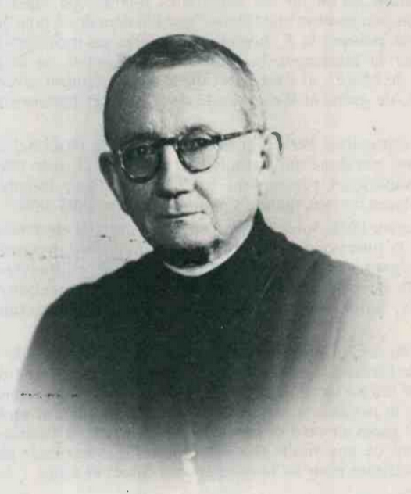

“We will read below the interesting Biography of Brother Hippolyte-Victor. No notice had yet appeared on this Brother who was a Great servant of the Congregation”. Thus wrote Bro. Hilaire Nourrisson in the Introduction to his Article written in 1990. He was surprised at the long silence which had blunted the memory of this “great servant of the Congregation” and, in particular, Principal worker of the Cause of Beatification of Father de la Mennais.

CHILDHOOD AND YOUTH (1878-1903)
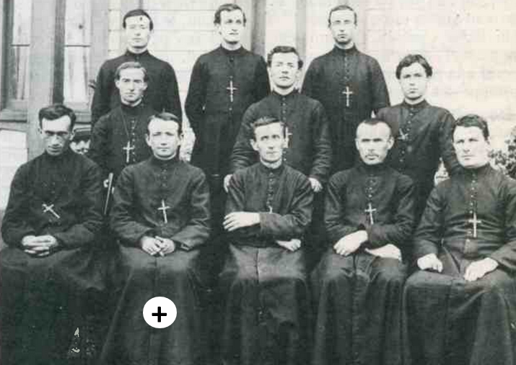
He was born in a small village in Mayenne, 12 km from Pontmain, where the Virgin had appeared to children. Very early on, the family settled in Fougères, a center of Industrial Shoe Production. He knew very difficult conditions in his childhood: Manual Labor to help his family, Poverty, Premature death of his parents. He attended the School of the Brothers “St-Sulpice”: he was a Brilliant and Distinguished student. It remained deeply marked by the examples of his Masters, in particular by the piety of his Director, Br. Juventin Simon and by the “holiness” of the young Brother Louis-Joseph Rivière, full of zeal, who died at the age of 25. He will say: “I consider myself happy to have felt the influence of these Religious of high mark”. It was on this well-trodden path that the young Jules also traveled: he first entered the Juniorate at Livré and then, at the age of 13, at Ploërmel, for his Postulancy. After three years of intense study, he could enter the Novitiate with a record group of 75 Novices. He became Bro Hippolyte-Victor. On the Register we note about him: “Very Good, Very Pious, Delicate Nature, Beautiful Feelings, but would perhaps be Weak”. Indeed, he knew an infection of the Spinal Cord, of which he healed with some difficulty. Considering this state of fragility, the Superiors entrusted him with the Teaching and Direct Research of all the Documentation related to Father de la Mennais. These were the years of the Introduction of the Cause of Beatification, of the preparation of the Informative Process (732 pages) composed by Mgr De la Villerabel, of the writing of the Biography of Jean-Marie de la Mennais by Mgr. La Veille. The Reverend Bro. Abel, Superior General, had prophetically entrusted Bro. Hippolyte with the task of Mennaisian Research, which he would have taken up forty years later, as the linchpin of the cause of Beatification.

ON MISSION TO THE ROCKY MOUNTAINS (1903-1910)
1903: The Secular Laws of the French Government forced the Congregations to emigrate abroad to pursue their Mission. Part of our Institute was spreading out into the Rocky Mountains of North America. The Brothers supported the School activity of the Jesuit Missions. Scattered among the Mountains and the Forests, night and day, they shared the life of the young Natives, more inclined to the freedom of the Prairies than to the efforts on the Books. Br. Hippolyte shared the Horse races, the Rigors of the climate, the Fraternal life in the Schools of the mission. Often, he became a Nurse during the frequent Epidemics.
In 1910, the Rockies Mission was closed. It really demanded heroism: “How dare the Superiors launch us into such an adventure?” The Missionary Brothers wondered.
IN HAITI
Bro Hippolyte (+) young Brother in the Rocky Mountains
From the Rocky Mountains, Bro. Hippolyte was sent to Haiti. He was a Professor at the Institution St-Louis-de-Gonzague in Port-au-Prince. As a teacher, he was not a Trainer who aroused enthusiasm, but he asserted himself through the quality of his teaching. He immediately became the Director of the Institution: he succeeded in obtaining Government Subsidies and ensuring the smooth running of School Activities for 32 Brothers and 900 students. Endowed with remarkable qualities as an Administrator, he collaborated with the Principal Director Bro. Archange Penhoët: he prepared files for the Ministry, solved Financial problems, ensured Contracts with teachers, Obtained Subsidies for School Furniture, built a Rest House for the Elderly and Sick Brothers. When Bro. Archange was appointed Assistant, it was Bro. Hippolyte who replaced him. Under his impetus the work of the Brothers experienced a period of great development: “We were proud to have him as our Head and we felt well defended”, affirmed the Brothers. Indeed Bro. Hippolyte had good relations with the American Authority, which commanded on the Island and which, at the beginning, wanted to enslave the Brothers to its own interests. He gave an important contribution to the Foundation of the Haitian Library undertaken by Bro. Ernest-Louis Dion, which would become a Fundamental Institution of Culture in Haiti. At the end of his mandate, the Authorities and the population granted him signs of their esteem. On his departure the Bulletin de la Quinzaine wrote: “Haiti has lost in him a Great friend and a Distinguished servant.”

IN JERSEY: ASSISTANT TO THE SUPERIOR GENERAL (1933-1946)
In 1933, he was elected Assistant to the Superior General. Br. Étienne, appointed him General Bursar, according to the forecast of Br. Constantin-Marie: “He is cut out to manage the Finances of a Kingdom. You will see that he will become Bursar General of the Institute!” He did his job as a Rigorous Administrator and far-sighted Financier, with the precision and fervor that characterize him. He also found time to dedicate himself to his “Mennaisian” passion. With Bro Archange, he researched and collected everything concerning the two brothers Jean-Marie and Félicité de la Mennais: Books, Articles, Translations, Publications of all kinds: he thus accumulated more than 2000 “Mennaisian” Documents and Books. He also renewed the links with the descendants of the family of Marie, the sister of the two de la Mennais and, by this means, he could retrieve valuable childhood and family Documents. Bro Hippolyte was not satisfied with collecting, but, in his turn, he studied and composed learned Memoirs on several aspects of the Biography and thought of the two La Mennais. In 1941, the Superior General received from Rome the list of objections of the Promoter of the Faith. Br. Etienne instructed Br. Hippolyte to work out the answers to be given to the Congregations of Rites. He worked on it for a year and a half, composing 566 pages of four typewritten Volumes, which would serve as the basis for a first response. From 1940 to 1945, during the war, he experienced with his colleagues the harsh conditions of the German occupation of the Island of Jersey. Bro Hippolyte used his Diplomatic talents to obtain, from the German Authority, acceptable conditions for the Community of Brothers and also for other Religious Communities on the Island. He took his share in the material tasks to improve the regime of restrictions: maintenance of the garden, conservation of the fruits, making of the heaps of manure. Every morning, he was going into Town with an improvised vehicle to collect the skimmed milk from the Jersey Diaries. He also became Nurse to Br. Floribert Rolland, whose state of health required constant care, day and night.
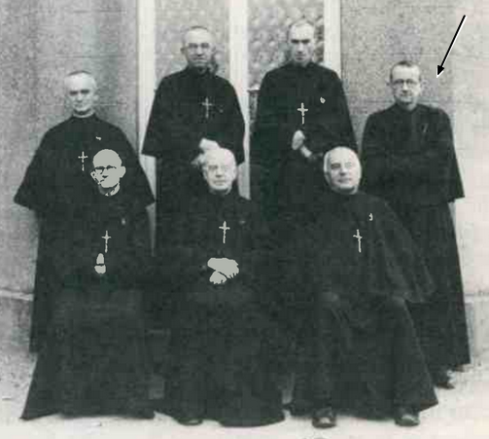
At the Council of RF Etienne, top right
PROCURATOR AND POSTULATOR TO THE HOLY SEE IN ROME (1946-1958)
From Jersey, Br. Hippolyte was transferred to Rome: he was appointed Procurator to the Holy See, Postulator of the Cause of Jean-Marie de la Mennais and Visitor of the young Italian District. He was immediately charged with a delicate and difficult task: the pursuit of the Cause of Beatification. It was in danger of being arrested. In the Pre-preparatory session, the objections of the Promoter of Faith were so strong that they risked blocking everything of the Servant of God.” Only one of the members of the Commission had expressed the vote in favor of the continuation of the Cause. The Secretary of the Congregation of Rites, Msgr. Antonelli, entrusted the work for the elaboration of the answers to the Historical Section, chaired by Mgr. Frutaz. The doubts concerned above all the submission of the Servant of God to the Magisterium of Pope Gregory XVI who had condemned the ideas of his brother Féli, the Administration of the Congregation of St-Pierre, the Obedience to some Bishops of Brittany, the relations of Fraternal Charity towards his brother Féli. Bro Hippolyte collaborates closely with Mons. Frutaz. Helped by Bro. Hubert Libert, Archivist, and Bro. Donat Caron, he carried out research work that was to last almost ten years. He searched in the Archives of Paris, the Vatican, Brittany; he collected Documents and Testimonies from the First Trials, in particular those collected by Bro. Abel Gaudichon and Bishop de la Villerabel. In 1955, he was able to deliver to Monsignor Frutaz 18 Booklets of answers, which would be the basis for the writing of the Additional Summarium: a monumental work of 700 pages, which would unlock the Cause and would open the way to the Proclamation of the Heroicity of Virtues in 1966. Mons. Frutaz would be able to testify: “The work was finished a few weeks before the death of Bro. Hippolyte. He was able to read the manuscript of the last Chapter in his bed of pain and death. Without his help we would never have succeeded in writing this work”. The competence of Br. Hippolyte in the History of the Church was highly appreciated in the circles of the Vatican Congregations and the Pontifical Universities of Rome. He was often asked for Articles on the two brothers from La Mennais, on the History of the Church in France, on the Mennaisian Congregations… He also took care of the small Italian District, which he directed with rigor and attention. He encouraged its expansion by purchasing the New Juniorate at Castel Gandolfo and developing the Sant'Ivo School in Rome. From 1952, his health began to show signs of weakness. In 1953, he left the Direction of the Italian District. Despite the decline of his strength, he worked at an exhausting work rhythm. When he was in Sant'Ivo, he walked every day, whatever the weather, to the Vatican, returning regularly to the Community at 1 p.m.
In the midst of this intense activity and with this fragility of health, he always remained very attentive to the pursuit of the Father's Cause. In 1955, he was informed of the particular healing of a 5-year-old girl, Josette Poulain, in Combourg, France. She had fallen, had suffered a severe head trauma: The Doctors had planned a Trepanation of the skull. The Daughters of Providence prayed for her and, after a short time, she was completely cured. Bro. Hippolyte, with his “Mennaisian” intuition, realized the importance of this healing and prepared the stages for the Canonical process, which must be celebrated first in the Diocese of Rennes, then in Rome. He contacted the witnesses, requested the opening of the Diocesan Process, he was present at the Introductory and Conclusion Sessions. The Closing Session of the Inquiry was celebrated on June 24th, 1957, in the presence of the Archbishop of Rennes, Cardinal Roques. On his own initiative, the Postulator requested a Medical Consultation from Italian Experts, among others Dr. Sympa, one of the Consultors for the Canonization of Saint Maria Goretti.
The health of Bro. Hippolyte was always weaker. He was diagnosed with Stomach Cancer. He was treated at the St. Filippo Neri Hospital, then he was flown to France. In Josselin, he received Palliative Treatment. Despite great suffering, he never complained and “forgot his beast” in work and prayer. He put in order his last Mennaisian Notes for the Summarium. He confided: “The prodigal son will soon throw himself into the arms of the Father (and of Father de la Mennais)”. What will happen on January 21st, 1958.

SOURCES:
Chronicle N° 344, October 1990 Br. Hilaire Nourrisson, who notes: “Work carried out for the future Menology, starting from an ample collection of Documents brought together by Br. Jean Le Bihan/ Menology V pp. 1813-21

