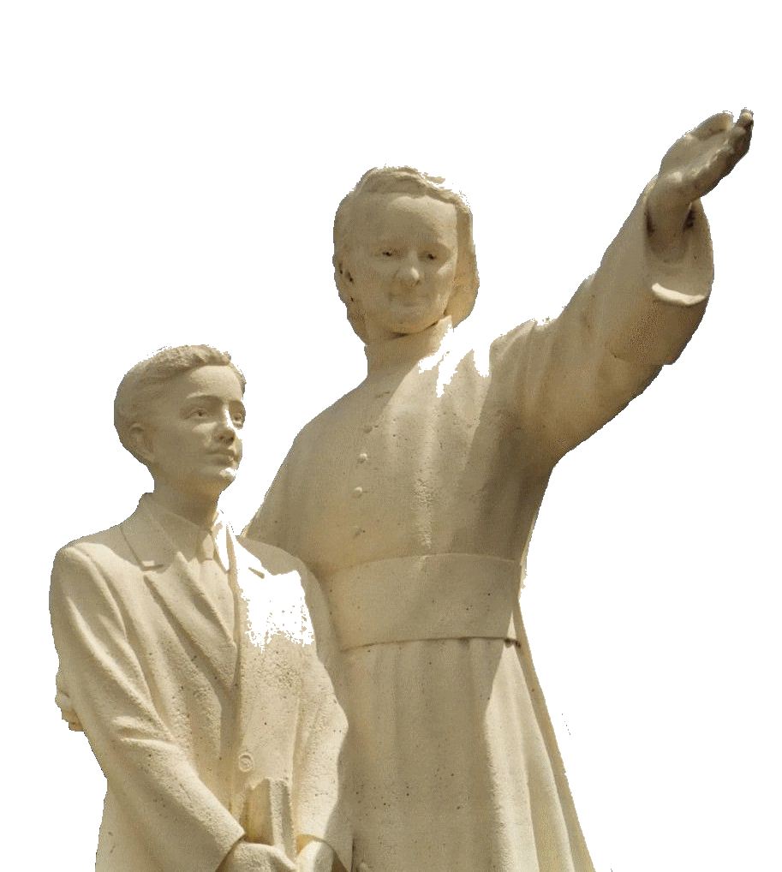

**MENNAISIAN NOVENA**

**SEPTEMBER 2025**

***Pilgrims on the Path of Prayer***

1. **NEWS of the POSTULATION**

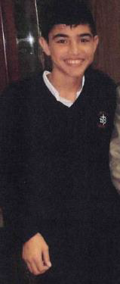

After the Summer Break, we are resuming the Ordinary Course of Our Father's Cause. We have Two Positive Pieces of News:

1-The enrichment of the File of Expert Opinions in favor of the resumption of the Examination on the Recovery of Enzo Carollo, by Specialists appreciated by the Dicastery and, at the same time, a New Update of the state of Health of Enzo by the Doctors of Argentina.

2- Resuming contact with the Officers of the Dicastery for the Causes of Saints, to prepare for a New Examination by the Medical Commission (preparation which would still require some time).

The Postulator also asked for advice to explore the possibility of a possible Introduction of the cause for some Brothers who have left particular traces of holiness.

1. **PRAYER INTENTIONS THROUGH THE INTERCESSION OF THE FATHER.**

WE PRAY FOR:

* The School year beginning, in several Countries, with the blessing of two young New Saints: **Carlo Acutis and Pier Giorgio Frassati.** May they be the Patron Saints and Witnesses of Christian life for Our Students.
* **Brothers, Sisters, Lay People in Fragile Health**, especially those in Retirement Homes, with their Treasures of Offering and Prayer.
* Young people **seeking a Vocation** and on the path to Formation. Let us pray especially for the Province of St. Therese of the Child Jesus in Uganda, which is preparing to celebrate its First Centenary.
* **The sick** reported by Local Animators
* The **sick reported to the Central Postulation**: Br. **Alberto Pardo** and Mr. **Stéphane** (their health was improving); **Anna** and her two disabled sons **Silvia** and **Luca** (she was managing to do her housework); **Claudio** (serious eye problems), **Monica** (Cancer); **Mr. Lazo Flores** from the Philippines (affected Spine, slowly recovering); **Leanna Rubinos**, daughter of an Associate Member, suffering from Leukemia.
* Our Brothers in the most dangerous places: **Congo, Haiti, South Sudan.**
* The Brothers of the New Mission in Timor-Leste: **Stéphane, Philippe and Éric.**

1. **FAVORS OBTAINED THROUGH THE INTERCESSION OF FATHER DE LA MENNAIS**
2. PREMATURE BIRTH (Prud'homme, Sask., 22-9-1977)

*“I have very often received notable favors from the good Father de la Mennais. Once again I come to give him thanks and testify that, truly, he does not abandon us. That was on the Occasion of a Premature Birth and seriously involving the mother. After having invoked with faith and confidence the good Father de la Mennais to restore health to Mrs. Suzanne Grimard de Mackenzie on the Occasion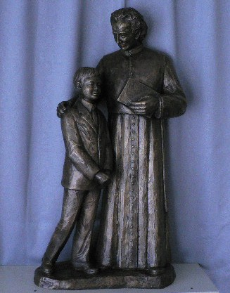 of a Premature Birth, I informed all the relatives of that difficult circumstance and invited them to join in my prayers.*

*Urgently summoned, the Husband rushed to his Wife, after having hurriedly covered more than twenty miles. No one could imagine that man remaining a Widower, with six children in his care. Yet everything went well and without any other Major Health Incident. The Doctor could not understand how that Lady was saved. There was, in his opinion, another power than that. Thank you to the good Father de la Mennais; I would have recourse to you again! » Sister Bertha Grimard, Daughter of Providence*

1. FAVOR REPORTED BY BR. MICHEL GOUGEON, PHILIPPINES (2025)

*"Regarding Our Sick, here in the Philippines, we have removed from the list Analinda Santos (Teacher at Saint Anthony College) who was suffering from Cancer: Remissioned or Cured, too early to say... We continue to pray through the Intercession of the Father."*

**THE SHRINES OF THE BLESSED VIRGIN MARY AND THE BROTHERS: THE APPARITIONS OF LA SALETTE (September 19th, 1846, France, Hautes Alpes) AND THE HISTORY OF OUR BROTHERS IN BRITTANY**

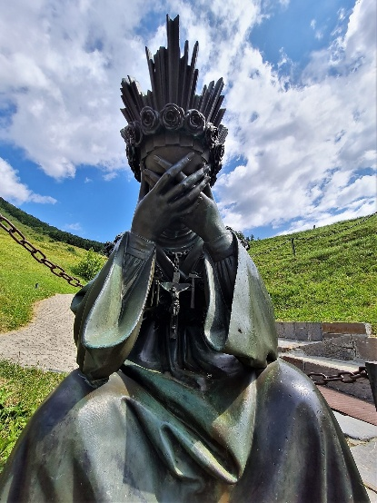

**“If men convert!”**

**The Apparition**

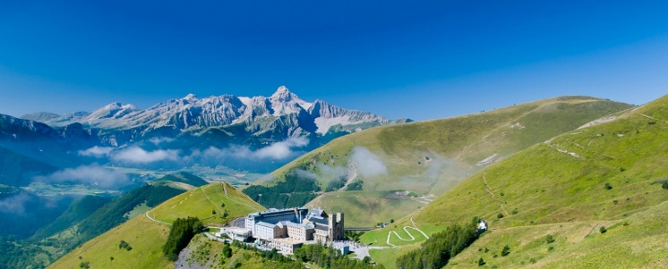Late Summer 1846: September 19th. Two little Shepherds, Mélanie Calvat, 14, and Maximin Giraud, 11, were grazing a few Cows, eight in all, with a small Goat and the little boy's Dog. They had to climb the peaks of Mount Planeau, 1,800 m high, in the French Alps, two hours from the Village of La Salette. They were very poor and almost without family: they were born in the small Village of Corps, where they lived in Slums without Light and with little Love. Maximin was orphaned by his mother, and Mélanie plays the little Shepherd for the families of the surrounding Villages. Yet the Virgin has chosen those two poor little ones to entrust them with a Great Message.

In the Afternoon, after a moment of rest, they see a Circle of Light, like a Small Sun, in a Small Valley, next to a Spring. They were attracted by the Strange Phenomenon. They approach with a mixture of curiosity and fear. Inside the Light, they saw a Woman crying, her Head in her Hands. She was dressed like the Women of the Region, but with Crowns of Roses on her Head and Feet and an Iron Chain on her Chest, to which were attached a Crucifix and Signs of the Passion. She addressed them: “***Come closer, my children. Do not be afraid. I am here to announce Great News to you***.” She raised her Tearful Face and spoke to them in Patois. Filled with pain, she revealed the Offenses against her Son: the Abandonment of the Sacraments and Prayer, the Insults against God, the Transgressions against the Commandments. “***If my people do not want to submit, I am obliged to let go of my Son’s Arms; I could no longer support Him.” She explains the Consequences of that Bad behavior: Poor Harvests, Hunger, and Diseases. “How long have I suffered for you!” But she also encouraged Conversion: “If they convert, the Stones and Rocks would become Heaps of Wheat and Potatoes would be sown by the Land.” She concluded: “Say your Prayers well, my children, in the Evening and in the Morning! At*** ***least say, if you do not have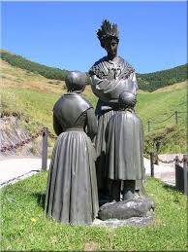 time, a Pater and an Ave Maria****! ”*The Beautiful Lady gave them a Mission: “My children, make all that known to my people.” Then, as if sliding, she raised to the Top of the Slope; she looked up to Heaven, then lowered her gaze to the Two Little Shepherds. They would like to hold her back, but she melted into the Light.

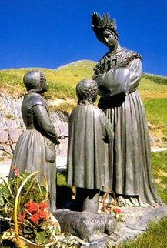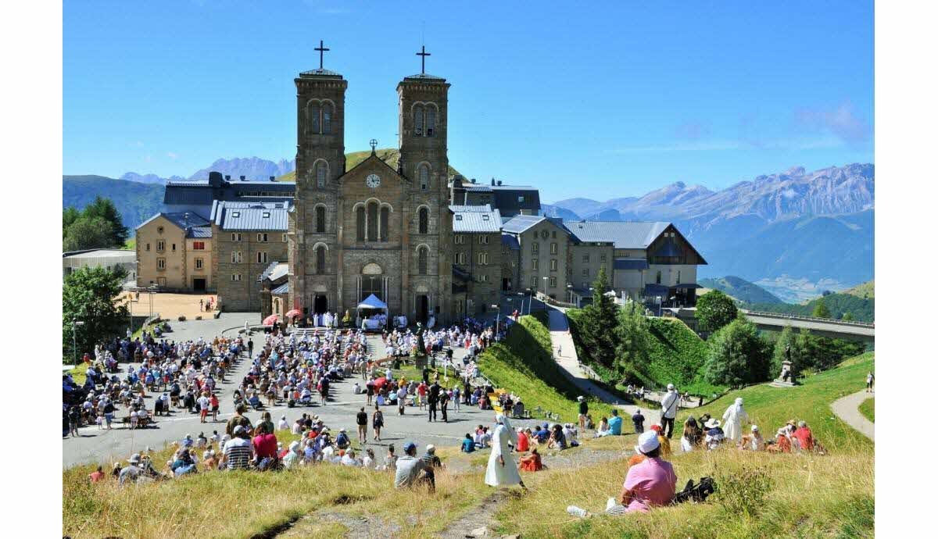Back in the village, the two children began to tell everyone that story. After Initial Opposition and Mistrust, the Faithful began to believe in the Apparition of the Virgin. They remained astonished by all the details revealed by the Beautiful Lady, whom they now recognized as the Blessed Virgin. The Priest, moved, became an Apostle of the Message. After much Questioning and Investigation, the Bishop of Grenoble, Mgr. Philibert de Bruillard, declared on September 19th, 1851: “***The Apparition of the Blessed Virgin to the Two Shepherds on the Mountain of La Salette, bore within itself all the Characteristics of Truth and the Faithful were justified in believing it to be Indubitable and Certain.”*** A Great Movement of Devotion followed that Event: soon Construction of the Sanctuary began; Pilgrimages were organized, and Celebrations multiplied. Brilliant Conversions followed, and the First Healings were confirmed: a Great Renewal spread in the Church, even beyond the Borders of France.

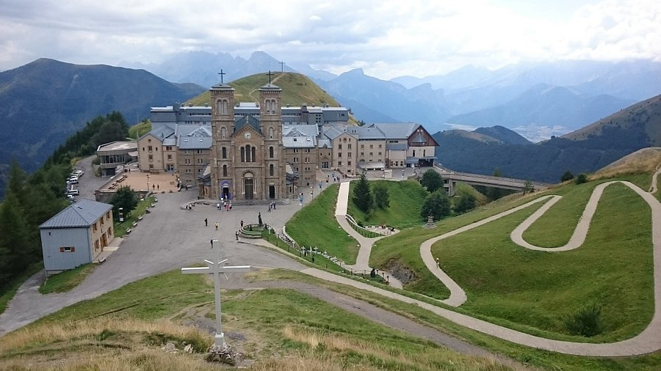We could conclude with some thoughts from Spiritual Figures on those simple and at the same time Grandiose Apparitions.

**“Mary, Our Mother, told us that we Lack the Sense of Sin, which led her to burst into Tears. We were called to understand the Intimate Love of God for man that the Virgin revealed to us**.”(Card. Martini) **“La Salette was a Message of Hope, carried by the one who is the Mother of Mankind.”** (John Paul II) **“La Salette was the Most Important Religious Event of the 19th Century.” (**Maritain**) “La Salette does a Great Deal of Good in the present, but it would do much more in the future.” (**The Holy Curé of Ars)

**LA SALETTE AND BRITTANY: Miss Maria de la Fruglaye**

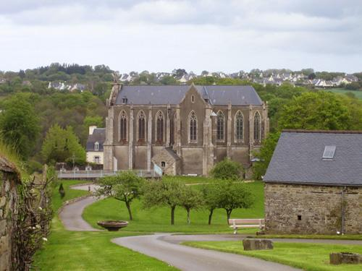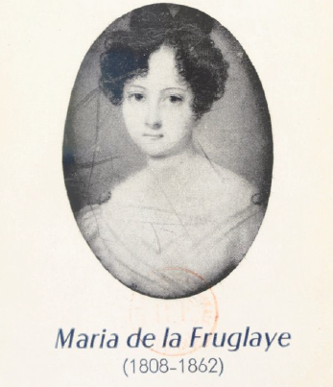Why a Sanctuary dedicated to Our Lady of La Salette, in Morlaix (Brittany), located more than 1000 km from the place of the Apparition and almost immediately after? That was the Origin. In 1830, the Hospital Nuns of St. Augustine of Quimper were dismissed from their Hospital by the City Administration. After three years of dispersion, they were welcomed into the Large Convent of St. Francis, bought for them by Miss Maria de la Fruglaye, in Ploujean, near Morlaix. That Young Lady lived with her father at the **Château de Keranroux,**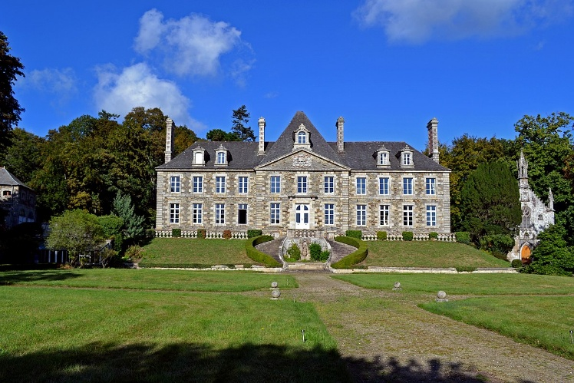 located opposite the Nuns' Institute. Maria was then 25 years old and was already filled with Zeal for God and Ardent Charity towards the Poor and Children. She supported the Christian Institutions of the Region with her Resources. She was called “the Saint of Ploujean”. In 1846, she had learned of the Apparition at La Salette and was very touched by it and wanted, in some way, to dedicate to the “Weeping” Virgin a place of Prayer and Reparation for Sins.

She obtained from the Priest, Father Perrin, a Piece of the Stone on which the Virgin had placed her foot during the Apparition. The Community's Chaplain, Father de Kermenguy, built a Small Oratory in 1847.

An Extraordinary Intervention came to change the Plans. The Nuns had built, next to the Hospital, a School with Boarding and Day Schools***. “Two Students fell Seriously Ill. They were condemned by the Doctors, could not eat anything and were drying up day by day. The Nuns thought of invoking the Virgin of the Alps… They began a Novena, then Another. No Reaction. The Third ended on September 19th, the Anniversary of the Apparition. An Admirable Miracle: the Two Sick People were cured and the Cure was Confirmed by the Doctor***!” As a sign of thanks, the Community wanted to build a Chapel.

The Priest, Father Le Moal, wanted a Sanctuary that was not too cramped and open to the Parish: the First Oratory was extended. The Blessing took place on September 18th, 1848, and the next day the First Pardon of La Salette in Morlaix was celebrated, with a Large Gathering of Pilgrims. It was the First Public Chapel built in honor of Our Lady of La Salette, a “daughter who preceded the mother,” because the Church of the Apparition was not begun in La Salette until 1852. Because of that, its Provisional name was “Our Lady Reparatrix.” In the following years, a New Chapel was built.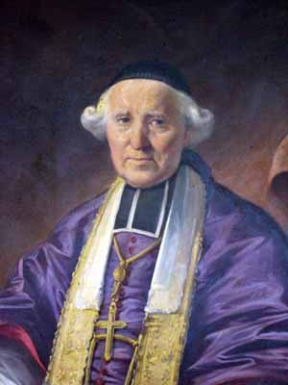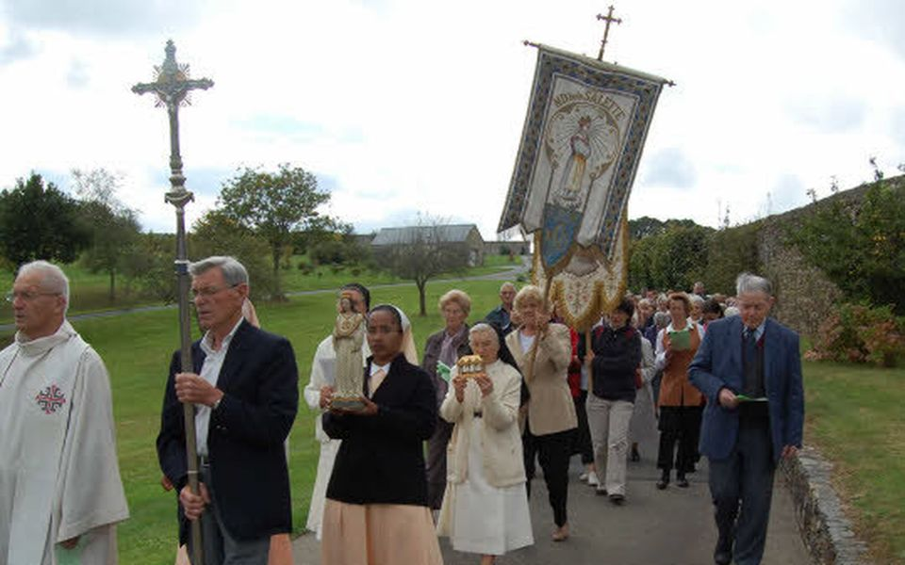more spacious, with a Large Stations of the Cross. ***Since 1848, the Pardon of La Salette has taken place every year in Morlaix:*** it takes place on the Third Sunday in September and many of the Faithful from the Region participate.

**The Brothers, Miss de la Fruglaye and La Salette**

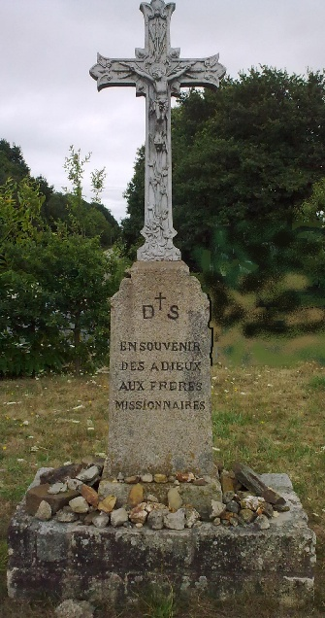The Intermediary between the Brothers and the Apparitions of La Salette was undoubtedly the de la Fruglaye Family: Mr. Charles-Emile de la Fruglaye, Nobleman of Kéranroux and his Daughter, Miss Maria, considered by all, in the Region of Morlaix, as a True Saint. The Abbot de la Mennais knew that Family very well, perhaps since he was Vicar in the Diocese of St-Brieuc: the Region of Trégor was on the Border of the Two Dioceses. Certainly, he was very close to that Family: Miss Maria left us the Account of many Personal Memories of the Founder, especially on his Childhood and on the Vicissitudes of Féli (see the Biography of Merlaud): Memories that she had heard Directly from Father de la Mennais.

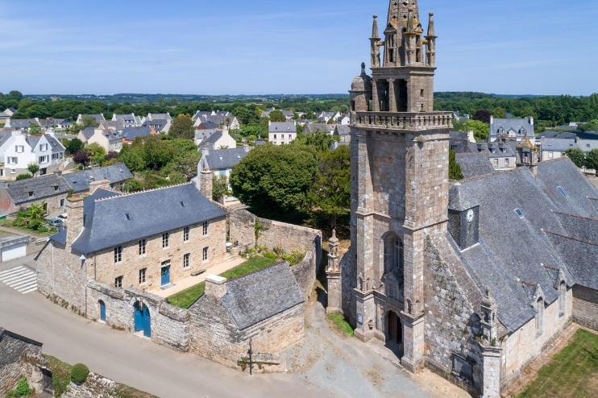We find the de la Fruglaye Family in the founding of the Schools of Finistère, in particular that of **Ploujean**, the First Established in that Department. Miss Maria succeeded in reestablishing a sort of Reconciliation between the Bishop of Quimper, **Mgr. de Poulpiquet,** and Mr. de la Mennais, whom he believed to be drawn into the Revolt of his brother Féli. ***“I am writing immediately to Mr. de la Mennais to announce your Good Intentions and to ask him to hasten the Appointment of a Brother [Polycarpe Ollivier]. We see no other way of providing a Christian Education for Our Little Children who ask for the Bread of Instruction and find only Almost Poisoned Hands to break it for them…”*** Maria made available to the Brother a Room and Land on her Property for the New School: that was to open the Door for the other Educational Establishments that the Founder would have founded in Finistère.

That Climate of Collaboration and almost familial understanding with the de la Fruglaye Family went as far as choosing the Château de Kéranroux as a Welcoming Stopover for the Missionary Brothers who were to embark in the Port of Brest: that was the case for the First Missionary Expedition to Guadeloupe, in December 1837. It would be the same for others.

[](https://www.lamennais.org/petites-vies-de-freres-temoins-desperance/)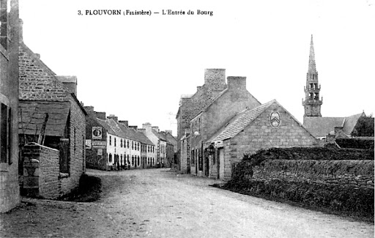Finally, the presence of Maria de la Fruglaye was not unrelated to the work of the “Saint***” Brother Zoël of Plouvorn***, a Town very close to Ploujean. He arrived in Plouvorn in 1842, aged just 23. Miss Maria watched over his New School and helped the young Brother overcome the obstacles that the Anticlerical Administration of Morlaix put in the way of his Appointment as a Municipal Teacher. In 1846-47, the years of the Terrible Famine, they helped each other to help the starving, to find out about the price of Wheat, and to organize a Social Bakery to save the Poor from famine. That Work of Charity also took its inspiration from the Apparitions of the Virgin at La Salette (see A. Guénolé), as a call to the conversion of hearts and to mutual aid. Brother Zoël was to die a Victim of his Devotion in caring for the Abandoned Typhoid Fever Patients: a Zeal he had seen embodied in Maria during the Cholera of 1833 and in other Epidemics. The two “Witnesses of Charity” sanctified their Region through their Heroic Zeal.

**SOURCES: APPARITIONS OF LA SALETTE (Missionary Fathers of Our Lady of La Salette) / Our Lady of La Salette in Morlaix: Pilgrimages of France / of St-Jérome “Life of Marie-Anne de la Fruglaye” 1868 / FA Pesquer EM37 / FA Guénolé: “The FIC in Finistère”**