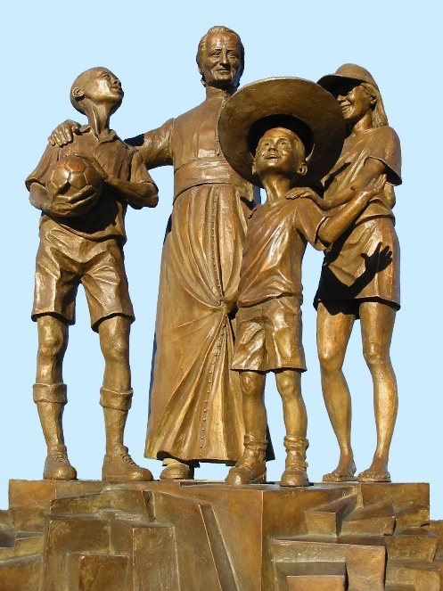
MENNAISIAN NOVENA
JUNE 2026

- NEWS FROM THE APPLICATION
On May 28, the Dicastery for the Causes of Saints received the responses from the two doctors who had studied the supplementary dossier prepared by the Postulator concerning the healing of Enzo Carollo. In June (June 10?), these responses will be examined and discussed by the “Ordinary Congress” of the Dicastery's officers, which ordinarily meets every Wednesday. At this meeting, it will be determined whether the study of Enzo's healing can be submitted for a second review by the Consulta Medica (Medical Commission).
If the outcome is positive, the Dicastery for the Causes of Saints will appoint the seven physicians who are members of the Consulta Medica to conduct a specific examination of our case. They will receive the 2016 files (prepared by the former Postulators, Brothers Delfin Lopez and Gil Rozas) and the 2025 supplement. Naturally, the physicians will need time to study the case. We must continue to be patient, watchful, and pray.

- Prayer intentions through the intercession of Father de la Mennais
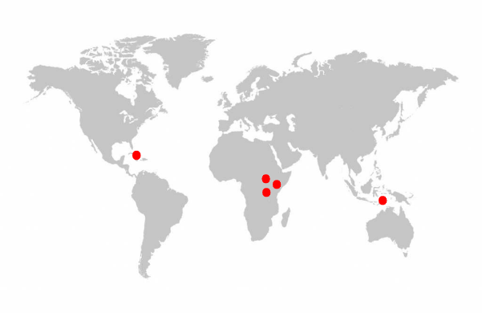
We wish to entrust to the intercession of Father de la Mennais: the Brothers, the Daughters of Providence, and the Mennaisian Laity, the growth in holiness of the Institute, and the sick entrusted to his care. In particular, we entrust to his intercession:
- The Brothers of Haiti (9 communities): in a time of disorder, social violence and serious economic difficulties.
- The Brothers of the Congo DRC (4 communities): the context in the Northeast of the country (where we are present) is still fragile, with fighting, migration, undernourishment, and a precarious health situation.
- The Brothers of Tanzania (6 communities): for some time now, the social climate has needed to be more peaceful.
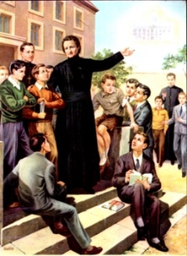
- The Brothers of South Sudan (1 community): they are suffering the consequences of the civil war in Sudan, with the presence of many refugees in the camps and a serious food and health crisis.
- The Brothers of East Timor: we support them in their efforts to integrate into the ecclesial and social environment, especially in the world of education.

Recommended patients, especially :
Mrs. Anne-Lyse from St-Brieuc; Brother Jean Herbinière; Brother George Kamanda, Dario as a child, suffering from leukemia; Gioacchino, cancer; Dionisio, brother of Brother Dino, circulation problems ; Sandrine, a teacher in a Catholic School in France, suffering from Charcot’s disease.

NOTICE: We have many relic images available. They can be distributed to the sick, but also to people who have any kind of favor to request, for themselves or for others: conversions, answers to vocations, important choices, job searches, addiction problems… Father de la Mennais readily blesses his children. To obtain them, you can ask your local leaders, who can obtain them from members of the General Council.

- FAVOURS RECEIVED THROUGH THE INTERCESSION OF FATHER DE LA MENNAIS
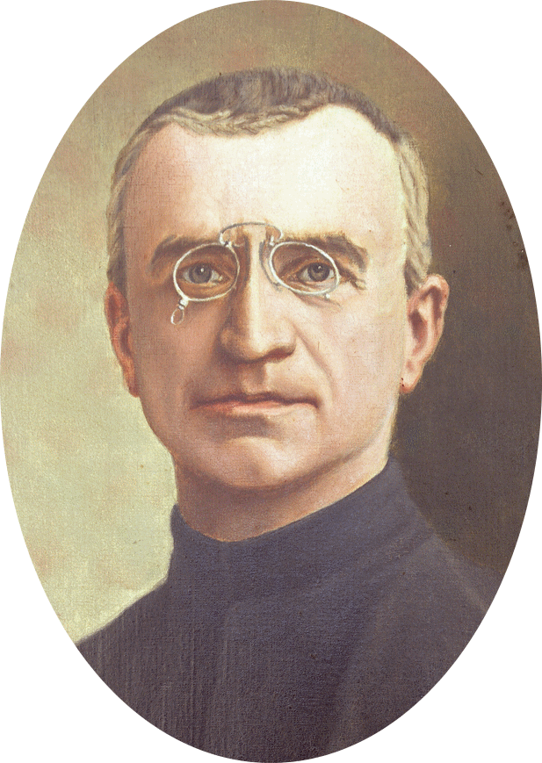
The tradition of prayer to obtain favors through the intercession of the Father in the Mennaisian Family
“During the presentation of the Cause in Rome in 1911, Superior General Brother Jean-Joseph emphasized the need for prayer for each of his Brothers: “Let us pray and pray with great faith. If we cannot yet offer public worship to the Servant of God, nothing prevents us from invoking him privately and recommending that others turn to him to ask for graces and even true miracles. Let us therefore make it a habit to commend our sick, even those in despair, to our good Father. Let us give them an image of the Servant of God; let us pray with confidence, fervor, and perseverance.”

This appeal deserves to be heard again. For a servant of God to attain Beatification, it is necessary that “God, who sees into the depths of hearts, attests to the holiness of his Servant through miracles performed after his death and through his intercession.” Therefore, let the faithful Mennaisians not hesitate to address the Venerable Father individually, to obtain, on their behalf, the striking proof of his power before God.

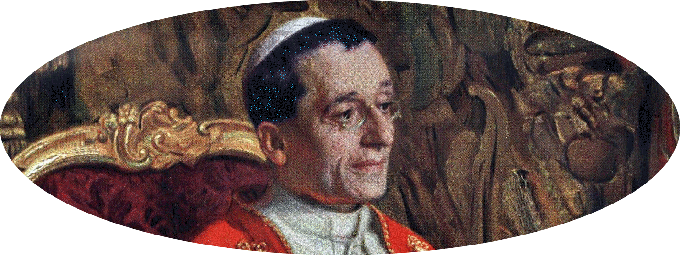
On October 9, 1915, Brother Jean-Joseph, having gone to Rome to offer the homage of his Institute to Pope Benedict XV and to recommend to him the recently introduced Cause of Father de la Mennais, was promptly asked by the Pope: “Have you had any miracles?” “Yes, Holy Father,” replied the Superior General, “many favors have already been obtained, and we pray for more.” “This is very important,” added the Holy Father, “and for this reason, it is necessary to make your Founder known, distribute his images, invite the sick to turn to him for healing, and, early on, request doctors’ certificates, because often, when the illness has disappeared, doctors attribute the cure solely to the forces of nature and their remedies, refusing to acknowledge the intervention of Heaven.” (Brother Jean-Charles Bertrand, article in Missions FIC, June 1983, p. 7)

This is yet another exhortation for the entire Mennaisian Family: the recognition of the father's holiness will be a call to the holiness of his sons; the fervor of the Father's apostolic zeal will open new horizons to the Mennaisian mission; the witness of the Beatitudes lived by Father de la Mennais and his sons and daughters will give new impetus to the attraction of the Mennaisian vocation.

TRACES OF SAINTINESS IN THE HISTORY OF THE INSTITUTE:
THE CENTENARY OF UGANDA PROVINCE (1926-2026)

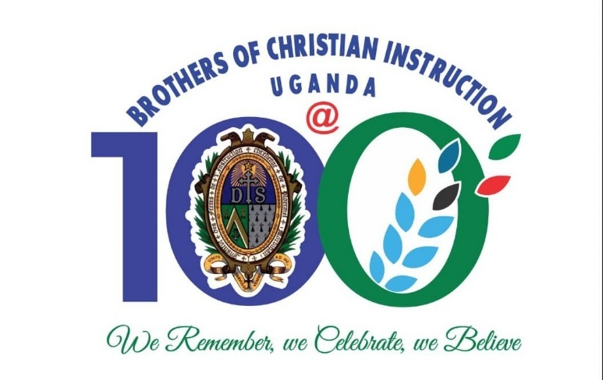
THE CENTENARY OF THE PROVINCE OF UGANDA (1926-2026)
Part 4: EARLY RECRUITMENT AND TRAINING THE NEW MISSION IN UGANDA

As we promised in the previous segment of the history of the foundation of Province of St. Teresa of the Child Jesus, this presentation offers us the opportunity to appreciate the early efforts that were taken in recruitment and formation of the indigenous candidates into the Congregation. It also in brief, gives the status quo of the houses of formation.

Among the points that were clearly expressed in Brother Provincial’s speech to the Brothers assembled in the La Prairie chapel for the ceremony of the departure of the first missionaries on the 9th June 1926, were the following prophetic words: ‘We want to see you direct with success the Kisubi College and Bikira Teacher Training College [….]Who knows, perhaps from some of those students, […] might form, the nucleus of the African Province of the Institute. And already we feel rise in our hearts a tender love and friendship for those future African Brothers’. Indeed, by the work of God’s grace, it did not take long before these words were fulfilled.

Regarding the prospects of recruitment of the indigenous young men into the Institute, Brother Charles and the other Brothers were greatly encouraged by Bishop Streicher, and later in 1929 by Father Voillard, former missionary, who was then Superior General of the White Fathers in Rome. He was on visit to celebrate 50 years of the arrival of the first missionaries in Uganda. The other encouragement was drawn from the evidence they saw around: the rapidly increasing number of the local priests, seminarians and of the religious Sisters in the indigenous congregations founded in Uganda; as well as the numerous candidates to the budding congregation of the Banakaroli Brothers. All these encouraged Bro. Charles. In his capacity as the head of the mission to immediately seek permission to begin recruitment without any delay.
The two aspiring candidates, Patrick Kahuzo and Anthonio Lugolobi, with the brothers Edgar and Donat

On 30th June 1928, hardly two years since the arrival of the first Brothers, a letter from the Superior General was received that was giving permission to the Brothers to begin receiving candidates for the congregation, and allowing the construction of a ‘temporary house’ to receive them. Upon receiving this permission to open the juniorate, it was none other than the mother of Brother Edgar Mary Delome, a missionary Brother who had arrived in 1927, who offered a substantial part of the cost of construction of the first building that would house the juniorate. Thus, this good mother, becoming the first officially known benefactor towards the formation of Ugandan young men discerning their call to be Brothers of Christian Instruction.
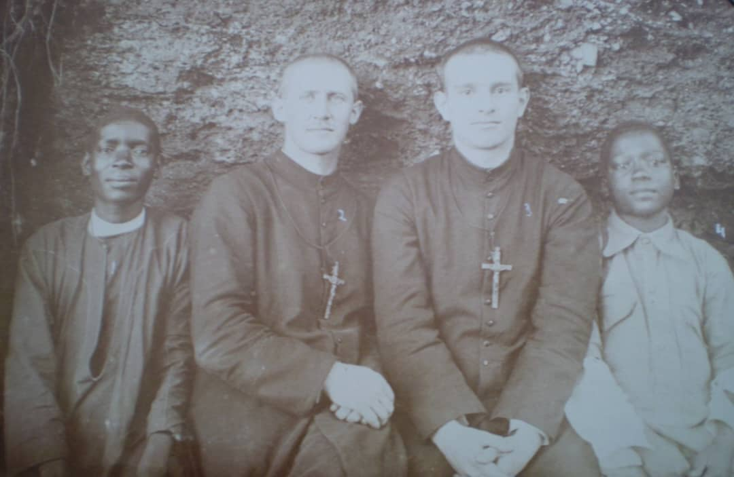
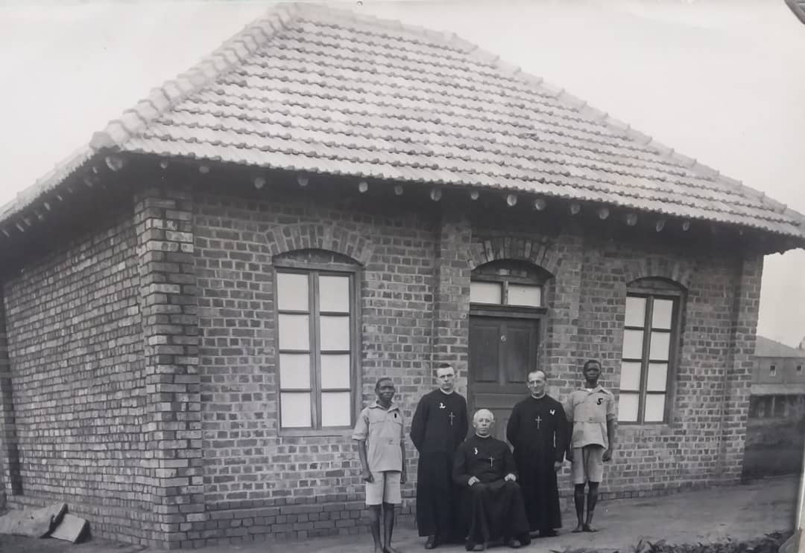
This first building, in a single room, was set to serve as a multipurpose space: classroom, dining room, prayer room and dormitory. It was measuring approximately 6 by 8 meters, (20 by 26 feet). Construction work was entrusted to Brother Tobie Kizza, a trained builder who was himself the first professed Ugandan Brother in the Society of the White Fathers. The Foundation stone was laid on 12th September 1928. The Opening and blessing ceremony of the house was held on 10th January 1929, presided over by Fr. Joire, the Chaplain of the Brothers and of St. Mary’s College in the presence of the Brothers and students of St. Mary’s College. To underline the importance of this event for the new East African mission, a Papal blessing from Rome, was received at Kisubi a few days later. Present also were two young men who had already been living with the Brothers and discerning their vocation. They were Patrick Kahuzo and Antonio Lugolobi. They were the first occupants of this house. They were shortly joined by the third, James Sambwe, thus forming a cohort of the three first aspirants.
The first two aspirants to Kisubi with the Brothers, in front of the first small training house.
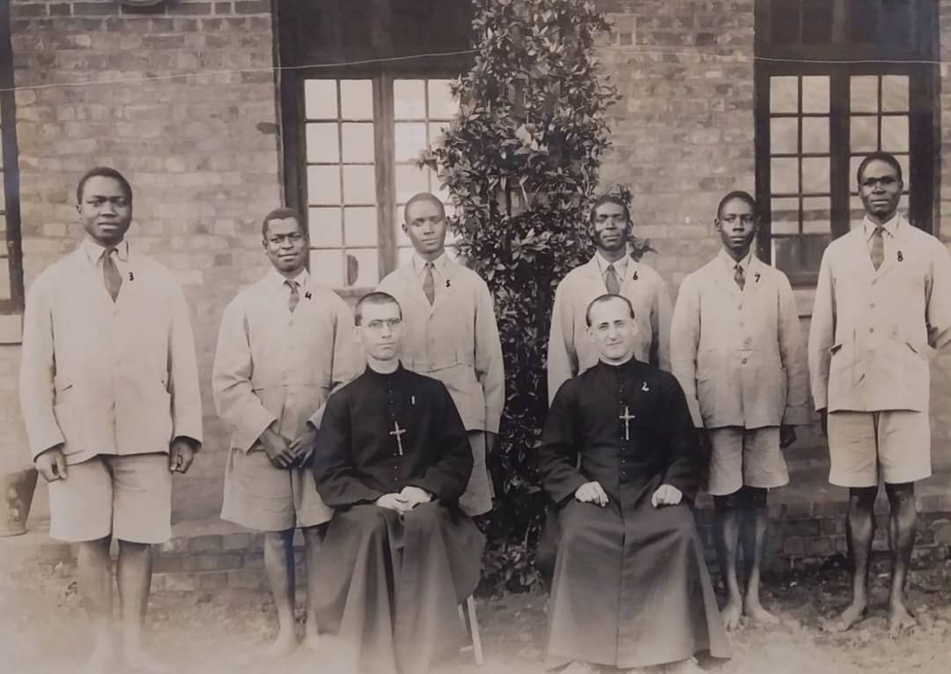
Aspirant Patrick with the 5 other aspirants of the 2nd group, as well as the Kisubi Brothers.
Of the original three young men, none of them made it to the Novitiate. Patrick stayed until the end of 1933, while Antonio stayed for only two years. Unfortunately, shortly after joining the group, James Sambwe showed symptoms of meningitis. He was advised to return home for treatment but his condition only got worse there, and he died. The remaining two were happily joined by a second cohort of admissions that were made towards the end of 1929. It is this cohort that was destined by God’s grace to produce the first five Ugandan young men to enter the novitiate in 1937, and to make the first religious profession as Brothers of Christian Instruction on January 6th 1938. The aspirant in this second cohort included the following, as registered in their order of arrival: Benedicto Zayera, who became Brother Alphonsus Zayera; Yozefu Lutaya, who became Brother Aloysius Lutaya; Sezario Ssemakula, who became Brother Francis de Sales; Stefano Bwanika, who became Brother Stefano Bwanika; Yozefu Ssebbowa, who became Brother Yozefu Ssebbowa.

These first five Brothers, form a strong and solid taproot on which several other roots, have grown over the years, by the grace of God. This has allowed the once small shoot of indigenous Brothers, supported by their expatriate missionary Brothers, and above all, irrigated and nourished by the grace of God, to be now a grown-up tree of the Mennaisian Family in the eastern part of Africa. Three Brothers of the original five, Brothers: Alphonsus Zayera; Aloysius Lutaya and Brother Stefano Bwanika, by God’s grace, persevered to the end.
Today the tombs of these three Brothers are with us in Kisubi cemetery. They are a true and living testimony of this bold, unwavering, free, and joyful personal YES; inviting us to a daily repeat in one’s heart the: ‘Here I am Lord, for you have called me’. Their example and that of the many who have followed them are to be emulated. They instil courage match on without fear or self-pity. They are signs of God’s fidelity towards those he calls to follow that path marked out by holy founders, in spite of personal vulnerabilities. An invitation to be Christ’s messengers in service of the needy brother or sister, especially the education of the children and youth according to the charism of the Brothers of Christian Instruction.
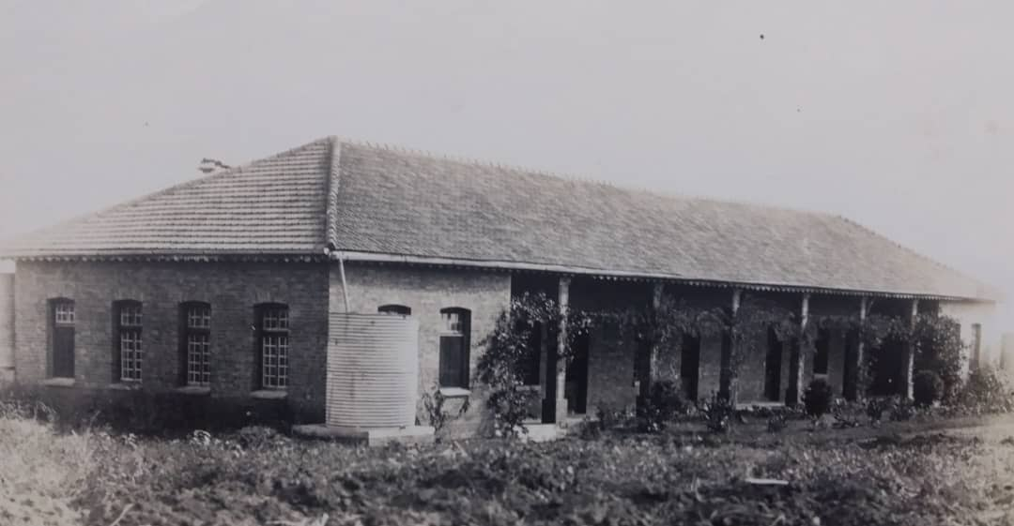
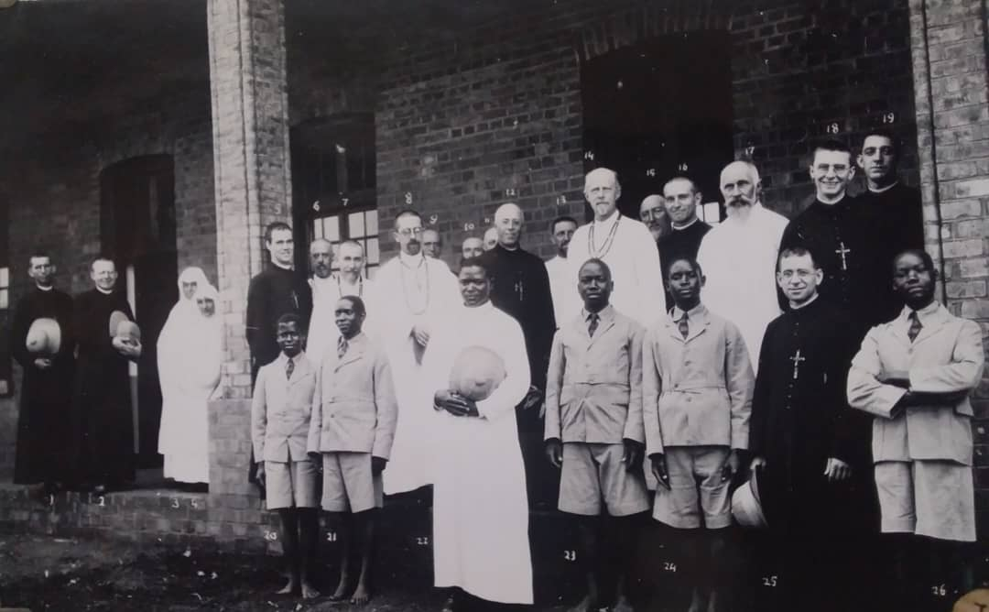
Looking back to the late 1920s, the anticipated increase in the number of young men who wished to discern their calling to become Brothers led to one conclusion: the first hurriedly constructed small building was not sufficient. The space around it too was not adequate for a house of formation. Therefore, Brother Charles requested the Bishop to grant some land to the Brothers so as to build a much larger and more permanent buildings for the purpose of formation. Bishop Henry Streicher at first granted some 30 acres, (about 12.14 hectares) of the uncultivated land at Kisubi, adjacent to St. Mary’s College. Moreover, he promised to give more land according to need – which he actually did, this land is today much larger on which are established various educational and formation institutions, and of course the Kisubi principal house and headquarters of the Brothers in East Africa.
Blessing of the new Postulate building.
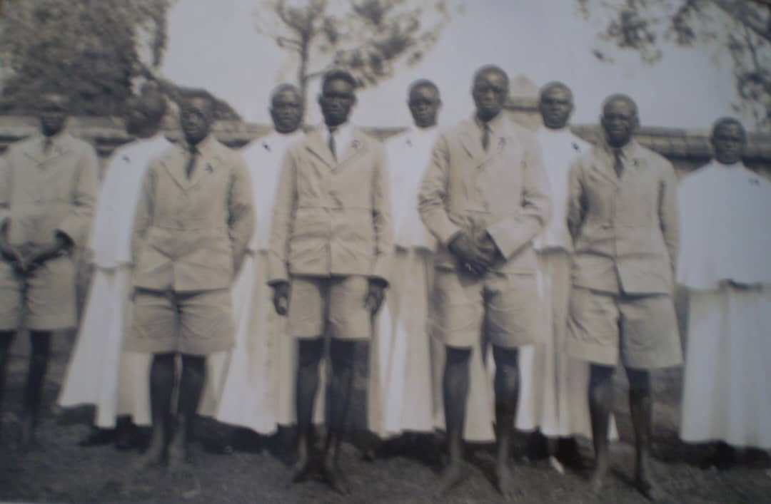
Brother Charles sent the plans for an enlarged formation house to the Superior General. The General Council approved the proposed project, first of one building for the Postulate. Towards the end of 1929 the construction of this bigger building was begun under the supervision of Brother Herman, member of the White Father Society, and by January 10th 1931, which coincided with the second anniversary of the blessing of the first building, the work on the new building had been completed. On that same anniversary day, the blessing of the new large spacious building, comprising six rooms of various sizes was done by Father Joseph Cabana (then the general bursar of the White Fathers mission, but later became Bishop). The postulants transferred to the new building under Bro. Alphonsus Joseph La Pointe, as the first Postulate Director, mission he held until his early death in 1935. was completed. On that same day, Father Joseph Cabana (then bursar general of the White Fathers' mission, later a bishop) blessed the spacious new building, which included six rooms of varying sizes. The postulants moved in under the direction of Brother Alphonsus Joseph La Pointe, the first director of the postulancy, a position he held until his untimely death in 1935.
Day of the first vows of the 5 Novices with the group of 5 new candidates
With the official opening of the postulate, the novitiate was the next stage to come. The request to open a novitiate at Kisubi was presented to the Superior General in 1933, but according to procedures of that time, there was yet a requirement for the approval from the Holy See. In the meantime, another spacious building, identical to that of the postulate had already been completed in the course of the year 1934 awaiting that moment when the novitiate was to be opened. The construction of this second building had been entrusted to a local constructor, Mr. Alexander Kiregga. Fortunately, Rome responded favourably by issuing an indult to open the novitiate of the Brothers of Christian Instruction at Kisubi, Uganda in 1935. It was procured through the help of Bishop Edward Michaud, the Vicar Apostolic of Uganda, who was at that time on his regular visit to Rome. Who then carried it and delivered it to Brother Charles at Kisubi. This indult was received with great joy in Uganda.
On January 6th 1937 the five senior postulants were admitted to the novitiate. The entry into the novitiate was marked by the vesture ceremony when the novices transited from the civilian dress into the Brothers religious habit – the cassock, even though as novices they never received the crucifix; which according to the Ceremonial was only received after the first profession of the vows. Brother Bernadine of Siena was appointed the first Master of Novices, in the history of the Province. On that date the prophesy given in the Provincial’s address on 9th June 1926 was fulfilled, and so was the ardent desire of the missionary Brothers themselves, and the dream of the young Ugandans who had been in the house of formation since 1929. A year later, on 6th January 1938, the five novices pronounced their first religious vows in the Parish Church of Kisubi from that day, their religious habit was complete: cassock, crucifix and cape. After six years of temporary profession, the six Brothers took the final profession on 06th January 1943. In memory of this day and in gratitude to God for the graces received, through the Blessed Virgin Mary, a Grotto of our Lady of Lourdes was erected at Kisubi to commemorate this historical event.
The formation house at Kisubi had most of the time some young men, except for only a few years. During the Second World War, [1939 – 1945], it was a painful period for the mission and for recruitment and formation. In spite of these hard times War, the Brothers continued to respond to the calls of the Church within the means and personnel available. The major challenge, like elsewhere, was the grace of perseverance! There is always a gap between the called and the chosen – it is biblical! This in no way discouraged the missionary Brothers. Neither does it, today. In fact, even those that do not remain members until death, many first contributed to the apostolate of the congregation for several years before withdrawing. Even after they have left, many of them remain very closely attached to the works and spirit of the institute and as very active members of the Church. This proves that a good religious formation will always imprint an indelible mark in the life and character of a person.
To give more light to this, we now provide a table of entry into the novitiate of candidates at the Novitiate at Kisubi and Kasasa from Uganda, Kenya, Tanzania and the Seychelles as one mission from 1937 until 1969. In 1969 the Superior General reorganized the East African mission splitting it into three sectors. Seychelles was attached to the Canadian Province of New Brunswick, and Tanzania attached to the Province of Our Lady – USA, and Uganda alone and a first African Provincial, Brother Gerard Celestine Ajuang, was named for Kisubi.
Table of the Novices between 1937 and 1967. The majority of the novices came from Uganda; Kenya had 4, Tanzania had 3 and Seychelles 2.
Year | Registered novices | They left | They died as Brothers
1937–46 | 18 | 10 | 8
1947 – 56 | 35 | 26 | 9
1957–66 | 39 | 28 | 11 [of which 2 are alive]
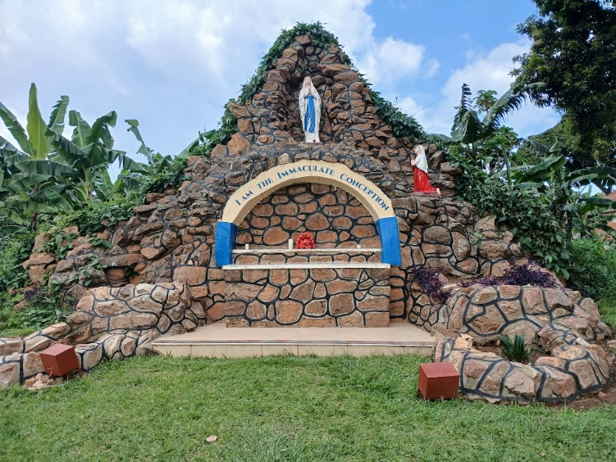
There were, no novices in the years: 1938, 1939, 1941, 1942, 1944, 1945, 1948, 1951, 1959 and 1968. By the grace of God, the prayers of the Brothers and the hard work of the Brothers responsible for recruitment and the various levels of formation, there has practically been a continuous flow-in of vocations until today – when there are no novices, there were at least aspirants or postulants!
Since the opening of the juniorate at Kisubi in 1929, followed by the postulate, then the novitiate in 1937, all the houses of formation were located at Kisubi. In the history of the Province there are other places in Uganda, and elsewhere in East Africa where formation has been done. In 1954 the Juniorate was transferred from Kisubi to Kasasa until 1967 when it was phased out in Uganda. Other juniorates were at Mwanza in Tanzania, forming aspirants from 1956 – 1969; then another one at Mahe, the for the aspirants in the Seychelles from 1950s – 1960.
The postulate at Mount St. Teresa, Kisubi, Uganda, started around the year 1934 and has since then continued to be at the same place without any interruption until today. The other places that served as postulates in the mission are: St. Michael Postulate, at Mwanza in Tanzania which opened 1961 and closed in 1971 but was later re-opened at Moshi in 1979, and is still open today, but under the jurisdiction of St. Michael the Archangel Province.
The novitiate was opened at Kisubi in 1937 and stayed there until 1954; when it was moved to Kasasa, still in Uganda. It was at Kasasa from 1955 to 1968. For the novices of the Seychelles, it very much depended on the particular needs of the times, some candidates from the Seychelles had the novitiate in their home country in 1960 and 1962 others elsewhere, even outside Africa.
Even after the reorganization of the East African mission, from 1969 to 1972, a joint novitiate was at Peramiho Benedictine Abbey in Tanzania. However, due to the unfavorable political climate in both Uganda and Tanzania, the Ugandan novices had their novitiate at Kisubi as from 1972 to 1990, while the Tanzanian novices continued at Peramiho until 1977. Since 1991 to until to date, a joint novitiate is at Kasasa, Uganda again. It serves the Provinces of St. Teresa of the Child Jesus, St. Michael the Archangel and the District of Our Lady of Kibeho. The Scholasticate, since its establishment as another separate stage of formation in 1949, has been at Kisubi, but was rather recently, (6th November 1998) it was moved to a more spacious home at Kanywa, still located within the greater Kisubi area.

SOURCES.
- CHRONICLE OF THE FIC BROTHERS, years 1926-1969.several articles in Numbers that cover that period.
- MISSION DE L’EST-AFRICAN -Uganda, Tanzania, Seychelles, Several numbers for this period.
- FIFTY-SIX YEARS IN EAST AFRICA, esp. pp. 12 –18
- THE BROTHERS of CHRISTIAN INSTRUCTION in EAST AFRICA,2000, pp. 35 – 39
- 75th PLATINUM MAGAZINE,2001, pp. 22-23,26.

