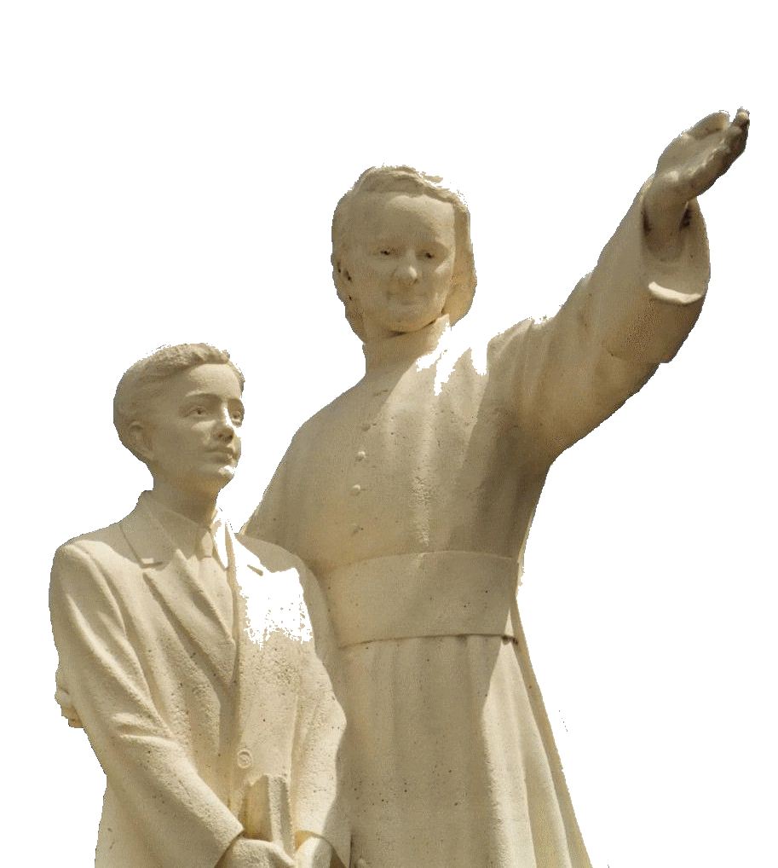

**MENNAISIAN NOVENA**

**FEBRUARY 2025**

***Pilgrims on the Path of Prayer***

1. **POSTULATION NEWS**

**THE CAUSE OF FATHER DE LA MENNAIS:**

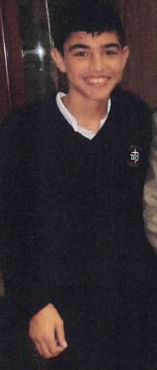We are in the Phase of Definitive Study of the Healing of Enzo Carollo. We have collected the Additional Documentation necessary to pass a Second Examination on the Healing of Enzo Carollo - in addition to the excellent Summarium carried out by the Postulators Bros. Delphin Lopez and Gil Roxas. These were the following expertise:

* That of Dr. Cristian Garcia Roig, from Argentina, Director of the Pediatric Intensive Therapy Service, Mater Dei Hospital, at the time of the Hospitalization of the child Enzo Carollo, in 2006. He sent a new update of that Healing, answering a Series of Questions posed by the Postulator, on July 23rd , 2024.
* We also received answers from other Argentine Doctors: from Dr. Hugo Arroyo, Neuropediatrician and from Dr. Huaier, Infectiologist, who visited Enzo in 2024.
* That of Prof. Roberto Cauda, ​​President of the Institute of Infectious Diseases at the Gemelli Hospital, Rome, in favour of resuming the Examination of the Case.
* That of Dr. Andrzej Krzysztofiak, Infectious Diseases Specialist at the Bambino Gesù Pediatric Hospital, Rome.
* That of Dr. Giancarlo Scoppettuolo, UOS Head for the Treatment of Infectious Diseases, at the Gemelli Hospital, Rome.
* A Neurologist, Dr. Massimi L., was collaborating with the Doctors who were in Rome.

**“HOLY” BROTHERS WITNESSES OF HOPE**

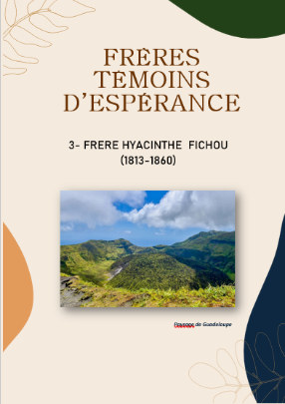On the Congregation's website:

([www.lamennais.org/ressources/publications](http://www.lamennais.org/ressources/publications)), you could find “LITTLE LIVES OF BROTHERS WITNESSES OF HOPE”. These are fairly simple Booklets (between 20 and 30 pages), Well-Illustrated, which told fascinating stories. They are short lives of the Brothers who spent their lives in a moving Human and Spiritual Adventure doing immense good around them. A life full of “Fiery Zeal and Iron Courage”, among the little Schoolchildren of Poor Brittany, the Slaves in the Antilles, the Inuits in Alaska, the young people in the New Africa… You could go through these Short Biographies with the Students, give them to read, make them known to Families, Teachers, use them in Religious and Vocational Animation. For the moment, we have completed three: Brother Zoel, the Ardent Young Master of the Poor, Brother François Cardinal, Missionary who offered his life in Rwanda, Brother Hyacinthe, the Evangelizer of Slaves. We are currently preparing a fourth one on Brother Constantine, the Holy Brother of Alaska. ENJOY READING!

**INVITATION**: We would be very happy to receive other LITTLE LIVES from Brothers to insert in that Collection; or, at least, the Documentation which could be used to write them.

1. **PRAYER INTENTIONS THROUGH THE INTERCESSION OF THE FATHER**

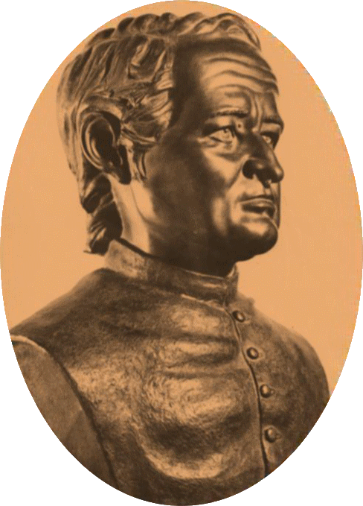We continue to receive News of the Initiatives led by the Brothers in various Regions of the World: New Professions of Vows, Apostolic Animation Camps, Prayers for the Novena. This was a beautiful sign of vitality for the Entire Institute!

During this Month we pray for:

* The Three Brothers who have started the New Mission in Timor Leste
* The Brothers in Regions threatened by Disorder and Instability, particularly Haiti and Central Africa
* Our Patients: Brother Luis Aldecoa (Parkinson's) / the children Tommaso and Alessandro (they are doing much better) / Caroline, a Mother from Uganda / Giuseppe and Massimo (Ischemia Stroke), Fathers; the young girl Irene (anorexia) who has started a Course of Therapeutic Rehabilitation.
* The Intentions indicated by Local Animators.

1. **FAVORS OBTAINED THROUGH THE INTERCESSION OF THE FATHER**

The Postulator received a Testimony about a very recent Extraordinary Healing. The Healed Man was a father, Sergio Musitano, father of Two Daughters, Former Students of the S. Ivo School in Rome, run by the Brothers. It was his wife, Daniela Allegra, who sent that story.

*“Rome, January 8th, 2025*

*To the Postulator,*

*It would not be easy to get through the year that just ended, but he tried.*

*Sergio had been having strange Symptoms for a few years: Headache, Back Pain, he could no longer digest Certain Foods, he often had Gastrointestinal Problems: he put it all down to Excessive Fatigue and Physical Exercise. Around the end of 2022, he started losing Weight and Sweating Profusely at Night and that situation lasted until he was Hospitalized.*

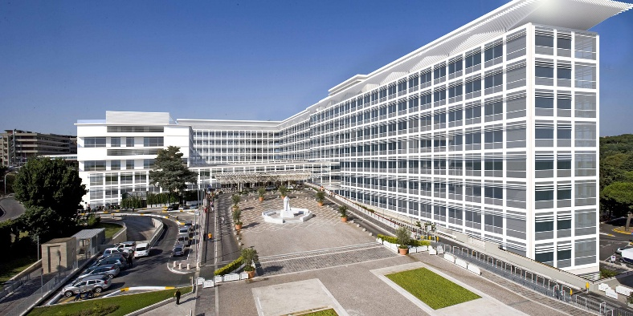*On December 12th, after Playing Tennis and going to work at his Office, he felt unwell (Fever, Swollen White and Painful Hands). As soon as he got home, he treated himself as if he had a Common Flu. The first day he had a High Fever and then a constant but moderate Fever. For some time, I had suggested that he does Blood Tests, but perhaps he was afraid of them.*

**Gemelli Hospital, Rome**

*On Friday 15th I stopped listening to him and in the Afternoon, I called a Doctor Friend, who as soon as he knew the symptoms, suggested that I run to the Emergency Room without wasting any more time. In that way, we discovered that he had 600,000 White Blood Cells and a Spleen dilated to 33 cm. We were advised to be Hospitalized immediately at the Large “Gemelli” Hospital, but we arrived there very late in the Evening, we were told to come back the following morning. Fortunately, he was immediately given a Bed and he remained Hospitalized until December 23rd. He returned and stayed at home until the 28th, when he was called back to the Emergency Room again, because of the decidedly Incorrect Blood Count. During that whole period, he continued to lose weight and was angry and very confused (perhaps because of the Cortisone he was given). He stayed in the Hospital for about ten days, the Central Venous Catheter (PICC) was applied and the Doctors started with Chemo and Immunotherapy. Once he was out of the Hospital, every three Weeks he followed the above Therapies every three days. As the Blood Count ​​recovered, the Spleen also improved, until it resumed its Normal Dimensions.*

*Finally, at the end of August (2023), he underwent an Autologous Transplant (also called Auto transplantation or Autograft) and, according to the Doctors, he was Miraculously Cured. At first, they were talking about a Life Expectancy of a few Weeks and Today they are talking about Ten Years. What was incredible was the recovery. To be able to do the Transplant, it was first necessary to completely reset the Blood Count, which normally rebuild themselves in a few Months. In Sergio they recovered immediately. As soon as he finished the Month of Hospitalization, he was immediately healthy. Of course, that Month of almost Absolute Isolation (I could see him only one hour a Week and well Isolated) was not a walk in the Park, but for the moment, fortunately, it was only a memory.*

*I hope I have covered Our Experience completely. I would never stop thanking you for the Prayers that the Entire Institute Addressed to God for the Healing of Sergio, thanks to the Intercession of Venerable Jean-Marie de la Mennais.*

*Daniela Allegra*

“The Intercession of Father de la Mennais was witnessed by the Image-Relic of the Founder sent to Sergio’s Family and by his name which was indicated among the Recommended Prayer Intentions, present in the Bulletin of the Postulation. (Declaration of the Postulator, Br. Dino De Carolis)”

1. **JUBILEE PRAYER PILGRIMAGE 2025**

**THE APPARITIONS OF THE IMMACULATE CONCEPTION IN LOURDES AND THE MENNAIS BROTHERS**

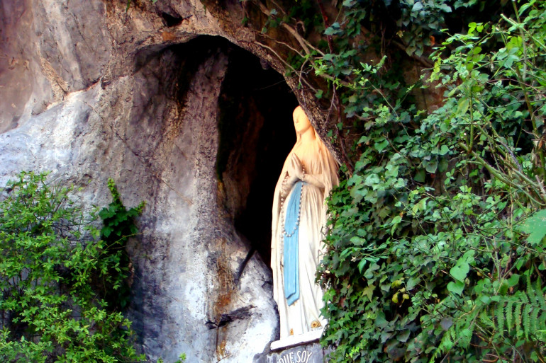The Apparitions of the Immaculate Conception in Lourdes gave rise to one of the Most Popular Marian Pilgrimages in the World. Millions of Pilgrims flock there every year to pray and ask for Conversion, with Healing of Soul and Body. Although very old, Father de la Mennais had attributed great importance to these Apparitions: He had considered the presence of his Brothers as a Privilege and the Faithful Custody of the memory of these events as a duty. He had Great Veneration for the Dogma of the Immaculate Conception and he wanted to dedicate the Chapel of the Mother House to her name. Let us follow that Very Special Marian attachment to the Immaculate of Our Founder.

In Lourdes, a Town at the foot of the Pyrenees, the Virgin appeared to Bernadette at the Rock of Massabielle, on February 11th, 1858, in a Dirty and Dark Pig Shelter. The Brothers of La Mennais had opened a School in that Town in 1855, Directed by a Brother from Martinique, Brother Léobard-Marie Bourneuf (1831-1916). His Assistant was Brother Cérase, who knew the Local Dialect well. They left us Important Accounts of the Events of those days, which were the fruit of Several Interviews with Bernadette and which have been used by Historians of the Apparitions. We would present Extracts from them, which were preserved in Our Archives.

**Letter-Story of the Apparitions by Brother Cérase (FICP)**

* Let us begin with a Letter from Brother Cérase Escoubas to his Family, written before May 1858. That Text was probably the First Written Testimony of the Apparitions of Lourdes. It painted a Picture very similar to the future Accounts that Bernadette would give. That Text was integrated by other Extracts - placed in Parentheses - taken from an Additional Memoir written in 1881.

*“That child, barely thirteen years old, and two other children of her age, were collecting some dead branches in a wood located on the Banks of the Gave, at the Gates of Lourdes. They had to cross a Small Stream; it was February 11th. The water was cold; nevertheless, Bernadette's companions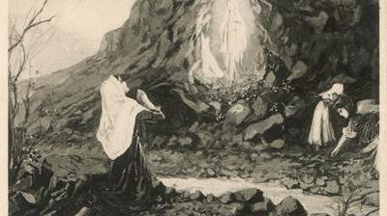(that was the name of the young Seer) crossed the Stream. Bernadette hesitated and, while she was taking off her shoes, she heard a Sound of Wind… She looked up at the Huge Rock in front of her and saw a Bush that seemed to be shaken by the wind. Near that Bush she thought she saw a Lady dressed in White, she rubbed her eyes to see better and she made out a Lady who was smiling at her. Then she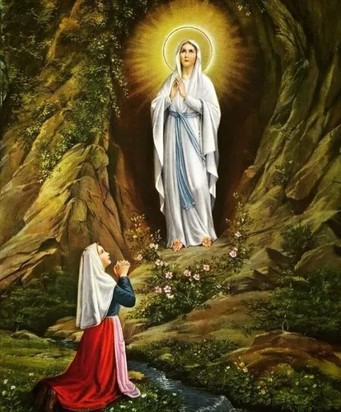instinctively knelt down and recited her Rosary, watching the Apparition. After a few moments, the Lady disappeared and Bernadette crossed the Stream to go to her companions and ask them if they had seen anything… She described the Lady to them in the following manner: That Lady was about my height, a little taller perhaps; she was dressed in a White Dress: she wore a Blue Sash that falls to her feet; her head was Veiled; her feet were bare and on each of them was a Golden Rose; her Hands were outstretched, like those of the Image of the Miraculous Medal; on her Arm hangs a Rosary.*

*When she got home, Bernadette told her Parents what she had seen: they paid little attention to that Story… Her parents gave in to her desires and she returned to the Grotto, still accompanied. She began to recite her Rosary and the Apparition suddenly appeared. The child rushed to throw Holy Water on Her. The Apparition (Aquéro) began to smile and approached, Bernadette continued her Rosary and soon after the Lady moved away and disappeared. That New Apparition provoked Vast Reactions: The Strong-Minded mocked the Believers; the Simple People firmly believed in the Apparition of the Holy Virgin; the Serious People did not pronounce themselves. The following Thursday, the child returned to the Grotto; she was given paper and ink. The Vision appeared: she replied to Bernadette that she would not write anything; She only asks the young girl to return to that place every Morning for two Weeks, which Bernadette would do Every Morning at six o'clock.*

*At first, she was accompanied by few people; but the Story of the changes that the Seer's Physiognomy underwent when she was in Communication with Aquéro soon attracted a Prodigious Crowd of people. From three o'clock in the Morning, men, women, and children from Several Leagues around invaded the Surroundings of the Grotto. The young child could be seen kneeling at the edge of the River fixing her gaze on a Bush that was on the Rock and, a moment later, a slight smile appeared on her lips; often she shed Tears, but her Tears in no way altered the features of her face. Sometimes she crossed on her Knees, kissing the Earth around her, a distance of ten meters; then she washed herself in the water that gushed at the Foot of the Rock, drank of that Water and ate of the Herbs that grew in that Humid Place. [“She was crying because she did not understand the order that the Apparition gave her to drink in a place in the Grotto where she could only see Grass. She dug the Damp Earth with her hand and Water appeared. She drank and joy returned” Memoir 1881]. Towards the end of the fortnight, the Apparition said to her: “My name is Mary Immaculate; you would tell the Priests that I want*e*d them to come here in Procession and Build a Chapel here. I promise you nothing in this 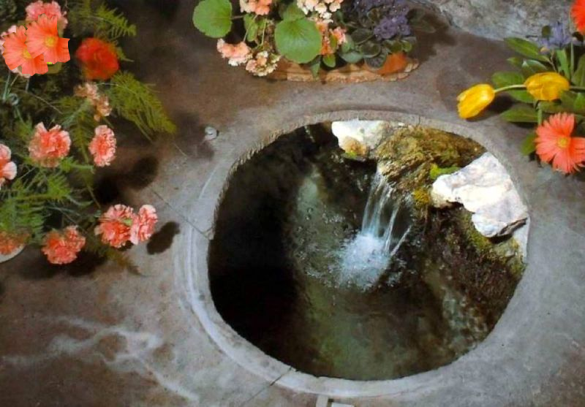World, but in the other I would make you happy” [I cannot say why I wrote on my Letter: I am Mary Immaculate. It seemed to me that the Apparition was First Designated in that way. I was also able to write that: “I am Mary Immaculate” was exactly the same thing as: “I am the Immaculate Conception” Memoir of 1881].*

*She said three other things that the child claims she cannot tell anyone. The words I have just quoted were not said in the same Interview, but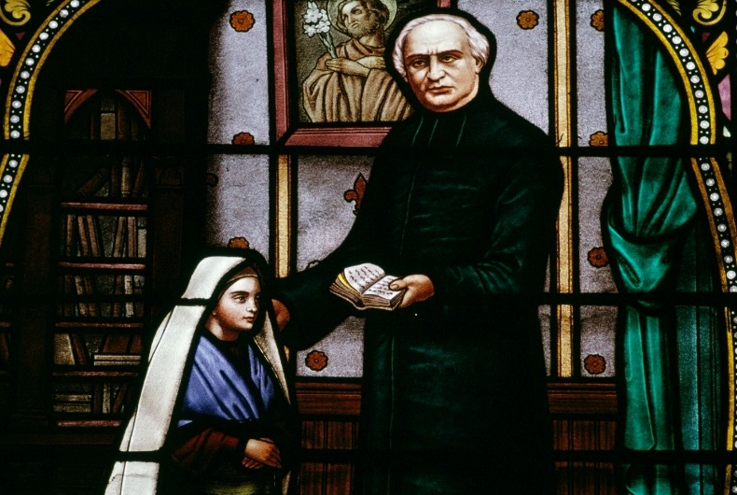during the last days of the fortnight. These, dear parents, are the facts as I have gathered them. What was true in all that? Before making a decision, we must wait until the future has given its Accounts.” [It was not surprising that I did not believe at first. I was incredulous for a long time. I only believed in a somewhat firm manner when the Commission Appointed by Mgr. Laurence had recognized the Miraculous Cure. Brother Léobard believed almost from the first days: the Vicars also: the Priest did not say much. The Majority of the Population of Lourdes and the Surrounding Area believed from the first moments. Memoir of 1881]*

**Letters from Bernadette to her brother Jean-Marie, who became (from 1870 to 1876) a Brother of Christian Instruction**

The Soubirous Family had 9 children. Even after the death of the Parents, the Fraternal ties were very close.

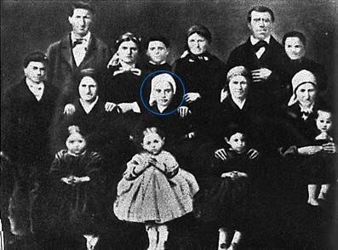Bernadette, in Nevers since 1866, wrote several Letters to her brothers and sisters. In Our Archives we have kept a Small Booklet that collected them. Let us present Some Pieces of those that she sent to her brother Jean-Marie. He had been a student of Our Brothers, with his little brother Bernard-Pierre.

During the Winter of 1869,he had returned to the Novitiate of the Brothers at Lavacan (Pavia, Auch). Bernadette wrote to him: “My dear and beloved Brother, I wanted to express to you the happiness that my heart felt on learning of your Entry into the Novitiate of the Dear Brothers of Christian Instruction. How fervent we should both be to thank Our Lord and the Most Holy Virgin for the Remarkable Grace of having called us to Her Service, we who are So Weak and So Ignorant; let us apply ourselves above all to studying the Science of the Saints by imitating their Virtues of Humility, Obedience, Charity and Self-Forgetfulness. I thank you for your prayers to me; pray also for Our Parents and for little Pierre. I have been very ill this Winter, which has prevented me from writing to you sooner… I beg you to present my deep respect to the Superior and recommend me to his fervent prayers and those of the Community. Farewell, my good brother. Do not forget me near the Sacred Hearts of Jesus and Mary.” (21-4-1870)

May 20th, 1873.Bernadette wrote to her brother, who had taken the Religious Habit with the name Brother Marie-Bernard.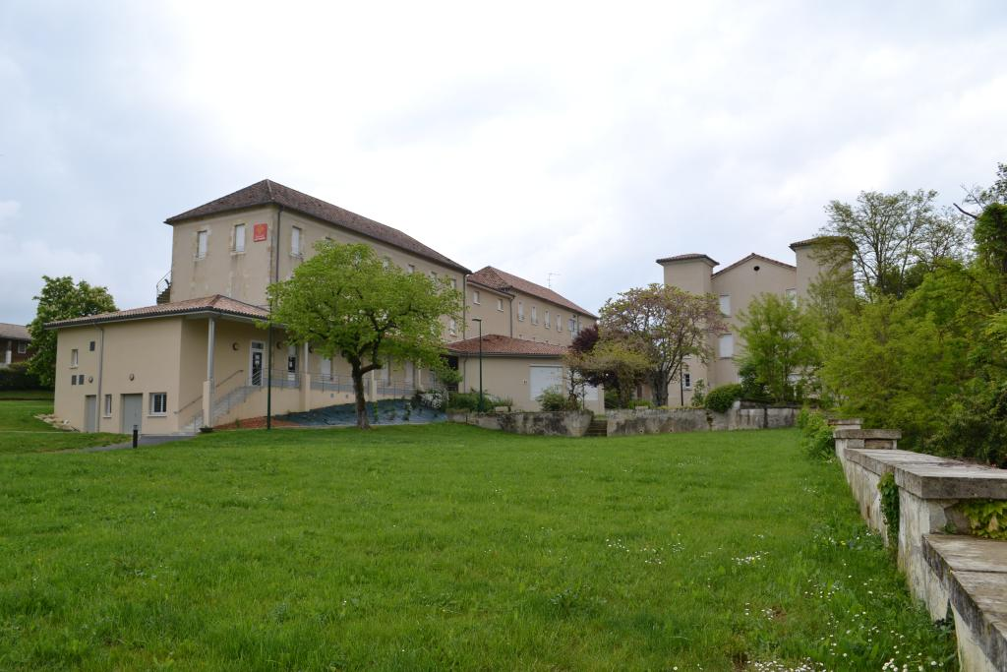

**Lavacan Novitiate Today**

“My very dear brother, I am sorry that I could not give you News of myself sooner. I had just been seriously ill; it had forced me to stay in bed for Three Months. Do not worry: I have nothing in my chest; it was a Heart Disease… I abandon myself into the hands of Our Lord and the Most Holy Virgin… I beg you to offer my profound respect to the Dear Brother Director and the prayers “Mary, conceived without sin, etc…” are addressed for his intention; I am very happy to think that I am united in prayer with your Dear Community… Give me News as soon as possible.”

July 1876. Bro. Bernard was finishing his Military Service. He was making a Serious Discernment about his Vocation, to guide his future. Bernadette understood the delicacy of that Moment and she felt the Duty as “Head” of the Family (the Parents were deceased) to support her brothers. She wrote to Jean-Marie: “My Cousin told me that you were waiting for your leave this year. Tell me a little what you are thinking about to do… It seemed to me that it was my duty, as your eldest, to watch over you. I confess to you that, at this moment, I am deeply concerned about your future and that of Pierre. I pray every day to Our Lord and the Most Holy Virgin to enlighten you. I recommend that you above all be very faithful to your Duties as a Christian; it is there that you would find strength and light in all the sorrows and difficulties. I know that the Military have a lot to suffer and in silence. If they would take care to say every Morning: “My God, today I want to do everything and suffer everything for love of you,” what merits would they not acquire for Eternity! Farewell, my good brother, I leave you with a very affectionate embrace and recommending that you always be very reasonable. Your sister who loves you always.”

These were very Spiritual and at the same time very Human Letters. The Simple and Family Holiness of Bernadette at one time directly touched Our Congregation of Brothers and transmitted to it the Blessings of the Immaculate Virgin Mary.

**THE BROTHERS AND LOURDES**

We wanted to add Simple Points of Contact between Our Institute and the Apparitions of Lourdes.

* The name of the Chapel of the Mother House: Father de la Mennais wanted to dedicate the Large Chapel of Ploërmel to the “Holy and Immaculate Heart of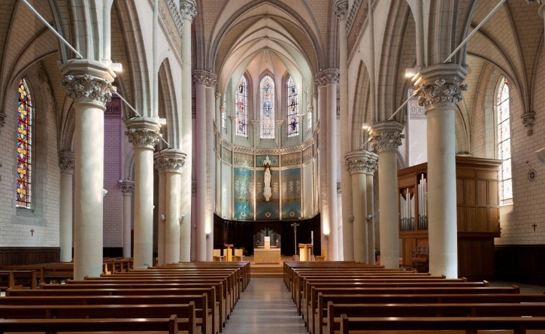Mary”. He had added the Chapel to the Great Roman Basilica of St. Mary Major, to obtain the same indulgences.

It was in 1856, two years after the Proclamation of the Dogma of the Immaculate Conception of Mary. The Founder certainly had a Strong Devotion to Mary Immaculate, following closely the Great Marian Movement of the 19th Century. Because of that, he listened to the News of the Apparition of Lourdes and encouraged his Brothers (Leobard and Cérase) to follow closely that Extraordinary Event. The Documents: Letters, Memories, Testimonies, Writings, produced by Our Brothers were precious for the Investigations on the Apparitions, the Miracles and the Cause of Bernadette. Important Names (Trochu, Messori, Cavallera, Laurentin…) of the Reviews (Ascétique et Mystique, Etudes…) drew on that Material. Let us add that the Brothers have always been present and active in Lourdes since the Foundation in 1855 (Three Schools, the Choir, the Services at the Grotto, the Reception of Pilgrims…).

* 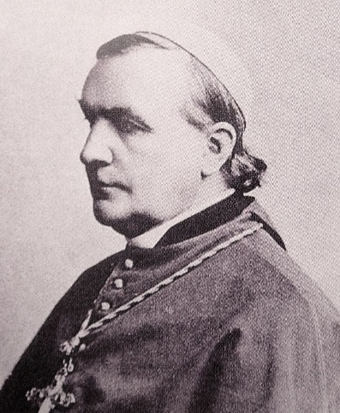Monsignor Forcade. The Bishop who helped Bernadette to enter a Religious Institute was Mgr. Théodore-Augustin Forcade. In his early youth, he had been a Missionary in China and Japan; then, in 1853, he had been Appointed Bishop of the New Diocese of Guadeloupe, in the Antilles. In Basse-Terre he had met the Director of the School, Brother Hyacinthe Fichou, who enjoyed a Great Reputation for Holiness: he had Evangelized the Slaves in their Homes, he visited the Jail, he prepared the Population for the Sacraments, he taught Children and Adults without sparing himself. By sharing with him the Work of Evangelizing the Former Slaves and their Children, Mgr. Forcade had also been touched by the Spirituality and Apostolic Fervor of the Brother. In particular he admired his Piety towards the Immaculate Virgin, in whose Honour he had founded a very Fervent Association. It was the time of the Proclamation of the Dogma of the Immaculate Conception and the Apparitions of Lourdes. The Two Apostles followed these Events with fervour. Subsequently, Mgr. Forcade was called to France as Bishop of the Diocese of Nevers in 1860. While making his Pilgrimage to Lourdes, he met Bernadette who revealed to him her desire to become a Nun. He favoured her by exempting her from paying the required Dowry and by having her accepted into the Sisters of Charity in his Diocese of Nevers, where she remained until her death. Did Br. Hyacinthe inspire that Meeting?

***SOURCES: FICP ARCHIVES ROME: FICP ARCHIVES: Cartons Lourdes/ Revue d'Ascétique et de Mystique n.1 1929: F. Cérase and F. Léobard / FILE of Jean-Marie Soubirous: Letters from Bernadette to her Brothers/ Chronicle of the FIC: Ploërmel, July 1954/ Biography of Brother Hyacinthe: AFICR***

