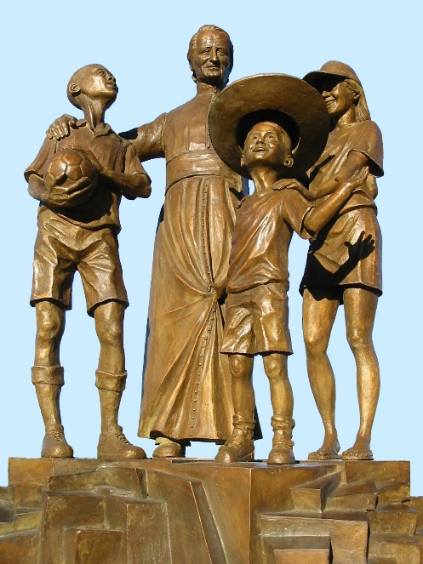
MENNAISIAN NOVENA
APRIL 2026

- NEWS FROM THE POSTULATION
On January 15th, the Postulator of the Brothers of Christian Instruction and the Daughters of Providence presented the Petition to the Dicastery for the Causes of Saints. The Cause for the Beatification of Our Father de la Mennais has been a long one: begun in 1899 with the Diocesan Inquiry in Vannes (Brittany), Officially Introduced in Rome in 1911 to the Congregation of Rites (which also handled the Causes of Saints), it continued through the Other Stages: Approval of his Writings, Reputation for Holiness, a New Exhumation, and the Validity of the Process. It overcame significant Obstacles in the Historical Area of ​​the Examination for the Recognition of the Heroic Nature of his Virtues, which was recognized in 1966 by Pope Paul VI.

In 2016, the Postulation presented to the Medical Commission of the Dicastery for the Causes of Saints the Alleged Inexplicable Healing of the Child Enzo Carollo. It was deemed Explainable by a Vote of 5 to 2. In 2022, the 1956 Healing of Little Josette Poulain, cured of an Epidural Hematoma, was presented. While acknowledging the Case as Exceptional, the Medical Commission issued a Suspensive Judgment, in the absence of more Advanced Diagnostic Evidence. Currently, the Postulation has taken up the Case of Enzo Carollo again. The File has been submitted to the Study of Several Highly Reputable Physicians, each of whom provided their Expertise. On January 5th, 2026, the Postulation presented the 2016 File, along with that Additional Documentation, to the Dicastery. The Undersecretary, Fr. Turek, entrusted the Task of studying that File to Two Physicians. If at least One of the Two Doctors declares the possibility of the Inexplicable Nature of the Healing, then the Matter would proceed to the Decisive Judgment of the Medical Commission (Consulta Medica). Finally, if the Latter gives a Favorable Opinion (at least 5 out of 7), the Matter would proceed to the Theological Commission, composed of Theologians and Bishops, to confirm that the Healing was obtained through the Intercession of the Venerable, Candidate for Beatification (in Our Case: Father de la Mennais).

So for now, Our Part was that of the Wise Virgins who prepared their Lamps to welcome the Bridegroom who was coming. Our Task would be to:

- PRAY, as many Generations have done and continue to do for a long time. Don't hesitate to update the Novena, adapting it to the Local situation: Needs, Celebrations, Vocations, and Testimonies…
- WATCH, to increase Our Filial Devotion to the Father, to entrust to Him the Needs of the Church, the World, and Our Institute. To Record and Make Known the Favors received.
- ENLARGE Devotion to the Father to the whole Mennaisian Family; to make known the Father and his sons, in their Holiness; to Distribute Images and Prayers; to Highlight Mennaisian Places and Mennaisian Dates in each Province.

- Prayer Intentions through the Intercession of Jean-Marie de la Mennais
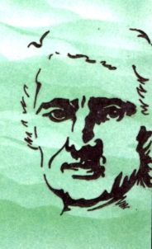
- For the Beatification of Father de la Mennais, source of a New Impetus and Fervent Vocations.
- We offer a Special Prayer of Thanksgiving for the Province of Uganda, which is celebrating its Centenary and preparing for New Apostolic Challenges.
- Let us pray for the needs of the FIC Provinces in difficulty: Haiti, Congo, South Sudan, Tanzania, and for the New Mission in Timor-Leste.
- For the Patients recommended, in particular: Mrs. Anne-Lyse, Headmistress of the “La Providence” School in St-Brieuc, founded by Father de la Mennais in 1820; for Brother George Kamanda of Uganda…
- Let's add the Patients recommended by the Local Organizers.

- Favors received through the Intercession of Father de la Mennais: Favors of all kinds
“Father de la Mennais is no less an Intercessor for Each Person with God in circumstances other than those of Recovering Health; and the favors that resulted from those were among the Most Numerous and often also among the Most Particular.
During one of his Trips to America, Brother Charles-Jules Poitras found himself unable to return to Uganda for an indefinite period, as all Maritime and Air Transport Companies were disrupted by the Mobilization. He then prayed a Novena to the Father: on the Last Day of the Novena, he received an offer of a Plane Ticket to return to his African Mission.
Regarding Uganda, let us also mention the Conversion of an Old Man. His grandson, a Former Student of the Kitovu School, had recommended him to Father de la Mennais, at the suggestion of his Former Teacher, Bro. Eugène-Marie.
In England, a few years ago, after a Novena to the Father, Bro. Cyprius received just in time, by Special Mail, a Passport that many attempts with the American Consul and the Secretary of State had been unable to obtain for him.
As for the successes achieved in Examinations by Candidates who had previously placed themselves under the Founder's Patronage, there were so many Fine and Numerous Examples that it sufficed to make a Brief Mention and offer thanks to that good Father. The Custom among Our Candidates of recommending themselves to him dates back a very long time. In the October 1921 issue of L'Écho des Missions, Brother René-Maurice recounted how Three Candidates for the Advanced Diploma, having entrusted themselves to the Father, succeeded in passing that difficult Examination under Truly Exceptional Circumstances.” (Jean-Charles Bertrand, Collection of Favors, p. 107)

TRACES OF SAINTINESS IN THE HISTORY OF THE INSTITUTE:
THE CENTENARY OF THE PROVINCE OF UGANDA (1926-2026)

THE CENTENARY OF THE PROVINCE OF UGANDA (1926-2026)

- THE BEGINNINGS: THE FAREWELL IN CANADA AND JOURNEY FROM LA PRAIRIE TO UGANDA
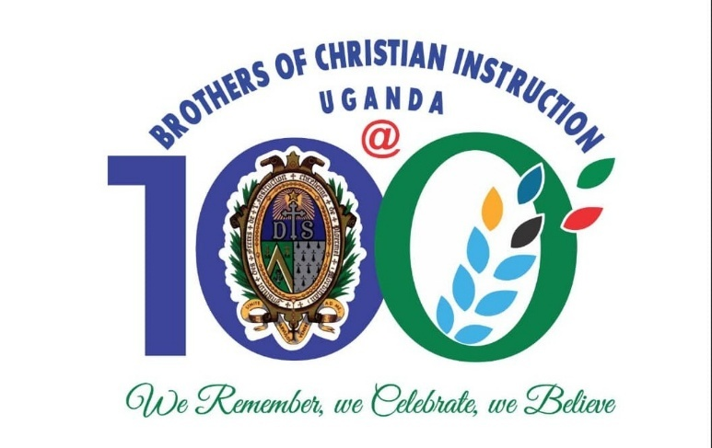
THE JOURNEY AND ARRIVAL OF THE MISSIONARIES IN 1926
This Second Presentation on the History of the Foundation of Province of St. Teresa of the Child Jesus is a continuation of the Events of the Farewell and Departure Ceremony. It was important to note, that by the time the Flourishing Province of Canada was sending out the First Missionaries to Uganda in 1926, it had only been forty (40) years, that was, since 1886 when the Brothers from France laid the First Foundation in Montreal.
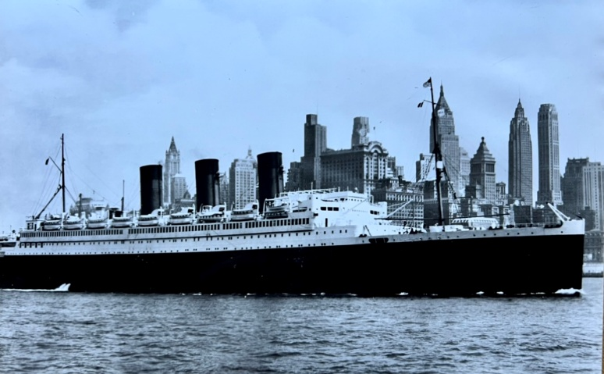
On that Historical Wednesday evening, 9th June 1926, the Provincial, Brother Celestin-Auguste, together with all the other Brothers of La Prairie Community had gathered for that Solemn and Memorable Ceremony. The Canadian Province, then called the St. John the Baptist Province, was taking a Leap of Faith as they witnessed their Own Members embraced that Adventure in Faith and Trust in Providence. The Missionaries were full of zeal and ready to live to the full the Missionary Calling and Spirit that had long existed in the Institute since the days of Fr. Jean Marie de la Mennais himself when he first sent the First Group of Missionary Brothers in 1837. An Experience of Self-donation that had been replicated already by Large Number of Missionary Brothers to Several Missions, including in Africa: Senegal, Guinea Conakry and Egypt.

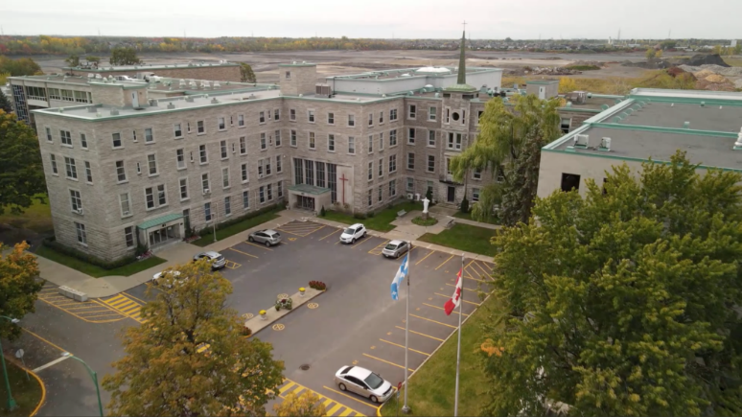
The following day, Thursday, 10th June 1926, the Four Missionary Brothers with their Luggage bound for that Long Journey, left the House of La Prairie to the Community of Montreal; from where later that day, they were to Board a Train to take them to New York. Brother Eugene Paquette, one of the Four Missionaries narrated in his Report about that Journey what happened upon Arrival at the Community of Montreal: ‘‘Brother Liguori, Headteacher at St. Zotique School in Montreal invited us to Dinner. He had invited also Father Poitras C.S.C., a young brother of Bro. Charles-Jules Poitras, and the Members of Our Montreal Houses. Brother Provincial accompanied us to the Bonaventure Railway Station where a Great Number of Brothers, Relatives and Friends had already assembled to wish Goodbye to the First Delegation to Our Ugandan Mission. We could not forget the presence of Father Robillard, W.F., and General Bursar for Uganda who was on a Visit to Canada. He wished us a Happy Voyage and assured us of the support of his Congregation’’.
Upon their Arrival in New York, they were received by the Little Brothers of Mary of St. Anne’s Academy, where they stayed for a day. With the help of their Bursar, they visited some Interesting Sites in New York including the Museum of Natural History. On the following Saturday, 12th June 1926, the Four Brothers embarked on a Luxury ‘Paris’ Boat of the General Trans-Atlantic Company from New York bound for England. It took Six Days to reach Plymouth. Brother Eugene continued to share the experience on that ‘Real Floating City’ that:‘‘We were fortunate to have Mass celebrated Every Morning by Father Cassagne, a Marist who was also on the Boat.’’

Brother Eugene continued to note that: ‘‘On the 18th, we were in Plymouth where the ‘Sir Walter Raleigh’ was waiting to take us to the Docks. As we travelled to Southampton by Train we had the Opportunity to admire the Beautiful English Countryside, and at 5.00 pm, we arrived at Bitterne Park where we met Our Brothers of St. Mary’s College.’’ After a Week or so of Rest and Visits, particularly visiting the White Father’s Community at Bishop’s Waltham, the Four Missionary Brothers took yet another Boat, though for a Much Shorter Journey, towards Jersey Island. On Tuesday, 29th June, they were received by the Superior General, the Reverend Brother Jean-Joseph Quirion and his Assistants at the Notre-Dame de Bon Secours Generalate House, then in Jersey Island, which they also had the Opportunity to visit.

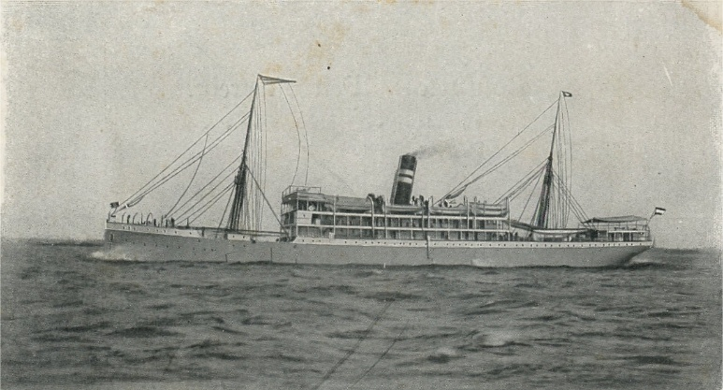
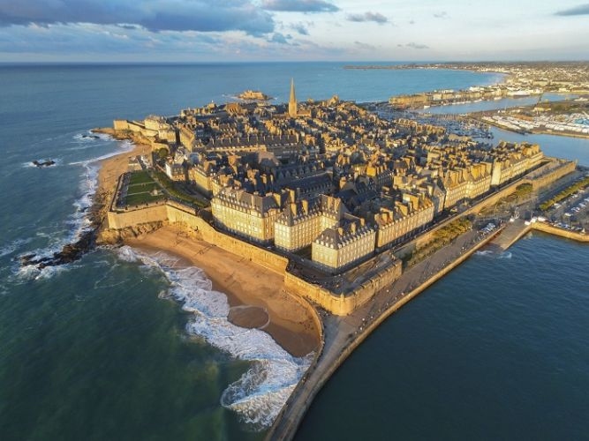
That same Tuesday Evening, they were again taking a Boat that was heading to St. Malo in Brittany. A place so dear to the Brothers. After about a Day in St. Malo, on Thursday, 1st July, the Brothers took a Train to Ploërmel. Their Experience at the Motherhouse was as if they had Physically met Fr. Jean Marie de la Mennais. It was a Real Moment of Prayer and Renewal of their Spiritual and Missionary Energy. Here, it was as if they heard the Words from the Mouth of the Founder exhorting them to go forth without Fear, and to remain faithful to their Vocation as they worked for the Extension of Reign of Christ in Africa. Another Place they could not afford to miss was a Visit to Lisieux, and so, on Monday, 5th July, they were in Lisieux. They knelt at her Tomb in prayer to commend their Mission to her who promised to help the Priests and the Missionaries. They attended Mass and afterwards visited both the Monastery and the Home of St. Teresa – les Buissonnets.

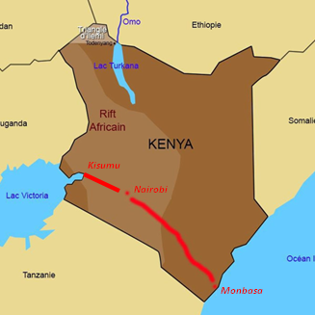
Still by Train, they travelled from Ploërmel to Paris where they were received by the White Fathers who also helped them to visit a Few Remarkable Places in the City; especially the Churches of Montmartre and Notre-Dame de Victoires (Our Lady of Victory). From Paris they continued the Journey, by Train, to Marseille. In Marseille, they were warmly received at the Procure of the White Fathers who also furnished them with Extra Items: Clothing and Small Materials, as well as Malaria Medicines that would be applicable in the Tropics. Here, they had the Opportunity to move up to the Church of Notre-Dame-de-la-Garde (Our Lady of Good Custody) overlooking the Entire City and the Open Sea. Before Our Lady, they entrusted the Remaining Part of their Journey to her Maternal Protection; she whom Sea Voyagers never call upon in vain.

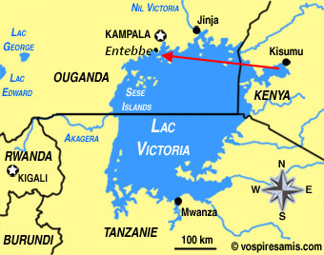
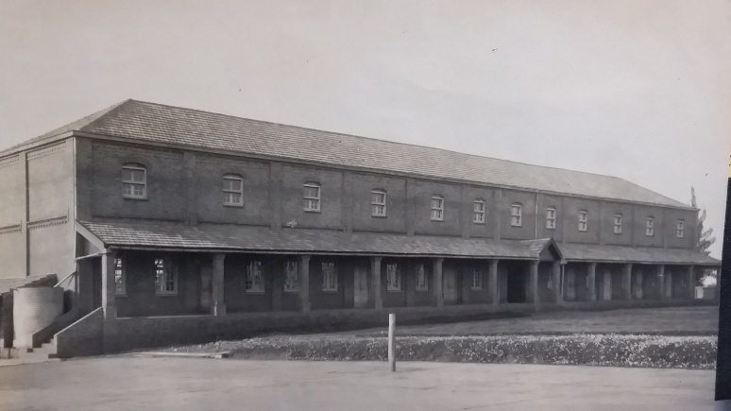
Then on Thursday, 8th July, the Four Missionaries in company of Two White Fathers and Nine White Sisters, moreover, 3 of the Sisters being also Canadians, embarked on the ‘Roland Garros’ Ship heading to Mombasa. The presence of the Priests on the Boat enabled them to attend a Solemn Mass Every Sunday in one of the Halls of the First Class. Several surprises were awaiting them on that Long Voyage across the Mediterranean Sea, then through the Suez Canal, then along the Red Sea, and eventually entering the Indian Ocean, and sailing on up to the Port of Mombasa, on the East African Coast. Some of the Frightful Occurrences on the Boat included: the Death on Board of One of the Members of the Crew as they approached the Suez Canal that threatened the halting of the Entire Journey in case it had been due to Plague that was Highly a Contagious Disease. Then it would have as well affected several other persons on the Boat. Fortunately, the Medical Authorities upon ascertaining that no Member of the Crew or Passengers had the Frightful Disease, they allowed the Boat to keep on its Journey. Brother Eugene citing those Threats in his Narrative noted: ‘‘First it was Plague, then the Unbearable Heat through the Red Sea, and again a Fire on Board, which fortunately, was mastered quickly by the Crew, finally, the Waves in the Indian Ocean that were very high and the Ship could hardly advance as it was the Monsoon Season’’. With a Great Relief, they entered the Port of Mombasa on the Friday, 30th July. They stayed at the Procure of the White Fathers, a place that was strategically positioned, and received many Missionaries from Several Congregations, arriving in, or departing from the Continent. The Ship arrived at Mombasa just in time for the Weekly Train that was due the following day to take them up to the Port of Kisumu on the Eastern Coast of Lake Victoria. They reported a Comfortable Train Journey that enabled them admire many features along the way towards the interior of the African Continent towards Uganda. Upon their arrival at Kisumu, that same Sunday afternoon, 1st August 1926, they Boarded yet another Boat the ‘Clement Hill’ to cross Lake Victoria from Kisumu to the small Port of Entebbe – Kigungu Landing Site. They arrived there the following day on 2nd August 1926, and thus set foot on Ugandan Soil for the First Time.
Le Père Michaud et le Père Nadon et les 4 Frères, le jour de la passation
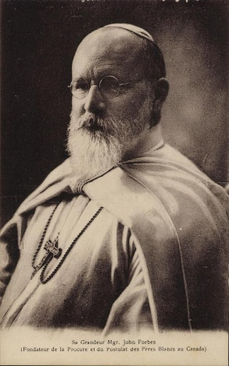
At Entebbe, the Brothers were very warmly welcomed by several White Fathers among them, the Apostolic Vicar himself, and Bishop Henry Streicher, who actually invited them to ride with him in his Small Ford to the Residence of the White Fathers at Entebbe. They stayed for Two Days, that was, 2nd to 4th August, with the White Fathers for a bit of Rest after that Long Journey. Bishop John Forbes would not be present at that Happy Occasion of the arrival of the Brothers of Christian Instruction in Uganda as he was already watching from Heaven. It was he who had championed the Request of the Brothers to that Vicariate. He had previously suffered from Heart problems, and so had to leave Rubaga in February 1925. After spending a few Months in Mombasa, he went to Paris and then to Billère, where he unfortunately died of a Heart Attack on 13th March 1926. He was buried in the Cemetery of the White Fathers in Pau.
St Mary's de Kisubi en 1926
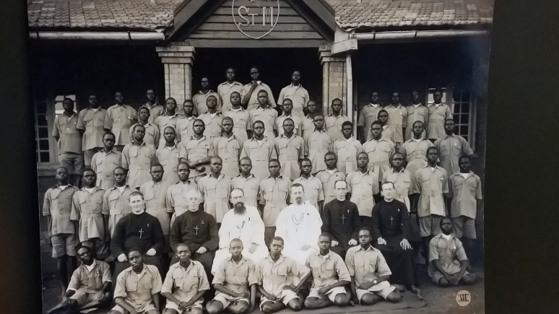
It was on Wednesday, 4th August, that the Missionary Brothers boarded the Mission Lorry from Entebbe for a Twenty-minute Drive to Kisubi White Fathers Mission. They were warmly received by Father Edward Michaud and Fr. Jean d’Arcy Nadon. That same day, they were shown around St. Mary’s College and on 6th August Fr. Edward Michaud, who was the Headmaster at the time of their arrival handed over the School to the Brothers in a Brief but Significant Ceremony witnessed by Fr. Nadon. After, the Handover, Fr. Edward Michaud, (who later was appointed Auxiliary Bishop of Kampala) remained as the School Chaplain, while Father Nadon served at Kisubi Parish.
We would conclude that Part of the Story with yet another Quotation from Brother Eugene’s Communication: ‘‘On the Saturday following Our Arrival, i.e., 7th August, we consecrated Our Mission to the Sacred Heart of Jesus, to the Blessed Virgin Mary and to St. Joseph. May that attract many Blessings on Our Work,[...], and to implant Our Congregation in that part of Africa.’’
SOURCES.
MISSION DE L’EST-AFRICAN -Uganda, Tanzania, Seychelles, September 1966, pp. 3 -6
FIFTY-SIX YEARS IN EAST AFRICA, ESP. PP. 11-12
THE BROTHERS OF CHRISTIAN INSTRUCTION IN EAST AFRICA, 2000, pp. 14 – 16.
75th PLATINUM MAGAZINE, 2001, p. 14.

