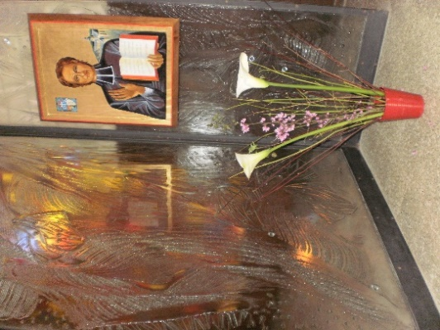
MENNAISIAN MONTHLY NOVENA
DECEMBER 2023
- APPLICATION NEWS
CONGRATULATIONS to all the Mennaisian Animators for the Animation of the Great Novena of November: we were able to admire the Splendid and Prayerful Mennaisian Homes, Places of Prayer, Meditation and Meetings. You also presented many Intentions through the Intercession of the Father: Sick people, Vocations, Families, The World of Young People... Continue with this Momentum in your Devotion to Father de la Mennais. You can report some Stories of favors received: in Family, at School, in your Environment... We could make them known.

- ENZO CAROLLO'S HEALING RESUMES
- The Postulation began to work in Two Directions. First, it is obtaining Accounts from Four Doctors Specializing in Infections, to respond to the Objections of the 2016 Medical Commission. Second, it has asked the Brothers of Argentina for Documentation on the General Situation Current Work of Enzo C. The Research is already well Advanced.
- We continue to prepare the Files to explore a Possible Holiness to be recognized by certain Brothers. Everything is still at the Informal Level.

- INTENTIONS
- We pray for our General Chapter, now close: so that the Mennaisian Family becomes ever more, like Mary, Servant of Hope.
- For Mennaisian Vocations; so that they can give their contribution to the Christian Education of today's Young People and Children.
- For the PEACE Announced by the Angels in these difficult days, especially for Children in Countries of War for a long time.
- For Patients Recommended:……………………………………………………
- FAVORS RECEIVED
(IN THE COLLECTION OF BR JEAN-CHARLES BERTRAND):
HEALING OF BROTHER LUBIN in SENEGAL
Brother Lubin had pricked the thumb of his left hand with a date thorn. The thumb swelled to a worrying extent and this swelling was accompanied by intense pain which caused him Continuous Insomnia. Sleep became impossible for him for several nights. He was transported to the Military Hospital in Saint-Louis, Senegal. He remained there for several days, but, despite the care of Doctors, no improvement was seen. The Doctor opened the Abscess which had formed several times and removed a large quantity of Purulent material. Nothing better had yet appeared. The arm became very large and blackish. The thumb especially was very black. One Evening, the Doctor came to see the patient and said to him: “I think we will have to cut off your arm to prevent Gangrene from setting in the rest of the body”. At the Saint-Louis School, when we learned of this decision of the Doctor, all the Brothers were extremely moved, and, that same Evening, began, with their students, a Novena to Father de la Mennais.
The next day, the Brothers went to the Military Hospital to see the sick man and learned from his own mouth that around Nine o'clock, the previous Evening, an improvement had suddenly occurred and that the sleep, which had fled for a long time, had returned. This Sleep had been Extremely Restorative. Now it was precisely the time when the Brothers and all the students of the School had begun their Novena. When the Doctor came to pay his visit in the Morning, with the intention of attempting the Operation, he found that the patient was much better and that the Operation was no longer necessary. Progress was continuous since then and, after a few days spent in the Hospital, during which the healing was almost complete, the Dear Brother returned to the Saint-Louis School and immediately resumed his Ordinary Occupations.
SOURCE Collection FAVEURS, Br. Jean-Charles Bertrand p. 30 (ARHIVES FIC Rome)

- HISTORY OF MENNAISIAN DEVOTION:
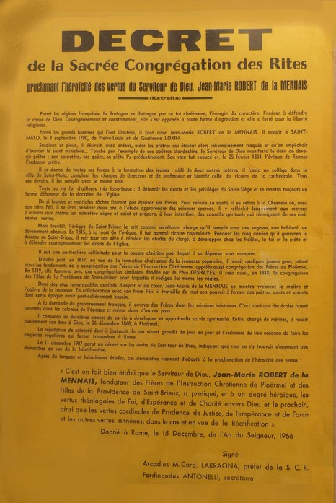
THE PROCLAMATION OF THE HEROICITY OF THE VIRTUES IN 1966
Six years after the Great Celebrations of the Centenary of the Death of Jean-Marie de la Mennais, the Mennaisian Congregations were able to celebrate another Great Event: The Proclamation of the Heroic Virtues of the Founder. We know that the Cause of Jean-Marie risked being blocked definitively in 1946. The more Serious Objections concerned Jean-Marie's relations with his brother Féli, the Tensions within the Congregation of Saint-Pierre with Priests, relationships with certain Bishops. The response to these Objections was entrusted to the Historical Section Chaired by the General Rapporteur, Mgr Frutaz. The latter, working in concert with the Postulator, Brother Hippolyte-Victor Géreux, had carried out Meticulous and Complete Research. Finally, he had composed a Large Volume of around 700 pages: the “Summatium Additionalis”. The result was Jean-Marie's absolute fidelity to the Doctrine and Authority of the Church, while observing fraternal affection with his brother and respect for Ecclesiastical Authorities. Brother Hippolyte had helped Mgr Frutaz to the end of his strength. He was replaced by the new Postulator, Brother Gabriel-Henri Potier.
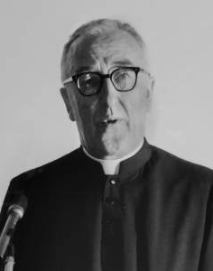
On June 21st, 1966, the Preparatory Meeting opened in Rome in the presence of Pope Paul VI. Present for the Institute was the Superior General, Brother Elisée Rannou. This time the Agreement on the Judgment of Heroicity of the Virtues was Unanimous. One of the Consultors confided to Brother Elisée: “I knew Féli, but I did not know that he had such a brother. We must exalt his Virtue, spread his Story: a man Admirable in his Loyalty to the Church. For him it is not his person that counts, but only Christ and the Church”. Bishop Frutaz reveals that the Pope ordered the immediate preparation of the Decree of Heroicity.
Six months later, on December 15th, 1966, the General Congregation for the Proclamation of the Decree of the Heroicity of the Virtues of 6 new “Venerables” took place [This Title - according to the New Legislation is now reserved for those who have Obtained Recognition of the Heroicity of the Virtues]. The Postulators are summoned to the Vatican, in the presence of the Cardinals and the Pope. “After the Veni, Sancte Spiritus, begins the reading of the Decrees of Venerability, illustrated by a short Biography. Paul VI spoke with each Postulator in a Family Manner, finally he gave his Blessing.” (Bro. Potier) In the Decree we can read: “Clearly appears the practice of the Theological virtues of Faith, Hope and Charity towards God and towards one's neighbor, as well as the Cardinal Virtues of Prudence, Justice, Temperance and Fortress and other Virtues, by the servant of God, Jean-Marie Robert de la Mennais, Founder of the Institute of the Brothers of Christian Instruction of Ploërmel and the Daughters of Providence, to a Heroic Degree. This Decree is of Public Law and must be Recorded in the Acts of the Sacred Congregation of Rites”.”
Mgr Frutaz
This Solemn Proclamation constituted the last stage of the Cause of Beatification entrusted to the Direct Work of the Church. From now on we had to pray to ask for the Direct Intervention of Divine Providence (a miracle) through the Intercession of the new Venerable. There was great exultation in the Mennaisian World, but also throughout Brittany and in the World of Christian Education. We witnessed a flowering of Celebrations of Recognition and Praise of God, faithfully recorded in the Chronicle and in the Courier of the Venerable. We review a few of them.
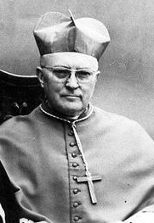
- April 23rd, 1967, in St-Malo, birthplace of Jean-Marie, Mgr. Gouyon, Archbishop of Rennes, celebrated a Solemn Mass at the Cathedral: he praised his Heroic Virtues, from the first years under the Revolution, and his Undertakings in favor of Childhood and youth. The French was represented by Mr. Yvon Bourges. The Newspaper “Ouest-France” wrote Government: “May the Echo of this Enthusiasm not be extinguished following this day of Thanksgiving, but may it inspire confident Prayers to obtain his Beatification”.
- May 8th and 12th, in St-Brieuc, Bishop Kervéadou payed homage to the former Episcopal Vicar in “his” cathedral. Among the Daughters of Providence, Father Chevalier extoled the Heroic Virtues of the Founder.
Mgr Gouyon
- May 15th in Derval (Loire-Atlantique), Bishop Mgr. Vial celebrated an Open-Air Mass with the Artistic Participation of Young People in Training.
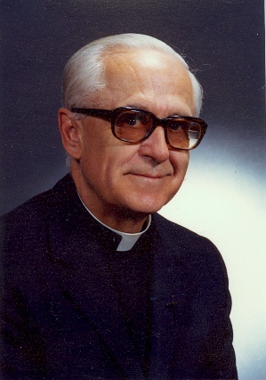
- June 8th, in Ploërmel, Motherhouse of the Brothers, the Bishop of Vannes, Mgr. Boussard Solemnly read the Decree of the Heroicity of the Virtues at the Chapel, which had become too small for the Occasion. Followed a Series of Speeches, Sporting Events, a Visit to the Large Park and especially to the Monumental Clock.
Celebrations are organized all over the Mennaisian World.
- CANADA: September 17th, 1967, Mgr. Pelletier celebrated the New Venerable at Pointe-du-Lac: Mass, Reading of the Decree, Perpetual Professions, Country Meal, Offering of the Spiritual Bouquet. In La Prairie, November 5th, Mgr. Coderre celebrated Thanksgiving for the Heroic Virtues of Jean-Marie: “a Priest who accomplishes his Mission in the shadows, without sparing himself; he persevered in the fight for the good of youth, despite persecution and misunderstanding.”
Mgr Coderre
- Throughout the Institute, Celebrations, Prayers, Artistic Sessions, Sporting Events, Vocational Activities were repeated: in Spain and South America, in the African Missions, in Alfred (USA) and in Haiti, in the Small Districts of Tahiti, England, Italy.
- THE DAUGHTERS OF PROVIDENCE participated in Celebrations in Europe and Canada. “We experienced unforgettable days, under the watchful eye of our Father. His Spiritual Attraction is still strong, as in the time of his ardent life on Earth. The Teachers and Students have splendid Memories of these days and confide to the Father their Dearest Intentions.”
We can conclude that this Fundamental Stage of the Cause of Beatification of Father de la Mennais was celebrated throughout the Mennaisian Family in a Conscious and Solemn Manner. This Happy Event was a gift from Providence to strengthen Devotion to the Father and to give New Impetus towards holiness to all the members of the Mennaisian Institutes. It will constitute a Providential Preparation for the difficult times, for the Church and the World, which would present themselves shortly and which would have required true Heroic Virtues to face them.
SOURCES. FIC Chronicle 1966-1967 /Le Courrier du Venerable 1966-67
- TRACES OF HOLINESS IN THE MENNAISIAN CONGREGATIONS:

BROTHER NORMAND BERGER, USA – CONGO (1948-1989)
Normand Berger lived his childhood in the period of Euphoria which followed the end of the Drama of the Second World War, in his Country: the USA. Now it was necessary to return to the path of Peace, Economic Development, and Social Coexistence throughout the World, for which the United States had taken the role of guide in the West. During these years in the USA and Canada there was a Climate of Serenity and Fervor: Large Families, Intense Work, rooted Christian Traditions, Confidence in the future. The Mennaisian Congregations were also experiencing a moment of expansion: Abundance of Vocations, New Foundations, Missionary Openness, Fervor in Formation and in the Apostolate.
The Young Normand attended his father's same School in Prévost, revealing the same qualities and achieving the same successes. He continued his studies, almost naturally, at the Brothers' Juniorate in Alfred (Maine, USA). He continued his Secondary Education at Lycée St-Louis in Biddeford. Then in 1967, he entered the Novitiate at Alfred, the Motherhouse of the American Mennaisian Brothers. Here Brother Normand could live years of Serenity and Quiet Spiritual Growth. His character, rather reserved, does not lead him to Noisy and Chaotic Demonstrations. His master, Br. Eugène Belisle, notes his attitude to Meditation, his attention to Catechism, the precision of his Spiritual Notes, his Predisposition to put himself in Service. In his Choices and his Judgments, he always refers to the Gospel.
At the end of the Novitiate, he completed his studies at Walsh University (Ohio). But here he does not find Alfred's Atmosphere of Peace and Contemplation. These were the years of Protest, of Pacifism, of the Great Demonstrations against the War in Vietnam, of Disorder and Revolt even within the Church, of the Departure of so many Consecrated Persons, of the Vocations Crisis... Normand, by his character, but also by his Spiritual Instinct, did not share this Atmosphere. The behavior of a few Scholastics who allowed themselves to be influenced by a certain climate of disaffection surprised and impressed him. He continued his Training faithfully in the Institute and decided to dedicate himself to the Disciplines where he felt inclined, Mathematics and Physics, in which he made rapid progress. However, one fear casted a shadow over his future. He wondered if his Vocation was really in Teaching. In fact, he was not comfortable in a Class, which could put him in difficulty, given his reserved character, who did not want to impose himself with Authority. In fact, his first two years at Louisville High School were a period of great suffering and little Enthusiasm: he did his duty, but “dragging his feet”.
RADIO-ALASKA MISSION
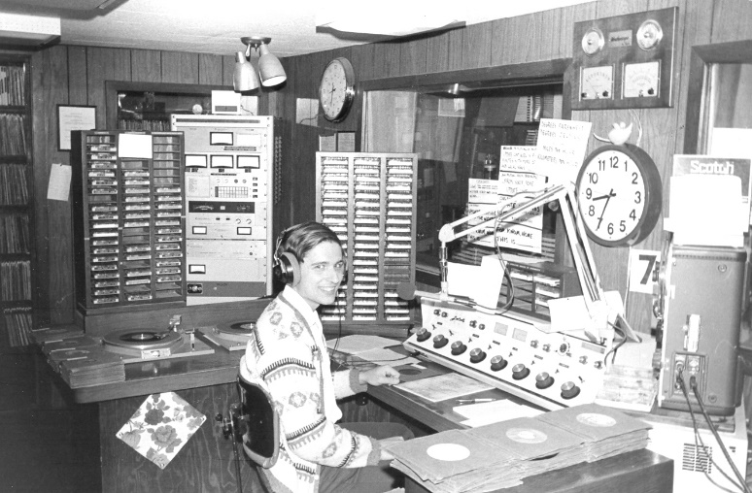
Bro Normand Berger in Nome
The Superiors realized this difficulty. Bro. Normand was sent to the University of Akron to improve his skills in Math and Physics and at the same time he participated in Teacher Training in Canton. During this period, he sought a more suitable Apostolic Orientation. He suggested to the Superiors to go on a Mission to Alaska, Fairbanks, Nome, to work in a Radio Station. It was a Catholic Broadcaster, which operated in a difficult context: Alcoholism, Depression, Suicide Attempts. Bro Normand became a Radio Technician, responsible for Programs and Information Services. Radio “Knom” became the reference point for Religious Entertainment, Information and General Culture in Western Alaska. Very early on in Nome, a small Community of Brothers was formed: Brother Normand on the Radio, Brother Albert Heinrich for Religious and Parish Services, Brother Raymond Bérubé for Reception and Community Services. For ten years, the Community led this Mission: it adapted very well to the Population, forged bonds of friendship with the Eskimos, and Evangelized in Union with the local Church. Bro Normand was at ease: he transmitted live from 7 p.m. to Midnight. During the day he prepared the News and supported the other Presenters. These were years of Spiritual and Apostolic Fruitfulness. He gave so much, but also received so much: “I learned a lot about Life, about Myself and about God.” He entrusted himself to the Lord who always accompanied him and directed him. He was happy in his Community with the other Brothers, but he also knew that this experience could only be temporary.
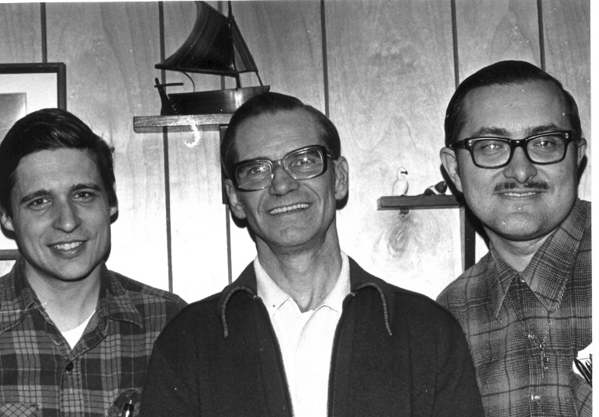
Brothers Normand Berger, Raymond Berube and Albert Heinrich
IN AFRICA: MISSIONARY IN CONGO
Now Brother Normand was called to a new field of Apostolate. During the ten years in Alaska, he obtained a Private Pilot's License, to accompany passengers in the Immense Solitudes of the Arctic. In Africa, the North American Brothers had opened a New Mission in the wide-open spaces of the DR Congo: they needed Radio Specialists, Mechanics and Pilots. Brother Normand saw the finger of God in this call. He followed a very Specialized Course as an Airplane Pilot for 18 months, he acquired Several Flight Certificates in the “Wings of Hope” Organization. He perfected his French in the Communities of Quebec.
In April 1987, he went to Dungu, in Northwestern Congo. He was responsible for the services of Radio Technician, Mechanic and Pilot in the NGO Association “Avions-sans-Frontières”, supported by the Canadian Government. The beginnings were difficult: there was a delay in giving him his Pilot's License and the Equipment for the Radio arrived very slowly. Brother Normand was not discouraged: he enthusiastically joined the Community of the Brothers of Dungu. Everyone was struck by his Religious Spirit, by his commitment to Technical Activity and by his Humor in getting by with expressions of the French Language. He won the esteem of everyone, thanks to his competence, but also to his patience and his Spirit of Delicacy and collaboration.
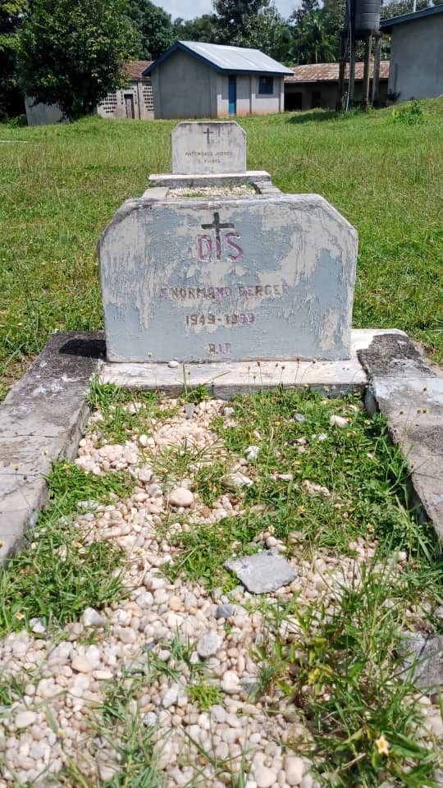
In Dungu, in addition to Ordinary Services, “Norm” (his battle name) began a New Activity, in full line with the Mennaisian Mission: A Modest Electrotechnical Professional School. The students were his Congolese collaborators. To give them serious Professional Training, he set up an Electronic Devices Laboratory. “In this Workshop they could Store and Repair Transmitters and Receivers, which have become essential in a Region without Telephone, Poor in means of Postal Communication, where every Trip is an adventure.” The small School grew: he took on a few Apprentices whom he trained little by little, and who would become his Helpers and, eventually, would succeed him. He also received three young African Brothers, who arrived in Dungu in September 1988: he introduced them to Technical Work and helped them to improve their English. Very soon they would become his great friends. Bro Normand lived happy days in Dungu: he became more “Congolese” every day, even if there was no shortage of difficulties. It went from the Frigid Climate of Alaska to the Scorching Tropical one. He was not used to African food. He had little resistance to Malaria and, what was more, was allergic to some of the best remedies for this Disease. Nevertheless, he felt happy to belong to such a Generous Community and a Quality of Life of Prayer and Warm Fraternal Support, which he highly appreciated. He knew that his Technical and Professional Services made a valuable contribution to the Mennaisian Mission of the Vice-Province and also to the Local Ecclesial Community. It was already developing important Projects to improve Communications. In particular he was thinking of establishing a New Base for Avions sans Frontières in Mahagi, near the Northern Ugandan Border of Lake Albert. Bro Norm spent a moment of cloudless serenity, fears and doubts had dissipated. The certainty that drove him to make, where he was, a quality contribution gave meaning to his deprivations and his life in the bush. With his Brothers, he raised a Song of Thanksgiving to the Lord.
THE TOTAL DONATION
“Watch: The Kingdom of God is coming like a thief.” It was not in the Middle of the Night, but in the fullness of Apostolic Fervor and Interior Peace, that Brother Normand heard God's call. He was forty years old, he was in the full vigor of his strength: he could still do a lot of good; but the Lord, in His Mysterious Providence, asked him for another Testimony. That day, February 16th, 1989, he was in the Cockpit of a CESSNA for an almost Routine Flight. It carried two Missionary Brothers: Brother Robert Duchesneau and Brother Rémi Claveau; they were accompanied by the Brother Provincial, Brother Lucien Baffaro and a couple of Dutch lay people. For reasons unknown, the small plane crashed into the side of the Nyaragongo Volcano and fell to the ground. No one survived. Apparently, it was a tragedy which took away living strength from a Mission full of promise and which tore away righteous people from the affection of their loved ones. But God had other ways, even if they were not immediately understandable. The New Provincial, Brother André Bellefeuille, gave this interpretation dictated by faith: “We think that our Brothers stopped on their way, that they remained there, behind us, immobilized in implacable silence. But that's not how it is. The last act of their existence projected them forward. Now they are with Jesus, they go before us, they call us, they attract us with all their strength towards the Kingdom. The message they were to announce, they addressed to the Mountains, across the African Sky, all at once, with a loud cry, as Jesus did on the Cross, at the moment of death. After this gesture, everything is accomplished. Our poor words add nothing. “There is no greater love than to lay down your life for those you love.” Through the Eucharist, the Lord transfigures our very dead into powers of life. The grain of wheat thrown into the ground dies to germinate and become an Abundant Harvest.”
It was not easy for the Missionary Brothers, for the Young Province of Congo, for the family members of the victims, to absorb the pain and the precious contribution of the deceased Brothers. At the same time, this tragedy was an opportunity for New Impetus for the Canadian and American Provinces and for the Entire Institute, particularly for the Missions. The Brother Provincial could conclude: “Through this sacrifice, united with that of Jesus, may God ensure the preaching of the Gospel on all Earth. May He bless the efforts that we will double. May He raise up New Workers for His Harvest. Finally, may this Ordeal strengthen the Fraternal Bonds that already unite us. Once these Tombs are closed, a Great Job awaits us. Like those who left us, we are all sent, all Missionaries.”
The four Brothers rest in the Regional FIC Cemetery in Dungu. The Testimonies of affection and gratitude received by the Missionary Brothers, by the Province of Quebec, by Avions sans Frontières, by the USA Motherhouse of Alfred, were extremely numerous and impressive. A particular closeness linked Bro Normand to the Local Population: he had become so integrated into Congolese life that he was considered one of them. Brother Patrice Ménard, Author of a Biographical Reconstruction on Brother Normand Berger, expresses this conclusion: “Incomprehensible and Inadmissible Tragedy, from a human perspective! Mission accomplished and significant, however in the eyes of God!”
Tomb of Brother Normand Berger in Dungu
SOURCES:
MENOLOGY VII p. 2714-2717 by F. Patrice Ménard
FIC ROME ARCHIVES: Biographical Sheet
“F. Normand Berger” / CARTON 412/4 RD CONGO

