**MENNAISIAN NOVENA**

**JANUARY 2025**

***Pilgrims on the Path of Prayer***

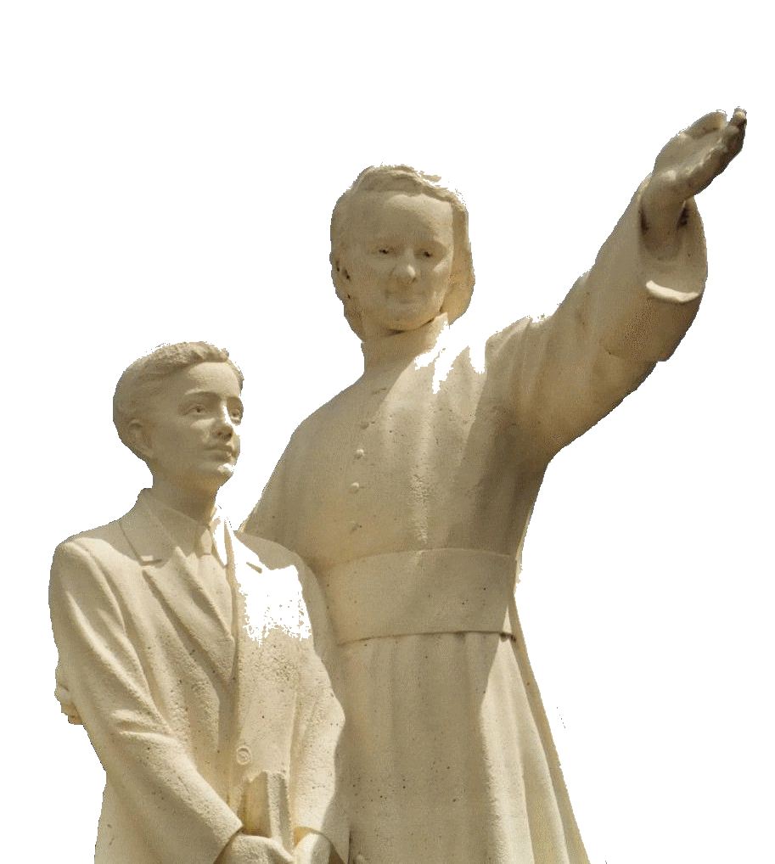

1. **POSTULATION NEWS**

**A “LITTLE HOLY FAMILY YEAR” IN THE GREAT JUBILEE OF THE CHURCH**

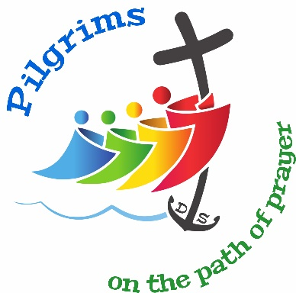The year 2024-2025 marked an important date in the History of the Cause of Beatification and Canonization of Our Father Jean-Marie Robert de la Mennais. On October 7th, 1899, the Tribunal responsible for instructing the Beatification Process of Our Founder was constituted, Presided over by the Bishop of Vannes, Mgr. Latieule. That Process, called Informative, held 86 Sessions and heard 26 Witnesses who made 55 Depositions, from October 7th, 1899 to August 29th, 1901. The Documents of the Process, comprised more than Two Thousand Pages, were taken to Rome by Brother Abel Gaudichon, Superior General, and given to the Congregation of Rites, which was then dealing with Canonizations. It has been 125 years since the Cause of Jean-Marie began; It would therefore be a Small Holy Year that would be inserted into the Great Ecclesial Jubilee of the Church. One more Motivation that would be added to the Prayers, Celebrations and Pilgrimages that Pope Francis invited us to live.

**WHAT ABOUT THE CAUSE TODAY?**

We should have reached an Important Moment. Dr. Cauda du Gemelli, an Internationally Renowned Specialist in Infectious Diseases, had updated his Expertise (in favour of the Resumption of the Cause of Enzo Carollo) and added Significant Elements.

The Neurologist, Professor L. Massimi, was now collaborating with the Two Infectious Disease Specialists, Dr. Scoppettuolo and his Colleague from the Gesù Bambino Pediatric Hospital, Dr. Andrzej Krzysztofiak: They would have developed a Joint Expert Report in January.

**“HOLY” BROTHERS**

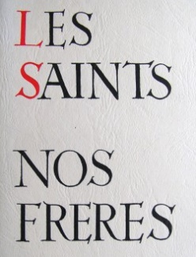We certainly have Holy Brothers in the History of Our Institute. Some have left important, even Heroic Traces of their Virtues, to the point of giving their Lives and even Martyrdom: They were very well known in the Oral and Written Tradition of the Congregation. It would be better if they were better known, for the Spiritual and Vocational Growth of Young People. The Great Obstacle to introducing their cause is the Search for a Reputation for Holiness: especially in the Places where they Lived and Worked. I ask the Brothers who could accomplish this Task (Difficult, Patient and Delicate) to dedicate themselves to it a little, to make these Beautiful Lights shine in order to enlighten especially Our Young People. We already have a Historical basis for Brothers Zoel Hamon, François Cardinal, Hyacinthe Fichou and now Constantin-Marie Roulin.

1. **PRAYER INTENTIONS THROUGH THE INTERCESSION OF THE FATHER**

The Mennaisian Animator Brothers have done a great job during the November Novena. They followed the Intentions of their Regions that have communicated to them. We also received News with Beautiful Images on the Mennaisian Initiatives, especially from Spain, Mexico, Indonesia, Rwanda and Congo: Buds full of Hope!

We particularly recommend the Three Brothers who would soon begin the New Mission in Timor-Leste: we asked for them a Holy Beginning, in a Context of Peace and in the Tradition of fervour of Our Missionaries.

In Next Month we continue to pray for little ***Tommaso*** (he is almost out of danger) and ***Alessandro*** (he is better), for Mothers ***Liliana*** (she died, after having lived one more year than the Doctors expected) and ***Caroline***, for Fathers ***Giuseppe*** (Cancer), ***Sergio*** and ***Massimo***; Irene (young girl, Anorexia); the other Intentions indicated by the Local Animators.

1. **FAVORS RECEIVED THROUGH THE INTERCESSION OF THE FATHER**

That was a beautiful Testimony expressed with candid confidence in the Intercession of Father de la Mennais.

Willimantic, Conn. USA, 455, Ash St, 1977

*“I am Mrs. JP Bovino, born Marie-Rose Lambert, niece of Br. Alfred-Marie (Donat Lambert), deceased at La Pointe du Lac, brother of my father.*

*I do not know if Venerable Jean-Marie de la Mennais would one day be canonized. For that purpose and to respond to a pressure of conscience, I would relate to you Three Special Favours, Extraordinary Healings obtained through the Intercession of that Great Servant of God.*

*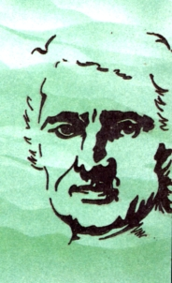First of all, it was a Favour to me, a Healing that was considered Miraculous at the time it took place. When I was 6 or 7 years old, I was struck down with Whooping Cough. I was very ill for several Weeks. In the last days, I coughed terribly, even spitting up Blood during these Exhausting Coughing Fits. The Doctor who was treating me finally warned my Mother that I had reached the very end of it and that I would probably not survive until the next day.*

*We had in Our Family the Image of the Venerable Jean-Marie de la Mennais and we all had an Extraordinary Confidence in his Powerful Intercession with God. In the Evening, when the Doctor informed my Mother that it was the end, that I would not survive the night, Mother was so upset that she forgot the Image of the Venerable de la Mennais. I was coughing so much that I could not sleep. Suddenly I remembered that they had forgotten to place the Image under my Pillow. I called my Mother, who was busy with the other children at the time, “Try to take the Image yourself and ask for your Healing”. I was very weak and that simple gesture was almost impossible for me to do. However, I succeeded and, holding the Image in my hands, after kissing it, I asked the good Father to obtain my healing from God. I placed the Image under my pillow and fell asleep immediately. I did not cough again during the night, which also relieved my Father and Mother, who took their turn to watch and comfort me. The Next Day the Doctor came as usual and found me sitting in my bed, smiling, holding the Image of Jean-Marie in my hands. I was cured. The Doctor affirmed that this was a Miracle, because he was firmly convinced that I did not have the strength or the resistance to undergo other attacks.”*

*On Another Occasion, it was my sister who was struck down with Pneumonia. She was ill and caused us much worry. We turned again to Father de la Mennais and, thanks to his Intercession, we were heard again.*

*Later, at Our Neighbours, it was the father of the family who suffered from the same Illness. The Doctor had almost abandoned him, so convinced was he that he could do nothing more for him. It was then that Mother gave the Picture of Jean-Marie de la Mennais to that Grieving Family and invited them to have a lot of confidence and especially to Pray with Faith so that he would Intercede with God. And it was Healing again, to the Doctor's Great Astonishment*.” (SOURCE: F. Jean-Charles Bertrand, Collection of Favours attributed to Father de la Mennais, pp. 61-62)

1. **JUBILEE PRAYER PILGRIMAGE 2025**

**3- THE YOUNG SANCTUARIES OF THE VIRGIN IN WEST AFRICA: SENEGAL, IVORY COAST, TOGO, BENIN, AND THE BROTHERS**

The youth of Christianity in Africa was not only a question of age: youth of Religious Practice, of Consecrated Vocations… We perceive the enthusiasm of Liturgical Assemblies, the Generosity of Community Initiatives, the Fidelity in persecution that reaches Martyrdom. Another sign of that Spiritual Youth was the crowds in the Sanctuaries dedicated to the Virgin Mary that become Centres of Devotion, Conversion and even Ecumenism. These Sanctuaries were rather recent – ​​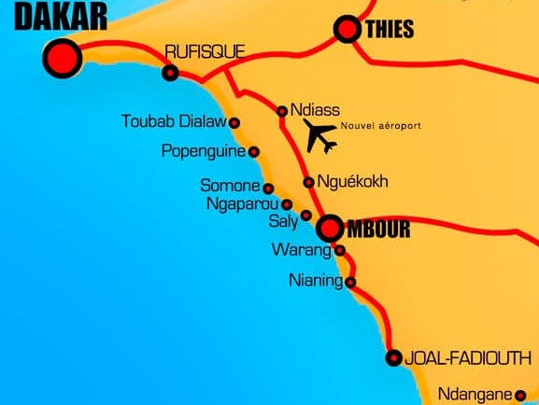Most of them were less than a hundred years old - but they gathered together Innumerable Crowds from their Nation and from neighbouring Nations. Let us see the most important Sanctuaries in the Countries where the Brothers of Christian Instruction are present.

1. **SENEGAL: POPENGUINE: OUR LADY OF DELIVERANCE (1888)**

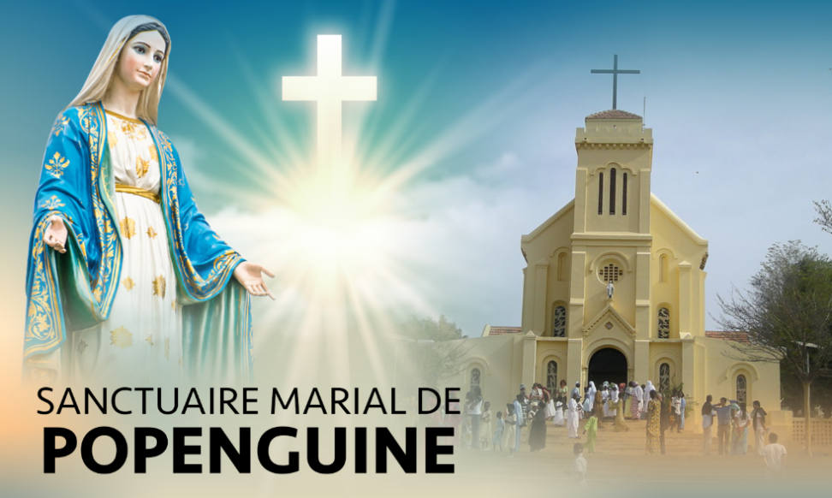Popenguine was a small Centre on the Coast, near Dakar and Thiès. In 1888, the Missionary Fathers of the Holy Spirit began to build a Marian Shrine to venerate the “Black Virgin”. Immediately that Church became an Ever-Growing Centre of Pilgrimage and Marian Devotion for Christians, but also for Muslims. Pope St. John Paul II, in his 1991 visit, gave the Church the Status of a Minor Basilica and the Mission to become a Centre of Dialogue between Christians and Muslims and a Meeting Place between North Africa and Sub-Saharan Africa. To accommodate the Masses of Faithful who filled the Sanctuary during the Feasts (especially on Whit Monday), a Huge Reception Centre was built, which had 30,500 Seats and a Large Lourdes Grotto. Currently Popenguine is recognized as a National Sanctuary by the Conference of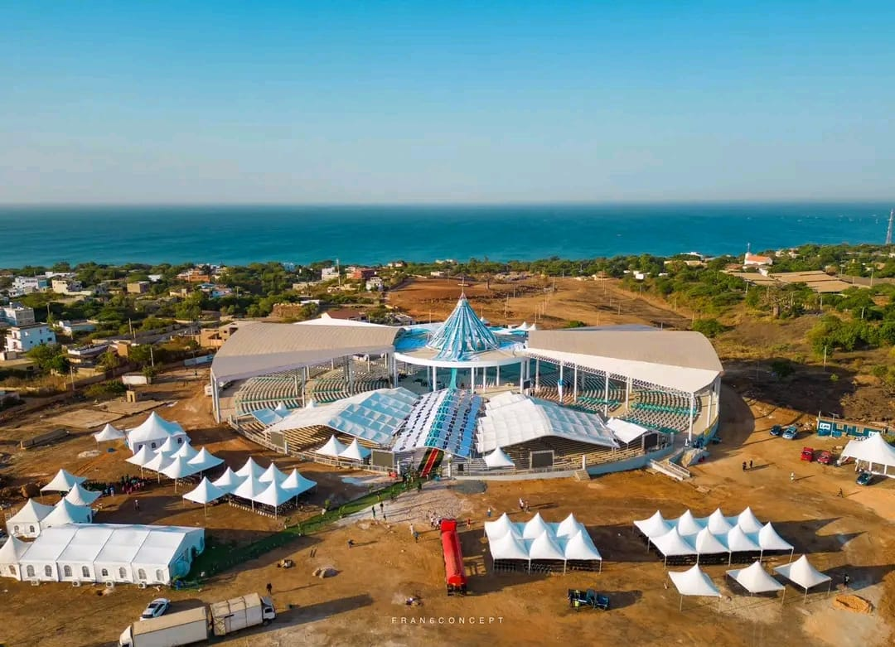

**New Sanctuary of Popenguine**

Bishops of Senegal, Mauritania, Cape Verde and Guinea-Bissau. From that Land, which preserves the Memory of Slavery, the Church invoked Mary, Our Lady of Deliverance. “May She deign to Intercede to deliver us from the Slavery of Sin and draw us towards that of Freedom that Grace and Truth Produce.”

1. **IVORY COAST: ABIDJAN. OUR LADY OF AFRICA, MOTHER OF ALL GRACE (1985)**

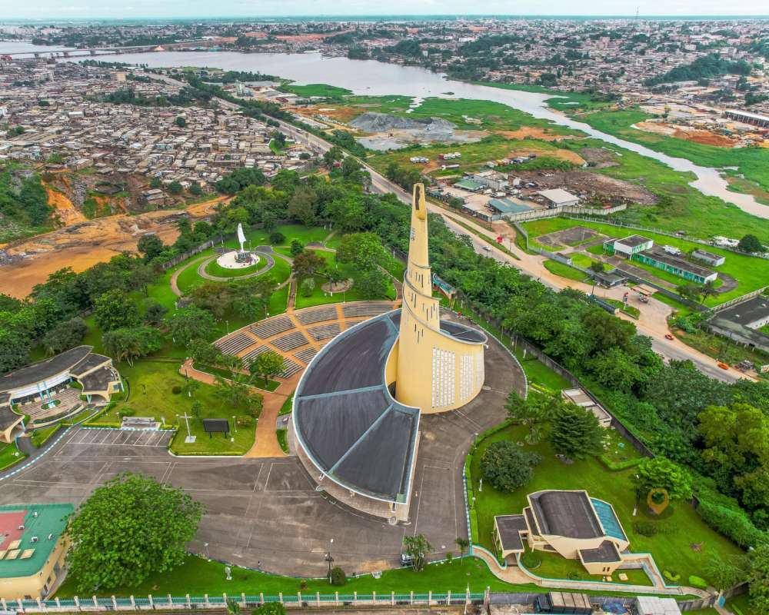As early as 1960, Bishop Bernard Yago, Archbishop of Abidjan, considered it necessary to have a Sanctuary dedicated to Mary in Ivory Coast. Providence would help him. In a District of the City, in Attécoubé, a Church had to be built which the District lacked. Bishop Yago took advantage of the Financial Aid of the President to transform this Church into a Large National Marian Sanctuary. Pope John Paul II visited Ivory Coast in 1980 and blessed the First Stone of St. Paul's Cathedral or the future Marian Sanctuary. He suggested that that Sanctuary be dedicated to “Our Lady of Africa”; Card. Yago added “Mother of all Grace”. In 1985 the First Stone was laid and in 1987, the Marian Year, the Sanctuary was Solemnly consecrated by the Archbishop, in presence of other African Cardinals, Government Representatives and a Multitude of Faithful. Currently its clear and slender Silhouette was visible in the City. In giving the Title of Our Lady of Africa, John Paul II explained: “In entrusting Africa to the Immaculate Virgin, we placed it under the protection of the Mother of the Savior. How could Our Hope be disappointed? How when you invoked her with fervour, would she not lead you to her Divine Son, to the fullness of her Love?” In 2012 the Marian Shrine of Abidjan became the National Marian Shrine.

**The Notre-Dame-d'Afrique Sanctuary in Abidjan - Baab**

1. **TOGO: TOGOVILLE (ANEHO) OUR LADY OF LAKE TOGO, MOTHER OF MERCY (1973)**

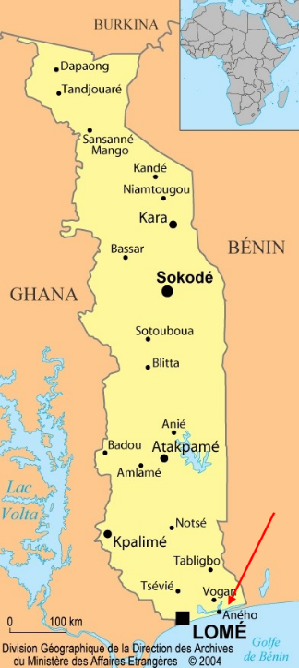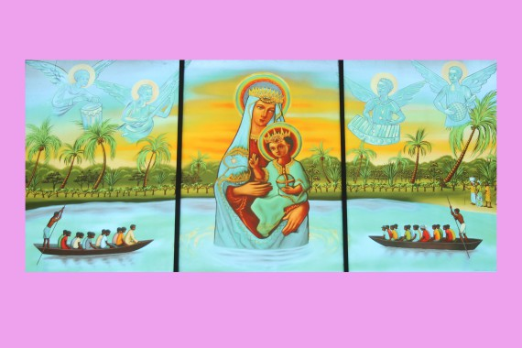Togoville was a Civil and Religious Centre, located on the Banks of Lake Togo. For a long time, the village Purification Festival was celebrated there every three years: a Series of Ceremonies intended to keep Diseases and Evil Forces away from the Village. The Missionaries of the Divine Word, very well received by the Population, built a Church for Christians in 1910. “It was from the observation of what Togoville means to the people that the inspiration came to create a Centre there that would also be a point of reference for Christians, a place of Piety: why not transform the Church into a Sanctuary dedicated to the Mother of all Mercies?” An Italian Artist (Michelini) was asked to paint a Picture of the Virgin to be placed in the Sanctuary. After a long preparation, which included the Veneration of the Image in all the Parishes on the Coast and in the Capital Lomé, the Icon was accompanied from the Cathedral of Lomé to Togoville. Here was the description from the Togo Press Newspaper of November 5th, 1973: "4,000 Participants at the Enthronement Ceremony. Togoville was the Scene of a Historic, Religious and Christian Event. A crowd of Pilgrims from Togo and Abroad attended the Solemn Enthronement of Our Lady of the Lake, Mother of Mercy, which took place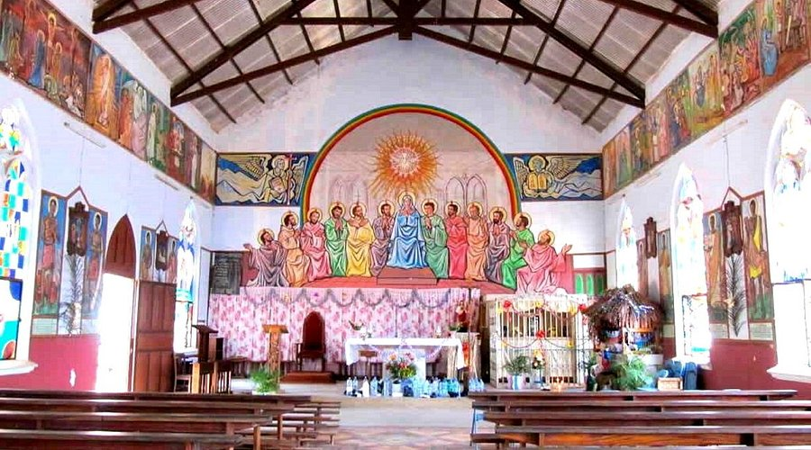

**OUR LADY OF LAKE TOGO CATHEDRAL**

*after the Concelebrated Mass in the Open Air, presided over by Dosseh Anyron, Archbishop of Lomé. The Ceremony was delayed by three hours because of the Mass of the Faithful who came in Greater Numbers than expected… The Arrival of the Holy Virgin on the Bank of Togoville was an Event. All the Spiritual Leaders and Priests of Our Sacred Forests, as well as the Clergy of Togoville had come to meet Her… Finally, the Holy Image was Solemnly carried to the Chapel, where it was venerated by the Religious and Civil Authorities, the Traditional Leaders and the Frowd of the Faithful.*

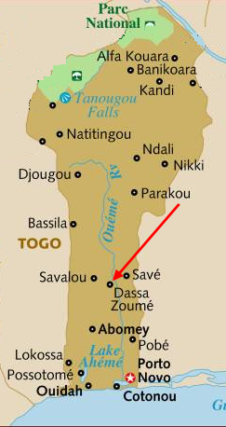From that day on, visits and Pilgrimages only multiplied. In 1985, Pope John Paul II visited Togoville, confirming the Togolese people's belonging to Our Lady of the Lake, Mother of Mercy. Since 1994 the Sanctuary has belonged to the Diocese of Aného, ​​created by John Paul II, who encouraged the Veneration of Her Memory. “O Mother of Mercy, on this day, in this place, we feel the need to take you as Our Mother, so that you may keep us close to Jesus the Savior, ever more faithful in the Service of all his brothers, who are also your children, especially in the Service of the Smallest, of those who know the Greatest Distress.” (John Paul II in Togoville 1985)

1. **THE SANCTUARY OF THE CAVE OF OUR LADY OF ARIGBO, DASSA-ZOUMÉ, BENIN, 1954**

The Grotto of Our Lady of Arigbo is a place of Great Pilgrimages in Dassa-Zoumé, in the South-Central part of Benin. On February 11th, 1954, one hundred years after the First Apparition of Lourdes, the Apostolic Vicar of Ancient Benin, a Fervent Devotee of the Virgin Mary, consecrated the Natural Grotto of Arigbo, placing there a Statue of the Virgin and a Luminous Cross. He established the Pilgrimage of Dassa-Zoumé and made Arigbo a place of Prayer and Marian Devotion. In the Local Language Arigbo means: She who sees everything, like a Mother who watches over her Children and gathers them together. As in Lourdes, many Sick People flocked to the Grotto to receive God's Blessing, through the Intercession of the Immaculate Mother.

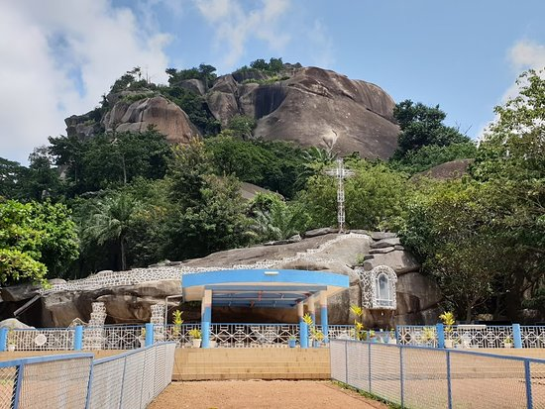Every year, during the Ascension and Assumption Celebrations, tens of thousands of faithful gathered in that Sacred Place. Pilgrims come from Benin, but also from Togo, Niger and Burkina Faso. The Celebrations were presided over by the Bishops of the Catholic Church (for several years by Beninese Cardinal Bernardin Gantin). The Entire Country participated in that Great Celebration and the Civil Authorities were always present. In 1982, Pope John Paul II encouraged the Beninese people to welcome the Christian Faith, which Mary had helped to grow through Pilgrimages to her Arigbo Cave. “The Goal of the Christian Missionaries was to raise up here sons and daughters of the Church, in their own Right, developing their Ancestral Values ​​compatible with the Gospel, and destined to be organized into a Church with their Priests, Nuns, and Bishops.” And Pope Benedict XVI, in the Cathedral of the Capital Cotonou, in 2011, invoked the Holy Virgin whom the Faithful Honor in Dassa-Zoumé: “O Queen of Justice, obtain for us Filial and Fraternal love, obtain for us to be Friends of the Poor and the Little Ones, obtain for the peoples of the Earth, the Spirit of Fraternity. O our Lady of Africa, obtain from your Divine Son Healing for the Sick, Consolation for the Afflicted, Forgiveness for Sinners; Intercede for Africa with your Divine Son; and obtain for all Humanity Salvation and Peace. Amen.”

**The Marian shrine of Our Lady of Arigbo in Dassa-Zoumé in Benin**

1. **THE BROTHERS OF THE SAINT-PAUL DISTRICT: SENEGAL - IVORY COAST - TOGO - BENIN**

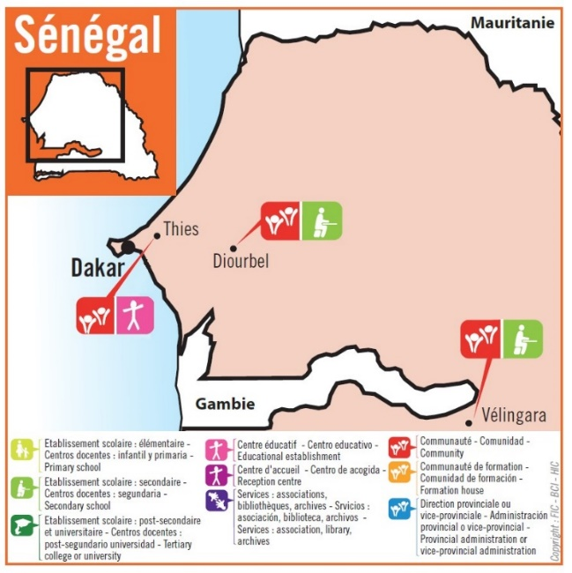

**SENEGAL: 1967**

The First Mission of the Brothers (1841-) had left a Deep Mark and a Memory that has never been extinguished: Founders of Christian Schools, Nurses during Epidemics, Farmers in the Desert, Promoters of Vocations for the Church… In the 1904Cemeteries of Senegal, their Names remain: Liguori, Didier-Marie, Héraclien… In 1904, the Brothers had to leave the Country. In 1967, some Former Students saw “their” Brothers return. It was those from the Nantes District who took charge of that Mission. They opened Schools in Saint-Louis and Diourbel, with the support of the young Brothers who chose Civil Cooperation Abroad. They also founded Experimental School Centres, the “Bush Schools”. They worked for Evangelization in the Service of the Church, in dialogue with other Religions, especially with Muslims. Currently in Senegal there are Ten Brothers in Three Communities, including Two Colleges: Diourbel and Vélingara; in Thiès a Home welcomed young people from Surrounding Villages.

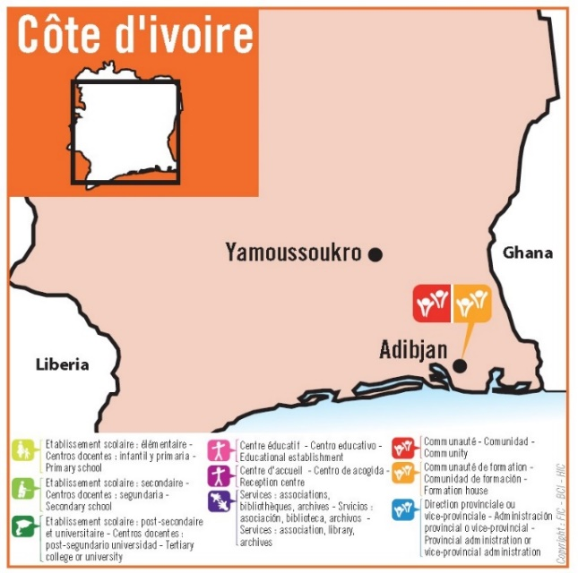

**IVORY COAST**

In 1979, Bishop Agré, Bishop of Man in Ivory Coast, came to Rome to ask the General Council for help in Evangelizing his Young Christianity: The Diocese needed Educational Structures for the Training of a Christian Elite. It was the District of Rennes that responded to that Call. The First Brothers Founded the Lycée Jean de la Mennais which developed, also receiving help from other Confreres and some Daughters of Providence. Currently Ivory Coast has two FIC Communities: they are located in Abidjan and provide Training for the Three Years of the French-Language Scholasticate (Africa and Haiti). They also welcome other young Brothers who are University Students.

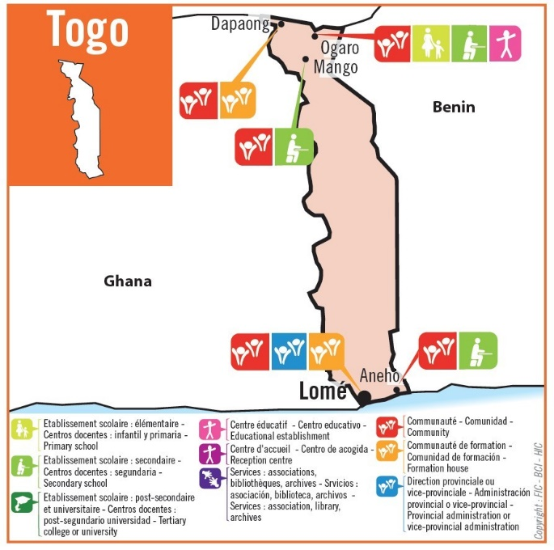

**TOGO**

In 1982, Mgr. Hanrion, Bishop of Dapaong, asked the Brother Visitor of the Quimper District for support in the Evangelization and Human Promotion of his Diocese in the North of the Country, where the presence of Catholics was very low (4%) and people suffered from Malnutrition. The Brothers, once arrived, developed a 90-Hectare Plot of Land and built an Agricultural Training Centre, the CARTO: Tambimong-Ogaro Rural Animation Centre. It would welcome Households from the Surrounding Area to Train them in Agricultural Work: Plowing, Crop Maintenance, Livestock Breeding, etc. During their stay for Several Months, efforts at Instruction and Evangelization would be undertaken. In France, the Association “Les Amis d'Ogaro” actively cooperated in that Project.

Currently in Togo there are Five Communities: in Ogaro the CARTO and the La Mennais School Complex, in Mango the Mgr. Hanrion College, in Aného the St Pierre and St Paul College; in Lomé the District

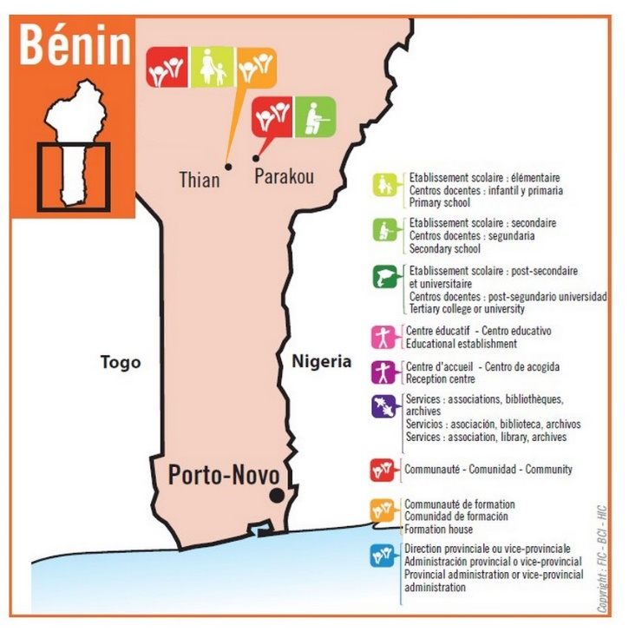**BENIN**

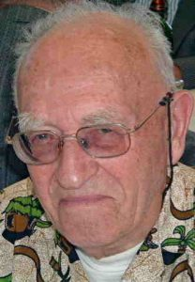In September 1990, Four Brothers arrived in the House; finally, Dapaong: That was the place of the French-Speaking Novitiate (Africa, Haiti). Togo has kept its Promises, which are still destined to bear much Fruit! in Benin and formed a Community in Parakou. They responded to the request of the Bishop of the Diocese, Mgr. Assogba, who was keen to offer young people who had a plan for a Priestly Vocation but who had not been able to follow a Normal Schooling, the opportunity to complete their Intellectual Training before entering the Seminary. “The Harvest is ripening in Our Country. If we wait for another 10 years it would be too late. We lacked Workers!” The Call was heard by the Gabriel Deshayes Province. In the First Community was Brother Yves-Jean Labbé, Former Director of the Scholasticate.

He was 71 years old. A Vast Field of Apostolate opened up to Our Brothers: Catechesis, Ongoing Training, Teaching at the Seminary...

Currently in Parakou the brothers form Two Communities: in Boundarou they run the Catholic College “Les Hibiscus” and in Thian they run the Jean de la Mennais School and are responsible for the Postulate.

May Our Lady of Deliverance of Popenguine, May Our Lady of Africa and the Mother of all Graces of Abidjan, May Our Lady of Lake Togo, Mother of Mercy of Togoville, May Our Lady of the Grotto of Arigbo, Mary Immaculate, always give her Maternal Blessing to that Young Province of the Institute and accompany it in its Growth Full of Promise and Hope!

SOURCES: 150th Anniversary of the Missionary Action of the FIC (Br. Sylvestre and Paquin) / The FIC Chronicle: 1980s-1990s / La Mennais.org: The FIC in the World: St-Paul Province (West Africa) / FIC Directory 2024

