Novena from August 18th to 26th, 2026
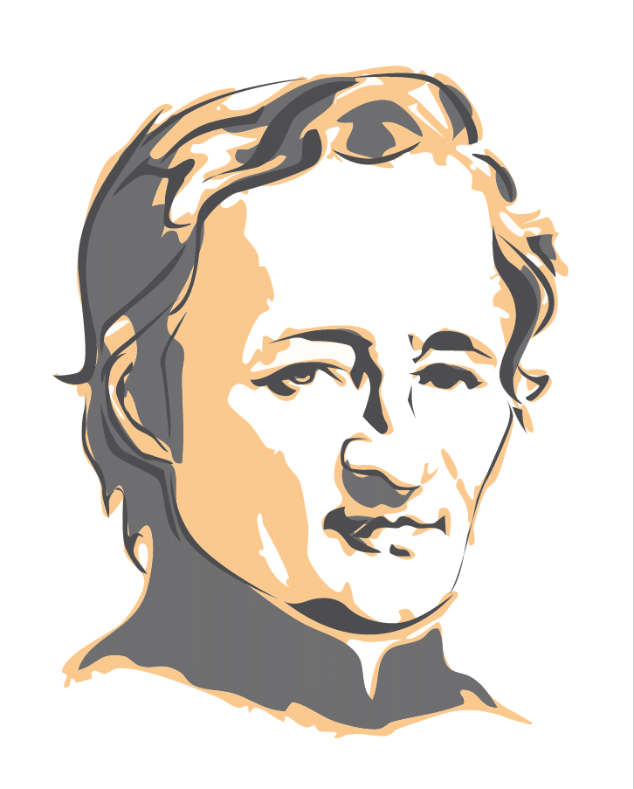

Each Month, we make it Our Mission to pray for the Beatification of Our Founder, Jean-Marie de la Mennais. Through him, we entrust to the Lord the Intentions we have requested. These Intentions come to us from the Districts and Provinces. The representative of each Entity sends these Intentions to the Postulator Brother, who includes them in the Monthly Bulletin.
Do we truly feel personally involved? Have we ever suggested to a Sick Person or someone going through a difficult situation that we pray with them and for them during the Novena?
Gestures and Actions can express our trust in the Intercessory Power of Jean-Marie de la Mennais. We can cite various possible manifestations of our Faith in the Merciful Power of the Lord: contact with the Relic Image, a Pilgrimage to the Tomb of the Father or to a Monument erected in Our Respective Countries. Let us not hesitate to invite and involve the Sick and their Families, Our Students, Our Friends… Why not pray systematically for the Beatification of Our Founder during Our Community Gatherings of Brothers or Mennaisian Families?
There's nothing revolutionary in these proposals! It's about each of us, Mennaisian Brothers and Lay People, committing ourselves personally and with conviction to that Prayerful Approach. That is Our Part: to Intercede! The Lord would answer Our Prayer.
"Oh! If only we knew what faith can do!"
If only we could place Our Trust and Hope in her alone! JMDLM

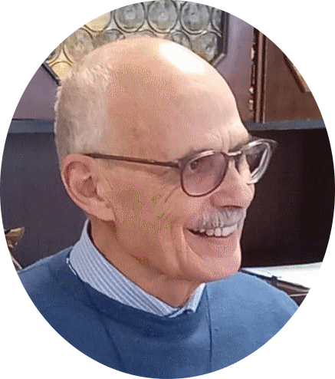
APPLICATION UPDATE (JULY 2026) (Brother Dino)
“At the Dicastery’s Ordinary Congress in June, we obtained access to a New Medical Commission (Consulta Medica). Currently, the Official Printing Office is printing the necessary Copies (about fifteen) for each of the Physicians tasked with studying Enzo Carollo’s Case of Recovery. That File comprises all the Previous Documentation (826 pages!) compiled by Brothers Delfin Lopez and Gil Rozas, along with the Addition of “Favorable” Expert Opinions from the Physicians “on Our Behalf.” Furthermore, during that Period, we have gathered another Report that could provide us with a further Contribution.”
At the beginning of September, Copies would be distributed to the Members of the Commission: The President and Seven Experts. They would have Approximately Two Months to study the Prepared Dossier. On a Thursday in November—the day of the Consulta Medica Meetings—The Commission would Issue its Official Response, in the presence of the Officers of the Dicastery. For the Response to be Favorable, it must have a Clear Majority: at Least Five Out of Seven.
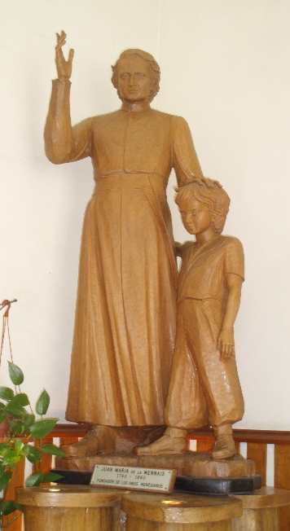
If the Medical Commission's Response is Favorable, it would be followed by a Theological Commission: That Commission would have to verify whether the Healing was obtained through the Providence of God, thanks to the Intercession of the Venerable (Jean-Marie de la Mennais). The Pope's Signature closes the Cause for Beatification. For that to happen...If it comes to pass, you must PRAY and PRAY A LOT! »

The Intentions of the Month:
Recommended Patients:
  - Brother Jean Herbinière, Brothers George Kamanda, Dominic S.Kahangire, Onesmus Mutakirwa,
  - Dario (Leukemia), Gioacchino (Cancer), Dionisio (Circulation Problems),
  - Sandrine (Charcot's Disease)

Note: You'll notice that these Intentions are Identical to those proposed in July! Feel free to suggest New Intentions!

Novena Prayer:
God Our Father, you gave Jean-Marie de la Mennais,
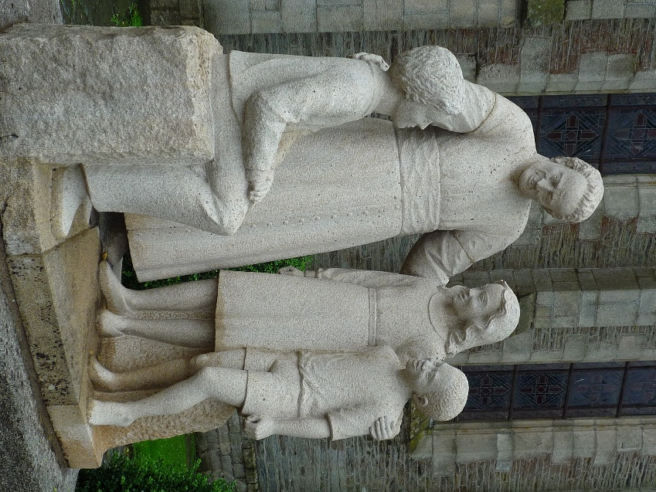
a Generous Heart and an Unwavering Zeal
to make known and loved your Son Jesus and His Gospel.
Grant us to follow his example.
Give us the courage to build united and fraternal Communities.
Help us to proclaim Your Gospel to the youth of today.
For the Glory of your Name,
grant that the holiness of Jean-Marie de la Mennais
may soon be recognised and proclaimed by the Church.

Deign to grant us, O Lord, through his Intercession,
the healing of the persons recommended ...
Through Jesus Christ, Our Lord. Amen.
O Lord Jesus, Glorify your Servant, Venerable Jean-Marie de la Mennais.

