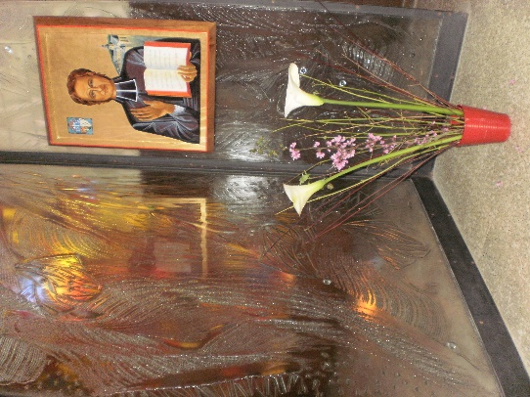
MENNAISIAN MONTHLY NOVENA
MARCH 2023
1-NEWS OF POSTULATION
Some news regarding the holiness trials linked to the history of our Mennaisian and ‘Deshaysian’ Congregations:
- We have practically finished the list of Mennaisian Animators of the Institute. We will soon form a WhatsApp group to set links between the Postulator and the appointed Animators. In this way we will be able to better animate the Mennaisian Devotion, in particular the monthly novena.

- Without anything official, the Postulation is in the process of exploring the life of some Brothers who left a mark of presumed holiness. It is a rather long work of historical research, which aims to give the General Council all the necessary to evaluate a possible request for the opening of a possible Trial with the Dicastery for the Causes of Saints.

- With joy we follow the developments of the beginnings of the Cause of Beatification of our co-founder, Father Gabriel Deshayes. The group of “Gabriel Deshayes’ Friends” brought together the five religious Families which are linked to him and got in touch with the Bishops concerned. We are still in the initial phases, but finally it is on the way: our wishes and our prayers so that the Church may one day recognize the holiness of this Servant of God, who knew how to hide his great zeal by his beautiful humility. Many thanks to the whole Association. The Brothers of Christian Instruction are represented there by Br. Gabriel Rivière, Treasurer and Br. Claude Launay, Secretary.

- The FIC St-Jean-Baptiste Province (France) has made the official request for the transfer of the mortal remains of Brother Ménandre Gortais (see his presentation below) from Paimpol (Côtes-d'Armor) to Ploërmel. This Brother left a special memory of “holiness” in Paimpol, where he dedicated himself to the children and to the whole population, even giving his life during a cholera epidemic. He had been buried in the chapel of Lanvignec. His remains, placed in a box, will be donated by the Commune of Paimpol to the Mother House of the Brothers in Ploërmel. In this way, another faithful and “holy” disciple of our Founders will be highlighted.
2- INTENTIONS FOR THE NOVENA
Let us continue to pray for the intentions recommended to Father de la Mennais:
- BROTHER JEAN-PAUL PEUZÉ: his health is slowly improving. He came out of the induced coma spontaneously. He started to move, talk, feed again….
- Ms. MYRIAM DE COURÈGES: The postulation received these words from her: “I rejoice for Bro. Jean-Paul! May his life be blessed more and more… Here it is not famous. I am in the hospital for a pneumothorax following a puncture. I think I'm moving slowly, but surely towards the last passage. I feel very poor for the meeting that I envisage in faith, but today is rather the night of the senses. Thank you for your precious prayer.”
In South America,
- ARGENTINA: we pray for Griselda Piana, Romina Aguirre, Julieta Peralta
- BOLIVIA: we pray for Azucena TarupalloTejerina e Doris Cuellar Becerra, di San Borja
- CHILE: Viviana Teresa Maldonado Canas
All of these people are affected by cancer.
- ITALY: we continue to pray for Massimo Mensurati, father of three children, recovering from a stroke and for Giuseppe: 11-year-old child treated at the Children's Hospital “Bambino Gesù” for leukemia.
- CANADA: we have received several requests for prayers for the people already mentioned.

3-FAVORS OBTAINED THROUGH THE INTERCESSION OF FATHER DE LA MENNAIS: HEALING OF A MOTHER (COMBOURG, FEBRUARY 1959)

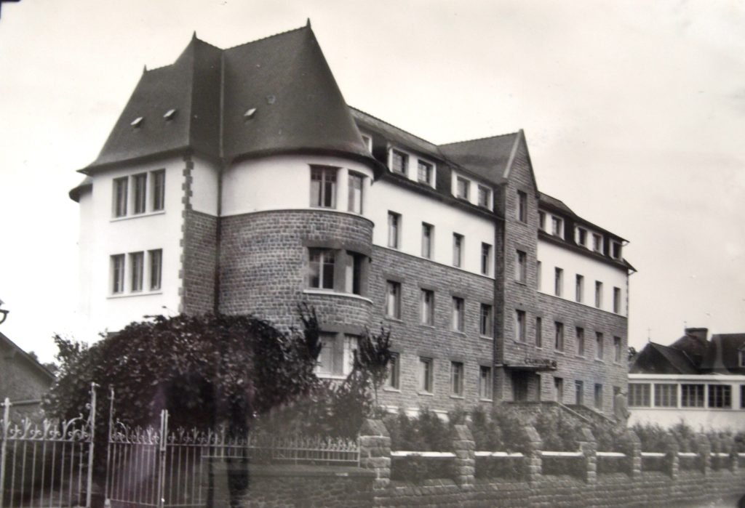On February 25, a young mother, Denise Arnal, returned to the St-Joseph de Combourg clinic, run by the Daughters of Providence. She courageously bore the last sufferings of motherhood. As the pain were going on for several days, the doctors decided to resort to an operation. This was going very well: the mother and her family were full of happiness for the birth of a little boy and a little girl. Everything seemed to be going well. But the next day the patient's situation became worse: generalized infection, difficulty breathing, extreme weakness. Despite the doctors' care, the patient's condition did not improve. We began to think about a new operation, despite the probability of very serious risks. Blood donors were invited. The surgeon deployed all his knowledge and he still had hope. But during the intervention the patient became very purplish, the breathing weak and irregular: one no longer felt the pulse, the pupils dilated. The surgeon declared that she was lost and that he could do nothing more for this poor woman. We were not resigned: oxygen was distributed in high doses, artificial respiration was practiced, transfusions were made in the arms and legs. All the treatments remained without result. This time, all seemed lost. In a burst of faith and trust, the Sisters ed the patient to Father de la Mennais, they placed a relic image under the pillow, ed for prayers from the Community, began a novena with the students of the two Mennaisian schools of Combourg ( Brothers and Daughters of Providence). Gently Mrs. Arnal gave signs of life: she moved a hand, she lifted her chest slightly. To everyone's astonishment, the patient came back to life with extraordinary rapidity. She answered questions, tried to take off her oxygen mask. It was only little by little, under continuous surveillance, that the patient came back to life. She could leave the clinic after five weeks and returned to her family. In very good health, she took care of her two children.
It was with joy and gratitude that the family realized the wish to go to the tomb of the Venerable Father in Ploërmel. The memory of this healing remained forever etched in their hearts. For the Daughters, this great favor stimulated their piety: “We cannot forget the many graces already obtained in our Clinique St-Joseph in Combourg, France: in particular that of Josette Poulain, cured in this same clinic on January 23, 1955.”
Source: Testimonies of the Daughters of Providence, collected by Bro Jean-Charles Bertrand, (FIC Canada)

4- HISTORY OF MENNAISIAN DEVOTION: 4- THE FIRST FRUITS OF THE FATHER'S DAY (1927)
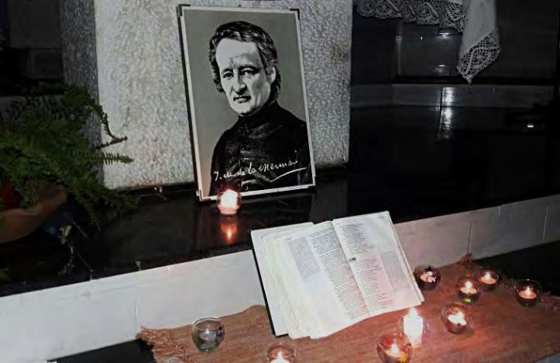
From 1928, that is to say after the first “Father's Day” instituted by the circular of the Rev. Brother Jean-Joseph, the Chronicle of the Institute began to publish the account of the fruits of this initiative. “It immediately revealed itself as a happy divine inspiration. The whole Institute felt a breath of religious enthusiasm pass over it, as if it had a presentiment that this institution would hasten the glorification of its true Founder”. The Chronicle then developed the different ways in which the Week was celebrated by the Communities and by the schools. “Everywhere the Brothers responded to the Superior General's invitation. Filial love made it eloquent to praise the Father and his work, ingenious in making him known to his students. We organized preparatory Novenas, we composed rich spiritual bouquets, the life of the Servant of God and the history of his teaching Institutes were exposed in numerous talks : the Brothers of Christian Instruction and the Daughters of Providence”. Then we described the enthusiasm and the fervor with which the young people and the children welcomed this initiative. Their response was amazing. “In all the countries, in all the classes where we speak of the Venerable de la Mennais, a holy recollection seizes the souls of the children; they listen eagerly and want to hear again; they multiply the sacrifices; they look with admiration at the image of the great Benefactor of Childhood. A good number, during the preparation, go to Mass and receive Communion every day”.
A spiritual breath invaded the soul of all children, even the most difficult and rebellious. “Not a punishment given all week,” read several accounts. “One feels everywhere an invisible presence: the spirit of the Father dwelling in the midst of his sons, in the midst of the children and young people whom he loved so much on earth”
The accounts also pointed to other important fruits: first of all, a Family spirit that spread in the Institute. “These days, with the week of preparation that precedes them, are a very effective means of developing the family spirit in the Institute, creating, in the veneration of a common Father, a powerful bond of union between the teachers and students”. They also helped to create links between all the Mennaisian communities, scattered around the world, especially where they were relegated to a certain clandestinity. Another important fruit that could be harvested during these Days was the call to a vocation to religious life, particularly linked to the Mennaisian charism. “These days are salutary to the Brothers, by strengthening them in the esteem of their vocation and to the pupils by developing in them the Christian spirit. In many cases – one has in fact the happy experience – they are at the origin of a religious or priestly vocation”. Facing the beauty of the Father’s life, taken with fervor by his charism and his “holiness”, listening to the gestures of his mission and his missionaries, the seed of the Christian vocation sank into the hearts of young people, always ready for the great ideals.
These were the first fruits of the Father's Days: they began their journey almost a century ago and continue to bear fruit to this day.
SOURCES: MENOLOGE IV pp.1352-53/ CHRONIQUE-S from n.84 (March 1928)

5- MENNAISIAN WITNESSES: BROTHER MENANDRE GORTAIS (JEAN-MARIE) 1815-1849: A POOR BROTHER WHO TEACHED AND LIVED THE GOSPEL

Jean-Marie was born in Questembert (Morbihan, France) on March 5, 1815. His father, Thomas-Marie, and his mother, Françoise Le Bot, were small farmers who led a deeply Christian life. They were assiduous in the religious celebrations of the parish and brought their child with them. Jean-Marie was attracted by the Eucharist: he got up very early to go to mass, he approached the altar, he was a choir boy. He spent so much time at church that the mother worried that he might neglect his study duties. But the child replied that it was in the Mass that he drew his strength. Indeed he attended the school of Questembert, and then that of St-Martin-sur-Oust, with excellent profit. He was a very delicate and sensitive child: he liked quiet situations, prefered calmer companions with whom he went fishing to sell the fish. He was very attached to his family, his brothers and his mother whom he consoled in difficult situations.
At 11 years old, Jean-Marie received First Communion: an early age for the time, but he already knew the Catechism by heart. In his projects there was a desire to give his life to the Lord. He had a priest uncle, parish priest in Réminiac, who helped him to perfect his studies, followed him spiritually and advised him to enter the religious family of the Brothers of Christian Instruction of Ploërmel which was not far from Réminiac. Surprisingly, it was his mother who became a major obstacle to overcome: she understood that she was going to lose the most pious, the most obedient, the sweetest child. But she also understood the will of God for her son, who told her: “Mom, I absolutely want to become a Brother, because I want to obtain my salvation and work for the salvation of the children”. Jean-Marie entered the Novitiate at the age of 15. He confided to a friend: “I love my family very much. My affection for her is a sweet duty of conscience. Nevertheless, if God calls us to follow him in religious life, it is in him and in the Congregation that we find our new family”.
In the Novitiate he found a famous master in the Institute, Br. Hippolyte Morin. Jean-Marie, who became Brother Menander, found himself in his natural environment: he gave his all to study and manual work, he was full of spirit in recreation, he prayed with reverence.
Thus prepared for his task as a Christian educator, he received his first obedience: master in Pléguien, a small center in the Gulf of St-Brieuc. These were the heroic times of the Institute. The master was ready, but there was no room. The town hall tried to solve the problem by offering the master a special room: a laundry room! Br. Ménandre was not discouraged: the vats and the sedimentation basins had to be removed, the water points closed, the parquet refinished, the furniture placed for the classroom. The classroom-laundry retained high humidity, which a weak stove could not reduce. Br. Ménandre was 16 and a half years old. He was not afraid to face these problems. He began his adventure of Christian education: he loved his 60 students, he taught them with the generosity of his young age! He began to develop his pedagogical method and his way of explaining the catechism. But in this first experience there was a shadow that bothers him: he could not stand loneliness, he still needed a master and a brother. Fr. de la Mennais understood this little Brother. He placed him in Bourbriac, where there was Bro. Amédée Le Guyader, who was completing his formation, reassures him with his examples and his advice, strengthened him in the faith. Bro. Ménandre, after this year, where he “completed” his formation, returned to Pléguien, in his laundry room, with his little ones and he remained with them in complete serenity for eight years. He obtained the Certificate of Capacity and became a municipal teacher.
Let's take a look inside his class by listening to the advice he gave to the Brothers: “Prepare the catechism in writing. Use simple words. Mix explanations with pictures, examples, simple stories. If some disturb, take them back, but at the end of the lesson. Call to your aid the angels and the saints. If we are not perfect, let us keep ourselves in humility and patience”.
After ten years as a “Brother placed alone”, Fr. de la Mennais entrusted Bro. Ménandre with a “school for two Brothers”, the school of Paimpol, a fishing town (for cod around the coasts of Newfoundland in the Atlantic Ocean). The classes were very large, the pupils were lively and noisy, as in all maritime countries, the work of the teachers was overloaded. In addition to their strenuous class, they gave evening classes to sailors during the winter and, on certain days, specialized courses in drawing and hydrography. The two Brothers lived in an attic of the presbytery, which also served as a work office. It froze in winter and suffocated in summer. The Brothers did not complain; on the contrary, they voluntarily procured other occasions for sacrifice: overwork, very sober food, austere rules. Fr. Ménandre also took care of his young assistant: he gave him a lesson in pedagogy during rest days, he comforted him during recess, gave him spiritual suggestions during walks, visited his class and supported him: “The simple memory of examples and advice from this Brother makes me cry with joy”. The dedication of Br. Ménandre was supported by an intense spirituality. He followd the parish liturgy and collaborated actively with the rector, whom he loved like a father. He had a special devotion to Our Lady, whom he venerated with multiple signs: rosary, office of the Virgin Mary, month of May, Congregation of Mary, ornament of Marian images.
Our “good Brother Ménandre” was present in Paimpol for ten years. He wa esteemed by all and devotes the best of his resources to his mission as a Brother teacher. But the Lord was going to ask him for the supreme gift. In 1849 in Paimpol, as in the other “sardine” towns on the Breton coast, a terrible cholera epidemic broke out. Already in Lorient in February died 365 people. “In a short time in Paimpol there were many victims: everyone was scared. But the dear Brother, consulting only his zeal for the glory of God and charity for his neighbour, went away every day, as soon as his class was over, to spend his free time with the cholera patients; on Sundays and Thursdays he spent almost the whole day there. He rendered them all the services that the most devoted nurse can render to a patient, so much so that he tired himself rubbing them, for he had spent part of the day there. The priest, seeing his assiduity with the sick, said to him one day: - My brother, you will end up catching cholera. “Well, Monsieur le Curé, if I die of cholera, I hope I'll be the last. “ Indeed he died of cholera and no one was affected after him in the town of Paimpol; at least that was what several trustworthy people told us”.
Chapel of Lanvignec
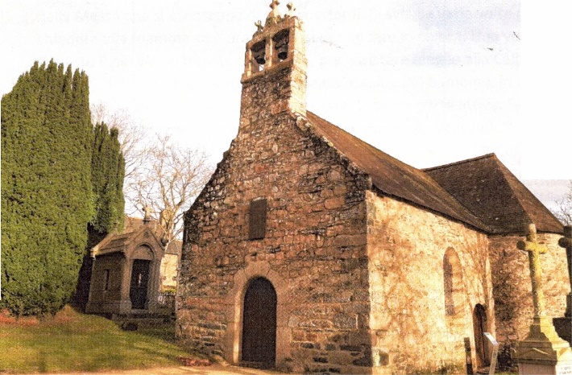
Indeed on November 22, after having visited Bro. Abel in Plouha, he had to go to bed, received the sacrament of the sick and “he gave back his beautiful soul to God” on the day dedicated to the Heavenly Mother. He was 34 years and 8 months old. This death was a general mourning in Paimpol: parents, children, benevolent, hostile, all paid Bro. Ménandre a well-deserved tribute. His students, full of esteem and veneration, erected a small monument over his tomb. Seven years later, during the exhumation of the remains of the dear deceased, Mr. Allenou collected them with care and had them placed in a reserved place in his private chapel (in Lanvignec).”
Let's conclude this brief with some testimonials about our "GOOD BROTHER MÉNANDRE GORTAIS", as we can read in his box.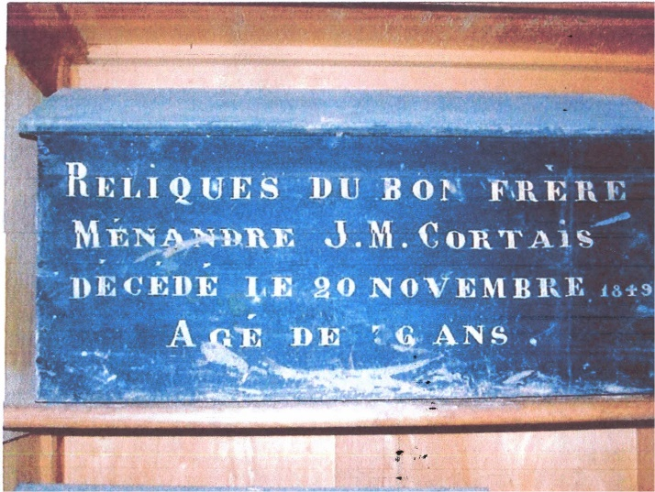
Box of the remains of Bro Ménandre
Br. Cyprien, the future Superior General, then a young master in Pordic, wrote to Br. Abel: ”This dear Brother was not an ordinary man; there was something superhuman in him, a constancy, an elevation in goodness that is not ordinary… God gave us this treasure” And Father Ruault, in the name of Fr. de la Mennais: “This excellent Bro. Menander, that accomplished model of all religious virtues, was taken from you so abruptly. It is a great loss for the Congregation. Such models make more impression than one might think on a large number of other Brothers at the time of retirement…”
Bro. Menander is one of the lights of our heroic times to put on the candlestick.
SOURCES:CHRONICLE NOVEMBER 1875 pp173-1857 // MENOLOGE pp.1343-47/ IN THE SERVICE OF CHILDREN… pp. 137-47/ MANUSCRIPT in Italian: BIOGRAFIA DI FRERE GORTAIS MENANDRE Bro Dino De Carolis.

