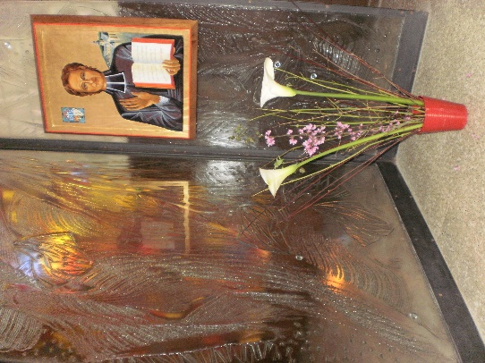
MENNAISIAN MONTHLY NOVENA
JANUARY 2023
- NEWS FROM THE POSTULATION
After the Under-Secretary of the Dicastery for the Causes of the Saints opened up the possibility of continuing the examination of the healing of Josette Poulain, the decision to either continue or to stop was entrusted to the responsibility of the General Council. To enable a more thorough discernment, the Postulator organized two meetings for the Superior General. The first took place on December 23rd 2022, at the Generalate, with the paediatric neurosurgeon of Gemelli Hospital, Dr. Massimi Luca. The doctor explained how, according to his study of the Josette file, the clues present in the Summarium can sufficiently demonstrate the cause of the child's trauma and therefore the nature of the healing. The second meeting took place in a hall of the Congregation for the Causes of Saints on January 2nd 2023 with Father Boleslaw Turek, a non-commissioned officer of the Dicastery (through the window we could see the queues of people on St. Peter’s Square wishing to pay homage to the mortal remains of Benoit XVI). In this interview, which lasted almost an hour, Fr. Turek summarized the state of the cause, the two negative responses from the specialists, then the intervention of Dr. Massimi's expertise and finally the positive change of the one of the two experts who opened the possibility of having recourse to the examination of the Medical Commission. It is now up to the General Council to decide the future of the Cause.

- RECOMMENDED INTENTIONS
We continue to pray for
- Mrs. MYRYAM DE COURRÈGES, who was one of the two “ab inspectione” official doctors of the additional investigation led by the diocese of Rennes (and who gave a favorable response). She has advanced stage cancer which she battles with courage and great faith. “I go down slowly but surely, with painful, ever more frequent injections. However, I contemplate the Father with open arms full of Love and, at the same time, believe that the powerful healing of Jesus is still at work… I am still on my feet and I hope to experience Christmas with all our children. And indeed, Merry Christmas to all of you… In communion with your Congregation at the foot of the crib, with all the wishes that are yours and ours.”

- JULIETA PERALTA, an enthusiastic 27-year-old teacher from Cosquin, Argentina. Doctors have diagnosed a metastasised cancer. She is currently undergoing medical treatment. The Mennaisian family have begun a novena to Jean-Marie for her.

- MASSIMO MENSURATI: father of three children, he has suffered a cerebrovascular incident, with very serious consequences for his physical movement and speech. He is now unable to work. Rehabilitation promises to be very long. His family is very confident in Father de la Mennais.

- CESARE C., a young man currently in prison. Please pray for him and his family who commend themselves to Father de la Mennais.

- FAVORS RECEIVED
We have not received many notifications of favors obtained through the intercession of the Father. Certainly, he protects us in a special way, and we must collect the favors and report them: first to the local Mennaisian animators and then to the General Postulation. The Postulation has distributed picture relics to the Provincials, each with a small piece of cloth which touched the tomb of the Father in Ploermel. They are to be used with great confidence and faith. While waiting to report more cases, we publish a favor obtained by a nun in Uganda in 1960.
“I want to thank Father de la Mennais. In February a tumor grew inside my upper lip. In a few days the state of my lip became alarming. The 5cm swelling completely blocked my eyes and prevented me from swallowing anything. At that moment I prayed to Father de la Mennais, I started a novena and I applied the picture relic to my lip. I was transported to the hospital. After consulting the doctors concluded that an operation was urgent, saying to each other that perhaps I would not wake up in this world. Meanwhile, a new growth had appeared on my lip. I redoubled my prayers to the Father. A few minutes before the operation the tumor opened on its own, letting abundant pus flow and giving me immense relief. The surgeon asked me, "What did you do to your lip?" He couldn't hide his astonishment. He even went to get other doctors from the hospital to see for themselves the strange phenomenon. This is how I was cured by the intercession of Venerable Jean-Marie de la Mennais.” (Sister Sécondas, Narozari Parish, Masaka, Uganda 1960)

- THE HISTORY OF THE DEVOTION TO FATHER DE LA MENNAIS
Let us begin a fresh retelling of the history of our DEVOTION TO THE FATHER, its origin, its development, its moments of fervor, its evolution. We can learn much from this history today.
AN AWARENESS OF MENNAISIAN HOLINESS
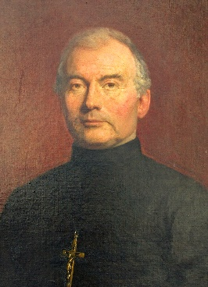
In the early days of the Institute, the presence of the Founder, Jean-Marie, was material and palpable. Many Brothers had known him directly. His memories were present in physical locations, in his works, in his words, in his writings. We had not felt the need to collect and archive this immense heritage which was still alive within the Mennaisian Congregations of the Brothers and Daughters of Providence. The official recognition even of his holiness did not appear either urgent nor important. Everyone was convinced of the holiness of Jean-Marie and sure of his protection. As the years passed, the awareness of having had a man of God as Founder grew. We began to feel the need to have instruments of knowledge of his life, his works and his spirit and we took measures to ensure this. By collecting memories, writings, documents, etc. the Institute was able to publish the first biographies, penned by a variety of different authors: Ropartz - “The life and works of Jean-Marie de la Mennais”, de Mirecourt - “Father Jean-Marie de la Mennais, The Brothers of Ploermel - “A friend from childhood”, Herpin - “Jean-Marie de la Mennais, his principal ideas and writings” and especially Laveille - “JM de la Mennais 1780-1860”.
Bro. Cyprien
CHEVREAU s.g.
Encouraged by several illustrious ecclesiastics to open the Cause of Beatification of the Founder, the General Council, presided over by Br. Cyprien, consulted several bishops, among others those of Vannes (place where the diocesan Process should have taken place) and the Archbishop of Paris. All gave their enthusiastic consent. In the session of April 7th, 1895, the Council took the decision to introduce the cause. The canonical various stages followed: the recognition of the remains, the constitution of the Diocesan Tribunal, the appointment of the Postulator in the person of the Marist Father Nicolet, the process of communicating information, the research of the writings… until the Introduction of the Cause to the Congregation of the Rites of Rome. What was the purpose of all this long and laborious trial, which for Jean-Marie would have lasted for so many years? It is Brother Abel, Superior General at the time, fervent devotee of the Father and ardent apostle of his holiness, who gives us the answer. He addressed the Brothers with these words:
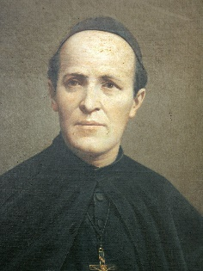
“ “One of the most effective means we have to advance in the perfection that God asks of us is to allow ourselves to be penetrated more and more with the spirit of our Founder. This good Father has not abandoned us: he is always with us through the Constitutions he bequeathed to us, through the sublime virtues he practiced and the memory of which excites us powerfully to follow in his footsteps. Let us have a tender and confident devotion to him and let us not pass a day without addressing him at least one pious invocation. If the spirit of our Father animates us, we will be strong because we will keep union and peace between us, and we will compete in piety, zeal and devotion in the accomplishment of the work of God in the positions entrusted to us by holy obedience. Let us love and observe our holy Rule in which he traces for us, on behalf of God, the sure way to Heaven. Let us meditate on his life and the instructions he bequeathed to us: is not our Directory like the mould in which our beloved Father wants each one of us to be formed? Let us each become more and more aware of the greatness of the mission entrusted to him by Divine Providence and, consequently, of the greatness of our own mission, since we are called to continue the good work he has begun.”
Bro Abel
GAUDICHON, s.g.
Bro. Abel experienced the joy of depositing the Acts of the Diocesan Process with the Sacred Congregation of Rites and rejoiced at the welcome that the circles of the Roman Curia reserved for the Process of Jean-Marie de la Mennais, which will be judged as "one of the most beautiful and important of the 19th century”. Under the fruitful impetus of Bro. Abel, the Mennaisian Congregation felt the spirit of its Founder circulating in its veins. He encouraged the spiritual sons of de la Mennais: “Every religious must be the living copy of the father in the house of grace that he inhabited. He must seek his father's soul wherever it left its mark.
SOURCES:
MENOLOGE p. 199 8, Fr. Abel/ p. 424 General Council
ARCHIVES FIC ROME Biographies of the Father/Circulars

- MENNAISIAN WITNESSES
BRO. ZOEL (AURELIEN HAMON) 1819-1851
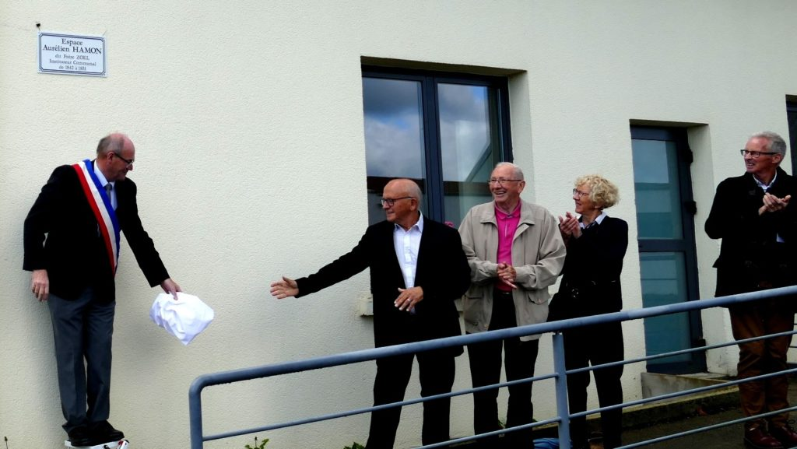
One of the Brothers who left behind him the memory of a “holy” life is Brother Zoel. At 21 he arrived in Plouvorn (Finistère), a small community in Brittany. He taught in an old chapel-ossuary to more than a hundred students. He transformed his school into one of the most flourishing in the region. He gave his students a very strong Christian formation, both during lessons and in free time. He had a predilection for the poorest and he welcomed all those who asked for a place in his school. In 1847 a terrible famine caused hunger and misery. Fr. Zoel invented a “social bakery” charity, to meet the needs of the local population (more than 800 people) who were dying of hunger. In 1851 a tragic epidemic of typhoid broke out, which caused innumerable victims. The heart of Bro. Zoel was moved with compassion. At 4am he went to bandage the most disgusting wounds with his charitable hands. The scourge he faced with Christian courage did not spare him. He died at the age of 31. An irreparable loss for the parish”. In Plouvorn, his memory is still alive and his life has been explored in a series of articles, books and testimonies, begun by nos. 5 and 6 of The Chronicle in 1875. He was a “socially conscious” Brother who lived the Gospel to the letter, and who drew his strength from the Eucharist, even to the offering his life for his Brothers, the little ones, the poor, the sick. “He saw in the Christian school the solution to this problem: to instruct, to catechise, to clothe and feed the pupils, especially the poor”.
Inauguration of the plaque in memory of Bro Zoël, Aurélien HAMON. September 2019

