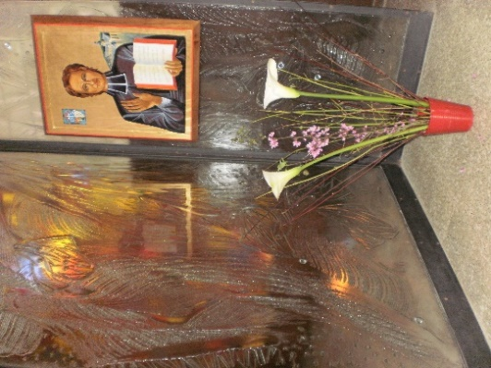
MENNAISIAN MONTHLY NOVENA
SEPTEMBER 2023

1-NEWS OF POSTULATION
The Postulation is currently looking for New Ways for the recognition of a Scientifically Inexplicable Cure. For this, we are waiting for Reports from the Mennaisian Family and we rely on the Facilitators. In addition, we are studying the possible presentation of the cause of Brothers or Sisters who have a certain “reputation for holiness”. For the moment we are in the process of deepening the Biographies of Bro. Zoël Hamon (Plouvorn, France) and Bro. François Cardinal (Canada and Rwanda). All contributions: Legal Acts, Letters, Images, Writings, Testimonies... are extremely valuable. Currently we are in the informal phase of study to examine if there is substance for a possible introduction (first to the local Bishop).

2- RECOMMENDED INTENTIONS AT THE INTERCESSION OF FATHER DE LA MENNAIS
* LOCAL INTENTIONS: proposed by the Animators of each Province-District of the Mennaisian Family
* GENERAL INTENTIONS:
1- A mother with advanced stage cancer, with a handicapped adopted daughter who attended our School in S. Ivo. She was operated on in a Hospital in Rome and the family joins in the prayers of the Novena
2- Palma, a young Aspirant of the Sisters of Providence in Nebbi, who suffers from a form of Chronic Bronchitis. During attacks she must spend 3 to 4 days in the Hospital. Palma knows Father de la Mennais well and she joins in the prayer of the Novena with the whole Mennaisian Family.
3- A prayer also for Mrs. Josette Poulain who fell seriously ill and is in Hospital.

3- FAVORS RECEIVED
We remind the Animators to send us some cases of favors received through the Intercession of the Father or to report them in the local Novena. Send to the Postulation all that concerns the Mennaisian Devotion.
Here is another example mentioned in the Bulletin “Missions” of Bro. Jean-Charles Bertrand.
“A mother from Biddeford, Me, USA, writes:
Since 1952, one of my children, 5 years old, suffered from very painful Headaches. Several doctors, after examining him, believed him to be suffering from Poliomyelitis. But the Headaches continued to the point of becoming unbearable. I had then recommended him to the prayers of the Monthly Novena to the Venerable de la Mennais.
At Maine General Hospital where I took my little patient, the X-ray revealed a brain tumor. It was in 1952; however, it was not until July 1954 that the operation was attempted: it lasted six hours. The surgeons discovered a second, deeper tumor, which they dared not remove. They told me to bring the child back to the Hospital six months later. The little patient would then undergo a series of Examinations.
However, in September 1954, when the Surgeon took a new X-ray, he saw such a worrying growth of the tumor that he ordered an immediate Operation. My child entered the Hospital for the second time on September 17th,1954. I then asked the Brothers of the School to pray to Father de la Mennais for the success of this Operation, which was even more serious than the first. And my family joined the Community every day for this Novena.
The operation was fixed for September 23rd 1954; but, the day before the Doctors took a New X-ray, and, to their great surprise, none could find any trace of the tumor! We were on the fifth day of the Novena. Two days later the child left the Hospital. Since that time, he has been examined twice. Finally, the Doctor declared him cured in some Inexplicable Way. My little boy now goes to School and is in perfect health.
later the child left the hospital. Since that time, he has been examined twice. Finally, the doctor declared him cured in some inexplicable way. My little boy now goes to school and is in perfect health.
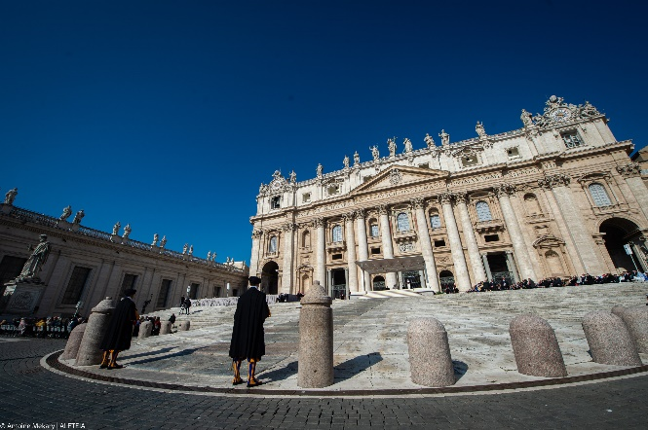
4- HISTORY OF MENNAISIAN DEVOTION:
8- THE PURSUIT OF THE CANADIAN BRANCH: THE BULLETIN “TOWARDS BEATIFICATION” (1935-1945)
Towards the second part of the 1930s, the Congregation was going through a good moment of recovery: in France the Schools enjoyed greater freedom and were able to develop. Haiti continued its work of Educational and Cultural Mission. Spain, after the terrible Civil War, fervently developed the Christian Animation of the Schools and was able to branch out into South America. Small Communities sprang up in Egypt, in England, in Italy. But it was above all in Canada and the USA that we witnessed a real flowering of the Institute. The Canadian Provinces of La Prairie and Pointe du Lac had become the driving force of the Congregation: thanks to the Brothers who had come from France, they had strong Mennaisian roots, they had the Enthusiasm for New Foundations, they had significant Economic means. From Canada had left a New wave of Missionaries in the Heart of Africa, which opened a very promising Mission. It must also be considered that Canada had not been drawn into the disastrous Second World War and, at least in its Territory, enjoyed a peace unknown elsewhere. For all these reasons the Canadian Brothers, in a certain sense, have taken in hand the work of the Mennaisian devotion and they have been the Protagonists of its diffusion.
Indeed, during the War years (from 1939 to 1946) the Chronicle appeared in a very small and irregular way. In the same years in Canada, a very simple Typewritten Magazine was published with the title: “Vers la Béatification”. It wanted to give new impetus to devotion to the Father, as if to hasten his Cause for Beatification. At the same time, it would have asked for the protection of the Institute during the War. The Visitor, Br. Lambert Méréal, presented it thus: “Here is a new leaf. It appears on time, without any pretension, but imbued with that filial affection which all the Brothers have for their Venerable Founder. Its title “Towards the Beatification” indicates its object: to help the Cause of Beatification of Father de la Mennais.” The Canadian branch was traversed by a strong current of Mennaisian devotion: numerous accounts were given of favors received through his Intercession; the intentions to be recommended were collected; knowledge of the Father's life was disseminated through Illustrated Strips, Anecdotal Stories, Scenic Games. Above all, we insisted on the celebration of the Novena from the 18th to the 26th of each Month. The bulletin was addressed to the hundreds of Brothers, to the ten thousand pupils and their families, to the 36 Schools. Soon he will also join the Daughters of Providence and their works. Br. Méréal concluded with the words of Br. Abel: “Our Venerable Father remains within our Institute. Let us therefore have a tender and trusting devotion to him: let us not pass a single day without addressing to him a pious invocation”.
The first Director of the little Magazine was Bro Bernardin de Sienne Crépeau, an expert Connoisseur of Father de la Mennais and his fervent devotee. Let’s quickly present the summary of these years:
* 1940-1941: The first bulletin sets the Mennaisian tone with its Articles: Words and Stories of the Father, Collection of Intentions, Reports of Favours, Documents of the Cause, Publication of the request to open the Cause by the Bishop of St-Brieuc, Mgr Fallières in 1899, Portrait of the Father by Minister Guizot. We tell the story of the great Novena of the Week of Vocations, with the Spiritual Bouquet made: Mennaisian highlight now become familiar to the students. Echoes of the War: News of the Bombardment of Southampton and the Installation of the Juniorate at Roscoat. Celebration of the 50th Anniversary of the Novitiate in Canada.
1941-1942: Morning Spiritual thought dedicated to the story of the Father. We talk about Haiti, the Schools of Léogane and the Valley, the Ugandan Mission. The Daughters of Providence begin to collaborate with the Magazine. The Novena is always well followed: New proposals are Launched. The Director publishes the History of the Cause of Beatification in stages.
1942-1943: Change of Direction: Br. Bernardin succeeds Br. Florentin, who continues in the same line. We insist on the Cause: History, Account of the two Exhumations (1900 and 1926), Legal Modalities on Veneration. Prayer Intention for Peace (fourth year of War). The News is broadcast that the Germans would like to melt the Bronze Statue of the Father in Ploërmel. A large space is given to the Novena: Masses in the morning at 7.30, Consecrated Vocations, Theater Performances on the Father and the Missionary Brothers.
1943-1944: Each Novice writes an Article: “What marked me in the History of the Father”. We are starting to offer Quizzes. The Novena is always honored, it must be “Glorious, Solemn, Filial, an Apotheosis!”
1944-1945: The Little Magazine does not keep pace, because of the difficulties caused by the War (sixth year!) The Articles increase, but the enthusiasm is the same. Coincidence: during the landing of the Allies in Normandy, the Director presents the Normandy Branch of the FIC. The proposed Novena becomes an International Publication: France, England, Missions. Directors are urged to give ample space to Christian Youth Movements, especially Catholic Action.
The Adventure of the Bulletin “Towards the Beatification” ends in April 1946, by offering Shows, Questionnaires, Stories, Intentions… on Father de la Mennais: a “baton passer” for others to take over. In fact, it will be collected in two phases: first with the New Review “L'ENTRAIDE FRATERNELLE” which will bring together three Publications (JE ME SOUVIENS – VERS LA BEATIFICATION- POUR LA MOISSON), addressed above all to young Brothers. Afterwards, a more Specialized Magazine was born, entirely dedicated to devotion and to the Mennaisian cause: LE COURRIER DU VENERABLE, which will immediately have an International Distribution. It is the confirmation of the great devotion of the Canadian Mennaisian Branch, which had its humble but precious bud in the modest Magazine “Vers la Béatification”.

5-TRACES OF HOLINESS IN THE MENNAISIAN CONGREGATIONS
Bro ATANASIO (MARTINEZ FELIX)
FAMILY AND TRAINING
Born into a very Christian family, the first of six children, he was advised to enter the Formation House of Nanclares. At the age of 14 he began his Formative years with an uncommon sense of responsibility and seriousness: “He was a real model for me. What attracted my attention more was his love for work and his deep piety. During the recreations he amused himself with simplicity and cheerfulness”. He liked to play “pelota” where he excelled. He overcame health problems and continued his Education: he did not have a great disposition for studies; on the other hand, he was very involved in manual labor and in Spiritual Growth.
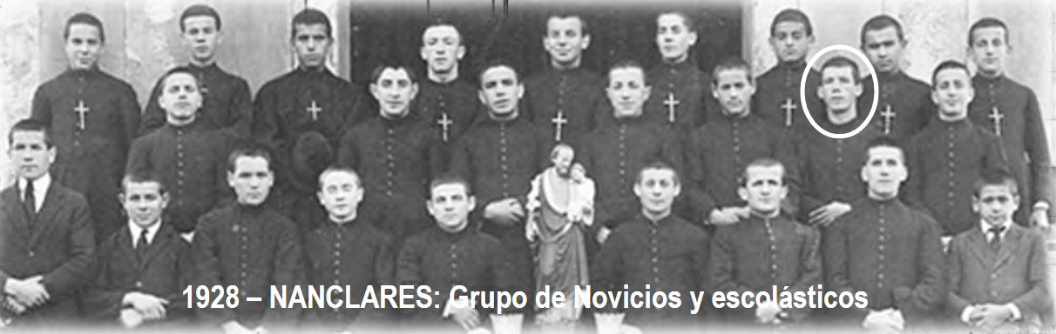
He entered the Novitiate on August 14th, 1927. He took the habit of the Brothers (which he could wear for a few years because of the Anti-Religious regime) and with the name of Atanasio, above all he tried to become a good Religious: “He was modest and didn't like what shines on the outside. He was very fond of his Religious Community and learned to live the Rule of the Brothers with love. Very delicate towards everyone, he was careful not to offend others. All these virtues were born of a Solid Spirituality, in particular of the devotion to the Virgin, to which he had devoted himself. His colleagues with a touch of teasing and admiration called him: “the Holy Father”.
WITH THE ABANDONED CHILDREN OF “LA CASA DE PRESERVACIÓN”
His first Apostolic Destination, in 1929, took him to Bilbao, to the “Childhood Refuge”. It was a Social Institution that welcomed young people in difficulty. It provided for three sections: young people in Re-education, Minors sent every day by the Juvenile Judge and the “Casa (house) de preservación” (kind of Orphanage) for about fifty children from 9 to 12 years old. They came from difficult, incomplete and marginalized families. Often the little ones arrived at the Casa in a state of misery and accustomed to Micro-Crime. The work of Education with these children was difficult and delicate: they needed Affection, Support, and Psychological Wisdom. Bro. Atanasio devoted himself to this work with attention for each of the little ones and Maternal Patience. The children understood his dedication and responded with gratitude. At the Casa de Preservación, there was a Community that had to organize itself for the Educational Task, for School Teaching and for Community Life, especially for the Prayers of the Rule. It was not always easy, especially since there was a certain dispersion in the Community. For our Brother it was a difficult but passionate start. Thus, his Colleagues testified: “He was very Recollected, and Very Pious. In Class he was very interested in the progress of his students. Their Notebooks were well organized and the Homework well presented. With delicacy and respect he taught children to love God. Someone said: Bro. Atanasio teaches only one thing: The Road to Heaven”. In the Records of the Judgments of its Directors, he had good marks for: Religion, Teaching, Childcare, and Prayer… but he had a rather modest mark for Discipline. Which meant, under the Rigid Pedagogy of the times, that he had a Family Relationship with his Abandoned Grandchildren and that his Authority was based on Trust and Good Relations, rather than Rigidity. of Discipline.
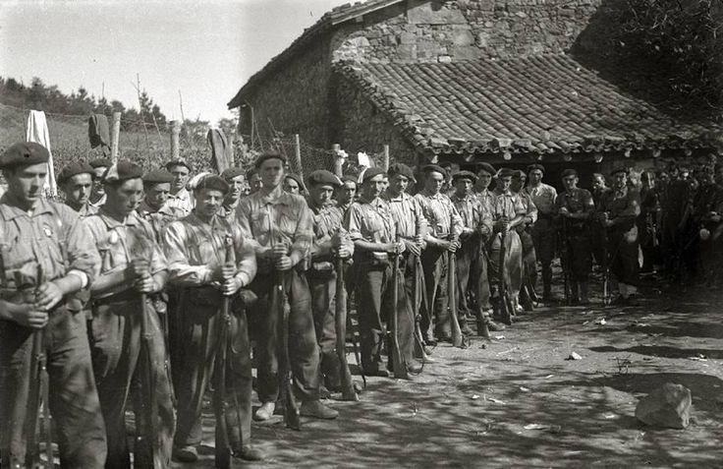
After two years at the Refuge, he was recalled for Military Service. He was sent to Morocco. Bro Atanasio was losing his children, but God was preparing him, without knowing it, for the most important test of his life. He wrote letters to Superiors to keep himself linked to his beloved Institute. While reading it, a Brother Assistant declared: “Here is a real child of the Congregation!” In 1933, his life in the Barracks over, he was temporarily sent to Reinosa, to the Great School of the Brothers S. José. We were in the Politically very turbulent years. Faced with ever clearer and more violent Religious Persecution, Bro Atanasio lived in a Catholic Community of great fervor and numerous activities: Eucharistic Movements, Catholic Action Associations, Social Movements, and Apostolic Groups…. In Reinosa, Bro Atanasio was in charge of Supervision, Manual Work and Animation of the young people's free time. Only one year in Reinosa and, in 1934, he was back at the Casa de Preservación, in the Children's Section which had been transferred to Nanclares. It was there that he had left his heart and he was very happy to resume his activity, among his children, who welcomed him with great Joy. The Director could confirm: “Although he could not wear the Religious Habit [we are in the middle of the “Frente Popular”], he kept the simplicity and modesty of Religious Life. He was Pious, Punctual, Devout, Full of Delicacy and Discretion in relationships. He took a great interest in the studies of his students and their Educational and Spiritual progress. He was good with them, he knew how to make himself respected and loved by all. He corrected by uniting firmness with moderation and charity: his Self-control amazed the witnesses”. Now Bro. Atanasio was 24 years old: he dedicated himself to God through Perpetual Vows in the Congregation. It took great courage to take such a step in 1936, the most violent and bloody year of the persecution. Indeed, these were the years of the Civil War in Spain.
Spain - 1936-39. - GC - National requests | Historia de españa, Spain, Historical photos
When the War broke out, after the Insurrection of the Nationalist Army, on July 18th, 1936, all the Brothers of the Province - except 3 who were in Reinosa - were gathered in Nanclares for the Annual Retreat. Several Brothers were enrolled in the Nationalist Army. A certain number were employed in the monitoring of the Water Basins in the Mountains, others in the Auxiliary Services and one part was sent directly to the Combat Front. The Brothers were framed among the “Requetés”, that is to say, the Volunteer Soldiers. “The Religious milieu of the Requetés was positive. They came from Christian families and they had respectful moral behavior. They honored the slogan of the Nationalists: “God, Fatherland, King”. Bro. Atanasio, like the other mobilized Brothers, was Political: he took part in the War, driven only by his Religious Spirit, as a True Crusader of Christ.” (Br. E. Sainz) At the front, the Brothers could not follow the prayer times, but they could participate in Mass and Confession in the Parishes where they passed. Bro Atanasio urged his Comrades to pray with him. When it was his turn to watch at night, he invited the other Soldiers to recite the Rosary together.
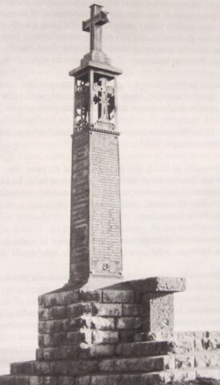
On October 8th, he launched himself with his companions on the top of a hill defended by the Republicans. A second group of Nationalists set out to defend the first. But the Republicans pushed back the second group and the first, defenseless, was annihilated. Among them also fell Bro Atanasio. He was barely 25 years old. The Assistant Bro. at the time, Bro. Francisco Aparicio, wrote: “Although we know nothing of the very last moments of our dear Bro. Atanasio, we do not doubt that he will have in a supreme effort, united with holocaust of his life, an act of perfect love which will have opened to him the gates of Heaven, where he now prays for his Brothers in Religion, for the extension of the Reign of Our Lord, the regeneration and prosperity of his dear homeland . “His comrades in Arms say that the day before his death they saw him, recollected in a Church preparing to receive the Sacrament of Penance. He wanted to be prepared for the supreme encounter with Jesus. His attitude became ever more fervent. “The nuns of Barria, where he served Mass during the 50 days he spent on Secondment in Ozaeta, have fond memories of this good Brother. On learning of his death, they sent their condolences to Brother Provincial, saying that they had no doubt that Brother Atanasio should enjoy a Beautiful Reward in Heaven.” (Br. Francisco Aparicio) keep the best memories of this good Brother.
A magazine from Vitoria published this memory: “Felix Martinez Saez, Hermano de la Instrucción Cristiana, sergeant of the 11th company of Requetés of Alava, died gloriously in the Alto de Arlaban, the day October 8th.” Below you could read his Eulogy with that of another soldier: “They lived like people full of rectitude, they died like saints. Both succeeded, at this decisive hour for Spain, in bringing together the love of God and country, sacrificing their own lives and sacrificing it totally”. Currently on a Large Iron Cross, a plaque with the names of Sergeant Felix Martinez and the other Requetes, who fell on this peak offering their lives for peace and reconciliation, keeps their memory and asks for a prayer.
Monument in memory of the killed of the Requetés regiments - Arlaban

