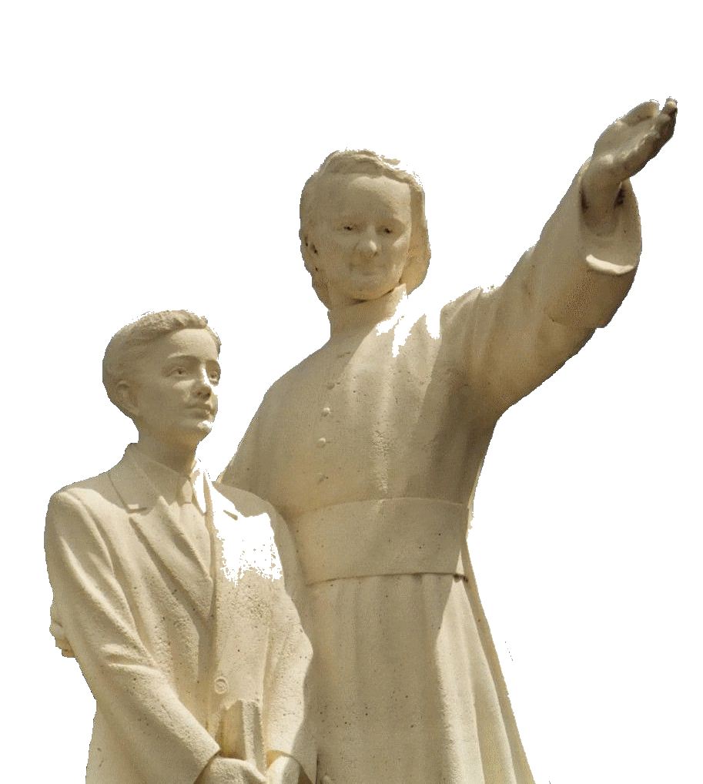

**MENNAISIAN NOVENA**

**AUGUST 2025**

***Pilgrims on the Path of Prayer***

1. **POSTULATION NEWS**

In recent Months, the pace of progress in the Father's Cause had slowed down: the Doctor who was supposed to summarize the various expert opinions was no longer available due to family problems. So, two other Specialists were contacted, in particular a Neurologist, Carlo Jovine, who had been contacted by the Dicastery for the Causes of Saints, even before the 2016 Meeting of the Medical Commission, of which he was also a Member. Professor Jovine agreed to take up Enzo's cause and confirm his favorable opinion by responding to the New Objections, which are always more complex. He received the Documentation prepared by the previous Postulators, Brothers Delfin Lopez and Brother Gil Rozas, with other updated expert opinions. It should be added that Dr. Jovine participated in the examination of the Healings for the Canonizations of M. Teresa of Calcutta, Pope John Paul II, and most recently Carlo Acutis. Let us pray even more!

1. **PRAYER INTENTIONS**

A request to the Mennaisian Animators: If you have any Intentions to propose for the Entire Mennaisian Family, please send them with a brief explanation. Also, try to send follow-ups on reported cases.

**LET US PRAY FOR:**

* **Brothers, Sisters and Lay People in Fragile Health**, in Nursing Homes or Retirement Homes. We ask them in return to offer their difficulties and their prayers. These are very valuable resources, especially for Mennaisian Vocations and the Beatification of Father.
* **Patients recommended by Local Facilitators**.
* **Patients reported to the Central Postulation**: the injured Bro Alberto Pardo (he was improving significantly) and Mr. Stéphane (he was adapting to his New Health Condition); Anna, Cancer, with two disabled sons: Silvia and Luca (she was fighting courageously); the children Tommaso and Giovanni Paolo (out of danger, but recovery is long); Irene: over Anorexia, but still fragile.
* Let's add: Claudio (serious eye problems), Monica (Breast Cancer), Dr. Giancarlo S.: difficult time
* **Our Brothers in the Most Dangerous Places**: Congo DRC (Bunia), Haiti, South Sudan
* **The Brothers of the New Mission in Timor-Leste**: Stéphane, Philippe and Éric.

1. **FAVORS OBTAINED THROUGH THE INTERCESSION OF FATHER DE LA MENNAIS**

**PONTIVY, SAINTS-ANGES BOARDING SCHOOL (France): CURE FROM PNEUMONIA**

*“On Sunday, January 23rd, André Vétal played, like his comrades, with ardor on the Kernivinen field. After the game, not having covered himself immediately, he caught a cold. The next day at 4 a.m., the Dormitory Supervisor saw him return from the sinks staggering and shivering with a fever. He had a Temperature of 39.2°C. When he got up, he asked him to stay in bed and wait for the Sister Nurse. After Lunch, the Sister found him with a Temperature of 39.7°C. She took him down to the Infirmary and asked the Brother Director to call the Doctor. The latter came in the Afternoon and immediately Diagnosed Acute and Frank Pneumonia of the Right Vertex. The Temperature rose to 40.4°C. His face was congested, his eyes were cloudy and injected. His Breathing was difficult, Jerky, and Very Short. The Pulse was beating at 140. The Doctor prescribes a Course of Sulfonamides, Penicillin, and Cardiac Tonics. He asks that the first Injection be given as soon as possible. It would be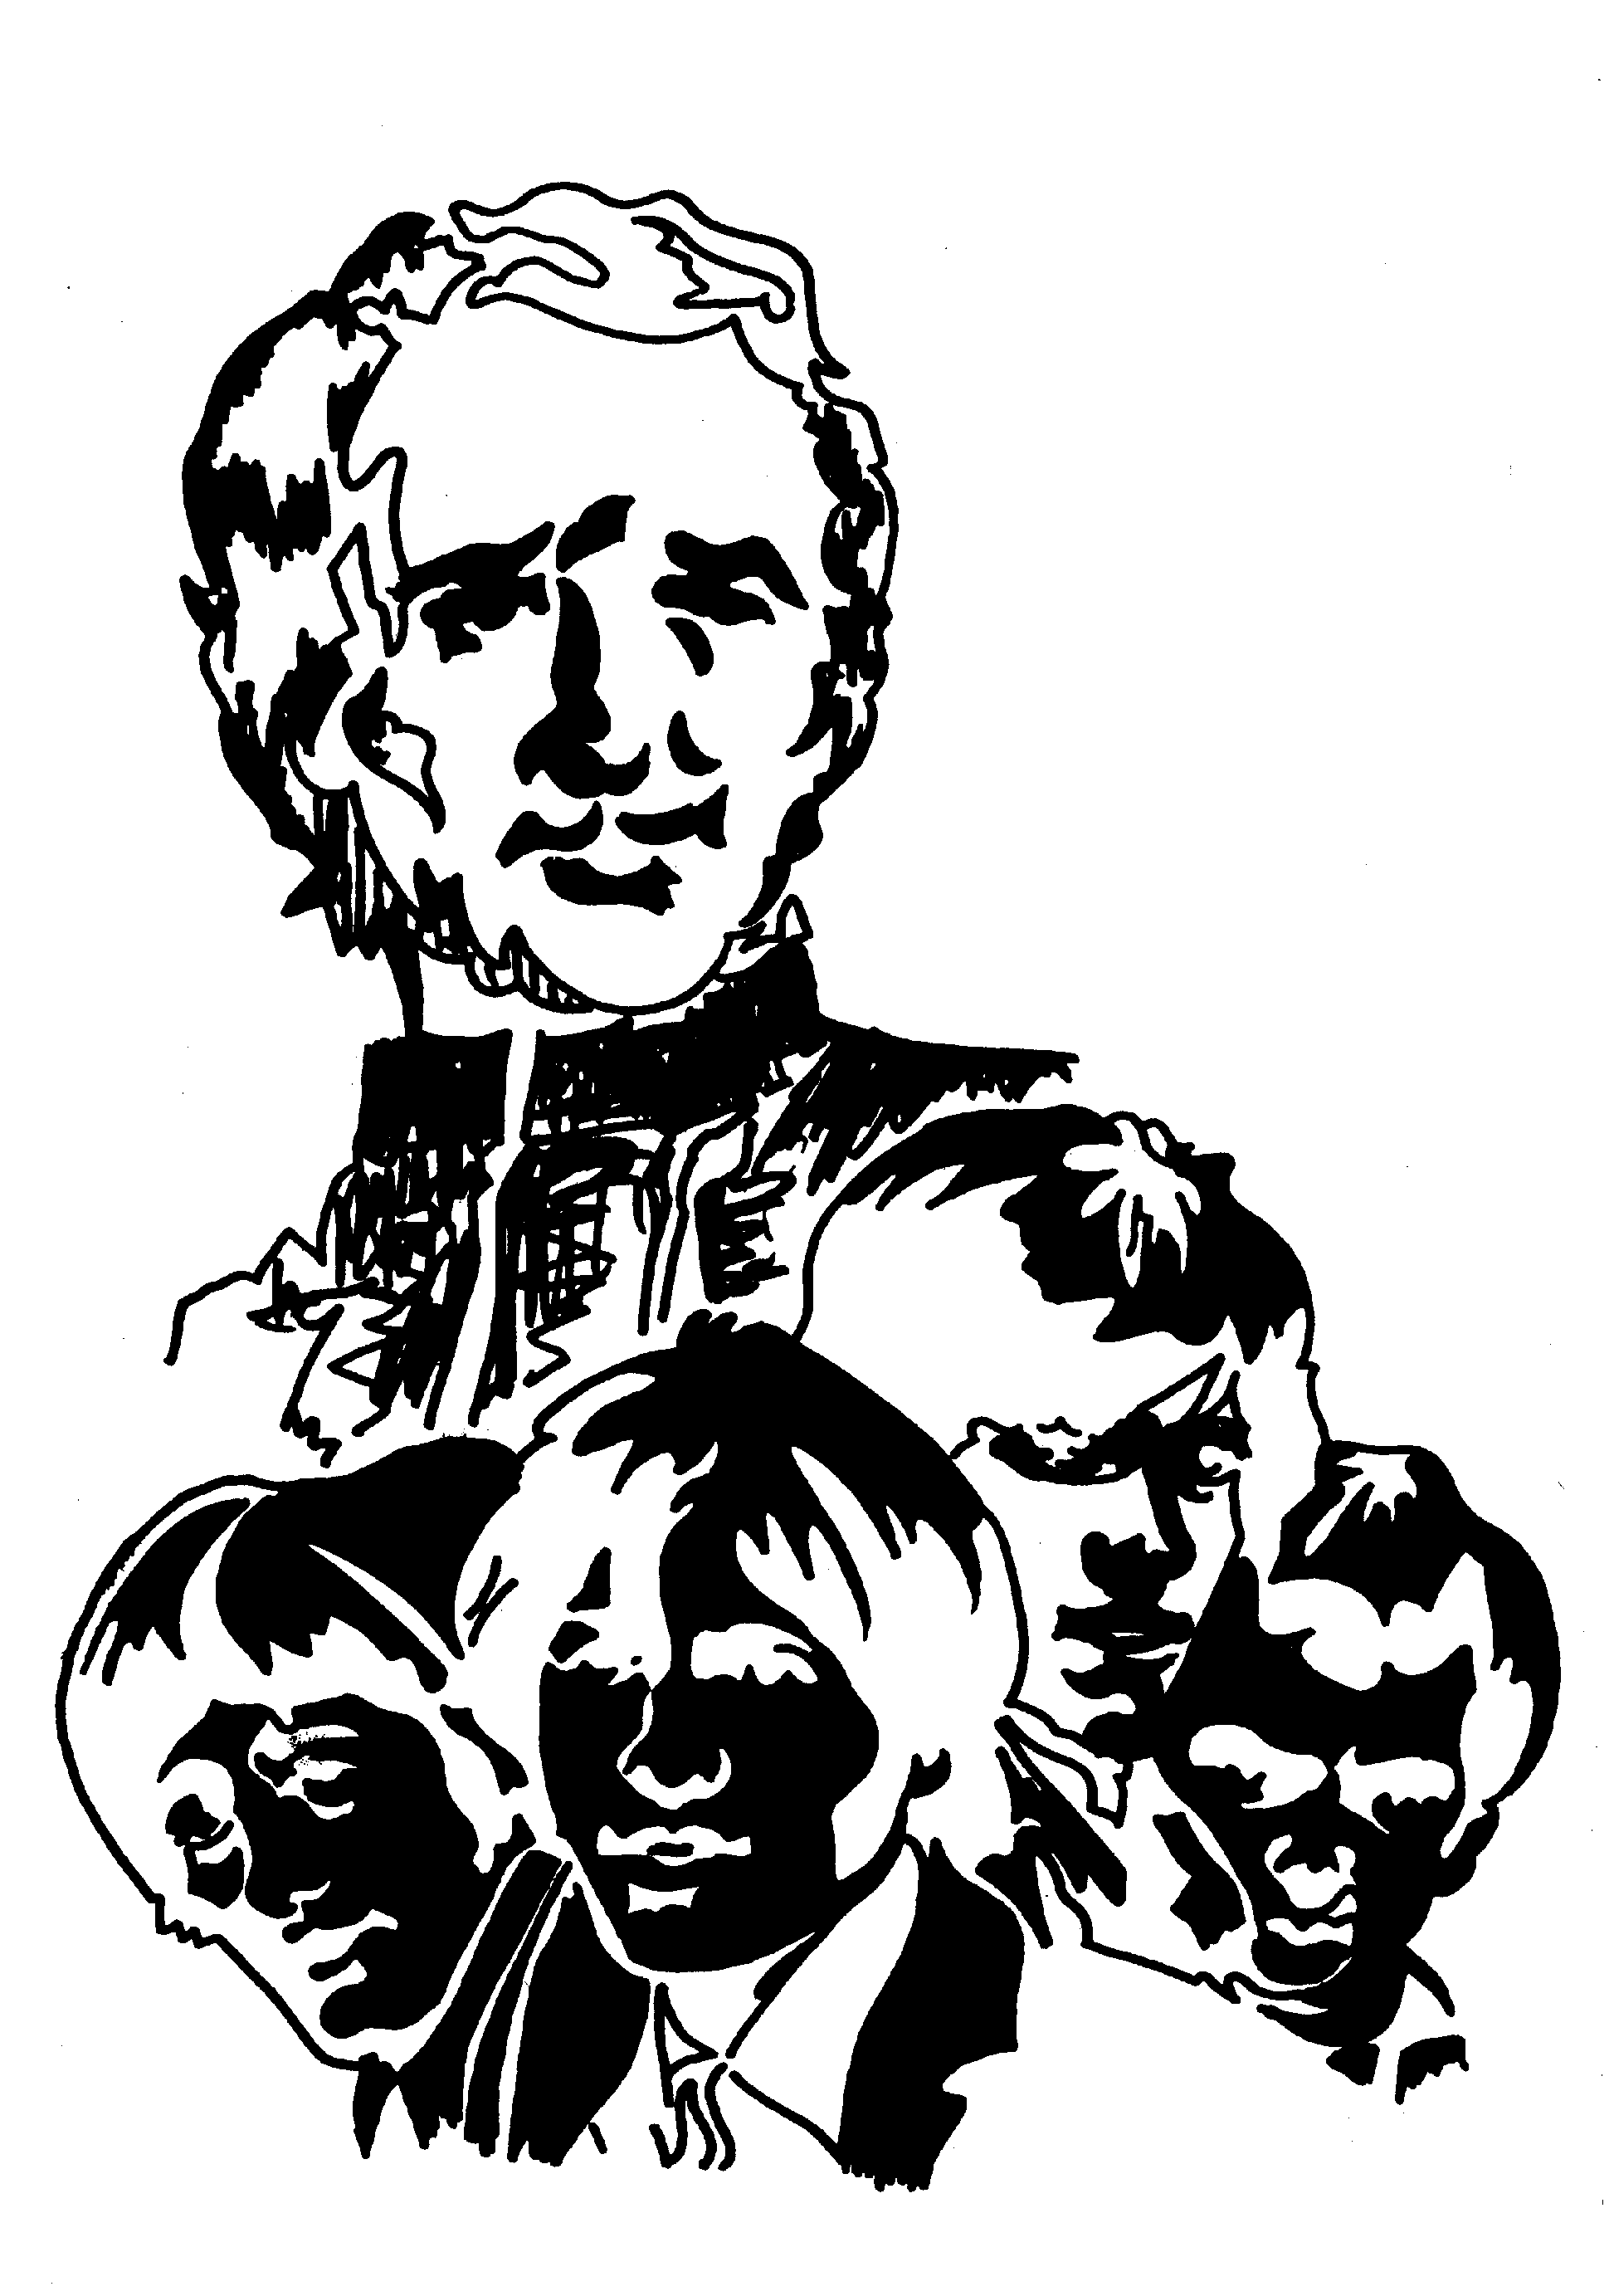 made around three thirty.*

*Around 5 O'clock, the sweating patient was completely changed and the Brother Director carried him to another bed. André was unaware of anything. The first question he asked the next Morning was: "Where are the others?" The Brother Director placed a Relic of Father de la Mennais under the Patient's Pillow and went into the study to pray for him. During the first part of the night, André was agitated, but at least he slept. In the Morning, his sleep was peaceful, his breathing calm. The Fever had disappeared, as well as the Pain on his right side. The Pneumonic Murmur, however, was more intense, and the Doctor made the same diagnosis as the day before, without hesitation.*

*The Treatment stopped on the third day. Despite that, the Fever did not rise again. André was eating and sleeping normally. That may seem surprising, but that Illness was a Cyclical Disease of 7 to 9 days. However, André was allowed to read on the third day and got up on the fifth. On Monday, January 31st, he resumed his Classes without convalescence. The Doctor had, however, envisaged an indefinite stay at home. On February 3rd, André went to Ploërmel to the Father's Tomb, to pray and give thanks. Since then, he had been doing very well.*

NB- The Doctor who treated the young Vétal saw fit to leave Brother Director a certificate which he ended with that sentence: “Despite stopping treatment on the 3rd day of the Illness, the condition of young André Vétal remained the same today, the 6th day, and the Tubal Murmur had disappeared. He could resume his activities on January 31st, 55, which seemed surprising for a Disease that usually progresses cyclically.”

**(Collection of Favors through the Intercession of Father de la Mennais, Brother Jean-Charles Bertrand, La Prairie, Canada, 1985)**

1. **THE SHRINES OF THE VIRGIN AND THE BROTHERS: OUR LADY OF CAP-TROIS-RIVIÈRES (CANADA)**

**The Attentive and Tender Gaze of a Mother**

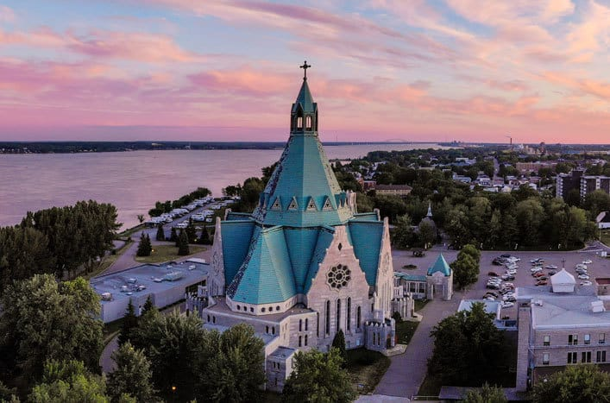“The Notre-Dame-du-Cap Shrine is a Catholic Marian Pilgrimage Site located at Cap-de-la-Madeleine, near the City of Trois-Rivières, on the Banks of the St. Lawrence River. It was dedicated to the Virgin Mary and welcomes more than 800,000 Pilgrims each year. The Site has been designated a National Shrine by the Canadian Conference of Bishops. It is the Second Largest and Most Important Marian Shrine in North America, after that of Our Lady of Guadalupe in Mexico.” Let us try to reconstruct the stages of its Long History.

**THE FIRST TWO CHAPELS**

For nearly 300 years, the Site of the current Notre-Dame-du-Cap Sanctuary was the Nucleus of the Sainte-Marie-Madeleine Parish. It is located at Cap de la Madeleine, on the left bank of the Great St. Lawrence River, at the Mouth of Lac-St-Pierre, about 100 km from Quebec City.

In 1659, Lord Pierre Boucher had a First Wooden Chapel built to serve as a Parish Church, with a Beautiful Bell and a Small Cemetery nearby. In 1720, a New Parish Church was opened for Worship. Built of Stone, it replaced the Old Wooden Chapel. It was placed under the Patronage of Saint Mary Magdalene, with a Chapel dedicated to Our Lady inside.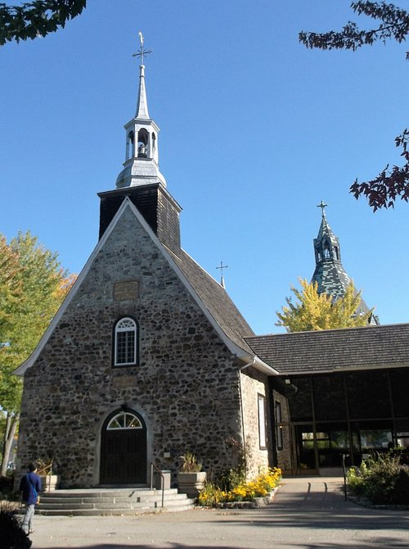The Parish Priest, Father Paul Vachon, was a Great Devotee of the Virgin and had established the Confraternity of the Rosary in the Parish in 1694. After Father Vachon's death, that Marian Devotion began to decline, until it almost completely disappeared for over a Century.

However, a New Boom took place in the Middle of the 19th Century: in 1845 the Rosary Confraternity was reestablished by the Parish Priest, Abbé Tourigny; in 1854, the year of the Proclamation of the Dogma of the Immaculate Conception, a Parishioner donated the Statue of the Virgin, which would become known as “Notre-Dame-du-Cap”; from 1867, the New Parish Priest, Fr. Luc Desilets, gave a very strong impetus to Marian Devotion, in particular to the Recitation of the Rosary. After seeing, inside the Church, a pig chewing a Rosary in front of the Altar of the Blessed Virgin, he said to himself: “People drop the Rosary and it was the pigs who pick it up.” That Spectacle pushed him to reawaken Faith and Prayer in the Parish.

**SIGNS OF OUR LADY'S PROTECTION**

The Marian Revival experienced a New Fervor: the number of people attending the Parish was constantly increasing, and the Small Church was becoming insufficient to accommodate them. The Bishop decreed that a New, Larger Church must be built. To save money, it was considered demolishing the Old Church and using its Stones; the remaining stones would come from the South Bank of the St. Lawrence River. They waited for Winter so that the River would freeze over and sleds could cross it on the ice. Father Desilet instructed his Parishioners to Pray the Rosary every Sunday in order to obtain Ice to cross the River. But the Winter of 1878-79 was exceptionally mild, and the Waters did not freeze. The First Half of March passed, and the Season of extreme cold was soon to end: would it no longer be possible to build the Church? It was then that Father Desilet made a Vow to Mary that if she intervened, he would consecrate the Old Church to her, renouncing the idea of demolishing it. His prayer was immediately granted. Heavy snow fell. An Ice Jam formed. The Parishioners set to work to consolidate the Ice and Snow Bridge and mark it.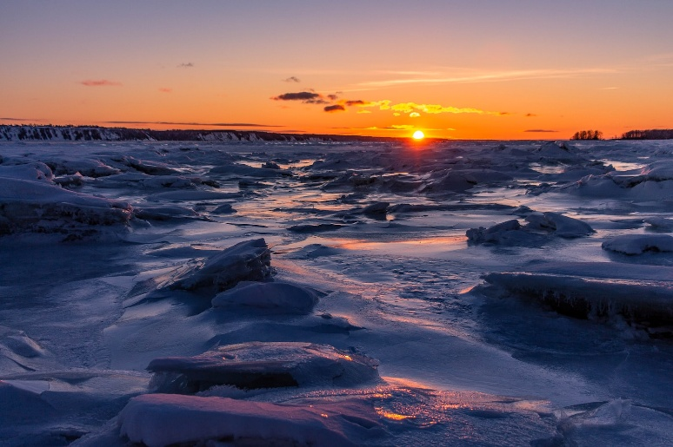They worked for several days, until they formed an Icy Path two kilometers long. They used it to transport Stones across the River from March 18th to 26th, with 175 Horse-Drawn Carts. The Parishioners spontaneously named that Bridge “The Bridge of Rosaries.” It was the “First Miracle” linked to the Sanctuary.

The New Parish Church was built, which would also serve as a Church for the Pilgrims who arrived in Large Numbers, attracted by the Fame of the Miracles. A New Priest, a Missionary in the Holy Land, Fr. Frédéric Jansoone [who would be proclaimed Blessed in 1988] came to help Fr. Desilet. He would confirm the Vow he had made to ask for the Grace of the “Bridge of Rosaries”: to dedicate the Old Little Parish Church to the Virgin. On June 22nd, 1888, Fr. Jansoone presided over the Ceremony of Consecration of the Old Church of St. Mary Magdalene to make it the Sanctuary of Our Lady of the Holy Rosary. He pronounced Prophetic words: “*From now on this Sanctuary will be that of Mary. Pilgrims will come from all the families of the Parish, from all the Parishes of the Diocese and from all the Dioceses of Canada*.” On the same day, the Statue of the Virgin in the side Chapel was placed above the High Altar, where it has remained ever since.

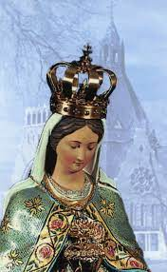To give another Sign of her Maternal Intercession and her Special Presence in that Sanctuary, the Virgin would take advantage of that day that the Parishioners had dedicated to her. “That same Evening, around 7 p.m., Father Jansoone, Father Desilet, and a Disabled Man, Mr. Pierre Lacroix, prayed to the Virgin Mary in the Small Sanctuary. They would witness the “Miracle of the Eyes.” According to the three men, the Statue of the Virgin, whose eyes are lowered, looked straight ahead for Several Minutes. “*The Statue of the Virgin, which had its eyes completely lowered, had its eyes completely open; the Virgin’s gaze was fixed; she was looking ahead, straight at her height. The illusion was difficult: her face was in full light due to the Sun shining through a Window and perfectly illuminating the Entire Sanctuary. Her eyes were Black, well-formed, and in complete harmony with the rest of her face. The Virgin’s gaze was that of a Living Person; he had an expression of severity, mixed with sadness. That Miracle lasted approximately 5 to 10 minutes*.” (P. Jansoone) Did the mysterious expression of that look mean Mary’s Maternal Concern to keep the Faith and the Invitation to follow her Son, in a future that would be tempted to forget Him?

With the increase in the Number of Pilgrims, it was necessary to enlarge the Parish Church (that of the Bridge of Rosaries) and install New Services. The Community of the Oblates of Mary Immaculate was called to serve the Parish and the Sanctuary. The Grounds of the Sanctuary of Our Lady of the Holy Rosary of Cape Town were enriched with Sacred Spaces: the Stations of the Cross, the Way of the Rosary, the Bridge of Rosaries (in 1924) … and above all with a New and Vast Basilica, adapted to the Growing Influx of Pilgrims. “*Built between 1955 and 1964, the Basilica of Our Lady of Cape Town was a Vast Octagonal Building, with a Pyramidal Dome, surmounted by a Lantern and a Cross…”*

The Statue of the Virgin of Notre-Dame-du-Cap had been crowned twice: in 1904, when she was proclaimed by the Church “The Virgin of the Canadians” and in 1984 by Pope Saint John Paul II. During that visit, he proclaimed: “*This Marian Pilgrimage is an Immense Grace given to the Canadian People. May the flow of faithful never cease in this Place!... I think of the 10,000 Young People from Schools across Canada who prepared my visit: You too, build the Church of Canada*!”

1. **THE BROTHERS OF CHRISTIAN INSTRUCTION PILGRIMS AT NOTRE-DAME-DU-CAP**

The Marian Devotional Branch of Our Brothers in Canada was remarkable. The Juniors were welcomed with these words: “The Queen of this House is the Blessed Virgin.” Devotion to Mary, according to the Doctrine of Father de Montfort, inherited from Brother Longin Torlait, Novice Master at La Prairie, would always remain in honor in the Houses of the Brothers. The Magazine of the Juniorate of La-Pointe-du-Lac, “Le Petit Juvéniste,” contained a Commentary on some aspects of that Devotion. It also mentioned the Sessions prepared for the Feast of the Immaculate Conception, with the “Consecration to Divine Wisdom through the hands of Mary.” Marian Feasts were celebrated with Songs and Special Prayers. Every Saturday, a Marian thought was decorated on the Blackboard and the Young People were invited to pray the Rosary. In the Brothers' Properties, several places were dedicated to Marian Prayer, in particular the Grotto of Lourdes, well-appointed in all the Houses.

The Juniorate of Pointe-du-Lac was quite close (about twenty km) to the Basilica of Notre-Dame-du-Cap, dedicated to the Virgin of the Rosary.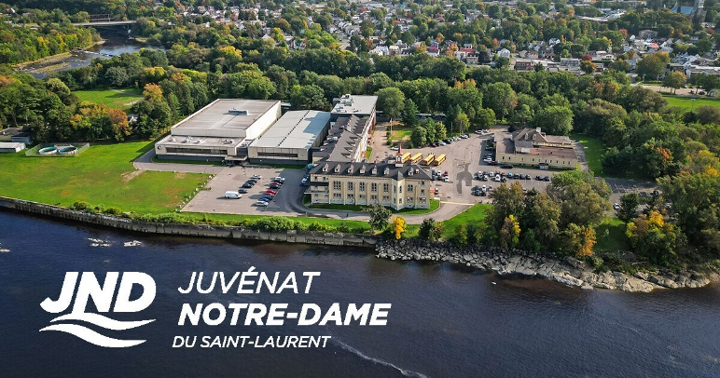Almost every year, “Le Petit Juvéniste” recounted at length the Pilgrimage that the Juniorate made there in September: for everyone it was a Beautiful and Joyful Outing to which they attached Great Importance and of which every detail was meticulously prepared. In a Naive Poem, Brother Louis-Eugène Le Mouée, under the name of Jean Credo, recounted that of September 1914:

*“The Little Pilgrims”*

1. *Above the Old, Trembling Pines, / the Sky has become less dark / and the White Beds of the Large Dormitory / are outlined in the Gloom.*
2. *We see anxiously opening, / watching for the dawn that is about to break, / here and there, Little Eyes / turning towards the Window.*
3. *Do you know why sleep / has deserted so many Eyelids? / And why, since waking, / these children say prayers?*
4. *They will go early in the Morning / to the Sanctuary of Mary. / Already the Young Pilgrim / thinks about it with love and prays.*
5. *The signal is given: Get up! / In silence we must get ready; / we hurry, we think of everything, / because we are preparing the Party.*
6. *We walk along meditating / on the Merits of the Virgin: / and very close to us, we hear / the Water breaking on the Bank.*
7. *What is that dull buzzing? / The Eye looks, the Ear listens: / it's the Buses! Cheerfully, / everyone gets in: On the Road!*
8. *Along the edge of the Meadows and Coppices/ the fast Buses pass, / and we advance, collected, / in the Mist with its damp Flakes.*
9. *As we say the Ave / in a murmur of Joy, / the Sun suddenly rises, / over there, where the Horizon glows red.*
10. *The Bird sings of the dawning day, /mingling its Prayer with ours: /the breeze, with its caressing breath/carries both to the Sky.*
11. *We speed quickly and without stopping / towards the Cape of Madeleine / whose slender and pretty Bell Tower / stands, Silver, in the Plain.*
12. *Finally we arrive, happy, at the Door of the Sanctuary / which for two hundred and fifty years / has opened every day for prayer*.”

*John Credo*

The Account of the “Little Juvenist” gave us many details about the Coach Journey, about the visit to the Statues of the Rosary and the Stations of the Cross, about the Mass and the Devotions*… “We entered the Modest Sanctuary. Our eyes were immediately drawn to the Miraculous Statue of the Blessed Virgin. We were as if seized with fear and admiration at the sight of that Statue: she had already opened her Eyes and how many Miracles had been performed at her feet!... An Atmosphere of Piety, Calm and Happiness permeated and delighted us… We sang the Praises of Mary: that year in Cape Town the Second Centenary of the Foundation of the Chapel was being celebrated… Then we had Lunch under the Shelter intended for Pilgrims… We made a Procession on the Esplanade in front of the Rosary Groups. Around noon we left that Place so full of attraction. A last visit to the Virgin Mary, a Last Hymn and a Last Prayer:*

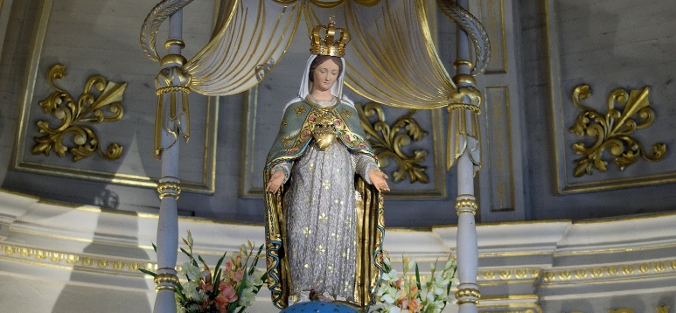***A*** *Hail Mary, hail! Prostrate on our knees*

***V*** *Hear, before your Altar your Little Juniors.*

***E*** *Listen to us, O Queen, O Virgin, hear us!”*

Let us entrust the future of Our Institute to Our Lady of the Holy Rosary!

***SOURCES: FIC Rome Archives: Canada section, La Pointe du Lac: Review “Le petit Juvéniste” 1914/ FA Tassé: “After Seventy-five years:***

***The FIC at Pointe-du-Lac, Quebec from 1911 to 1986***

**B-SOWING IN THE BLOOD OF THE CANADIAN MISSIONARY BROTHERS: “who sows in Tears, reaps in Joy”.**

We have already briefly outlined the History of the Canadian Province. We now wish to highlight two Events which demonstrated the total dedication of the American Mennaisian Brethren and which watered the seeds of their Mission with their Blood.

1. ***THE AIR CRASH IN CONGO DRC on February 16th, 1989 which caused the death of four Brothers.***

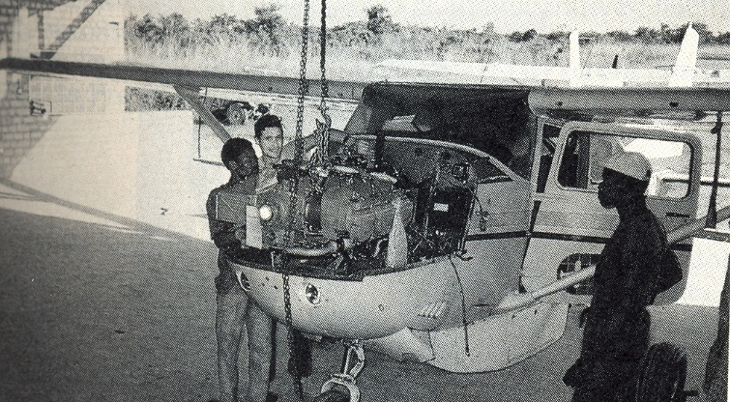On February 16th, 1989, the small CESSNA 206G Plane took off from Goma Airport (East Congo) for Dungu (Northeast Congo). On Board were 6 people: the Captain, **Brother Normand Berger** (40 years old) from the United States and 5 passengers: **Brother Lucien Baffaro** (46 years old), Provincial, **Rémi Claveau** (39 years old), **Robert Duchesneau** (65 years old) and two Dutch Lay Missionaries: **Arie Van Geldere and Annie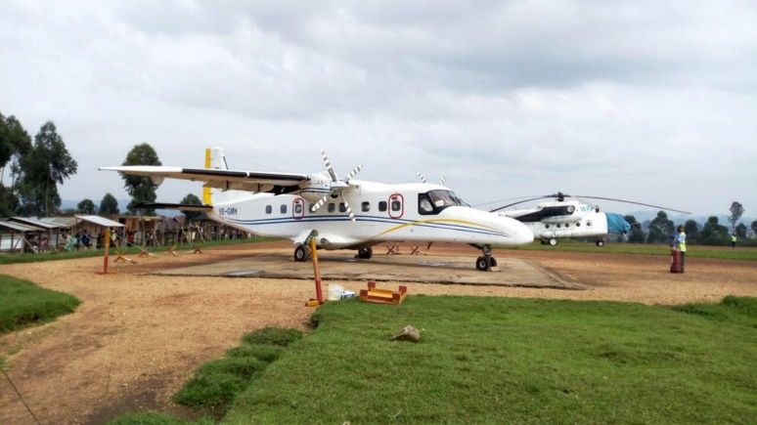Van Den Burgt**. Bro. Normand was an Experienced Pilot, who had flown the Goma-Dungu route hundreds of times. But that day something went wrong: a sudden change in the Weather? Thick Fog around the Nyiragongo Volcano? …”According to the results of the investigation, it could be assumed that the Pilot tried to break through the Clouds and that he was probably misled by the Weather in Goma, which was not equal to that of the Nyiragongo Volcano […] These hypotheses are confirmed by the fact that, until he finally entered the clouds suddenly in the area of the Volcano and due to reduced visibility, hit the trees and the Plane fell, following that impact the Fire broke out”. (Technical Investigation Report, Civil Aviation Directorate, Republic of Zaire (Congo). The Accident left no possibility of survival for the 6 Occupants of the Plane. One can imagine the immense pain felt by the Brothers and by the Families of the Victims and the void it caused among the Missionary Brothers and the Local Church. Let us quote some passages from the Letters of Condolence and Encouragement of the Superior General at the time, Br Bernard Gaudeul: “…We know well that the Cross is the condition of Redemption… Our Brothers, who now rest in Zairean Soil, to which they had all dedicated several years of their lives, would be a cause of blessing for it; from the heights of Heaven they would watch over you and intercede with the Father so that many Workers may arise to replace them for the Harvest.” (18-2-1989) Let us also quote some words from Mgr E. AitiE, Bishop of the Diocese of Dungu-Doruma, very affectionate to the Brothers: “For me, witness to the immensity of the pain of all the FIC of the Institute, of their grieving parents, bent with them under the weight of a Crushing Cross “to Death”; but witness even more moved by all the Sacrifices that the Lord comes to ask of us, I am convinced that he awaits us at the Crossroads: to purify us of Our Dross, to shake us all of our half-measures in the application in our lives of the radicality of the Gospel and above all, to blow in Our Diocese bent under the Heavy Cross of Our Calvary a Wind of Pentecost capable of shaking our whole Little Universe… For me, Brothers Lucien Baffaro, Rémi Claveau, Robert Duchesneau, Normand Berger ARE SAINTS TO PRAY TO MORE THAN PARENTS TO CRY.” (Sources: AFICR Box 412-4: Congo/Zaire)

Bro Normand Berger with Masta, Apprentice Mechanic

1. ***THE “MARTYROUS” DEATH OF BROTHER FRANCIS CARDINAL (November 29th, 1992)***

Thus, L'Osservatore Romano of November 30th, 1992 announced the Sad News: “*Kigali, November 30th. Another Missionary had been assassinated in Rwanda. Brother François Cardinal, 50 years old, of Canadian Nationality, was killed yesterday, November 29th at 8:30 p.m., by six men wearing Military Uniform who burst into the Residence of the Brothers of Christian Instruction in Butamwa, located 30 km from the Rwandan Capital, Kigali. Brother Cardinal, present in Butamwa since 1980, directed the Agricultural Training Center attended by Poor Young People from the Region. The Body of the Religious was horribly mutilated by Bullets (and was hit by Eight Projectiles) fired from High-Caliber Weapons.*

*The Community of the Brothers of Christian Instruction included three other Brothers, two Rwandans and one Canadian. There were no witnesses to the tragedy. An investigation was underway.*

A Telegram from the Holy See conveyed Pope John Paul II's Condolences: “…*The Pope deplored that unacceptable recourse to violence, prays for the Community of Brother Francis, for the Agricultural Training Center he directed and for all the Christians of Butamwa, so that they may find Peace and freely exercise their Educational Mission. He invokes Our Lady of Africa for all those Intentions*…”

In the Introduction to his Biography by FG Boucher, 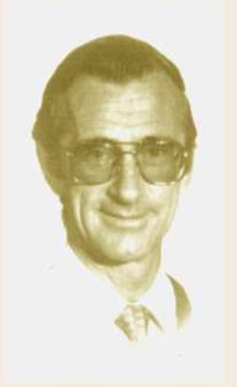we could read: “*The FIC Institute has known among its own a Martyr, a Member whose generosity went so far as to shed his Blood to defend the Poor, the Exploited and the Oppressed! On November 29th, 1992, that Honor was given to him in the person of Br. François Cardinal*” (Sources: Biography of FG Boucher, La Prairie, Canada/ Biographical reconstruction and “Petite Vie” by the Postulation, Br. De Carolis)