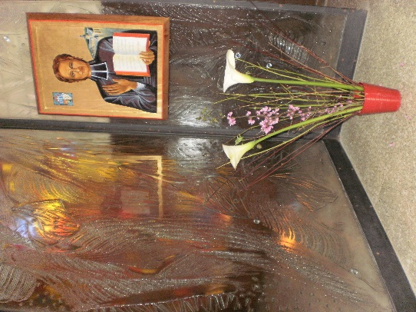
MENNAISIAN MONTHLY NOVENA
JULY 2023
1-NEWS OF POSTULATION
- On June 1st, the Medical Commission met to examine the case of little Josette Poulain's recovery from a presumed Epidural Hematoma. The answer was as follows: the elements of the diagnosis lead to affirm an exceptional cure, but they are not sufficient to establish with certainty its inexplicability. So the judgment is “Suspensive” (suspended): neither positive nor negative. There will be a Report written by the Secretary of the Commission which will give the Minutes of the Meeting of Medical Specialists.

- INTENTIONS FOR THE NOVENA
We continue the prayer through the intercession of Jean-Marie de la Mennais. Let us not be afraid to entrust to him the problems, the illnesses, the difficulties of all kinds of all those we know: he is our Father! The Mennaisian Animator Brothers will collect these Intentions and present them to the Intercession of Father de la Mennais. Anyone who has received an important favour is invited to report it to the Brother Animator, to make it known and – possibly – to examine it officially.
FAVORS RECEIVED
Healing of a Nun of Providence of St-Brieuc
“For two years, Sister Sainte-Marguerite will recount later, I had been affected by a sore throat, which in the month of September redoubled in intensity; I felt a great pain to speak and I feared not being able to make my Class any more. I went to find the Doctor who told me that the attack was very serious; he gave me strong remedies and added: “An operation will be necessary, but I think you are too ill to undergo it at this moment. You will have to come back three times a week. If it doesn't get better, you won't be able to teach anymore." My ears felt the blow, like the throat, and I became almost deaf. The noise made me suffer a lot and it was impossible for me to keep a Recreation. In response to the advice of Mother Saint-François-de-Sales, I began a Novena to our Venerable Father de la Mennais. Five of our Sisters and my younger brother, a junior at Guingamp, joined their prayers to mine. We recited three Pater, Ave and Gloria every day, followed by the Invocation: “Venerable Father de la Mennais, pray for us.”
I did not feel any improvement during this Novena; on the contrary, towards the end, the sore throat redoubled and, at night, I had suffocations which frightened me. Mother Superior, worried about my condition, told me that I should see the Doctor on Thursday January 24th. Then, full of confidence, I began to speak to the good Father again on Tuesday the 22nd: The Sisters who had prayed with me and the students at the Boarding School were good enough to redouble their fervour and join in my prayers. “My good Father, you still have two days to cure me: it is absolutely necessary to do so, so that the Doctor declares me completely well” - I said in my heart. On Thursday the 24th, in the morning, I prayed with ardour and hope. Around 10 O'clock I went with Mother Superior to the Doctor. As soon as he inspected my throat, he said, "Sister, you are healed, you don't need to come back here anymore!”. My confidence in the power of our revered Father was so great that the Doctor's words did not surprise me: I was expecting them. On returning to the Community, I went to the Chapel to thank Our Lord and the good Father for the grace I had just obtained and I began a Novena of Thanksgiving.
However, the noise still hurt my ears. I turned again to the good Father and began another Novena. On the last day, wanting to see if I was heard, I went to the middle of a recess where more than fifty children were jumping and talking: I suffered in no way. Since then I do it every day without being inconvenienced and I hear very clearly”. (Sister Sainte-Marguerite, FdlP)
- HISTORY OF DEVOTION TO FATHER DE LA MENNAIS
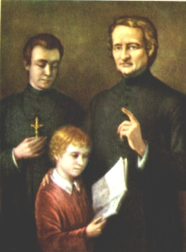
THE YEARS OF NAIVE AND COURAGEOUS FERVOR
Chronicle No. 151 for the Month of May 1939 reports two examples of the Novena. The first made by a very young Brother with children from 8 to 10 years old, the second with teenagers. Let's look at the first example:
1-THE NOVENA IN A PRIMARY SCHOOL
Let's tiptoe into a Mennaisian Classroom at the end of Primary School. For the Week of the Father, their young Master has prepared a small program with two Objectives: 1- The Beatification of the Father. 2- Religious vocations of all kinds, but in particular of Teaching Brothers. Here are some details.
LIFE OF FATHER DE LA MENNAIS: explained by the Teacher and to be deepened by the students.
- Birth-youth-Altar boy/the combatant-the love of children/His Institutes-Death-Survival/the Brothers-works-Development-in short supply.
VOCATION OF THE BROTHERS: with Leaflets to comment on
- In the World many children have never heard of Jesus - there are Atheist Countries.
- Gospel workers are insufficient - many children and young people are left to fend for themselves.
- Existence is not made to accumulate wealth, but to be given and to achieve good, especially where there is Misery and Injustice”

PRAY : The Brother exhibited in the Class the Image of the Father, in front of which the children prayed for his Beatification. They recited a dozen Rosaries, arms outstretched with fervour. The Master had recommended them to say the Rosary on the way to School. Every morning, a group piously attended Mass. The most edifying was the corner of the Sacrifices: “I got up early to go to Mass - I said my Rosary on the way to School - I ate soup that I didn’t like - I did an Errand when it was dark - I prayed with my arms crossed…” The Brother had encouraged people to respond generously to God's call, to put their lives at the service of the Gospel and others in the Vocation chosen by God. In particular, he invited people to embrace the Vocation of the Brother:
By way of conclusion, the Director of the Chronique, Br. Célestin-Auguste Cavaleau, writes: “These examples sufficiently proved the generosity of our students. No wonder, after so much effort to see several Vocations decided to come. And how could our Father not bless, with some favours, such well-disposed children?”
- TRACE OF HOLINESS IN THE MENNAISIAN CONGREGATIONS:
BROTHER ZOEL (AURELIEN HAMON)
In our Institute we have had a large number of Brothers who have left a fine reputation for “Holiness”. In Plouvorn (Finistère, France), the memory of a Brother has still been kept alive, more than 150 years after his death: the “good” Brother Zoël.
His father Yves-Gilles Hamon, originally from Trégor, was part of the Chouan rebels, who fought against the Revolution. After a youth of fights, dangers, prison... a family is formed. He learned the Trade of Shoemaker, but he obtained a Post of Customs Officer, which lead him to move along the coasts of Brittany. He married Angélique Quimper, from Lannion, who gave him four children. Aurélien (future Fr. Zoël) was born in Plouha in 1819. The family was rather poor, but honest and hardworking, with a solid traditional faith. The two boys received a good Education in Ecclesiastical Institutions and in the School of the Mennaisian Brothers. The youngest, Jean-Louis, entered the Novitiate in Ploërmel. Being endowed with exceptional Artistic skills, he became a Drawing Teacher. But after a few years he left the Institute to pursue his career; he will become a Famous painter. Of his brother Aurélien, we do not know many details: we know that he has a good Cultural level, that he was part of the Compagnons du Tour de France, learning several Trades there. He had a great desire to give himself to God and to others: at the age of 20 he entered the Novitiate, at the same time as his brother left it.
Having become Bro. Zoël, he deepened his vocation with a valuable Teacher, Bro. Hyppolite. He immediately obtained his Certificate of capacity for teaching. He made his first experiences first in Dol, then in Dinan: he was in charge of a Primary Class and teaching drawing. In 1842 he arrived in Plouvorn, a small town in Finistère. The Local Authorities had requested a Religious Teacher for their School. Fr. Zoël on his arrival was 23 years old. He spent all his energies on this work. His School was a Chapel-reliquary which served as an Ossuary in the enclosure of the Church. With his practical sense he fitted it out for the pupils: he redid the floor, he repaired the roof and the windows, he had the latrines added. He was full of attention for his children: he used Benefactors to clothe and feed them. It organized the work, classifying the students according to age and level of learning. The parents had absolute confidence in him: they entrusted their children to him, who also came from the surrounding Towns: their number grew to over 120 students. Fr. Zoël was not satisfied with his teaching in Class. On his days off he put himself at the head of his troop of “mustards” - as he called them - and with them he was going into the Countryside: he explained Nature directly; together they praised the Lord like St. Francis, they prayed to the Virgin in her Chapels; they were going to help some families in difficulty. Bro. Zoël was with them in the Church, in the Square for Recreation, in the School for instruction. Its pupils obtained excellent results in the Institutes of the Cities where they pursued their studies. The Municipality was taking steps to have Bro. Zoël recognized as the Official Teacher of the Commune and the Inhabitants considered his distance from Plouvorn a Public misfortune. The Founder was very pleased with himself, but tried to moderate his zeal by urging him to reduce the number of children, but to no avail: Bro. Zoël never refused anyone, especially the poorest. “He who visits his little Christian School admired the good behaviour of his children, and their good health. He saw in it the solution to this problem: to Instruct, Moralize, Clothe and Feed poor students ».
1847. Br. Zoël had been in Plouvorn for 5 years. It was the year of the terrible famine, “that horrible year of scarcity, the memory of which alone makes one shudder”: there were several bad Harvests of Cereals, the Harsh Winter froze the Vegetables in the Fields, late Blight destroyed the Potatoes. The beggars multiplied, the population suffered and died because of the famine. The price of flour became inaccessible because of Speculators who took advantage of it. The exasperated people attacked the Wheat Deposits. Bro Zoël saw his children wasting away from lack of food; he saw his people becoming victims of famine and Speculators. He himself would remedy it. Drawing on his background as a “Compagnon du Tour de France”, he organized a Discount Bakery, a “charity bakery”. He bought large quantities of wheat at a good price. He was lent an oven by a Benefactor. He hired several women to bake and cook. He would transport the bread to the Country with the help of his “mustards”. But everything was well ordered: Bro Zoël organized a system of “bons” for the poor who could not pay anything; established an accessible price for who could share the expenses; recruited Volunteers for distribution and transportation. All this lasted for months: The Administration was so perfect, that it left no debt. Bro. Zoël was everywhere the soul of this Providence Bakery. "He organized a Bakery at a discount, on a simple and skillful plan of execution: he was happy enough by this competition, to cause the sale of bread to cease at such a high rate that the Country was starving for it.
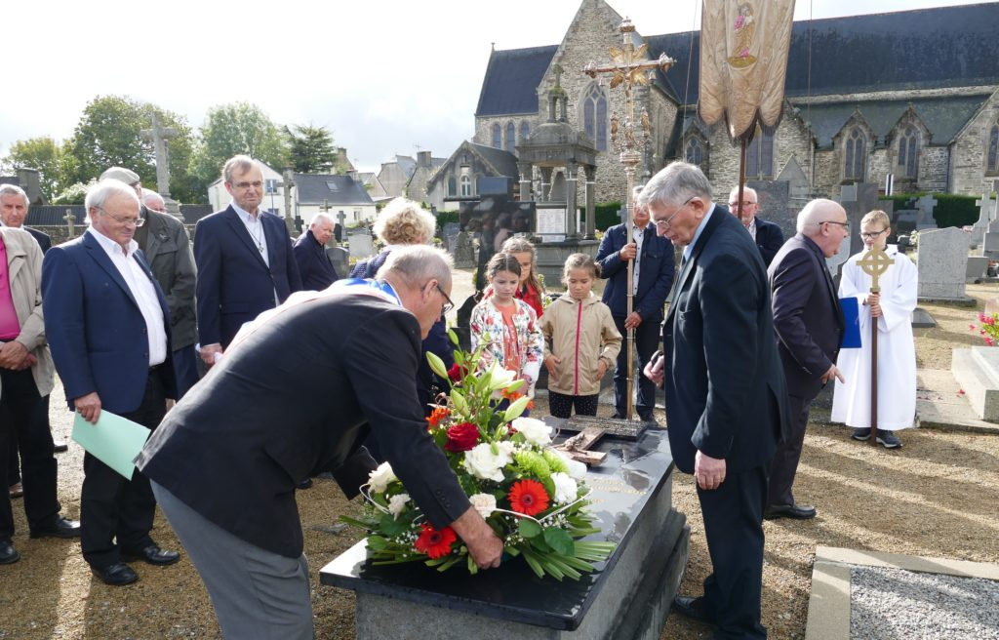
Following these months of great fatigue, Bro. Zoël's health took a first jolt. But he recovered quickly and found himself among his children, enthusiastically living his adventure of Christian Education: he dreamt of founding a Boarding School, he put pressure on the Founder to open New Schools in the surrounding area. He had a passion for his Religious family and cultivated friendship with neighbouring Brothers. But a new Ordeal would befall “his” people. This time it was the mortal danger of an Epidemic raging in the Region: Typhoid Fever accompanied by Cholera. Bro. Zoël still felt called to his children and their families. He went in search of Medicine, Linen, and Food. Very early in the morning, before starting his Ordinary day of Prayer and Class, he went on the damp and dark paths, bringing consolation and remedies. “When Typhoid was raging in many houses and the unfortunates were lying on a bit of straw, without clothes, without remedies, without a friend who dared to treat them, he was there to plead the cause of the abandoned patient, to go from four o'clock in the morning to bandage with Charitable hands the most disgusting wounds.”
Laying of a wreath, the cross and a commemorative plaque for September 22, on the tomb of Brother Zoël, Aurélien HAMON.
Bro Zoël knew well that he put his very life at risk, but he followed the Commandment of Love of his Master Jesus: “love one another, as I have loved you; there is no greater love than to lay down one's life”. He too was affected by the Epidemic and succumbed. “Alas, our fears that he himself would succumb to these dangers were only too well founded. The scourge he faced with the courage of a Christian did not spare him. Irreparable loss for a Parish where he would not be replaced, a noble victim of devotion”. Bro Zoël ended his life on April 13th, Palm Sunday: he was going to celebrate his Easter in Heaven at the age of 31. At his funeral, an entire people followed his coffin in mourning and tears, but also in gratitude for his Teacher, who was for them a father and a brother of immense tenderness. “For him, not a suffering, which he did not hasten to alleviate, not a misfortune which he could not help, not an affliction which he was not happy to pity and to console.” Even today, Plouvorn faithfully guards his memory, invokes his protection and considers him a great Benefactor. Tradition has it that on his tomb, mothers carry their children to help them walk: Bro Zoël helps each of us to walk in Charity to the end!

