

**MENNAISIAN NOVENA**

**JULY 2024**

1. **APPLICATION NEWS**

The Postulation continues to follow Doctors in Italy and Argentina who are deepening the study of Enzo Carollo's healing. We would like the times to be shorter, but we have to present New Elements to request a Second Examination from the Dicastery of the Causes of Saints and that is not simple. We continue to pray persistently for the Intentions Indicated.

At the same time, we continue to highlight the treasure of “Holiness” of several of Our Brothers. We are in the process of organizing a form of Publication for the dissemination of their Biographies.

1. **NEWS FROM THE ANIMATORS**

***SOUTHEAST ASIAN***: Bro Michel Gougeon sent us News of the difficult situation in the Philippines. The Community of San José-Antique prayed a lot to Father de la Mennais for Vocations and for the Sick. Vocational perseverance is quite fragile, despite the enormous efforts of all the Brothers. Efforts and prayers which – we hoped with certainty – are giving rise to Beautiful Vocations for the Brothers in other parts of the Institute, particularly in South-East Asia. Devotion to the Father was very present and prayer obtained small and large favors. Like the healing of Mrs Cora, from the Mennaisian family, who recovered from a Serious Depression following Cancer: she found all her Dynamism: for her it was the fruit of prayer to the Father.

***URUGUAY****:* We received many photos from Brother Guillermo and the Mennaisian Family of Uruguay. The Images show us Mennaisian Celebrations full of Colours, Symbols and Volunteer Initiatives of young people and Adults for the Poor (homeless, elderly, suburban children, etc.). We can see the growth of the Mennaisian Family which is strongly involved in all these initiatives.

***MEXICO****:* There are several Evangelization Initiatives in the Country Villages around Huatusco. These Missions are carried out “in Mennaisian Family Mode”, by Brothers, Families and Young People.

1. **PRAYER INTENTIONS**

* ****Let us pray that Chapter 2024 may give many Fruits of Hope; let us also pray for the General Council which has been Confirmed
* For the Complete healing of ***Br. Alain Josselin***
* For the young ***Augustín German*** from Our School in Montevideo (Uruguay). He has a Very Serious Illness (Osteosarcoma), apparently without Medical Solution.
* For little ***Tommaso Leonetti***, a one-year-old child (Rome). He swallowed Caustic Soda, which caused serious damage to his Digestive System.
* For ***Greta***, a 9-year-old girl from Rome, with Very Serious Head Cancer (Cerebral Glioma with Metastases). She can't even be operated on.

1. **FAVORS RECEIVED**

*Providence of St-Brieuc, 16-3-1927*

Nearly 2 years ago, on April 21, 1925, I was quickly called to my sister, a young woman of 22, suddenly in danger of death. After the birth of a baby, on April 8th, her health was recovering Normally when Very Bad News, relating to her Business, caused this Terrible Crisis: the heart was beating at more than 130, the Fever was Very High. The Doctor, a family friend, was sorry. He told me: “I don’t understand anything and I’m helpless. If I give some remedy for the Fever, the heart would give its Last Effort.”

I had brought a Relic Image of Our Venerable Father; I placed it under the pillow of my poor little sister who had a very bad night. At times she no longer had knowledge, at others, on the contrary, she repeated the Invocations that we constantly addressed to the Venerable de la Mennais. At midnight the Priest Administered Holy Viaticum to her. It was then that I promised to Publish the possible recovery of my sister, if the Venerable Father would save Our Sick Person.

The next two days brought no change; the Doctor gave the same Diagnosis. But on Thursday Morning, an Inexplicable Improvement occurred. I left that same evening, because Our Classes were starting again the next day. At the same time, I was convinced that it would be best to persevere. My hope was not disappointed... The whole Parish was amazed at such a Healing and the Priest, when he saw my sister again, could not help but say to her: “There is the Resurrected One!” I therefore discharged with Great Joy the debt of gratitude contracted by my family towards the Venerable Jean-Marie de la Mennais”

*Mother Saint Clare of Assisi, Daughter of Providence*

1. **HISTORY OF MENNAISIAN DEVOTION**

**n.17: THE PATH TO HOPE**

Our Religious Institute, like many others, is going through a moment of Fragility and Hope. The Fragility is clearly visible in the drop in the numbers of Staff, especially in the West, in the increase in the average age, in the Abandonment or Reduction of Works, in a Precarious Financial Situation and in general in a certain Worry facing the Future. However, the Mennaisian Congregations would not allow themselves to be defeated by the difficulties. The Brothers and Daughters of Providence followed their Founders, immitating their Confidence in Providence, in Apostolic Courage, in Naked Faith in Jesus Crucified and Resurrected, in the Missionary Audacity which never lacked the sons of John -Marie de La Mennais.

This was how Missions were opened or strengthened in difficult Regions, where Poverty and Political Unrest reigned until Wars, such as in South Sudan, South East Asia and Haiti. In many African Countries, Haiti, Indonesia and in other parts of the Institute there was a Great Momentum of the Mennaisian Charism, a growth of Works and vocations, full of promise on a solid basis of Formation and Spirituality.

The Superiors became Interpreters of this New Climate of Hope, which was the Watchword that has guided the Direction of the Mennaisian Family, especially in recent years. The 2018 Chapter could affirm, following to the Dicastery for Religious Life: “*Discernment looks at the horizons that the Spirit shows to the Church. He allows Himself to be guided towards great things, by means of small and fragile signals, by putting our weak resources into play. It’s about creating places where we live the Evangelical logic of gift.”* And the Superior General, Br. Yannick Houssay, confirmed: “*We will enter into the dispositions that were those of Father de la Mennais and Father Deshayes: a great love of God, an intense desire to follow Christ, to resemble Him, to share His love towards each man, above all towards the smallest and the desire to build together the work of God”.*

The New Superior General, Br. Hervé Zamor, in his 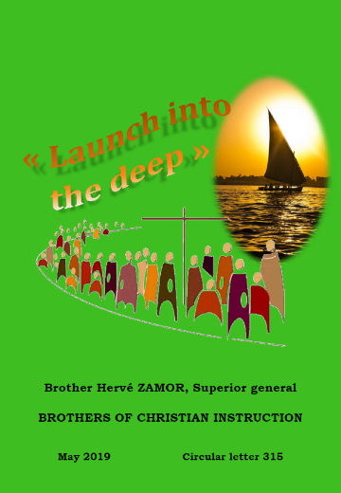First Circular (2019) urged the Brothers to “Launch into the deep”: “*This Invitation from the Lord is addressed to all the Brothers who are on the shore, who are washing their nets and who are tempted to put them away. To those who have toiled or are still toiling all night without taking anything. To those whose nets are full and who call on others to help them. The Lord always goes before us. His time is today. Do we dare to believe it? He wants to fulfill us beyond our expectations. Are we open to his surprises?*” These words echo the exhortations of Father Jean-Marie de la Mennais: “*Around us nothing is stable, so let us not rely on man, the miserable toy of the most unforeseen events; let us rely on God Alone; let us attach ourselves only to God Alone; we only desire the fulfillment of His will, always Holy, always just, always merciful*.” Brother Zamor continued on the path of Hope, in his Second Circular of April 2021 “In Mennaisian Family Mode”. He urged it to become a Bakery, following the example of the venerated Brother Zoël, who in the early days of the Institute, had created a “Social Bakery” during the food shortage of 1846-47 in Plouvorn (Finistère). This Brother, ardent Apostle with his 114 students, made himself a living Eucharist, giving his life to care for the sick in an Epidemic, dying at 31 years old. “*Breaking Bread is the reason for Our Congregation. Today is an urgent Mission. To meet this Missionary challenge, the Brothers and Laity of the Mennaisian Family are invited to lend each other mutual support. Like members of the same body, we are called to be Mothers, Fathers, Brothers or Sisters, Bakers when it comes to meeting the different needs of the children and young people entrusted to us. This is living more and more in the style of the Mennaisian family*.”

This same call for hope would be the refrain of the General Chapter of 2024 which arrived at a time of Great Difficulty: The Historical Context was made Dramatic by the COVID Pandemic Crisis, by the resumption of Wars especially in Europe and the Middle East., by Climate Disorders; inside the Institute the fragility was ever more evident by the decline in numbers [706 Brothers] and Vocations in many Countries, by weakness due to Age and Illness. In the Circular of March 2023, the SG explained the Orientation: “The Theme chosen was “Servants of Hope” and the Biblical Icon, the first sign of Jesus in Cana. Why these two choices?

*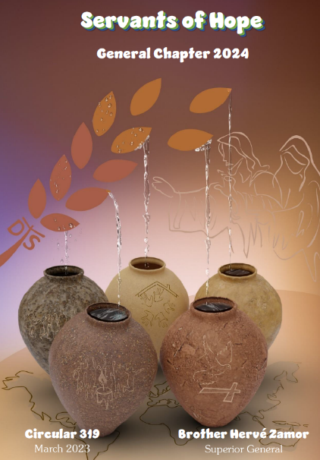Fruit of the discernment of the Major Superiors gathered in Rome at the General Conference in 2022, this Text from the Evangelist John found a particular resonance in us at the end of the re-reading of the Provincial Chapters and the Last General Chapter. We welcomed it as a call to a New Beginning, to a True Conversion. Only the Word of God Listened to, Welcomed and Lived following the example of Mary would be able to change Our Water into New Wine. In the Context of the Health, Economic, Ecological Crises and the worrying Armed Conflicts which are shaking Our World, on the one hand and in the face of the Great Fragilities and the Aging of Our Institute, on the other hand, the first sign of Jesus in Cana reminds us that the Lord is not indifferent to Our Calls of Distress. On the contrary, He is ready to grant them if we* let ourselves cry to Him with Faith, Hope and Perseverance… The Theme “Servants of Hope” connects and gives meaning to what Our Congregation was currently experiencing. At the Heart of Our Fragilities, the First Sign of Jesus in Cana showed us what we could expect from Mary, Our Mother: Strength in Our Struggles, Consolation in Our Sorrows, Hope in Our Failures and Joy in Our Victories...”

The Circular from Br. Hervé Zamor traced a Spiritual Itinerary of approach to the Chapter, on the different aspects of the Gospel of the Wedding at Cana. In each he offered Reflections drawn from the Word of God, from the Magisterium and also from Father de la Mennais. As an example, we take the following lines from n° 4: Filling the Jars with Water, which was inspired by the Founder: “Jean-Marie de la Mennais always urged the Brothers to give the best of themselves in the service of God and the *young people in their care. Thus, he invited them to work every day with New Courage and Great Zeal for the Glory of the One who had called them while maintaining their trust in God Alone. What the Lord asked of them, he said, was not Primarily Success or Achievement, but the Generous and Total Offering of their lives. He often reminded them that “The Work of God does not depend on this or that man, but that the Lord always used what was Weakest to carry out what was Greatest.”*

1. **TRACES OF HOLINESS FIC: BR CHARLES-JULES POITRAS AND THE PIONEERS OF THE MISSION OF UGANDA (1926-1947)**

In 2026 the Province of Saint Teresa of the Child Jesus will celebrate its First Centenary. Let us try to briefly trace the History of the Founding of this Mission.

Mgr Forbes, Coadjutor of Mgr Streicher, Vicar Apostolic of Uganda, came to urgently ask for Brothers from the Superiors of Jersey, for the Schools of his immense Vicariate. Bro Jean-Joseph, SG would have told him: if Canada agreed to take charge of the Mission, the General Council also accepts. On January 26th, 1924, the Provincial Council of Canada decided to take charge of the Mission, postponing the sending of a First Contingent for two years for the necessary preparation.

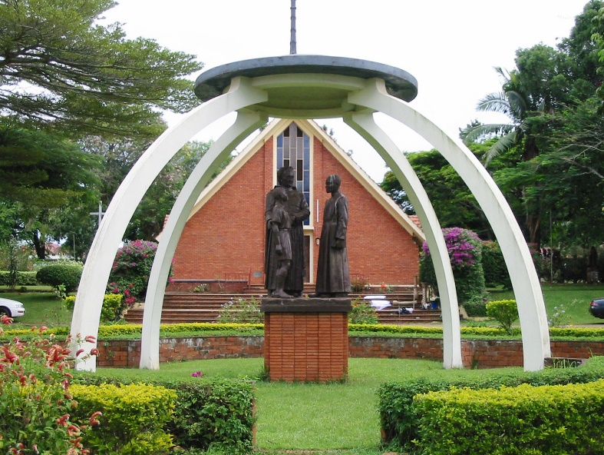

**Monument of the Founders at Mount Saint Teresa, Kisubi**

**HISTORICAL AND RELIGIOUS SITUATION OF UGANDA**

In the Kingdom of Baganda and neighboring Populations, under the English Protectorate, the White Fathers (Missionaries of Africa) and other Evangelists had begun to announce the Christian Faith. In a few years the Gospel had spread rapidly. Christianity had deeply touched the Hearts of the People, particularly young people attracted by the person and message of Jesus. To stop Christian Conversions, Kings and Religious Authorities of the place began to harshly persecute the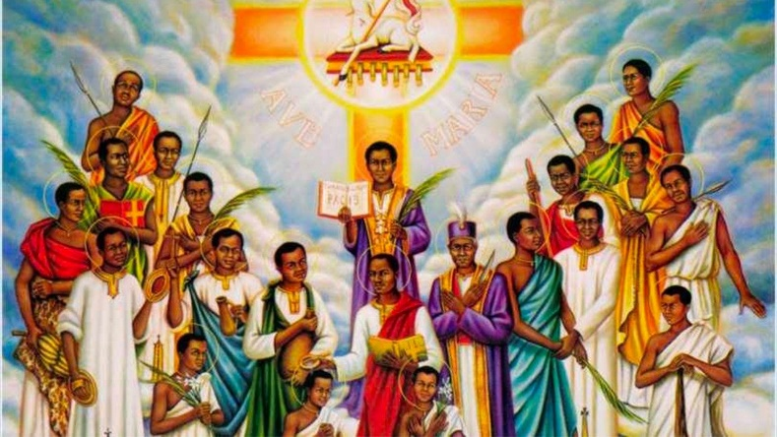

**Martyrs of Uganda**

New Christians and Catechumens. Among others, in the years 1885-87 in Namugongo 22 young Christians accepted Martyrdom. Quite early - the Blood of the Martyrs was the seed of New Christians - the Faith spread throughout the Country. The White Fathers and Evangelical Missionaries began to establish many Parishes and build Churches. At the same time, they Multiplied Schools to promote the well-being and knowledge of New Generations. “The Church was keenly aware of the Critical Role that Schools must play in the Development of African Countries and in the growth of the Church on the Continent.” The Apostolic Delegate would say to the Missionaries: “Attach a lot of importance to your Schools. Where you cannot carry out direct Evangelization and the Education of young people at the same time, leave your Parishes and advance your Schools. The Christian-Inspired School provided a Total, Intellectual, Moral and Religious Education: The Faith could extend “to the Whole Man”. It was a great means of Spiritual Attraction and Progress.

The Missionaries established a remarkable variety of Academic, Agricultural, and Technical Schools and Colleges, but they knew they must resume their Pastoral and Sacramental Activities. In addition, the level of Schools requires Specialized Teachers: The School Organization, Programs and Skills follow those of England and only Trained Staff can meet this New Requirement. It is precisely in this circumstance that the initiative of Mgr Forbes, sent by the Vicar Apostolic of Uganda, Mgr Henri Streicher, would fit.

**THE BROTHERS IN UGANDA: FIRST APPROACHES**

**F Charles-Jules Poitras**

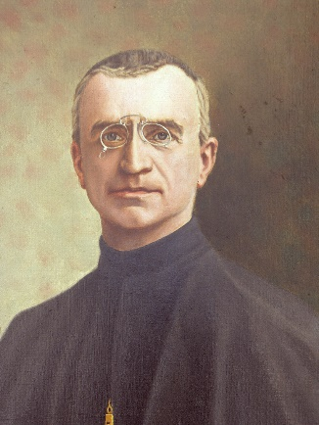Bishop John Forbes had Canadian Origins and was well acquainted with the Brothers of Christian Instruction, established in Canada since 1886: An Evangelist in Africa, when he returned to his Country, he liked to explain his Missionary Adventures to the Brothers and young people in Training. In 1924 he spoke to Brother Jean-Joseph, SG, about sending the Brothers to his Mission Land to take charge of the Schools. During this period the Institute was slowly recovering from the Crisis of Persecution of 1903, followed by the years of the Great War. Everywhere the Brothers encounter Great Difficulties and used their strength to get back up. Internationally, the only place that was “quiet” and growing quickly was Canada. It was to this Province that we must address. Indeed, the response from the Provincial Council, chaired by Br. Célestin-Auguste Cavaleau, was positive. The young Mennaisian Branch began to branch out in the Missions, to help Christianity at its Birth.

**Br. Jean-Joseph, SG**

It was necessary to begin preparing the First Contingent of “African” Missionaries. It was Bro.**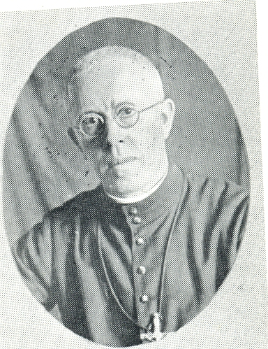Charles-Jules Poitras** who was named founding Director of the New Mission. He was born in Ste-Scholastique, Quebec, in 1884, in a family of 15 children, 5 of whom became Nuns, 3 Brothers (the last was the Founder of Our Mission in Japan) and a Father of the Holy Cross. “He was a Most Active Man, full of Fire and Enthusiasm, Very Zealous for the advancement of the reign of Christ. Director of the Largest School in the Province in Grand'Mère, he led his School with Flying Colors, which had 24 Brothers, a few lay Teachers and 800 Students.” Depriving himself of this was a Great Sacrifice for the Canadian FIC. To break away for practicing English, he had to spend the 1925-26 School year in Plattsburgs (USA) with Our Brothers.

With him, three Brothers were preparing for the Mission:

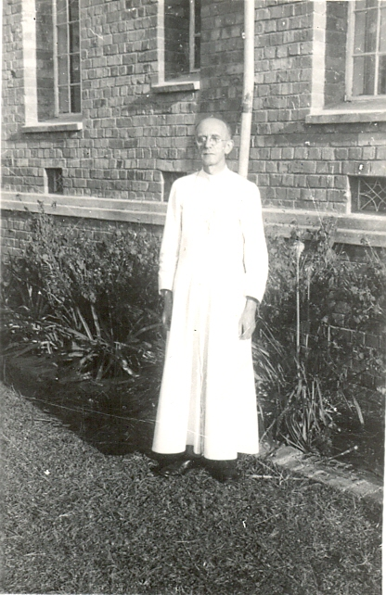***Brother Joachim-Léon Collerette,*** 41 years old, originally from Mascouche, “was Very Good and Very Friendly, Very Calm and Never Excited”. He knew English well, having lived for several years in England with the Superiors. He returned old and sick to Canada, after a life completely spent at the Ugandan Mission.

**Bro Joachim-Léon Collerette**

***Brother Eugène-Marie Paquette,*** born near Lac Mégantic, was only 26 years old. “He seemed very Good and always Friendly and Smiling. He would effectively support Brother Charles, especially in the Recruitment of Indigenous Vocations. He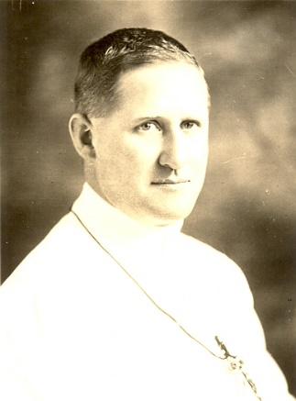 would exhaust himself in the Mission, to the point of falling ill and giving his life at the age of 50.

**Bro Eugène-Marie Paquette**

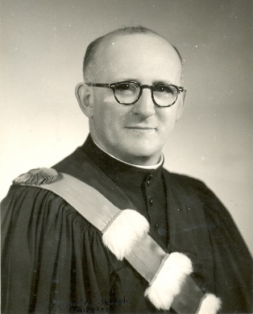***Brother Stanislas-Joseph Taillefer***, 21 years old, completed the First Contingent. “Full of Quicksilver, he couldn't sit still, ready to throw himself headlong into any good work that presented itself, always Active, Joyful, Lively, Slightly Original” (Bro Hubert Libert). In addition to his practical abilities, he was the Chronicler of the Mission.

**Bro Stanislas-Joseph Taillefer**

**TRAVEL AND FIRST IMPACT ON UGANDA LAND**

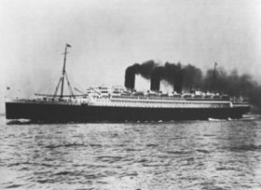In the Chronicle (Echo of the Missions) No. 75 and 76 of September and November 1926, we found the detailed and even Moving Account of the Farewells to the Main House of La Prairie: Special Retreat, Kissing of the Feet, Te Deum, Blessing, Speeches of Superiors. We relived in Canada the Ceremonies of the Former Missionaries in the time of Father de la Mennais. June 10th began the Long Journey: Boarding in New York on the Transatlantic “Paris”, arriving in England at Plymouth, short stay in Southampton and especially in Jersey to receive encou-ragement from the Superiors in opening that Mission at such a difficult time for the Congregation. Travelers spent a few days in Brittany to visit the places where the Institute was born, in particular Saint-Malo and Ploërmel, with a detour to Normandy to venerate the New Saint Thérèse in Lisieux. Who would be the Boss of the New Mission. By Train they arrived in Paris, then in Marseille where they were welcomed by the White Fathers. On July 8th, Aboard the Ship “L'Aviateur Roland Garros”, they crossed the Mediterranean, passing through the Suez Canal: They could only speak with Our Brothers from the outside, because on the Ship there was an Outbreak of Epidemic. They continued to Mombasa. From there by Train and Boat they crossed the Region of the Great Lakes, where they were surprised to find a rather Cold Climate, instead of the Great Heat that they expected there. They arrived in Entebbe, Uganda, where they were warmly received by Mgr Forbes. Finally, on August 4th, 2026, they arrived in Kisubi, the Promised Land of their Mission.

**Transatlantic “Paris”,**

On August 6th, Father Blanc Michaud, later Vicar Apostolic of Uganda, placed the Institution of Saint Mary's College in the hands of Brother Charles and his three Confreres. This was the School

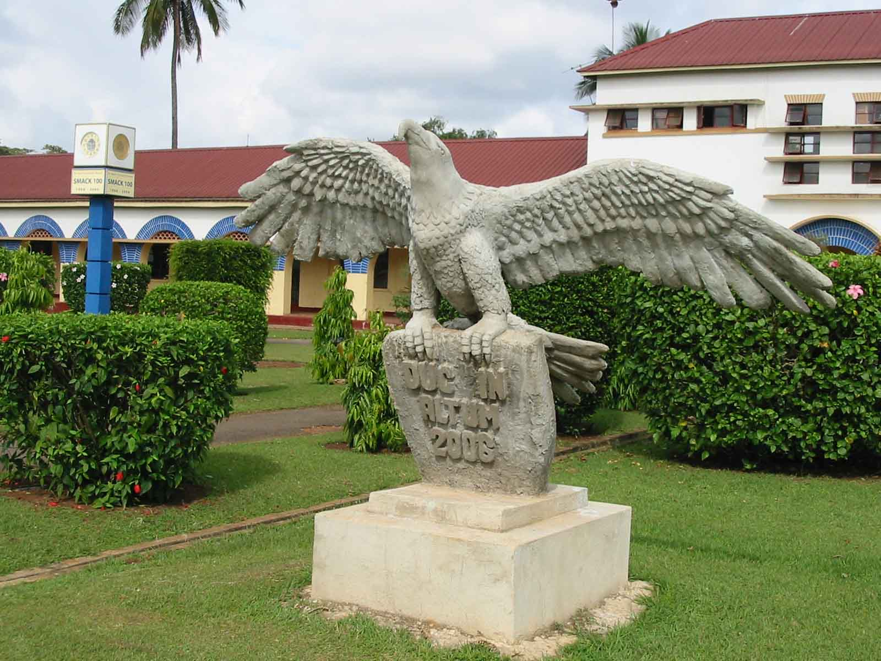**Monument "Duke in Altum" at St Mary's Kisubi**

Catholic Secondary School which prepared students for Administrative and Technical Professions or for Entry to Makerere University. In the whole Country there were only two others, run by the Evangelical Church with Lay Teachers, in Buddo and Namyliango. It was not without emotion that the four Brothers presented themselves three days after their arrival in the Country, in front of their New Students. It certainly wasn't easy to bond with them in a satisfying way. One of the witnesses of these early days still remembers: “Four Ethnic Groups shared the group of 50 students from the College, each with its Own Customs, its Own Language, its Prejudices towards White People. It was going to take Great Tact, an almost Hroic Self-Sacrifice to handle, without hurting them, these 25-year-olds, whose Mentality and Habits were so far removed from those of the Newcomers. Then, it goes without saying, that these students remained strongly attached to their First Teachers and only partially understood the sudden change in Teaching Staff. Added to this delicate situation was the Introduction of a New Program, with Subjects hitherto unknown to the students and which required some changes to Timetables, Texts, Habits... We then remained greatly surprised by the ease with which the students complied with the Various Changes and Methods of their New Masters, thanks either to the good will of the students, or to the Skills, Patience and Passion of the New Teachers.” (Bro Stanislas-J)

In fact, the Brothers had adapted quickly to the New Situation. Mr. Hussey, Director of Education, a Protestant, came to Kisubi to pay a Detailed Three-Day Visit to St. Mary's College. He composed a Laudatory Report on the smooth running of the School and the Speed of Brother Charles and his Collaborators in adapting to Local Conditions. In a few Months they had managed to complete the Entire Course for the Neglected Subjects, they had composed Textbooks adapted to the Learning Level, they had established Relationships of Mutual Trust with the students.

At the end of 1926, the Government gave the Colleges of Uganda their First Examinations according to the New Standards and New Curricula. It was time to verify the validity of the Work of the New Missionaries! St. Mary's College received 24 Degrees from 28 Applicants (other Colleges received a much lower number of Degrees). In addition, Kisubi was Awarded 15 Scholarships out of 20 Offered by the Government. Successes were to continue in the following years. The Exams for the Brothers went well. Now, with the confidence of the Country, they could work on the Evangelization of youth through Christian Schools.

**PERSPECTIVES AND FIRST APOSTOLIC DEVELOPMENTS**

The New Missionaries were not limited to Intellectual and Technical Elevation. They were clearly aware of the Objectives of their Action, according to the words of the Founder: “My Schools are Established to make Jesus Christ Known and Loved”. Eight years after their arrival in Uganda, Fr. Hughes, Deputy Director of Education for the Vicariate, could testify: “The Brothers of Christian Instruction have been working with us in Uganda for eight years. If we were to judge their Results solely from an External Point of View, for example on the results of exams, we would be forced to recognize them simply by the Constant Progression of their Success.

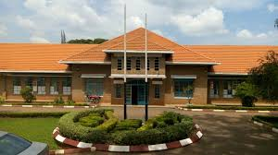

**St Heny's College - Kitovu**

*But they* *are worthy of something else and, whatever their external successes, they have already accomplished a Truly Sublime and Magnificent Work, in developing the Intellectual and Moral Formation of Our Catholic Youth...”* Judgment confirmed a few years later by the Apostolic Vicar Mgr Cabana: “Such was the Program of St Mary's College and the Ideal of the Brothers of Christian Instruction... This Intense Work of Christian Formation Our Brothers of Kisubi l They accomplished with a zeal that never failed in their Noble Missionary Task.”

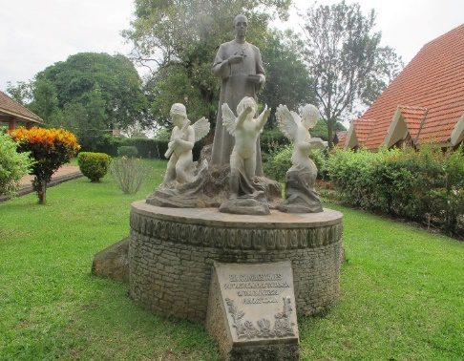Through the waves of New Contingents of Brothers, especially Canadians, the fields of Apostolate spread to other places in the Country: to the Secondary School of Kitovu in 1927, to Mbarara in 1930, to Virika in 1937, to the Normal School of Hoima in 1938, in Bukuumi in 1948. Almost everywhere the Brothers took over from the White Fathers. The Extension in the Territory developed at the same time as the Action of Education and Evangelization: “the diffusion of Catholic Associations such as Catholic Action, the Scouts, the Eucharistic Crusade; Cultural, Sporting, Social Initiatives, such as Sports Competitions, Gymnastics, Music, Theater, Societies Literary”. It was an Integral Educational Offering, which was inspired by Christian Values ​​and which embodied them in the Passionate Experiences of young people.

**Monument at Kitovu, Bro Charles-Jules Poitras, the Founder**

**VOCATIONAL PROMOTION**

Brother Charles, the Inspiration for the efforts of the Young Mission, had formed the Project of finding, among the young people who attended St. Mary's College, Collaborators for the work that he and his Confreres had undertaken on Earth. African. He informed his Superiors, who at first showed hesitation: the Ugandan Church was too young, better a completely African Institute, it was first necessary to Train an Indigenous Clergy... But Brother Charles presented his Project with unfailing confidence bounds in Providence and with the clairvoyance of the Prophets: the youth of Uganda and other Countries would have been Evangelized by the Ugandan Brothers, Fervent and Courageous like their Holy Martyrs. In 1929, the Director received the First two Juvenists in a Poor but Welcoming Room, which served as a Classroom, Refectory, Dormitory... and which had been paid for by the Mother of a Brother. Soon the Number of Recruits reached Four and increased steadily, confirming God's Blessing on the Emerging Work. In 1930 the New Juniorate was built, which began to take on a Regular Rhythm, with serious Cultural and Religious Preparation, under the Direction of Brother Edgar-Marie and then of Brother Alphonse-Joseph, while “Br. Charles did not lose sight of this Precious Seed that he had collected.” Great Joy in 1937 for the First taking of Habits of Ugandan Novices. Among them were **Brothers Stephen Bwanika, Aloysius Lutaya and Alphonsus Zayera,** the First of a Multitude of Brothers from East Africa.

Let us now follow the Protagonist of this Missionary Adventure.

**BROTHER CHARLES-JULES POITRAS**

We have already spoken of the large and deeply Christian family. “Among the Poitras we never failed, when the day was over, however harsh it was, to kneel for the Long Prayer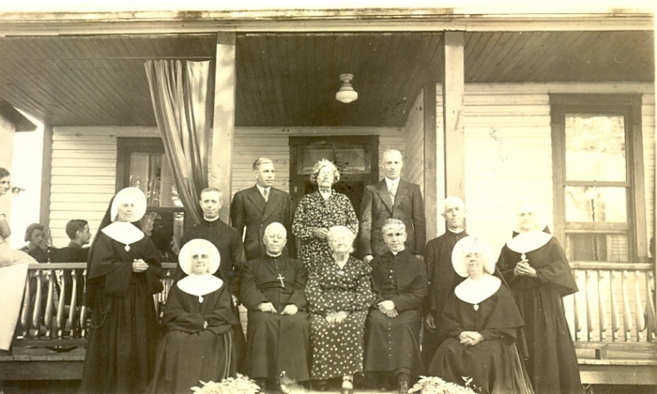

**Family of Brother Charles-Jules Poitras**

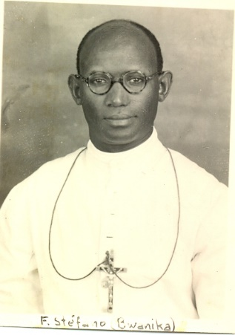

**Bro Stefano Bwanika**

Evening and the Recitation of the Rosary. Jules-Henry gradually forged a Soul of Heaven and sensitive to the distresses of Earth. In the family, the Law of Duty and Work imposed a demanding Schedule on everyone. Jules found his part in the Parish School run by the Brothers. He revealed himself as a Punctual and Attentive Student. At the end of his Twelfth Year, he asked his Parents for Permission to join the Brothers in La Prairie. And it was a Resolute Young Man, already well won over by his Religious Ideal, who knocked on the door of the Prairie Juniorate, to experience years of Prayer and Formation there. He was ready to engage in the Apostolate of Christian Schools first in Montreal, then in Shawinigan. In 1916 Fr. Charles had the good fortune to follow a Spirituality Session under the direction of the Great Apostle of the Sacred Heart of Jesus, Father Victor Lelièvre. He was very marked by it: this Devotion would guide his Spirituality and the League of the Sacred Heart would be a Providential Means for his Apostolate. The Superiors entrusted him with the Management of one of the Largest Educational Establishments in the Region, in Grand'Mère, which he would make buzzing with initiatives of all kinds: Religious, Cultural, Sporting, while also taking care of the Vocation Guidance.

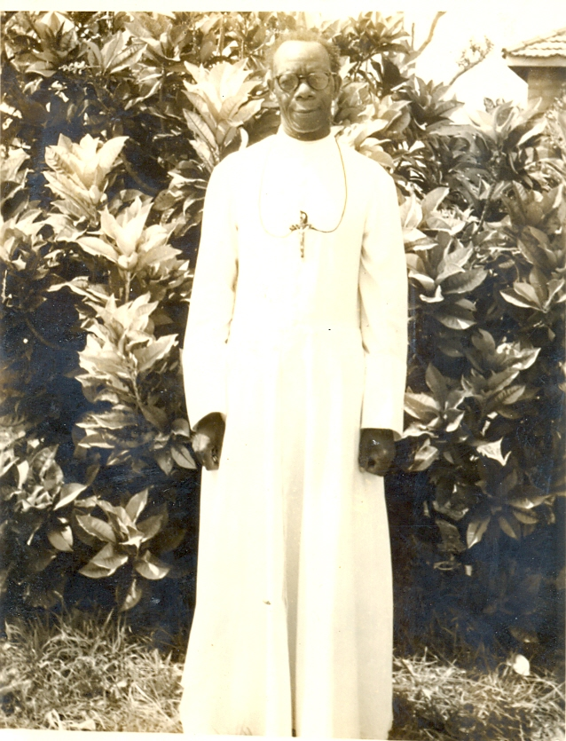

**Bro.Alphonsus Zayera**

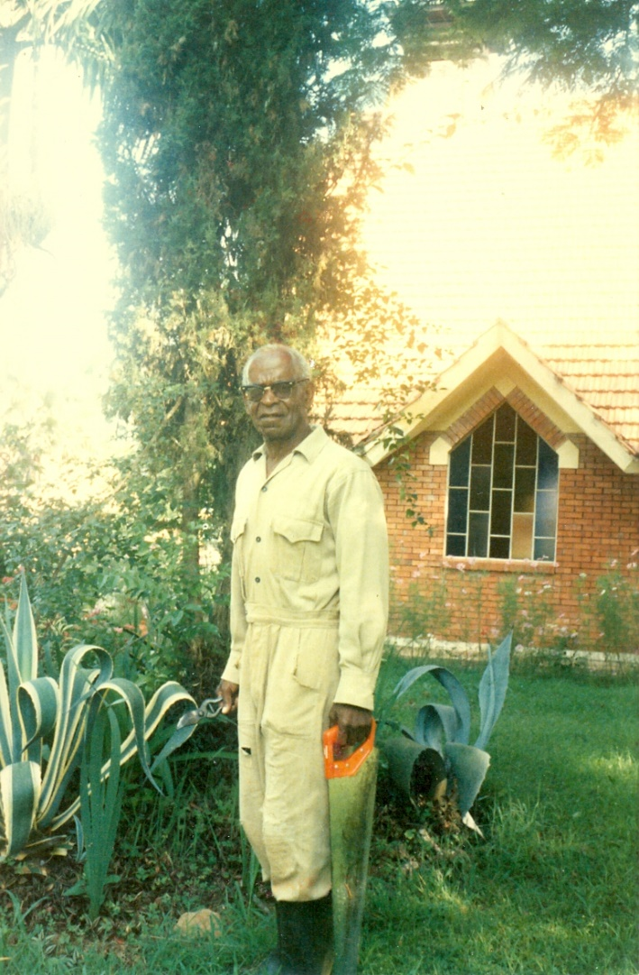

**F Aloysius Lutaaya**

It was in the midst of this Intense Academic Activity that the Provincial Council, in 1924 at the end of his First Directorate, entrusted him with the founding of a Mission on African Soil: A Difficult Work which required Solid Religious People and Ardent Apostles. After the Agreements of the Superiors with Mgr Forbes, Delegate of the Vicar Apostolic Mgr Streicher, the First Missionary Team arrived in Uganda on August 4th, 1926. We followed the story of the First Heroic Times of the Mission. “For 20 years, Brother Charles would be the Soul of the Saint Thérèse of the Child Jesus District. A rather Firm Superior who was esteemed by all, a Zealous and Courageous Apostle, he would know how to mobilize the Human and Apostolic Energies of his Brothers, to whom he would Communicate his Faith and his Greatest Enthusiasm. The Testimony of the fruits of the Brothers' First Works would open up the confidence of the Local Church, which would put many Diocesan Schools in their hands. "Br. Charles also actively participated in this Apostolic Development, he took part in the Joy of his Brothers, after having shared their Work, not forgetting to be near them in the concerns of 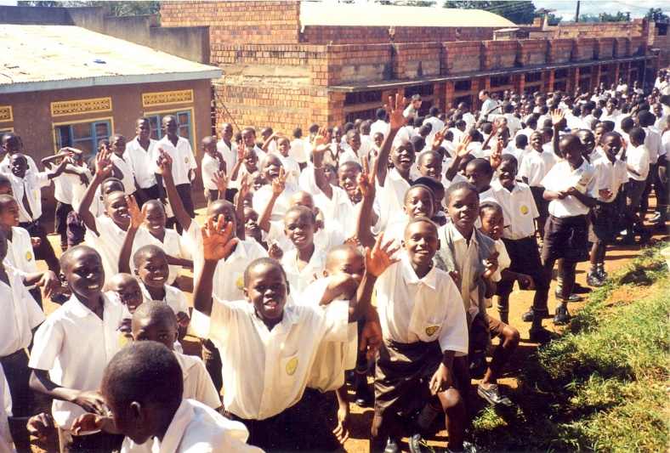Administration”.

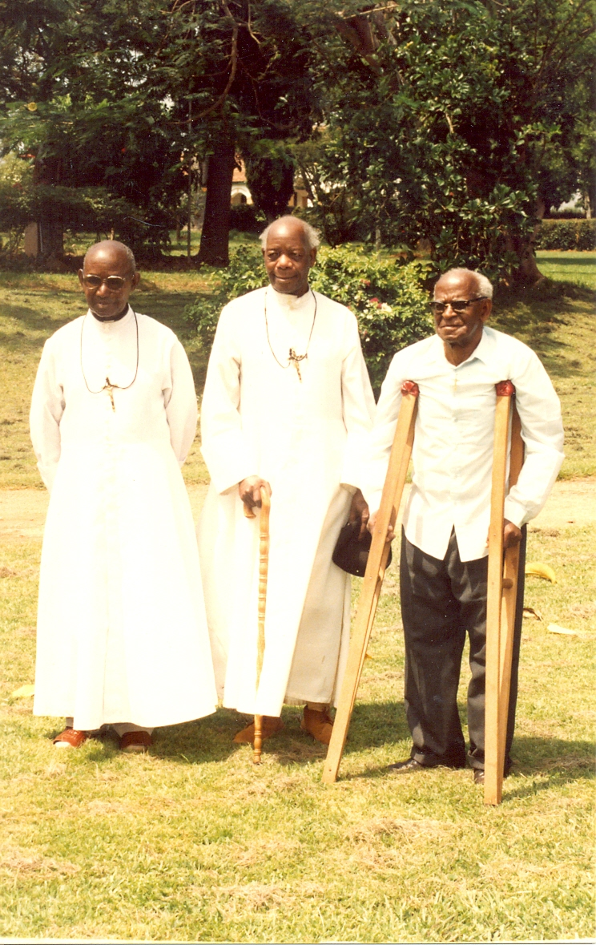

**The 3 Pioneer Brothers, during their 60 years of Religious Life**

The Mission was beginning to take off, when after 5 years it was shaken by a Severe Ordeal: Brother Charles had had an Unfortunate Motorcycle Accident. “He came out with Great Suffering, but above all with a slavish dependence on his Torn and Broken Limbs. This Accident would cause him to undergo Serious Surgical Interventions, followed by Hemorrhages, Suppurating Wounds and Stubborn Fevers. For a long time one of his legs would remain Inert, forcing him to use Crutches and he would only be able to move with difficulty, leaning on a Cane. He must reduce his excessive activity. He suffered from High Blood Pressure and Headaches tormented him day and night, without however shaking his Optimism or Suppressing his Joyous Bursts of Laughter. He trusted in the protection of Heaven, but he testified to perfect submission to the Will of God. Despite numerous Internships in Hospitals in Uganda, France and Canada, the tireless Trainer had to slow down. He “only” continued to lead his Brothers who arrived regularly from the Canadian Provinces, to give his Courses in Kisubi, to follow the Juniors who became Postulants and then Novices. He was a father to them, transmitting to them his unshakeable confidence in their Mennaisian Vocation. His Prophetic challenge proved victorious: Today this part of the Institute is one of the Most Fruitful for New Vocations of Brothers.

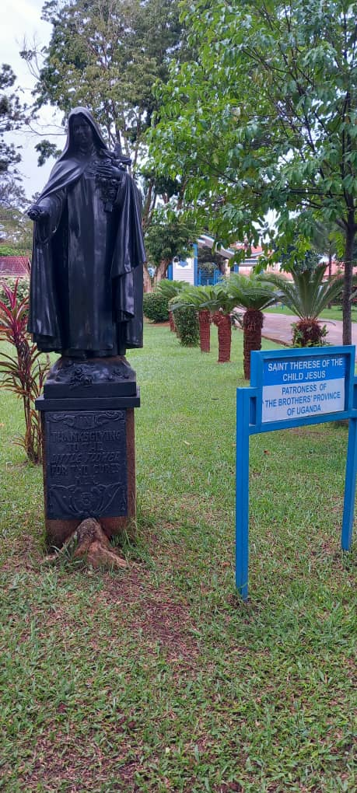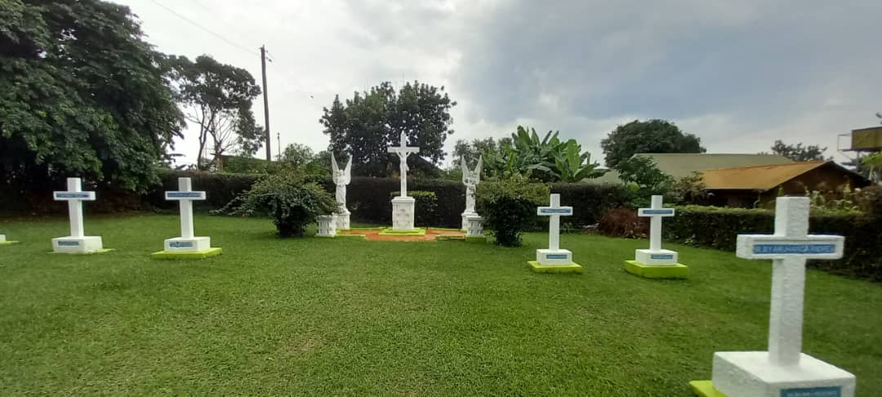Br. Charles demonstrated this concern even at the end of his life. When, in clear awareness of his Health Limitations, he entrusted his Position of Principal Director to a younger Brother, Bro. Alphonse-Maurice, he claimed for himself the Position of Master of Novices. From 1945 to 1947 he poured into the Souls of the Novices the excess of his soul as an Apostle, his Filial Love for the Founder and attachment to the Institute, for which he had spent his life. “It was in this Apostolate that death took him, on September 23rd, 1947, at the age of 63, just a few hours after his Last Conference to his Novices.”

The Missionary Work of the First Missionaries in East Africa was still very much alive. Brother Charles rested “in the Small Cemetery of Mount St. Teresa in Kisubi in the shade of the Giant Yew Trees which pointed towards the Sky as a sign of Hope. We only kneel at his grave with the greatest respect, conscious of the Eternal Presence of God to whom he gave his soul and his life.Bro. Charles continued to give in this place of peace the Testimony of an existence inflamed by the love of God and the hope of the coming of his Kingdom always and everywhere.”

A SYMBOLIC CONCLUSION: THE STATUE OF SAINT THERESA

Brother Charles immediately placed the Property of Mount St. Teresa, received by the Vicar Apostolic, under the protection of St. Teresa of the Child Jesus. These were the years when the “little” Great Saint was highlighted by the Church: in 1923 Proclaimed Blessed, in 1925 a Saint and in 1927 Patroness of Missions. The Director wanted to put the New District under the Special Protection of St. Thérèse. But materially a Statue was needed that could visibly express this presence. Brother Director found nothing better than to contact the Source Directly, that is to say the Carmel of Lisieux. “Mount Saint Theresa did not yet have the Statue of its Patron Saint; Juvenists and Novices ardently desired it and prayed to their little saint with fervor, when Brother Charles had the idea of ​​writing about it to the Carmel of Lisieux. By the same mail, Mother Agnès de Jésus, Abbess of the Monastery and Sister of Saint Thérèse, received the following note from a lady from Paris: “In gratitude to our kind and good little Saint, I am sending you the following sum: included for a Statue of Saint Thérèse; I would like it to be given in preference to an African Mission. I undertake to pay for the Transport.” (The details of two healings followed).

Let us judge the emotion of the Mother Abbess and, a Month later, that of the Happy Inhabitants of Kisubi, when they were informed of the gesture of their beloved Patroness. The “miraculous” Statue currently occupies a place of honor in the center of a lawn, under a canopy of Giant Acacia Trees. She sits at the Center of her Kingdom and smiles at her Little Protégés. Several times a day, Juniors, Novices and Scholastics come to kneel at the foot of her Pedestal, look at her with confidence, hoping that the Rose Petals she holds in her hands would soon come to life and fall on their Foreheads in a Rain of Graces.”

SOURCES (FIC ARCHIVES 406-4)

* 25 YEARS IN UGANDA by F. Stanislas Taillefer (IFRC Archives)
* OUR GREAT MISSIONARIES, Br. CHARLES-JULES POITRAS by Br. JC Bertrand (MISSIONS September 1985)
* NOTES ON THE FOUNDING OF THE FIC MISSION IN UGANDA by Br. Hubert Libert AFICR
* I FRATELLI FIC SULLE SPONDE DEL LAGO VITTORIA by F. Remo Andreucci AFICR
* 150th ANNIVERSARY OF FIC MISSIONARY ACTION by FF. Sylvestre and Paquin
* CHRONICLE (ECHO OF MISSIONS) 1926-1927 / 1961/ 1976-77