1. 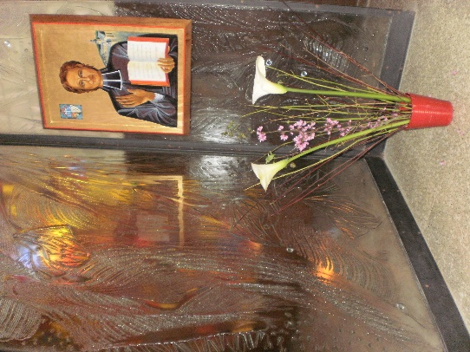**MENNAISIAN MONTHLY NOVENA**

**JUNE 2023**

**1-NEWS OF POSTULATION**

* The Mennaisian Family is awaiting the result of the Medical Commission which will take place on June 1st. All Mennaisians, Young people, Lay people, Families, Daughters of Providence, Brothers of Christian Instruction, Friends of our Founder Father, are united in prayer to obtain the divine blessing through the beatification of Father de la Mennais. Let us follow in the path of prayer and sacrifice, begun so many years ago by all the sons of Father de la Mennais. The grace we want to ask commits us to a new impetus of personal sanctification and apostolic mission, in the charism received by our Founders.
* We have just learned the news of the death of **Doctor Mrs. Myriam De Courrèges**, on May 11th. She had been one of the “expert” doctors in the additional diocesan investigation of Rennes for the presumed inexplicable healing of Josette Poulain. His conclusion was as follows:
* *“The epidural hematoma remains the only probable diagnosis with the intracranial hypertension it induces. Only surgery with osteotomy and evacuation of the hematoma can correct this lesion. The spontaneous favorable evolution is inexplicable.”*Alongside other less favorable opinions, Mrs. De Courrèges' opinion is very encouraging. Now she prays with us in Heaven.

1. **FAVORS RECEIVED**

We prayed at length for Mrs. De Courrèges' recovery from her serious illness (cancer). Apparently we weren't answered. However, she showed unfailing faith and hope, transforming her itinerary of suffering and decline into a path of offering and love for her beautiful and numerous family, for the Mennaisian family, for the world. I wanted to make known part of his correspondence with the Postulator during these last months.

* 2-22-2022: « My father, new chemo today, new descent into hell. To live it under the mantle of Mary at the foot of the Cross of Salvation. I pray to your Jean Marie de la Mennais. Thank you for your prayer. »
* *10-3-2022: « I will approach the third chemo. I will have a report on Monday. I am very weakened. I have a hard time praying. I give everything to Jesus on the Cross for the Salvation of the world. Thank you for your attention and prayer.*»
* 10-7-2022: « Thank you for your message. The chemo had to be stopped, because it became toxic on the kidneys, two months ago. Suddenly I regain appetite and strength. And the Lord gives me the grace of his benefits, likewise the prayer of friends which is powerful communion, because the scan this week shows a stability of metastases. My doctor thinks that my summer will be peaceful, which suits me, because I receive my seven children and their families. We go from overtime to overtime by grace. I keep JM la Mennais and your cause in my heart! »
* 25-10-2022: “Thank you for your message. I am followed by the palliative care services and I alternate stays in the service or at home according to the care needs (various punctures). The disease has spread and the chemo, the last of which was devastating, is definitively abandoned… consent, prepare, accompany husband and children. I receive the Body of Christ almost every day. The Rosary helps me stay at peace. I thank the Lord very much for his blessings in my life. Thank you very much for your prayer. »
* 11-15-2022: “Thank you. State more or less stable at present, but we no longer have any treatment. By the grace of God…In his hands. »
* 6-11-2022: [Father's Day] “Excuse me, I didn't do anything with Josette. So she didn't have her MRI. I'm so tired. Thank you for your prayer. I pray to JM de la Mennais for your cause. [Mrs. Myriam, on her own initiative, wanted to convince Josette to have an MRI. The following week the Dicastery for the Causes of the Saints granted our cause the possibility of accessing the Medical Commission]
* 14-12-2022: “Great news. I'm going to call Josette. I go down slowly but surely with, more and more close, painful punctures. At the same time, to contemplate the Father with open arms full of Love, and at the same time to believe that the healing power of Jesus is still at work... I am still on my feet and I hope to experience Christmas with all our children (except the one in service for the work of the Orient in Armenia). »
* 23-12-2022: “[for Christmas] Thank you [for the wishes]. In communion with your congregation, at the foot of the manger, with all the wishes which are yours and which are ours. [Greeting card with family photo and the words: “God sent the Spirit of his Son into our hearts. (Ga 4) Let us open our hearts to receive the King of Peace”]
* 3-2-2023: [On the announcement of the illness of Assistant Br. Jean-Paul Peuzé] “Thank you for your prayer. I will pray and offer the sufferings for your Assistant General, in deep communion. »
* 28-2-2023: “I rejoice for Bro. JP. May his life be blessed more and more. It's not famous here. I am in the hospital for a pneumothorax following a puncture. I think I'm moving slowly but surely towards the passage [written in blue]. I feel very poor for the meeting that I envisage in Faith, but today is rather the night of the senses. Thank you for your precious prayer. »
* 21-3-2023: “Thank you for the news [improvement of Bro. JP and access of the cause to the Medical Commission]. I'm home, but very out of breath and I can't do much anymore. The Lord accompanies me as well as many nice people. I am in communion with everyone and JM Lamennais. »
* April 9-Easter-2023: “Thank you very much. Christ conquered death. Christ is truly risen. Road harder and harder, but I remain in communion of prayers and intentions. »
* 22-4-2023 [On the announcement of the date of the Medical Commission for Josette] “I don't quite understand what that means. In any case, I pray the Holy Spirit to be at work. Well in communion… I am in palliative care service. I could not any more. Breathing is increasingly restricted. The Holy Spirit is the master in me, for he gives great peace to me and to mine. Everything that will happen will be from Him… I hold the hand of the good Virgin, in communion with you and JM Lamennais. I'll give you my husband's number. You can fill it in if I have already given the spirit. »
* 23-4-2023 [To the response of the Postulator: “Received, but wait for Providence so dear to Fr. de la Mennais”. Yes, yes, I'm in no hurry, life is so beautiful (Jesus you are the source of life). In the meantime, I write little things. »

This is the last message from Mrs. Myriam De Courrèges on WhatsApp. On May 2nd , the Postulator wrote to her: “Good morning, Mrs. Myriam, how are you? We have entered the month of May, the month of Mary. A prayer to Our Lady for you, for your family and for the whole Institute of the Brothers and Daughters of Providence”. Let us also add a thank you, full of emotion for his splendid testimony of faith and for his filial love for Father de la Mennais.