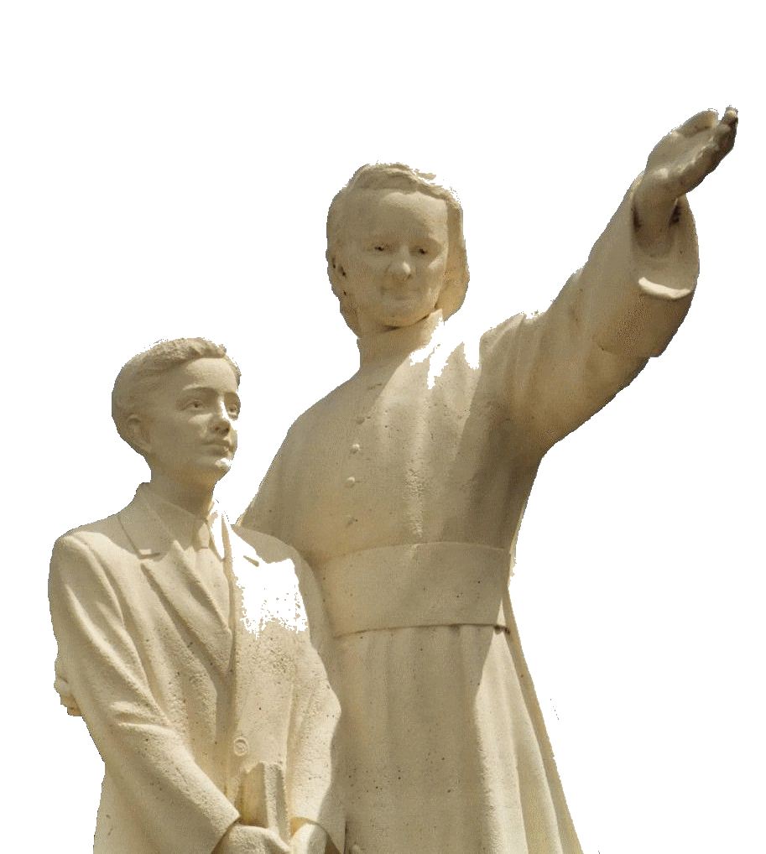

**MENNAISIAN NOVENA**

**JUNE 2025**

***Pilgrims on the Path of Prayer***

1. **APPLICATION NEWS**

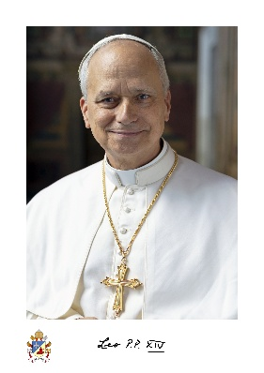**THE CAUSE OF FATHER DE LA MENNAIS**

In union with the Entire Church, we heartily rejoice at having received from the Holy Spirit the New Successor of Peter. We pray for him and prepare ourselves to follow his Pastoral Ministry with Docility, according to the Heritage of Our Founders and the Tradition of Our Institute. With the Inauguration of the New Pontificate of Pope Leo XIV, the Dicasteries of the Vatican Curia have resumed their Activities.

Likewise, the Doctors to whom we entrusted a more In-Depth Examination of Enzo Carollo's Healing have continued their Studies, in order to draft an Agreed Response to be presented to the Dicastery for the Causes of Saints. To complete their Report, they have requested a Neurological Assessment from a Pediatric Neurologist. We would pray that the Examination may be completed quickly and, above all, that it may find the Right Path to Demonstrating the Inexplicability of the Healing.

**OUR BROTHERS IN REPUTATION FOR HOLINESS**

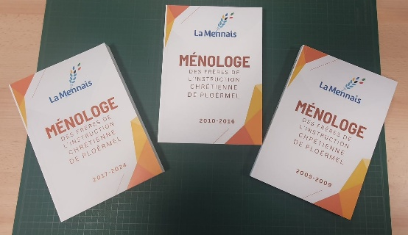In the Institute there has always been a Tradition of recognizing certain Brothers as Witnesses of a Holy Life and an Ardent Apostolate. Good Documents to know them could be found from Several Sources: the Various ***Menologes*** (Cavaleau and Balanant) which have been enriched with ***Four Other Volumes*** (2024-2017; 2010-2016; 2005-2009; 2001-2004) by the Secretary General, Br. Hervé Asse; a Good ***Number of Biographies***, more or less Voluminous and intended for Various Categories of Readers: Students, Adults, Brothers, Young People…; Biographical Notices, composed on the Occasion of Important Celebrations; Speeches at Funerals; Provinces (Canada…) have published a ***Series of Lives of Brothers*** well known in their Districts… At the Postulation, we are doing a Work of Preparation for a Possible Introduction of the Cause of Beatification for some Brothers who left a Strong Reputation of Holiness in their Lives. In Our Congregation, we have had Treasures of Holiness and Heroism (Brothers Zoel, Cardinal, Hyacinthe, Arthur, Constantin, Lucien Séveno…).

We propose: 1- Keep the Documentation concerning the Brothers, the Religious and the Mennaisian Lay People: preserve Letters and Personal Writings, Articles, History of the Schools, Images; Write down the Memoirs especially of the Elderly Brothers… 2- Compose, for those who could and have time, directly the Biographical Memory of some well-known Brothers. One could write Short Lives or more In-Depth Biographies.

1. **INTENTIONS FOR THE NOVENA RECOMMENDED TO THE INTERCESSION OF FATHER DE LA MENNAIS**

We entrust to the Intercession of Father de la Mennais:

* 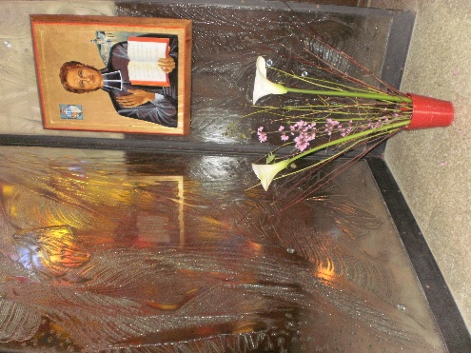***Several Brothers are in Poor Health***; many are present in the Homes of Elderly or Sick Brothers. These Brothers are very valuable to the Entire Institute: through their Prayers and the Offering of their Trials, they give Additional Fruitfulness to the Work of all the Brothers. They could make a Commitment to Recite a Regular Rosary for the Beatification of the Father and for Vocations.
* Two Injured: ***Br. Alberto Pardo***, Bursar of the Province of Spain, and Mr. ***Stéphane***; let us pray for their Speedy Recovery.
* Our Patients recommended by Local Organizers.
* ***Anna***, Cancer and her two Disabled Sons ***Silvia*** and ***Luca***; the Children: ***Tommaso***, ***Alessandro***, ***Alvaro*** and ***Giovanni-Paolo*** (Brain Cancer); the Adults: ***Caroline***, ***Massimo***, ***Camilla***.
* ***Our Brothers in the Most Dangerous Places***: South Sudan, Haiti, Congo DRC and the Brothers who have started the ***New Mission in Timor-Leste:*** Br. Stéphane, Philippe and Éric.

1. **FAVORS OBTAINED THROUGH THE FATHER'S INTERCESSION**

***Plattsburgh, NY USA. Little Girl Cured of Dangerous Fever***

*“At the beginning of December, the Spanish Flu made a second appearance in Plattsburgh. Ruth Lemaire, aged five, found herself confined to a Bed of Pain. For four days, the Fever remained above 39.5°C. The grieving Mother wrote a note to a Nun she knew, asked for Prayers, resolved to do and promised whatever that Nun of the Congregation of the Grey Nuns of the Cross of Ottawa saw fit to order. The latter, who still had fresh in mind the Recent Recovery of Sister Marie-Aimée, of the Hawkesbury Community (through the Intercession of the Father), sent a Picture of Father de la Mennais, recommending that the Mother placed it on her Child's Chest and immediately begin a Novena to the Venerable, with the Commitment to publish the Favor if it was obtained. Madame Lemaire, full of confidence, eagerly granted that request.*

*The next day, the Patient's Condition was such that the Doctor felt it his duty to prepare the Mother for the Cruel Sacrifice. Prayers redoubled in intensity to obtain the Healing so ardently desired. The Mother placed the Image of Our Venerable Father in the Hot Oil compressed that she applied to her Child's Chest. The following day, a noticeable improvement occurred, the improvement continued so well that two days later, the Family Doctor, a Protestant, said to the Mother: "You know, it wasn't me who cured your child." "What do you mean by that, Doctor?" she continued. "Well, Madam, I don't know how it happened, but the Child was visibly alive again. There was no remedy that could bring about such a change in such a short time!"*

*The Child continued to get better and was now in Good Health. The Mother, full of Joy, came herself to tell me all that had happened. She devoutly preserved the Image of the Venerable Father de la Mennais. Brother Oscar-Joseph*

*Sources: Collection by Br. Jean-Charles BERTRAND:*

*Favors obtained through the Intercession of Father de la Mennais.*

**4-THE SANCTUARIES OF THE VIRGIN AND THE PILGRIM BROTHERS OF HOPE**

**Shrines of the Virgin Mary in Southwest Asia: Indonesia, the Philippines, Japan, Timor-Leste**

**THE GREAT STATUES OF MARY: BEACONS OF THE FAITH OF THE PEOPLES**

In Asia, Religious Tradition dates back to very Ancient Times. It was deeply rooted in all Peoples through the Manifestations of Rites, even Public ones, the Construction and Veneration of Places of Worship, Pilgrimages and Prayers of Conversion and Purification. In keeping with that Ancient Tradition, in the Heart of the Countries of Southeast Asia, we found a particular Phenomenon: on the Summits of Several High Mountains, the Faithful have placed ***Statues of the Holy Virgin***. They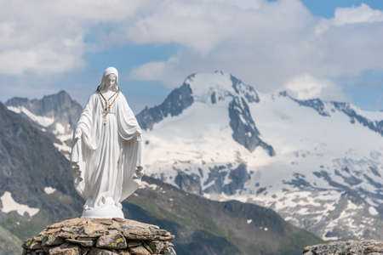 were the Destination of Many Pilgrimages, especially by Christians, but also by Muslims and Asian Religions.

The Statues, Large and Highly Visible even from afar, became Beacons of Faith. Christians, in the shadow of Mary's Protection, could revive their Faith, meet with their brothers in the Church, and ask Jesus for the Necessary Graces through Mary. Those Sacred Places gave Christians, often a Minority, and the Dignity of their Faith amidst different Religions. The Virgin Mary, with her Maternal Presence of Gentleness and Peace, was well accepted by Most Asian Peoples: she became the Mother of All. She awaited them in the Places where Large Statues had been multiplied and also in the "Grottoes of Lourdes": the Faithful went to their Mothers in the Simplicity and Joy of Little Children. Let us see some of those Particular Statues, in the Countries where Our Mennaisian Brothers are present.

**INDONESIA**

On the Island of Flores, the Catholic Heart of Indonesia, a Marian Pilgrimage Site could not be missed. In the Diocese of ***Maumere***: ***in Nusa Tengara,*** in the village of ***Wuli Wutik***,

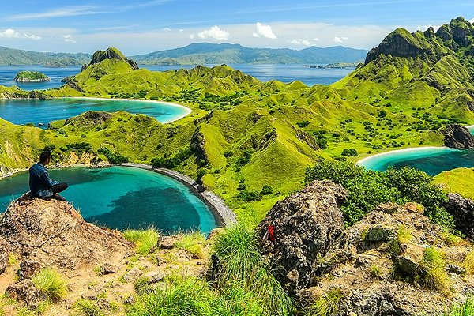On top of a Hill stood a 28-Meter-High Statue of “***Mary, Mother of All Nations.”*** Nearby was a Spirituality Center and the Village of Nile, which meant “Light.” The Faithful saw in Mary “the Light that Guided and Protected the peoples of the Earth.” Also in ***Flores***, in the Diocese of ***Ende***, in ***Mbay***, Numerous Pilgrimages are organized to the Gua (Grotto) Maria, especially during the Months of May and October, during which the Faithful fervently celebrate the Eucharist and Recite the Rosary together: “Pilgrimage was a way to deepen one’s Faith, to strengthen ties between Christians, and to spread Mutual Love.” Marian Devotion seemed to be the Secret that animates the Faith of the Predominantly Catholic Population of Flores. It has managed to maintain its Christian Roots and even it’s Influence in a Delicate and not always Easy Context.

Nusa Tengara

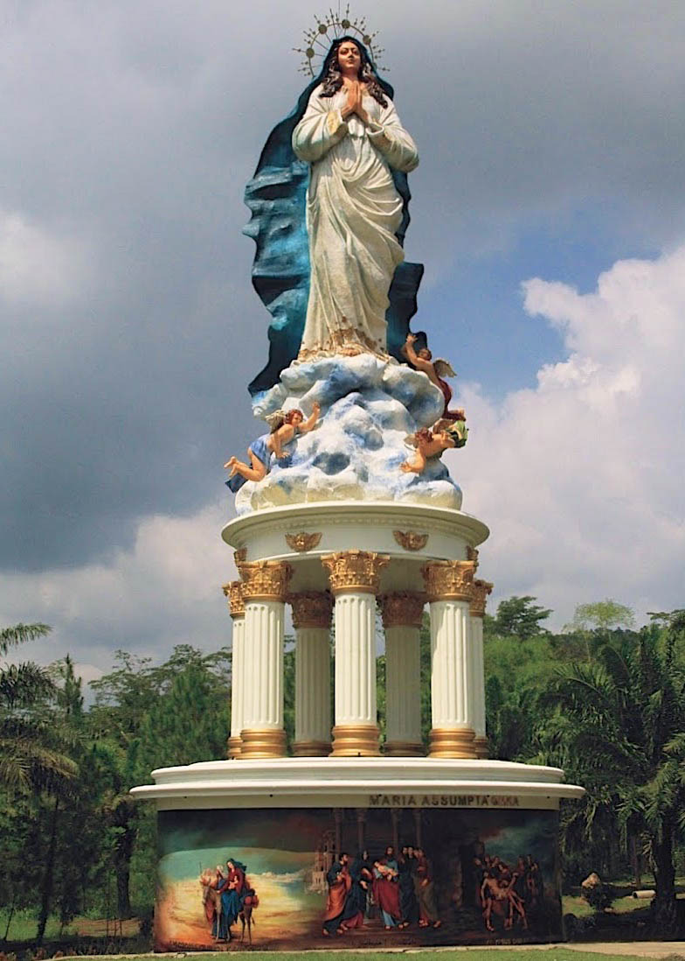Still in Indonesia, but on the Island of ***Java***, in ***Ambarawa***, the Virgin Mary has long been venerated in her Gua Maria, especially by Reciting the Rosary while climbing the Hill. “In 2015, during a Grandiose Ceremony, the New Statue of Mary, Our Lady of the Assumption, was blessed: at 42 Meters High, it [was] the Tallest Statue of Mary in the World.” It was sculpted by Three Local Religious Sculptors. It was significant that this Enormous Statue of Mary was born in a Context of Peace and Interreligious Dialogue: the largely Muslim Population welcomed the Tens of Thousands of Christian Pilgrims, who participated in the Processions, as did their Civil and Religious Authorities.

In ***Central Java***, a few kilometers from the City of ***Yogyakarta***, was the Sanctuary dedicated to the Virgin Mary, the most frequented by Indonesian Christians. It was here that the First Javanese in the Center of the Island were baptized. “Today, Young people and Adults gather at night for Long Prayer Vigils, during which the Inner Spirit, typical of the Javanese Soul, find New Strength to live a Fervent and Authentic Christian Life.”

Indonesia was one of the Countries in the World with the Most Marian Shrines. Almost every Island has a Shrine to the Virgin, especially in the Form of Lourdes Grottoes: 32 in Java, 8 in Sumatra, 7 in Sunda, 3 in the Moluccas, and 6 in Sulawesi. We could conclude that Devotion to the Virgin Mary was deeply rooted in the Spiritual Life of the approximately 10 million Catholics. And the most frequent comment from Non-Christians was: “But look how Beautiful Mama Miriam is!”

**PHILIPPINES**

To celebrate the 500th Anniversary of the arrival of Spanish Missionaries in the Archipelago with the First Proclamation of Christianity, the Christian People of the Philippines wanted to leave a Mark. Since 2000, a Monumental Sanctuary has been built in Batangas, on the Island of Luzon, on a Plateau overlooking the Verde Island Passage, which leads into the China Sea. That Sanctuary was a Vast Place of Prayer on a Relief named ***Montemaria***, in the Center of which a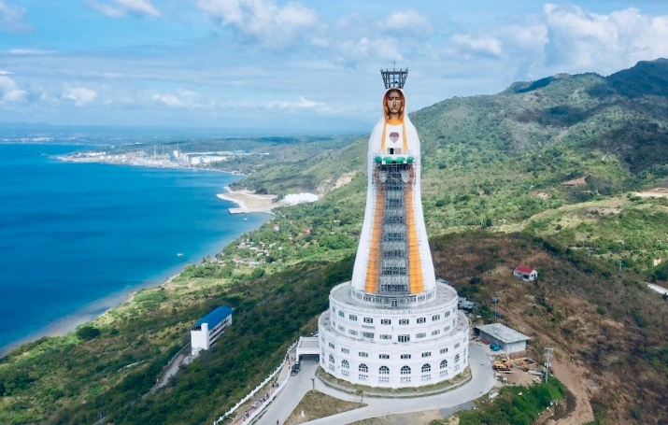 Huge Statue of the Blessed Virgin was built, visible throughout the Region. That Statue was given the Title of “***Mother of All Asia***”: it would therefore extend its Protection not only to the Philippines, but to all of Asia. The Incredible Size of the Statue, 98 Meters High, was intended to make it visible even from very far away. The Construction, completed in 2021, for the 5th Centenary of the Evangelization of the Philippines, was a place of Fervent Pilgrimages. It offered the Faithful Chapels for the many Celebrations, Places of Meeting, Encounter, Prayer, Reception and Accommodation… The Vast Surrounding Land was designed as a Place of Prayer and Inner Pacification, with its Stations of the Cross, the Rosary Paths, the Green Alleys,

Ambarawa - Indonesia

Montemaria

Places of Silence and Contemplation. That Statue of the Virgin, the Tallest in the World, was a Sign of Peace and Meeting for peoples, under the gaze of Mother Maria, who welcomed all her Children into her Immense Heart, ready with Tenderness.

**TIMOR-LESTE**

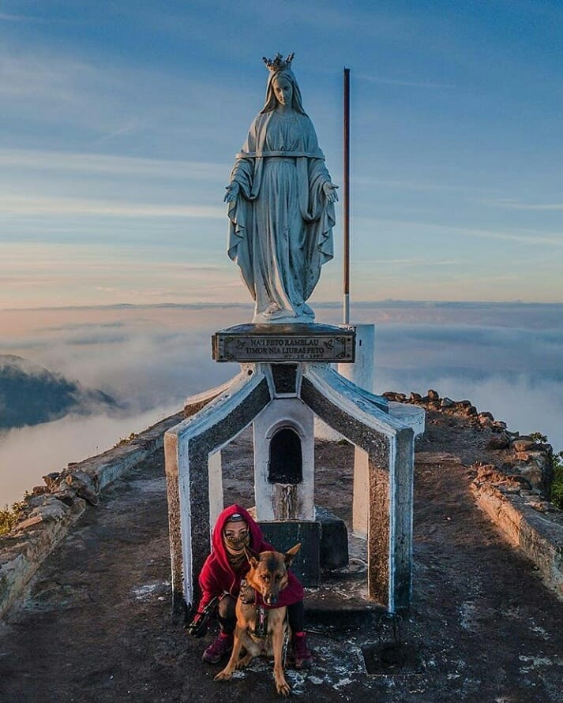The Island of Timor was divided into two parts: Timor-Leste, an Independent State, and West Timor, which was part of the Republic of Indonesia. The Highest Mountain Range on the Island was located in the Territory of Timor-Leste and formed the ***Tatamailau***, with the Massif of ***Mount Ramelau***, which has a peak of 2,963 m. Since the Entire Island of Timor has a Strong Catholic Majority, the Mountain was dedicated to the Virgin Mary. On the Plateau, a place of Worship, the ***Uma Lulik***, was built, with an Altar for the Celebration of the Eucharist, next to a Statue of the Virgin Mary of the Annunciation. On March 25th, a Crowd of Pilgrims climbed the Mountain and spent the day in Prayer: the Faithful recited the Rosary, Sang Hymns, and offered their Devotions throughout the Night. In the Morning, the Bishop celebrated Holy Mass before leading the Procession for the Final Ascent to Mount Ramelau, where the Large Statue of the Virgin awaited her Children. Pilgrims come from near and far. For many of them, that Pilgrimage was a Tradition they do not want to abandon. Other Celebrations are held in October, the Month of the Rosary. The people of Timor-Leste have enthusiastically embraced the Values ​​of Christianity and recognized the Virgin Mary as their Patroness and Protectress.

Monte Ramelau

**JAPAN**

One of the Most Important Centers of Christianity in Japan was the Cathedral of the Immaculate Conception or St. Mary of Urakami in Nagasaki. During the 19th Century, despite difficulties of all kinds, the Catholic Community had managed to grow and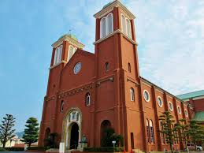 to transmit the Faith especially in those places linked to the First Evangelization of Japan at the end of the 16th Century. She was able to build a Beautiful Cathedral in Urakami, the Largest Christian Structure in the Asia-Pacific Region. In 1945 the Atomic Bomb fell on Nagasaki on August 9th, 500 m from the Cathedral, bringing death and destruction. Among the rubble, the Head of the Virgin was found, with holes in place of Eyes and a Scar on the right Cheek. First placed in the Nuclear Holocaust Museum, that “Relic” was transferred to the Reconstructed Cathedral, inside a Chapel, which became a place of Prayer for Universal Peace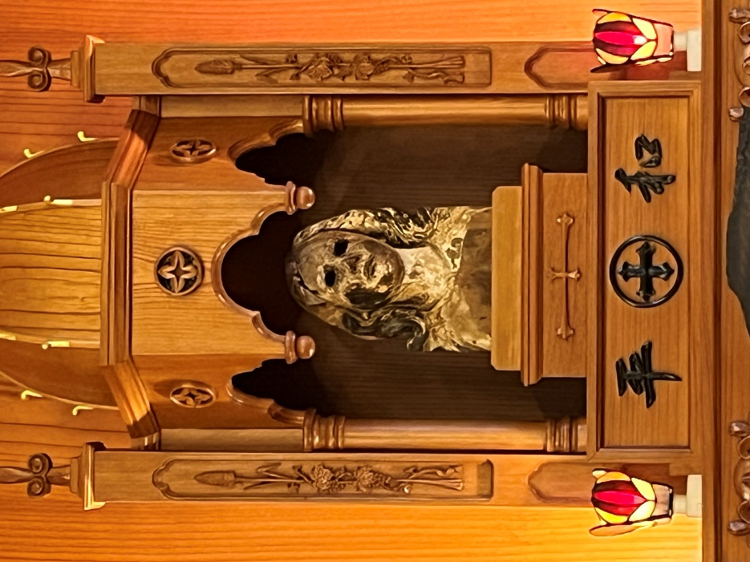. The Image of the Holy Mother of God and Mankind looked at Humanity with her Empty Eyes (the glass pupils have completely melted), but remain full of Tenderness. On her Right Cheek, we notice a sort of Wound, which was reminiscent of a Tear. It was the participation of the Mother, with all her Heart, in the Pains of her Sons and her Maternal Intercession so that the time of Peace may triumph over all Wars.

Figure1Urakami Church (Urakami Cathedral)

**\*\*\***

**THE BROTHERS IN SOUTH EAST ASIA:**

**JAPAN, PHILIPPINES, INDONESIA, TIMOR-LESTE.**

**JAPAN**

On July 20th, 1951, the Pointe-du-Lac Province in Canada sent the First Three Brothers to Japan. They responded to a Pressing Invitation from the Holy See and the need to help rebuild a Country that had been completely destroyed both Materially and Morally. The Province committed to sending Three Brothers per year for the First 15 Years. In 1971, 44 Brothers were placed there: a Huge Donation made by the Canadian Province, especially since the Brothers sent had to be particularly well-prepared in the Language, Academic Studies, and the Evangelical Approach of a people with a Very High Degree of Organization. The Mennaisian Work developed around Three Institutions: St. Mary's International School in Tokyo, for the Christians of the Capital; the large School, from Kindergarten to Secondary School, of Seiko Gakuin (The Holy Light) in Yokohama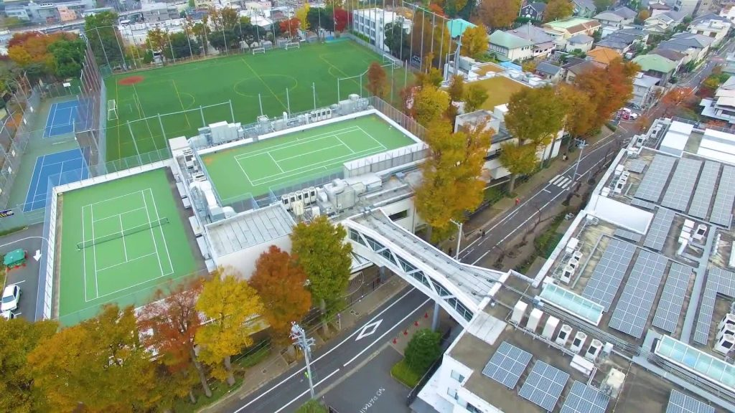? A Secondary School in a more Modest Environment in Shizuoka. Special attention was given to the Proclamation of the Gospel: Celebrations of Christian Feasts, Catechesis, Catechumenate and Baptism. A remarkable effort had been made to develop a Pastoral Care of Consecrated Vocations, in particular with a view to a possible Re-Entry into the Congregation, but the unfavorable context has not allowed the emergence of a New Generation. Currently the Brothers form a Single Community, which follows the Christian Animation of the Three Japanese Institutions of the Institute.

St Mary's Tokyo

**PHILIPPINES**

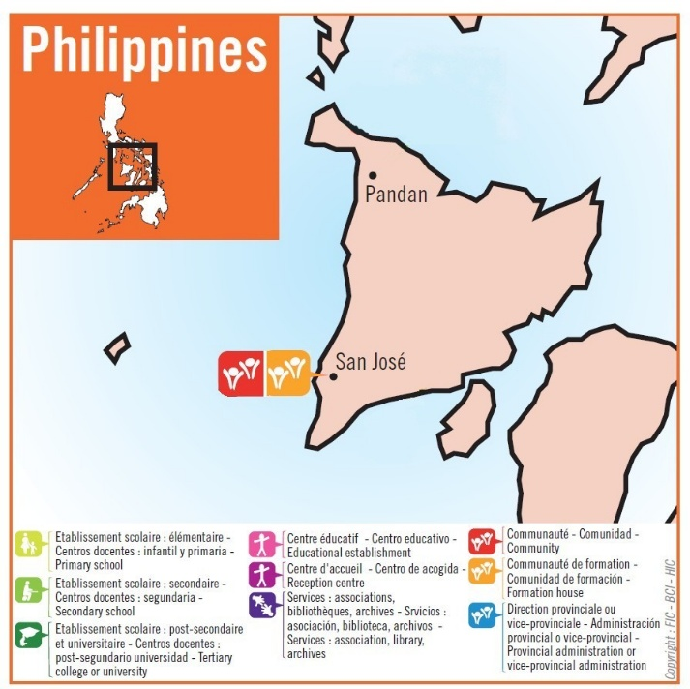The Brothers of Japan did not give up. They landed in the Philippines, a Materially Poor but Predominantly Christian Country. There they could contribute to the Cultural and Technical uplifting of young people. At the same time, they could propose the Vocation of the Brother in an environment more familiar to Figures of Religious and Missionary Consecration. In 1987, the Brothers of Japan decided to establish themselves in the Philippines. A First Team of Four Brothers went to Panay, one of the Country's 11 Large Islands, specifically to San José. Over the years, the Brothers taught at the Diocesan College. At the same time, they invested themselves in serving the Diocese and in Teacher Training. In 1994, the Brothers added a Technical Section for young people less attracted to Theoretical Studies: Classes were given at the School, but Practical Training took place in the surrounding Workshops and Factories. In 2004, the Bishop entrusted the Brothers with the management of the Pandan Bay Institute Secondary School in the North of the Island. They worked hard to rebuild the Buildings and gave the School a Mennaisian Character. In 2012, in conjunction with the Indonesian Mission, the Scholasticate was opened in Manila for young Brothers from South-East Asia. They received Religious Study Courses from the Marist Brothers at MAPAC. Currently, the Brothers in the Philippines are going through a difficult time 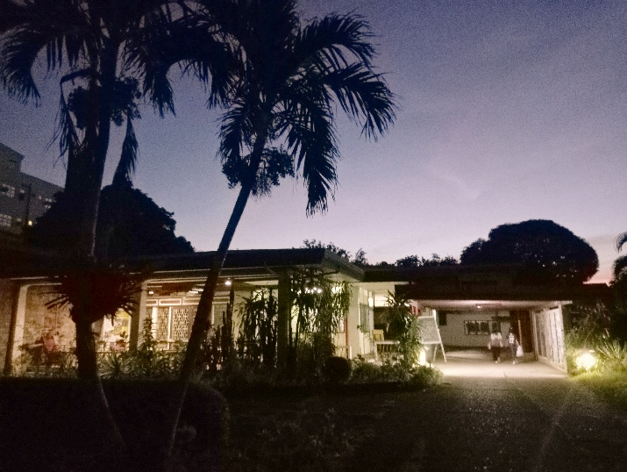difficult. The Scholasticate was transferred to Yogyakarta in 2023, and the Pandan Community, the only one with a School, was closed in 2024. The Brothers are present in San José, which would become the cradle of Asian Mennaisian Vocations: there would be young Second-year Postulants and the Novitiate, which would also be established there. All the Brothers, Formators and those in Formation, showed a remarkable Mennaisian Devotion, which they also extended to their Lay Collaborators. Certainly, the Lord and the Virgin Mary would bless their Mission.

Postulancy-Novitiate Community in San José

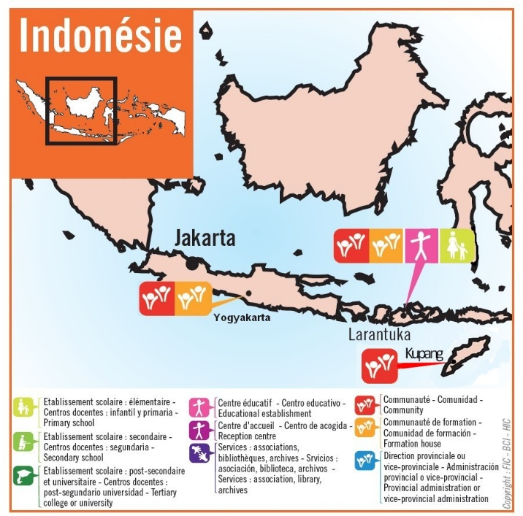**INDONESIA**

On January 2nd, 2000, Four Brothers (Two from Spain and Two from France) arrived on the Island of Flores in Larantuka, Indonesia. They began collaborating with the Bishop and other Local Religious Communities, especially in Teaching, but also in forging very close ties with the Local People. A Severe Ordeal shook the Small Community: the Superior, Br. Nicolás Mediavilla, died in December 2004, struck by Malaria: that sudden death was like the Grain of Wheat that dies to bear Much Fruit.

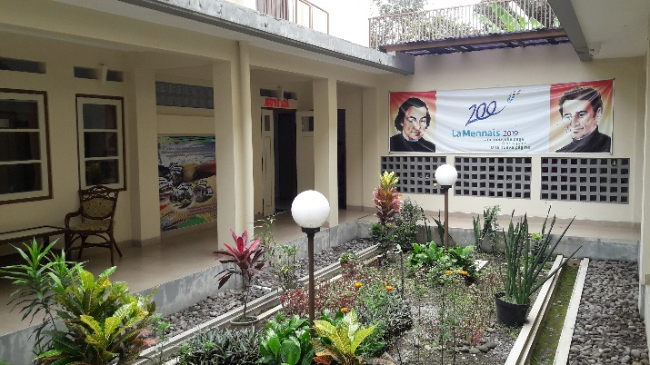A few years later, the Brothers founded Pusat La Mennais, a Training Center offering Courses in Mechanics, Computers, English, Fishing, and Sewing. Some young people were drawn to the Brothers' Life: a Pre-Postulancy was opened for them to pursue a Vocational Career. A second Community was established in Yogyakarta in 2010, Welcoming Postulants and Novices. The First Indonesian Brothers took their First Vows in 2011. The Scholastics then continued their Studies in Manila, Philippines. An important step for the Mission was the opening of the SDK Mennais Primary School in Larantuka in 2015. Currently, another Community is present in the Western Indonesian part of the Island of Timor, in Kupang, for young Brothers studying at the University. In addition, Yogyakarta was home to the Scholasticate for Southeast Asia. Indonesia is a Mission full of Promises: the Virgin Mary guides these people towards “the Light of all Nations.”

F. Nicolas Mediavilla,

Yogyakarta Community

Our 3 Brothers recently arrived in East Timor: from left to right: Brothers Eric Mugisa, Philippe Douti and Stéphane Le Pape

**EAST TIMOR**

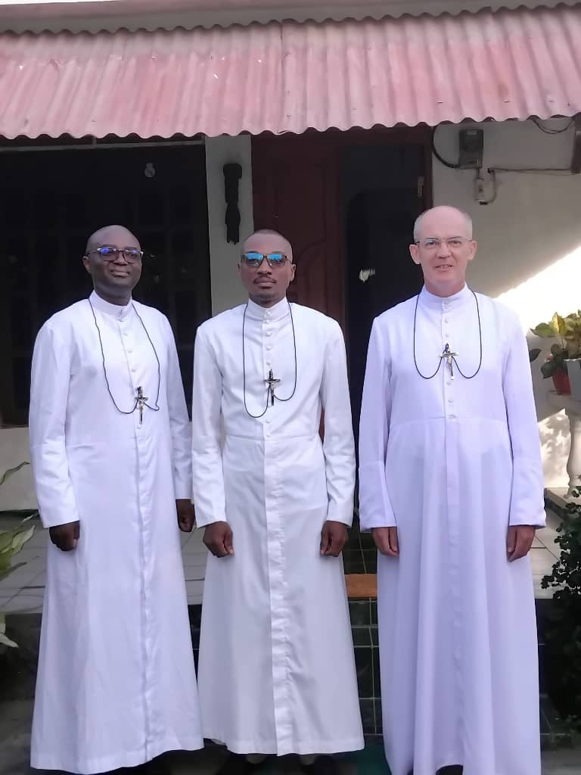The Latest of the Brothers' Missions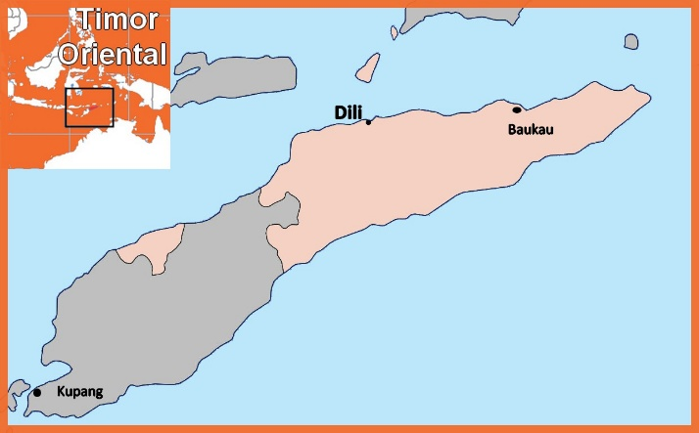, the Mennaisian Brothers are located in the Eastern Tip of the Island of Timor. It would be opened in 2025 by Brother Stéphane Le Pape of the District of St. Francis Xavier (Asia), Brother Philippe Douti of the District of St. Paul (West Africa) and by Brother Éric Mugisa of the District of St. Joseph (Congo, DRC). In the Western part of the Island of Timor, which belongs to Indonesia, the Mennaisian Brothers

East Timor (Leste) capital Dili.

have a Community in the Large City of Kupang. But Timor Leste is another Nation: a Small Territory of 15,000 km², Inhabited by a Population of Approximately 1,400,000 Inhabitants, 33.8% of whom are aged 0-14. It has undergone Dramatic Vicissitudes in recent times due to a War of Independence (from Indonesia), with Hundreds of Thousands of Victims. The situation of children and young people was still very fragile. The 2015 Children's Rights Report states: "Until 2002, Timor-Leste was ravaged by a War of Independence in which children were enlisted as Soldiers. It didn’t always guarantee Education and Justice. Child Labour, Exploitation of Minors, and Violence were Phenomena that had not been curbed by the State. Added to that was a Very Fragile Health Situation: Malaria, Measles, Typhoid, Dengue Fever, Infections..." Regarding Education in particular, it states: "14% of Children aged 6 to 11 are not enrolled in School, and access to Schools continue to be a problem in Some Rural Areas. Only 36% of young people are enrolled in Secondary School. In addition, Teacher Training was insufficient, and Schools lack Equipment." The people of Timor rely heavily on their Christian Faith, and their Fervent Devotion to the Virgin Mary who gives them Hope for the Future. It was in that vein that the Brothers would make their Missionary Contribution, especially to Children and Young People.

**SOURCES: LA MENNAIS.ORG: FICs AROUND THE WORLD/ FIC DIRECTORY 2024 and 2025/ POSTULATION BULLETIN: BIOGRAPHY OF BR. NICOLAS MEDIAVILLA / FIC CHRONICLE November 1997. Fic in the Philippines**