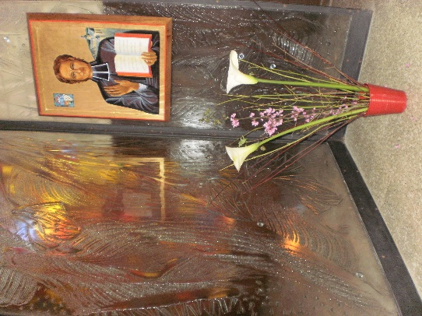
MENNAISIAN MONTHLY NOVENA
MAY 2023
1-NEWS OF POSTULATION

- CAUSE OF FATHER DE LA MENNAIS: The official typography of the Dicastery for the Causes of Saints “Nova Res” in Rome has had 18 copies of the Summarium printed, which contains the entire file of the investigations (295 pp.), supplemented by the latest expert opinions. These allowed the Cause of Fr. de la Mennais to access the Consulta Medica (Medical Commission). Today, the medical specialists (children's neurosurgeons) received the file and they will have a few weeks to study it. The date of the Consulta Medica is set for June 1st by the Dicastery for the Causes of Saints. This is an important moment for the Cause and it will be necessary to redouble the prayers for the Beatification.

- 'TRACES OF HOLINESS' in the Mennaisian Institutes
The Postulation is doing very precise historical research on some Brothers in view of a possible introduction of a possible Cause. The interested bishops and the General Councils of the Mennaisian Institutes will deem it appropriate to pursue this proposal. For the moment the Postulation is reconstructing the biography of Bro. Zoël (Aurélien Hamon), who lived and died with a great reputation for Holiness. In this research, the collaboration of several researchers – historians, archivists…- brothers and lay people – is precious.

2- RECOMMENDED INTENTIONS
We continue to pray for Bro. Jean-Paul Peuzé, Assistant General and for Mrs. De Courrèges, doctor intervening in the diocesan inquiry of Fr. de la Mennais.
The Mennaisian animators will point out the local intentions to entrust to the intercession of the Father. You can tell them your personal intentions.

3-FAVORS RECEIVED THROUGH THE INTERCESSION OF THE FATHER. Table of favors in 1911
“Pope Benoit XV, asked about the advancement of the Cause of Father de la Mennais by the Superior General Jean-Joseph, replied simply: “Do you have any miracles?”. At that time 9 cures, published until then in the Echo des Missions of the BCI (Chronique), had been added to the 18 contained in the Informative Process of Vannes, printed in Rome in 1911. It is therefore to these favors considered miraculous that Bro Jean-Joseph thought when responding to Benoit XV. This figure of 27 was remarkable, but as early as 1904, the advocate of the Cause, Bishop Salotti, later Prefect of the Congregation of Rites and Saints, could write, ending the list of cures attributed to Jean-Marie de la Mennais: “We find there many proofs which show that no disease resists the powerful intercession of the Servant of God.”
To whom would we again ask this question: - Do you have miracles? - what could we answer? Omitting the less important temporal favours, the sole account of the extraordinary cures attributed to the intercession of the Venerable and published in the Chronique de l'Institut, gave the figure of 128 which, added to the 18 of the Vannes Trial, gives a total of 146, 51 of which were obtained in Canada. This total only includes relationships that are sufficiently explicit.
These healings proceed according to a more or less uniform pattern: “these are serious illnesses with danger of imminent death. Doctors often admit their impotence and advise administering the last rites. It is then that a pious hand places under the pillow or on the chest of the dying man a relic image of the Venerable Father. Then we begin, in the family and at school, a novena to the Founder. Then, contrary to all the predictions of science, a rapid improvement takes place in the patient's condition; then there is convalescence, which is often very short, and the return to perfect health.”
Article by Br. Jean-Charles Bertrand (“Missions” magazine September 1983 p.7)

4- HISTORY OF DEVOTION TO THE FATHER OF LA MENNAIS
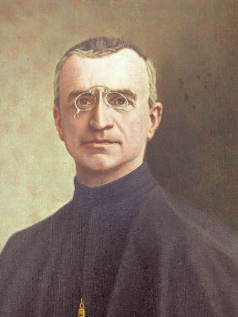
In the years 1920-1930 there was a great development of the Mennaisian Devotion: it was considered as the distinctive feature which gave the family spirit in the new geography of the Congregation. The principal author of this Mennaisian Spring had been the Superior General Br. Jean-Joseph: he had instituted the Day and the Novena of the Father, he had disseminated knowledge of the life of the Father and of the schools and works of education according to the Mennaisian tradition. Henceforth the Devotion to the Father was a reality everywhere, but let us see how at the time it was interpreted through an article of the Chronicle of n.142, November 1937, of the Director Bro Célestin-Auguste Cavaleau (pp. 85-89)
Brother Jean-Joseph
“The Devotion to Father de la Mennais is no longer to be recommended to his children: for ten years the accounts of the Chronicles show with what enthusiasm the day of the Father is welcomed by teachers and pupils.”One of the objectives of this spiritual mobilization is to hasten a glorification “so dear to us all”. And for this, the article cites the advice of Pope Benedict XV. “It's very important to get miracles. For this it is necessary to make your Founder known, to distribute his images, to invite the sick to pray and to ask the doctor for certificates; because often, when the disease has disappeared, the doctors attribute the healing to the forces of nature and their remedies alone, refusing to recognize the intervention of Heaven”.
The article explains these 3 following aspects:
1-MAKE KNOWLEDGE OF THE LIFE OF FATHER DE LA MENNAIS
“Teachers and pupils must know the story of the Father well: there are biographies suitable for everyone, that of Laveille for a higher level, that of Auvray accessible to all. There are many anecdotes full of attractions and adventures. It is also very useful to present the life of many Brothers and Sisters who followed the Founder in a life of “holiness” simple and heroic at the same time: “the saints next door”. »
2-CELEBRATE THE FATHER BY EXTERNAL MANIFESTATIONS OF PRIVATE WORSHIP.
Without attributing to the Father an official cult, which is not yet due to him, one should not exclude either signs of homage, affection, filial veneration, which nourish Devotion towards him. Bro. Célestin indicate some of these signs:
- IMAGES :
“We will place large images outside (statues) or paintings inside, to highlight especially during the Novena. The portrait of Fr. de la Mennais will become familiar to all who attend the school. The small images will be very useful to stimulate individual zeal: they invite to the filial love of the Father, they recall his zeal, in cases of illness they can be distributed, with the prayer on the back one can pray for many intentions. »
- NOVENA
“These are nine days of special prayers addressed to God through the intercession of the Father. They will be simple, with a personalized request for a well-known favor; they will be supported by the fervor and commitment of everyone. These moments of special prayer will be highlighted on particular days: the 8th and 26th dedicated to the Father, Wednesday dedicated to vocations.
The Day of Father de la Mennais is the culminating moment of this devotion: it will be a great feast, with celebrations, demonstrations, games. Everyone will be invited to the sacraments of Reconciliation and the Eucharist. Each class will have the opportunity to prepare specific intentions and activities. On this occasion all the students will make the offering to God of a spiritual bouquet, filled with “flowers”: masses, communions, rosaries, sacrifices, acts of kindness, personal prayers. »
3-GET MIRACULOUS INTERVENTIONS
Through the Father's intercession a great number of favors have already been obtained and it is important to make them known. We must continue to pray to obtain the graces, especially in the event of serious illness. It is good to follow the following procedure:
The students will inform the Director; the latter will give the interested family a relic-image (piece of cloth having touched the tomb of the Father); the class and the school will be invited to pray during a special novena; in the event of sudden recovery, collect the statements of eyewitnesses, the findings of doctors with health documentation. »
The writer concludes: “At last the children know that the great miracle of Father Jean-Marie de la Mennais is the work of the two religious institutes he founded. The difficulties, the efforts, the virtues practiced by the Founder, the apostolic zeal for the Christian schools… lead to the conclusion that “the finger of God is there”!

FATHER'S DAY WITH THE DAUGHTERS OF PROVIDENCE
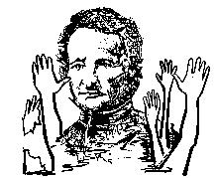
The Daughters of Providence were the first Institute founded by Father de la Mennais. With them, his presence was natural and full of affection. At first they didn't feel the need to have any particular signs of his memory. But, as the years passed and the eyewitnesses disappeared, the memories of the Father became fainter and one felt the need to have concrete signs of his presence. Driven by the example of the Brothers of Christian Instruction, they also began to think of new forms of presence of their Founder. Thus in 1938, for the first time they organized Father's Day in the Mother House of their Congregation in Saint-Brieuc. There had been a whole movement of devotion to the Father, shared by a large number of Daughters of Providence. For this Day the date chosen fell on March 25th : feast of the Annunciation and anniversary of the first emission of the Vows of the Daughters of Providence. There had been a very simple program for the week: every day there was a reading on the life, works and virtues of the Founder. Finally, the Prayer for the Beatification of the Father, “that ardent apostle of youth, a missionary with fiery zeal and iron courage,” was recited fervently. After the celebration of the Solemn Mass of the Annunciation, nuns and students gathered in the main courtyard around the statue of the Founder and prayed fervently, in the traditional formula, “so that soon the halo of the blessed shines on the forehead of Venerable JM de la Mennais and that he be recognized as a model of attachment to the Holy Church and protector of our Christian schools”. From that moment on, Devotion to the Father worked in parallel in the two Mennaisian Congregations.
4-TRACES OF HOLINESS IN THE MENNAISIAN FAMILY: THE APPARITIONS OF THE BLESSED VIRGIN AT KERIO TO A FUTURE BROTHER

September 10th, 1874. In these years, France went through troubled and difficult times with a terrible war with the Germans, even bloody popular revolts, unstable governments, a strong revolutionary and secular thrust. In a small agricultural town in Brittany, Noyal-Muzillac, Morbihan, a 17-year-old young man, Jean-Pierre Le Boterff, was at work. He was a farm boy at Pierre-Marie Boulard’s, who operated the Kério land. He was part of a family of six children where he was used to working seriously and methodically; he manifested a fervent devotion to the Blessed Virgin. At his home, the rosary was recited every evening with the family, according to Christian traditions. It was a fact that, very young, he already had his rosary – and a sizeable rosary! - and that he liked to say his Aves to his Heavenly Mother. Seeing him praying in church, people said: “He prays like an angel”. He attended the communal school run by a Brother of Christian Instruction from Ploërmel, where he learned the essentials. After his first Communion he was placed as a farmhand: he gave his master complete satisfaction, never complained. Always happy and friendly, he liked to play with children.
THE “APPEARANCES”
[We follow the story as it was kept in the notebooks of the Parish of Noyal-Muzillac and in the living tradition of the Brothers of Ploërmel and the Pilgrims of Kério. The Apparitions do not - yet - have an official recognition from the Church, but the ecclesiastical authorities have always given the authorization to be able to carry out prayers and pilgrimages; to build a chapel, to honor this place with religious manifestations at the private and public level].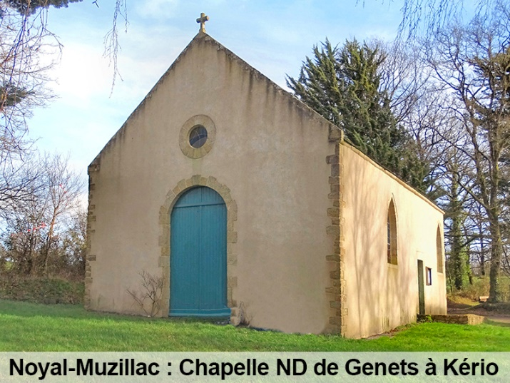
This Thursday, September 10, Mrs. Boulard, her aunt and the young valet were at work in a sloping field to cut millet. Contrary to his habit, Jean-Pierre frequently interrupted his work to look towards the valley, towards a grove. Something attracted him, but he didn’t dare talk about it. Finally he decided : “Oh the Lady! Can't you see anything above the oak tree over there? A lady all in gold!” “You are dreaming, Jean-Pierre. Think about work!”. The two women started laughing and laughing at him. Then they went home to prepare the meal. Once alone. He felt attracted by an invisible force, and ran towards the valley. A Lady was waiting for him. She was wearing a blue dress strewn with stars (as in Pontmain's Apparitions), a gold coat, but Jean-Pierre saw neither her hands nor her face. The lady spoke to him: “Come, my child, do not be afraid. I am the Mother of God. Pray a lot because I cannot support my Son's arms (same expression as at La Salette). Next Sunday, go with your mother to Sainte-Anne d'Auray to pray for Brittany. You will recite many Rosaries and you will do this pilgrimage barefoot”. “But I won't be able to, my feet will hurt!”. “No, I'll put something under your feet and you won't hurt. I also ask you to come and pray here until I tell you otherwise.”
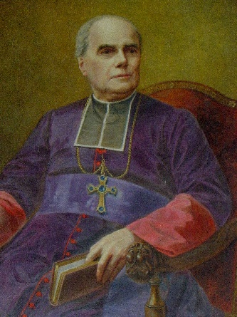
At the farm, everyone was worried. Jean-Pierre arrived, both upset and full of joy. But he was afraid of this pilgrimage: “All night long I will walk barefoot reciting the rosary! It is the Mother of God who asks me. But what is Brittany? » He ddin't even know the name of his country!
During the following days he went to the valley and he prayed his rosary continually. On Sunday evening he left with his mother for Ste-Anne d'Auray: 45 km, a ten-hour journey on foot. At the door of the country he took off his shoes. In the village of Keruel, he was thirsty and quenched his thirst at a fountain lit by a providential light, which would accompany the pilgrims to the Sanctuary. The beads of the Rosary passed between the fingers. They arrived at Sainte-Anne around four o'clock. They attended Mass and prayed for sinners and Brittany, according to the desire of the Virgin. They immediately resumed their journey. Another ten hours on the road. The mother had consumed the soles of the shoes, Jean-Pierre still walked barefoot: but they didn't feel tired at all.
Bishop BECEL - Vannes
The following Wednesday Jean-Pierre was in the valley; he took with him little seven-month-old Pierre Boulard. The Virgin, like a good mother, was seen by the two “seers” full of clarity. The little one looked in the same direction and exclaimed: “Mom, there!” and indicated the place by hand and gazed. When he returned home, he took his first steps. In the evening Jean-Pierre prayed near the big oak tree. At seven o'clock the Mother of God appeared to him in a dazzling light. She spoke to him: “I thank you for your loyalty. You won't see me anymore. Keep praying and doing penance for sinners. Miracles will be the sign of my presence. Many people will come here to pray to me. They will not see me, but I will be there, invisible, listening to them; I don't promise to grant them all, but none will leave without feeling relieved.” She entrusted him with several secrets for her confessor, which he would have to transmit to Mgr Bécel, bishop of Vannes. And then she gave the young man a singular invitation: “Go and become a Brother of Ploërmel; it is the desire of my Son.” She bowed to him in a salute, then she disappeared.
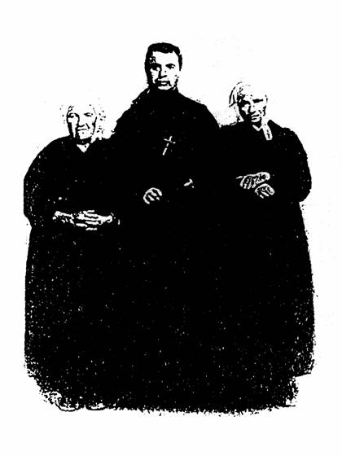
Brother Florien-Marie LE BOTERFF surrounded by his mother and his aunt
The next morning Jean-Pierre communicated to the confessor, Father Balet, the message that the Virgin entrusted to him for the bishop. This one was amazed to hear him pronounce words in Latin! The rector did not give importance to the event; but the “pilgrimage” continued. The prayer of people isolated or in groups was incessant. A small chapel was built, then a simple and very meditative church. One of the rectors, Abbé Michelot, wrote the story of Kerio's "Apparitions" in the parish notebook and began to transcribe the story of graces and favors - some very simple, others extraordinary - which were verified in this place of Marian prayer.
Two years later, the young Jean-Pierre entered at the novitiate of Ploërmel of the Brothers of the Mennais, according to the desire expressed by the Virgin. He took the name of Br. Florien-Marie. He told the story of the Apparitions to his Director, Br. Amand-Joseph, who was very struck by it, transcribed it and made it known to the groups of Novices. The authenticity of the account was confirmed by the conduct full of piety and devotion of Bro. Florien-Marie. He received the role of nurse at the Mother House. He exercised it with maternal delicacy. Always at the disposal of the sick, loving to render them all possible services, he recited the rosary with them, he recommended that they had great confidence in the Queen of Heaven. When the sick were at their last moments, he did not leave them, he prepared them to receive the last sacraments, he assured them of God's mercy and placed them in the arms of “his” Virgin of Kério. (Amazing resemblance to Saint Bernadette Soubirous of Lourdes). In 1888, at the age of 31, Br. Florien fell seriously ill. He was happy to see his good Heavenly Mother again. He was buried in the Community Cemetery: on his cross was placed a small statue of the Virgin and a rosary. For what ? “It is the tomb of a little Brother to whom the Blessed Virgin appeared”.
And little Pierre Boulard, the “seer”-child, what has become of him? He too, having become Bro. Pierre Edouard, entered the novitiate of the Brothers of La Mennais in 1888, as if taking over from Bro. Florien. He prepared himself well for his mission as a teaching Brother. He left for the missions in Haiti. He rendered great services to the Institution Saint-Louis in Port-au-Prince, taking on heavy tasks, until he consumed his health, struck down by yellow fever at the age of 34.

SOME CONCLUSIONS
To conclude, let’s make a few related reflections:
- BRITTANY. The Virgin asks to pray for Brittany. Brittany has always been a region of strong Christian traditions. In revolutionary France, which linked the conquest of human rights to the struggle against the Church, Brittany was a fortress which could help the Nation to reconcile social, civil and cultural progress with the values ​​of the Gospel. It was the millennial tradition of France, as the eldest Nation of the Church.
- AURAY: In Auray there was the sanctuary of Sainte-Anne, mother of the Virgin Mary, principal patroness of Brittany. The figure of Sainte-Anne is not present in the Gospels, but she has always been very much alive in popular tradition. A very human presence, linked to the family, to women, to motherhood, to children. It translates the faith of the Gospel proclamation into very human and familiar terms, which are part of the traditions of “Christian daily life”.
- THE MESSAGE FOR THE BISHOP OF VANNES, MGR BECEL: he was a bishop very attached to the Christian tradition of Brittany and he fought against the anticlerical laws of the end of the 19th century. He had Catholic teaching particularly at heart. It is to him that the construction of the great Basilica of Sainte-Anne d'Auray (1870-77), the symbol and center of faith in Brittany, is due. Did the message of the Virgin of Kerio want to encourage this enterprise?
- PLOËRMEL BROTHERS: It is quite extraordinary that Our Lady indicates a particular Congregation in her messages. The Brothers of Ploërmel (de la Mennais) covered Brittany with a very tight network of schools: most villages and towns had an institution of the Brothers. It was the approval of an apostolate which could evangelize all of Brittany through a mission which announced the faith by Christianly inspiring civilization and culture (“whole man”), especially in the modern era which tends to separate faith and culture?
A small addition. When children fail to walk at the normal age, they are often taken to Notre-Dame de Kério and there they stand up and take their first small steps. An astonishing resemblance to the tradition that can be seen in Plouvorn, near the tomb of Brother Zoël Hamon, a “holy” Brother of Ploërmel!
SOURCES: NOTRE DAME DE KERIO in Noyal-Muzillac 1992 by Bro Théodore VOLANT / REINE DE L'ARVOR: Apparition of the Virgin in Brittany by Yves du Menga (Rostrenen) pp.203-212/ MENOLOGE: F. FLORIEN-MARIE ( Jean-Pierre Le Boterff) II pp.636-638 - Bro PIERRE-EDOUARD (Pierre Boulard) IV pp1368-1370 / Mgr Bécel: These bishops who marked the history of Vannes OF
VIDEO: “Notre Dame de Kério” on You Tube Cat Productions KTO, 52 mn (Testimonies of the Curé P. JE Fresneau, the Brothers of Ploërmel, the Laity)

