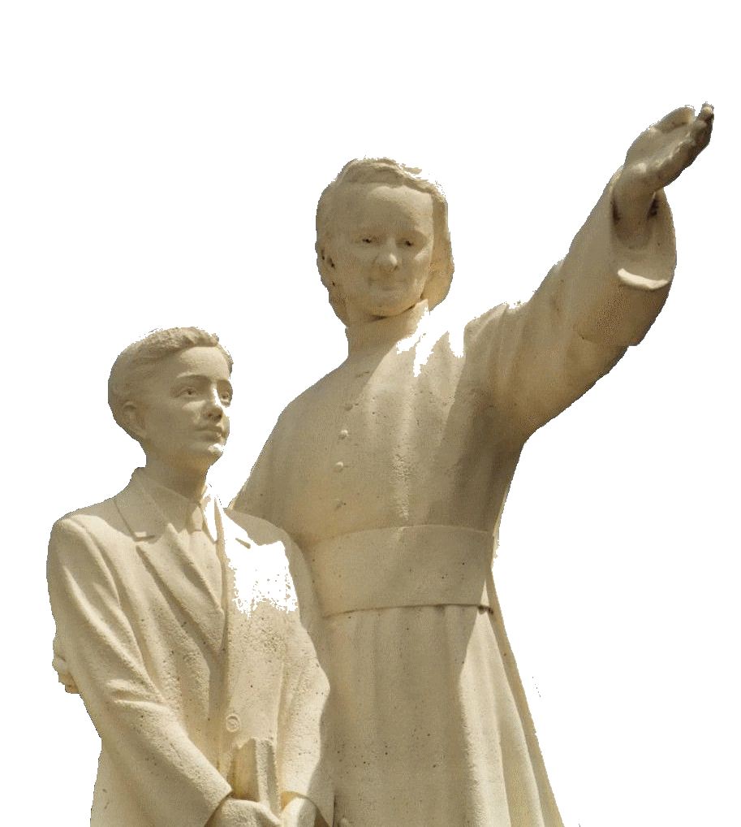

**MENNAISIAN NOVENA**

**MAY 2025**

***Pilgrims on the path of Prayer***

1. **POSTULATION NEWS**

In recent Weeks, we have been gripped by the News of Pope Francis's Illness and Death, along with the Solemn and Moving Funeral Rites. We have joined in the Prayers of the Entire Church to ask for the Assistance of the Holy Spirit for the Cardinals gathered in Conclave for the choice of the New Successor of Peter.

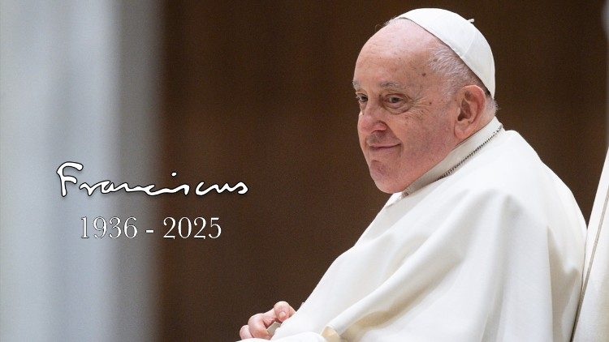We continue in that Prayer, also in Memory of Pope Francis, who came from Argentina and was close to Our Brothers in Buenos Aires. These are some Memories passed on by the Brothers, in particular by Brother Alfredo Lazzaroni, who was Superior of the Community and Director of the Cardinal Copello Secondary School.

**POPE FRANCIS IN REFERENCE TO COLEGIO CARDENAL COPELLO:**

*“Francisco (Archbishop Jorge Mario Bergoglio) knew the Cardenal Copello College very well. One day I received a letter from Jorge Bergoglio, in which he asked me to admit a Student to the Initial Level. As always, it was a simple letter, in which in a few words he asked me if there was any possibility of leaving a place free for him. The boy entered Our College and attended Classes from the age of three until the fifth year of Secondary School, which he completed at the age of 17.*

*I don't remember if Father Jorge Bergoglio ever visited Our School, but I knew he was close to us in several situations we experienced. His intervention and collaboration were carried out through the Archdiocese's Education Office.*

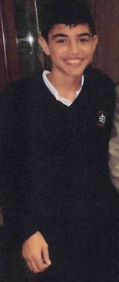**POPE FRANCIS IN REFERENCE TO THE INVESTIGATION OF THE HEALING OF ENZO CAROLLO:**

*What he did was quickly form the Ecclesiastical Tribunal to investigate the Possible Miracle at the Local Level. The Interrogations were conducted at the Metropolitan Seminary. He then surely accelerated the sending of the Investigation File to Rome.*

* **THE STUDY OF HEALING BY ENZO CAROLLO**

During the last Month, the activity of the Vatican Curia has been focused on Major Church Events: The Celebrations for the Funeral of Pope Francis and the Meetings of the Cardinals for the Election of the New Successor of Peter. Consequently, the Work of the Dicastery for the Causes of Saints has been suspended. Work continues on the Scientific Study of Enzo Carollo's healing with the Doctors involved.

* **LITTLE LIVES OF THE BROTHERS, WITNESSES OF HOPE**

To the Four Short Biographies on the Witness Brothers of Hope (Brothers Zoel, Hyacinthe, Cardinal and Constantin) a Fifth has been added, that of Brother Alpert Oxibar, a Legendary Figure in Our History: A very Simple and Original Brother, full of Smiles and Fraternal Spirit.

1. **PRAYER INTENTIONS RECOMMENDED TO THE INTERCESSION OF FR. DE LA MENNAIS**

We entrust to the Intercession of the Father:

* 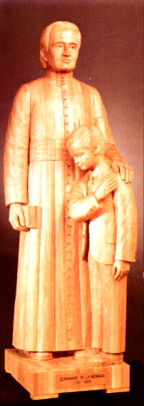**Several Brothers** in Health Difficulty who recommend themselves to the Intercession of the Father: many are present in the Homes of the Elderly or Sick Brothers. Brother Alberto Pardo, Provincial Bursar of the Province of Nuestra Señora del Pilar, Spain, had a Serious Car Accident on Easter Sunday. He is in Intensive Therapy at the Hospital in Burgos. Let us Pray for his quick Recovery.
* Recommended Patients, in particular:

-Mr. Stéphane: Motorcycle Incident with serious consequences

-A really delicate case: a Mother Anna, sick with Cancer, who has two disabled sons Silvia and Luca

-Sick people recommended by Local Animator Brothers;

- “Our Sick Children”: Tommaso (out of danger), Alessandro, Alvaro and parents: Caroline, Massimo (he is making progress), Camilla;

* Let us place under the protection of the Father the three Brothers who would open the New Mission of Timor Leste: Br. Stéphane Le Pape, Br. Philippe Douti and Br. Eric Mugisa
* **AN INVITATION FOR ELDERLY OR SICK BROTHERS**

We invite the Elderly or Sick Brothers, especially those in Retirement Homes, to intensify their prayers and offer their difficulties for the Good of the Church, for Peace in the World, and also for Our Mennaisian Institutes. In particular, we entrust to them the Cause of Beatification of Father de la Mennais, because it is a gift that comes from God and we could obtain it through His Grace.

A PROPOSAL: RECITE (in addition to the Novena) Each Month/ or Each Week / or Everyday a ROSARY for the BEATIFICATION of Father de la Mennais.

1. **FAVORS OBTAINED FOR CHILDREN THROUGH THE INTERCESSION OF THE FATHER:**
2. **St-Alexandre de Kamouraska, Canada: Healing from Tonsillitis**

*“Little Bruno Bouchard, aged two and a half, had been suffering cruelly from Tonsillitis for over a Week, despite the Medication prescribed by the Doctor. The latter, faced with the ineffectiveness of his remedies, brought a New Prescription which he declared marvelous; then he promised to return in two days. But the child did not take that Medicine. Warned by the family, the Brother Director of the School began a Novena to Father de la Mennais with the Students; he gave each of the two brothers of the little sick boy, students at the School, a Relic Image which they brought home. Seeing those Relic Images, the mother felt her confidence grow; she placed the Relic in a Sachet which she tied around the Neck of her Sick Child.*

*The following night, around 11 p.m., the child began to cry, complaining that his Throat was causing him great pain. After great efforts, as if to vomit, he managed to expel his Infected Tonsils. When the Doctor returned two days later, he could not hide his satisfaction at the radical effect of his famous remedy: “I told you that my remedy was marvelous!” “The child didn’t even touch it!” replied the mother; and she added: “I’ll tell you later what happened.” “How was it then that he was cured? I don’t understand!” replied the Doctor. From that day on, the child felt no more discomfort. The cure was complete.”*

1. In Spain: a Six-Month-Old Child recovered

*“About two Months ago, I found Our Butcher in tears. Having asked him the cause of his grief, he told me that at two o'clock in the morning, he had left his Firstborn, aged Six Months, for dead. I immediately gave him a Picture of Our Venerable Father, to place under the child's head. The latter immediately opened his eyes. Improvement began to be felt and the child gradually returned to Perfect Health, after having been condemned by the Doctors. At the end of the Novena made to the Father by the Novices, he was out of danger.”*

Brother Ulysse Baron, Nanclares, June 4, 1915

1. **THE SANCTUARIES OF THE VIRGIN AND THE BROTHERS, PILGRIMS OF HOPE (CANADA, USA, MEXICO)**

**OUR LADY OF GUADALUPE, MOTHER OF THE LITTLE, MEXICO 1531**

According to the Ancient Writing in the Nahuatl Language, “Nican Mopohua” and the Stories of Tradition, on December 9th, 1531, on the Hill of Tépéyac, a little North of Mexico City, *and* a singular event took place.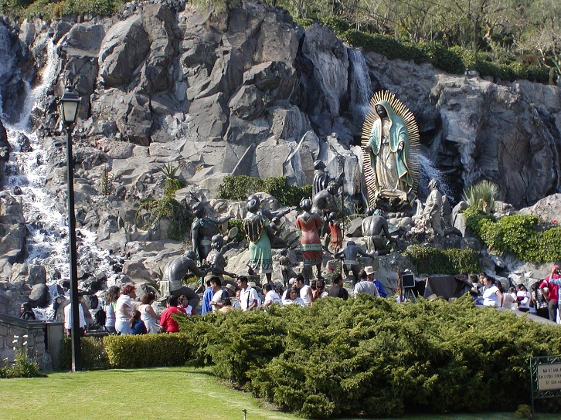A 51-Year-Old Peasant, who had lost his beloved wife, Lucia, was going to Mass: he had recently been Baptized and wanted to deepen his Faith. Those were the years of the Spanish Conquistadores, who had “Discovered” the New World: with their Technological Superiority, the Conquerors quickly overcame the resistance of the Indigenous Peoples, the Aztecs, Toltecs, Maya, Incas…. By assigning the “New” lands to the Kingdom of Spain, they exploited the Wealth of those Populations, to the point of reducing them to their service. Among the New Arrivals, there were also Missionaries: they announced the Good News of the Gospel of Jesus; they considered them in their dignity as people with the Souls of children of God; they sided with them, treating them as brothers and defending them from the Violence and Greed of the European Invaders. The Local Population embraced Christianity in masses: Missionaries spread the New Religion everywhere and tried to mitigate the rapacity of the Conquerors, who saw only the Land to exploit and the Slaves to use.

Juan Diego - the Peasant's name - was walking along the path when he heard a Melodious Bird singing. Then there was Silence, and a Voice was heard: “My little Juan!” With sweet joy Juan Diego climbed the Hill and discovered a Young Girl standing there, dazzling with light. “I am the Virgin Mary, Mother of the True God through whom all lives. I desire that a small Sanctuary be built for me in this place, to give men the Mediation of my love and my help. Go to the Bishop, be my Messenger to ask him to build that Sanctuary here.” Poor Juan went to the Bishop. He was kept waiting; but, with the stubborn patience of the humility, he succeeded in being received. The response of the Bishop, Msgr. Zumarraga, was not encouraging: “We must come back another time. I would think about all that.” In the Evening, on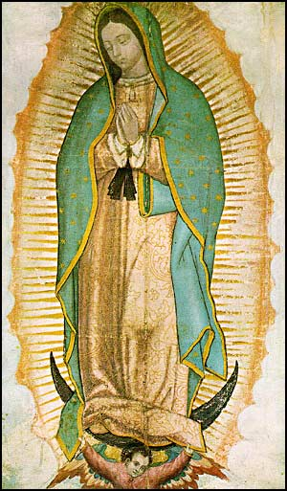 the way back, Juan met the Beautiful Virgin who was waiting for him. He was discouraged: “The Bishop did not believe me. I am not up to representing you: send someone more worthy than me.” But the Virgin had made her choice: he was to be her Ambassador. “Among so many people, I have chosen you: my Will would be fulfilled through your undertaking, my son, you, the smallest. I order you to return Tomorrow Morning to the Bishop and tell him again that it was the Virgin Mary, Mother of God, who had sent you.” Early the next day, Juan Diego set off to see the Bishop. He repeated the request of the “Mother of the Savior” in Great Detail. But Bishop Zumarraga asked for a sign. On the way back, the Virgin was there: “You would go Tomorrow to take to the Bishop the sign he asked so that he may believe.”

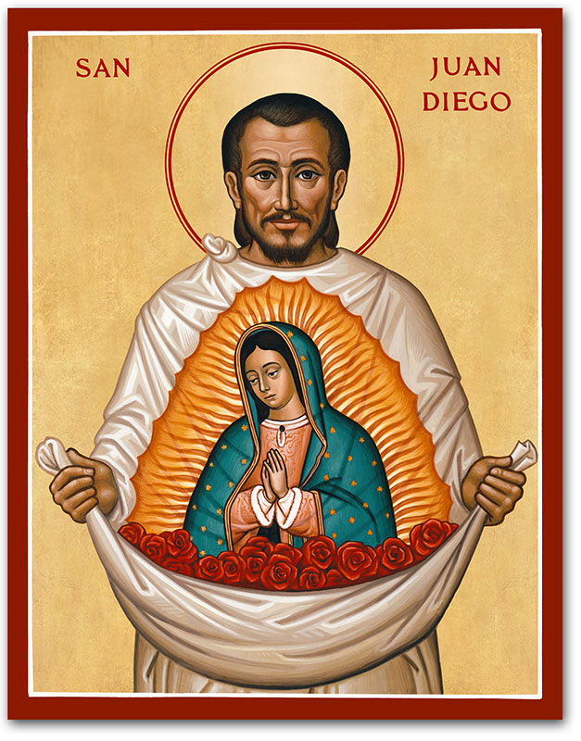Early the Next Morning, the Peasant was on his way, but not to the Bishop's palace. He was going to find a Priest for his uncle, who was dying. He took another path to avoid meeting the Virgin. But she was there: “What afflicts you was nothing. I am your Mother, I protect you: do not let your Uncle's Illness afflict you, for he was not going to die: He was already cured!” Then she ordered him to climb the Hill of the first encounter. Where there were Thistles and Thorns; Juan admired the Splendid Roses of Castile: he cut them and placed them in his Tilma (cloak). The Virgin reassured him: “Those flowers are the sign that you would take to the Bishop. You would tell him from me that he must fulfill my desire. Do not be afraid, you are my Messenger!” “Little” Juan Diego went to the Bishop. The Guards made him wait and wanted to see what he was wearing in his Tilma. Finally, he was brought into the Prelate's presence: "My Lord, this was the sign that the Virgin has given me, so that you may build a Church wherever she asked." He opened his Tilma: the Roses of Castile fell from it and "the Image of the Venerable Virgin Mary, Mother of God, appeared on the Mantle." Speechless with Admiration, the Tearful Bishop knelt down, asked forgiveness for his disbelief, and placed the Holy Image in his Oratory.

The Chapel was built on the Designated Site. The Image of the Venerable Mother of God, Virgin of Guadalupe, was transferred there with a Solemn Procession. Countless crowds immediately came to visit the Heavenly Image of the Mother of Mercies: An Immense Pilgrimage that has never stopped since, growing with each passing year.

The Venerated Image has been the subject of ever more In-Depth Scientific Studies, which confirm the Mystery of Celestial Intervention in that Portrait. Thus, no trace of pigment was found in the Study of its Colors; the very Rustic Textile Support, which was expected to deteriorate in about twenty years, has resisted for several Centuries; the Ophthalmological Examination reveals an Image at the bottom of the eyes and we see human figures that reproduce the scene of Juan Diego opening his 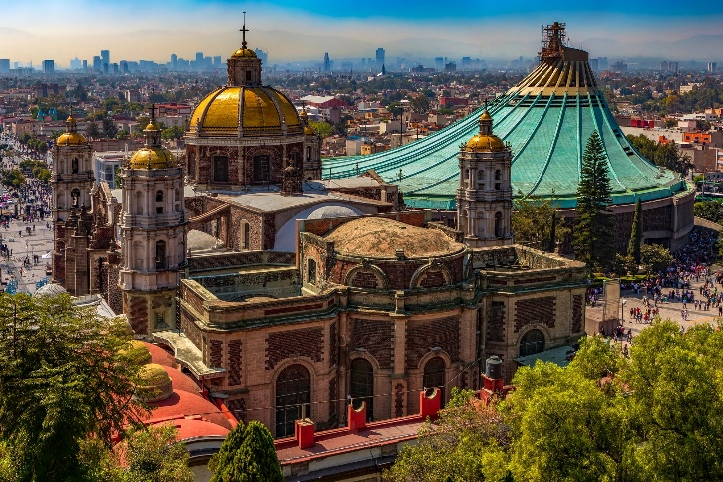Tilma before the Bishop; moreover, the Venerated Image has remained intact even after several accidents, including several real attacks. To venerate the Holy Mother of God, the “Morenita Virgen de Guadalupe”, The Sanctuary had been rebuilt several times; the last, even larger, was completed in 1974. Millions of Pilgrims (about ten million a year), coming from all over America, go there every year, with a Simple and Fervent Faith. The Holy Pope John Paul II went there four times. On his first visit, in 1979, he proclaimed, addressing the Virgin: “The Pope felt, in the Intimacy of his heart, what special bonds unite you, Mary, to these people and these people to you; these people, who affectionately call you “La Morenita”. These people and, by reflex, that Whole Immense Continent, lives its Spiritual Unity in relation to your Motherhood: you are a Mother who, with her Love, Creates, Preserves and Strengthens the Unity among her children.” The Latin American Pope Francis, in the great Mexican Shrine, in 2016 exhorted: “The Mystery of Guadalupe is to venerate the Mother and to hear in our ears: “Am I not here as your Mother?” And these words must be remembered, listened to, introduced into one’s own heart, in all the moments of life, in the difficult moments, and the happy moments of life, and at every moment. “Do not be afraid, am I not here myself, your Mother?”

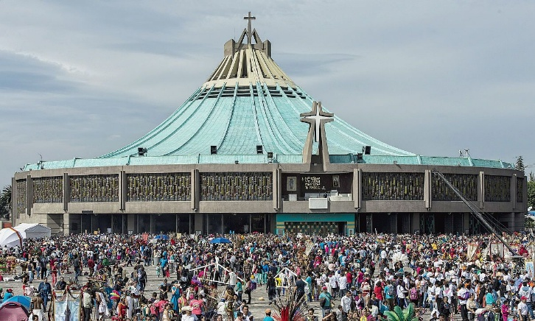Our Lady of Guadalupe has been and remains a powerful means of proclaiming the Gospel. Her appearance as a young Indigenous Woman, wearing clothing that reflected the Local Culture, had a profound impact on Evangelization in Latin America. “The Virgin of Guadalupe is venerated as the Patroness and Queen of all Spanish-Speaking Peoples and the American Continent. Her Image has become a Symbol of Unity and Identity for the Latin American Faithful, reflecting a message of Love, Compassion, and Hope” (G. Grammatico).

**THE BROTHERS OF THE JEAN DE LA MENNAIS PROVINCE: CANADA, USA, MEXICO**

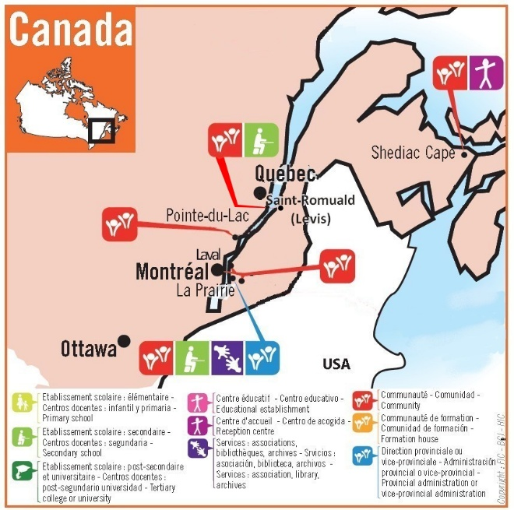**CANADA**

Towards the end of the 19th Century, the French Government's Orientation focused on the Secularization of Schools: in 1886 it privatized all Schools not directly managed by the State; in 1903 the Combes Government abolished the Religious Congregations involved in Social Work, particularly in Education. The members of these Institutes were faced with a choice: either continue their activity clandestinely in France or expatriate to another Country to continue exercising their Mission in complete freedom. It was necessary to find Countries that Officially Recognized the Congregation and could offer hospitality to the Brothers who had left France. The Superiors turned to Canada, Spain, Eastern Europe, the USA (Rocky Mountains and Alaska), England...

Canada, under the Leadership of Br. Ulysse Baron, became the Welcoming Land for hundreds of French Brothers who wanted to continue their Apostolate. Under the impetus of the New Arrivals, Schools multiplied, thanks also to a New Reinforcement from France of more than 100 Brothers. Preparations soon began for the Next Generation: the Postulancy and the Novitiate were filled with young Canadians. Schools multiplied and New Districts were opened with beautiful Motherhouses. Publishing Initiatives were launched for Teachers, Students, Children and Young People. In turn, the Province became Missionary: first by helping Haiti, Egypt, and the USA; then, from 1926, by founding the Missions of Uganda, Kenya, Tanzania and Japan in 1951. In 1954 the Province exceeded 1000 Brothers with 100 Novices.

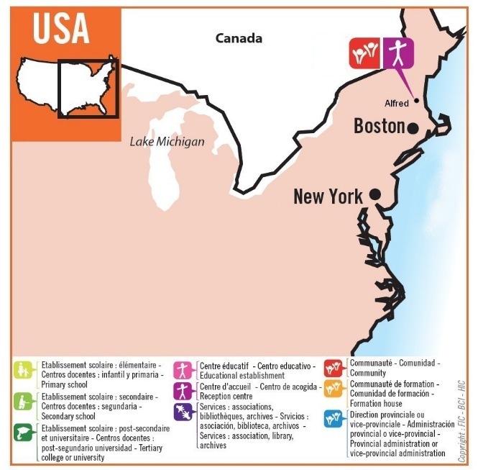

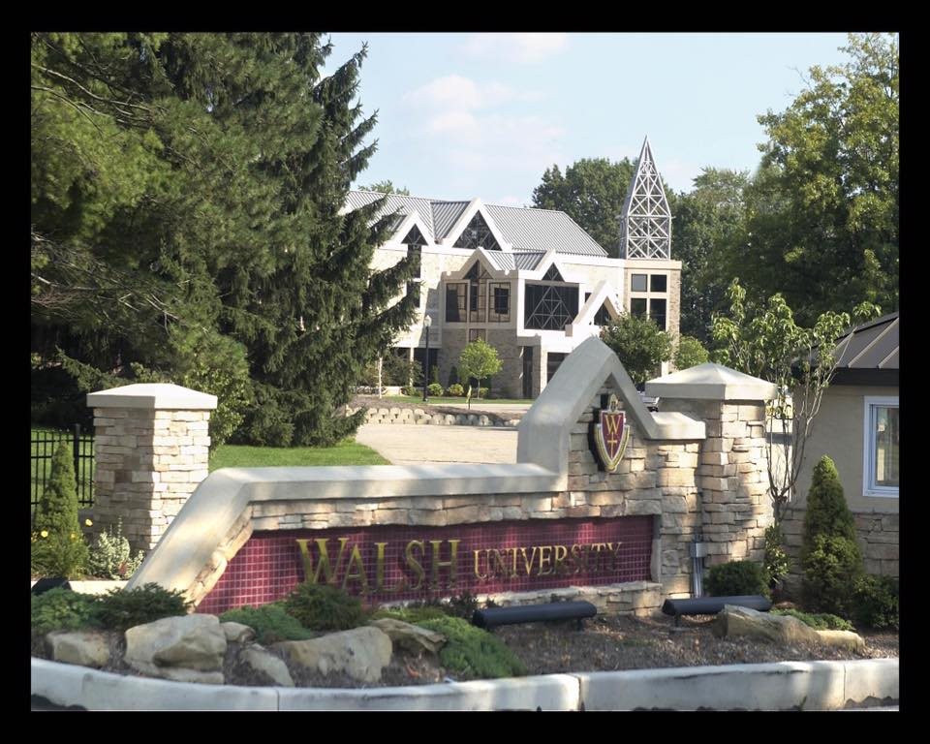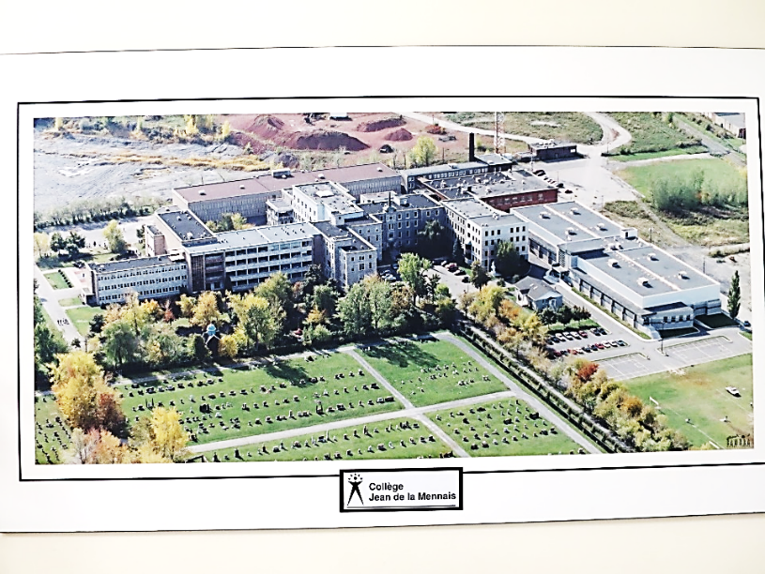However, the years of the "Quiet Revolution" arrived. A Profound Crisis shook Western Societies and shook the Church. The Brothers were forced to abandon their Schools to enroll in Enormous, Anonymous "Multi-Purpose" Schools. A large number deserted the Congregation, which became smaller and more fragile. Despite the Crisis, the Canadian Brothers relaunched their Missionary efforts: in 1968-9 they opened the Difficult Missions of Rwanda-Burundi, Congo DRC, and in 1987, the Philippines. In Canada, the Brothers' numbers declined rapidly, but the Work of the Schools was resumed, in collaboration with Mennaisian Laypeople; initiatives were launched for young people in difficulty; and Associations that assisted the Missions (Prodeva, Terre sans Frontières, Secours Mission) were supported. Since 2017, the Province has taken charge of the New Mission in Mexico, near the Virgin of Guadalupe. Currently, faced with an apparent lack of a future, the Brothers continue in their hope, which was based on the promises of the Missions they founded in Africa, Asia, and Central America. They also hope in Providence, to which they entrusted, with their Prayers, the offering of their limits and the fervor of their devotion to the Founders Jean-Marie de la Mennais and Gabriel Deshayes, who always distinguished them. The Virgin Morenita, the Mother of difficult times, comes to their aid.

Walsh University

Mother House of La Prairie

**UNITED STATES OF AMERICA**

In 1903, the young Quebec Province was struggling to accommodate the large number of Brothers who had emigrated from France. The Superiors were pleased to find a home in the United States, in Plattsburgh, near the Border. The Brothers gradually spread throughout the Country. They opened Secondary Schools in Plattsburgh, Fall River, Louisville, and Canton, which became a University. In 1946, the Communities in the United States were established as a Province, under the Name of “Notre Dame.” The Province purchased the Small Shaker Village, which became the Central Home of the Brothers in the USA. The Academic Commitment was rather demanding, and the Brothers’ Work was not easy. Yet they succeeded in giving their Institutions a Christian and Mennaisian Character. The American Brothers also gave their support to African Missions, especially in the Congo (Brother Pilot Normand Berger, tragically killed in

Plane with other Brothers and Lay people); they sent two Brothers to Nome, Alaska, to serve in a Radio Station; they actively supported people in difficulty: in Alfred they hosted the York County Shelter, an Organization that helped men who were homeless or struggling with Various Addictions. In 2016, the Notre Dame Province merged with the Jean de la Mennais Province of Canada. The Virgin Mary, “Our Lady,” so prayed to and loved by the Brothers of the USA, would certainly come to the aid of that Country, which has lived so Intensely the Spirit of Charity of the Founders.

**MEXICO**

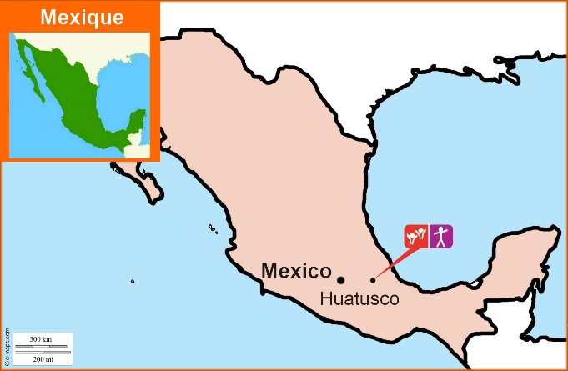The Small Community of Huatusco, Mexico, quite close to Mexico City, has a very recent History, but it is full of great promise. “Starting in 2006, two Canadian Brothers became involved in the AGAPÊ Center in Mexico. They established the “John Paul II Center” in Huatusco, where they and a Team are responsible for an Educational Center for Children, Youth, and Adults.” Activities are focused primarily on Summer Camps and Vacations, volunteering for the Poor, and Spiritual and Liturgical Animation. The Young Animators are well supported and prepared.

*“In 2017, the Jean de la Mennais Province took complete control of the Work, and the Community decided to plant its roots in Mexican Soil by risking a Vibrant Vocational Ministry and accompanying young people on a Personal Journey. The Mennaisian Family played a Major Role in that New Presence.”*The Community received support from other Provinces (Haiti, France,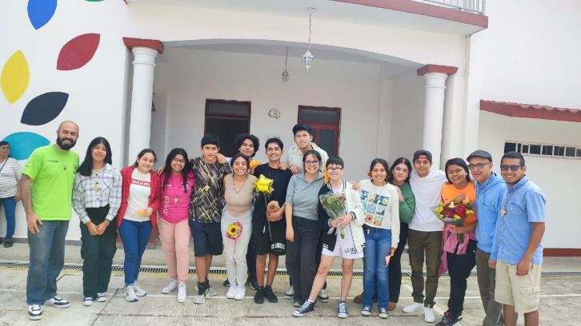

Brothers, Laity and Youth at the John Paul II Center

South America) for its Mission to Young People, Vocation Ministry and Formation (Novitiate and Scholasticate in union with other Spanish-Speaking Provinces). In that Initial Mexican Work, the reality of the Mennaisian Family was very much alive and the Laity could count on it. The Virgen de Guadalupe would place under her Tilma the sons of JM de la Mennais, who were present so close to the place where she appeared to St. Juan Diego, to reveal her Maternal Protection to him: “Do not be afraid, am I not your Mother?”

**SOURCES: “The Mennaisian Institute in the World / Two Mennaisian Congregations (Cueff-Morgan) / Brother Ulysse Baron Ménologe, pp. 692 et seq. / News from Huatusco (Brothers Mario Couture and Guillermo Dávila)**