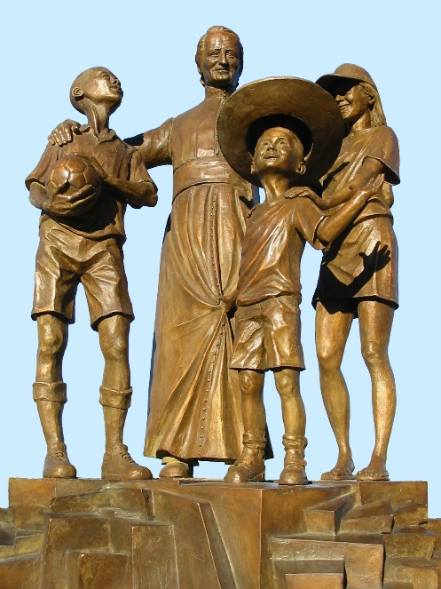
MENNAISIAN NOVENA
MAY 2026

- NEWS FROM THE POSTULATION
- THE CAUSE FOR THE BEATIFICATION OF JEAN-MARIE DE LA MENNAIS
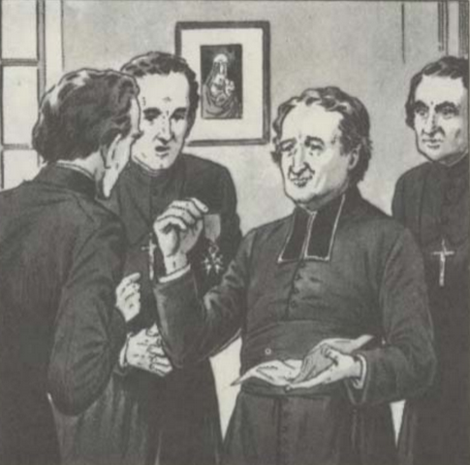
We are approaching an Important Moment for Our Venerable Father Jean-Marie de la Mennais. The Healing of Enzo Carollo must be submitted to the Judgment of the Church, which would determine whether that Event involved the Extraordinary Intervention of Divine Providence through the Intercession of the Founder. For now, the Dicastery for the Causes of Saints has submitted the Case File to Two Doctors, who—within a Month or Two—must provide their Medical Report. Then, if One of the Two Doctors gives a Favorable Opinion regarding the Scientific Inexplicability of the Healing, it would be the turn of the Medical Commission of Seven Doctors. And, as a Final Step, before the Pope's Signature, there would be an Examination by the Theological Commission, composed of Bishops and Theologians. That Commission must discern whether the Healing was obtained through the Intercession of the Venerable Father.
For us, the Duty remains the same: To Pray and Watch, like the Wise Virgins awaiting the coming of the Bridegroom. We are part of the long line of Brothers, Sisters, Students, Families, and Clergy who, for over 120 years, have prayed with confidence to see Our Father recognized as Blessed: He himself does not need that Official Recognition (we know how Father de la Mennais acted with his Legion of Honor Cross!); but for us, it would be a Great Gift from God for Our time.
- A CENTENARY, A MEMORY AND A HOPE
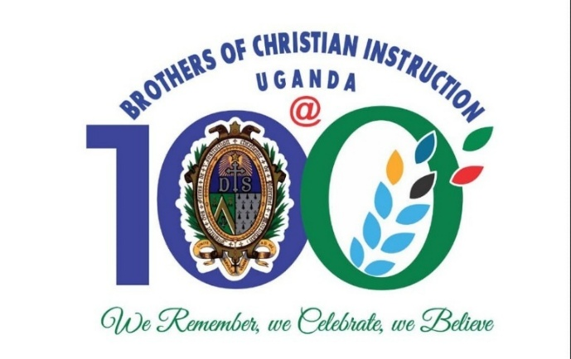
This year we celebrate the First Centenary of the Province of Uganda. The Brothers of Canada gave that Wonderful Gift to the Church, to Africa, and to the Institute. Now this Province is thriving in its Apostolic Vitality and sends Workers to other parts of the Congregation. That Remarkable Missionary Success, founded on the Hard Work and Sacrifices of the Pioneers, brings us back to the Glorious Chapters of so many of Our Brothers who gave their lives in Missions throughout the World. In particular, the Postulator has just written—based on the very thorough Studies of Brothers Louis Balanant, Delfin Lopez, Philippe Friot, Gilbert Ollivier, Paul Cueff, and others—a Comprehensive Overview of the Epic Journey of Our Missionary Brothers in the Antilles. They left behind an Exceptional Reputation for Heroism and Holiness. In total, there were 715 Missionary Brothers in Guadeloupe and Martinique; 26 died before reaching the age of 25. More than 100 under 50 years Old; they Evangelized Tens of Thousands of Slaves; some Brothers are spoken of as True “Saints”: Br. Hyacinthe, Br. Arthur, Br. Timoleon, Br. Herman-Marie… That Work would be made available soon.

- Prayer Intentions through the Intercession of Father de la Mennais
- We continue to pray for the Mennaisian Family who find themselves in Difficult Contexts: Haiti, DRC, South Sudan, and Tanzania and for the Brothers of the Timor-Leste Mission.
- We Recommend to Father de la Mennais the New Vocations, especially in Western Countries, which are experiencing a Profound Vocational Crisis.
- For Patients recommended by Local Facilitators.
- For those who ask for the Father's Protection: Mrs. Anne-Lyse of Saint-Brieuc; for Brother George Kamanda;for Bro. Onesmus Mutakirwa; for Brother Jean-Herbinière, long-time Master of Novices in Dapaong (Togo); for Two Lay People Gioacchino and Sergio; for Dario, a Small Child with Leukemia; for Rachele, Brain Cancer.

- FAVORS RECEIVED THROUGH THE INTERCESSION OF FATHER DE LA MENNAIS
We are publishing the Concluding Remarks of a Doctor's Account of a Cure attributed to the Intercession of Father de la Mennais. To protect Anonymity, we are omitting the names of people and places.
* MEDICAL-LEGAL ASPECTS
1- Acute, Extremely Serious Event, with Immediate Danger to Life (prognosis reserved quod vitam), need for Intensive Therapy, Pharmacological Coma and Respiratory Support.
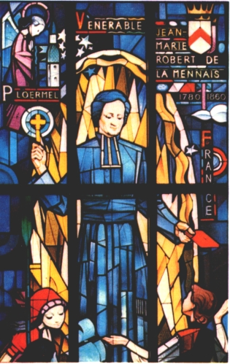
2- Status Epilepticus Refractory to Common Anticonvulsants, with a high risk of Permanent Neurological Damage, Mortality due to status Epilepticus Refractory to 4 drugs around 36%.
3- The Infectious Etiology due to Mycoplasma Pneumoniae is confirmed and constitutes an unpredictable and unavoidable Exogenous Event. At the time of Clinical improvement, the Young Patient was not taking any Effective Medication…
4- The Child's virtually complete Neurological Recovery, certified by MRI, EEG and Clinical Assessments, was exceptional and unexpected, with the absence of Serious Permanent Neurocognitive Deficits, which in similar Cases are the rule.
5- The Clinical History and the Testimony of the Treating Physicians highlight the extreme seriousness of the Clinical Picture and the high probability, avoided, of Serious Neuropsychological Outcomes.
MEDICAL AND LEGAL CONCLUSIONS
Child XXX suffered an Acute Pathological Event, diagnosed as Mycoplasma Pneumoniae Encephalitis with Seizures and Prolonged Coma. That condition has a mortality rate of 5-15%, but more importantly, it could have serious consequences. Without resuscitation, the child would not have survived. Given the immediate onset of Encephalitic Manifestations, it was thought that the Autoimmune Component triggered by the Mycoplasma was of Secondary Importance; such an Immune-Mediated Reaction typically appears 15 days after Infection.
The Diagnosis was made late, and Specific Treatment for Mycoplasma was administered for only three days (from the 7th to the 10th of the Month) in a Clinical Condition that had not improved by the 15th of the Month. Clarithromycin Treatment was resumed on day 18th, when the Brain Biopsy came back positive (but by that date, despite a New Attack and a rise in Fever, the Patient was already improving). Treatment with Human Immunoglobulins and Steroids, initiated based on the Hypothesis of an Autoimmune Form, was ineffective, which was expected, as Autoimmune Encephalitis triggered by Mycoplasma was typical of late-onset Encephalitis, relative to the initial symptoms of the Disease (Fever).
Although the opinions expressed by the Commission [of the Dicastery] are widely shared, the manner in which the child began to improve in the absence of Specific Therapy appears difficult to explain. It must be considered that the Majority of the Medical Literature on the progression of Mycoplasma Pneumoniae Encephalitis refers to case studies (100% of Cases) treated very early with targeted Therapies. Consequently, the almost complete recovery, rapid though not immediate, was Clinically Relevant but Scientifically difficult to explain and deserves to be reconsidered due to that exceptionally favorable and unexpected outcome. The Neuroradiological Evolution, also showing the disappearance on MRI of the severe alterations of the acute phase, appears exceptional and unexpected compared to usual patterns.
City X Prof. X XX Date: March and April Year XXXX
TRACES OF SAINTINESS IN THE HISTORY OF THE INSTITUTE:
THE CENTENARY OF THE PROVINCE OF UGANDA (1926-2026)

THE CENTENARY OF THE PROVINCE OF UGANDA (1926-2026)
- THE BEGINNINGS: THE FIRST TEN YEARS OF THE NEW MISSION IN UGANDA

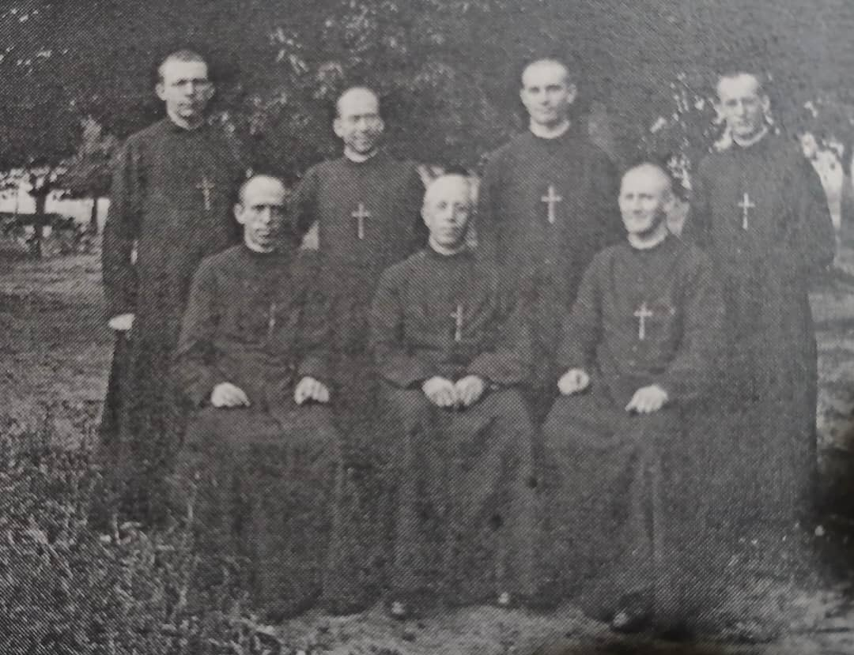
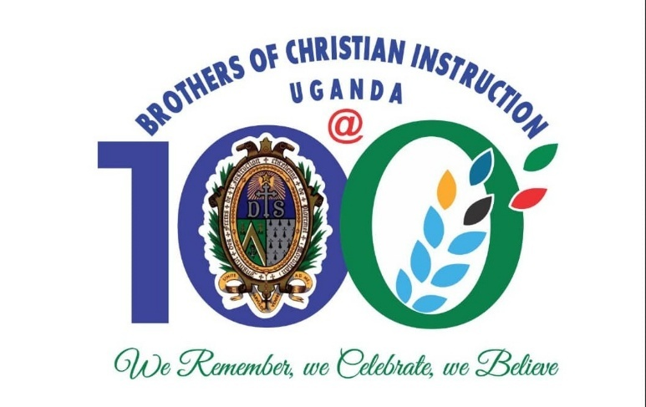

THE GROWTH AND CONSOLIDATION OF THE FIC MISSION
This Third Presentation on the History of the Foundation of Province of St. Teresa of the Child Jesus gives a highlight of the Events of the First Ten Years of the Mission (1926 – 1936). Those years registered a Rapid Growth and Expansion of the Mission of the Brothers of Christian Instruction in Uganda and beyond. That Growth was made possible by the arrival of a Few more Groups of Missionary Brothers in the subsequent years that made it possible to get engaged in New Missions.
1st and 2nd Groups of Missionaries

From the First Four Missionaries who arrived in 1926: Brother Charles Jules Poitras, Brother Joachim Leon Collerette, Brother Eugene-Marie Paquette and Brother Stanislas Joseph Taillefer. The Second Group of Three Missionary Brothers included Brother Edgar Marie Charles Edward Delorme, Brother Lucien Joseph Wilfried Vincent and Brother Donat Marie Maurice Trudel who arrived in 1927. One Brother: Alphonse Joseph Edmond Lapointe arrived in 1928. The following year, 1929, saw the arrival of Five Brothers: Brother Philip Joseph Wilfrid Lachance, Brother George Augustine Armand Lord, Brother Aime-Marie Hormisdas Lebel, Brother Louis de Gonzague Edmond Dufrene, and Brother Adrian Henri Deneau.

In 1930, Three Brothers: Brother Columbkill Mary O’Byrne (from England), Brother Viateur Marie Antoine Tittley and Brother Emery Edward Charles Joseph Vezina. In the following year, 1931, another group of Six Brothers: Brother Alphonse Maurice Lambert, Brother Joseph Gonzales Louis Dansereau, Brother Heraclius Albert Germain Brunet, Brother Hermenegilde Albani Abel Joseph Lalonde, Brother Austin Mary Thomas O’ Donnell (from England) and Brother Raymond-Raymond. In 1932 Two Brothers: Brother James Philippe Joseph Marie Arsenault and Brother Edmond Gabriel Joseph Christian Labelle. The following two years, 1933 and 1934, witnessed the arrival of Two Brothers: Brother Bernardine of Siena Conrad Crepeau in 1933 and Brother Thomas Lambert in 1934.

The Only Year in which the Mission did not receive New Missionaries was 1935, while in 1936 Three Brothers: Brother John Leonard Edmond Aubin, Brother Mitchel Paul Amator and Brother Philip de Jesus Bernard Julian Joseph Levesque arrived in the mission. Thus, a total of Twenty-nine (29) Missionary Brothers arrived within the First 10 Years of the Mission. The arrival of those different Groups enabled the rapid growth of the Mission.
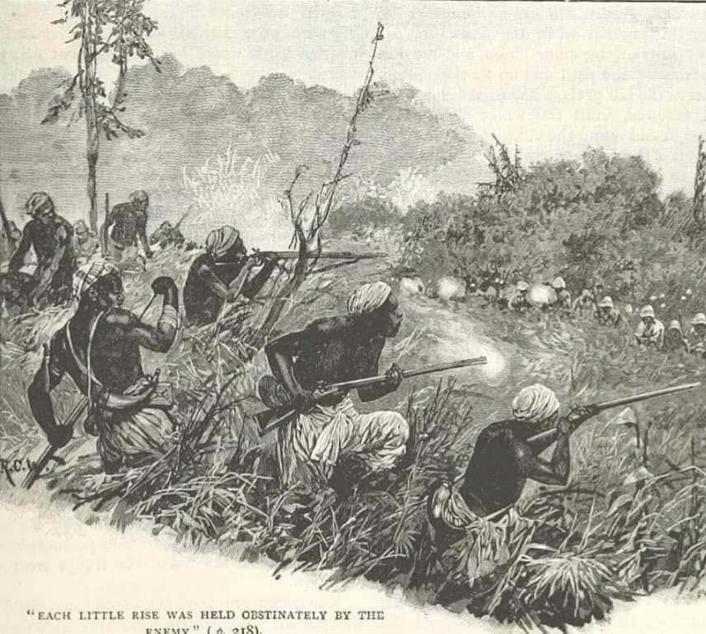
It was worth noting that the Invitation of the Brothers of Christian Instruction was against the background of entrusting them the Mission of especially developing a quality High Education Sector that had been perceived to be missing. It was necessary to support the existent Catholic High Schools, Teacher Training Colleges and Secondary Schools (Colleges). The Church saw that as a privileged way of Training a Catholic Laity with Strong Moral Principles and Values for the Country's upcoming Leadership Structures. It was in view of that Intention that the Brothers involvement in the Primary School Sector was not taken as an immediate need at the beginning. The Education of the Children in the Primary Schools was taken up rather tardively.
Wars of Religion (1888-1892).

It was also important to note that the Brother understood their Mission as being Truly Catholic; and thus, without Attachments or Loyalty to one Group of Missionaries. Although the Original Invitation to come to Uganda was made by the Missionaries of Africa, (White Fathers), and in whose Vicariate they were received, the Brothers shortly widened their Scope even to the Vicariate under the Mill Hill Missionaries. The Brothers accepted the Mission in those Schools without any hesitation.

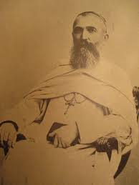
From a Historical Point of View, it ought to be remembered that the Mill Hill Missionaries also had been requested to come to Uganda by the White Fathers; especially by the insistence of Bishop Livinhac to Propaganda Fide. Having been the Leader of First Contingent of Catholic Missionaries to Uganda who arrived in 1879 and the First Apostolic Vicar (Bishop) in Uganda, he saw the need. By that time, he had returned to Rome upon his Election as the Superior General of the White Fathers. The presence of the Mill Hill in Uganda was to serve as a Pastoral Solution to diffuse the unfounded motivation for the Violent Conflicts between the Catholics on one side and Protestants with Moslems on the other side that had ended in the Unfortunate Religious Wars (1888 – 1892).

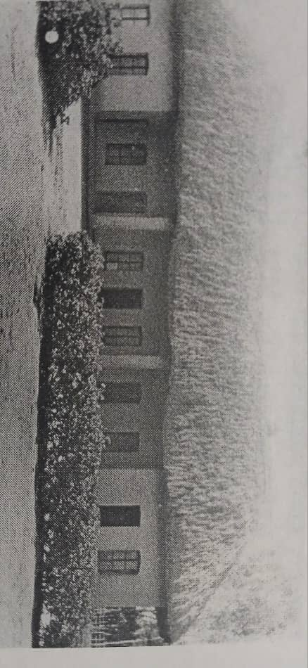
That Conflict had been driven by the claim that ultimately it was a War between France (French Mission - the Catholics) and Britain (British Mission – the Protestants and their Collaborators), especially in the Kingdom of Buganda. Thus, it was necessary to invite British Catholic Missionaries to the Mission in Uganda to eliminate the Political Misconception that aligned the Catholic Mission and its Activities to France. The arrival of the Mill Hill Missionaries in 1895, sanctioned by Propaganda Fide in Rome after the Creation of the Upper Nile Vicariate on 6th July 1894 served as a Lasting Solution to the Problem.
Brothers Community house at Bikira 1927
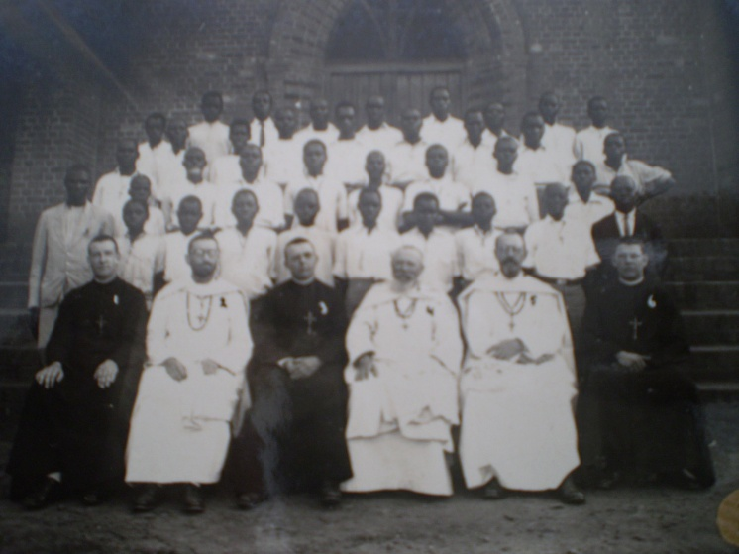
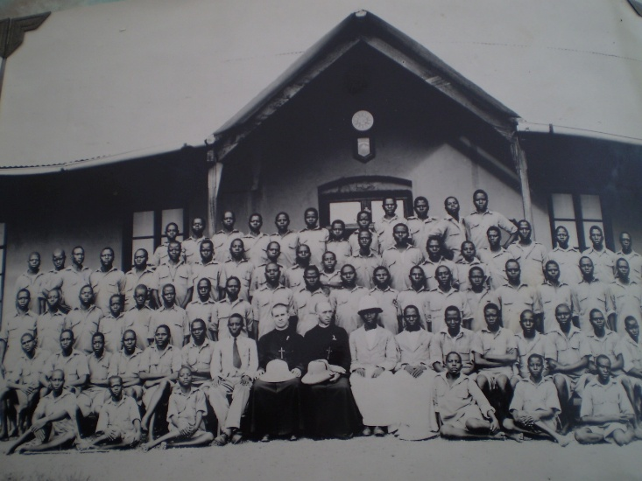
The Growth and Consolidation of the FIC Mission within the First Ten Years, (1926 – 1936) was carried out in the Vicariates under the White Fathers, and under the Mill Hill Missionaries. The Chronological Foundation of, or withdraw from a FIC Mission was based on the Real Pastoral and Education Needs in the Vicariates, but especially on the availability of FIC Personnel resulting from the arrival of New Contingents of Missionary Brothers. St. Mary’s College at Kisubi having been the First Mission of the Brothers in 1926, Bishop Streicher had placed a request for the Brothers to extend their services to Bikira Teacher Training School at Bikira in Masaka as well. It had originally been a Catechetical School which was upgraded by the White Fathers to serve at Teacher Training College to meet the needs of providing the much-needed Teachers in the many Primary Schools of the Vicariate. He had equally requested Brothers for St. Henry’s High School at Kitovu also in Masaka.
St. Joseph's Nyamitanga (1930) Brothers and Priests (White Fathers) and Students
St. John High School Nandere (1931)

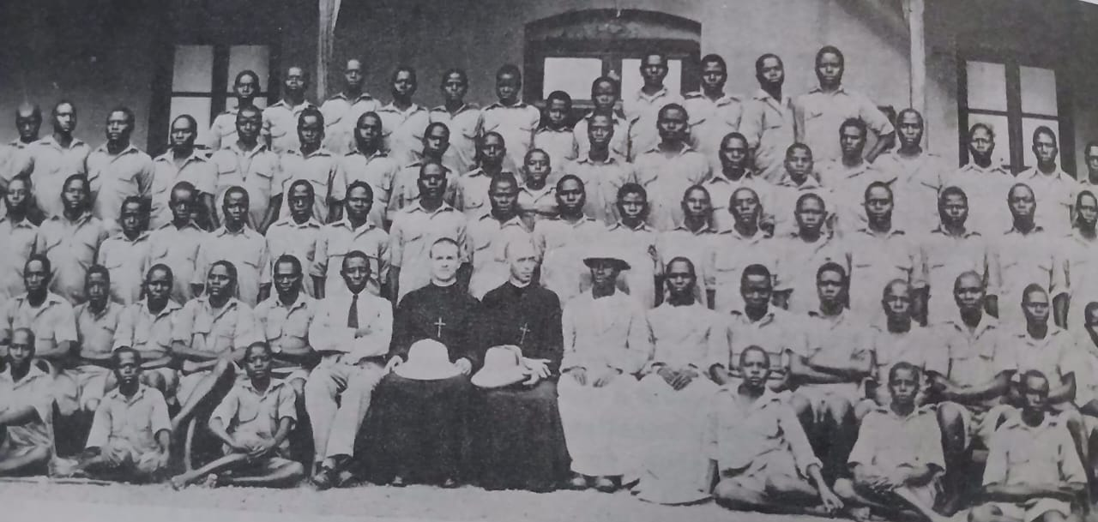
With the arrival of the Second Group of Missionary Brothers, the First Wish of Bishop Streicher to hand over Bikira Teacher Training College to the Brothers was realised. Two Brothers selected for that College had the obligation to learn the Vernacular (Luganda) as it was one of the Necessary Tools of Instruction for the Teachers. On December 20th 1926, Brother Joachim-Leon left Kisubi for Bikira to prepare to take over as the New Principal of the T.T.C the following year. He was shortly joined Bro. Lucien Joseph Wilfried Vincent. Bishop Streicher had indicated that the Brothers were not only to take charge of the T.T.C, but were also to get fully involved in the Religious Formation of the then Nascent Local Religious Congregation of the Banakaroli Brothers. Moreover, a significant number of the Teachers-in-Training at Bikira T.T.C. were either Aspirants, or Postulants to that New Congregation. The Two Brothers had just got fully immersed in that Double Apostolate as Tutors and Formators when only two years later, at the end of 1929, a Discernment by the Superiors led to a decision for the withdrawal of their services from the Bikira Mission.
Students of Bikira T.T.C with the 2 Brothers in 1927.
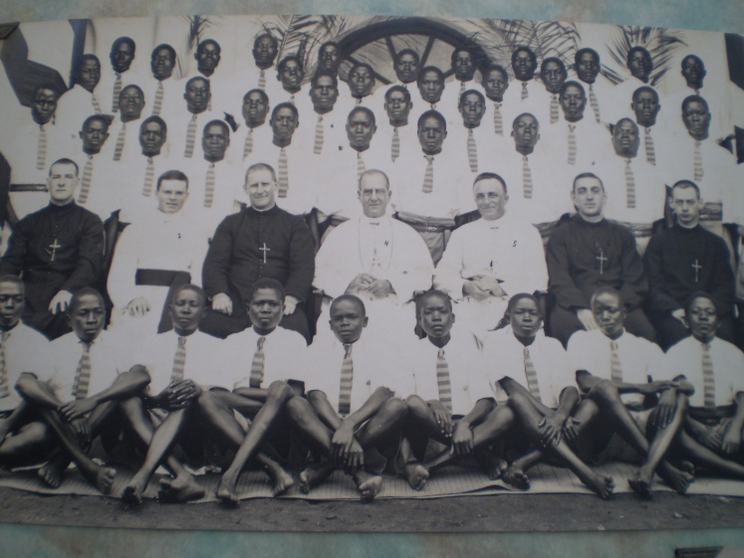
Handover at Namilyango: the FIC and the Mill Hill Missionaries gathered around Bishop Campling and the students in 1929
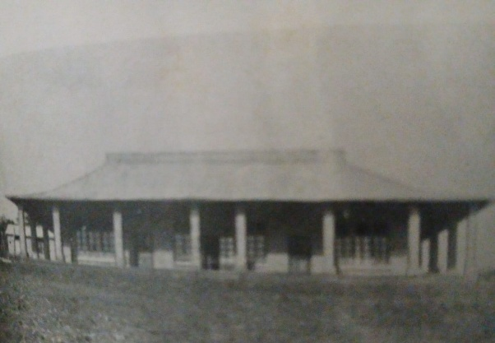
The other wish of the Bishop was also fulfilled when Brother Eugene Marie Paquette from Kisubi was appointed to take up a New Mission at Kitovu. He arrived a little earlier and was joined by Brother Donat Marie Maurice Trudel. The Brothers took Charge of the School in the August of 1927 from the hands of Fr. Laberge, White Father and its Founder in 1922, who had directed it up to the time of their arrival. As just indicated above, the Brothers withdrew from Bikira Teacher Training College at the end of 1929. The Two Brothers who had served at Bikira were appointed to take over a New School, St. John High School at Nandere which had been founded by Fr. Francis Xavier Lacoursaiere, (who later became the First Apostolic Vicar of Rwenzori Vicariate created in 1932, with his residence at Nyamitanga - Mbarara). Unfortunately, Nandere School did not last many years due to the Plague Epidemic that was ravaging that part of the Country. It was closed, among other reasons, for Health Concerns at the end of 1931.
One of the School Buildings in Namilyango during the FIC Era
In that same year, (1929), the Brothers took Charge of St. John High School, Nandere, the Mill Hill Bishop based at Nsambya – Kampala, Bishop John William Campling, received a Positive Response to his request too. He wanted the Brothers of Christian Instruction to take Charge of Namilyango College. That College was at the same Level as St. Mary’s College, Kisubi. On 13th August 1929, the Bishop himself and his Vicar General, Fr. Minderop, came to Kisubi to pick the Three Brothers who had been promised to him. The Brothers appointed to Namilyango were: Brother Aime-Marie Hormisdas Lebel, Brother Louis de Gonzague Edmond Dufrene and Brother Stanislas Joseph Taillefer. Brother Charles accompanied them to ensure that all was well.

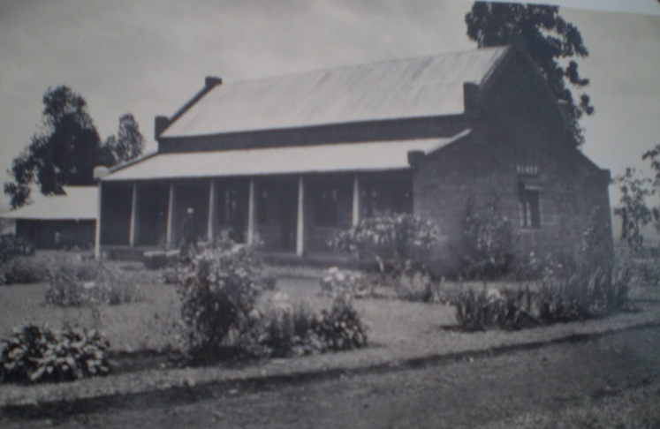
From the words of Brother Charles, and the experience of the other Brothers, they were greatly impressed by the Warmth of the Reception accorded them by the Mill Hill and the Materials that were put at their disposition in the Residence which were far above what was even in their Own Residence. After the Handover Ceremony, the 19th August was their First Day in the School. All seemed to have been going well, however that School was handed back to the Mill Hill Missionaries at the end of 1932.
Residence of the Brothers in Yala

Bishop Streicher had earlier also requested the Brothers of Christian Instruction to take over St. Joseph High School Nyamitanga in Mbarara. That was realized In August 1930 when Brother Edgar Marie Charles Edward Delorme, Brother Emery Edward Charles Joseph Vezina and Brother Viateur Marie Antoine Tittley arrived at Nyamitanga and took Charge of the School from the White Fathers. That School was later handed back to the Bishop in 1960.

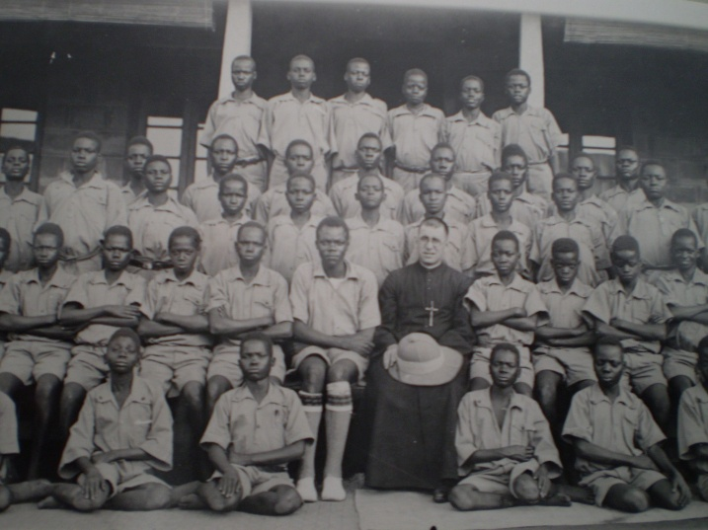
The following year, August 1931, the request of another Mill Hill Bishop, in Kenya, the Prefect of Kavirondo (1925) and later renamed the Vicar Apostolic of Kisumu (1933), Bishop Gorgon Gregory Brandsma was granted. He received the Three Brothers promised to him to take up Mission at St. Mary’s School, Yala. That School had Two Sections: The Secondary School and the Teacher Training College with a Vocational Studies bias in Agriculture and Carpentry. The T.T.C. was training Teachers for Primary Schools in the Entire Country. The Brothers appointed to that Mission were: Brother Louis de Gonzague Edmond Dufrene, Brother George-Augustin Lord and Brother Heraclius-Albert. At the time of taking that School. Brother Joachim Leo, who was the acting Superior of the Mission, following Bro Charles’s absence on Treatment Abroad. It was the acting Superior who accompanied them across Lake Victoria to Kisumu in Kenya. They received a warm reception and support, even though the early days of the Mission were not easy. Due to some Personnel Challenges, the School of Yala was handed back to the Bishop at the end on 1941.

In the period 1932 – 1936 there were no New Missions that were accepted by the Brothers or even handed back. However, there were several developments in the Domain of Consolidating the Mission and in the Area of Recruitment and Formation of the Indigenous Candidates into the Congregation. The Next Segment of the History of the Province would treat that detail in the East African Mission.
The Class of Br. Heraclius Class in Yala (1932)
SOURCES.
CHRONICLE OF THE FIC BROTHERS, years 1926-1936.specific pages within nos. 79 – 83, 92 – 98.
MISSION DE L’EST-AFRICAN -Uganda, Tanzania, Seychelles, Several numbers for that period.
FIFTY-SIX YEARS IN EAST AFRICA, ESP. PP. 12 –18
THE BROTHERS of CHRISTIAN INSTRUCTION in EAST AFRICA,2000, pp. 20 – 28.
75th PLATINUM MAGAZINE,2001, p. 14

