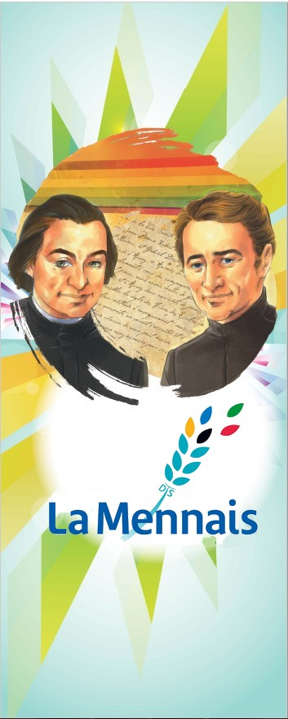
MENNAISIAN NOVENA
May 2024
- POSTULATION NEWS
The Postulator was called to the Chapter to take Stock of the Current Situation of the Cause of Beatification. In Summary:
- After the Examination of the Recovery of Josette Poulain was stopped, we took up the cause of Enzo Carollo. Currently it is being studied by four Italian Doctors and followed by other Doctors in Argentina. The Results will be presented to the Dicastery of the Causes of Saints.
- The Chapter was made aware of the Organization of the Devotion to the Father by the Local Animators, who are responsible for adapting the Prayer to Father de la Mennais, the Novenas, the Mennaisian Devotion in each Country. They are also responsible for following Prayer Intentions and informing the Postulator about the Favors received.
- The Postulator presented the question of Introducing the Causes of some Brothers who have left a Reputation for Holiness, to the Dicastery of the Causes of Saints. He recommended carefully guarding the Written and Oral Memory of the Brothers and the Veneration of the Places where they passed, and even of their Tomb.

- INTENTIONS OF THE NOVENA
We continue to pray for:
- Bro Alain Josselin. He left the Saint-Malo Hospital for the St-Yves Clinic in Rennes, specializing in supporting people who have undergone Serious Surgical Interventions.
- Our Brothers, Students, Families and People of Haiti, who are going through a time of Great Difficulty.
- The Peace: it is threatened in several parts of the World, particularly for Children, the First Victims of War.
- For Recommended Patients indicated and followed by Mennaisian Facilitators in each Country

- FAVORS RECEIVED
. Let us transcribe the Medical Report of Brother Joseph Tinkasimire, following the account he gave of his healing (April Novena), obtained following the Intercessory Prayer addressed to Father de la Mennais.
“Bro Joseph Tinkasimire is an 86-year-old man who presented to CorSU Hospital on 08/12/2022 with left hip pain. He injured his hip following a fall. His X-ray and CT scan revealed a minimally displaced Intertrochanteric Fracture of the left Femur. He also had Advanced Degenerative/Arthritic changes in the same Hip Joint.
He was kept in bed continuously for six Weeks. When he was examined six Weeks later, X-rays showed Callus Formation at the fracture site and he began Physiotherapy Treatment for Rehabilitation. He was also put on Treatment for Calcium Intake.
Two Months later, he was walking on crutches. He benefited from a 3 cm shoe extension to compensate for the shortening of the left lower limb. When examined three months later, the fracture was found to be well united and using a cane for support. During his last Consultation on 01/18/2024, Brother Joseph did not feel any pain, except for occasional discomfort when he exerted too much effort. He still uses a cane and can walk up to two kilometers. Any help given to him is appreciated. »
Doctor Paul Muwa, Department of Orthopedic Surgery,
CoRSU Hospital, Kisubi (Uganda), 12-4-2024

- HISTORY OF MENNAISIAN DEVOTION
16-MARCHING TOWARDS HOPE (2000-…)
- NEW LOOK AT THE FOUNDER
Like most Religious Families in recent years, Our Institute also reveals an aspect of fragility: the number of Religious is decreasing, the closures of Works exceed those of openings, the Projects give way to Calculations of Survival. And yet the buds of hope, according to God's views, are growing. It is true that “the Works of God are born in the shadows and the morning dew descends during the night” (P. de la Mennais) and “if the grain of wheat does not die, it produces no fruit”. Let us try to find, in the field of Mennaisian devotion, the buds growing on the ever-young tree, planted by our Founders 200 years ago. On their ardent Trinitarian Love, on their Missionary Dream of announcing the Good News to the Little Ones through Instruction and Christian Education, the Life of Our Congregation Germinated, with the Unpredictable Breath of the Holy Spirit.

- A NEW FLOURISHING OF BIOGRAPHIES ON JM DE LA MENNAIS
On the Occasion of the 150th Anniversary of the death of the Founder, Biographies were published:
- JEAN-MARIE DE LA MENNAIS, WATCHER FOR THE FUTURE, (Bro Josu Olabarrieta), Original in Spanish: he tells the story of the Founder, putting it in parallel with the 7 days of Creation.
- THE COURAGE OF HOPE, JOHN DE LA MENNAIS: (Bro E. Drouin and Bro Blouin) Original in English, very detailed, the result of careful Archival Research.
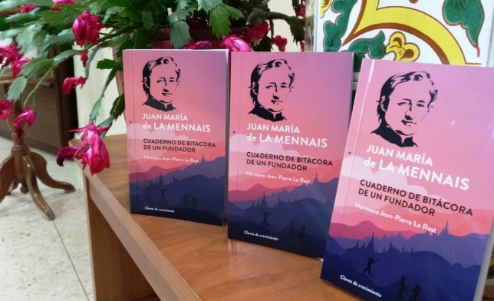
- GIAN MARIA DE LA MENNAIS, EDUCATORE PER UNA NUOVA SOCIETÀ CRISTIANA (Bro D. De Carolis), Original in Italian, popular Work to make him known in the Italian Environment.
JEAN-MARIE DE LA MENNAIS, A FOUNDER’S JOURNAL (Bro. Jean-Pierre Le Rest), in French, English and Spanish. The Author gives the floor to the Founder who writes in the first person, drawing the reader into the Human and Spiritual Adventure of Jean-Marie.

- PUBLICATION OF DOCUMENTS
Bro. Philippe Friot has definitively Published the Letters of Father de la Mennais. After the first collection by Br. Symphorien-Auguste (1937...), Bro. Louis Balanant in 1993 Published another, more complete one. The collection of the GENERAL CORRESPONDANCE of Brother Friot includes the SERMONS in Two Volumes of 1500 pages in total and the Father's Letters in 7 Volumes of approximately 4500 pages in total: A Meticulous Work, accompanied by notes and explanations, enriched by other Documents and Precious Indexes: A Monumental Work which is an Indispensable Instrument for all those who approach the knowledge of Father Jean-Marie de la Mennais.
A few years earlier, Bro. L. Balanant had composed a Second Series of MENOLOGY, in Three Volumes on the Brothers who died in the 20th Century, who left a good reputation for Holiness of Life and Apostolic Ardor. We can also find there a valuable source of Documentation of the History of the Institute in its most Significant Stages
- WORKS OF MENNAISIAN SPIRITUALITY
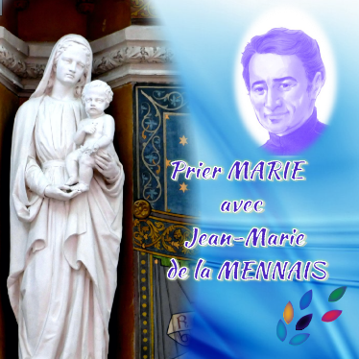
The Superiors General actively contributed to this growth of Mennaisian Spirituality. They have prepared simple and attractive Booklets with short sentences from the Founder, very suitable for Prayer. Bro. Bernard Gaudeul composed the Booklet: “Father de la Mennais calls to me”, putting in parallel the thoughts of the Father with the Rule of Life. He particularly thanks the Long-Term Archivist Bro Hubert Libert. Bro Yannick Houssay, during his Generalate (2006-2018), was greatly inspired by Mennaisian Writings. He often cited him in his Circulars and he composed Two Booklets: “Follow Jesus in the manner of JM de la Mennais” and “Thirty days with JM de la Mennais”: with a thought of the Father, a Little Meditation, a Prayer, a Practical Application. Bro Hervé Zamor presented an Instrument for the Mennaisian Family: “Praying Mary with JM de la Mennais”, Small Meditations on the Mysteries of Rosary taken from the Writings of the Founder. On this line we can also put the Beautiful Booklet by Bro Yvon DENIAUD: “Pray 15 days with JM de la Mennais”. In 15 simple chapters he presented the portrait of the Founder, his spirituality and his history, with thoughts and prayers.
Another Mennaisian Achievement is linked to the Files of Congresses and Meetings, as organized by the Mennaisian Training Institute in Ploërmel. Some Titles (from 2006 to 2009): THE AUDACITY TO WEAVE TOMORROW, DARE TO FRATERNITY, DID YOU SAY MASTER? NEW PATHS FOR FAITH.

- THE STRONG RESUMPTION OF THE CAUSE OF BEATIFICATION OF JM ROBERT DE LA MENNAIS
After the years of the Declaration of the Heroic Virtues of Father de la Mennais, there was a moment of pause for the process of Beatification. Explainable by several reasons: the changes to the Canonical Procedure desired by Popes Paul VI and John Paul II; a Certain Weakening of Devotions in General, especially in the Cult of Popular Saints and in their Miraculous Interventions; the return to the sources of the Foundation and the Charism which required Great Resources. The Postulators who succeeded one another, Bro Jean Le Bihan (1973-85), Bro Vincent Guillerm (1985-97), Bro. Philippe Friot (1997-2003) did a great job of deepening the Mennaisian Charism, they presented some cases of healing which were verified in Canada and South America, but we never achieved concrete results. The Postulators urged the Brothers of Ploërmel and the Daughters of Providence to resort to the Intercession of the Father even for Material Interventions. Bro Guillerm wrote: “The Official Prayer (Novena, Father’s Week, etc.) must be accompanied by personal prayer and that of families and friends. The Lord responds to this Prayer with Generosity. Let us say that we too, “Poor Humans”, it is necessary to support prayer with more Material Gestures, Signs of Our Faith. I am thinking of contact with Images, with Relics, Pilgrimage to the Places of the Servant of God, Monuments of Memory in different Countries. These are not Superstitious Gestures, but an expression of Our Confidence and a sign of the Humble Acceptance of our human condition, according to the style of the Incarnation.” But in practice no Extraordinary Healing had been presented to the Dicastery of the Causes of Saints.
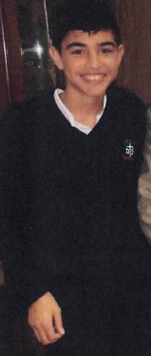
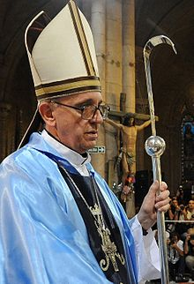
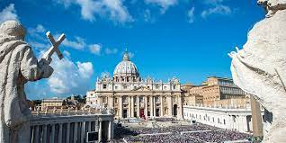
In 2003, Bro Delfin Lopez was appointed Postulator, also a fervent devotee of the Father. He had done much to animate devotion to the Father in South America, where he had been Provincial. He had communicated cases of healings specific to the Postulation, such as those of NELBA GONZALES (1994) in Uruguay, STELLA BAVA (2004) and PAOLA TABACHI (2006) in Argentina. They had been abandoned because of the fragility of the Medical Implant. In the same period another case occurred: Enzo Carollo, a little student from Our School in Buenos Aires, Card. Copello, affected by Meningitis caused by Mycoplasma Pneumoniae, was cured of this very serious infection in a supposedly inexplicable manner, without sufficient Medical Intervention, after recourse to P. de la Mennais. Bro Delfin followed the Diocesan Trial of Buenos Aires [during the time when the Archbishop was Mgr. Bergoglio, the future Pope Francis]. The process was followed in Rome at the Dicastery of the Causes of Saints by the New Postulator, Bro Gil Rozas (2013-16), until he presented the Medical Summarium (file) to the Official Medical Commission. The Final Judgment was not in Favor of Inexplicability: 5 against and 2 for. Till today, the case was stopped. The New Postulator, Bro Dino De Carolis, reopened an old file, which in its time had been presented by Bro Hippolyte-Victor: in 1956 a 5-year-old girl, a student of the Daughters of Providence in Combourg, France had had an incident which gave her a serious Epidural Hematoma and was cured in a supposedly inexplicable way, by praying to Father de la Mennais. The case had already arrived in Rome in 1962 after the Diocesan Investigation in Rennes. The Applicant requested an additional phase of the Rennes Investigation, which took place in 2018-20. The process arrived in Rome and submitted for Examination to the Medical Commission of the Dicastery. The judge's Judgment was “Suspensive”: we do not have enough Diagnostic Elements (and we cannot have others, given the time that has passed since the event) to demonstrate that healing can be explainable or inexplicable. Which meant a halt to the Examination of the Case. After these difficulties, the Postulation resumed the Great Work accomplished on the case of Enzo to see if it can be represented, with New Medical Expertise favorable to the Inexplicability.
Cardinal Bergoglio in 2008
Successive Postulators have contributed to growing Devotion to the Father by preparing a Special Monthly Bulletin. In these pages we find indications for Prayer, Intentions, Knowledge of the Father and Mennaisian Religious Families. We can also discover thoughts of the Father for each day, correspondence with the Provinces, Presentations of Particularly Heroic Mennaisian Witnesses. They were little leaves to animate devotion and affection towards Our Father.
- TRACES OF HOLINESS :
THE PIONEER BROTHERS OF THE FOUNDATION IN SPAIN.

THE BROS FRANÇOIS JOSEPH LAPEYRE, ELIPHIUS BESSABER, EXUPÈRE JOSEPH ESCUDER AND EMILIO RAMOS
End of the 19th and beginning of the 20th Century: in France, Anticlerical Laws expelled the Brothers from Municipal Schools, removed their Property, and placed Teaching Congregations outside the Law. The Institute, led by the Superiors, reacted immediately. Many Schools continue their action clandestinely; the Province of Canada, prepared for this threat, opens the doors to young Brothers who wanted to follow their Vocation in Full Freedom; New Mission Fields would quickly open up: Bulgaria, Türkiye, Egypt. Spain offered a welcome and perspective for the future to the Brothers, especially to those from the Province near the South. Let's try to delve deeper into this part of Our Mennaisian History.
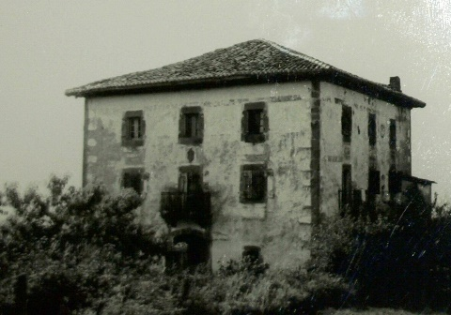
To respond to the threat from the French Secularist Government, the Superiors sent some Brothers from the prosperous Southern Province to Spain to study the Spanish Language and to explore the possibility of a future Establishment of the First Works. Thus, Brothers Eliphius Bessaber and Octavien were sent to Barcelona with the Marist Brothers to study the Language. Brother François-Joseph Lapeyre went to Bilbao and began to collaborate with Father Azkué, a Famous Language Specialist. The Brothers who were expelled from their Schools in the Midi Province, Sainte Marie (around Thirty Schools), are available to quickly open a series of Small Educational Establishments. They found a first refuge in Lujua.
We immediately began by establishing the Central and Formation House in Zugarramurdi (1903), then in Miquelemborda (1904). Then the Brothers opened in Etchebarri (1903) with Great Success. Next: Berrio Otxoa (1903), Baquio (1903), Dos Caminos (1904), Reinosa (1904). The Small School in Dancharinea-Urdax, started with Simple Lessons, became an “International School Center” because they Teach in Spanish, Basque and French. Then it will become the Training Center, before definitively establishing the Novitiate and the “Motherhouse” of the New Province in Nanclares de la Oca.
Zugarramundi
Let us go into the History of these Foundations, through the vicissitudes of some Brothers. We will realize the Fatigue, Enthusiasm, Sacrifices and Generosity required to carry out this Work. Let’s follow the “Little” story of some of them.
BROTHER ELIPHIUS BESSABER (1878-1918)
The Menologe presents him thus: “He is one of the Brothers who worked the most for the Introduction of Our Congregation in Spain, which is saying something. Given the particularly difficult circumstances which accompanied the Founding of the Various Houses”. A few Months after taking Spanish Lessons with the Marists Brothers, he
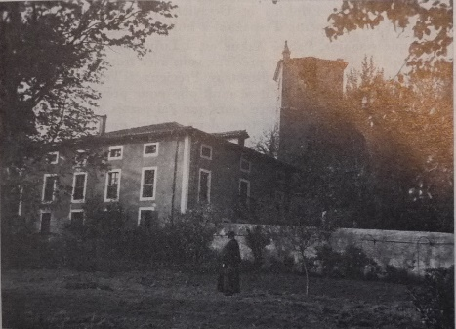
taught this Language to a group of Brother Refugees in Lujua, the First Temporary Reception Point. Bro Eliphius had his teaching hours, but he devoted himself to several services: he worked on the Small Farm of the House and in Breeding. Every Morning he went to the neighboring City of Bilbao to sell Milk House by House. “This last role caused him multiple incidents: Broken Cans, reproaches from Grumpy Customers, threats from Police Officers because he was breaking some Road Regulations, threats from Strikers who wanted to overturn his Car. None of this, any more than the fatigue which deprived him of hours of sleep, could discourage him.”
Bro Exupère Escudé
Lujua
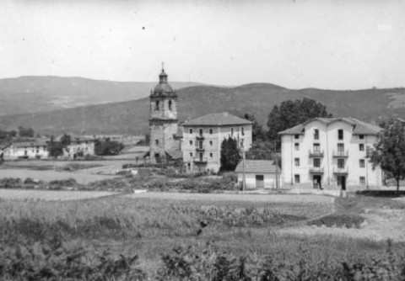
But he wants to actively enter into his Mission as a Brother. In September 1904 he was in Dancharinea: he began giving Lessons to some Local Children. He launched this Small School House which would become the “International” Center of Urdax, San Miguel College, to which the Novitiate would be Annexed. In the fall of 1904, he took charge of the Dos Caminos Municipal School. The School starts with great success. The Director adds Arts and Craft Classes to the Regular Teaching. In each School where he was placed, Bro Eliphius very early won the Goodwill of the Students and their Parents, thanks to his generosity and the openness of his heart. He would demonstrate this Paternal Spirit by collaborating in the Founding of the “Refuge” in Bilbao, a Small Boarding School where abandoned children entrusted to the Brothers by the Police are welcomed. The Chaplain of the Refuges, who knew him well, said of him: “I was able to appreciate the delicacy of his Virtue, his Zeal for the Work that God had entrusted to him and the goodness of his Heart for the Abandoned Children, for the Material and Moral Good for which he gave his life.” He died in 1918, during the “Spanish Fever” Epidemic: he was 40 years old.
Dos Caminos
BROTHER EXUPÈRE-JOSEPH ESCUDÉ (1854-1929)
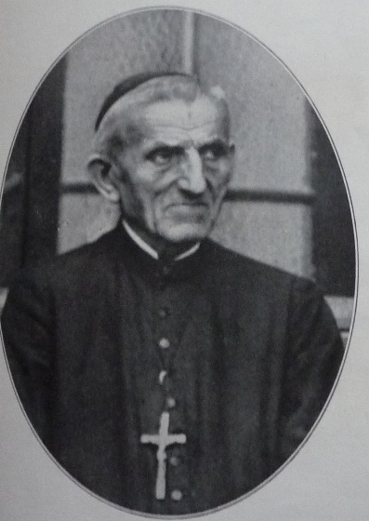
He spent the first 50 years in the Midi Province. Returning to the Novitiate, following his two Brothers, he held important Positions in the Bordeaux Region. In 1885 he was transferred to Lourdes, first to the Basilica Office and then to the Parish School. “It was a grace for him to go and visit the Grotto of Apparitions, especially in Winter, and to pray for the Institute.” He was in charge of the Choir of the Basilica, which he Directed Magnificently during the Solemn Ceremonies. In addition to Teaching and Director of the Choir, he was responsible for organizing Patronage for Former Students. He devoted holidays and Holiday Activities, Games, Religious Training, and Prayer for young people. In Summer he organized stays for Volunteers, Stretcher Bearers and even Passing Missionaries, who came to strengthen themselves at the feet of the Immaculate Virgin.
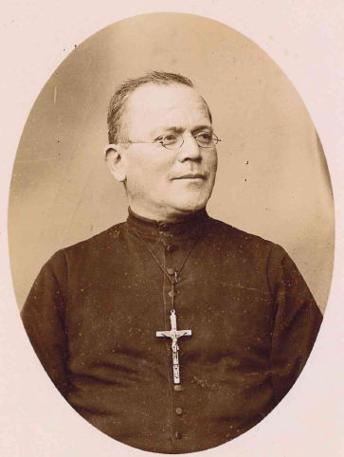
At the time of the Secularist Persecution, Bro Exupère was 50 years old. He was determined to pursue his Vocation by emigrating to Spain. He learned Spanish by Teaching it. He started at Echebarri, where he was Director and Organist. Then he was transferred to Dos Caminos and Bermeo. Not perfect knowledge of the language did not prevent students from achieving Extraordinary Progress as evidenced by Exam Results.
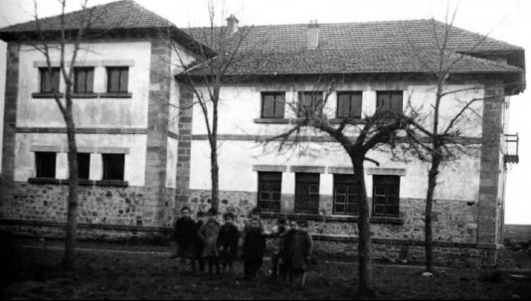
In 1917 he was put in charge of the Management of the “Refuges” in Bilbao. Despite his apparent Austerity, his Heart is intensely Devoted to these Abandoned Children. He is for them a Loved and Revered Father who uses all his care to make them happy: he personally watches over their Menu, he organizes Parties and Holidays for them, he celebrates the Ceremonies, especially at the Table. Bro Exupère had the talent of welcoming: his delicate attention to the Brothers made him the Patriarch Loved and respected by the entire Province of Santa Maria. He was still active in Mundaca in 1923, where it began to show signs of weakening. Despite these illnesses, he returns to the Refuges, like a Grandfather among his little ones: he lived among them, proposing initiatives, but above all by giving them his affection, readily returned by the children.
BRO FRANÇOIS-JOSEPH LAPEYRE
On December 7, 1929, at the age of 75, he received the Sacraments of the Sick. He would go to Heaven on December 8th, the Feast of the Immaculate Conception, which he loved and prayed for so much in Lourdes, uniting his beautiful voice to the Choir of Angels and Saints. A delicacy of Providence: he had lived for 20 years near the Grotto of the Sanctuary and each year he sent a Delegation of his Spanish Students to Lourdes. His devotion to the Virgin was legendary in the Province: now he could meet his beloved Virgin Directly in Heaven.
Munguia
BROTHER FRANÇOIS-JOSEPH LAPEYRE (1848-1929)
He began his Mission in the Large Secondary Schools of the Midi Province. For 30 years he was the Director of the Important Higher Institute at the Bastide in Bordeaux. A Teacher with Multiple Skills, he extends his knowledge from the Great European Literatures to Higher Mathematical Sciences. Gifted with remarkable Musical Talent, he was the Official Organist of his Parish and sets up a Musical Fanfare.
In 1903 he had to give up all these splendid activities: The Congregation was suppressed in France and in all its Colonies. Bro François-Joseph places himself at the disposal of the Superiors. He is sent to Spain, with a view to preparing a foothold for his Colleagues. He made contacts - as we have seen - with the Distinguished Professor Azkue. They negotiated to open the First Humble Foundation of Lujua, the First Refuge for the Brothers and place of Study of the Spanish Language. The very Modest Foundations are multiplying at a rapid pace. In 1903 Bro François, with Bro Etcheverry, opened the Baquio School, in the Heart of the Basque Region. The prospect of teaching children who barely know a few words of Spanish does not frighten the Distinguished Mathematics Teacher. On the contrary, he himself began to study the Basque Language to teach more effectively. The following year he was put in charge of the Reinosa Secondary School, which at that time was in complete decline.
Bro François brought it back to Very High Levels. The Superiors, who observed his abilities, sent him to Several Schools to take charge: in Munguia (1909-10), in Bilbao Berrio Otxoa (1910-16), in Bermeo (1916-20).
The years advance and Brother François' Health, although robust, began to show signs of age. Above all, increasing Deafness made Teaching difficult for him. He was then called to Nanclares as Director of Studies. He is also responsible for the Management of the Large Establishment, which has become the Main House of the Spanish Province and a Training Center for Postulants and young Brothers. In this role, in addition to the Administration of such a Large and Complex House, he managed to give hours of Mathematics Lessons: for him these were the “best” hours of the day. In the midst of these occupations, interspersed with Readings, Playing Dominoes, Reciting the Rosary or the Office of the Holy Virgin, he reached 81 years old. He is struck by a serious form of Bronchitis. He asked to receive the Sacraments and he entrusts himself to the Blessed Virgin, of whom he is very devoted. He ascends to Heaven on the Morning of August 15th , the Feast of the Assumption of Mary. Among the qualities that the Brothers attributed to Brother François, they indicate devotion to the Annual Retreat. He kept a small Notebook where he wrote down the Preachers' Instructions. The Notebook was yellowing, but nourished his Spirituality. " Bro Francis remains one of the Best Early Workers in Our Spanish Province.”
BROTHER EMILIO RAMOS (1894-1918)
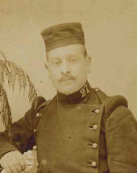
We want to end this Small Gallery of Portraits of the Brothers with a young Brother born in Spain: Bro Emilio Ramos. Originally from Santa Cecilia (Burgos), at the age of eight he moved to Reinosa with his family. He attended the College of the Mennaisian Brothers from its opening in 1904. Young Emilio stood out for his commitment to work, his fervent Spirituality and his keen Intelligence. He felt attracted by the Vocation of his Teachers, Brothers Elias Padel, Eliphius, Fausto Lay and François Lapeyre as Director. In 1908 he entered the San Miguel de Dancharinea Novitiate, where he was one of the First and Most Fervent Spanish Novices. In 1912 he was active at the Baquio School, where he found a young Director, Bro Adolfe José Gomiz, gifted with Great Human and Spiritual Qualities. To make his teaching more effective, he studied the Basque Language: he knew it so well that he obtained Congratulations from the Local School Board.
He must separate from his students, because he is called to the Bilbao Refuge (1914-17), to take care of Abandoned Children. He teaches with zeal and transmits to his children Great Religious Fervor. Through multiple initiatives, he animates Liturgical Periods and Christian Festivals, in particular the Month of March dedicated to St. Joseph, the Month of May dedicated to the Virgin, the Month of June dedicated to the Sacred Heart of Jesus.
For Military Service he was enlisted in Vitoria. He was quickly promoted to Non-Commissioned Officer. He found Religious Support among the Brothers of the Sacré-Cœur and in Nanclares. He was offered a contract for a Brilliant Military Career, but he decisively refused to remain faithful to his Vocation. His service finished, he returns to the Refuge, among his Abandoned Children, even better prepared to accomplish this delicate Mission.
He could still do a lot of good, but God accepts his good will. These were the years of the terrible so-called “Spanish” Epidemic. Two Months after his arrival in Bilbao, Brother Emilio fell seriously ill. He receives Religious Comfort, he offered to the Lord the Sacrifice of his young existence for his little beloved ones, for the Mennaisian Work in Spain and throughout the World and for the end of the War.
He was born in Heaven on October 15th, 1918, after a short existence, but filled with Love.
CONCLUSION: These Brothers are representatives of many others (often anonymous) who have spent their lives in the Service of the Kingdom of God: together they have dug the Foundations on which Our Congregation and in particular the Spanish-speaking part has been able to grow.
SOURCES: HERMANOS DE LA INSTRUCCIÓN CRISTIANA, Apuntes históricos: 1903-1928 (Nanclares 1928)
MENOLOGY: F. François-Joseph Lapeyre pp. 931-33/ F. Eliphius Bessaber pp. 990-92/ F. Exupère Escudé pp. 1398-1400/ F. Emilio Ramos pp.1295-96
FIC Historical Directory 2024: Spain

