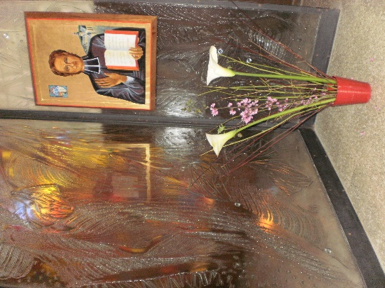
MENNAISIAN MONTHLY NOVENA
APRIL 2023
1-NEWS OF POSTULATION
Currently the Cause of the Father is at the stage of the Medical Commission (Consulta Medica). The Department for the Causes of the Saints has completed the Healing File (Summarium) by adding the latest medical expertise. The official printer (Nova Res, Roma) will publish 18 Dossiers, which will be distributed to the 7 Medical Specialists and to the officers of the Dicastery. There will be sufficient study time (a few weeks), after which the Prefect will set the date for the fundamental meeting of the Medical Commission. This will give the sentence of the scientific inexplicability or not of the cure, with the minimum majority of 5/7.
In our Mennaisian and Deshaysian Institutes we are experiencing important moments of echoes of “holiness”:
- The immediate preparation for the introduction of the Cause of Fr. Gabriel Dehayes, by coordinating the Institutes founded or co-founded by him and the Bishops concerned. This will be the beginning of a great discovery of an Apostle who has succeeded up to now in hiding his dimension of holiness through deep humility.
- Highlighting the testimony of the virtues and the apostolate of Brothers and Sisters who left particular traces of holiness during their existence. In this sense, the transfer of the mortal remains of “Good” Brother Ménandre Gortais was important (cf. The Novena of March 2023). He had been buried in a chapel in Lanvignec (Paimpol) and his remains collected in a box: he was venerated as a saint. Saint-Jean-Baptiste Province (France) wanted to receive this box at the Mother House. Now his testimony will be like a lampstead to enlighten Brothers, young people, children, at the birth place of the Congregation.
- We are also doing historical explorations on another Brother, who left a great reputation for holiness: Bro. Zoël Hamon. These searches are very long and complex. With the help of several collaborators, we try to reconstruct the vicissitudes of his first years and his heroic work as a Brother in Plouvorn (Finistère).

2- RECOMMENDED INTENTIONS
- We continue to pray for Brother Jean-Paul Peuzé, Assistant. The whole Mennaisian Family was close to him and prayed intensely for his healing, through the intercession of Father de la Mennais. Currently he is out of intensive therapy and is on the road to full recovery. The whole Mennaisian Family will continue to pray so that he can resume his important activity.

- OTHER LOCAL INTENTIONS:
The Mennaisian Animator Brothers will collect and report in their Province or District, the local intentions and the favors received through the intercession of Father de la Mennais.

3- FAVORS RECEIVED THROUGH THE INTERCESSION OF FATHER DE LA MENNAIS
Father de la Mennais protects his religious families everywhere and at all times. Here are three providential interventions from our Father:

- VICTORY, SASK, CANADA, DAUGHTERS OF PROVIDENCE (1901)
Barely two weeks after birth, little Nil Durette was rushed to hospital and put on oxygen for several days. After a transient improvement, he suffered a second attack of evil, which the doctors failed to diagnose. This time the child's situation was so serious that he was flown to Saskatoon and given oxygen throughout the trip. The grieving family had, from the first crisis, solicited the prayers of the Daughters of Providence and, with them, prayed to Father de la Mennais with great confidence. During the second attack, all redoubled their fervor. Also the joy of the parents was immense when the doctors handed over to them, safe and sound, their dear child, to the surprise of the health personnel. The Durette family remains deeply grateful to Father de La Mennais.
(Missions, September 1984, JC Bertrand)
- HAITI, LEOGANE, 1972 BROTHERS AND JUVENISTS
On November 18, being a national holiday, there was no school classes. We went to spend the day in Léogane about thirty kilometres from Port-au-Prince. On the way back, the car picked up speed on the beautiful road, while, juniors and Brothers, we sang. Suddenly, at a bend, the car spun out of control. Seeing the disaster coming in a flash, I cried out: “Father de la Mennais, save us!” Immediately, as if by magic, the car spun around and stopped dead on the unpaved road. Humanly speaking, this immediate and “jolt-free” stop is inexplicable. The van left a rubber mark on 7/8 metres. at least. In a few minutes more than a hundred people were on the scene to see… that we had nothing at all! The car turned around and we ended the day in thanksgiving, of which we might not have seen the end. Please relate this fact, as a sign of our gratitude to the good Father de la Mennais.
(Br. Nicolas, Missions February 1972, JC Bertrand)
- BOLIVIA, SAN BORJA, MARCH 2023
Among the novena prayer intentions was the healing of Dorys Cuellar Becerra de San Borja. We received this message from her:
“I would like to thank God for allowing my recovery. Thank you also for all the good people who supported and accompanied me during my fight against this disease. I would like to emphasize the deep gratitude to the Mennaisian Family for the constant support, affection and concern for me. My family and I are very grateful for all the love given and shown by the Mennaisian Brothers. May the Lord continue to bless you and allow you to do this beautiful human work, to help others, as well as to evangelize in our community. ”
(Dorys Cuellar Becerra and her Family)

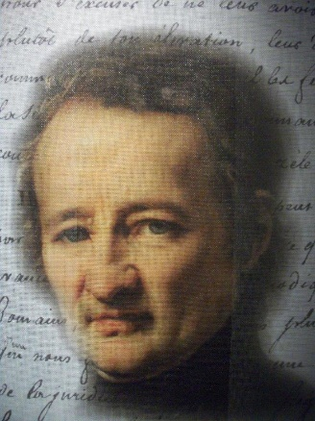
4- HISTORY OF MENNAISIAN DEVOTION - 5: THE YEARS OF THE NEW MENNAISIAN IMPETUS (1925-1935)

The institution of the day of the Father, preceded by a week or a novena of preparation immediately became a tradition in all the Mennaisian works spread throughout the world. The Institute had just recovered after the severe shock brought about by secularization: alienation of school works, clandestineness of Religious-teachers, displacement of Brothers to other countries. The Congregation was beginning to recover: schools were coming back to life. New Mennaisian buds were growing in other countries. In Canada, the Province promised rapid development. In Spain Brothers multiplied works and spread to South America. New communities were gaining a foothold in the Near East and in Europe. The Canadian Brothers opened new missions in the heart of Africa, full of promise. After so much suffering and trial, the Congregation was going through a moment of recovery and momentum, full of enthusiasm. This new phase was marked by growing Mennaisian devotion, progress in the Beatification process, expansion of Father's Day, multiplication of vocations, fervor and freshness of youth throughout the Congregation.
To appreciate this atmosphere of fervor, let us take a look at Father's Day in November 1935, the report of which was given in Chronicle n°132, March 1936. Let us see the introduction of the director Bro Célestin-Auguste Cavaleau: “Vocations Week and Father's Day were celebrated this year again, with pious enthusiasm by students and teachers. Reading the reports sent to us from the various Districts leaves a strong impression of fervor, generosity and family spirit. Devotion to the Father is increasing significantly from year to year: this bodes well for the prosperity of our Institute.” Let's go into detail for a few countries.
FRANCE (St-Yves-West District)
“During this week, our little pupils have shown a commendable goodwill. Indeed, despite the cold at the beginning, many did not back down, faced with the distance and the wind, to cross two, three, four kilometres to attend Mass. Then it was the rain; our children came again in large numbers - and by what routes! – to pray the Master to choose apostles among them. They demonstrated generosity through sacrifices of all kinds: 62,665 says the spiritual bouquet. One morning, by mistake, coffee was served without sugar to 60 interns aged 12 to 14. Well, no student made a gesture to warn the masters, all having their breakfast in the same room[…] To keep this impression for a long time, the masters distributed to the older ones, the recent brochure on Father de la Mennais and to others, a booklet on promotion and vocation.
HAITI (Port-au-Prince)
“The Brothers have installed in the place of honor in their classes, either a bust, or a portrait, or a small image of Father de la Mennais, and the pupils have brought flowers to adorn them. It is a very striking fact, that it is enough to announce a talk on Jean-Marie that immediately a joyful attention manifests itself on all the faces and that among the little tenth graders as well as among the tall Philosophy students. The spiritual bouquets were made with great seriousness; the pagans themselves have done their best. A little Jew made visible efforts; his ticket bears: Mass: 0, communion: 0, rosaries: 3, lessons: 18, sacrifices: 25, works of charity: 19”.

SPAIN (Bilbao)
“November 26th was particularly solemn. All the priests of the parish wanted to take part in this demonstration. “It has been a long time since we have witnessed a celebration overflowing with reverence and piety such as this. They promised to lend their support next year to invite all the parents of the students to this celebration which is so touching and so suitable for developing religious and priestly vocations”.
(Remember that we are on the eve of a civil war and terrible religious persecution)
CANADA (Saint-François-Xavier District)
“All the schools followed the regular Vocations Week program. Note the total number of Masses: 18,152 and that of Communions: 14,650. That is to say that a very large number of students have heard Holy Mass and have approached the Holy Table every day of the Novena”.
EGYPT (Ismailia)
"Bro Theodicien writes: “Anyone who knows how little attention and seriousness our students bring to everything they do, can say that the Novena was a success in Helouan. The many questions asked during recess following the dictations given in each class on the life and works of our Venerable Father are proof of this. It was a real crusade among the greats. Many said their rosary on their way to church, the refectory or study. Christians, Jews and even Muslims got into it wholeheartedly”.
TOTAL SPIRITUAL BOUQUET WEEK OF THE FATHER IN THE CONGREGATION – 1935
- Masses: 104,499 / Communions: 61,206 Blessed Sacrament Visits: 152,884 / Decades of the Rosary: ​​476,686 / Stations of the Cross: 28,838 / Hours of Work: 357,157 / Hours of Silence: 192,356 / Sacrifices: 370,359 / Various works: 384,0953 / 7 Prayers * TOTAL: 2,667,162
SOURCES: CHRONICLES from 1930 to 1936, in particular CHRONICLE n. 132,
March 1936, pp. 273-81

5- MENNAISIAN WITNESSES OF HOLINESS: BR. Constantin-Marie Roulin (1874-1926)

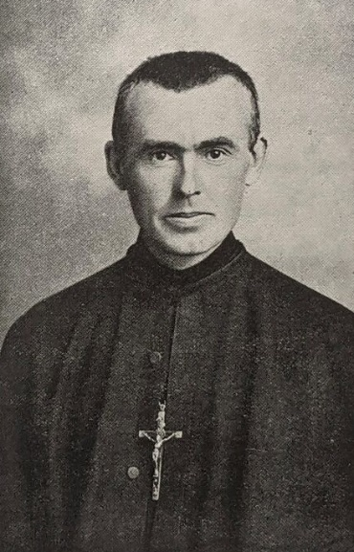
“The purpose of this modest biography of Bro. Constantin-Marie is not to prove his holiness. This work remains to be done. "Brother François Jaffré, author of this prophetic affirmation, affirms the constant tradition in the Congregation of the reputation of holiness of this humble Brother.
Brother Constantin-Marie ROULIN
Desire-Celestin Roulin was from the small village of Néant, near Ploërmel, the tenth child of a large and deeply Christian family. “At the parish catechism, as at the communal school, Désiré stands out from his classmates by his piety, his application and a marked taste for the study of religion”. The rector asked him to enter the Seminary. At 10 he had clear ideas: “I want to go to school in Ploërmel”. In fact, he attended the Brothers' day school in Ploërmel, he thus introduced himself to the Brothers, until the moment when the Director, Bro. Gordien, invited him: “Désiré, since you like it so well with us, why will you not become a Brother of Christian Instruction?” This was what the young man did, who entered the Novitiate in 1889 taking the name of Constantin-Marie. During his formative years, he matured his spirituality and prepared himself for the apostolate of the Brother. He began to experience health weaknesses, especially respiratory problems. More hardships: the difficult environment of the barracks and the transition from the fervor of the formative years to the reality of activity in the school. After a stay at Notre-Dame-de-Toutes-Aides, in 1898 he was called back to the Mother House, to the Community of Formators. He taught mathematics and science, but he also supported pupils in difficulty: to all, he gave the testimony of a fervent religious. He was well integrated into a community full of warmth and enthusiasm, where he was happy to live.
TO THE ROCKY MOUNTAINS
But these were difficult years for the religious Congregations in France: the persecution forced them to go underground or to expatriate to other countries: Canada, Spain, the Middle East... A group of Brothers was sent in 1903 to the Missions of the Western Rocky Mountains of the USA. The Brothers of La Mennais were called by the Jesuits to collaborate with them in the evangelization of the Indian populations of the mountains. 17 Brothers were distributed in the 6 Missions: they were at the service of the Jesuit Fathers, taking care of the schools: the young Indians, thanks to instruction and evangelization, would be able to acquire dignity and have a future. The Brothers shared the life of the young people, learnt English together, worked manually with them. Fr. Constantin had some problems with English, but his delicate and discreet character made him close to young people. He tried to follow them in what they know how to do, but it was not easy: "They are unbeatable in hunting, fishing, and above all horse racing: they approach a galloping horse , jump on his back and stand on it!”. Like the other Brothers, Bro. Constantin stayed with the young people 12 months a year, from morning to night, working with them, learning their mother tongue and respecting their tradition. Their life was not easy: they suffered loneliness, cold, hunger. A missionary will write: “How had the Superiors dared to launch us into such an adventure?” (F, Cyprius Trégret)
IN ALASKA
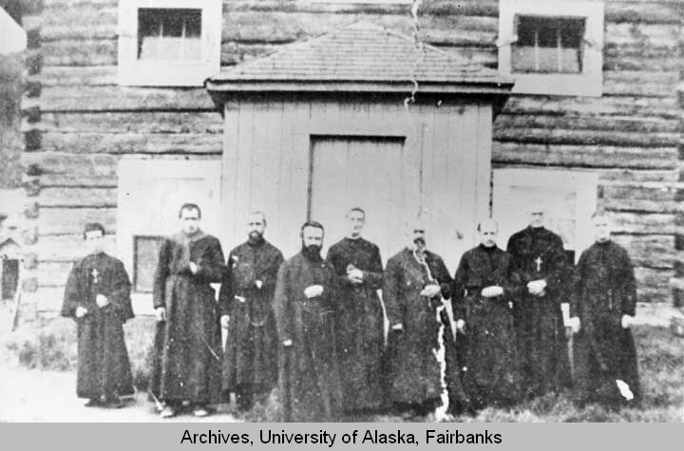
After a year, one of these Missionaries was sent to Alaska, in a mission of the Society of Jesus: it was Brother Constantin. He was ready to put up with anything, and hewould accept anything that was asked of him. But in his heart, he foresaw years full of painful trials: “I received my obedience as a death sentence. I asked my Superior what I will do there. He answered me: What we will tell you”. Bro Constantin left immediately for Alaska (1905). After an eventful trip on three boats, up the Yukon River, he joined Holy Cross, 1910, Jesuit priests and brothers in front of church
the mission that bore the significant name Holy-Cross. The environment was even more hostile: polar cold, days with little light, always the same food. “You will do what you are told to do”. And he obeyed. The Director of the Mission was a Jesuit Brother, Fr. Markham. He had an authoritarian character: he organized everything and disposed of people. In the mission there was the church, stores, stables…and two schools: one for girls, run by Canadian nuns and one for boys, run by the Jesuits with the help of Bro Constantin. This one had not been judged worthy to teach: he did not know English well, he had fragile health, he was “weak” in character. And then, “in the morning Bro. Markham told me what I had to do with the children and at noon what I should do in the evening”. In practice, Bro Constantin took care of the group of boys at all times when they were not in class: recreation, afternoon, meal, evening, night and often he had to plug the holes of teachers' absences or tardiness. During the night he had to stuff the stove with wood every hour, because it had to be always on, he assisted the young people in their bunk beds with the basins full of water. He would have liked to have a moment of teaching and especially of catechesis, but that too was forbidden to him. He could simply make them recite by heart the catechism explained by others.
Our missionary was seen as a little Brother, capable only of secondary activities, an invisible collaborator. But Bro. Constantin evangelized with his life. There was no shortage of work. During the summer it was necessary to make the reserve for the whole year. Hay was cut for the animals, dried and harvested amid clouds of mosquitoes. When the salmon came up the Yukon, it was a feverish activity: fishing with nets, cleaning and drying. There was also the multi-day long walk. We went up the river, we went into the woods for the happy harvest - sometimes in competition with the bears - of strawberries, raspberries and especially blueberries, to make jams. Above all, it was necessary to prepare a mountain of wood, for the heating of the houses, all year round, day and night. Bro Constantin, in spite of the fragility of his health, gave the example, encouraged, shared joys and fatigues with the young people. He had become a real brother to them, coming from afar to stay with them. They trusted him, confided their secrets to him. From him they learned a living, daily gospel.
Our missionary also had to undergo inner trials. The most difficult was loneliness: no colleague for three years. In the two years that Bro. René-Maurice Allory was present, they could stay together very little each day, but it was a moment of great consolation. Then the dear confrere will be removed from the mission because he overshadowed (!) the authoritarianism of Director Farkham. Bro Constantin received little understanding from the other Jesuit missionaries: contacts were only about activities. He, who was so sensitive, had no one to confide in. Bro François Jaffré compares him to Charles De Foucault in exile in the Sahara, he was solitary not by choice, but by obedience.Inside he suffered from loneliness, but outside no one noticed it. His Superior, Br. Bruno, wrote of him: “We have news of this dear exile: he is happy, healthy and happy”. He opened his heart only in his correspondence with Bro. Abel, Superior General and with some Brothers from the Rocky Mountains: “My suffering is completely interior. I have never complained, even though I am treated like “a broomstick”. It was his great humility and obedience that made him hide his abilities and he was happy to remain among the little ones, as Fr. de la Mennais had taught him. He confided to Bro. René-Maurice: “My sufferings would have crushed me, if I had not had the strength of faith”. He dedicated his free time to personal prayer or adoration in the chapel. He always had the rosary on him: he had a filial love for the Virgin.
Community House Southampton
In 1909 the General Council decided to close the Rocky Mountain-Alaska Mission. After spending 5 years in Alaska, 3 of which as the only Brother, Bro. Constantin was called back and appointed, unexpectedly, Master of Novices in England. The Superiors had seen the profound value of his spiritual life. Bro Constantin had achieved an entirely interior missionary epic: he had not left any great works or exceptional projects, but he had lived holiness in faith and charity, abnegation and humility according to the Mennaisian spirit. . For ten years he prepared generations of young people for the life of the Brothers, more by example than by words. At 50 he was appointed Assistant: he worked in humility and prayer. Stricken with a serious illness, he was taken on pilgrimage to Lourdes. But, at 52, he offered his life to God and to the Institute. The “holiness” of Bro. Constantin-Marie has always been recognized in the Congregation. Bro Jean-Joseph, Superior General, announced: “Let us bless God for having given us such a great model on Earth and a protector in Heaven.” His novices repeated: “He was a saint: we always pray to him!”
The many biographies about him confirm this tradition. They are also our SOURCES:
CHRONICLES / MENOLOGE / AT THE SERVICE OF YOUTH n.6 (Canada) / BROTHER CONSTANTIN-MARIE (Bro Célestin-A. Cavaleau pp.332) / MENNAISIAN STUDIES N. 38 Bro. François Jaffré

