MENNAISIAN NOVENA
APRIL 2024
- POSTULATION NEWS
In view of the 2024 General Chapter, the Postulation has prepared two files:
- The first contains the Responses of the Doctors consulted to re-examine the case of Enzo Carollo. These are 4 Expert Opinions studied by Specialists, which could be presented to the Dicastery of the Causes of Saints in appeal against the First Negative Judgment of 2016 (5 unfavorable votes and 2 favorable). This recourse is provided for by the Canonical Procedure and it is verified quite often.
- The second is composed of Three Biographies of Brothers who left a well-marked reputation for Holiness: Brother Zoël Hamon (France, 1819-1851), Brother François Cardinal (Canada- Rwanda, 1942-1992), Brother Hyacinthe Fichou (France-Guadeloupe 1813-1860). These Biographies, very in-depth from a Historical Point of View, will help the Brothers of the Chapter to decide on a possible Introduction of their Cause of Beatification, according to Canonical Laws.

- INTENTIONS OF THE NOVENA
- We continue to pray for the healing of Brother Alain Josselin, who underwent a very difficult and delicate Surgical Procedure. His family has always shown great devotion to Father de la Mennais by often going on pilgrimage to his tomb in Ploërmel.
- Let us pray for the people and the Brothers of Haiti. The Country is going through a Dramatic Moment: let us ask the Father for his protection in this land where so many Brothers have devoted themselves and offered their lives. May he also protect today the Brothers, the students and the current works of the Institute.
- A prayer in particular for the Chapter: may the Holy Spirit assist it with his gifts and make us Docile to the Inspiration he aroused in our Founders.
- Let us pray for the other Intentions of the previous month.

- FAVORS RECEIVED
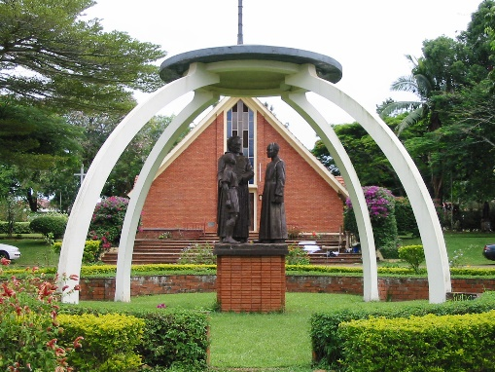
We point out a very recent favor which was communicated to us by a Ugandan Brother, Brother Joseph Tinkasimire, former Provincial of the Brothers of Uganda.
Brother Joseph Tinkasimire thanks the Lord for the healing obtained through the Intercession of our Founder Jean-Marie de la Mennais for the Fracture of the Femur suffered on 3-11-2022. “At first the Doctors suggested surgery to fix the fracture with screws, because it was near the upper end of the Femur and there was no other way to glue the two broken parts together. However, the Orthopedic Consultant advised me against the operation, saying that the fracture would have healed on its own. This left me in limbo, since the pieces of bone were not aligned.
The Brothers prayed throughout the year, at each Monthly Novena for my healing. For my part, I prayed every day throughout the Novena, asking for healing. In this period the only Treatment I received was a massage from a Local Specialist. I did not receive any Medical Intervention.
When on January 16th , 2024 I went to the Hospital for the Check-up, the Doctor, looking at the X-ray taken in the morning, exclaimed with Joy that I was completely cured and that he There were no obvious signs of fracture. I was released from the Hospital and Joy filled my heart.
I can only attribute the complete healing to the Intercession of Our Venerable Father de la Mennais. For this let us praise and thank the Lord.
(Now I am asking the Founding Father to obtain healing for me from Arthritis in my Hips. I am having problems undergoing Surgery… So, for me the only way to deal with my Arthritis is to pray for Healing in my hips. through the Intercession of Our Founder, if this is the will of God.)
Thank you…God bless you! Brother Joseph Tinkasimire
- HISTORY OF MENNAISIAN DEVOTION
n.15: DEEPENING AND EXPANDING THE MENNAISIAN FAMILY
In the momentum of the rediscovery of Mennaisian inspiration, the Personality and Spirituality of Our Founders, especially Father de la Mennais, took an ever more central place. In order to involve the many Lay people who, operate alongside us in School Works throughout the World, it was of great importance to communicate to them the Charism and Devotion to the Father. We began to equip Brothers and lay people with Instruments of Mennaisian Training.
NEW TRAINING INSTRUMENTS
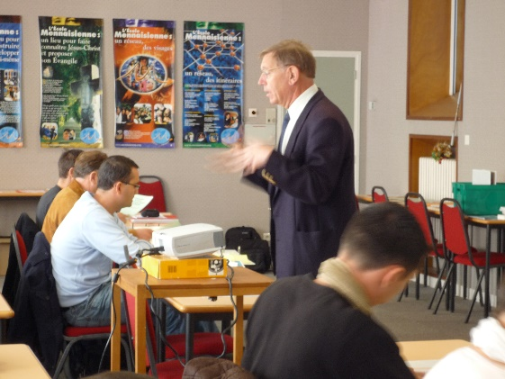
In France the Brothers organized the Mennaisian Formation Center, the CMF. “The CMF aims to help Brothers and Lay People (around Forty every two years) to better accomplish their Mission as Christian Educators according to Mennaisian Inspiration. It offers Training in 10 Steps, with Presentation, Personal Reflection, Exchange of Experiences and Joint Celebrations. The Formation is provided over two years, with 5 Sessions per year. The CMF is the result of the deepening of Mennaisian Spirituality, carried out by several Brothers, of collaboration with the Laity, of integration into the Pastoral Care of the Local Church and of Vocational Animation. In the other parts of the Congregation we work in the same way.
12th Class
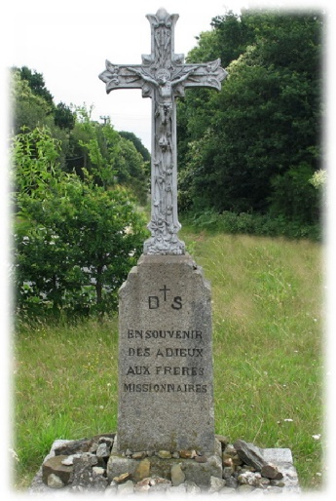
MENNAISIAN PILGRIMAGES AND CELEBRATIONS
This Movement of Mennaisian Deepening led to New Initiatives. We organized Mennaisian Pilgrimages to the places of Our Founders: The Mother House of Ploërmel, the Missionaries' Cross from where Brothers left for the Colonies, the Hometown of St-Malo, Saint-Brieuc for the origin of the Institute, Beignon and Auray for the early days of the Congregation in collaboration with Father Deshayes, the Country House of Chesnaie, a place of inspiration and fidelity to the Church... In each of these places sanctified by the Founders, the Historical fact and the message that emerges from it are recalled. Pilgrimages are very valuable for increasing Mennaisian knowledge and the Family Spirit of Visitors. This whole movement encourages Multiple Meetings, even at the International Level.
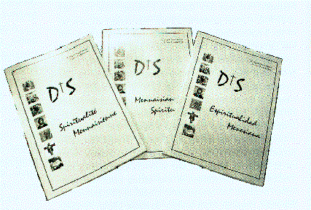
NEW STUDIES ON SPIRITUALITY
Studies on Mennaisian Spirituality found a Synthesis in a Book written by Brothers Miguel-Angel Merino and Josu Olabarrieta: “Mennaisian Spirituality”. The Titles of the Chapters indicate the main points: “1- Confess the Trinity. 2- He destroyed himself. 3- Peace to men of good will. 4- Called to be images of his Son. 5- Let the children come to Me. 6-Look at the Crucifix. 7- Gethsemane and Providence. 8-The Charisma to embody: The Good Shepherd. 9- The Universal Judgment.”
These In-depth Studies circulate within the body of the Congregation, but they are developed especially during the year of Renovation in Rome, under the direction of the Brothers who take over: Bro A Mayrand, G. Olivier, V. Guillerm, M. Merino, G. Cahier, G. Chatelier… These are months of Spiritual Renewal, Fraternal Experience and Encouraging Testimonies.
THE MENNAISIAN FAMILY
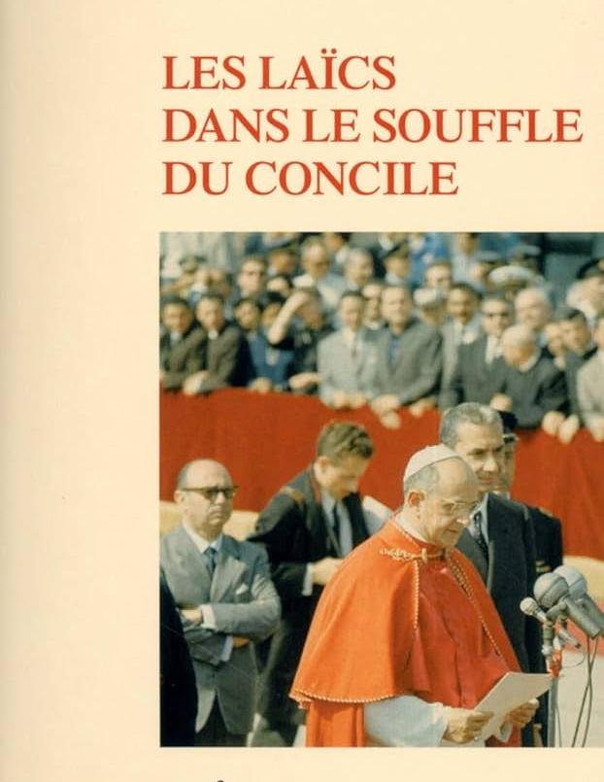
The Second Vatican Council highlighted the role of the Christian Laity, as one of the components of the People of God. The Brothers of Christian Instruction, like other Teaching Institutes, work in direct contact with the Laity at all times. Together they collaborate for the kingdom of God in Christian Schools. It was necessary to find Forms of Integration and Unitary Structures for ever closer collaboration. We began to offer times of Mennaisian Formation. Then the laity gradually entered the different Councils: School, Provincial, Institute. In this way the Mennaisian Family was enriched by Secular and Secular Experience: it could be closer to families, know the World of young people better, understand the problems and hopes of Society. The laity became the Second Arm of the Mennaisian Institutes.
It will still take time to reach this goal, but the movement has been launched. The 1994 Chapter expressed itself as follows: “We would also like to thank you [lay people] and congratulate you on the efforts that you have generously made to share the Spirituality of the Congregation and to associate yourself with its Apostolic Work. In the concrete gestures of daily life and in the strong moments of Fraternal Encounter and Reflection, we are happy to journey with you towards the realization of the Lord's will for each of our lives. “
SOURCES: FIC CHRONICLE, Years 1980-1995) / M. Merino- J. Olabarrieta, “Mennaisian Spirituality” 2002/ Chapters 1988 – 1994

- TRACES OF HOLINESS WITHOUT THE MENNAISIAN FAMILY:
BROTHER JEAN-CHARLES BERTRAND (1913-1999), AN INEXHAUSTIBLE MENNAISIAN DEVOTE

FAMILY- EDUCATION
Certainly, one of the Brothers who most spread the knowledge and devotion of Father de la Mennais was the Canadian Brother Jean-Charles Bertrand.
He was born in Coteau-du-Lac, about fifty km from Montreal. He grew up in a large, deeply Christian family. The father was a Teacher: he exercised his Profession with so much passion that all his children would devote themselves to teaching. Papa Bertrand taught at Les Cèdres, then he settled permanently in Montreal, at the St-Zotique School, run by the Brothers of Christian Instruction. Little Jean-Charles spent his first years of School there. His childhood was serene. He liked Games, but also Studying and Reading; he helped his family by working at the Neighborhood Grocer.
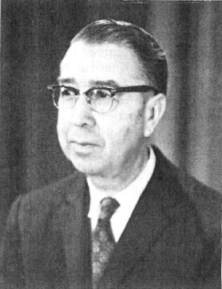
In 1927, he returned to the Juniorate of La Prairie where he was welcomed by Brother Bernardin of Sienne Crépeau. He completed the stages of his Formation by intensely preparing for his Religious Life and continuing his Intellectual and Educational Training.

ACTIVE BROTHER
At the age of 18 he began his years of Apostolic Action in the field of Christian Education. To Teaching - which at the time occupied the Brothers full time - he added the Animation of young people's Leisure Activities, the Choir, the Sessions... This was how 5 years passed at the School of Ste- Anne-de-Bellevue; then there were 3 years at St-Zotique (Alma Mater). In 1939, he became a Teacher at the “École supérieure St-Stanislas” in Montreal. For 12 years he devoted himself to it with all his strength. He particularly excelled in Teaching Physics and Chemistry. He continued to accumulate University Titles using his Moments of Rest or Leave. A short stop in 1951 to recharge his Batteries Spiritually during the year known as the “Second Novitiate” in Jersey. Upon his return, he took up the position of Director at St-François-Xavier and St-Jean-Baptiste (Montreal). In his charge, he found time to add Leisure Activities and Choir Director.
AT THE CENTER OF MENNAISIAN DEVOTION
Given his competence and dedication, the Superiors called on Brother Jean-Charles to put his Culture and his pen at the Direct Service of the Congregation. In 1963, he moved to the Main House in La Prairie. He was responsible for the Publication of School Textbooks and other FIC Works at the “Book Committee”. He began his collaboration in the dissemination of Mennaisian devotion by assuming the Direction of the “Courrier du Vénéral”, the Bulletin dedicated to Our Founding Father. From this date he devoted himself completely to making Father de la Mennais known and loved, not only in Canada but throughout the Institute.
The first and main part concerned the “Courrier du Vénérable”, the First Issue of which was published in 1950, by Brother Bernardin de Sienne Crépeau, and was admirably completed by the New Director. “A New Lease of life, enriched Documentation, a Rejuvenated Presentation for Our Mennaisian Review: The Golden Hour of the Courrier du Vénérable for which he composed 1440 pages.”
Then the Council invited to turn to the Missions and the Chapter of Renovation (1968-70) too. “It was an opportunity to transform the Community Magazine. The format changed. The Title became “FIC Missions” in September 1969. Each Issue allowed readers to travel through the different Countries where our Brothers work: The Reports were the result of long conversations with passing Missionaries or even visits to the Countries of the Brothers' Missions, carried out by Brother Jean-Charles. This Review would total 608 pages. He was not content with writing for the Missions: “each year he sent School, Sports or Medical Equipment to his colleagues: nearly 250 boxes had already found their destination in Africa”.
Bro Jean-Charles BERTRAND
It was not only the publication of Magazines that occupied our “Brother Director”. He wrote 80 talks on the Father and his Historical Context, for a total of nearly 1000 Typed pages.
- In addition to the Mennaisian Dissemination carried out through his numerous writings, he intervened directly through Conferences, Animation Sessions, Training Meetings. His notes revealed that he gave no less than 445 Talks. “He competed with the General Assistants by traveling to all the Retreats in the Canadian Region…” He spent time Training young people in Mennaisian Knowledge and Spirituality directly in Haiti and in the Missions of the Canadian Brothers in Africa.
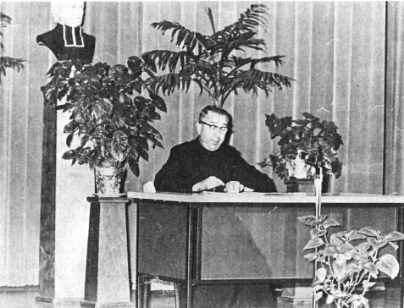
- There is a whole series of Particular Writings on the Founder. Brother Jean-Charles composed a life of the Father: “The Biographical Stages of Jean-Marie” (213 pages); a Document of 350 Questions and Answers; a 125-page Brochure deals with the Beatification of the Father. “Jean-Marie, Priest and Founder”; an Illustrated 50-page Book, with for each, Comment and Drawings by Ms. Odette Vincent-Fumet.
- We leave aside other works, on Father de la Mennais, but also on Father Deshayes and on the Biographies of “Saint” Brothers, especially Missionaries.
We want to add to this sum of inexhaustible services to the Congregation, in particular, on the Animation of Mennaisian Devotion two small signs which show the Fraternal Spirit of Brother Jean-Charles and his joy at belonging to this Great Family of FIC: 1- “Since 1927, he has provided happy colleagues with the service of a regular and appreciated haircut (satisfied customers can testify that he has had a Great Career with nearly 25,000 cuts) 2- Since at ten years, he presents the Tributes of the District to the Jubilee Colleagues and he writes their Curriculum Vitae.”
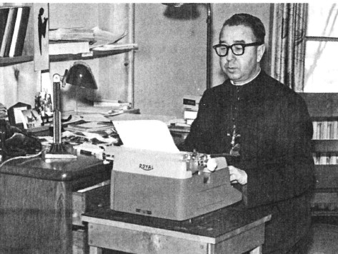
A few days before Christmas, on December 22nd, 1999, our Brother made the Supreme Meeting, to receive the Reward of faithful and ardent servant of God, but also of Our Founder, of whom he was a Passionate and Devout son. “You have devoted more than half of your Religious Life to magnifying the Founder, promoting his Cause and arousing the trust of thousands of people. You have drained Mennaisian energies from us and from those to whom you have made the Father known. You have helped us, we Brothers of the Canadian Region, to hold high for more than forty years the torch of Filial Love towards Father de la Mennais.” (F. Gaston Boucher)

SOURCES:
Personal file FIC ARCHIVES Rome/ Homage to the Jubilaires La Prairie-Oka 1979/ Our Jubilaires St-Jean-Baptiste 1989/ Curriculum vitae/LE COURRIER DU VENERABLE/MISSIONS FIC

