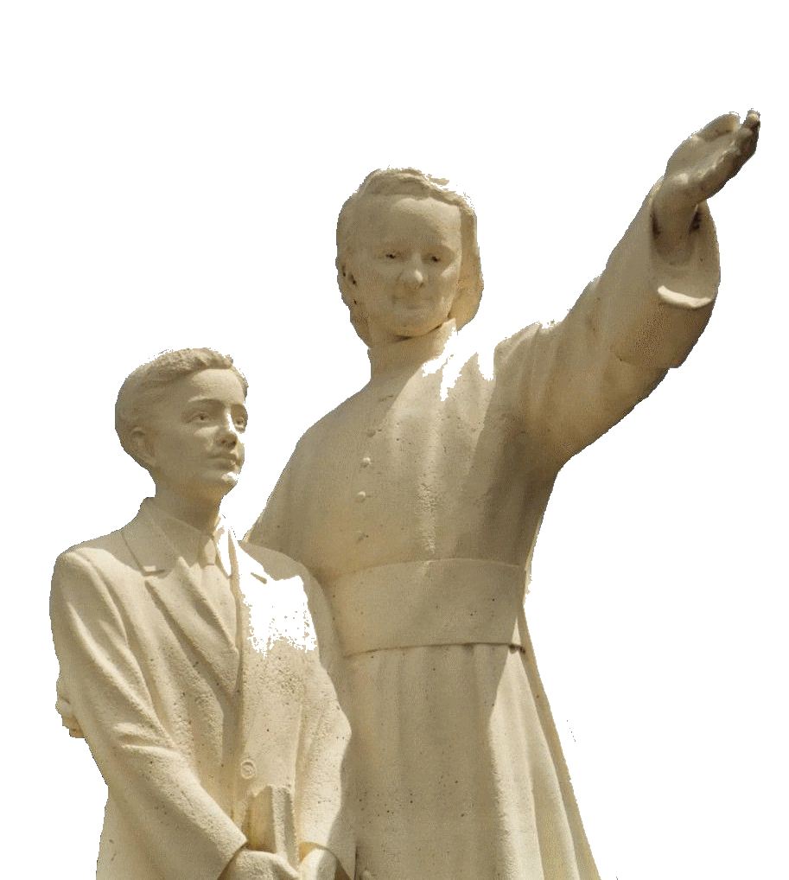

**MENNAISIAN NOVENA**

**MARCH 2025**

***Pilgrims on the path of prayer***

1. **POSTULATION NEWS**

**STUDY ON THE HEALING OF ENZO CAROLLO**

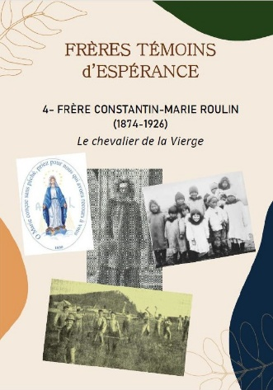We are currently presenting to the Dicastery for the Causes of Saints four expert opinions in favor of resuming the examination of the healing. This file will be studied first by two doctors appointed by the Dicastery. If at least one of the two concludes that it would be possible to demonstrate the inexplicability of the healing, then it will be possible to pass a second time to the official Medical Commission (after the first meeting on January 14, 2016). For the Cause to continue, it is necessary to reach, in this Commission, at least 5 votes out of 7. We trust in Divine Providence and pray, as we have done for over 120 years, that the Lord, through this Beatification, may help the world and the Church: the world with a joyful and solid human and Christian education; the Church with the mission of the enthusiastic and “holy” Mennaisian family.

**LITTLE LIVES OF THE BROTHERS WITNESSES OF HOPE.**

Our small Collection is enriched by a new Witness: Brother Constantin-Marie (Roulin) 1874-1926, born in Néant-sur-Yvel in Brittany and died in Ploërmel: he was a legendary missionary in the Rocky Mountains and in Alaska among the Inuit, master of generations of Novices in England at the time of secularization and war. Reading these small witnesses from our country gives much hope and can be used in apostolic and vocational meetings.

**PRAYER INTENTIONS THROUGH THE INTERCESSION OF FATHER DE LA MENNAIS**

* Let us thank the Lord for the recovery of ***Brother Alain Josselin***; at the same time let us entrust to the intercession of the Father other Brothers who have health problems, especially the elderly or sick Brothers. In particular, let us continue the prayer for ***Brother Aldecoa***.
* Let us continue our prayer for the children ***Tommaso*** and ***Alessandro***, for ***Caroline*** (Uganda), ***Massimo*** (ischemia)
* Let us begin a special prayer for ***Stéphane*** (France) who had a serious motorcycle accident and was left paralyzed.
* Let us accompany in prayer our three Brothers who will open the new mission on the island of Timor Leste (Asia): ***Br Stéphane Le Pape, Br Philippe Douti and Br Éric Mugisa***

**LOCAL INTENTIONS and RELIC IMAGES**

Let us also follow the intentions indicated by the local leaders. They also have the possibility of distributing relic images, which are usually brought by the general assistants. They have been traditionally used in the Mennaisian family. They contain a small piece of cloth that touched the tomb of Father de la Mennais in the chapel of the Mother House in Ploërmel. Let us help ourselves with these small material signs, which Our Lord Himself did not disdain to accomplish the wonders of Providence, through the intercession of His humble and heroic servants.

1. **FAVORS RECEIVED**

We present an extraordinary favor obtained in Canada.

*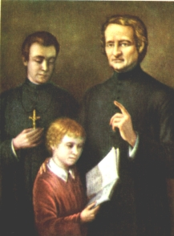“Throughout the month of January, Sister Marie-Aimée, music teacher at the Grey Nuns Academy in Hawkesbury, Ontario, showed signs of obvious weakness. Endowed with great energy, she fought against the illness that was already wearing her down and devoted herself tirelessly to her many students. On February 4, exhausted, she was forced to take to her bed. The doctor diagnosed a dangerous attack of typhoid fever; which aggravated the case. For more than two weeks, the fever remained around 40°C. On February 19, the doctor judged it prudent to have her administer the sacraments of the sick. On the 23rd, a medical eminence from Ottawa was summoned to decide what could be done to save the Sister from death. He declared bluntly that it was death in the near future. All seemed lost on the human side. The Sisters, however, had not waited for the critical point to launch suppliant prayers to God. They made, at the same time as the school pupils, a novena to the Venerable de la Mennais, whose image they possessed with a piece of his clothes. This novena did not bring the desired result. It even seemed that the patient was getting worse day by day. “Always hoping against all hope”, the Sisters made a second novena. On the evening of the last day, the doctor, summoned in all haste, declared that the patient would not survive the night. The heart was very weak and the patient, exhausted by more than three weeks of a fever that did not abate, seemed in fact doomed. Towards midnight, a noticeable improvement came, breathing became more normal and the heart regained strength. The doctor, who expected at any moment to hear the news of his patient's death, was quite astonished by this sudden change, and frankly declared that there was something miraculous about it. Since then, the patient has continued to get better and is currently in full convalescence. She is even stronger than she was before the illness. A grateful tribute to Father de la Mennais!”*

Source: Br. Jean-Charles Bertrand, Revue “Missions”, pp. 6-7, March 1986

1. **JUBILEE PRAYER PILGRIMAGE 2025**

**OUR LADY OF PILAR, PATRONESS OF HISPANIDAD**

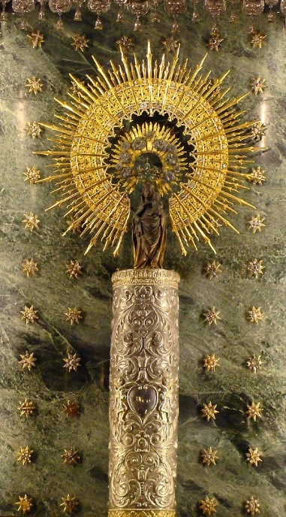

According to tradition, around the year 40, the apostle James the Greater, brother of Saint John the Evangelist, had traveled to the western extremities of the immense Roman empire, the ancient Iberia. James, the ardent “son of thunder”, had brought to the work of evangelizing these populations all the enthusiasm and zeal of his soul. But, despite his enthusiasm and his fatigue, the fruits of his preaching were almost nil. Discouraged, he had sat down on the banks of the Ebro, the great river. Suddenly, he was dazzled by a sparkling light and in this light he saw the Virgin Mary surrounded by angels, her feet placed on a small column (“pilar”): she encouraged him to continue his mission, assuring him that a multitude of people would come to the faith thanks to his preaching. She also promised him that the Christian faith would never be lacking in Spain.

The Virgin showed the apostle the precious stone column and an image that represented her. She also expressed her desire to build a temple dedicated to her on the site of the small pillar: “This “pilar” with my image on it will remain here and will last in the holy faith until the end of time.” The apostle James is said to have immediately had the sanctuary built, which would become the first sacred place in the world dedicated to the Mother of God. Today, on this site, stands the grandiose Basilica of Our Lady of Pilar. Tradition tells that Santiago resumed his evangelization, obtaining great fruits; then returned to Jerusalem, where he 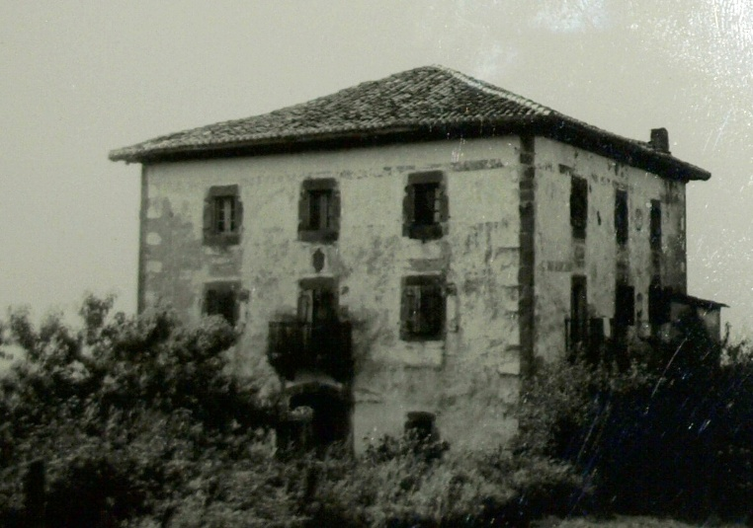received martyrdom by King Herod Agrippa. His disciples collected his mortal remains, to bury them in Spain, where the Cathedral of Santiago de Compostela currently stands, the goal of the famous pilgrimage of millennial tradition.

The people of Zaragoza took charge of the sanctuary of the Virgin, which guarded the Pillar given by the Holy Mother of God. This was already venerated by the apostles and the first Christian communities, as the Mother who points to her son Jesus, “column and foundation of the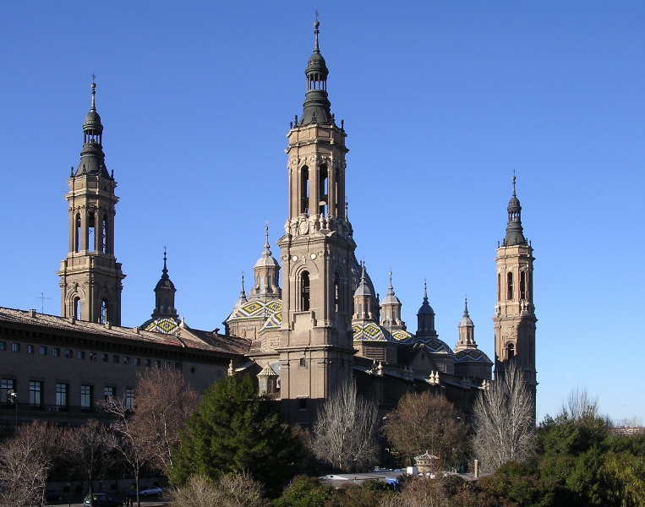 faith of the Church”. The sanctuary of Pilar was rebuilt several times, always larger, until it became a very large church: 130 m long, 67 m wide, crowned with eleven domes, ten lanterns and four towers. Crowds of pilgrims go to pray to the Virgin in this sanctuary, to ask for growth in faith and also graces for spiritual and material health, as many accounts testify. The Congregation of Rites confirmed the authenticity of the apparitions in 1723. The feast of Our Lady of Pilar is celebrated on October 12. She has been declared patron saint of all Spanish-speaking countries (Hispanidad).

**1903 in Zugarramurdi**

**Basilica of Nuestra Señora del Pilar**

**THE BROTHERS OF THE PROVINCE OF NUESTRA SEÑORA DEL PILAR**

The Mennaisian Province of Spain was born out of persecution. The anticlerical laws of the French government drove the Brothers out of their schools and banned their teaching. The Superiors sent some representatives of the Institute to prepare the reception of the Brothers who were determined to continue their Mennaisian mission in Spain. It was mainly the Brothers of the Sainte-Marie du Midi Province, in the southwest of France, quite close to Spanish territory, who asked to emigrate to this new country. The Sainte-Marie Province was very prosperous at the time: it had about thirty

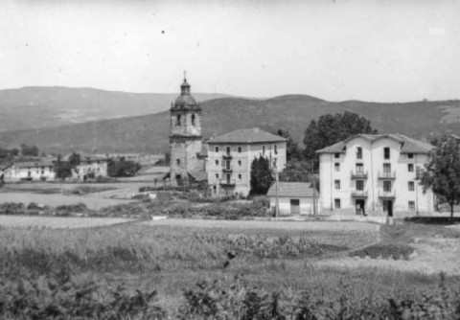communities, was established in important cities (Bordeaux, Biarritz, Lavacan, Montpellier, Perpignan…), it had a great presence in Lourdes in the animation of pilgrimages… For the most part the Brothers opted to pursue their vocation in the world, in particular in Spain. The emigrant Brothers settled in makeshift houses, near the border, in 1903 in Zugarramurdi. The beginnings were difficult: teaching in a new language, seeking economic means through all kinds of work, precarious housing in small schools, winning the trust of the populations… The new superior, Brother Ulysses, managed to buy in 1914 the seaside residence of Nanclares de la Oca, which became the Mother House and the training center of the new province. The school centers multiplied, especially in the Basque Country and Cantabria. We started with small schools: Miquelemborda, Dancharinea, Lujua, Etchevarri; then Berrio-Otxoa de Bilbao, Baquio, Dos Caminos, Reinosa. We can notice in this province special attention for Children and young people in difficulty: in Bilbao and Nanclares, “The Shelter” was opened, a reception center for young people entrusted by the Police or children of prisoners. The educational works developed rapidly and radiated the “menesiano” charism. Now the Province was able to send a good number of missionary Brothers: to Haiti and Italy as reinforcements, and in 1933 to Argentina to found a new mission. During the terrible years of the civil war, they shared the drama of the populations and entrusted them to the protection of Heaven. In the 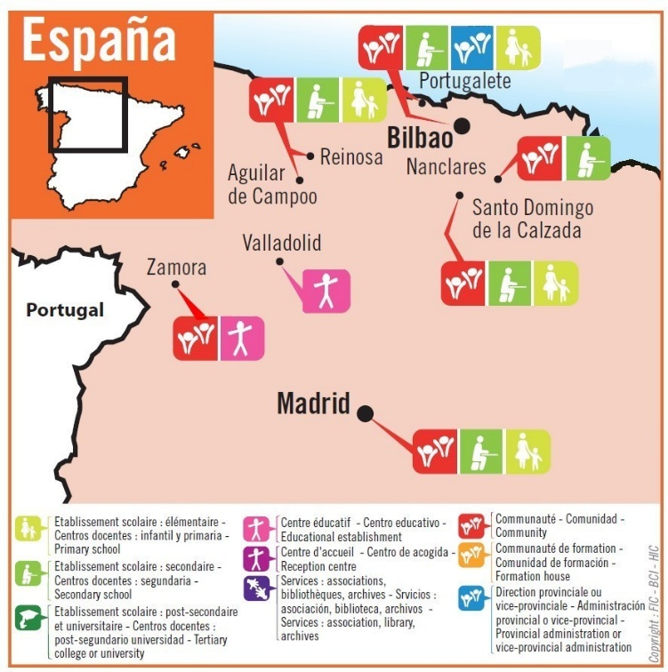post-war period, the Province grew in activities and in the number of Brothers: they currently work in 8 educational institutions of rather large dimensions. They have also opened two professional centers to welcome young people who have dropped out of school, socially and in their families, to reintegrate them into society. They have also resumed the missionary momentum by opening communities in Chile, Bolivia and Indonesia. Through these missions they offer the young people in their schools a demanding missionary commitment, by getting heavily involved in the establishments. Especially in recent years, the Province and each school establishment have invested a lot in the training of teachers, parents and young people so that the Mennaisian charism and the educational principles of JM de la Mennais are shared by the Brothers and the Laity: in this way, it is the entire Mennaisian Family that becomes the subject of the mission to children and young people. Devotion to Father de la Mennais has always been alive in this Province: it has highlighted the traditions of the Institute, the pilgrimages to the places of origin and the deepening of Mennaisian spirituality, in particular by Br.Merino. This Province, which has chosen the name of Our Lady of Pilar, receives the protection of its patron saint, even in these times of difficulty. She is the guarantee of the birth of a new Christian adventure in the education of new generations.

**1904 El Camino**

**CHILE**

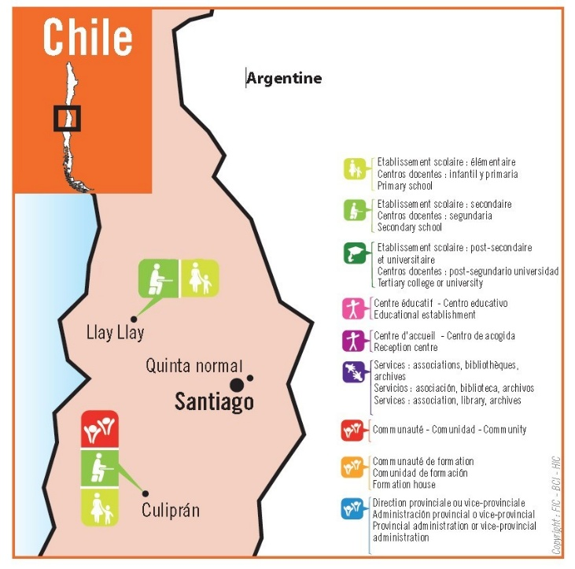After the General Chapter of 1982, the Spanish Province decided to open the Mennaisian mission in another Latin American country: Chile. In March 1984, three Brothers took charge of a rural school, previously managed by the state in Culipran. The following year the school was destroyed by a violent earthquake. A new building was built to welcome young people from the surrounding countryside, providing them with suitable 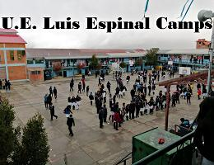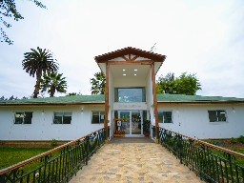education, especially in the field of agriculture.

**Centro Menesiano de Culipran, Chile**

In Llay-Llay the Brothers took charge of a century-old parish school, which they transformed into a vocational high school with 850 students.

Very close to the capital Santiago, in Quinta Normal, they opened a facility that welcomes young people and Brothers in formation and serves as a coordination center for the communities of Chile. Currently the Brothers and Laymen of the Mennaisian Family of Culipran coordinate the other educational centers.

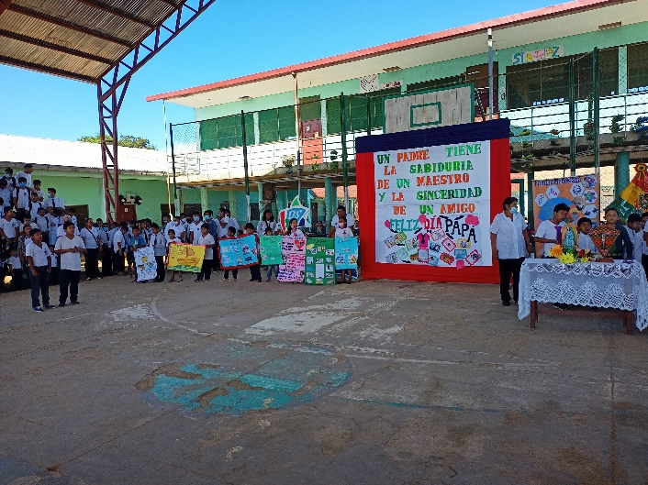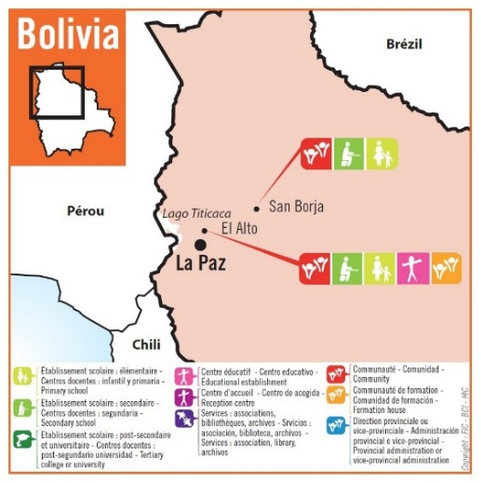

**BOLIVIA**

After Chile, the Brothers of Spain decided to set up a foundation in Bolivia, in El Alto de la Paz, at an altitude of over 4,000 m. They arrived there in October 1984. They collaborated with the organization “Fe y Alegría” founded by the Jesuit Fathers. The school operated on a double day basis with over 2,200 students aged 5 to 17. The Brothers encountered an environment that was difficult for breathing and fatigue due to the altitude. However, they worked with street children in the poor neighborhood where they were based.

**San Borja**

**Colegio Luis Espinal Camps, El Alto**

Still with “Fe y Alegría” the Brothers coordinate 4 educational centers in the East of Bolivia, in San Borja. Here the environment is completely different, in the middle of the Amazon rainforest, with a hot and humid climate. They welcome more than 2,500 young people, sharing the daily life of the inhabitants.

Our Lady of Pilar, who supported the apostle St. James in his mission, certainly continues her work of protection and blessing for these new apostles, in Spanish-speaking lands.

*SOURCES: Historical notes 1903-1928/ Two Mennaisian Congregations, Cueff and Morvan/ Mennesian lives, F. Elias Sainz/ FICs in the world: Lamennais.org*