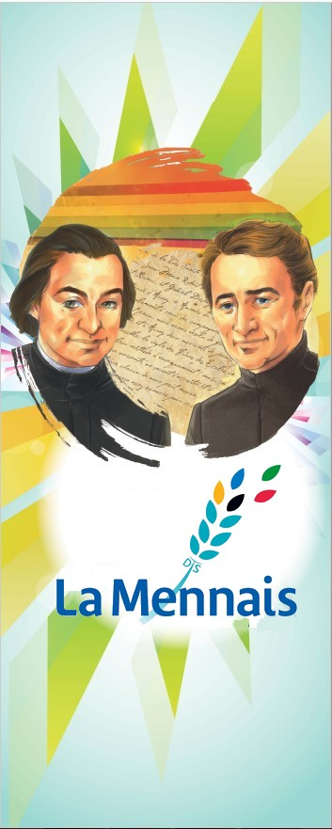
MENNAISIAN NOVENA
MARCH 2024
- POSTULATION NEWS

HEALING FOR THE CAUSE OF FATHER DE LA MENNAIS
We have Four Doctors who are thoroughly analyzing Enzo Carollo's Recovery. They will give their Expertise in the Middle of March. After the Postulator has recorded their relationships at the Dicastery for the Causes of Saints, he will ask Two Official experts from the Dicastery for their opinion on this healing. If one of the two considers that it could be inexplicable, a New Meeting of the Medical Commission can be requested. This will have at its disposal the Documents already presented in the First Meeting of 14-1-2016 by Br. Postulator, Br. Gil Rozas, to which will be added the New Expertise of the Doctors engaged in recent months. Recently the Brothers of Argentina were able to carry out a Neurological Examination on young Enzo, to which he submitted quietly and which gave quite satisfactory results. For the moment we are waiting and praying a lot through the Intercession of Our Father.
We invite you to follow the sick for whom we pray and, if this is the case, to collect the Relative Medical Documentation: Our Founder has not finished giving us his protection and he is watching over us and Our Institute.
PRESENTATION OF SOME BROTHERS AT THE DICASTERY OF THE CAUSES OF SAINTS
Our Institute of the Brothers of Christian Instruction of Ploërmel and the Institute of the Daughters of Providence maintain a Great Heritage of “Sanctity”, which has developed over the years and in all parts of the World. The Tradition of Our Institutes has collected their Memories in many Documents and the reputation of their “Sanctity” has extended to us. The Gospel exhorts us to “Put light on the table to enlighten all who are in the House.” The possible Beatification of a few Brothers or Sisters would give a Luminous Testimony, an Encouragement to a New Spiritual and Apostolic Impulse, a Radiant Vocational call for young people.
For the moment we have begun to delve deeper into the Biography and Spiritual Portrait of certain Brothers, in particular:
- Brother Zoël Hamon: Prototype of the Brother from the beginning, Teacher of 114 Children, Social Baker, Volunteer Nurse, died of his Devotion at 32 years old
- Brother François Cardinal, Canadian Missionary in Rwanda, Teacher and Facilitator in a Youth Agricultural Center, Witness to Justice and Faith, killed to Silence his Prophetic Voice, at age 50
- Brother Arthur Greffier and Brother Hyacinthe Fichou: Representatives of the Great Epic of the Missionary Brothers in the Antilles, Teachers of the Black Population, Catechists of Slaves and Prisoners, attentive to their Brothers, who died of Exhaustion: at 46 years old for the Brother Hyacinthe, and in Exile, for Brother Arthur.
The Decision for a possible decision to Introduce the Cause of Beatification to the Dicastery of the Causes of Saints belongs to the General Chapter. The Postulation will prepare the Necessary Documentation for the Chapter. Let us recall what the Superior General, Brother Bernard Gaudeul, wrote at the General Chapter of 1994: “As for the Beatification of the Brothers of the Congregation, nothing has been done. I admit that I do not clearly see how to achieve the Wish Formulated by the Chapter. There should be pressure coming from the Faithful and the Brothers, with Precise Testimonies of Holiness. Do they exist? Were they not left to die at the time and in the Countries where they were found?” In the 1988 Chapter it was hoped: “The General Chapter is favorable to the idea of ​​Introducing the Cause of Beatification and Canonization of one or other Brother of the Congregation in the more or less near future.”
- PRAYER INTENTIONS

- We first want to pray for our General Chapter (March 25th - April 25th) which begins and ends during the Novena: Our Founders may assist the Brothers of the Chapter.
- The sick reported by the Brother Leaders. We recall a few of them:
- HAITI: Naya Benoit, 12 years old in Coma since the age of 2, Brain Cancer; Lesage Dessalines, 14 years old in a Coma since the age of 2. Little Nick Danus Titus has ascended to Heaven: he is going to pray for us.
- ARGENTINA: Daniela Vescovi, Pancreatic Cancer; Zamira Iborra, Uremic Syndrome.
- SENEGAL: Mathilde Kayoungua, Cancer and Legal Insufficiency.
- ITALY: Giuseppe: Chronic Leukemia; Carlo: Danger of Leg Amputation.
- FRANCE: Bro Alain Josselin (delicate surgical procedure) ; Intentions placed on the Tomb of Father de la Mennais.
- UGANDA: Mary Nyakahara, generalized cancer; Carol Gayiya, (Bro. Gerard Byaruhanga’s sister, generalized cancer.
- ASIA: Corazon Mondragon; Yukari Holmes; Lise Beaudouin; Robert Sripko; Katarina Eda Botha.

- FAVORS OBTAINED THROUGH THE FATHER’S INTERCESSION:

- A THANK YOU FROM ARGENTINA, 2024
“My uncle Raoul is still on Treatment. It wasn't easy, but thanks to everyone's prayers, thanks to those who interceded for us like Jean-Marie, we can testify with the whole family that God was present to save our uncle. Many times, I have listened or read that the Lord does not save you from sickness, but saves you in sickness: and truly that is what happened. It would take too long to go into details, but I can assure you that today my uncle is facing Illness and Treatments surrounded by the love of his family, with all the beautiful moments that this entails, despite the disease. Please continue to join us in prayer.” (Testimony of LAURA TAMBASCO)

- HEALING OF A CHILD AT THE SAINT-FRANÇOIS XAVIER SCHOOL, MONTREAL, CANADA
At the request of Br. Théonas-Marie, of the St-François-Xavier School in Montreal, the following report was sent to him by the mother of a ten-year-old child, healed through the Intercession of the Abbot of the Mennais.
“Very good Brother, I have a little boy of ten who fell ill, the last days of September, with Typhoid Fever; the Illness got so bad that, on October 8th , several Complications arose which made all hope of Recovery disappear. The Doctor immediately telephoned my husband, who was working far away, telling him to come back as soon as possible, if he wanted to see his child still alive.
I myself sent for the Rev. Father Plante, Jesuit, so that he could come and Administer the Last Sacraments to my sick son and apply to him the Indulgences of a Good Death. Having leaned over him and believing him to be dead, Rev. Father hesitated for some time before Administering it. Then I sent for Brother Théonas, Director of the St-François-Xavier School my son attended. He arrived immediately with a Rosary having touched the body of Abbot de la Mennais and an Image that we placed under the patient's pillow. Then we began to pray, in union with the good Brothers of Christian Instructionand, all together, we asked for the healing of my little boy (if it was God's will) through the Intercession of Father de la Mennais.
It was around noon when the Director placed the Image and the Pious Relic under the pillow: the little patient was already cold at that time; his teeth were tightly clenched. In the evening, around four o'clock, however, he began to open his eyes and recognized his father. For several days he remained in a very weak state and became almost deaf. But, to the great surprise of the Doctor and all those who had witnessed his Illness, the child returned completely, without any trace of Infirmity. Recognition and thanks to Father de la Mennais.”
(In the collection of favors obtained through the Intercession of Father de la Mennais, by Brother Jean-Charles Bertrand, Canada)

- HISTORY OF MENNAISIAN DEVOTION:

14-A NEW MOMENTUM FOR THE MISSION IN THE SCHOOL AND IN THE WORLD

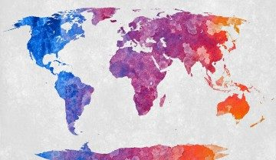
The General Chapter of 1988 placed particular emphasis on Mission. The First Orientation proposed: “Affirm explicitly, with Boldness and Respect, the Word of God in each Establishment, with all the requirements that this Announcement implies.” Sub-specifications: “Value the School as a privileged place of Human Promotion and Evangelization / Strive to establish with the Laity a communion in the service of Educational Work / Intensify the Missionary Effort even at the Cost of Sacrifices in Personnel and Finances”. There were two main commitments: to Actualize Evangelization in and through Schools and to open New Mission Fields in Territories that needed a Christian School. This emergency could concern either the peoples of the First Evangelization, or the Western Countries which needed a New Evangelization, as proposed by the French Region: “The Brothers are trying to understand where the Originality of the Vocation of the Teaching Brother today lies and how to live and share the Charism of the Congregation in a Catholic teaching threatened with losing its Identity”.

CHRISTIAN ANIMATION IN SCHOOLS

The 1983 Rule recalled the very clear Project of Father de la Mennais: “the Christian School links in the same time and the same act, the acquisition of knowledge, the Training in Freedom and the Education of the Faith .” (Rule 1983, Directory n.106). It also indicated New Instruments to animate Education and Instruction in a Christian sense: Christian Inspiration of Culture, Catechism, Apostolate and Prayer Groups, Membership in Ecclesial Youth Movements and Associations. During this period we witnessed the birth of Informal Groups such as Faith and Prayer, Notre Dame du oui…, guided by the Brothers and led by Young People. There was an abundance of Training Offers: Spiritual Retreats, Summer Camps, Participation in the Activities of National Associations, such as the Eucharistic Youth Movement, Catholic Action, Renewal in the Spirit. In Canada, the Brothers have given rise to Christian Training Groups: Camp Service Jeunesse, Agape, Cofavi… There have also been Projects to help young people in Third World Countries. In the Institute the figure of Father de la Mennais constituted the glue of all these Initiatives, especially around certain important dates as in 1988, 150th FIC Missions, which gave New Impetus to the Missionary Spirit of the Institute. In fact, Organizations for the Development of Economically Poor Countries date back to this period:
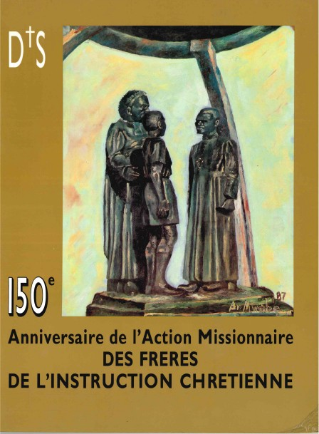
AVIONS SANS FONTIÈRE, PRODEVA, ASSIFIC, Volunteer Groups of Senior Students. There was also the search for New Areas of Social and Religious Openness to meet New Forms of Poverty: School Escapism, Drug and Alcoholism, Immigrants, Disabled People, etc., where supported Brothers devoted themselves to these Activities. Hospitality and Volunteering, by their Communities.

NEW MENNAISIAN MISSIONARY FLOWERS (1970-1990…)

Alongside this Evangelization effort in Schools, the Institute gave Great Impetus to “ad gentes” Missions. The Brothers have opened New Frontiers of Apostolate, especially in Schools, in Developing Countries. The Provinces of France reopened the Old Mission of Senegal (1967), then established themselves in Ivory Coast (80), Togo (82), Benin (90), with different Types of Activity: Schools City, Bush, Agricultural Centers… The Canadian Brothers established themselves in Central Africa, in Poor and often Dangerous Regions: Congo, Rwanda, Burundi (1968 and 69), then in Kenya and Tanzania. The Spanish Province opened Mennaisian Centers in South America, in rather Poor Territories: Chile (1983), Bolivia (1993), Uruguay. A little later International Communities of Brothers were opened in Asia: Philippines (1987), Indonesia (2000). The entire Congregation breathed this Missionary Breath, which brought it back to the Spirit of the Founder. In a difficult moment for the Countries of Ancient Mennaisian Tradition, the New Sons of Jean-Marie were able to carry out a work fully in accordance with their Charism, which responded to the urgent needs of so many children and young people, as in the early times “Heroic” of the Institute. And as in the early days, Providence would have rewarded them with New Vocations and a Hundredfold increase in Resources.
It was such an important perspective that a Great Mennaisian, Brother Jean-Charles Bertrand, after having had to close his “Courrier du Venerable”, opened another Review under the Title: “MISSIONS OF FIC, Missionary and Mennaisian Animation”. This Review was the Forefront of Mennaisian Devotion during this difficult period, from 1968 to 1990: it exposed in each Issue the Mission of a particular Country, in its Social and Religious Context. It also retraced the History of the Great Missionaries of the Congregation. The Director continued to point out the Intentions Recommended to the Father, the Favors Indicated, the List of Benefactors. In his leave of this precious Magazine, F. Bertrand wrote: “With this Publication of June 1990, the Publication of the Magazine “Mission” ends. Thus, for Forty years, “Le Courrier du Venerable” and “Missions” would have animated the Cause of the Venerable de la Mennais and collected numerous Testimonies of very Transparent Favors of the Spirit of Faith and Trust for a large number of people. Heaven will respond in due time to this Popular Piety, while the Church will then hasten to proclaim Blessed this chosen one of the Lord, Great Apostle of childhood. Thank you, Dear Readers, for your Spiritual Commitment in the footsteps of Jean-Marie de la Mennais and for your Generous Support throughout these years. The Good Founding Father remains with you and will continue, without a doubt, his power of Intercession with God.”

(SOURCES: REPORTS OF THE CHAPTERS of 1988 and 1994; Chronicles 1990-96; Magazine: FIC MISSIONS, Canada, FJC BERTRAND 1969-969)

- TRACES OF HOLINESS IN THE MENNAISIAN CONGREGATIONS: BROTHER NICOLAS MEDIAVILLA, A LIFE GIVEN TO THE MISSION

Bro. Nicolas Mediavilla Garcia linked his name to the founding of the Indonesian Mission. He spent only three years there, and yet he gave the greatest gift to this Mission: the gift of his life. He sowed in the soil of one of the youngest Mennaisian Missions, the seed of his body, which would bear much fruit.
Bro Nicolás Mediavilla
Bro. Nicolas, or Nico, as he was familiarly called, was born on March 12th, 1947 in Amaya, a small Town in the Municipality of Sotresgudo in the Province of Burgos, Autonomous Region of Castilla y León
(Spain). His parents are Eugenio and María. At a very young age he entered the Juniorate of Nanclares: he spent 6 years there (1958-1964). He felt very good there, especially in the Games and the Fraternal Atmosphere. He was very interested in Sports, Music, Shows, a little less in Studies. He did not have Good Academic preparation in his tiny village: the Grades for the First years were Very Bad. However, we noted slow but constant progress in Successive Classes, especially in Scientific Subjects: Mathematics, Physics, and Chemistry. His student report showed very high marks in his Studies at the Scholasticate in Philosophy and Theology. (Years 1964 to 1968). His University Studies focused on the Subjects he preferred: he obtained his degree from the University of the Basque Country, with the Title of “Licenciado en Ciencias, sección Matemáticas” on 26-1-1983. Bro Nico had already started teaching, advanced studies and directed Classroom activities together. He stayed up to date on everything related to Education Issues and News. He attended Specialized Courses on: “Total quality in Education”; Courses which reflected Brother Nico's interest in all Aspects of Education and young people, in School and in Society. “The Pedagogy of Teaching”; “Prevention
HIS MISSION IN SPAIN AND INDONESIA
Bro Nico followed a fairly regular Teaching path. From 1968 until 1999, he taught in Several Schools: Bilbao 68-71, Aguilar 71-76, Portugalete 76-82, Santo Domingo 82-88, Aguilar 89 – 99. On his teaching qualities as Educator, we have some Testimonies: “Nico was a born Educator. He taught Mathematics to Evangelize. He was a Guide and Friend of young people for years, in Portugalete, Santo Domingo de la Calzada and Aguilar de Campoo, shoulder to shoulder with other Educators; Friend and Brother, Humble Servant, always Available, Welcoming, always Searching. He ended his days at Larantuka School. Nico always had a Fraternal behavior, always having a Positive outlook on people and events, a total welcome towards anyone. Never a Negative Judgment. Sometimes silences stronger than him, astonishments that he did not know how to ward off. Nico was a Brother practicing Humor, having a sense of Celebration [his famous songs remain sung at the top of his lungs: “Paloma couccouroucou!”], asking himself and asking questions, capable of giving advice if asked.”(Chronicle July 2003)
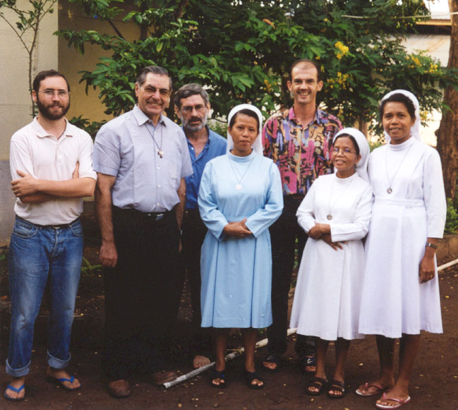
By broadening the view on his Spiritual and Apostolic Portrait, the Article continues: “Brother Nico loved humility: he was a simple man, with an easy smile. He was a Man of Prayer. He was a Brother, a Teacher, a Friend of young people. In contact with the Poor, he knew how to convey through his words and gestures the mystery that seduced him and that his eyes could not hide: he was absolutely in love with the Lord Jesus.” It is for this reason that he agreed to be sent on a Mission: a Completely New Mission, without any experience, in a task entirely to be discovered. Relying solely on his Faith, Brother Nico goes where the Lord sends him: he will bring the hope of the Gospel to young people far away,who are hungry for his Word and who are waiting for Brothers who will help them put it into practice. at the center of their lives. “He embarked for the unknown by going to Indonesia to demonstrate virginal love towards the poor. The Lord was his only wealth. No riches in his room: only a little linen and Diaries, witnesses of his crazy adventure. He lived to be where the Lord wanted him. He ignored suffering and insecurity. After a few months of Rest and Discernment during a Summer in Spain, he returned to Flores, because he had heard the voice of his Beloved resounding in that of the Superiors who sent him and the young people who asked for him.”
The General Council appointed Brother Nico Superior of the Small Community of Larantuka, on the Island of Flores. He is at the same time Deputy Director of the Darius Secondary School, managed by the Diocese, in which the Brothers collaborate. Above all, it opens the Small Community to welcoming the population with very simple but Attractive Initiatives: Sewing and Mechanics Workshop, Organized Fishing, Computer Courses. All activities are inspired by the proclamation of the Gospel: the Community offers moments of Prayer and Religious Formation, in which young people and adults participate in good numbers and willingly. From the start the Mennaisian aspect is strongly emphasized and the people start very early to know and love Father de la Mennais.
The Testimonies of those who knew Bro Nico show that his attitude touched their hearts, even in such a short time, barely three years. “We were able to realize how in a short time they grasped the main lines of Nico's Spirituality and also the main lines of Our Mission: Simplicity, Proximity, Welcome, Attention to the Most Disadvantaged, Presence among Children and Young People, Seriousness and
Perseverance in working with Students. They invite us to continue on this path and offer it to young Indonesians who wish to follow this path.” (Daniel Bruder)
THE DEATH OF Bro NICO: LOVE UNTIL YOU GIVE YOUR LIFE
On December 22nd, we celebrated Christmas in Community with the College Teachers, before the Holidays were dispersed. Nico thought he had just a Common Fever and took Flu Medication for a few days. On December 26th he went to the Nuns' Hospital: the analisis revealed nothing: No Malaria. He is prescribed complete rest. On the 29th his condition worsened: he was transported to Lela Hospital. He is put on Oxygen. The Doctor declares The First Missionaries in Indonesia with SG Bro Jose Antonio Obeso.
that it is a strong attack of Malaria; he is taken care of by a Health Team. During the night he seemed to get better. The next day, December 30th, he had a seizure: he began to breathe like someone who was choking. The Doctor is worried, asks to inform his family and the Brothers and to call a Priest to Anoint him. Nico slowly fades away. In the last moments his arms, which he held stretched out along his body, open and move towards his chest, as if in a gesture of welcoming the Lord who comes to seek him. In the evening, the Hospital Ambulance takes Nico's body to Larantuka. Before the arrival, a large group of young Motorcyclists precedes and announces the arrival of the body: many people welcomed the remains of the Brother and all night long people keep vigil and praying. For 2 days, Nico's body was watched, day and night, by the people of Larantuka with Prayers and Hymns.” (Bruder Stef)
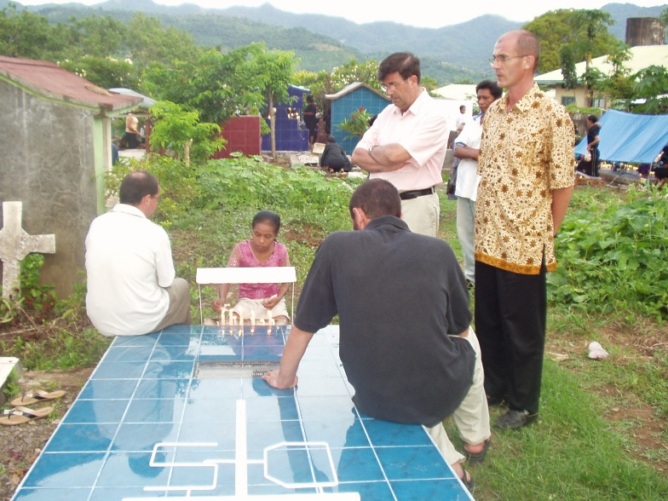
On January 2nd, the Solemn Funeral was celebrated in the Parish Church in the presence of two Bishops, 14 Priests, Superiors of the Mennaisian Brothers, Religious Communities, a sister of Brother Nico, Encarna, and a huge crowd. After Communion, Indonesian Tradition provides a Solemn Moment of Farewell: from the Bishop, the Brothers, the College Teachers, and Young Students: “Brother Nico carried out the Mission of Brother de la Mennais to Perfection. Brother to all and Teacher to young people, sharing their lives. He continues to carry out his Mission as Brother and Teacher, because he obtained what he desired: to be a brother of Jesus.” (Students)
Then it was time for the Coffin to be closed and transported to the Cemetery, amidst Tears and Songs: everyone gives their Blessing on the Coffin by covering it with flowers. “Nico's remains are there, where he always wanted them to be, close to the Community, with the people in all simplicity... Since then the Tomb continues to attract the visit of many people who come every day to pray , put candles, enjoy his tenderness, his smile, his listening.” (Komunitas BPK)
A CROSS FULL OF HOPE
The Superior General, FJA Obeso, wrote a letter full of consolation and hope to the Brothers and young people of Larantuka, painfully affected by the death of Brother Nico. We give some passages:
“The Construction of a New Community always bears the sign of Martyrdom. The Formation of the Community had a difficult process for some moments; “yet the challenge of living a new reality, the hope in the Lord and the faith in the Brothers, gave us the impetus to continue trying,” he himself wrote a few weeks ago: But to build it we must believe that God makes his way to us. “Now our Community is Mission-Oriented, open, welcoming and well integrated and we are always gaining strength.”
We can be killed by one thing and die for another. Nico was killed by Malaria and Poverty. But he died for the Mission for which he had offered his life. The Brothers of Larantuka will not be able to forget his Easter: they were marked by the way he recorded his existence in his last moments: Raising his arms, as if he saw the Invisible, he said: Father, welcome me, I put my mind in your hands. He gives a great gift to his Brothers: what better seed for the Mission to bear fruit than this life of a Brother, full of faults - as he said of himself - but always holy. The Lord met him very early, with the baggage, light in itself, but full of God, more than ever.”
Tomb of Br Nicolás Mediavilla, in Larantuka
The blood shed, the body welcomed by the land of Flores, weaves new links with it. This body in the Earth is the best seed; may the Lord make it produce one hundred to one, in Vocations for the beloved young people of Larantuka. The Lord will touch their hearts, so that they can take over from the one who gave his life for them. Brothers of the Community and young people of Larantuka, you have become more Orphans than ever. You have lost a brother who loved you deeply with the heart of God. But you have gained a Holy Brother, who was willing to give his life to God as well as to yourselves. You will always be in his prayer, you will always be in his Missionary Heart.”
(SOURCES: MENOLOGY OF THE BROTHERS OF SPAIN; REPORT by Brother Josu Olabarrieta; File by Brother Nico Mediavilla Garcia in the FIC Archives of Rome; Letter to the Community of Larantuka from Superior General Brother José Antonio Obeso)

