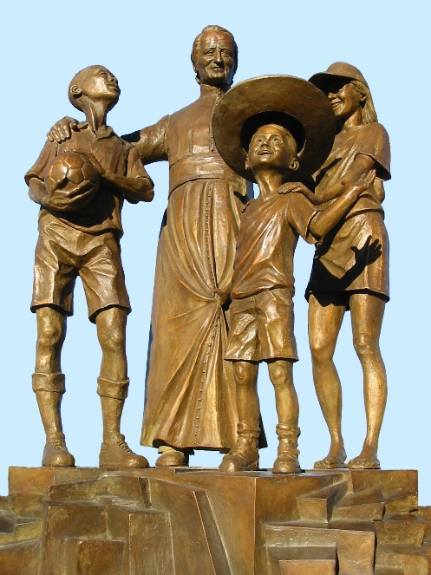
MENNAISIAN NOVENA
FEBRUARY 2026

- NEWS FROM THE POSTULATION
The Postulator has completed the File including the Expert Opinions of the Five Doctors on the alleged Miraculous Healing of Enzo Carollo.
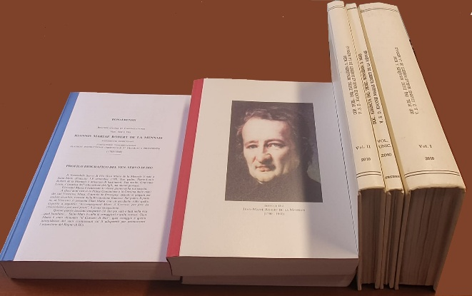
On January 22nd, with the Authorization of the Superior General, the Postulation Committee submitted to the Dicastery for the Causes of Saints the Official Request to reopen the Examination of Enzo Carollo's Healing. With that request, the Postulator presented the Summarium (the Dossier compiled during the previous investigation) prepared by former Postulators Brothers Delfin Lopez and Gil Rozas. In addition, we provided Medical Reports written by Five Doctors—convinced of the Scientific Inexplicability of the Healing and therefore in favor of reopening the Examination by the Medical Commission. The Dicastery sent that Material to Two Specialists, who would study Enzo Carollo's Case. At the end of their study, they would give their Opinion: if at least one of them supports the finding of Inexplicability, a New Examination by the Medical Commission would be possible. Let us Hope and Pray!

- Prayer Intentions through the Intercession of the Venerable Jean-Marie de la Mennais
- Let us pray for the Beatification of Father de la Mennais, source of a New Impetus and Fervent Mennaisian Vocations.
- We offer a Special Prayer this year for the Province of Uganda, which is celebrating its First Centenary: 1926-2026. Let us thank the Lord for its Beautiful Flowering and for the New Apostolic Challenges that await it.
- Let us pray for the needs of the FIC Provinces in difficulty: Haiti, Democratic Republic of Congo, South Sudan, Tanzania and for the New Mission in Timor Leste.
- Recommended Patients: Bro. George Kamanda (Uganda), Sergio, Lazo Flores, Filomena (very ill), Rachele and Monica (Cancer), Claudio (Optic Maculopathy).
- For Patients recommended by Local Facilitators.

- FAVORS ATTRIBUTED TO THE INTERCESSION OF FATHER DE LA MENNAIS.
HOW MANY CURES AND FROM WHICH DISEASES: AN OVERVIEW
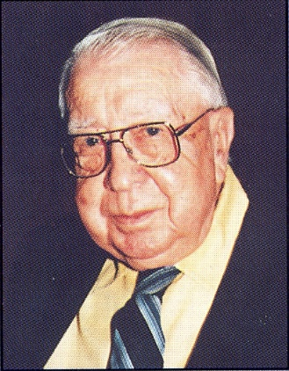
We borrow from Bro. Jean-Charles Bertrand a Synthetic Study on the Cures obtained following the request for Intercession addressed to the Venerable de la Mennais.
“At the time when the Pope was emphasizing the necessity of Miracles for the Advancement of Father de la Mennais’s Cause, Nine Healings, previously published in the FIC’s *Echo des Missions*, had been added to the Eighteen contained in the Vannes Report, printed in Rome in 1911. It was those Favors, deemed Miraculous, which Brother Jean-Joseph, Secretary General, had in mind when responding to Pope Benedict XV. That figure of 27 was remarkable, but as early as 1904, the Advocate of the Cause, Monsignor Salotti, later Prefect of the Congregation of Rites, could write: ‘Therein lies ample proof that there is no kind of Illness that can resist the Powerful Intercession of the Servant of God, JM de la Mennais.’ To whomever would ask us again: ‘Do you have Miracles?’ what could we answer?”
Bro. Jean-Charles BERTRAND
Leaving aside for the moment the less important Temporal Favors, the Sole Record of Extraordinary Healings attributed to the Venerable's Intercession and published in the Institute's Chronicle yielded 128, which, added to the 18 from the Diocesan Process of Vannes, gave a Total of 146, 51 of which were obtained in Canada. That Total included only Sufficiently Explicit Accounts; it excluded mere Mentions expressed in Vague Terms and lacking Documentation. That List continued to grow. [That was 1983]
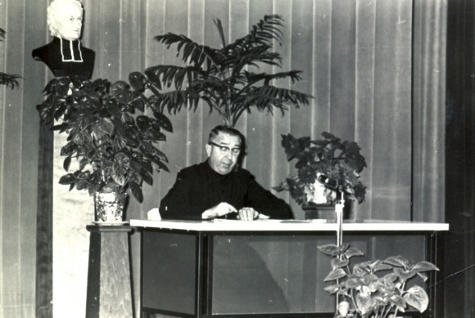
The Ailments cured through the Venerable's Intercession were of all kinds: besides some Thirty Chest Diseases (Pneumonia, Tuberculosis, Pleurisy, Bronchitis, etc.) and some Twenty Serious Digestive Disorders, there were 9 Cases of Typhoid Fever and 7 of Meningitis, then Sore Throats, Eye, Ear, Head or Heart Ailments; cases of Scarlet Fever, Rheumatism, Hip Pain, Epilepsy, Uremia, Paralysis, Eczema, Diabetes; Wounds, Tumors, Burns…
As for those who benefited from those Healings, the Statistics Mention about Thirty Students of the Brothers and an equal number of Mothers, mostly relatives of the Brothers; the Brothers themselves were listed as 19, to which should be added 12 Young Men from their Formation Houses. We also saw 6 Daughters of Providence, Three other Nuns, 15 Girls, 9 Men, 8 Young Boys, 7 Infants, and an 80-Year-Old Man.
Those Healings unfold at a roughly Uniform Pace: they involved Serious Illnesses with imminent danger of Death; often the Doctors admit their powerlessness and advised administering the Last Rites. It was then that a Pious Hand places a Relic Image of the Venerable Father under the Pillow or on the Chest of the Dying Person. Then, a Novena to the Founder began in the Family and at School. Then, contrary to all Scientific Predictions, a rapid improvement occurred in the Patient's Condition; followed by Convalescence, often very short, and a return to Perfect Health.
The Speaker, the "Director" of the "Venerable's Courier".
(SOURCE: Bro. Jean-Charles BERTRAND, “Missions” Review, June 1983, p. 7)

- THE APPARITIONS OF OUR LADY OF KERIO (Brittany, France): FLOWERS OF THE FIELD OF OUR LADY OF KERIO (last part)

BRIEF NOTES ON THOSE APPEARANCES
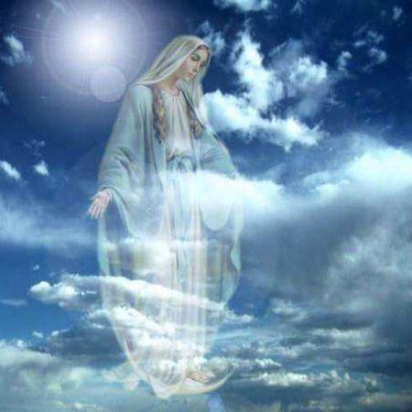
The Apparitions at Kério were “Minor” Apparitions. They did not have the impact of the Major Apparitions of Guadeloupe, the Miraculous Medal, La Salette, Banneux, etc. Lourdes, Fatima, Kibeho… They have a tone of simplicity and familiarity, retaining a Rural Charm. But their Smallness should not prevent us from receiving the Message that the Virgin Mary wished to entrust to her children. We try to gather her signs from Heaven like a bouquet of simple and wonderful wildflowers.

MARY'S SIGNATURE
In those Apparitions, even within Families, we could see Characteristic Signs that testify to the presence of Mary:
- “The Starry Dress”: As in Pontmain, the Virgin appeared in a Blue Dress, adorned with Stars. Those are the Colors of Heaven.
- “I supported my Son’s Arm”: As at La Salette, Mary appeared beside her children, who are going astray and bringing about their own ruin: the Wars that would come, ever more deadly, would be the consequence of Hatred and Sin.
- “The Wind and the Spring”: as at Lourdes the Wind announced the Discreet Presence of Mary, an Event of the Holy Spirit; she made a Spring gush forth to Quench the Thirst of Men and of Jesus.
- “The Light that accompanied the Path”: As at Rue du Bac, Mary sent her Angels to light the Way that led to God.
- “The Walking Child”: Just as the Virgin Mary taught Jesus to walk, so she taught her Children to walk in the Way of her Son.
- “The Rosary”: the Fundamental Signature of Mary in all her Manifestations; a Large Rosary, visible to mark the Prayerful Repetitions of the Prayer of the Poor and the Walkers.
- “The Miracles”: As everywhere Mary appeared, “there would be Miracles that would be the Sign of her Presence among Us.” Father Michelot recorded several of them: Healings of the Body and Healings of the Heart.
SAINTE-ANNE-D'AURAY
The Blessed Virgin Mary “commanded” Jean-Pierre to make a Pilgrimage on Foot to reach the Sanctuary of Saint Anne: a Very Long Journey, taking 24 hours, pushing the Limits of what was possible. But She protected the Two Pilgrims, sustaining them by giving them Light, Drink, Energy, and Joy: they must arrive at Saint Anne with the Mission of Praying for Brittany.
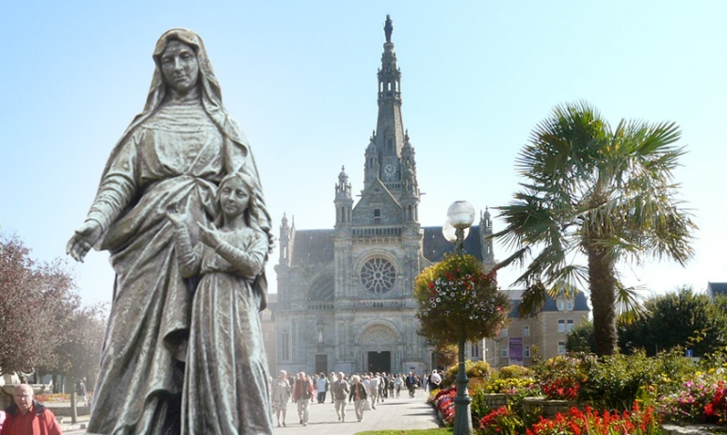
That Sanctuary was the “Spiritual Center of Brittany,” and Saint Anne, the Mother of Mary and Grandmother of Jesus, was its Patron Saint. She represented the Simple and Profound Faith of God's People, especially the “Little Ones,” who knew how to embody Faith in Everyday Actions. Anne, like her Husband Joachim, was not mentioned in the Gospel, but she had always been Very Much Alive in the Tradition of God's People: a very Human Presence, linked to Family, to Women, to Motherhood, and to Children. She translated the Christian Faith into Very Human and familiar Terms that are part of the Traditions of Everyday Christian Life, of Festivals and Seasons.
In Sainte-Anne d'Auray, the Vast Basilica that stands today had recently been rebuilt (1872) on the site of the Old Chapel of the Visionary Yves Nicolazic. Saint Anne had appeared to him between 1623 and 1625, revealing the Location of the Ancient Statuette. She had invited him to dedicate a Space for Prayer and Pilgrimage, a Center of Spirituality for all of Brittany, which her humble servant Nicolazic had faithfully fulfilled. From then on, Brittany was placed under the Special Protection of Saint Anne. “Saint Anne told Yvon Nicolazic that God wanted that place. God chose that Land to be a Holy Place; God willed that a Part of your Land, a part of your Country, France, should be Sacred Land, reserved for God, so that He might be honored there… What would save the World as Humanity kneeling before God. It was in Adoration that we discovered Our True Dignity, the Ultimate meaning of Our Existence. It was by kneeling that Humanity discovered its Greatness and Nobility… Saint Anne came here to tell the Bretons, to France, to the whole World that Adoration was the only Remedy for Despair. Faith in God and Adoration are the Only Means that could guarantee Humanity a Solid and Lasting Peace.” (Cardinal R. Sarah, Envoy of Pope Leo XIV, Homily at Sainte-Anne d'Auray, July 26th, 2025)
BRITTANY
“What is Brittany?” The “little” Apparitions of Kerio answered the question that the Visionary Jean-Pierre had been asking himself: to rediscover the Spirit of Brittany and to pray for it. Brittany has always been a Region of Strong Christian Traditions. In Secular France, which linked the conquest of Human and Civil Rights to the struggle against the Church, Brittany had always distinguished herself by its Fidelity to Christianity and its Resistance to Secularization. Brittany could demonstrate how to reconcile Social, Civic, and Cultural Values ​​with the Spirit of the Gospel, for a Civilization fully respectful of Individuals and Society.
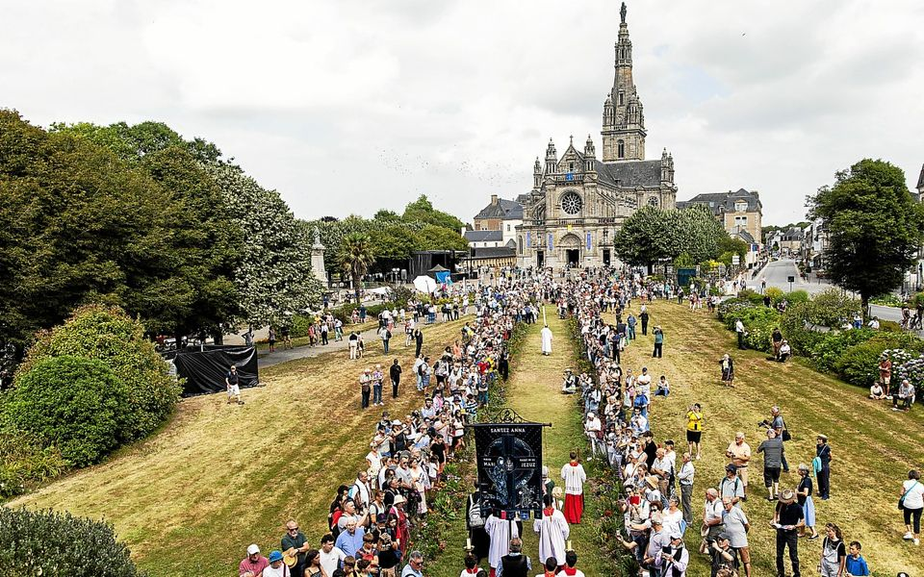
It represented the Age-Old Tradition of France as the Elder Nation of the Church. Only by giving God His Rightful Place could a just and United Civilization be built. That could be seen as the Virgin Mary and Saint Anne's Approval of the Great Missionary Work of the Breton Saints: the Holy Pastors and Bishops, the Holy Monks and Priests, the Martyrs during the Persecutions against the Christian Faith, and the Modern Saints: Yves, Louis Grignion de Montfort, Jeanne Jugan, and the Venerable de la Mennais. We could also add the Humble and Ardent Apostolate of so many Religious Sisters and Brothers—in particular the Brothers of Ploërmel—who dedicated their lives to serving the Sick, the Poor, Children, Young People, and Families in the Most Remote Corners of the Region, often at the Cost of their Health and Even their Lives.
THE MESSAGE FOR THE BISHOP OF VANNES, MGR BÉCEL
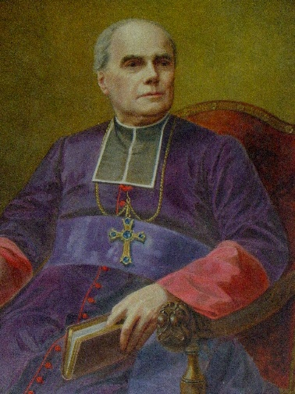
The Bishop of Vannes, Jean-Marie Bécel, was born in Beignon, a Land of Priests faithful to the Church (and Resistant to the Government) to the point of Heroism (see the History of Priests during the Revolution, such as Father Gabriel Deshayes). “His Long Episcopate (32 years) was characterized by the defense of the Church against the Anti-Clerical Laws of the late 19th Century. He stood firm in all areas to oppose what he considered a Form of Apostasy. The defense of Catholic Education was particularly dear to his heart, as was the Development of a Positive Press… The Major Undertaking of his Episcopate was the Completion of the Basilica of Saint Anne in Auray, begun by his Predecessor, Bishop Gazailhan. From his childhood, Bishop Bécel always had a Special Devotion to ‘Our Lady Saint Anne’ (from Ouest-France). He was very attached to the Sanctuary as the starting point for the Reconstruction of the Breton Faith. In that Place, so important for the presence of the Family of Jesus, Faith could experience a Powerful Renewal. Indeed, the Sanctuary became a Place of Conversion for those from afar, a Fertile Source of Consecrated Vocations, a Site for the Reconstruction of Culture and Civilization inspired by…” the Gospel. The Great Pilgrimages organized to the Sanctuaries also became an Eloquent Testimony of Faith lived and proclaimed by an Entire Christian People who showed their Faith publicly and were proud of it.
The Mysterious Message in Latin—which has never been transcribed—that the Virgin entrusted to the Humble Farm Boy, perhaps aimed to encourage Bishop Bécel to continue his work: the defense of the Christian Faith and the Promotion of the Church's Mission in Secularized Society. That was what the Bishop accomplished with fervor, not only for his Diocese of Vannes, but for all of Brittany and—we might add—for the Entire Church.
ENTER THE BROTHERS OF PLOËRMEL: IT WAS MY SON'S DESIRE
It was quite Extraordinary that the Virgin Mary indicated a particular Congregation in her Messages. The Brothers of Ploërmel (founded by two Breton Priests, Jean-Marie de la Mennais and Gabriel Deshayes) covered Brittany with a very Dense Network of Schools: Most Towns and Villages had a Brothers' School. Mary's Invitation had the Character of an Endorsement of an Apostolate that could Evangelize all of Brittany: a Mission that proclaimed the Faith by Christianizing Civilization and Culture (“the whole person”), especially in the Modern Era, which tended to separate Faith and Culture, relegating Religion to the Private Sphere. Father de la Mennais expressed that Mission as: “To make Jesus Christ known and loved by children.”
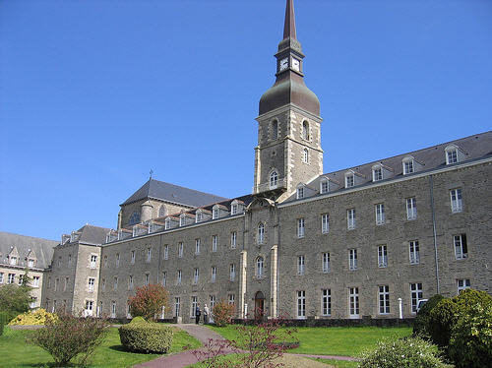
proclaimed the Faith by Christianizing Civilization and Culture (“the whole person”), especially in the Modern Era, which tended to separate Faith and Culture, relegating Religion to the Private Sphere. Father de la Mennais expressed that Mission as: “To make Jesus Christ known and loved by children.”
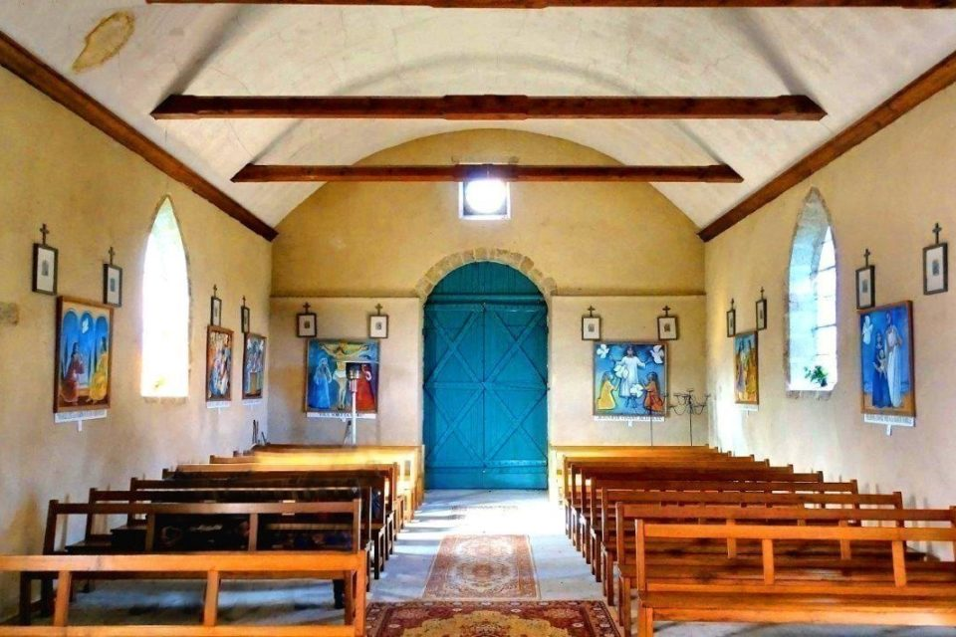
Mary's Call and Jesus' Desire remain ever relevant, giving Great Impetus to young people in that Adventure of Hope for a World to be Renewed. In that Light, the beautiful example set by the Two "Visionaries," who became Brothers of Ploërmel, could inspire the desire to dedicate the energies of their Youth to God: like Brother Florien, serving the Sick in the Formation Houses of Ploërmel, and like Pierre-Edouard, in the Missions of Heroic Times in Haiti. In our time of "Vocational Decline," the words of the Virgin and Jesus encourage young people to embark on the Adventure of Proclaiming the Good News. That would be the Season for an Educational Project that would illuminate, through Christian Faith, the New Civilization that was emerging. The Great Challenges of Peace, Care for Creation, Technology, Life, and Family await a generous response from Young Christians. The Harvest was Plentiful; the Laborers would surely come to the Call of Mary and Jesus.

OUR LADY OF KÉRIO AND SAINT ANNE OF AURAY: A MESSAGE OF HOPE
- THE APPEARANCE OF FAMILY
Our Lady of Kerio was Our Family Apparition. Everyone could feel at home there. It was easy to go, to Pray, and to Participate in Short Celebrations. She was the Virgin of the Holy Family of Nazareth, with the added, discreet presence of Grandmother Anne. The Spirit of Kerio was simple, Daily Prayer, Small Intentions, Feelings of Peace and Serenity, and Consolation after Personal or Family Trials. But it was also an Opportunity for Conversions of Heart, Family Reconciliations, and Generous Responses to Jesus' Call through Mary: in imitation of the Young Mary, Daughter of Anne.

STARTING POINT OF THE PILGRIMAGE
Kério was not intended to be a Pilgrimage Destination, but a Starting Point for Pilgrimages to Sainte-Anne d'Auray.In Kerio, one doesn't linger: one must leave. “Get up and walk!” Like Mary after the Angel's Announcement, she sets out in haste for the Mountain Region. When God called, it was by setting out that we would discover God's Plan and bring Jesus to the World, to the little World that awaited Hope from us. Then, together, we would be able to Sing the Magnificat with Mary, Elizabeth, Anne, and all the Little Ones of the Gospel.
One simple addition: when children had difficulty walking, they were often taken to Kério to take their First Steps. A striking similarity to the Tradition found in Plouvorn (Finistère), near the Tomb of Brother Zoël Hamon, a Little “Saint” Brother of Ploërmel.

KERIO'S SONG
Let us conclude Our Spiritual Pilgrimage with the words of a few verses from the “Canticle to Our Lady of Kério”
- In the Land of Vannes, Mary appeared; Daughter of Saint Anne, receive Our Greetings.
R/AVE, AVE, AVE MARIA; AVE, AVE, AVE MARIA!
Young Jean-Pierre, your beloved child, offered you the Prayer that Gabriel said.
- You showed yourself to him in that Bright Valley; sublime encounter! You told him Your Name.
- “Brittany offended me, barefoot you would go, for Your Repentance, to Ker Anna”
- “I would perform many Miracles there, and all Obstacles would be overcome.”
- Mary, Our Mother, Glory to you above, to you on Earth, Glory in Kerio.

“SAINTE-ANNE D'AURAY: A STORY OF RENAISSANCE AND CONVERSION AT THE VERY HEART OF COLLAPSE” (Bishop Centène, Bishop of Vannes)
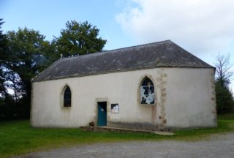
- 1623-25: That was the Discovery and Reconstruction of the Chapel which had been destroyed for 924 years.
- Twelve years later came the Unexpected Conversion of Pierre Le Gouvello, nicknamed “The Devil of Brittany,” touched by the Intercession of Saint Anne, simply because he gave Alms to the Poor and recited a Hail Mary Every Day.
- The Story of Sainte-Anne d'Auray was a Story of Rebirth where all seemed lost. “God's Plan could not fail. Faced with Current Secularization, we might think that Christianity had run its Course. Just as the Temple in Jerusalem was rebuilt after the Exile, so too was the Chapel of Sainte-Anne Rebuilt after the Revolution. It was God's Plan unfolding in Human History, through the upheavals of that same History, but without ever losing its power.” (Bishop Centène)
CONCLUSION:
Let us conclude that Brief History of the Apparitions of Our Lady of Kério, so closely linked to the Sanctuary of Sainte-Anne d'Auray, with a few verses from the Traditional Hymn of Sainte-Anne d'Auray:
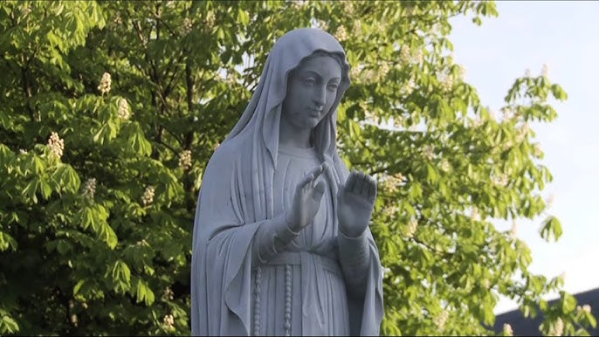R: SAINT ANNE, O GOOD MOTHER/ YOU WHOM WE IMPLORE/ HEAR OUR PRAYER/ AND BLESS YOUR BRETONS
- To show the Earth that we believe in Heaven—Our Brittany was proud—to surround your Altar.
- When Error was unleashed - to overcome Our Faith - Mighty Sovereign - we hope in you.
- Protect the Holy Father whose Humble and Great Heart suffered on Calvary, like Jesus dying.
10- Your Immaculate Daughter - Queen in the Divine Abode - to Our Troubled Soul - Smiles with Love.

SOURCES:
“OUR Lady of Kerio, in Noyal-Muzillac”,Brother Théodore Volant 1992 / Our Lady of Kerio, Yves du Menga, in “Queen of the Arvor: Apparitions of the Virgin in Brittany” pp. 203-12, Rostrenen / Menologion of the Brothers of Christian Instruction, F. FLORIEN-MARIE volume II pp. 636-8 and F. PIERRE-EDOUARD volume IV pp. 1368-70 / Bishop Jean-Marie BÉCEL, those Bishops who have marked the History of Vannes, Ouest-France, 2-1-2020 / Cardinal R. Sarah, envoy of Pope Leo XIV to Ste Anne d'Auray, Homily in the Celebration for the Fourth Centenary of Apparitions of Saint Anne to Yvon Nicolazic, July 26th, 2025 / Bishop Centène, Bishop of the Diocese of Vannes: Pastoral Letter for the Jubilee of the Sanctuary of Saint Anne of Auray 2025
VIDEO: “Notre Dame de Kerio” on YouTube (Cat Productions KTO, 52 min)

