

**MENNAISIAN NOVENA FEBRUARY 2024**

1. **APPLICATION NEWS**

Postulation activity takes place in Three Sectors:

* STUDY of the HEALING of ENZO CAROLLO: Four Specialist Doctors (3 in Italy and 1 in Argentina) are at work to deepen the case of Enzo's cure. The work is long (the Summarium prepared by Brothers Delfín and Gil is composed of 835 pages) and complex. The Doctors work closely with the Postulator.
* STUDY OF THE BIOGRAPHY OF BROTHERS WHO LEFT TRACES OF PRESUMED HOLINESS: for the moment we have written the life of Br. Zoël Hamon (first Brother of France), of Br. François Cardinal (Canadian Missionary in Rwanda) and we are in the process of delving into the life of the Catechist Brothers in the Antilles (Br. Arthur, Br. Hyacinthe). These Biographies were presented for a First Informal Consultation to some Officers of the Dicastery of the Causes of Saints: they encouraged us to continue the work.
* ORGANIZATION OF COLLABORATION BETWEEN THE POSTULATION AND MENNAISIAN PROVINCIAL ANIMATORS. We are in the process of setting up Local Mennaisian Animation to: collect Local Intentions, to record the Favors Received, to Animate Devotion to the Father (Prayer, Knowledge, Pilgrimage), distribute Animation Materials, etc.

1. **PRAYER INTENTIONS**

* For the **General Chapter** of the Brothers of Christian Instruction: March 25th – April 25th, 2024.
* HAITI: **Nick Danus Titus**, Seventh Grade student (11 years old) in St-Louis de Gonzague, Blood Cancer; **Naya Benoit**, 12 years old, in Comas since 2020, Brain Cancer; **Lesage Dessalines**, 14 years old in a Coma since the age of 2.
* ARGENTINA: **Daniela Vescovi**, Pancreatic Cancer; **Zamira Iborra**, Uremic Syndrome.
* SENEGAL: **Mathilde Kayoungua**, Cancer and Kidney Failure.
* ITALY: **Massimo**, Ictus; **Giuseppe**: Leukemia.
* FRANCE: The Intentions are placed on the Tomb of Father de la Mennais.
* ASIA: **Corazon Mondragon**, **Yukari Holme**, **Lise Beaudouin**, **Robert Scripko**, **Katarina Eda Botha**.

1. **FAVORS RECEIVED THROUGH THE INTERCESSION OF THE FATHER**

**CURE OF MENINGITIS OF LITTLE THERESE ROYER, MUZILLAC, November 1915**

On Sunday, November 3rd, 1913, in the evening, little Thérèse Royer, from Doyenné, in Péaule, fell ill. She was 7 years old. The parents thought it was indigestion and were not at all worried. The next day and the day after, no change in the patient's condition. On Wednesday morning, the parents took her to the village to consult Doctor Besse. The Doctor predicted Meningitis and prescribed some remedies. In the evening of that same day, the child's Confessor was called. The next day, Thursday, the frightened parents called for Doctor Orhan, from Muzillac. He confirmed the diagnosis and did not change anything in the Prescribed Medication. But he found the case so serious that he thought it necessary to prepare the parents for an outcome which he judged must be fatal. He also had the child's Confessor informed of the seriousness of the case. The little sick girl received the Anointing of the Sick.

On Friday a Terrible Crisis occurred and it was thought that Thérèse was going to die. On Saturday morning Doctor Orhan saw her again and found no improvement. Sunday morning Crisis even more terrible than all the others, lasting four consecutive hours. The poor child uttered terrible cries. She had to be held by force in her bed. On Sunday evening, while she was still alive, Father Rocher, her Confessor, returned to see her after Vespers. He was accompanied by Mr. Coto, Brother of the Institute of Brothers of Ploërmel. The latter gave the child an image of Father de la Mennais with a Relic of his. Everything was placed under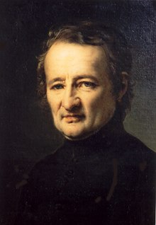 the little sick girl's pillow and the parents, for their part, promised a trip to the Father's Tomb if he cured their daughter.

A quarter of an hour had not passed when all Crises, all Excitement, all Cries had ceased and little Thérèse, who could not be made to eat anything, was asking for Chocolate. Since that time, none of the prescribed remedies have been administered. The next day, despite the Doctors' Defense, Thérèse got up from her bed. She got better day by day and, less than eight days later, she left the bed for good and walked around the house. It didn't take long for her to resume her usual routine and return to Class. For more than a month after the illness, the child no longer wanted to part with his image, even at night. “It was the Father who healed me,” she said to everyone who spoke to her. Since then she has felt absolutely nothing; Morally and Physically, she kept no trace of the Terrible Illness.

These are the facts that many witnesses could attest to, with me. (JM Deblond, Rector-Dean of Péaule on 12-8-1915). Followed by the signatures of Father Joseph Rocher, Confessor of the child/of Rose Gilbert, mother of the child/of Joseph Royer father).

TESTIMONY of DOCTOR ORHAN

*“I, the undersigned G. Orhan, Doctor-Physician in Muzillac, Morbihan, certify having given my care to little Thérèse Royer, for Meningitis and certify that this little one was cured in an Inexplicable Way. Here are the facts: On November 6th, 1913, a Colleague saw this little patient and made the Diagnosis of Meningitis. The grieving family asked me the next day, November 7th; I only confirmed the Diagnosis already made and at the same time gave them a glimpse of the fatal outcome in a short time. On November 9th, I came back again, no change. Two days later, November 11th, recalled for the third time, what was my amazement when I saw all the meningitic symptoms recede. The family told me that they had felt much better after the visit of a Brother who gave them an image of Father de la Mennais, with Relics. This little one subsequently continued to get better and better, then recovered.*

*I describe this healing as supposedly Miraculous, first of all because it occurred without any Effective Treatment; there were no Lumbar Punctures or Serum Injections done; then because, this healing obtained, contrary to what always exists in cases of healings obtained by human means, it has not retained any Physical, Intellectual or Moral Defect. » Muzillac, 9-8-1915 / signed: Doctor Orhan*

SOURCES: COLLECTION OF FAVORS ATTRIBUTED TO F. DE LA MENNAIS, Bro. Jean-Charles Bertrand, AFIC Rome

1. **THE ANIMATORS WRITE TO US:**

CORRESPONDENCE WITH MENNAISIAN ANIMATORS:

We are beginning to receive abundant correspondence with our Mennaisian Animators who are so precious in fueling devotion to Father de la Mennais. We are publishing some of them received.

* Province SAINT-JEAN-BAPTISTE: The Novena is well underway in the Province, praying every day, following the year's theme of establishments and Communities: BUILD TOGETHER. An Office of Vespers has been composed for each day. “Together with 1-Creator God 2-the Congregation 3-the Province 4-the Community 5-Guided by the Spirit 6-the Laity 7-the Young People 8-the Church 9-Christ. (Br. Michel Bouvais)
* From CONGO, Raymond Hamelin School Complex: “Beautiful opening of the Novena. Every morning we pray together, with the Intervention of a Brother. Example: “the School as Temple, Hospital and Workshop”. (Br. Clément Abeli)
* From Kupang, INDONESIA: In the Photos we can see Meetings and Moments of Prayer with Brothers, Young People and Consecrated People. “started Founder’s Day with them”. (Br. Fabien Lagur)
* ESPAÑA*:*Prov. Nuestra Señora del Pilar: “In the Communities of the Province of NS of the Pilar we initiated the great Novena de Noviembre and in the Colegios the Week of Juan María. Agradecidos to Juan-María and the Generations of Hermanos that we precede. / In the Week of Juan María we dared to enter our Colegio de Madrid as a Home or Rincon of Prayer in the Main Hall with Images that lasted for many years. (Br. Raul Blanco)
* DISTRITO DIVINA PROVIDENCIA(Argentina-Bolivia-Chile-Uruguay) The Brothers make the Great Novena to Jean-Marie in September. Currently they are engaged in investigating the case of the healing of Enzo Carollo, in communication with the family of young Enzo and Specialist Doctors. (Br. Ricardo Morzan)
* MEXICO: a Large Number of Mennaisian Initiatives and Volunteering, throughout the year (H. Guillermo)
* UGANDA: “I wish you all Happy Day of our Founder. May we soon obtain the Miracle needed for his Beatification, November 26th”. (Bro. Joseph Tinkasimire)
* PICTURES-RELICS: We are in the process of making Relic Images (with Fabric that touched the Father's Tomb) in several Languages. They are distributed by the Brothers of the General Council in their Travels and in particular will be available at the next General Chapter. Provinces wishing to receive Relic Images in a Particular Language (Indonesian, Japanese, Local Languages, etc.) should send the text (Summary of Life and Prayer) to the Postulation.

1. **HISTORY OF MENNAISIAN DEVOTION:**

**13- THE UPDATE OF THE MENNAISIAN MISSION (approximately 1970-1990)**

In the 1970s the World of Education underwent Profound Transformations. The State intervened directly in the development of School Structures and in Educational Orientations. It ensured the right to Education of all Orders and Degrees, increased the years of Schooling, Centralized Programs and Controls. The Catholic Schools were faced with two Challenges: Economic Survival and the possibility of exercising its Specific Mission, Evangelization through the School. It no longer had the aim of ensuring Education for all, because the State took care of it. Consequently, the Catholic Schools had to find the means to Finance themselves, through Contributions from Families; or they had to establish an Agreement with the State, through Contracts which ensure the necessary contributions, on condition of integrating into the National School System, at the risk of tempering or putting into the background their Christian character.

In France the State offered two types of contract: Simple with Modest Contributions or Association with Significant Financial Support, conditioned by Direct Integration into the National Education Service. The Authorities of the Congregation had an immediate reaction “wishing to strongly emphasize that above any consideration of a Financial Nature, they place the concern for the Christian value and the Educational and Apostolic Influence of our Establishments”. A few years later, however, this Orientation faded and many Schools, especially Secondary and Technical, entered into an Association Contract (F. Paul Cueff, Deux Congrégations Mennaisiennes pp.88-89).

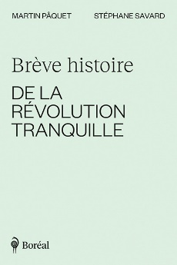In Canada, the “Quiet Revolution” radically transformed the School System through the institution of “Comprehensive Schools”. Schools were grouped into enormous establishments of several thousand students, almost all under Secular Management. The Brothers foundd themselves in a Minority; their influence was very reduced, diluted in a body of hundreds of Teachers and under a Management which did not recognize the priority of their Educational Charisma. The Province reserved the right to keep Private Schools, which remained outside Public Management. A Brother Provincial expressed his perplexities at all levels regarding this situation: “What happens to the Education of Faith and Morals, in these environments where the strictest neutrality actually reigns? And yet these Schools are listed as Officially Catholic! … We have the right to challenge the Academic Quality of teaching and the Educational, Psychological, Moral and Religious value of some of our Comprehensive Schools”. (Br. Roger Provost, Visitor, Oka, AGAFIC Congress, October 1969)

In other Countries where the Institute exercised the Mission of Evangelization through Christian Instruction the situation was similar. Jean-Marie de la Mennais’ Project “to make Jesus known and loved through Schools” was risking becoming difficult and almost impractical.

The reaction of the Institute was not long in coming. The Mennaisian Congregation implemented two important operations: 1- The return to the Sources of the Mennaisian Charism and 2- The Development of the Mission.

**1-THE REDISCOVERY OF THE CHARISMATIC SOURCES OF OUR FOUNDERS**

The first path for this Renewal was indicated by the Council in the return to the Original Inspiration of the Founders in its Purity, Spiritual and Apostolic Fervor. Indeed, during these years there was a flowering of Works which deepened the Charism and the History of the Origins of the Congregation. Here are some of them.

ANTHOLOGY TAKEN FROM HIS WORKS: JEAN-MARIE DE LA MENNAIS, Br. Marcel Doucet, 1980.

This was the first Essay that used the Writings of the Father as a basis for knowledge of his Spiritual and Apostolic Portrait. “The Conciliar Magisterium reminded us of the need to bring to light and faithfully maintain the Spirit of the Founders and their Specific Intentions. What Spirit animated Father de la Mennais? These Biographies helped us to know him better, as did those of several Brothers who lived under his influence. Reading the writings, he left behind Constitutes another path to knowledge of this Spirit” (Foreword)

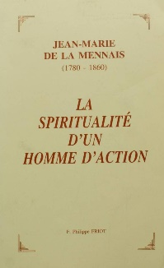THE SPIRITUALITY OF A MAN OF ACTION, Br. Philippe Friot, 1992. This Work constituted a more Systematic Essay on the Spirituality of the Father. This was how Brother Bernard Gaudeul, Superior General at the time, presented it: “The General Chapter of 1988 wanted the riches of the Mennaisian Heritage to be inventoried and, in particular, for the Spirituality of the Founders and the Brother to be studied and explained in order to live more intensely in the Congregation, integrate it into Initial and Ongoing Formation, offer it to young people seeking Vocations, share it with Lay people.” And this was how the Author explained the Title of his study: “If Jean-Marie de la Mennais appears to us first and foremost as a Model of Dedication to the Church, of Fidelity to the See of Peter, of Commitment to the service of Christian Education, it also reveals itself as a Guide whose entire Interior Life is nourished by the contemplation of the suffering Christ and loving abandonment to God, who is Love. This is the secret of its Spiritual Fecundity and the Heart of its Message”. (Preface by Brother Gaudeul and Conclusion p. 325)

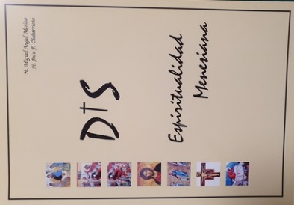MENNAISIAN SPIRITUALITY AND MINISTERIAL SPIRITUALITY, Bros Merino and J. Olabarrieta. For the Spanish-speaking Sector, the very in-depth studies of the Brothers should be noted. Merino and Olabarrieta who interpreted the Subsidiary Devotion of the Spanish Brothers to Father de la Mennais. This Province also responded very seriously to the call of the Chapter. “Without a Spiritual Itinerary, a Congregation does not have a source from which to draw a common mysticism for the integration of the Charism: it is reduced to a Functional Structure. On the contrary, when its Spiritual Itinerary is traced, its members can enter into fruitful dialogue with the other Spiritualities of the People of God.”

THE FATHER OF MENNAIS INTERPELLES ME by Brother Bernard Gaudeul, 1991(extracts from the Father's letters to the Brothers grouped by Arguments)

MAGAZINES: MENNAISIAN STUDIES, since 1987

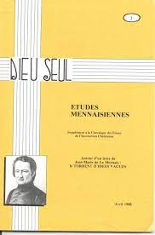During this period an important review began which critically studied the Historical Aspects of the Institute: the time of Origins, the first Witnesses, the time of the Missions, the Crucial Moments... “Many people asked us for studies serious about our Founders and our History. Thus, appeared the New Journal “Etudes Mennaisiennes” which sheds light on the Multiple Aspects of our History. These Notebooks (around fifty so far) “will give us New Motivations to admire and venerate our Founders and Predecessors and also to commit ourselves more resolutely to the path that they traced for us.” (Presentation of FB Gaudeul)

**2-THE RENEWAL OF THE MENNAISIAN MISSION**

The Second Branch of the Renewal promoted by the Council focused on the Development and Updating of the Mennaisian Mission: either through New Animation within Educational Centers, or through the opening of New Missionary Frontiers. [We will explore this aspect further later].

1. MENNAISIAN ANIMATION OF SCHOOLS

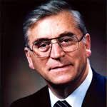Let us follow the orientations approved by the General Chapter of 1982, presented in a “Prophetic” way by the New Superior General Bro Bernard Gaudeul: “On the Assembly has passed the Breath of the Spirit. May Brothers and Communities in turn open themselves to its influence. He alone in fact is the source of Renewal... Let us be Spiritual, let us be Brothers, let us be Apostles!... Then the Apostolic Life of the Brother will find a second wind, the old trunks will give new sap, the sclerosis will give way, the timidities will melt away, a Missionary breath will carry our Brothers to the four corners of the World. Then the School Centers will change their face. Father de la Mennais would tell us again today: “My Schools are established to make Jesus Christ Known and Loved”. Let us ensure that our establishments do not become Secularized, neither in the daily life which animates them, nor in the teaching which is given there, nor in the Spirit and the Activities which take place there. On the contrary, let everything be ordered to the knowledge of Jesus Christ, with tact and discretion, but without fear and renunciation, with this conviction that nothing is more important for the young people of our time. They need to find in their Educator Teachers who understand them and love them, but who also have the courage to proclaim to them the Word of Truth which sets them free. Today it is not permitted for a Religious Educator to hesitate in his Faith, to be incapable of accounting for it. This requires that the Brothers be formed… Our Founders asked us to have a predilection for the poor. The Missionary effort corresponds to this call. Concern for the Intellectually and Spiritually Marginalized in our Schools, the presence of tenderness among the unloved and disinherited in our Schools is a way of being close to the poor. But shouldn't we try to open up to Immigrants, the Illiterate, those who are Retarded at School, the Lost, the Drug Addicts, even the Physically or Mentally Handicapped? Let us be lovers of the Poor and Poverty. Then our Religious Life will bear witness to itself, it will challenge young people: The Novitiates will fill up, the downward curve of Vocations will recover...

*More than ever our Identity as RELIGIOUS-EDUCATOR must be clear, or we will disappear in a Pitiless and Faceless World. Listening to the Founders, the incessant return to their Original* I*ntuitions, the study of Mennaisian Documents, the Development of Spirit of the Institute, will make us Spiritual Sons of Jean-Marie de la Mennais for the young people of today. Brothers, it is a Message of FAITH and HOPE that I send to you*.” (FB Gaudeul)

After 12 years of Generalate, the Chapter of 1994 would confirm the Orientations taken in 1982, emphasizing the MISSION with these indications: 1-CONVERT FOR THE MISSION: engage in a true conversion / 2- IN COMMUNITY FOR THE MISSION / 3- A MISSION FOR THE POOR / 4- A MISSION SHARED WITH THE LAYITY: it was a Project which required Interior and Community Renewal, Apostolic Courage, discernment of New Social and Cultural Challenges: the Polar Star for orienting ourselves was always the Inspiration of the Founders in the path of the Church.

1. A NEW FLOURISHING OF MISSIONS

From the end of the 1960s we witnessed an exceptional Missionary Expansion, shared by all the Provinces of the Institute: Canada in Central Africa, France in West Africa, Spain in South America, and the Provinces united in Asia. These Missions will bring a New Apostolic Breath and a New Mennaisian Lifeblood to the entire Congregation.

*SOURCES: Preface to the WORKS CITED/ CHRONICLES 1969-80/ Two Mennaisian Congregations, P. Cueff/ CHAPTER 1982-1988-1994)*

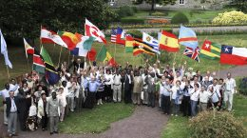

1. **TRACES OF HOLINESS IN THE MENNAISIAN CONGREGATIONS: BROTHER ALPERT-JOSE OXIBAR (1882-1979)**

Br. Alpert was a very well-known Brother in his time, not because of Great Merits, Positions held, or important achievements, but solely because of his Simplicity and Originality. We simply want to illustrate his portrait by naive FIORETTI who remained famous in the Mennaisian Oral Tradition.

1. 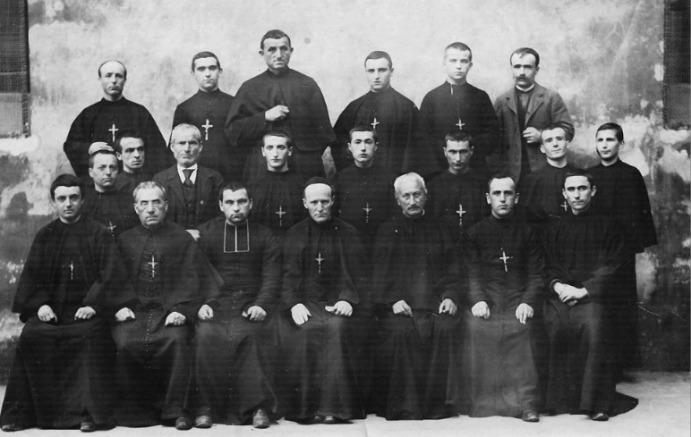He was a “Working Brother”. He had not been able to study regularly: he grazed the family flock and had received Rapid Training. He had taught a little in Primary School, then always in the Kitchen, Cleaning the Properties, Transporting Everything: he was willing to do whatever was asked of him. “I don't have time to be bored, day or night. In Jersey I was always with the Wheelbarrow, in the Kitchen, in the Vegetable Room, at the Burner of Brother Donat, to remove the ashes, in the Henhouse to take the stems of the cauliflowers, the manure... Here in Josselin I do the same thing: I am always with the Wheelbarrow, with the Coal, the Wood, the Cider, the Bottles, the Broom, the Rake etc. and it never ends. LIVE, BIBA!” He never refused any service. All the Humble, Dirty, Disgusting Work fell on him.
2. But F. Alpert was always happy, even if he was quite independent regarding the schedule. He was willing to do anything. In the Directory his qualification was: “Jack of all Trades”. He went everywhere quickly like when he followed his goats on the mountain. He went up the stairs three at a time, bringing Joy everywhere. Often in the paths he cleaned or on the trees he pruned, we could hear his songs aloud or his bursts of laughter. He ended his conversations, always spoken aloud, with his battle cry, linked to the memory of Spain where he had lived for a long time: VIVA, (BIBA) VIVA ESPAÑA, BIBA!

**Community in Nanclares (Spain)**

1. In Jersey there were important Formation Houses, where a fairly serious and well-ordered air reigned. Brother Alpert brought moments of Joyful Confusion, which the Novices liked but which the serious Brother Célestin-Auguste could not stand. When he was discovered in the “Crime” of prohibited communication, Br. Alpert quickly fled. To spread his Joy, he agreed to sing - and he willingly did so - Songs in Basque and Spanish. The highlight of his show was the recitation of the fable “The Wolf and the Lamb” with his Southern Accent, the Gestures, the Accented Expressions, which ended with his Battle Cry: BIBA, BIBA!
2. He built good relationships with everyone. During the War, Jersey was occupied by the Germans. With his cart he crossed the streets of the City and went to take the Leftover Food from the German Kitchens. Naturally the “color” of his clothing corresponded to that of the environment. One day he wants to buy the thread to sew a button into his jacket. But he had no money. No problem. He goes to the garden, takes a Beautiful Pear and brings it to the Merchant. He, faced with his “holy naivety”, gives him what he needed.
3. After the first impression of eccentricity, we realized his goodness. “This Brother had a big heart: he is charitable, helpful… he had many virtues.” He performed the humblest Services with his friendly character and good humor. During the German Occupation, a Brother lost his head. He needed everything. Br. Alpert washed him twice a day. In Josselin he was the Night Nurse. He took Maternal Care of the Brothers, even when he was called many times. In Spain he dedicated himself to children with great kindness. He remembered them as the happiest times of his life, the years spent at the Child Protection Shelter in Bilbao. “This Mssion gave him the opportunity to show his Affection, his Kindness, his Heart full of Tenderness. Br. Alpert was attentive to everyone with the concern of a Mother. Beneath a mask of Originality, he had a Soul particularly full of Mercy”.
4. He was a true brother to everyone. “I've never heard him talk bad about anyone.” He enthusiastically praised everyone, concluding: VIVA, BIBA! He cultivated a great friendship with all the Brothers, in particular with the “Working Brothers” “Br. Donat with his endless work! Br. Didailler, so good! Br. Hubert so delicate! Brother Marie-Bernard so strong and hardworking. Br. Cyprius tireless! Br. Angèle, my great friend! BIBA!” His relationships with Superiors were Evangelical. “You are all brothers”. They distrusted his originality, but with him they smiled willingly. He called Superor General Etienne “the Great General”, Brother Hippolyte-Victor “the little general” and Brother Louis-Arsène “the big General”. When he was put into animal breeding, his comment remained famous: “Previously I was in the high court, now I have moved to the farmyard”.

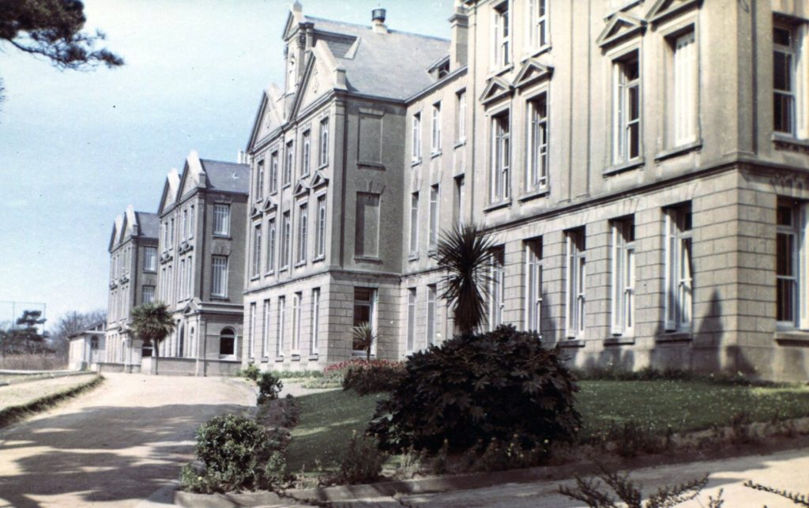

**Bon Secours in Jersey**

1. Beyond appearances, Br. Alpert had a naive and profound spirituality at the same time. “In Jersey he left the memory of a sincere devotion and a deep religious life. This nervous Brother from the South edified us in the chapel with his great meditation: he spent a lot of time on his knees motionless. Even outside of community prayer exercises, after work, he was often in the chapel to recite the rosary or walk the Stations of the Cross.” For him prayer was very simple: a time devoted to God, full of love, without fear of repetition, without the effort of deep reflections, but a time of love with a child's heart. Indeed he had been a little disoriented by the post-Council abolition of traditional prayer practices: “No more Corpus Christi processions, Eucharistic Adorations, Rosary, Stations of the Cross... Will disappear does she have faith? How to replace all of this? How to increase FAITH (underlined)?”

SMALL CONCLUSION

Two episodes through which we can see the joyful humility and naive “holiness” of Brother Alpert.

* *“Brother Célestin-Auguste, the Great Master, was always afraid that I would have taken the place at the table next to the lamb Brother Hubert, because he was convinced that I would have spoiled it. The opposite happened! It was the lamb who won, by succeeding in converting the wolf. BIBA!”*
* *“Dear Brother Donat recommended to me several times: -If any of us lack wisdom, let him ask God! I asked God for it, but I didn't get it. How to do ?"*Br. Alpert had perhaps not obtained the wisdom of men, but he certainly had found the wisdom of the little ones of the Gospel.

SOURCES: Personal file of Brother Alpert Oxibar and Correspondence (Archives R) HE SAINZ: VIDAS MENESIANAS pp. 21-28/ Brother Hubert Marie: My memories of Brother Alpert-José (Pedro Oxibar)