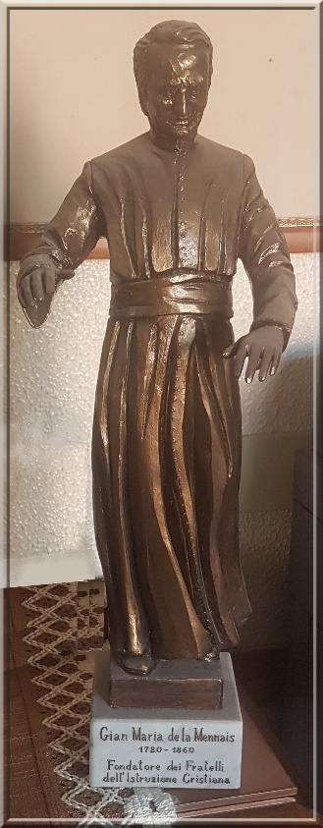
MENNAISIAN NOVENA
DECEMBER 2025
Pilgrims on the Path of Fraternal Life

- NEWS FROM THE APPLICATION

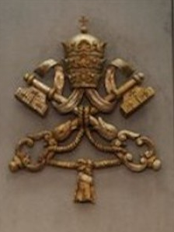
The Current Objective of the Postulation is to obtain Five or Six Expert Opinions from Physicians Highly Regarded by the Dicastery for the Causes of Saints. Those Opinions, which support the Scientific Inexplicability of Enzo Carollo's Healing, would be presented to the Secretariat of the Dicastery in order to Reopen the Investigation into the Explicability of Enzo's Healing, which occurred in Buenos Aires in 2006. In addition to the Five Opinions we currently have, Two more would be submitted: One by Dr. Chiodi, a Pediatrician, Pulmonologist, and Infectious Disease Specialist (specialties relevant to Our Case); and the Other by Dr. Gandolfini, a Neurologist and President of the Italian Catholic Physicians Association, who had already been contacted by the Postulators, Brothers Delfín Lopez and Gil Rozas. He had agreed to write his Report, which would undoubtedly be significant. We always have a Certain Impatience to reach the End, but it was necessary to prepare Ourselves well in order to do Our Part in the Work of Providence and arrive at the Medical Commission with Abundant Documentation.
Regarding the recognition of the Sanctity of Our “Heroic” Brothers, we have conducted fairly Detailed Research on some of them. What was needed to be developed was the “Renown of Holiness” of those Brothers: we must collect their Memories and Expressions of Devotion, commemorate Important Dates, and maintain the Places where they Lived and Died, and Print Images and Prayers. That was a Work to be undertaken everywhere, but particularly in the Provinces Involved: Brother Cardinal (Canada, Rwanda); Brothers Hyacinthe and Arthur (America, Haiti?); Brother Constantin (USA, England…); Brother Zoel, Brother Lucien Séveno; Brother Florien Le Boterff, and many others (France). We thank the Brothers who, would have the Time and Resources, could dedicate themselves to that Valuable Work.

- Prayer Intentions through the Intercession of the Father
Following the Beautiful Program organized for the Great Novena in November by the Brothers leading the Prayers in the Communities, we continue Our Prayer. In December, we remember Our Two Founders: Jean-Marie de la Mennais, who died on December 26th, and Gabriel Deshayes, who died on December 28th. Let us Pray for:
- The Brothers and their Families in Countries suffering from Political Instability, Armed Conflict, Violence, and Humanitarian Crises, in particular: Haiti, South Sudan, the Democratic Republic of Congo, and Tanzania; and also the Brothers of the Mission in Timor-Leste
- The Brothers, the Daughters of Providence and Lay People in vulnerable situations; for Retirement Homes, Centers of Prayer and Offering
- Patients reported to the Central Postulation Office: F. Alberto, M. Stéphane, Anna and her two disabled sons, a Vulnerable Family: father C. and mother M. with Cancer; Graziano: Young Husband (Cancer); Sergio: Lymphoma; Lazo Flores and Léanna Rubinos (Philippines): Leukemia
- The Sick People reported by the Local Organizers

- Favors attributed to the Intercession of Father de la Mennais
IN BRITTANY: SAINT ANNE REFERS THE HEALING TO FATHER DE LA MENNAIS
It was a Duty of Gratitude to make known the following fact to those who are interested in the Cause of Our Venerable Father de la Mennais. Around Mid-August 19…, I received a Letter from my Mother, recommending that I intercede through Our Founder, in order to obtain a Favor from him.
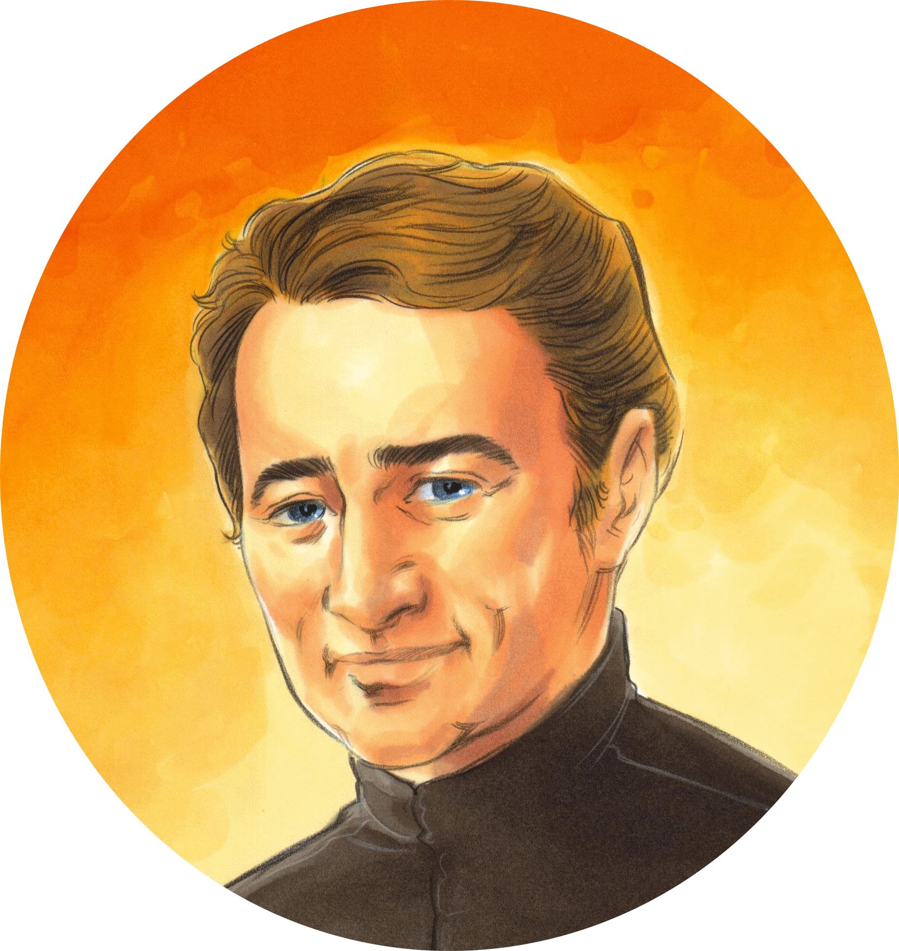
“Your brother and sister-in-law“,” she told me, “after consulting Doctor X, who declared that the Legs of your Little Nephew Marcel, aged two, were too weak to support him, they went to Sainte-Anne and brought the Child condemned by Human Science. Your two sisters accompanied them and prayed for the same Intention, but Our Good Mother, Patron Saint of the Bretons, remained deaf to their Supplications.”
In the First Days of September, I wrote to my brother, Pierre Pérot, and my sister-in-law, Honorée Vaguet, who lived in the Village of La Mormazière, in the Commune of Guilliers (Morbihan). “Since Saint Anne has not seen fit to answer Your Prayers directly, she urged you to approach Our Venerable Father de la Mennais with confidence and perseverance. He was eager to perform Miracles, and Many Favors have already been obtained through his Intercession. I am sending you his Image, on which was inscribed a Prayer asking God for his Beatification and Canonization. You would recite that Prayer Three Times a day and place the Image under the Child's Pillow. For my part, I would pray with you for Nine Days, and we would certainly be heard.”
Two Thousand Leagues away from the Little Being for whom I united my thoughts with my family, what Joy it was to learn that on the First Day of the Novena, Little Marcel had, leaning on it, walked around a Bench placed near a Table. On the Last Day, he didn't need that support; he left it and went, to his Mother's Great Astonishment, to play in the Street with his four-and-a-half-year-old sister. Now he run and reasoned like a Grown-Up.
Thanks to Our Venerable Founder. May my Nephew one day become a Member of his Congregation and make Great Strides on the Path to Perfection.
Brother Pierre-Alphonse
Note: The Account of that Favor demonstrates the Close Bond between the Brothers and the Sanctuary of Saint Anne of Auray, the Great Patron Saint of Brittany. The Story of the Apparitions of Kerio confirms the Brothers' Devotion to Saint Anne and the Special Protection of the Mother of Mary over Brittany in general and over the Brothers in particular.

- JUBILEE YEAR OF HOPE: THE SANCTUARIES OF THE VIRGIN AND THE MENNAISEIAN CONGREGATIONS

THE "FAMILY" SANCTUARY OF OUR LADY OF KERIO (NOYAL-MUZILLAC, MORBIHAN, FRANCE)
APPARITIONS TO JEAN-PIERRE LE BOTERFF
WITH LITTLE PIERRE BOULARD (September 10th -16th, 1874)

Part 1: THE STORY: A SIMPLE AND FAMILY-LIKE APPEARANCE
THE BEGINNING: SEPTEMBER 10th, 1874, KERIO VALLEY, NOYAL-MUZILLAC
Thursday, September 10th, 1874. In a Village in Brittany, Three People were working in a Sloping Field, enclosed by Embankments. They were cutting Millet, a Hardy Grain used for Animal Feed. We were at the Boulard Farm, in the Commune of Noyal-Muzillac, in the Eastern Part of the Morbihan Department, a few kilometers from the Sea and Nine from the Mouth of the River...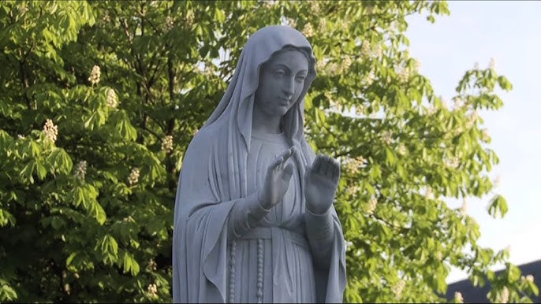Vilaine. “The Region was cut by Deep Valleys and enjoyed a Temperate Climate and a rather Picturesque Setting.” (Y du Menga. Apparitions of the Virgin in Brittany, Rostrenen – quotes to come: YdM) “From a Religious Standpoint, it had remained profoundly Christian.” (YdM) Indeed, scattered throughout the Territory, Several Chapels had been built, largely dedicated to the Virgin Mary. “In the Evenings, especially during the Autumn and Winter, the Rosary was recited as a Family, as was the Custom in the Breton Regions since the Missions of Father de Montfort and his Successors.” (Bro Théodore Volant, Our Lady of Kerio in Noyal-Muzillac, Muzillac 1992)
The Three People were Madame Boulard, the Mother of the Family who owned the Farm, her Aunt, the Widow Dréno, and a 17-Year-Old Boy, Jean-Pierre Le Boterff, the Farmhand. Let's take a closer look at him, as he would be the Main Protagonist of Our Story. “Who was that Young Man? He was Jean-Pierre Le Boterff, son of Jean-Marie, a Miller's Boy, and Anne Noyale Le Borgne, already a Mother of Three from a Previous Marriage. Two more Children would later be born. Jean-Pierre was born on October 15th, 1857, in the Village of Boisgestin (in the Commune of Noyal-Muzillac) and was baptized the same day. “He was an Excellent Sort: Kind, Affectionate, Obedient, Pious, not at all a Liar, and Very Simple. “(YdM) He attended the Local Primary School, run by a Brother from Ploërmel. He didn't seem particularly gifted Academically, partly due to his Chores around the House. Around the Age of Twelve, he received his First Communion with Great Piety. “Didn't people say, when they saw him praying in Church: 'He prays like an Angel!' People loved his Kindness and Frankness; he was always ready to help.” (Bro. Théodore)
After his First Communion and attending School, he was placed as a Farmhand with Jean-Marie Boulard, who farmed the Field at Kério. He gave his Master complete satisfaction, being courageous in his Work, Never Complaining, Always Happy, and Loving to play with Children. Indeed, he was very fond of Little Ones and played with them like a Child: he retained his Childlike Naiveté and nurtured his Natural Qualities, as well as his Piety. At Church, he edified everyone, and during the day he loved to Pray. “Going to and from the Fields, he always walked a little ahead or behind the others, holding his Rosary in his Hand, which he tried to hide in his Pocket. And his Rosary was rather large!” (YdM)
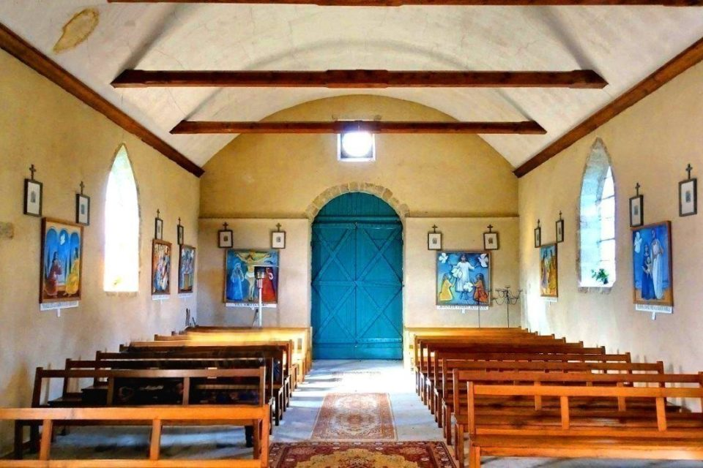
Chapel of Our Lady of Kerio

FIRST APPEARANCE: SEPTEMBER 10th, 1874, in the Morning
Let's return to the Morning of Thursday, September 10th, 1874. Our Three Workers were at their Tasks: Madame Boulard, her Aunt, the Widow Dréno, and the Young Servant, Jean-Pierre Le Boterff. They were cutting Millet in the Field at Kério, below the Village. Everything seemed to be going as usual. But that Morning there was something unusual.
Contrary to his usual habit, Jean-Pierre frequently interrupted his Work to look in the direction of the Valley of Oaks, towards a Grove. Something intrigued him, but he didn't dare speak of it. Around Ten O'clock, however, he made up his Mind: "Oh, the Bourgeois Woman! Look! Don't you see anything over the Oak Tree there? A Beautiful Lady all in Gold!"
-You're dreaming, Jean-Pierre!
The Two Women, having raised their Heads and seen nothing, began to laugh. Yet, the Young Man returned to the attack from time to time:
- But look, there she is! Let's go and see her!
- I think so!... Bah!... You're bothering us. Go get a Job. Everyone would laugh at you if you started telling Stories like that!
- But come on, let's go see her!
No one answered him. Around Eleven O'clock, the Two Women left to prepare the Meal. Once alone, Jean-Pierre felt compelled by an Invisible Force. He tucked his hat under his arm and ran towards the Valley, in the direction of the Lady.
The Farmhand would repeat the Story of that Encounter many times:
“The Lady wore a Blue Dress, strewn with Stars, a Silver Crown at the end of her right sleeve, a Golden Cloak, but I could not see her Feet, her Hands, or her Face. [Or were they too dazzling?] The Lady began to speak to me:
- Come, my Child, do not be afraid! I am the Mother of God. Pray much, for I could no longer support my Son's Arms. Next Sunday, take your Father and Mother, or someone from your Family, with you. You would go to Sainte-Anne d'Auray to pray for Brittany. You would recite as many Rosaries as there are Beads on your Rosary. And you would make that Pilgrimage Barefooted, except in the Towns and Villages.
- But I couldn't, my Feet would hurt!
- No, I would put something under your Feet and you would not be hurt. I also ask you would come and Pray here until I tell you otherwise, if your Masters do not object.” (Bro. Theodore)
Meanwhile, they were waiting for him at his Masters' House. “Mr. Boulard asked his wife:
- Where has the Servant stayed? Why isn't he coming to eat?
- Oh, he's "Flying" in the Valley. He said he saw a Beautiful Lady near the Big Oak Tree.
Jean-Pierre arrived shortly after, looking sad and pale. He was asked:
- What worries you?
- All Afternoon, I would walk barefooted, Rosary in Hand.
- Why was that, Jean-Pierre?
- The Lady asked me… But, what was Brittany?
(Like many of his Compatriots, the Young Breton didn't even know the Name of his Country).
That Evening he told his Mother, and her alone, what had happened to him during the day. He asked her to accompany him to Sainte-Anne d'Auray: “I won't tell Papa, he'd laugh at me; but please come, Mama!” Jean-Pierre showed a remarkable openness to the Virgin's Will.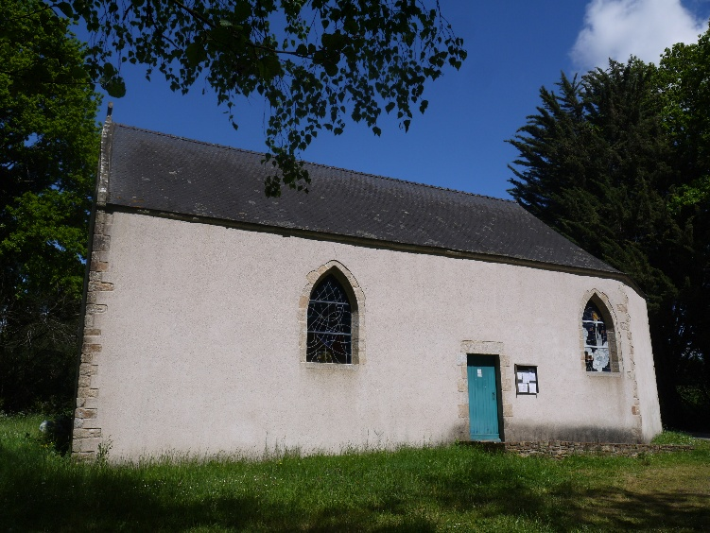
Chapel of Our Lady of Kerio
To go barefooted, to undertake an Incredibly Long Journey (86 kms), to make a Pilgrimage to a Virtually Unknown Place, with only his Mother for support and company…! That was the Trusting and Simple Faith of the Humble! That Day—it was a Thursday—and the following Two Days, Friday and Saturday, the Young Servant went to the Valley of “his Virgin,” hoping to see her, but above all to prepare himself Spiritually for the Great Pilgrimage. “He prayed for Sinners and the Souls in Purgatory, to answer the Desires of the “Mother of God,” as the Beautiful Lady had called Herself. The Beads of the Rosary slip through his fingers. It was with regret, when Night feel, that he returns home.” (Bro. Théodore)

THE PILGRIMAGE TO SAINTE-ANNE D'AURAY:
FROM SUNDAY, SEPTEMBER 13th, 5 PM, TO MONDAY, SEPTEMBER 14th, 5 PM
On Sunday Evening, the Eve of the Feast of the Exaltation of the Cross, after a Visit to the Valley, as the Angelus Bell rang, Jean-Pierre, accompanied by his Mother, set off for Sainte-Anne d'Auray (Keranna). He took off his Shoes at the Kerdréan Mill, just outside Noyal-Muzillac, faithful to Mary's Instructions. That Pilgrimage was a True Way of the Cross. They had to walk about Forty kilometers Barefooted, on Country Roads, through Dust, Pebbles, and Mud. Only with the help of the Blessed Virgin was the Young Man able to make relatively quick progress and overcome the Pain that returned with each step. His Mother also made her Share of Sacrifice, supporting her Son in carrying the Cross. Like in the Passion of Jesus, they were Thirsty. “Arriving at the Village of Kéruel, Jean-Pierre said to his Mother: 'Isn't there a Fountain around here?'”
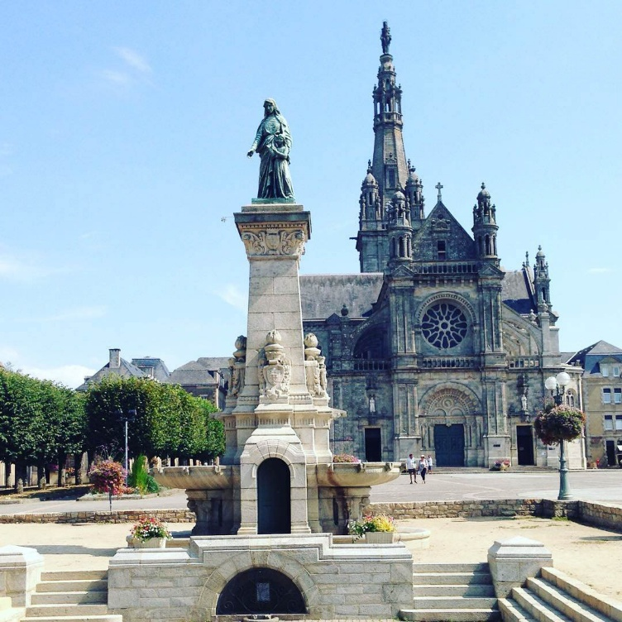- There it was on Our Right, look and drink, if you are thirsty.
Statue of Saint Anne in Sainte-Anne-d'Auray
Leaning over the Fountain, he and his Mother saw a Beautiful Light that shone on them as brightly as a Full Moon. “That Light would precede them to Sainte-Anne. The Pilgrims set off again, still in Prayer. Rosaries are passed one after another. They prayed for Brittany and for the Souls in Purgatory.” (Fr. Théodore) Following the Virgin's Invitation, they recited “as many Rosaries as there were Beads in their Rosary.” It was a Long Chain of Hail Marys’ that Jean-Pierre began, to which his Mother responded. During the Night, they passed through Towns and Villages, in the Silence of the Inhabitants, broken only by a few cries of Animals and the Gentle Repetition of the Marian Prayer. They passed by, without stopping, Small and Large Towns and Villages. One could assume they had taken the Shortest Route, passing through Moulin de la Cadillac, La Trinité-Surzur, Theix-Noyalo, and St-Léonard. They passed the City of Vannes, then took the More Solitary Roads of Béléan, Coete-Sal, Mériadec, and Kerhouil. It was still dark when they approached the Imposing Silhouette of the Basilica of Sainte-Anne. Finally, they arrived at the Goal of their Pilgrimage: the Splendid Sanctuary dedicated to the Mother of Mary, the Venerated Patron Saint of Brittany. It was Monday, at Four O'clock in the Morning. They had walked without stopping for about Ten Hours!
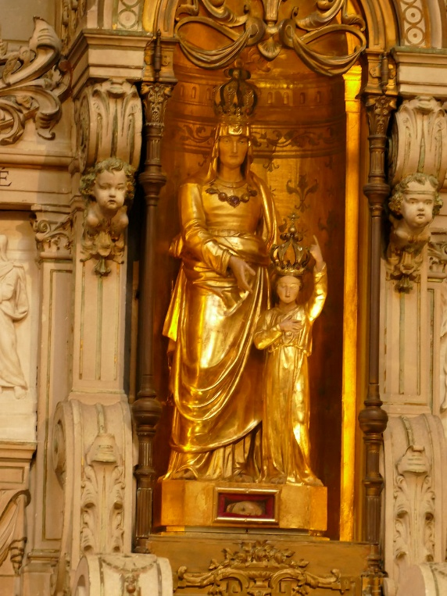
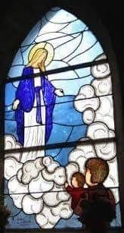

They immediately turned to the Sanctuary and attended the First Mass of the Day. That day was September 14th, the Feast of the Exaltation of the Holy Cross, in connection with their Stations of the Cross Pilgrimage requested by the Virgin Mary. “But Jean-Pierre, having not yet Confessed, did not dare to receive Communion, much to his regret.” (YdM) After participating in Holy Communion, the Two Pilgrims went to the Chapel on the Right where the Holy Mother of Mary, Saint Anne, was Venerated. As the Blessed Virgin had asked, they prayed for Brittany at the foot of the Altar dedicated to her Patron Saint. They joined many faithful who prayed fervently for Material and Spiritual Graces before the Small Statue of the Mother of Mary and Grandmother of Jesus. It had been rediscovered by the devout Saint Yvon Nicolazic, following the Instructions of Saint Anne, who had appeared to him and asked him to create a Place of Prayer in that Space. That year, 1874, marked the 250th Anniversary of the Apparitions and the Rediscovery of the Small Sacred Statue. Jean-Pierre and his Mother prayed fervently for their Family, for their Personal Needs, and especially for Brittany, as the Virgin had recommended to them in the Kério Valley. Why that Insistence from Mary, the Mother of God, on Brittany? Let's try a First Explanation. The Sanctuary of Saint Anne d'Auray was the "Spiritual Center of Brittany," the Living Soul of that Region, particularly faithful to its Roots and Christian Traditions. Did the Virgin already foresaw the Danger of a trend that would have set aside faith and separated the Christian Religion from the State, distancing it from all its Public Institutions, in the name of Secularism? In any case, the Virgin Mary had her Reasons, and Jean-Pierre was carrying out what she had told him, even though he didn't even understand what the Word Brittany meant.
“Their Devotions finished, around Seven O'clock [in the Morning] they began their Journey home. The people who saw them passed loudly expressed their admiration for that Young Man, walking barefooted, Rosary in Hand. The Soles of the Mother's Shoes were completely worn out, and she had to walk on her Stockings. But neither of them felt the Slightest Fatigue, despite having covered Eighty Kilometers in Twenty-Four Hours.” (Bro. Théodore) Their return Journey was certainly more peaceful. The Road was clear, and the Sun warmed that Early Autumn Day; their Hearts were light, having faithfully fulfilled the Duty requested by the Virgin; they were also encouraged by the people who admired their Faith and Courage. Finally, they arrived in Noyal-Muzillac at the same time they left: when the Bells rang for the Evening Angelus. They were certainly tired, but an Inner Strength had sustained them throughout their Pilgrimage. Jean-Pierre still had the Energy to go to the Valley. “He would pray once more for the Intentions the Virgin entrusted to him. But that night, She did not come to thank her Faithful Servant. However, he was very happy. He had fulfilled his Mission. The fact that he completed that Pilgrimage of more than 80 km in one go and without fatigue was for him Undeniable Proof that it was indeed the Virgin who appeared to him, who spoke to him, who took him as her Servant, who entrusted him with a Mission for his Country near the Patron Saint of Brittany.” (Br. Théodore)

SECOND APPEARANCE: Wednesday, September 16th, in the Afternoon
In the following days, the Young Farmhand resumed his Usual Work, but his thoughts remained with the Beautiful Lady. He hoped to see her again, to receive an Answer for the Service he had rendered her by undertaking his Long Pilgrimage. On Tuesday, September 15th, the Feast of Our Lady of Sorrows, Jean-Pierre went to the Valley and prayed, but the Virgin did not appear. On Wednesday, September 16th, probably in the Afternoon, at the end of his Workday, he went to the Oak Tree, carrying in his Arms Little Pierre Boulard, a Child of the Farm Family, who was not yet walking. “That Time the Lady was there, ravishingly Beautiful, full of Light, and Jean-Pierre saw her gentle face and her hands!” (Br. Théodore) The Apparition was brief; Mary did not speak to him, she simply smiled at him. She also smiled at the Little Child, for he gestured as if he too saw the Virgin: “He kept his gaze fixed on a point toward which, with his little hand, he wanted to direct Jean-Pierre’s gaze. Back at the house, he took his First Steps. Many times, he repeated, ‘Mama, there!’ pointing toward the Valley as if asking to return there.” (Br. Théodore) The Accounts emphasize that he took his First Steps as a Singular Intervention by the Virgin. Certainly, it was also a Symbolic Gesture: the Virgin helped one walk in the Divine Will; and she did so through an older brother who teaches the little ones to walk in Faith.
That was the Second Appearance.
That Day had already been filled with Extraordinary Events, all unfolding in a Family Atmosphere. And yet, the Virgin had other Missions to entrust to her Faithful Young Servant.

THIRD APPEARANCE: SEPTEMBER 16th AROUND 7 PM
“In the Evening, at Seven O’clock, near the Large Oak Tree where She appeared, Jean-Pierre prayed. The Mother of God appeared to him. That Time he could see her in Her Splendor.”(Or rather, the Virgin made his eyes capable of receiving Her Celestial Light). He recounted: 'She stood at Eye Level; when she removed her Veil, my Eyes were dazzled by such Beauty.' She spoke to him:
- Thank you for your Faithfulness in fulfilling all my Recommendations. You would not see me here again. Continue to pray and do Penance for Sinners.
- But I would need a Sign, otherwise no one would believe me and I would be laughed at.
- Miracles would be the Sign for it. Those who do not believe would not benefit from my Protection.” (Bro. Theodore; YdM)
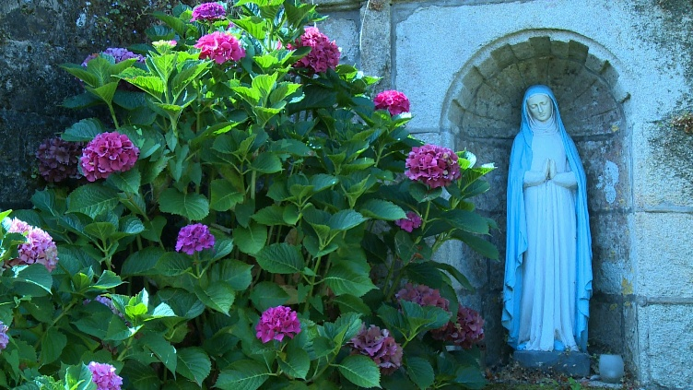The Young Farmer realized that those Small Family Apparitions were coming to an end. As in all Apparitions of the Virgin, the Sweetness of that Special Moment was veiled by a Poignant Nostalgia. He continued to ask his Beautiful Lady questions, as if to prolong their Dialogue. The Virgin continued to reassure him and appointed him her Representative, entrusting him with Important Messages for Important People. "Despite his emotion, he asked many Questions. Mary answered them all. Then she added: 'Many people would come to pray to me here. They would not see me, but I would be there, Invisible, Listening to them; I do not promise to grant all their Wishes, but none would leave without feeling relieved.'" (YdM-Bro. Théodore)
It was a Common Occurrence for the Blessed Virgin to bestow God's Blessings upon the Places and People where she had left her Presence. However, in accordance with her Custom, she acted in Conjunction with the Church, through the Approval of the Bishop of Vannes and the Rector of Noyal-Muzillac, who were the Hierarchical Representatives of Jesus of that Parish. “She entrusted to him, for his Confessor [Father Balet, Vicar], Several Secrets that the latter must transmit to Bishop Bécel of Vannes.” (YdM-Br. Théodore) Finally, the Virgin spoke directly of Jean-Pierre's Vocation. She revealed to him the Call that her Son addressed directly to that Young Man who possessed the Openness of the Children of the Gospel, but who had not yet given a Concrete Direction to his Life. “She exhorted him to enter the Brothers in Ploërmel; that was the Desire of her Son.” (YdM-Bro. Théodore) That Vocational Call could be seen as Natural: the Congregation of the Brothers of Christian Instruction of Ploërmel was the Most Widespread in Brittany, present in almost every Town; the Brother's Vocation was perfectly suited to the Young Servant who got along so well with Children and could be of Great Service, even if he hadn't had a Very High Level of Education; above all, he was Very Humble and Pious, according to the wishes of the Founders, Jean-Marie de la Mennais and Gabriel Deshayes. Nevertheless, the fact that the Virgin Mary named and designated the Institute of the Brothers of Ploërmel was a Sign of Trust and Protection. That Exhortation from the Virgin was heeded by Jean-Pierre, who became Brother Florien-Marie, and also by the Little Child he held in his Arms during the Second Apparition: Little Pierre Boulard became Brother Pierre-Edouard, a Missionary in Haiti.
After all that came the Moment of Departure: “The Virgin bowed before him in Farewell, then she disappears.” A Very Simple, Very Domestic Conclusion to the Apparitions, without any dazzling displays of Signs or Heart-rending Farewells. Everything returned to an Inner Simplicity, like a Family Goodbye.
The continuation of those Appearances, which we would call the Kerio Apparitions, were in line with the Simplicity and even Fragility that characterized its Unfolding.
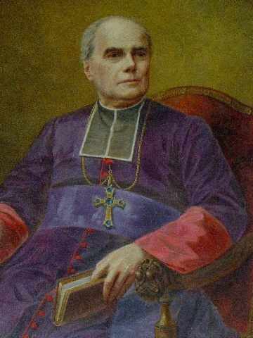
“The Next Morning, Jean-Pierre went to the Presbytery to give his Confessor, Father Balet, the Vicar, and the Message he was to deliver to the Bishop. As soon as he began to speak, the Vicar stopped him and said:
Bishop Becel of Vannes
- You're speaking in Latin!
- I don't know, I'm telling you what the Blessed Virgin told me to tell you about His Lordship.
He continued his Story, and then when he had finished, Father Balet added:
- Repeat what you just told me often, so you don't forget it.
His Mission completed, the Young Man returned to the Farm to resume his Work. The Rector, Father Corric, no doubt a little annoyed at not having been chosen as the Messenger, seemed unaware of what had just happened in his Parish.
The Account was rather Naive and raised some Questions: a Message in Latin that Jean-Pierre certainly didn't understand [a bit like Bernadette at Lourdes didn't understand the Message of the Immaculate Conception]; a Message that should be important, but which received no follow-up from the Bishop, at least apparently; a Parish Priest who let such an Important Event, which had been Confirmed in his Parish, go unaddressed for Trivial Reasons. In any case—as often happened with Marian Apparitions—what seemed to be considered Unimportant or Relegated to Silence and Oblivion returned with Force, bearing an Abundance of Spiritual Fruits and Graces of every kind.

(Story to be continued, next Novena)

