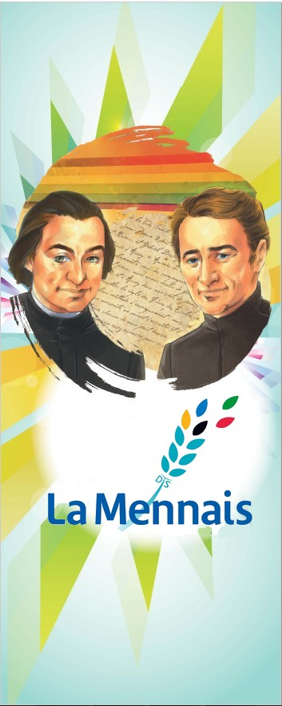**POSTULATION NEWS**

**MENNAISIAN NOVENA**

**DECEMBER 2024**

***CAUSE OF FATHER DE LA MENNAIS***

The Experts are now agreeing among themselves and reaching a conclusion. We have the impression that they are proceeding very slowly, but we must also know:

* That they continue their Ordinary Work in Hospitals where they have Positions of Great Responsibilities;
* That they refused a Financial Contribution to study the Case and draw up a Report: Their Work is voluntary and “in favour of the Church”.

***A little News***: from time to time, I contact Mrs. Josette Poulain by telephone. She was in Good Health and prays fervently using the Rosary that was given to her. A “Conversion” for her who was far from the Faith.

***CAUSE OF FATHER GABRIEL DESHAYES***

The Postulator asked the Dicastery for the Causes of Saints if it was possible to unite in some way the Causes of Our Founders, Father de la Mennais and Father Deshayes. The Answer was Negative: Each of the Two Causes must follow its Own Path, especially since they are at a very Different Stage of Advancement. Nevertheless, the Postulator of Father de la Mennais was contacted by Father Brient, the current Referent for the possible Introduction of the cause of Father Deshayes, and he put himself at his disposal to help him in the Canonical Procedures and in contacts with the Officers of the Dicastery for the Causes of Saints in Rome.

***INTERNATIONAL CONGRESS OF POSTULATORS (ROME)***

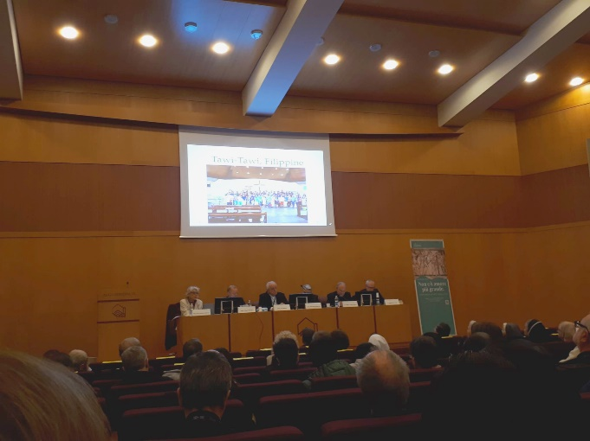From 11th to 14th November 2024, the International Congress of Postulators took place in Rome, at the Vatican, on the Theme: “There is no greater love than to give one's life: Martyrdom and the offering of life in the causes of the saints”. Following the Reports of the Experts and the Beautiful Testimonies presented, we could retain Some Conclusions:

* Martyrdom in Odium Fidei could be extended in Odium to other Virtues linked to the Christian Faith, in particular Charity
* In the New Way of offering life, there must be:
  + Direct Link between the Act of Charity and the Death of the Servant of God;
  + Awareness of Danger and Voluntary Offer of Life;
  + A Brief Time between Charitable Action and Death;
  + The Exercise of Christian Virtues at least to the Ordinary Degree: The Heroic Degree is not necessary

From that follows - in View of the Introduction of the Cause of Beatification, but also as a Fruitful Witness - the Duty to preserve the Memory of the Persons who have left Particular Traces of Holiness: Preservation of Documents, Diffusion of their Knowledge, Care of Places, Objects and The Tomb. The “saints” are a Good for those who knew them, but also for the Church and the Whole World.

1. **NEWS FROM THE MENNAISEAN ANIMATORS -**CELEBRATION OF THE GREAT MENNAISIAN NOVENA

In the News sent by the Mennaisian Animators, we have noted that the Novena was well Organized and Lived in many Communities of the Brothers. Here are some Initiatives :

* + ***Philippines***: “The Postulants prepared the Mennaisian Novena with Great Fervour.”
  + ***Province NS del Pilar***: for the first time, Brothers and Laity celebrated the Novena together online.
  + ***Aguilar de Campoo***: Magnificent animated presentation of the Mennaisian School.
  + ***Kupang, Indonesia***: Mennaisian celebration of the Community.
  + ***France***: Mennaisian Evening, Brothers and Laity in the Communities, with Prayer, Sharing, Conviviality.
  + ***Dapaong, Novitiate, Togo***: Mennaisian moment during the Inter-Novitiate Session.
  + ***Man, Ivory Coast, Catholic College, Jean de la Mennais***: Mennaisian Week, Tuesday, November 26th, 8:30 a.m., Thanksgiving Mass.
  + ***Bilbao, Berrio-Oxoa***: Mennaisian Animation with the Little Ones and their Teachers.
  + ***Indonesia***: celebration for their first Mennaisian Jubilee, 25 Years of Great Hope.
  + ***Mexico, Huatusco***: visit to the Elderly by the Young Mennaisians (Movimiento Juvenil Menesiano) with a Great Deal of Joy and Tenderness.

1. **PRAYER INTENTIONS**

The Intentions that we present to the Intercession of Father de la Mennais usually concerned Children, Young People, Teachers or Parents: The World of the Youngest or those who take care of them. Let us not hesitate to entrust to Our Father the Problems, the Healings and the Hopes of the Young and even their Spiritual and Psychological Ills.

* + ***Tommaso*and Alessandro**(6 and 4 years old, Cancer)
  + ***Liliana, Anna and Caroline*** (Moms, Cancer)
  + ***Sergio, Claudio***(Dads, Cancer) and Massimo: Ictus

***Irene***, young girl : Anorexia

* + *The Intentions* indicated by your Local Animators.

1. **FAVORS RECEIVED THROUGH THE INTERCESSION OF FATHER DE LA MENNAIS**

*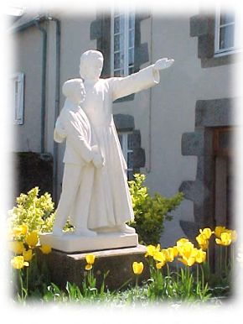****A HEALING ATTRIBUTED TO THE VENERABLE DE LA MENNAIS***

*“Barely a Month after his birth, little Raoul was seized with Worrying Ailments. He was not eating; he was vomiting; his stomach was hard and bloated. His father, very attached to the Brothers, immediately went to the nearby School, asking for Comfort and Prayers. Without delay, a Vigorous Offensive began in the Community, the Family and the Classes, the Ardour of which would only increase. Twice a day, all the Students were gathered under the Large Courtyard. They prayed with their Arms Crossed, repeating fervent Invocations, while a young relative of the Little Sick Boy would join the family and impose the Relic Image. Each one would even receive an Image of the Venerable, with Instructions to place it in full view and to remind the good Father, without fearing a familiar insistence, that there was a Cure to be obtained.*

*A very Famous Surgeon was to operate on Little Raoul. The Brother Director and a Colleague saw that Surgeon as well as the Attending Physician. On Thursday, February 11th, 1943, the Surgeon made an Incision for Appendicitis: He found that that Condition did not exist and that it was another Disease that he could not diagnose. The situation worsened. The Attending Physician announced on Friday that the Patient would not survive the day. He repeated the same prediction on Sunday. That Sunday was a day of great anxiety for the Parents. Their little one, who had not eaten since Wednesday, had taken on a most alarming earthy complexion. After Vespers, the Brothers, accompanied by a Delegation of Senior Students, went to Raoul's Cradle. Kneeling on the Floor, Arms Crossed, they all recited the usual Prayers with touching fervour. MR promises God that if He cures his child and wants him in His Service, he would gladly give him to Him. On Monday, February 15th, the child began to eat; a Noticeable Improvement appeared and became more pronounced the next day. But then on Thursday Morning, the Brother Director, in his Class with the 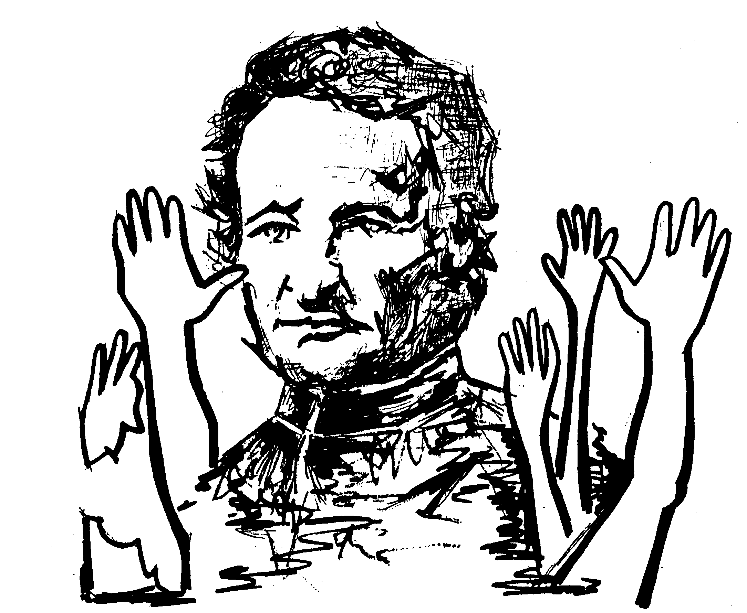Older Students, saw MR entered in Tears. Lumps suddenly appeared on the little patient's body. The Doctor called diagnosed a strangulated Hernia. It would take a 30 km transport, Anaesthesia and a Surgical Operation that made them fear the worst. The students heard the conversation. The Patient had become “their” Patient. Their trust in the Venerable One had not wavered for a Week, quite the contrary. They spontaneously suggested to the Br. Director that they would go and impose the Relic Image and pray with the family, while on their knees, on the cement of the Classroom, Arms Crossed, they would repeat the Invocations launched by one of them. On his return, the Director would find them in the same supplicating attitude.*

*Around 4 p.m., Little Raoul was taken to the Hospital, put to sleep, operated on for a Strangulated Hernia. They brought him back. He took his milk, but didn't give up anything. In a few days the lumps disappeared without Treatment. His condition improved very quickly and the little patient was able to go out. His Mother insisted on taking him to School first. What Admiring Joy the Adults had when they saw Little Raoul calm and rested in the stroller that had been brought into the Classroom. Without opening his mouth, the child eloquently preached confidence. The following days, when the Students gathered for thanksgiving, their Prayers would have Wings!*

FR-M. (Source: Jean-Charles Bertrand, Collection of Favours attributed to the Intercession of Father de la Mennais, pp. 59-60. FIC ARCHIVES)

1. **JUBILEE PRAYER PILGRIMAGE 2025**

**THE SANCTUARIES OF THE VIRGIN MARY AND THE MENNAISEAN INSTITUTES**

**2- “OUR LADY OF ALTAGRACE, THE MOTHER OF ALL GRACES: REPUBLICA DOMINICANA – HAITI**

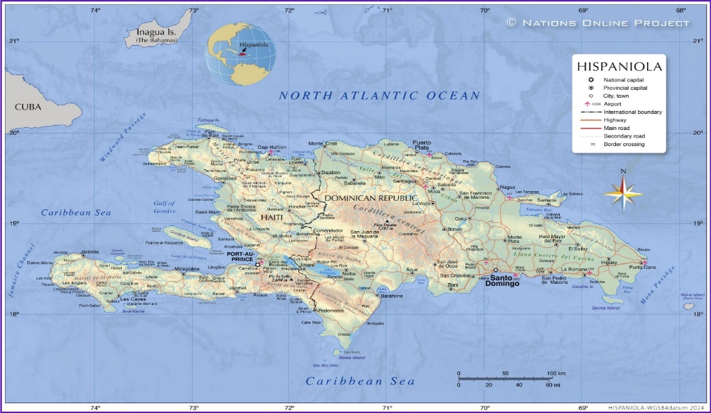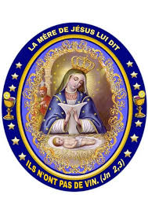

The Virgin Mary followed her Children everywhere, especially in the Most Difficult Places. Santo Domingo, shared between the Dominican Republic and Haiti, is one of the Large Islands of the Antilles. The Nature there is Splendid, but the Island is also afflicted by Serious Problems, especially in the Haitian part: Political Instability, Social Unrest, Natural Disasters. The Population has always had recourse to the Virgin Mary, whom they venerate under the Title of Our Lady of Altagrace (Alta Gracia or High Grace): “Altagrace means “High Grace”, that is to say the Maternity of the Incarnate Word, Jesus Son of God”. From this High Grace, as if from a Source, flow “Small” Graces that we implore for Our Conversion, for Peace and the Common Good of Society, for the Spiritual and Material Needs of Daily Life, for Ourselves and for Our Families. Let us try to follow the History of that Devotion, which was intertwined with History and Legend.

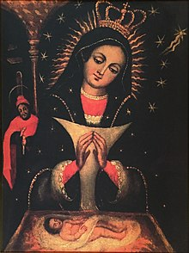

**\* THE REVERED IMAGE**

The Centre of that Veneration was a Miraculous Image kept in the Great Sanctuary of Higuey, in the Dominican part of the Island. It was a fairly thin Canvas, about a Meter High, which kept its Colours very alive. It represented the Scene of the Birth of Jesus: A Little Child lying in the Manger on the straw. The Virgin looked at Him with a Smile full of Tenderness, her hands joined. She wears a Blue Dress dotted with Stars, a Veil on her head and shoulders, surrounded by Small Flames and Twelve Stars, as well as the Comet of the Three Wise Men. On her chest she wears a Triangle of Light, a sign of her Virginity. A little behind, the Holy Family was there in its entirety with St. Joseph, who lights the Centre with a Candle. The whole scene was oriented towards the Child Jesus: because of that, the Painting was also Nicknamed the “Virgen del Niño”. But where does that Image come from? Its Origin was difficult to trace and there are many Versions. Let us relate some events that constitute stages of the transport of the Precious Painting to the Island of Santo Domingo (the Former “Hispaniola”).

**\* THE STORY OF THE HOLY IMAGE**

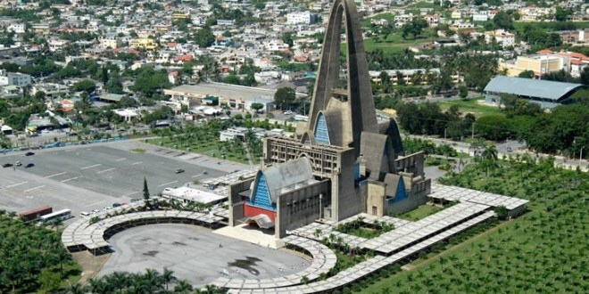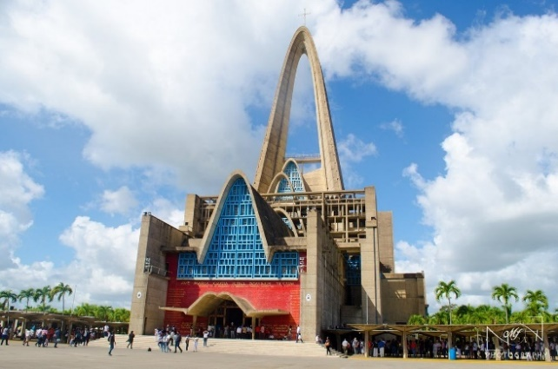That venerated Image was said to have been brought from Estremadura, a Region of Spain, by Two Merchants, the Trejo brothers, to the Caribbean Island at the beginning of the 16th Century. They are said to have offered it to the Parish of Higuey to be honoured there. Immediately, the Sacred Image gave rise to a Centre of Prayer and Evangelization. Conversions, Graces and True Miracles were verified around it. The Archbishop of Santo Domingo wanted to transport it to the Cathedral, but the Holy Image disappeared to reappear in the Parish Church of Higuey. Another Tradition reported that the Image of the Virgen de Altagrace appeared on an Orange Tree. It would be in this place that the first Marian Sanctuary in America was built. What was certain is that the Liturgical Cult in honour of Our Lady of Altagrace began on January 21st, 1569 and that it was on that occasion that a First Oratory was built, which still exists. Another important date linked to the veneration of that Patroness of the Island was January 21st, 1691. On that day, the Inhabitants, Caribbeans and Enslaved Africans, experienced the protection of the Virgin Mary in the Battle for their Freedom in La Limonade, in the North of Haiti. January 21st has become the National Feast.

**Basilica Catedral Nuestra Señora de la Altagracia in Higuey**

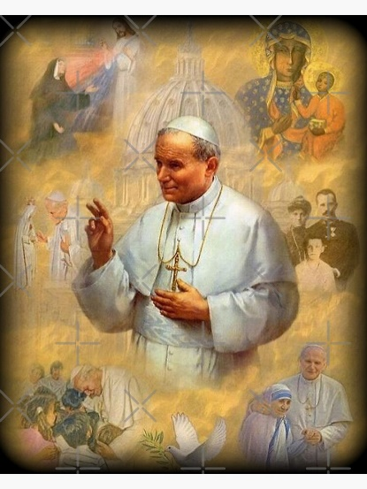In the 20th Century, a Large Park was inaugurated to make the Pilgrimage Sites more conducive to Prayer. The Pilgrimage Centre became increasingly important. Between 1954 and 1971, the current Basilica of Higuey was built, which guards the Venerable Image. It had been crowned in 1922, under the Pontificate of Pius XI. In 1992, Pope St. John Paul II, who came to visit that Sanctuary, offered a precious crown to the Virgin and Prayed thus: “Virgin of High Grace, you who are the Star of Evangelization, spread in everyone the Ardour of the proclamation of the Good News… Implore forgiveness for the Injustices Committed… Grant that the Life and Dignity of every Human Person, the Identity of Ethnic Minorities and the Legitimate Rights of the Indigenous People, the Authentic Values ​​of the Family and Indigenous Cultures, may be ever more respected.”

In Haiti too, Our Lady of Altagrace was Highly Honoured and invoked with Great Fervour. Recently a Parish was dedicated for her Special Veneration in the City of Delmas, very close to the Capital Port-au-Prince. The Institution of the Brothers of Christian Instruction, St-Louis-de-Gonzague, is present there and actively collaborates with the Parish.

**\* THE BROTHERS OF CHRISTIAN INSTRUCTION OF HAITI AND THE INTERCESSION OF THE VIRGIN OF ALTAGRACE IN THEIR HISTORY**

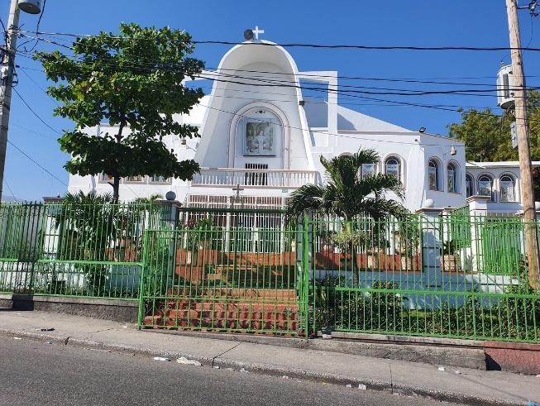In Haiti, on January 21st, the Population celebrates with Great Fervour the Feast of Our Lady of Altagrace. The Centre of that Solemn Celebration was the Parish-Sanctuary in Delmas: Novena, Prayer, Procession, Eucharistic Celebration. (…)

The Brothers of Haiti have experienced in their Long History of more than 160 years, the Maternal Protection of Our Lady of Altagrace, in many Dramatic Circumstances of their Difficult Work of Evangelization. Let us follow the Story in Three Stages, made by Brother Gérard Hautbois, a Long-Time Missionary in Haiti.

**1864-1914: THE HEROIC YEARS**

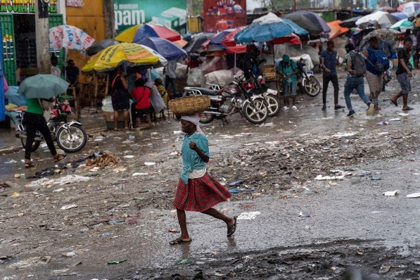In 1864, Brother Athenodore opened Two Schools with Great Effort, but he had to abandon them immediately, because of Political Unrest. In 1871, the Brothers returned: they founded other Schools. The State should provide the Premises, the Furniture, the Maintenance of the Teachers; in practice, the State often forgot the Salaries and the Brothers kept the students for free. The First Foundations of Schools were done in very difficult conditions. The Brothers lacked everything, they were poorly housed and had difficulty feeding themselves. Diseases were frequent. The Merciless Yellow Fever stroke the Brothers in 1879: In 40 days 7 Brothers died including the Principal Director, Brother Alpert; in 1882, Yellow Fever took another 8 Brothers; in 1896 another 8 Brothers. From their arrival in Haiti until 1897, 80 Brothers died from Typhoid, Malaria, Tuberculosis, Yellow Fever, Dysentery and other Diseases. The years between 1890 and 1910 were the most difficult for the FIC: Poorly Housed, in Dilapidated Premises, where hundreds of children were crammed together and barely had enough to eat. From 1897 to 1905, death took 30 Brothers, including 18 under 25 years old. Brother Pascal Libault, Director General, seeing the situation of Extreme Poverty in the Schools, the Illness and Hunger of the Brothers, the Debts that were impossible to pay off, the 500,000 F that the Works in Haiti costed the Institute, found no other solution than to close the Mission.

***OUR LADY OF ALTAGRACE INTERCED FOR THE FIRST HEROIC BROTHERS OF HAITI.***

**1914-1964: THE YEARS OF RADIANCE**

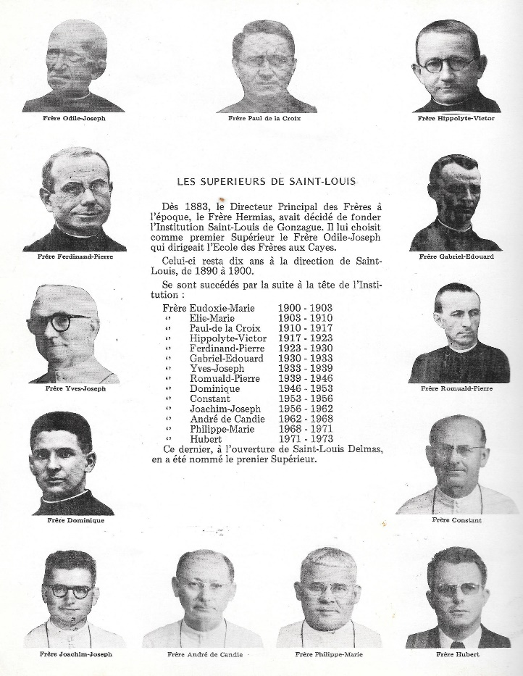Brother Odile, the New Director General, saved the Mission in 1909, when the General Chapter wanted to close it. His Dynamism and Enthusiasm, demonstrated in the Development of the Institution Saint-Louis de Gonzague, gave courage to the Brothers who expected the closure of the Mission. The situation improved thanks to the Agreements between the Superiors, Brother Archange and Brother Hippolyte, and the American Occupation Authorities (1915-1934) first and then the Haitian Government: The Salaries of the Teaching Brothers were set at $50: the Life of the Brothers was assured and the future brightened. In 1938, the Province had 131 Brothers, 22 Schools and more than 8,000 students.

Despite that Beautiful Flowering, in that Second Fiftieth Anniversary, there was no shortage of trials. 1914-18, First World War: 17 Brothers were mobilized. Several Schools had to be closed. 1939-45: Second World War. The Canadian and Spanish Brothers replaced the French at War. Much Work was done for a Local Succession: in 1956 a New Building was built as a Training House. The Seed was well prepared by the Work and Sacrifices of the Brothers.

***OUR LADY OF ALTAGRACE BLESS THE EFFORTS, THE MISSIONARY ENTHUSIASM, THE EVANGELIZATION WORKS OF THE MENNAISIAN FAMILY IN THIS COUNTRY SO GENEROUS AND TESTED****.*

**1964-2024: THE YEARS OF HAITIANIZATION**

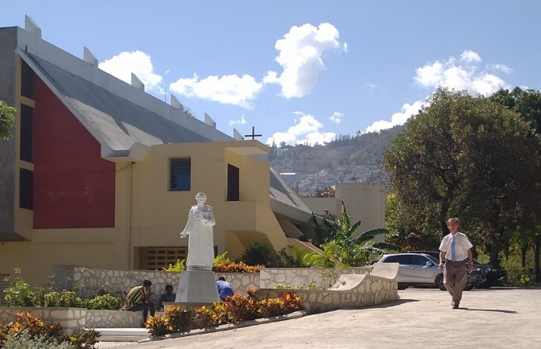The Brothers had confidence in the future, also supported by the Momentum of the Renewal of the Church under the pressure of the Second Vatican Council. They opened New Schools, a home for Aspirants to the Life of the Brothers and, in 1976, the Local Novitiate. France and Canada, in decline of Vocations, could no longer send Brothers. Nevertheless, 25 Young French Brothers provided significant assistance through the three years of cooperation carried out in Haiti. But now, the Succession was ensured directly by Local Vocations. The Postulancy and the Novitiate were established in Pétion-Ville; the Scholasticate was done in Abidjan with the Young Brothers of the French-Speaking African Provinces. The Provincials were now Haitian: Bros Serge Larose, Dufreine Auguste, Hervé Zamor. The latter was Elected Superior General of the Congregation, a sign of the confidence and the consideration of the Institute that he enjoyed, but also the whole Province.

In recent years, the Haitian Brothers have taken Direct Responsibility for Schools that have a Good Level of Education: 4 out of 8 reached the Final Year of High School. The Brothers worked hard to promote Local Culture through their National Library and the Publication of School Textbooks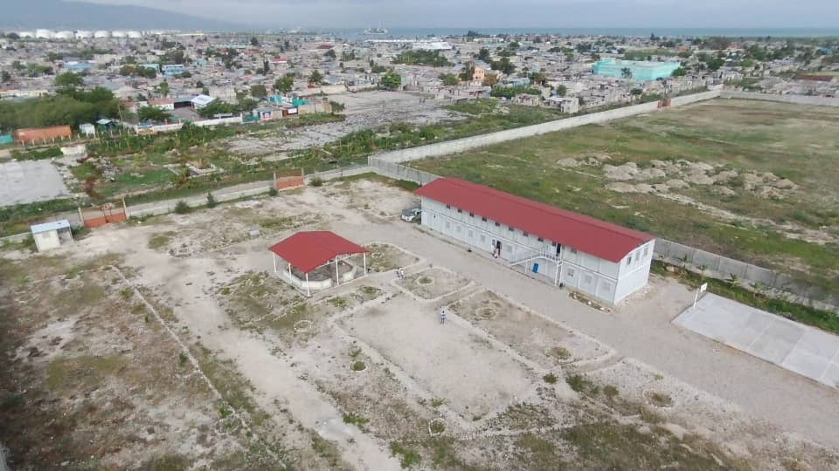 widely distributed in all Schools in the Country. They actively collaborated in Youth Ministry and Popular Evangelization. They had also opened a Centre on the Outskirts of Port-au-Prince, the Shantytown of Cité-Soleil, for the reception and Schooling of Poorer Children. Lay people were also involved in the Mennaisian Mission and actively collaborated with the Brothers.

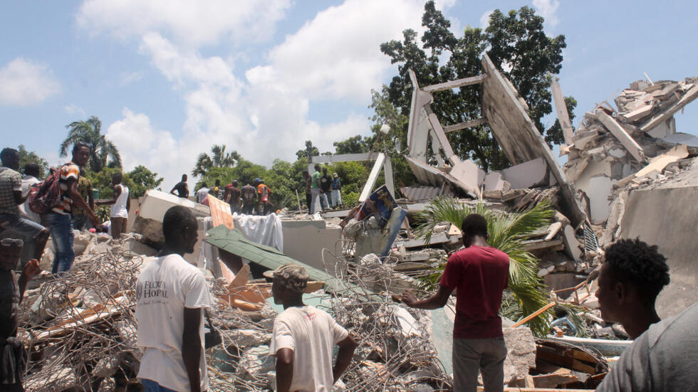During that last period, there had been no shortage of trials. They depended a lot on the Political Situation that was still Fragile and Unstable. The deplorable Economic Situation and the Leaders who were not always up to the task made that Country of 12 million Inhabitants a Favourite Target for all Adversities. In their Isolation, Haitians had experienced Epidemics and Disorders. Freedom of expression was often muzzled and Haiti became the Reign of Criminal Gangs.

In 2010, a Magnitude 7.2 Earthquake caused approximately 300,000 Deaths, including 2 Brothers. “The St-Louis School was completely destroyed, Delmas and Jacmel needed to be rebuilt, the Provincial House needed to be razed, the Juniorate, La Vallée, and Pétion-Ville needed to be repaired. In addition, Hurricanes left Ruins and Damage as they pass through.”

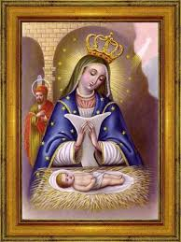In all these Trials, the Protection of Our Lady of Altagrace had allowed Haitians and the Brothers to survive, even to develop and to look to the future with Boundless Hope. “The Patron Saint who accompanied us today would accompany Our Children and Our Children’s Children because her Goodness was Infinite. We would never cease to Address Our Fervent Prayers to her in Complete Confidence because she has been Our Great Protector for more than Two Centuries.” (Lesly Condé, Former Student of the FIC of Cayes and Port-au-Prince)

***OUR LADY OF ALTAGRACE AND PERPETUAL HELP (* Title by which the Virgin Mary is highly venerated in Haiti), COME TO OUR AID, SUPPORT US IN THE SMALL AND GREAT PERILS OF OUR MISSION IN THE LAND OF HAITI.***

***SOURCES: “BROTHERS OF CHRISTIAN INSTRUCTION, 150 YEARS IN HAITI (1864-2014) Brother Gérard Hautbois***

***“BASILICA NUESTRA SEÑORA DE LA ALTAGRACIA – SANTO DOMINGO (A. DUNOYER)***