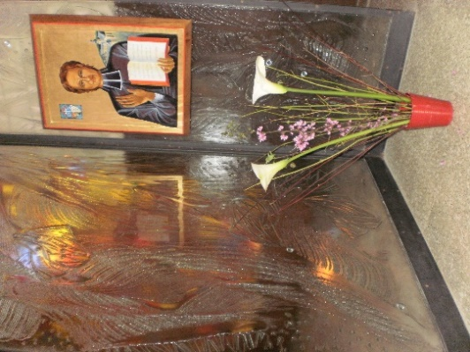
MENNAISIAN MONTHLY NOVENA
NOVEMBER 2023
- APPLICATION NEWS
We know that the Medical Commission has ruled on Josette's case, with a judgment of suspension. We wholeheartedly thank all those who worked on the study of this healing with passion and confidence : The Vice-Postulator Bro. Michel Bouvais, the Scretary Bro. Pierre Berthe, the Daughters of Providence, in particular Sr. Maryvonne Nivoit, Josette and the witnesses, Brothers, Priests and Lay people, of the Investigation and all those who prayed for the Beatification of Our Father Jean-Marie.
Now we return to the case of Enzo Carollo, who was healed in 2006 and whose Cause was studied and presented in 2016 to the Dicastery of the Causes of Saints, by Brother Postulators Delfin Lopez first and then Gil Rozas. This cure was examined by the Medical Commission and was declared scientifically explainable by five Doctors and inexplicable by two : so, we have a basis on which to work. We have taken again the file (Summarium) prepared for the occasion, very precise and complete : 835 pages ! We have submitted it for further examination by four Specialist Doctors who will study it thoroughly. The first Specialist, responsible for the sector of a large Hospital in Rome, gave us his first Conclusions : “I believe that the case of the cured child could be the subject of a more in-depth analysis by the Medical Commission, because the “child did not receive timely and appropriate therapy.” We are taking the necessary steps to take up this case according to the Canonical procedures of the Dicastery of the Causes of Saints.
We know that, among the Brothers, from the beginning of the Congregation there were some who gave a Testimony of Heroic Virtues and who left a trace of “Holiness” which has not faded. In particular we have reconstructed the Biography of two Brothers : of Br. Zoël Hamon (France 1819-1851) Devoted Master, Charity Baker, Nurse until the gift of life and of Br. François Cardinal (Canada-Rwanda 1942-1952) Missionary in Rwanda, “Martyr” of Charity.

- PRAYER INTENTIONS ENTRUSTED TO F. DE LA MENNAIS
FOR THE INSTITUTE:
- The Beatification of our Founder
- Vocations in all Countries of the Congregation
- The Next General Chapter : may it be a Fullness of Hope
- The Healing of our sick:
LOCAL INTENTIONS (by the Facilitators of each ountry)

- FAVORS RECEIVED
THE IMPORTANCE OF MIRACLES.
To proclaim a Faithful bBessed, the Church requires two conditions:
1- A holy life, lived in the Heroism of Christian Virtues – or in the offering of one's own life – or in the Martyrdom received because of Christ.
2- The Authentication of Holiness by the seal of Divine intervention through a miracle (a favor inexplicable humanly)
The Miracle does not increase the Holiness of the servant of God, but makes it authentic in the eyes of the Church and the World, at the appropriate moment, chosen by Divine Providence. Were there any miracles during the long journey of the Beatification of our Father de la Mennais? Following the reconstruction carried out by the Great Mennaisian devotee, the Canadian Brother F. Jean-Charles Bertrand, we could count more than 150 Healings of a certain weight. He collected them in a 110-page Notebook. It is from this collection that we draw the stories of these Extraordinary facts. We should increase their number through more current favors.
What is the Protocol to follow in these cases?
- Following with discretion and respect those involved in the Illness: Patients, Family, School, Parish, etc. Accompany them on a path of trust in Jesus and through the intercession of Father Jean-Marie.
- Praying publicly for this specific intention: we can use Official Prayers or more Spontaneous Formulas: there are Relic Images with a particular link to Father de la Mennais (cloth having touched his tomb).
- Prayer must be constant and of a certain duration: Triduum, Novena, one month... depending on the illness; it continues with Thanksgiving for the Material and Spiritual favors received.
- If the recovery shows signs of extraordinaryness, with discretion the family could be asked to ask the doctors for a copy of the medical file (including instrumental elements and images)
- The favor received must be reported to the local Mennaisian Brother Animator, who, if he deems it appropriate, will communicate it to the Brother Postulator. The latter may submit it for an initial informal examination either to the bishop of the diocese or to the Dicastery of the Causes of Saints. If the case is recognized as capable of being canonically examined, the Postulation will request the opening of the Trial, according to canonical rules.

AS AN EXAMPLE HERE IS A STORY OF A SPECIAL HEALING
By Brother Benedict Joseph: sight suddenly restored to a child
“I had a student, James Souva, who could not see in his right eye. Despite the remedies, his eyesight did not improve. I then suggested to the mother that she make a novena to ask for healing through the intercession of the Father, provided that she obtains a certificate from the doctor stating the nature of the illness. She eagerly agreed and took James to the specialist again. He examined the diseased eye with great care. He wrote the following statement: “James Souva is blind in his right eye. His blindness, due to retinal detachment, will persist. Vision in the left eye is normal.” After that we immediately began a novena in class, saying three Paters and three Hail Marys, with the prayer for the Beatification of Father de la Mennais, applying during these prayers a relic of the Venerable to the diseased eye. The community also made a novena. Every day, James and his mother attended the first Mass and received Holy Communion.
Towards the middle of the novena, a new complication, very likely to put our faith to the test. The eye began to swell and caused pain to the child, who had to stop attending class and only came when prayers were made for him. It continued until the Feast of the Sacred Heart, the end of our novena. Now, in the evening of that day, James suddenly declared to his mother that he saw with his right eye. At first she thought it was an imagination. However, after closing her left eye, she began to make various gestures that James described exactly. She presented him with a book and he read from a certain distance without difficulty. His sight was restored to him, despite the oculist's formal prediction to the contrary.
I admit that until then, I had not felt a very strong feeling of confidence in the protection of our Ven. Founder, not having had the opportunity to appeal in a precise manner to his credit with God. But I remained so struck by this healing, the assessment of which we leave to the judgment of Holy Church, that I would like to share our faith and our gratitude with everyone.”
F. BENEDICT JOSEPH

- THE TWO SUMMITS OF MENNAISIAN DEVOTION:
A- 1960: THE CENTENNIAL OF THE FOUNDER’S DEATH
B- 1966: THE PROCLAMATION OF THE HEROICITY OF THE VIRTUES
- THE CENTENNIAL OF THE FOUNDER’S DEATH
In the years following the war, the Mennaisian Institutes reached their numerical peak (around 2,200 Brothers). A long period of peace and regular work, the thaw between the French State and Private Education, gave new impetus to Christian Educational Works: Schools, Educational Production, Cultural Activities, Cultural and Sporting Activities. The level of studies is rising: Secondary and Pre-University Establishments, Technical Institutes of all kinds are spreading. The Courrier du Vénérable presents an overview of Mennaisian works “Cross the World” in their rapid growth. It is like a Beautiful Spring which ensures great promises of Development, thanks also to the numerous Vocations which fill the Formation Houses. In this period of great enthusiasm, the Celebration of the First Centenary of the death of our main Founder, Jean-Marie de la Mennais, increases attachment to the Congregation and the prospects for the future in the Mennaisian Institutes. In all the Countries where they are present, Solemn Events are organized: beyond the external aspect, they ensure a better knowledge of the Founder, the deepening of the Charism, the Promotion of New Vocations.
Here is a small Calendar of the most important Centenary Events celebrated around the World.
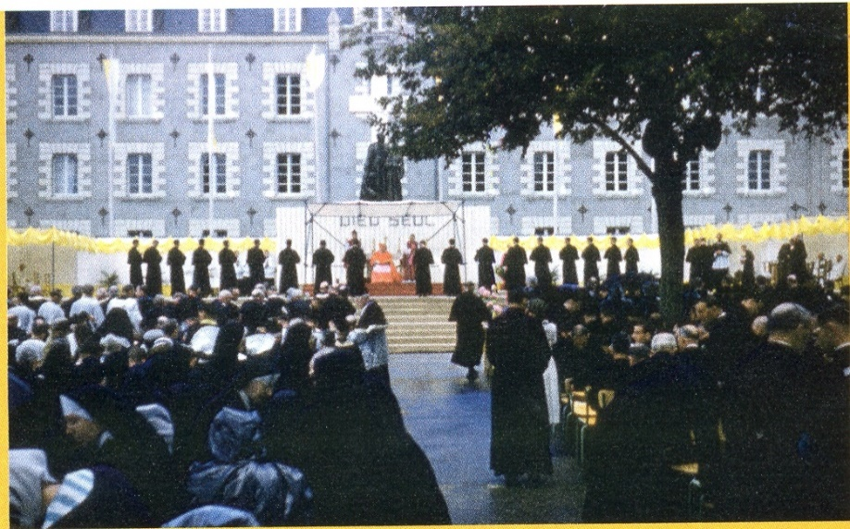
On November 26th, 1959, Ploërmel kicked off the Festivities. The Bishop of Vannes blesses the recent Constructions and the New Bells. St-Brieuc honored the Founder on April 24th, 1960: a Beautiful and Pious day, under the Presidency of Cardinal Roques, Protector of the Daughters of Providence.
On In Canada, Montreal and La Prairie, followed by the other Provincial Houses, organize rallying days for the Brothers present in North America (nearly a thousand). Present were Cardinal Léger of Montreal and Brother Elisée Rannou, Superior General.
Celebration of the centenary in Ploërmel
In each Country where the Brothers were present, the Centenary Celebrations were increasing. In South America, Celebrations were organized in Buenos Aires and Montevideo. In Africa the young District of Uganda celebrated the Centenary in Kisubi. Haiti celebrated it in Port-au-Prince, Jérémie and elsewhere. In Europe Spain, England and Italy actively participate in the Festivities. Even the small Districts of Polynesia and Japan were doing their part.
On November 27th, in Ploërmel, Mgr Bertoli, Apostolic Nuncio, presided over the Closing of the Centenary. The Speakers underlined the Spirit of Service to the Church of Father de la Mennais and his Unconditional Loyalty to the See of Peter.
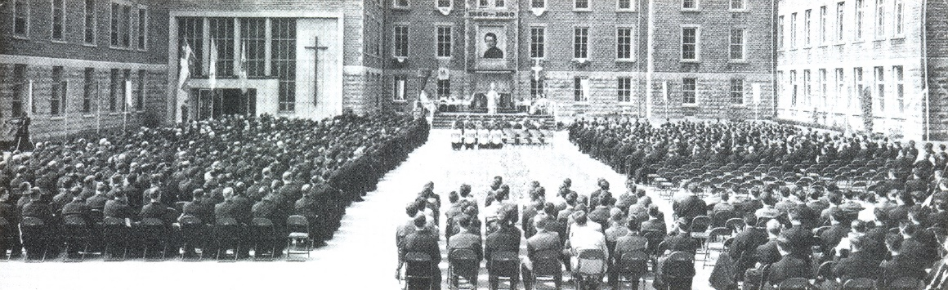
During this Jubilee Year we were witnessing a flowering of New Statues of the Father, which were exhibited outside. We also felt the need to further disseminate knowledge of the Founder. About André Merlaud is responsible for writing a new biography of the Servant of God, placing him in the historical and religious context of the time. For France, but also for the Church and for the Cultural World in general, the presentation of the Personality of Jean-Marie de la Mennais was a surprising Discovery. Everyone knew the Famous Féli Lamennais, but very few knew that he had a brother very faithful to the Church and to the Pope, Innovator in the Evangelization of youth, Candidate for the Heroicity of Christian Virtues, Brilliant organizer of Christian School, Man of action and group of deep Spirituality, “in which Humility exceeded Genius”. Merlaud, in his Interventions on the Radio, TV or in the Newspapers, compares Abbot Jean-Marie to St-Vincent de Paul, to St Jean Bosco or to the St-Curé d'Ars. The Biographer affirms that he must be pulled out of the shadowy corner where his Humility has placed him: “a hundred years after his death he is practically unknown and ignored: about his silence, he must speak to the Church and in today's World: his Message and Testimony are ever more current”. Naturally beyond this Magnificent Biography, during this year the Courier and the Chronicle published a large number of Studies on the Life and Works of the Founder: Commemoration Speeches, Specialized Articles, Biographical summaries, Anecdotal pieces by different Authors: FHC Rulon. Brother Léontin-Jean, FJC Bertrand, Brother Bernardin de Sienne…
Centennial celebration at the Prairie

The Centenary was one of the Highlights of the Mennaisian Congregations, a period of Enthusiasm and Great Perspectives, a Reservoir of Hope, which will prove precious in the difficult years to come.

- TRACES OF HOLINESS IN THE MENNAISIAN CONGREGATIONS:

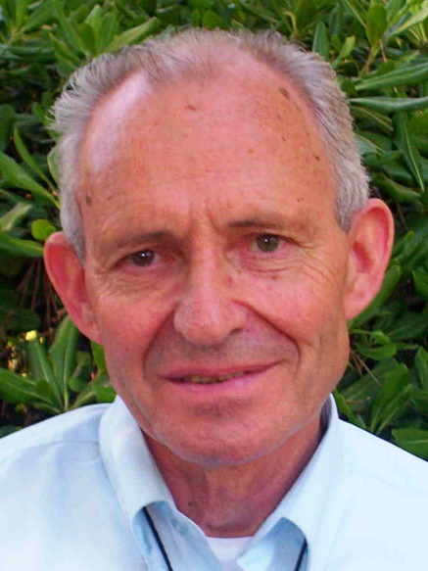
Brother GÉRARD CHATELIER (1944-2015)

The image that we will keep of Brother Gérard is that of a man whose face was lit up by a Broad Smile when he welcomed you to his Community or when you met him by chance during a Trip or a Walk. An Engaging Smile that immediately put you at ease as if you had known him for a long time. “We will remember a Luminous Person, full of Empathy, Extreme Sensitivity and Great youth of Spirit.”
Bro Gérard was born in La Chabossière, in Couëron, near Nantes. He was the youngest of a family of seven children. He was very close to his In-Laws, he was very close to his many nieces and nephews. It was in 1956 that Gérard left the family home to enter the Juniorate in Derval. In 1964, at the age of 20, he entered the Novitiate in Jersey to be a Brother. After the time of Theological and Pedagogical Training at the Scholasticate, he was placed in a Community in Nantes in September 1968. He taught a year in 6th grade, at Théophane Vénard College, at a time of Academic and Social Difficulties.
Having opted for International Cooperation instead of Military Service, he arrived in 1969, and for two years, at Didier Marie College, in Senegal. This College was Newly Opened by Mgr Dodds, the Bishop of the Diocese, and it was run by young Brothers, cooperating like him. The Classes were busy, but relations with the Fathers of the Catholic Mission were very good and the atmosphere between the four Brothers of the Community was Joyful and Fraternal. In this Country, with a very hot climate, he was able to win the goodwill of everyone, including the Muslim Community, with whom he had a positive dialogue.
On his return from Africa in 1971, Bro Gérard was appointed to the Collège Notre-Dame de l'Abbaye in Nantes, where, while teaching, he prepared for a Degree in Modern Literature. In 1977, he arrived at the Saint-Donatien Juniorate in Derval, Professor for a year, then Professor and Director following Brother Melaine Poirier. In this delicate position of Training young people, Brother Gérard was very appreciated by young people and families, listening to each other, but knowing - according to the Spirit of the Founder - to act near young people “with Gentleness and Firmness”. In 1982, he was appointed Vocations Delegate: a difficult and demanding Mission that he was able to fulfill with faith and discernment, accompanying young people with Rigor but also Delicacy, Tact and Respect. He participated in the Pastoral Animation of the Schools, investing in the Catechesis Service, in the preparation Teams for the Profession of Faith, for Confirmation, in the Animation of Recollections and Weekends offered to young people Establishments at the Abbey of Bellefontaine, at the Foyer de Charité de Tressaint or in other places. These were exhausting years, lived with little apparent results, despite great efforts. But Brother Gérard continued with complete serenity, promoting Vocations.
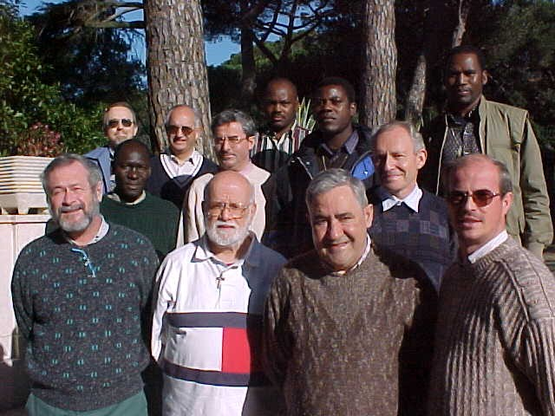
It was quite natural that the Superiors chose him in 1987 to be responsible for the Saint-Donatien Province, which included Schools and Communities of Brothers in Loire Atlantique, Maine-et-Loire, the Pyrenees and Senegal. Delicate and sometimes Complex Mission, which he assumed, for 8 years, near Communities but also Schools, which required a lot of travel, presence, listening, attention to people, without forgetting the encouragement to provide or the difficult decisions to make and which must be accepted. Mission not exempt from difficulties, from suffering when you have to help people in difficult personal choices or when you have to withdraw from places where you can no longer stay. There too the Brothers were able to appreciate his simplicity, his welcome, the respect for everyone and the way he encouraged and convinced. He knew how to train, encourage and stimulate... In these moments of great tension, of the first effects of the reduction in Vocations, he knew how to seek pacifying solutions and become close to the Brothers most affected.
Year of renovation: a group with the FF. Gerard and Merino
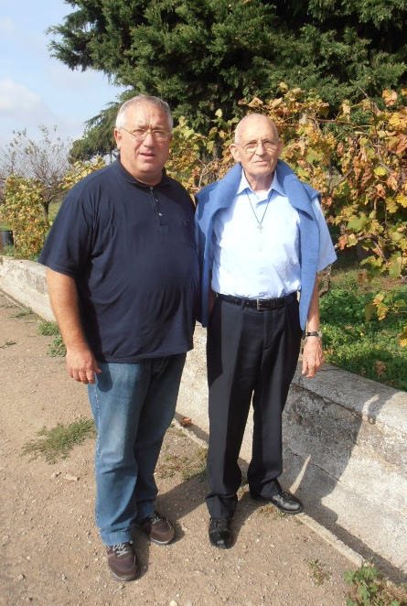
In 1995, the grouping of the 4 Provinces of France into a single Province freed Brother Gérard from his function as Provincial. He was called to Rome as Deputy Director of the Year of Renovation (a year of Spiritual Renewal offered to Brothers from all Countries) alongside Brother Miguel Angel Merino. For 9 years in Castel Gandolfo, with Brother Merino, they both formed a Perfect Tandem and complemented each other admirably. His knowledge of Languages allowed him an easy connection with the Brothers who arrived from all Continents. At Castel Gandolfo he was the right arm of Brother Merino, a Profound Theologian and Specialist in the Mennaisian Charism. Bro Gérard supported him in the shadows, providing all the services and material tasks, so as to free the Director from any worries. He always acted like this: wherever he was placed he gave himself completely, without pretending to put himself in the foreground. He taught through his life, through his example of simplicity, patience, attention to the needs of everyone. One of its tasks was the organization of Pilgrimages which were spread over the year of Renewal and nourished the Spiritual Life of the Brothers. They remained very vivid in the memory, the Pilgrimages to the Sanctuaries of the Virgin, to St. Benedict, to St. Mary Goretti, to the Basilicas of Rome. Brother Gérard had a particular devotion to St. Francis: he liked the Retreat in Assisi, the visit to the Franciscan places in Assisi and elsewhere. Bro Gérard in fact had a Franciscan Spirit: simplicity of life, humility, love for creatures, care of plants and flowers. He had a special friendship with the cats of the San Giuseppe Institute. While wild cats usually fled in front of everyone, they gently approached Brother Gérard, who played with them, and they willingly accepted the food he prepared for them. He did the same with the big cat Romeo, when he was placed at the Generalate. Naturally the most important Pilgrimage was that of the Holy Land. He organized everything perfectly. He seemed to be completely absorbed in material preparation, but he lived every moment and every place with deep Spiritual Joy, following in the same footsteps as Jesus! At Castel Gandolfo, he also very willingly received groups of young people who came for moments of spiritual Retreat. He welcomed young people with disabilities with his delicate sensitivity.
Brother Gérard in Castel Gandolfo, here with Brother Mario Forino

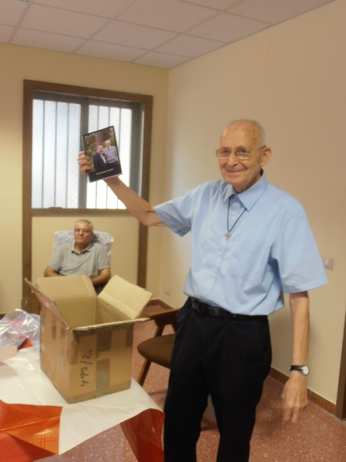
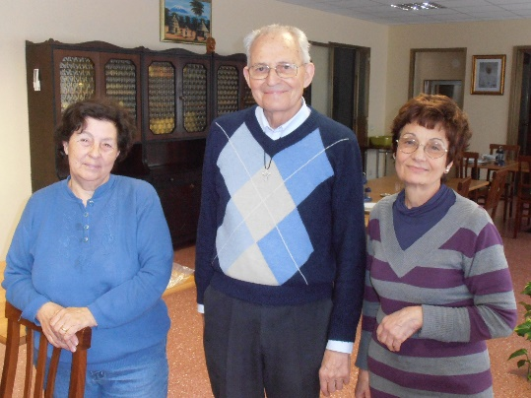
In 2003, the experience of the year of Renewal ended. F. Gérard took advantage of this for a year of Renewal at the Center Sèvres in Paris. In 2004, he returned to Rome, as Superior Director of the Generalate. He stayed there for 10 years. The Brothers of the Community testify: “We are grateful to Brother Gérard for his Commitment to the service of the Community, his generous availability to provide all the services of our house, his concern to create unity in such a diverse Community. How many times has he taken it upon himself to not let his legitimate impatience show. Upon his arrival he took charge of the almost complete renovation of the Generalate... Then, a second area where we owe him a lot are the links forged with the various Authorities of the Parish. He was part of the Pastoral Council where his opinions were well listened to and he was involved in the Parish Council Charity Committee. As for his role as Director of the Casa, we can only praise his relationships with the staff, always attentive to each other, close to each in the Joys and Trials that their families were experiencing, knowing how to emphasize in a festive way the great moments of the year. And in this regard, we cannot forget the way in which he was able to welcome the young people of Taizé…”
Brother Gérard on his departure from Casa Generalizia
F. Gérard with the staff of the Casa
He had been battling Cancer for 8 years. Bro Gérard had always been very discreet about his condition. He never spoke of his illness openly. The care he received at the Gemelli Hospital he followed independently, without ever bothering anyone to accompany him. Sometimes he had to wait for hours to get his turn. On August 1st, 2014, the very day of the 50th Anniversary of his Entry into the Novitiate - which he would not be able to celebrate with his Confreres - he experienced a New Stage in the worsening of the Illness. It was only with difficulty that he climbed back up the slope, until his Final Departure for France, on October 23rd, 2014. Brother Gérard knew the seriousness of his illness and the inevitable deadline, but he did not talk about it. “I am in God's hands,” he replied to someone who was worried about him. This meant that he experienced abandonment to God, total availability. He lived his Consecration to Christ to the fullest. It was his secret and it was undoubtedly because he was now walking on another path, a path of suffering and Communion with Christ, that he preferred the solitude of his room to too many visits. Brother Gérard offered his life in faith and serenity for the good of the Congregation and for all those he knew and loved. Collected in Prayer, he went to meet Jesus, always with a smile, which even illness could not erase.
The Superior General, Brother Yannick Houssay, who knew him well in Rome, gave his testimony. “All those who knew him emphasize his availability, his attention, his kindness, his smile, his discretion, his simplicity. He was attentive to those in need, simple people. I noticed it in Rome. The people he met in the neighborhood or the Parish loved him very much. They liked to confide in him. They felt listened to, welcomed. They felt they were important to him. The Staff of the Casa Generalizia, the Workers who came to work with us were welcomed by him like Kings. He welcomed the stranger, the one who is different, like a brother. If he sometimes seemed demanding, it was because he couldn't stand people being closed off to themselves and their own interests. I’m sure he must have liked Pope Francis’ insistence on going out to the peripheries of life.”
SOURCES:
- INTERVENTION AT THE SUFFRAGE MASS OF BROTHER MICHEL BOUVAIS
- TESTIMONIALS FROM THE BROTHERS OF CASTEL GANDOLFO AND THE GENERALICE HOUSE

