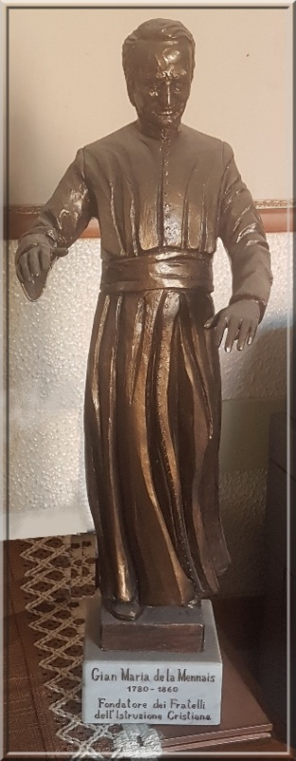
GREAT MENNAISIAN NOVENA
NOVEMBER 2025
Pilgrims on the Path of Fraternal Life

- THE GREAT NOVENA
- THE MENNAISIAN WEEK
- FATHER'S DAY
GUIDELINES FOR FACILITATORS
We have entered into the Great Mennaisian Novena of November, the Most Important of the Year, a Year in which we celebrate the Great Jubilee of Hope. In 2025-26, the Institute is experiencing a Moment of Joy for Our Brothers in East Africa, who are commemorating the Centenary of the Brothers' arrival in Uganda, and for the Indonesian Brothers, who have just celebrated the First 25 Years of their Presence in Indonesia.
It is also a rather difficult time for Several Provinces of the Institute with the decline in Vocations which leads to a reduction in the scope of the Mission to which the Mennaisian Brothers and Sisters have dedicated their lives.
By reviving an Old Tradition of the Institute we could make the “Mennaisian Week” a “Vocations Week”, encouraging young people to follow the Lord’s call through Our Founding Fathers Jean-Marie and Gabriel.
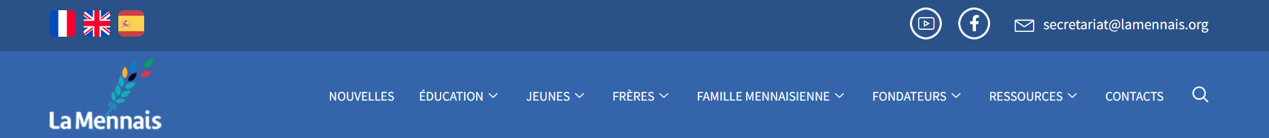
It is up to the Mennaisian Facilitators to propose Initiatives to lead the Novena for CHILDREN, YOUNG PEOPLE, FAMILIES, and MEMBERS OF THE MENNAISIAN FAMILY. Here are a few, with Concrete Information on the Materials needed for their Implementation (the La Mennais.org website is an Excellent Resource):
- For KNOWLEDGE at all Levels.
- For Younger Readers (but also for Others): at Lamennais.org
- https://www.lamennais.org/en/resources/ : Videos (about the Founder and several Brothers), Comics, Images, Photos of the Founders' History
- https://www.lamennais.org/en/founders/ “The Key Dates in the life of Jean-Marie de la Mennais”; Images and Photos of People and Places associated with Mennais; Bicentennial Exhibition in St-Brieuc
- https://www.lamennais.org/dans-le-monde/: History of the Institute in each part of the World;
- https://www.lamennais.org/petites-vies-de-freres-temoins-desperance/: “Little lives of Brothers, Witnesses of Hope” (Brothers, Champions of Heroism);
- https://www.lamennais.org/en/document/mennaisian-novena/?lang=en : Years 2004-2025.
- For PRAYER, CELEBRATIONS, PILGRIMAGE
At LaMennais.org you would find:
- https://www.lamennais.org/audio-chants-songs-cantos/ Mennaisian Chants, with Videos, Music and Texts in Several Languages
- https://www.lamennais.org/en/praying/ : It contains several Mennaisian Prayers;
- For the Thoughts of Father de la Mennais, they could be found in FOUNDERS: Texts of the Father: https://www.lamennais.org/en/founders/
- See also: https://www.lamennais.org/en/young-people/ : The Message from the Superior General to the “YOUNG PEOPLE”
- https://www.lamennais.org/photos/: The Pictures: the Website under “Founders,” you could reserve a Space dedicated to Father de la Mennais: “Espace La Mennais,” “Foyer Mennaisien,” etc. That could be a Place for Prayer and Meditation, a Pilgrimage destination, a Place to find Materials, a Place for Commitment, a Personal Ticket Box, etc.

- THE CAUSE OF JEAN-MARIE DE LA MENNAIS
(See below for the History and Current State of the Cause in the Postulation News Section.)

- MENNAISIAN VOCATIONAL WEEK
The Great Mennaisian Novena is a Very Favorable Opportunity to present the Vocation of the Mennaisian Brothers and Sisters. With respect and clarity, is the moment to ignite the Dreams and Projects of Teenagers and Young Adults for a Vocation that fills a life with giving and Solidarity, following in the Footsteps of Jesus, the Founders, and the Brothers.
- To Introduce the Young Jean-Marie and Gabriel to the Courageous Adventure of their Faith
- To Present the Story of Brothers who, in their simplicity, gave their lives, doing Immense Good even to the point of giving their own lives: (see “Little Lives of Brothers, Witnesses of Hope”)
- To definitively join the Mennaisian Family, by following the 6 Steps (see the website) https://www.lamennais.org/en/youth-6-ways-to-go-further/?lang=en/)
- To take a Concrete Step of Devotion to the Father: Special Prayer, Eucharist, Confession, Pilgrimage, Membership Card, joining a Mennaisian Group, Visiting a Community of Brothers…
All that in Union with the Superiors, the Vocation Officers, the Brothers who are involved in Animation, Witness, their Prayer and their Daily Offering.

1- NEWS FROM THE APPLICATION
THE STATE OF THE CASE OF FATHER DE LA MENNAIS
A- SCHEMATIC CHRONOLOGY OF THE CAUSE
-1899: Opening of the Cause of Beatification by the Institution of the Diocesan Informative Tribunal of Vannes and the Exhumation of the Body of the Servant of God (SdD) Jean-Marie Robert de la Mennais (August 6th, 1900)
-1901: Examination by the Congregation of Rites of the validity of the Diocesan Inquiry and the Writings of the SdD.
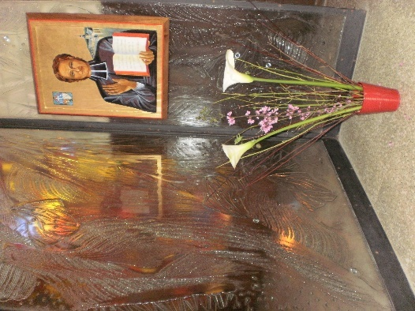
-1911: Introduction of the Cause for Beatification and Canonization of SdD Jean-Marie de la Mennais in Rome, with the Congregation of Rites (code number: 426), by the Decree signed by Pope St. Pius X. Since that phase, SdD has received the Title of Venerable.
-1915: Decree of “Non Cultu” (no improper worship).
- 1924: Decree of “Fama Sanctitatis” (renown of sanctity) and Second Exhumation in 1926.
- 1936: Decree validating the Apostolic Process in Rome on Virtues and Miracles.
- 1946: Preparatory Congregation for the Examination of the Heroic Nature of the Theological and Cardinal Virtues of the Servant of God: in view of the numerous difficulties raised (relations with his Brother Felix, difficulties with certain Bishops…) the Study was transferred to the Historical Section.
- 1946-1965: To address these objections, extensive research was undertaken by the Postulator, F. Hippolyte-Victor, in conjunction with Bishop Frutaz of the Historical Section, who was appointed Rapporteur of the Cause. Frutaz then compiled the “Summarium Additionale,” which proved crucial in refuting the Objections.

- 1965: The Preparatory Congregation welcomed the responses of the Summarium Additionale.

- 1966: General Congregation of June 21st: Pope St. Paul VI proclaimed the Heroic Christian Virtues of the Servant of God Jean-Marie Robert de la Mennais.

B- THE PRESENTATION OF A MIRACLE FOR BEATIFICATION
Since that point, the Institute has done extensive work on the Devotion, Spirituality, Charism, and History of Father de la Mennais and his Congregations. However, the Cause has not progressed. To achieve Beatification, the Church must recognize a Miracle: A Healing deemed Inexplicable from a Scientific Point of View, obtained through the Intercession of the Venerable. To achieve that, the most recent Postulators presented Two Specific Healings:
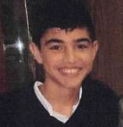
-2006-2016: Enzo Carollo: A five-year-old boy, who attended the Brothers' School in Buenos Aires, contracted Encephalitis in 2005 caused by a Mycoplasma Pneumoniae Infection. His condition was critical: he suffered Convulsions and Epileptic Seizures, and Respiratory Arrest. The Treatment he received seemed ineffective. At School, everyone prayed for him. Suddenly, on Easter Sunday, he experienced an Unexpected Improvement. He was out of danger and recovered quickly.
The Postulator Brothers Delfín Lopez and Gil Rozas followed the Diocesan Inquiry, presided over by Cardinal Bergoglio, the future Pope Francis. They prepared a complete and very Detailed Report for the Dicastery for the Causes of Saints. The Official Medical Commission (Consulta Medica) examined the healing. Its conclusion was: “that Healing was Scientifically Explainable by 5 votes to 2”; therefore, a Negative Verdict.

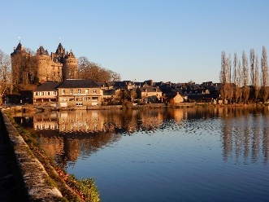
-1956-2023: Josette Poulain: That was a so-called “Historical” case that occurred in 1956 in Combourg, France. A five-year-old girl was playing with her younger brothers while her mother was working in the yard. While running, she climbed onto a Table, fell, and hit the corner of an Iron Stove. She suffered a Cerebral Hematoma, fell into a Coma, and was paralyzed. The Doctor immediately transported her to a Clinic, but she was still in a Coma. A Surgeon was called to perform a Trepanation to decompress the Hematoma. In the meantime, the Daughters of Providence Sisters prayed for her as a Community and placed an Image of the Father under her pillow. When the Surgeon arrived, he found that Josette was Breathing Well, No Longer Paralyzed, Conscious, and Speaking Calmly.

The Documentation of that Healing was collected by Father Hippolyte-Victor and sent to the Dicastery for the Causes of Saints as early as 1957. However, it was not Officially Presented. The Cause was reopened in 2017 by the Postulator, Brother Dino De Carolis, who requested a further Investigation in Rennes. That was carried out by the Tribunal presided over by Bishop D'Ornellas and overseen by the Vice-Postulator, Father Michel Bouvais. The File was then sent to Rome and examined in 2023 by the Medical Commission. The conclusion did not recognize the Inexplicability of the Healing and issued a “Suspensive” Judgment: A Judgment could not be rendered due to “the absence of Neuroradiological Instruments and Clinical Data that were not always consistent” [given the haste of the circumstances].
-2025: Resumption of the Examination of Enzo Carollo's Cure
In consulting with Medical Specialists, we found that several of them question the conclusions of the Medical Commission and favor further Investigation, citing several reasons: the care received was insufficient, the Brain Damage should have had Serious Consequences, and the Recovery was surprising… Currently, the Postulator is seeking out a number of Leading Specialists who would agree on the Need for a New Examination. [Note: Appeals for the Review of the Medical Commission's Rulings are quite frequent in the Dicastery for the Causes of Saints]

2- Prayer Intentions through the Intercession of the Father
- The Brothers and Families in Countries suffering from Political Instability, Armed Conflict, Disorder, Violence and Humanitarian Crisis, especially Haiti, South Sudan, Democratic Republic of Congo, Tanzania; the Brothers of the Timor-Leste Mission.
- Brothers, Sisters, and Lay People in Vulnerable Situations, Illness, and in Retirement Homes: they are Treasures of Offering and Prayers for the Mennaisian Family.
- Patients reported to the Central Postulation Office: Bro. Alberto Pardo, M. Stéphane, Anna and her two disabled sons, Claudio and Monica: father and mother with Cancer, Graziano: young husband (Cancer), Lazo Flores and Léanna Rubinos (Philippines): Leukemia
- The sick reported to the Local Organizers.

3- Favors attributed to the Intercession of Father de la Mennais
Among the Favors attributed to Father de la Mennais, we found above all the Healings of Illnesses, both Minor and Serious. But there are others as well: Prevention of Accidents, Rescue during Disasters, and a Great Number of Spiritual Graces that remain hidden in the Secrets of Hearts. In 1971, a Brother from Haiti reported that particular Story to the Editor of the Journal "Missions Fic," Brother Jean-Charles Bertrand:

“Haiti, Brother Nicolas: We are in the midst of the Great Annual Novena, from November 18-26 (1971) for the Glorification of the Father. We are putting all the more fervor into it because we were “Miraculously” preserved from death by the good Father, on the very day the Novena began.
November 18th being a National Holiday, we had the day off. We went to spend the day in Léogâne, about 30 kilometers (20 miles) from Port-au-Prince. On the way back, the Car picked up speeded on the Beautiful Road while we (the Youth Group and the Brothers) sang. Suddenly, around a bend, the Car became uncontrollable. Seeing the Impending Disaster, I cried out, “Father de la Mennais, save us!” Immediately, as if by Magic, the Car did a complete 180 and stopped dead on the Road without leaving the Asphalt. Humanly speaking, that immediate and “smooth” stop was Inexplicable. The Pickup Truck left a Rubber Track at least 20 feet long. Within Minutes, more than a hundred people were on the Scene to see… that we were completely unharmed. The Car turned around and we ended the day, which might not have ended, in a moment of Thanksgiving.
I would ask you to Report that Event in your Mennaisian Journal as a sign of Our Personal Gratitude to the good Father de la Mennais.”(SOURCE: “Missions of the FIC”, Director Jean-Charles Bertrand, February 1972, p.7)
- JUBILEE YEAR OF HOPE 2025

THE SANCTUARIES OF THE VIRGIN AND FATHER OF LA MENNAIS
PILGRIMAGES TO THE SANCTUARIES OF THE VIRGIN MARY AND FATHER DE LA MENNAIS:
SAINT-MALO and PLOERMEL

- Father de la Mennais's devotion to the Virgin Mary
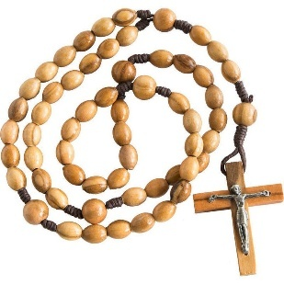
“The Tenderest Devotion to the Blessed Virgin Mary was recommended to the Brothers… May they strive, by imitating her Virtues, to draw down the Blessings of her Divine Son upon themselves and upon the children entrusted to their care.” “Always carry the Rosary with you, for it is the livery of Mary’s Servants and the Mark of her Children.” These are Exhortations from Father de la Mennais He always repeated it. He himself set an example of that “Tender” Devotion: every day he recited his Rosary: ​​“Your Venerable Father gave us a Beautiful Example of his Devotion to the Blessed Virgin. Since his First Communion, he had not missed a single day of reciting his Rosary, despite his Many Responsibilities.” (A. Garcia, Chaplain in Ploërmel). “He celebrated with Special Devotion the Feasts of the Virgin, which he prepared by Fasting; the last Office he recited in its Entirety was the Office of the Immaculate Conception.” (F. Friot, p. 227)
His Marian Devotion was simple yet profound, centered on the contemplation of the Mystery of Christ and the Church: it marked his Entire Priestly Life. “He had made himself the Servant (he even said “the Slave,” following Bérulle and Montfort) of the Queen of the Apostles. She led him to the Cross of her Son and, Mother of Sorrows at Jesus’ side, she sustained him in the Great Trials of his Life.” (Friot, p. 238) Towards Mary, Mother of Jesus and Our Mother, Father de la Mennais had a Devotion full of Tenderness and Faith, “steeped in the Ecclesiastical Doctrine constantly reaffirmed in this Marian Century, in which he found himself a Contemporary of the Events that occurred in 1830 (Apparitions at Rue du Bac), in 1848 (La Salette), 1858 (Lourdes) and in 1854 the definition of the Dogma of the Immaculate Conception.” (See Friot, p. 233)
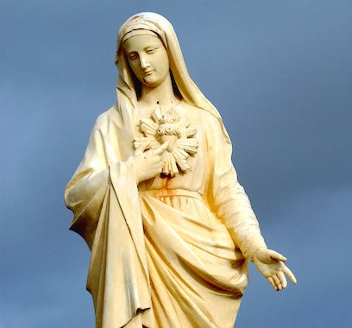
In his Apostolic Work, Father spread the Devotion to the Virgin Mary everywhere, establishing Marian Congregations, and True Centers of Spiritual Renewal. He made them the subject of his Sermons and Major Missions. “He loved to speak of Mary and did so in a way that showed how deep his Piety was toward Our Mother in Heaven.” (Bishop Maupied) He urged people to place themselves under her Protection, especially in the Most Difficult Times, to turn to her in Prayer, to prepare well for their Liturgical Feasts, and to consecrate themselves entirely to her. “We take the Blessed Virgin as Our Special Patroness: That Mother of Goodness and Mercy prays with us and for us. If we do not hinder her Prayers, we would obtain through her the Most Excellent Graces.” (Friot, p. 237) In the Great Missionary Adventure in the Antilles, facing Dangers, the Unknown, and Fragility, the Founder had taken care to place all the Brothers under the Maternal Protection of the Virgin Mary, “Our Lady and Our Mother.” In the Instructions to the Brothers for Guadeloupe, he wrote in the Last Point, on the 31st: “I recommend to them the Most Tender Devotion to the Blessed Virgin: they would have recourse to her very often, as to their Mother, and they would strive, by imitating her Virtues, to merit that she draws God’s Blessing upon their Work.”
With regard to the Sanctuaries and Outward Signs of Father de la Mennais’ Marian Devotion, we limit ourselves to two moments: the Period of his Childhood-Adolescence in Saint-Malo and that of the last years of his life in the Mother House of Ploërmel.

- THE ORIGIN AND FIRST STEPS OF DEVOTION TO MARY: IN HER FAMILY AND IN THE CHURCH OF SAINT-MALO
Let us try to find some Distant and Faint Traces of Jean-Marie de la Mennais's "Zealous and Enlightened Marian Devotion." In his very Christian Family, Prayer to the Virgin Mary was part of Daily Life. His mother, Gratienne Lorin, named Three of her Six Children Marie: the First, Louis-Marie; the Third, Our Jean-Marie; and the Last, a Daughter, Marie. She herself, a delicate and Deeply Pious person, had written a Commentary on the Magnificat: "In these lines, one finds a Doctrine and an anointing worthy of an Ascetic Writer." (Laveille p. 5) The Children of the family cherish fond memories of their mother: when she played the Violin and when she recited her Daily Rosary. Sadly, their Mother passed away when she was still very young, and it was their Aunt, Félicité Lorin, wife of De Saudrais, who took her place. The Children's Christian Formation was continued by their Uncles, who were in turn supported by Devout Ecclesiastical Figures: Bishop de Pressigny, Abbots Engerran and Vielle, and, in general, the Ecclesiastical Community of Saint-Malo. The de la Mennais Family lived very close to Saint-Vincent Cathedral, on Rue Saint-Vincent, inside the City Walls, which were accessed through the Saint-Vincent Gate. Jean-Marie, like his brothers, participated in the Celebrations, Traditions, and Christian Life of the Entire Community. Let us now examine some of the places that nurtured his Marian Spirituality.
- THE STATUE OF THE VIRGIN OF THE GREAT GATE
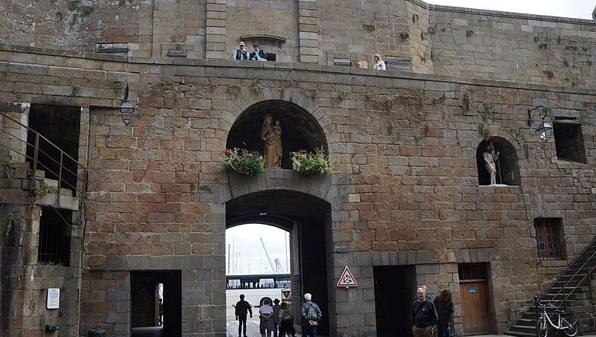Placed above the Grand Gate of the Ramparts, Statue of the Virgin Mary had protected the City of Saint-Malo for Centuries. Its origin was shrouded in Legend. It was said to date back to the 15th Century and to have mysteriously appeared in a Crate floating on the Water, despite its Weight. It was supposedly destined for the City of Saint-Malo, as its Special Protector. And indeed, it would protect Saint-Malo for Centuries. It prevented Enemies from destroying the City on Several Occasions. It stopped the Fire in the Walled Quarters in 1661. Because of that Favor, the Statue was Blessed in 1663, and Saint-Malo was Consecrated to the Virgin Mary, "so that she may forever bless the Pious City" (Father Huby). That was what she did during the Endless Wars with the English. Because of those Maternal Interventions, the people of Saint-Malo called her "Our Lady of Miracles." That Renown, however, did not prevent the Revolutionaries from unleashing their Fury against it. In February 1794, “the Sinister Le Carpentier, Leader of the Republicans, reigned supreme over the Corsair City: his eyes could not look without fury upon the Virgin of the Grand'Porte of St-Malo, or rather of “Port-Malo,” according to the New Name. He ordered that the Virgin and the Inscriptions be removed as quickly as possible, and that the space be converted into a Shop. A band of Fanatical Thugs broke the Right Hand, removed the Cloak, and smashed the Head of the Venerable Statue. Finally, they locked it away in a Dark Room.” (Abbé Descottes)
After the Turmoil of the French Revolution, the Statue was liberated, restored, and, thanks to popular support, returned to its place above the Grand'Porte in 1842. A Century later, during the Second World War, in the Battle for the Liberation of Saint-Malo, it was toppled by a nearby Shell. Restored once again, it resumed its position as a Protective Guardian at the Grand'Porte, known as the "Porte Notre-Dame des Remparts" (Our Lady of the Ramparts Gate). Currently, it has been replaced by a copy, and the Original was installed in the Cathedral in 2003 to protect it from the Elements.
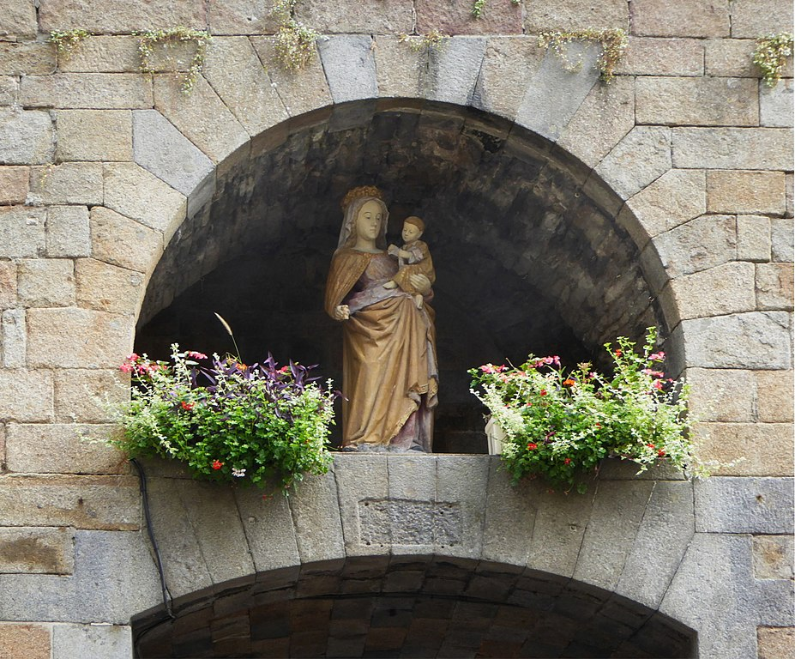The Statue of the Virgin Mary depicts her holding the Christ Child in her Arms. The Child was playing with a Small Bird. The White Limestone Statue was 1.93 Meters Tall. The Two Figures appear serene, as if they wished to reassure the City with their Protection. Countless Generations have contemplated and prayed before that Venerable Statue. We could also imagine that the La Mennais Family often visited it, as they lived on Rue St-Vincent, very close to the Grand'Porte. We could also picture the family going to the foot of the Statue to pray the Rosary in May and October, during the Processions that departed from the nearby Cathedral: Those were moments of Serenity and Prayer.
A completely different Atmosphere would emerge during the Revolution. Jean-Marie was in the throes of Adolescence. He immediately sided with the Refractory Priests and the Persecuted Church. In the nearby Place St-Thomas, he witnessed the Grim Spectacle of the Guillotine, but at the same time, he admired the courage of the New Martyrs of Christianity: “I woulddedicate my life to that Religion that they seek to destroy. It was the Foundation of a New Humanity.” The Young Jean-Marie would fight for Christ in secret, and in those days of Persecution, he would undergo his True Preparation to become a Priest: he would take up the Mantle of those who had been martyred.
- THE STATUE OF THE CROSS OF THE FIEF IN ST-MALO
In the Old Town of Saint-Malo, each District had a Cross marking its Territory (the fief). The Bishop and the Canons of the Cathedral held Lordship over their respective Fiefs. After the Fire of 1661, the District was rebuilt and enlarged, incorporating Rue Saint-Vincent and the Surrounding Area. Next to the Cross marking the New Fief, a Wooden Statue of the Virgin Mary holding the Infant Jesus was placed in a Niche. It was somewhat damaged at the base, perhaps due to a Fire. The Statue dates from the late 17th Century. During the French Revolution, it was hidden and later moved to the Cathedral, next to the Baptismal Font.
In the Tradition of Stories about Jean-Marie's Childhood and Youth, a particular Episode was recounted: “The Cathedral of Saint-Malo had no more Assiduous Visitor. The Family's Servant, the Faithful Villemain, knew that, and it was at the Feet of the Blessed Sacrament that she went to fetch him when his presence was required at the Family Home.” We could imagine that Jean-Marie might have been standing before the Statue of the “Virgin of the Cross” during those difficult times, when the Echoes of Persecution still resonated. He was preparing to become a Priest through diligent studies, but above all through a Strong Spiritual Life.
- THE STATUE OF THE CONSOLATING VIRGIN
Today, as soon as you entered the Cathedral, you encounter a Beautiful White Marble Statue of Italian Origin, bearing the Latin Inscription: “That Statue of the Virgin of Consolation was blessed in the year 1689, Rome…” Its History was summarized as follows: “This statue was intended for the Franciscan Convent in Dublin, but never arrived. Placed on the Altar of the Rosary in the Cathedral in 1820, it was sent in 1827 to the Chapel of the Orphanage on the Rock…”
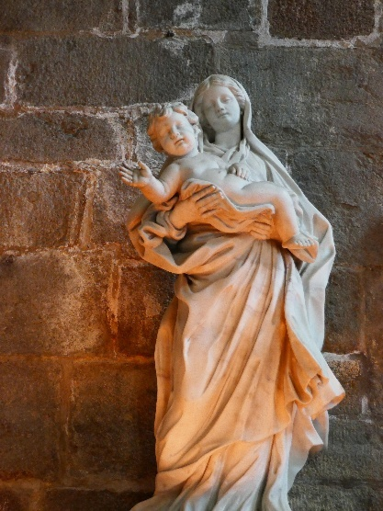
Here too we could imagine the young Jean-Marie in the years preceding his Priesthood and in the early years of his Apostolate in Saint-Malo, coming to pray the Rosary at the foot of that Statue, verymaternal. Indeed, she was placed with an Orphanage, almost a foreshadowing of the future Mission of the Young de la Mennais: he too would become the father of so many Spiritual Orphans. Those were also the years of his encounter with Father de Clorivière, who would enrich his Spirituality with Devotion to the Sacred Hearts of Jesus and Mary.
We could conclude that, in such a difficult Childhood and Youth, Jean-Marie was taken directly by the hand of the Virgin Mary, who prepared him for his Future Mission, through the Mysterious Paths of Providence.

- The Devotion to the Virgin Mary of Father de la Mennais as Founder and the Chapel of the Brothers in Ploërmel

Let us travel to Ploërmel in the year 1852. Father de la Mennais had begun his Old Age, after a life filled with Apostolic Work and Holiness. Trials, Illnesses, and Fatigue had taken their toll, but he still had Projects to accomplish. Among other things, he had to build a Large Chapel: it was to accommodate the Brothers for their Long Retreats, the old one being too small; but above all, he wished to offer homage to the Virgin Mary, to whom he and his brother Féli had consecrated themselves at a very young age: “Your Heart would not reject that humble offering of Two Poor Creatures who consecrate themselves to you forever.” (1809) In his Apostolic Work, Father de la Mennais had placed all his Works and Spiritual Children under the Virgin's Protection: “O Mother, take those Poor Little Children, carry them in your arms: I give them to you, I consecrate them to you, they are yours forever.” (Doucet, p. 155…) The Chapel of the Mother House was an expression of Jean-Marie's Filial Piety towards his Mother. He wished to dedicate it to the “Holy and Immaculate Heart of Mary.” Let us remember that the Church was living in a time strongly marked by Marian Devotion: Apparitions of the Virgin in Paris, at La Salette, at Lourdes, proclamation of the Dogma of the Immaculate Conception…
The Construction of the Mother House Chapel was rather accelerated, as if the Father wanted to see it completed before he died. A few significant milestones:
- September 1853: Br. Cyprien and Br. Fulbert start the Work and hire 200 Workers from Ploërmel (on 14/9/53: laying of the First Stone).
- September 8th, 1854: Father de la Mennais celebrates the First Mass there, on the Feast of the Nativity of Mary and in his 74th Birthday, (the Roof was finished).
- September 9th, 1856: Prayer Vigil. The Relics of the Martyr Saint Felicissimus and Three Other Saints are placed in a Silver Box.
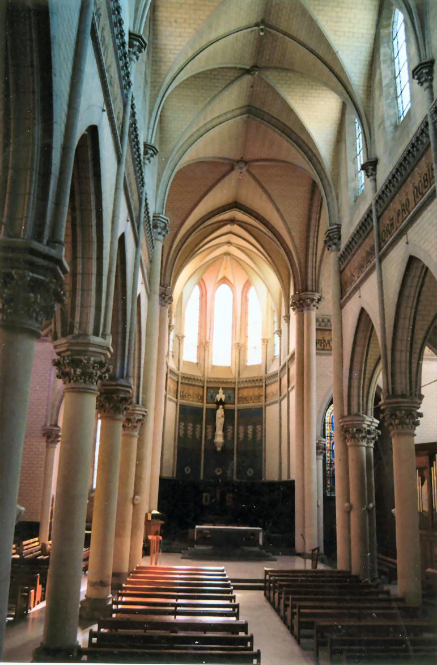
- September 10th, 1856: Bishop Jacquemet of Nantes Solemnly Consecrated the Chapel, with the Ritual Anointings and Invocations of “Peace to that House and Blessing to the Faithful, especially to the Members of that Congregation.” The Ceremony, one of the Most Important Celebrations in the Catholic Liturgy, lasted five hours. Two Hundred Priests were present, having come from all over Brittany. The Father was in the Gallery, surrounded by the Sick Brothers.
- September 10th: “At evening Benediction, the Church was illuminated inside and out. The Whole Town has come. Abbot Richard announced that the Chapel of the Mother House was affiliated with the Pontifical Basilica of Saint Mary Major in Rome and that it received all its Ecclesiastical Privileges.” At the end of those Solemn Days, the Founder could recite the Hymn of Thanksgiving by Old Simeon.

THE PRIVILEGES OF AFFILIATION WITH THE BASILICA OF SAINT MARY MAJOR OF ROME
Let us try to understand the Privileges granted by the affiliation (or Aggregation) of the Chapel of Our Mother House to the Pontifical Basilica of Saint Mary Major in Rome. That was granted to Shrines, Churches, Chapels, and Images that are united with a Special Spiritual Bond to the Basilica, so as to live Marian Devotion in Fraternal Communion.” (Regulations of Affiliation) That Marian Pontifical Basilica has forged a Special Bond of Spiritual Communion with more than 300 Marian Shrines Worldwide, thanks to an Official Aggregation that allows them to share in the Spirituality of the Basilica, Devotion to the Mother of God, Prayers of Intercession, and, in particular, the Treasure of Grace of Indulgences Granted by the “Penitenzieria Apostolica.”
“When could one receive a Plenary Indulgence?
- During the Feast Day of the Pontifical Basilica of Saint Mary Major (August 15th )
- During the Titular Feast of the Affiliated Church
- To all the Solemn Feasts of the Blessed Virgin Mary
- Once a year, on a Day freely chosen by each Worshipper
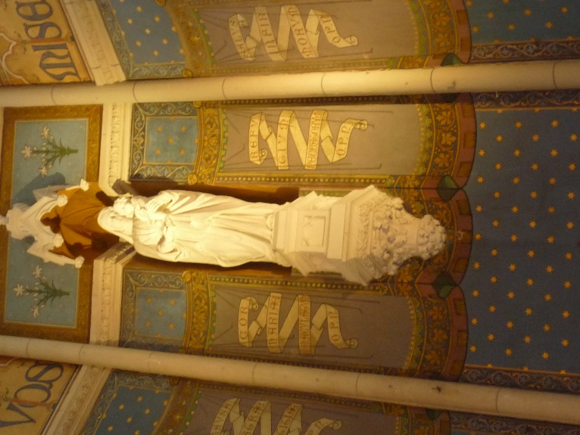
- Each time the Faithful go in Groups out of Devotion to the Affiliated Church or to the Pontifical Basilica of Saint Mary Major
What are the required conditions?
- Sacramental Confession
- Eucharistic Communion
- Prayer according to the Intentions of the Sovereign Pontiff
- Exclusion of Affection towards Any Kind of Sin
- Attending Sacred Services and Reciting at Least the Lord's Prayer, the Hail Mary, and the Creed”
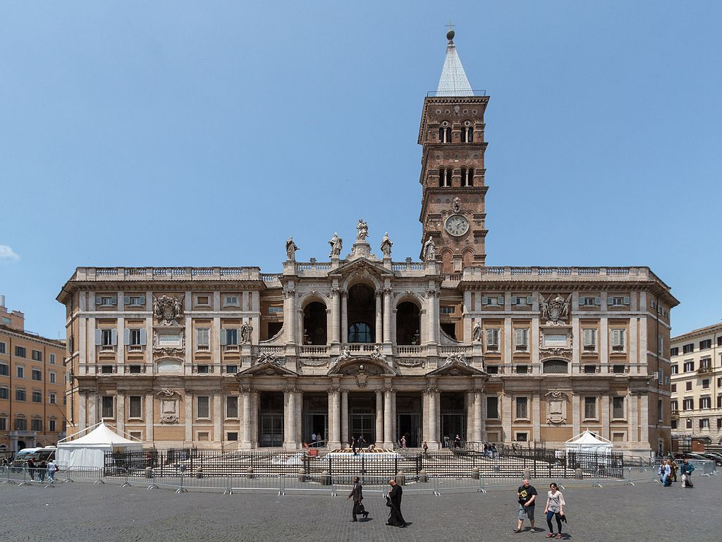
(Provisions of the Regulations for Membership)
Recently, in 2000, the Apostolic Penitentiary updated the criteria for affiliation with the Basilica, and consequently, Affiliations Prior to 2000 are No Longer Valid. Therefore, the Affiliation of Our Chapel in Ploërmel is No Longer Valid. To renew it, simply submit a New Application and provide the Documents indicated in the Regulations, which Our Superiors are currently doing. The Office of Aggregations would provide each Affiliated Sanctuary with a Diploma from the Pontifical Basilica of Saint Mary Major to display to the faithful, to inform them and invite them to prayer.
Let us conclude those Marian Memories linked to Father de la Mennais with the words of Pope Francis to our participants at the Last General Chapter in 2024: “At the close of your Chapter, you would Renew the Consecration of the Institute to the Immaculate Heart of Mary. Draw inspiration from the Teachings of her who, through her total ‘Yes,’ accepted that God’s Plan of Salvation for humanity be realized in her person. Cultivate within yourselves the zeal to set out in Service, Humility, Trust in God, and the Joy of being servants of his tenderness and mercy. Please, do not lose that Joy!”

SOURCES:
-Friot Philippe, The Spirituality of a Man of Action
-Doucet Marcel, Anthology of the Works of La Mennais
- FIC Chronicle: July 1954, Special Issue, no. 199
- Biographies of JM de la Mennais: Laveille, Ropartz, Merlaud, Olabarrieta, Le Rest, Albums Rigot, Chotard…
- History of the Statues of the Virgin of St-Malo (Descottes, Internet: St-Malo, Letters from Le Carpentier…)
- Correspondence with Monsignor Giuseppe Banfi, Head of the Affiliations Office of the Pontifical Basilica of Saint Mary Major and Official Regulations, Delegate of Cardinal Archpriest Makrikas Rolandas.

