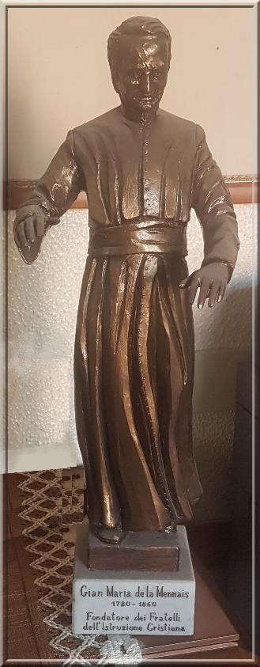
MENNAISIAN NOVENA
OCTOBER 2025
Pilgrims on the Path of Fraternal Life

- POSTULATION NEWS

After the Summer Break, we resume the Ordinary Course of Postulation.
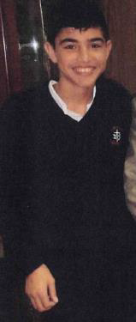
We know that the Main Step to be taken at this time for the Cause of the Founder is to succeed in overcoming the Examination of the Medical Commission of the Dicastery for the Causes of Saints. That must declare whether the presented Healing could be explained or not from a Scientific Point of View. We have presented, so far, Two Cases of Healings and we have received Two Negative Responses: the First declared the Healing of Enzo Carollo Scientifically explainable by 5 votes to 2; the Second gave a “Suspensive” Judgment (the Healing of Little Josette Poulain was considered neither Explicable nor Inexplicable) due to Insufficient Documentation, which at the time had not been collected in a complete manner, despite the efforts of the Postulator at the time, Br. Hippolyte-Victor.
Currently, the General Council has given the Postulator a mandate to resume the study on the Healing of Enzo Carollo, for several reasons: in the Medical Commission, Two Doctors considered the Healing Inexplicable; the Brother Postulators at the time, Brothers Delphin Lopez and Gil Rozas, did an Excellent and Complete Work (more than 800 Very Documented Pages) and also very detailed, which astonished all those who saw it. However, in order not to run the risk of having a Second Negative Judgment, it was necessary to present Additional Documentation: the First Part concerns the Current Situation of Enzo who is now 24 years old. It must be illustrated by the Witnesses and Doctors of Argentina. For the Second Part, it was necessary to collect the Expertise of the Specialists, who, with the same data, maintain that the Healing of Enzo must be recognized as Inexplicable. That Inexplicability extends either to the Cure Itself or to the future consequences of Serious Disabilities which should have struck the Little Cripple.
To achieve that Goal, the Postulator contacted several Doctors from Major Hospitals (4 have completed, 5 are currently studying the File), in order to increase the number of “Favorable” Expert Opinions. That is a rather Long Process, because it was added to their Regular Work. We must have the patience to wait, with Great Hope in Divine Protection, requested by Our Prayer. (We are in the Jubilee Year of Hope!). It continues the long wake of the Prayer of Our Mennaisian Institutes which have not tired, since 1899, of asking for the Beatification of Our Father Jean-Marie de la Mennais.
NOTES:During the Conference of Major Superiors, many Relic Images of the Founder were distributed. Please do not hesitate to request for them and distribute them to the Sick or Those in Difficulty.
With a view to a possible Introduction of the Cause of certain Brothers, the Postulator has given the Superiors more In-depth Biographies of Brothers Zoël Hamon and François Cardinal. We are looking for people who could give or collect Testimonies about those Brothers (Canada, Rwanda, France, etc.) and maintain their Memory: Tomb, Prayer Images, and distribution of Booklets (available on Lamennais.org>resources>publications>little lives).

- PRAYER INTENTIONS: Let us pray for:
- The Major Superiors, so that, after their General Conference, they could give New Impetus to their Provinces and Districts, in a particular way, to the Awakening of Mennaisian Vocations.
- Brothers, Sisters, Lay People in Fragile Conditions, with their Treasures of Offering and Prayer.
- Patients reported by Local Facilitators:
(NOTE: SEVERAL ANIMATORS DO NOT RECEIVE REQUESTS FOR PRAYER FOR THE SICK. LET US ASK FOR GRACE WITH CONFIDENCE, ESPECIALLY IN PREPARATION FOR THE GREAT NOVENA OF NOVEMBER: FATHER DE LA MENNAIS IS OUR FATHER!)
- The Patients reported to the Central Postulation: Bro Alberto Pardo and M. Stéphane: they are still getting better; Anna and her Two Disabled Sons: they found an unexpected welcome in an adapted structure; Claudio and Monica (Fragile Situation); Lazo Flores, Léanna Rubinos (Leukemia)
- The Brothers most at risk: Haiti, Congo, South Sudan and the Brothers of the New Mission in Timor-Leste.

- FAVORS OBTAINED THROUGH THE INTERCESSION OF FATHER DE LA MENNAIS

HAITI: FAVOR ATTRIBUTED TO THE INTERCESSION OF VEN. JEAN MARIE DE LA MENNAIS
“For the Edification of the Readers of the Echo of the Missions of the FIC (name of the Brothers' Review from 1903 to 1930), I would like to point out a Double Favor obtained through the Intercession of Our Venerable Father.
That was my little Nephew. He was an Orphaned Child from the Great War. Born in very difficult circumstances, he hardly seemed destined to live. He had to be fought with death for many Months. But my sister was not content to lavish the most assiduous care on her poor child, she recommended him to Our Venerable Father and asked me to unite my poor prayers to hers, which I did wholeheartedly. We were granted, because towards the end of his First Year, the child was doing wonderfully. The Second Year was very good and my sister had the joy of seeing her little Ernest develop and even become quite strong. But a New Trial awaited him.
Last November, a Most Serious Illness brought Our Little Ernest to the last extremity. The Doctor I consulted showed little hope of saving him. Poor Mother again had recourse to Our Venerable Father and wrote me a Tearful Letter in which she asked me to make a Novena Immediately. I did not receive that Letter until Five Weeks later, and I said to myself: either my Poor Little Nephew was already cured, or he had joined his father with the Good Lord; but it did not matter, I was going to make the Novena, because, for the Good Lord, there was no future; everything is present to Him, so perhaps He brought about the Healing in anticipation of that Novena that my sister asked me to make.
It was Faith in Prayer rather than Prayer Itself that God answers. So I began the Novena, reciting each Morning, after Communion, the Prayer found on the Image of Our Venerable Father. I was well inspired, for the Novena was not finished, when a Letter announced to me that all danger had disappeared. The Improvement quickly became more pronounced, and by the end of November the child was convalescent. It goes without saying that I ended the novena in thanksgiving.
I certainly could not claim a Miracle since the cure was not sudden, nor obtained without the help of human remedies; but for my sister as for me, it was to Our Venerable Father de la Mennais that we are indebted for that Favor and we continue to pray to him that his little protégé may become a good Christian, and perhaps even one of his children. Brother Albin (Haiti)

4-THE SANCTUARIES OF THE VIRGIN AND THE BROTHERS: THREE SANCTUARIES SCATTERED AROUND THE WORLD: POLYNESIA, ENGLAND AND ITALY

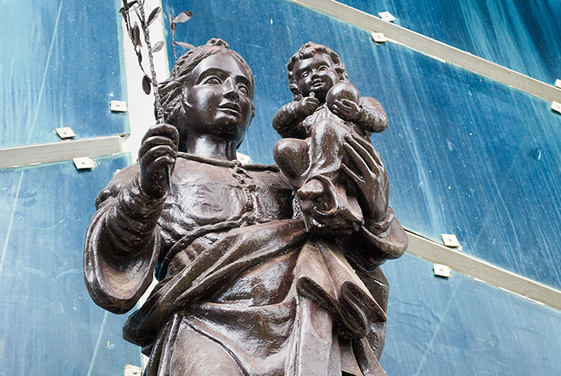
POLYNESIA
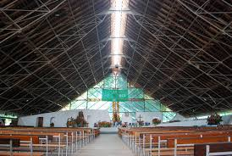
In the Pacific Ocean Archipelagos, the Virgin Mary was also Highly Venerated. In the Tepata Valley, in Papeete (Tahiti), stands a Shrine to Our Lady of Peace, under the Polynesian name of “Maria No Te Hau.” It was inaugurated in 1975. “Maria No Te Hau” means “Mary of Peace” or Our Lady of Peace. It was the name of a Parish in the Center of Papeete, a Large Open Structure, located in a Wooded and Relaxing Park. It was worth noting that Maria No Te Hau gave its name to Radio Maria Tahiti, a very Valuable Instrument for supporting the Faith of Isolated Communities.
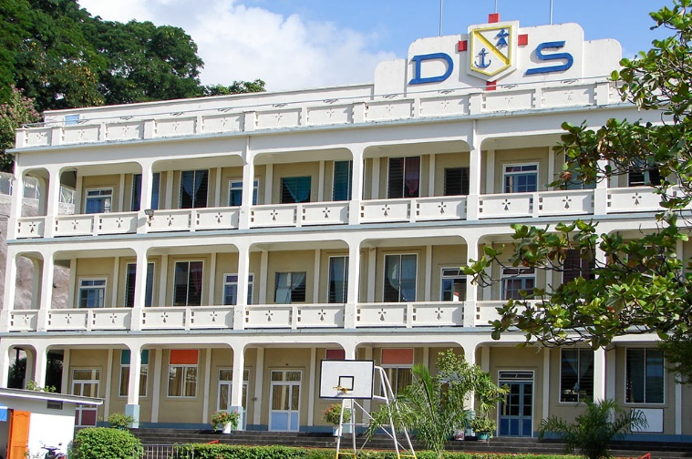
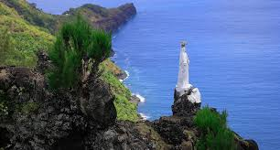
On the Island of Nuku-Hiva, part of the Marquesas Archipelago, a Large White Statue overlooks Hatiheu Bay. It is the “Madonna of Hatiheu,” erected in 1872 by a Missionary, Brother Michel Blanc, of the Congregation of the Sacred Hearts of Picpus. He was a Lay Brother skilled in several Trades: he built Churches, Sculpted Statues, and wherever he went, left Christian Monuments as a means of Evangelization and Unification for the Inhabitants. In 1874, a Church dedicated to the Virgin was consecrated in Hatiheu Bay in the presence of the Clergy, the Brothers of Ploërmel, and the Sisters of Cluny. “The Crowd was Innumerable; the Ceremony a Triumph: from then on, there was Greater Assiduity in Prayer. Work, Order, and respect themselves gained.”

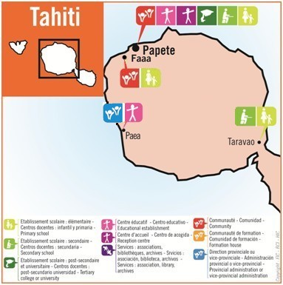
THE BROTHERS OF THE SAINT-PIERRE CHANEL DISTRICT, POLYNESIA
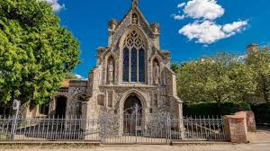
On October 17th, 1860, Four Brothers arrived in Tahiti: it was the Last Mission founded by Father de la Mennais, a Few Weeks before his death. The Brothers opened their School on December 5th with Four Students. Over the years they took over the Management of Several Public Schools; then they founded a Free School in Papeete, the Collège, and then the Lycée La Mennais, which would become a Very Important Institution for the Island. The Brothers actively collaborate in Diocesan Pastoral Work in Catholic Education, in the Animation of Youth Movements, in the Work of Vocations. The Community of Papeete was established in the Parish of Maria No Te Hau, ND de la Paix, which extends its mantle over the Oldest Mission of the Institute: the Virgin Mary would give them her Blessing full of Hope.
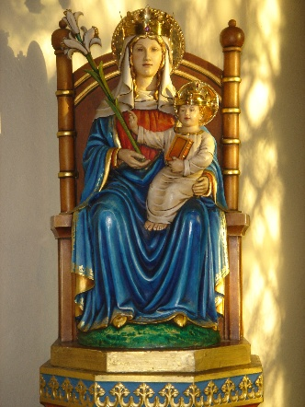
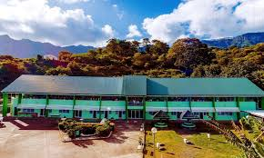
In the Marquesas Islands, in Nuku Hiva, the Brothers' Journey was intermittent. They were present from 1863 to 1866; then from 1898 to 1904; they were recalled in 1971. In 1998, in addition to Teaching through Schools, they founded a Professional Establishment Specializing in Agriculture and Development, the CED St-Joseph, which would become the Lycée Agricole St-Athanase. The objective was to “make the Marquesas Archipelago the First Garden of Farm Managers respectful of Tradition and open to Modern Agriculture.” The Community was very active through Te Oke Nui Radio and in Christian Youth Movements. The Virgin, Patron Saint of the Island, watches over the Small Community of Brothers scattered throughout the Ocean: she is the Star of the Sea who would guide them towards a future of Hope.

ENGLAND: OUR LADY OF THE HOLY WALSINGHAM HOUSE
The Most Famous of the English Marian Shrines is that of the “Holy House of Walsingham”, also called “The Nazareth of England” or the “English Loreto”. It is a very Ancient Shrine: its Origins date back to 1061, when a Noble Widow had a vision of the Blessed Virgin who showed her the Holy House of Nazareth and asked for a Chapel of the same size to be built. The Pious Lady had the Chapel built, which very quickly became a place of Pilgrimage to honor Our Lady of Nazareth and to meditate on the Mystery of the Incarnation. The Monks of St. Augustine built a Monastery there and a Large Church, thus giving great development to Pilgrimages until the 16th Century. From the Anglican Reformation, there was a period of abandonment and ruin. At the beginning of 1900, Catholics restored the Old Church: the Old Statue of the Virgin and Child Jesus was replaced and Pilgrimages resumed. The Marian Shrine of Walsingham has once again become a Center of Prayer and Ecumenical Meeting between Catholics and Anglicans.

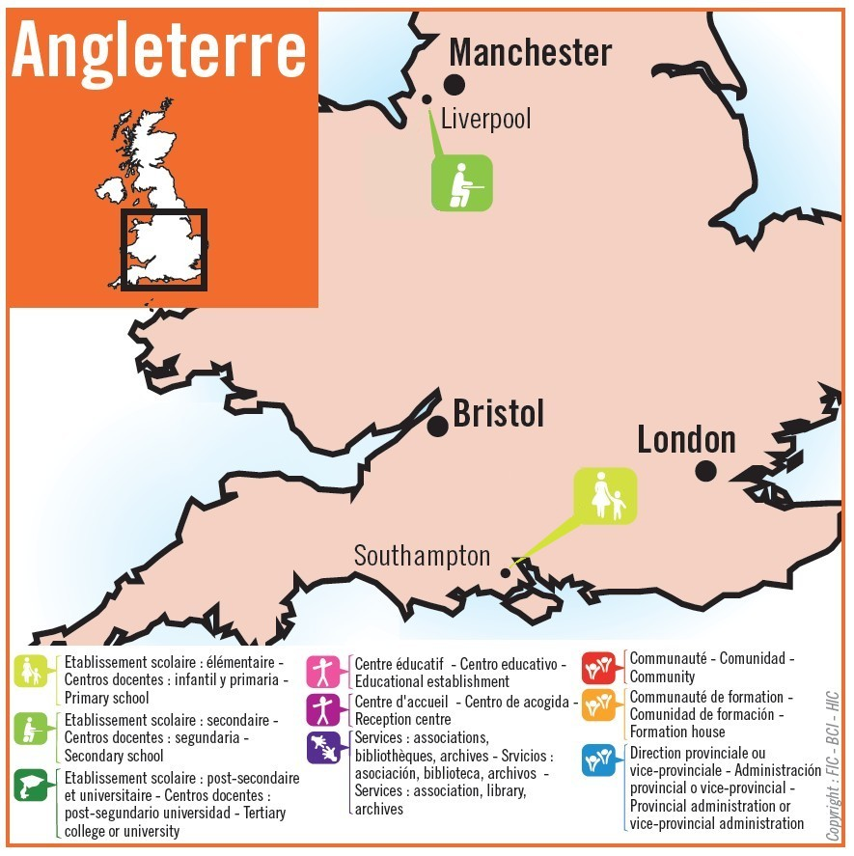
THE BROTHERS IN ENGLAND: A FAMILY HOME FOR THE INSTITUTE
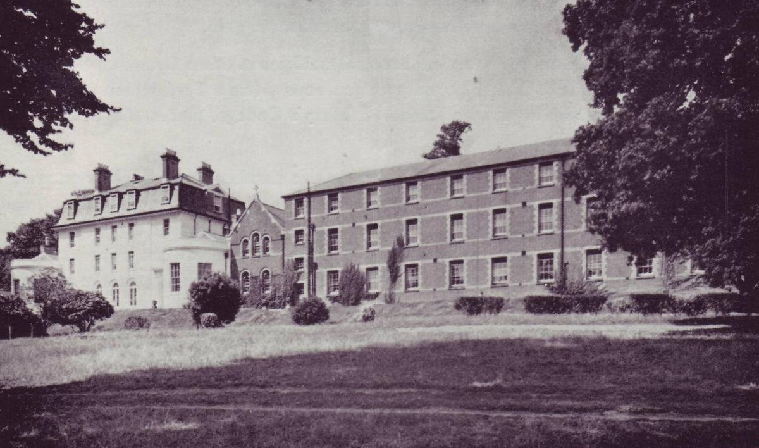
During the years of Secular Persecution in France, England provided a Providential Refuge for the Institute of the Brothers. In particular: the Superiors were able to continue their Work of Central Direction and Animation of the Communities scattered across several Countries (Canada, Spain, Haiti, New Missions, etc.); the Young People in Formation could pursue their Vocation as Brothers in the Novitiate in complete freedom, with exceptional Formators (Br. Constantin-Marie in particular). For that purpose, Several Houses were closed. Taunton (South-West England) welcomed the First French Postulants in 1903. Then the Congregation bought a Large Property in Bitterne, near Southampton: the Novitiate was located there from 1910 until 1922. Then came the transfer to the Island of Jersey in the former Jesuit College in Highlands. For 50 years it was the Residence of the French Novitiate and the General House for the General Administration of the Congregation, which was transferred to Rome in 1972. The Small English District began with the departure of the Novices from Bitterne, when the Brothers opened St Mary's College. Thanks to the contribution of the Juniorates of Pell Wall first and then of Cheswardine, the English Brothers replaced the French and Canadian Brothers. The Community of
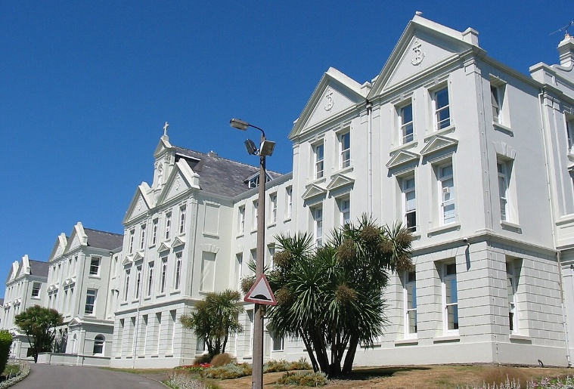
Southampton was closed in 2013 and Liverpool in 2021. The English Brothers shifted to the Communities in France, but they kept the Guardianship of the Two Establishments. The Congregation in England was the House of Providential Refuge in the Dramatic Times of Persecution in France: a “little Nazareth” where the Brothers had the opportunity to pursue their Vocation, to grow in tranquility, to prepare themselves in the Spiritual Company of the Holy Family, of Mary in particular: a Little Wink, the title given to the First English School of “St Mary's”.
Highlands College, Jersey

ITALY: MADONNA DEL DIVIN AMORE (ROMA), THE SIGN OF FIDELITY AND LOVE FOR THE CHURCH
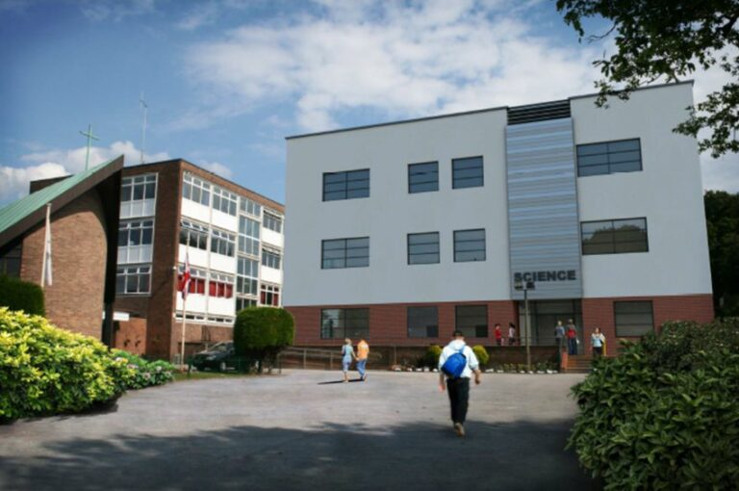
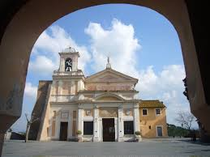
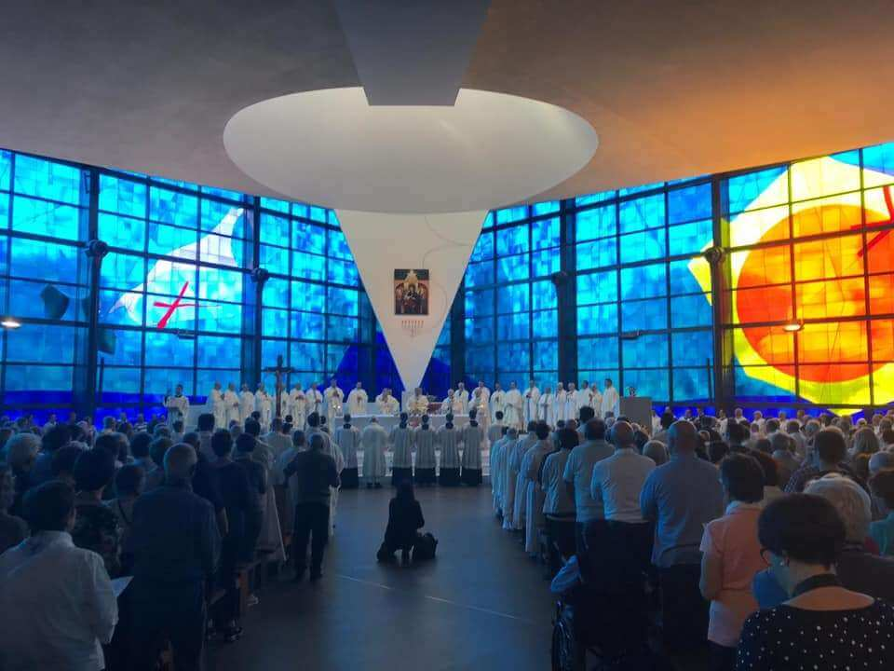
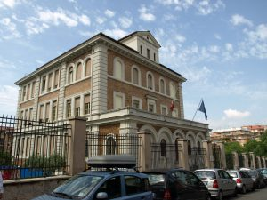
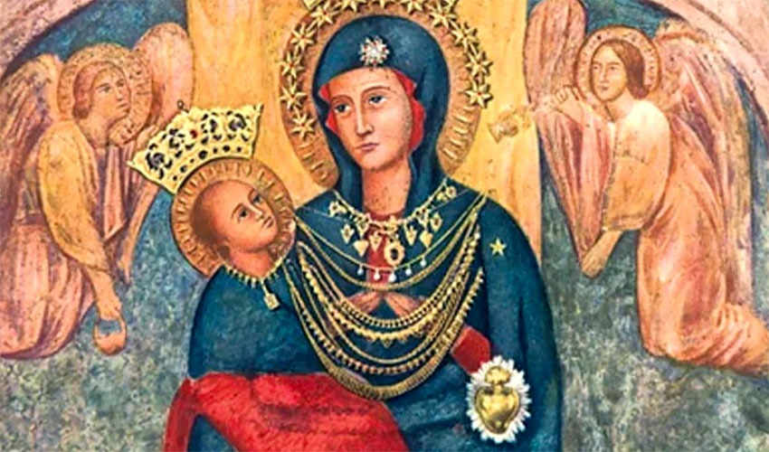
About ten kilometers from Rome, in the Middle of the Hills of the Roman Campagna, stands a Small Church: the Sanctuary of the “Madonna del Divin Amore” (of Divine Love), the Most Popular Marian Shrine in the Romans. Its History dates back to the year 1740. A Pilgrim on his way to St. Peter's Basilica in Rome got lost in the then Sparsely Populated Countryside. He went towards some houses and an Old Ruined Castle to ask for Directions on the way. When he passed the Ancient Tower, a Pack of Rabid Dogs attacked him. The Pilgrim, looked up, and saw an Icon of the Blessed Virgin with her Child, surmounted by the Dove of the Holy Spirit. He then invoked the Madonna to save him from Mortal Danger. It was then that the Animals stopped and dispersed. The Shepherds, alarmed by the cries of the Traveler, immediately run up and are astonished at what had happened. The News of the Providential Protection of the Virgin on the Pilgrim spread very early and the Image of the Madonna del Divin Amore quickly became the destination of a Fervent Pilgrimage. From then on, a Small Church was built on the top of the hill and the Holy Image was transferred there. With ups and downs, devotion to the Virgin continued for Centuries: the Population of Rome and the surrounding areas always sought her protection. In particular, the Image was taken to the Churches of Rome to ask for her Special Intervention during the Second World War. The Church of Rome, led by the Holy Father, begged the Madonna to spare the City from the destruction of the War: in June, the Allied and German Armies were about to collide and clash within the City Center, potentially causing the Disastrous Loss of Human Lives and Immense Religious and Artistic Treasures. Pope Pius XII made three wishes to the Virgin of Divin Amore if Rome were spared from destruction: 1- to Return to God through a True Conversion; 2- to Build a New Church; 3- to Carry out a Work of Charity.
St Francis Xavier, Liverpool, today
New Basilica of Divine Love
On the Evening of that day, June 11th, the Germans abandoned the City and the Allied Troops made their Peaceful Entry into Rome. The Virgin was proclaimed “Salvatrice dell'Urbe” (She who saved the City of Rome). The faithful have kept their promises: currently a Large Church has been erected, several Social Works have been carried out and Pilgrimages continue, in an Atmosphere of Prayer and Conversion.

THE BROTHERS AND THE MADONNA DEL DIVIN AMORE
The Brothers arrived in Rome in 1921 to establish the General Procure to the Holy See with Brothers Philip of Neri, Amans Salaun and Rodriguez Courteille, who were housed by the Marist Fathers in Via Cernaia. In 1931, the Istituto S. Ivo was built in the Monteverde District: it housed the General Procure, the Juniorate, the Residence of the Student Brothers and a Small School. The Juniorate moved to Castel Gandolfo in 1946. The Procure moved to Via della Divina Provvidenza in 1965; that House, enlarged, became the Generalate in 1972. The Istituto S. Ivo became a Center of Spiritual and Cultural Animation for the Monteverde District during the 90 years of its activity, it has faced Great Economic Difficulties, especially due to the reduction in Religious Personnel. Indeed, the Beautiful Promises that sprang from the Juniorate of Castel Gandolfo from 1946 to 1981 were not maintained, despite the great efforts devoted by the Brothers to the promotion of Vocations and the Apostolic Animation of Ecclesial Groups and Movements.
What traces remain is of the Small Italian District of “St-Pierre”, which remained without a Community?
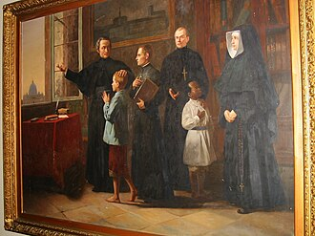
The very name “St. Peter” was a sign of the attachment to the Church of Fr. de la Mennais and the Institutes founded by him. The proximity, even residential, to the Holy Father in Rome and at Castel Gandolfo, was not only a functional opportunity for access to the Dicasteries of the Holy See; it was a closeness of Heart and a Sign of Fidelity to the Holy Church, for which the Founder “wanted to live and die.”
The Table of Venerability (1966) depicts Father de la Mennais surrounded by Two Brothers, a Daughter of Providence, a Poor Child and a Poor Girl. The Father points by hand to the Basilica of St. Peter, which could be glimpsed through the window. The Scene refers to the Church, which authenticates the stage of the Venerable's Journey to Holiness; but it also gives a glimpse of the goal of that Process: Beatification and Canonization, when they are recognized by the Church. The many Procurators and Postulators who worked on the Cause are well acquainted with the Halls of the Vatican Dicasteries. It is to be hoped that so many Efforts and Prayers of the Entire Institute for more than a Century would be heard by the Lord.

Let us conclude with the Story of an Authentic Miracle of the Madonna del Divin Amore, “che fa le grazie a tutte l'ore”. In the early Months of 1944, Br Remo Andreucci (Guido-Maria) and some other Brothers set out for a walk: they intended to go and see the Planes at Ciampino Airport. But, along the way, they had the idea of ​​changing their destination: instead of going to Ciampino, they could go to the Sanctuary of the Madonna del Divin Amore. The Distance was the same (12 km), and it was a Beautiful Pilgrimage. They arrived at the Small Church, they made their Devotions, and they rested a little. As they were leaving, they saw Dense Black Smoke rising in the direction of Ciampino Airport. In the Evening they learned that for the First Time that Airport had been bombed by the American Air Force and that there had been many victims and serious destruction. The Holy Virgin, Madonna del Divin Amore, had watched over those sons!

- SOURCES: Lamennais.org: FICs around the world/ The Chronicle of the years 1972-73/ “F. Constantin-Marie” (by Br. Célestin-Auguste Cavaleau) / “L'opera mennesiana in Italia” (by Br. Gilbert Diquélou-Henri)

