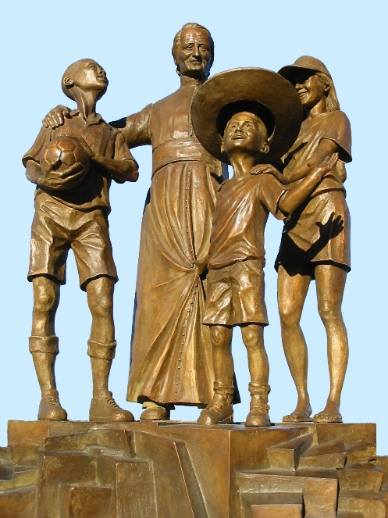
MENNAISIAN NOVENA
JANUARY 2026

- NEWS FROM THE APPLICATION
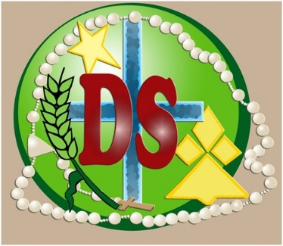
The Postulator has completed the Dossier, including the Expert Opinions of Seven Doctors regarding the Alleged Miraculous Healing of Enzo Carollo. He would now present it to the Dicastery for the Causes of Saints, which would in turn submit the Dossier to Two Specialists. If one of the Two Judges—based on those Expert Opinions—maintains that the Healing warrants Further Examination by the Medical Commission, the Dicastery could Officially Reopen the Case. Naturally, to follow the Canonical Procedures for that Potential Reopening, the Superior General's Decision, with the approval of his Council, would be required.
It should be noted that all those Doctors carried out their Work on a Substantial Case with care and dedication, and—with one exception—completely free of charge. They could be rewarded by praying for them and asking for Father de la Mennais' Blessing upon them, their Work, and their Families. Their Names are: Roberto Cauda, ​​Infectious Disease Specialist; Eugenio Magni, Neurologist; Andrzej Krzystofiak, Pediatric Infectious Disease Specialist; Carlo Jovine, Neurologist; Rosa Chiodi, Pediatrician, Pulmonologist, and Infectious Disease Specialist; Garcia Roig, Head of Pediatric Intensive Care at the time of young Enzo's Hospitalization; and Massimo Gandolfini, Neurologist. We also have current Testimonies from Enzo, who is now 25 Years Old, from his Mother, and from a Friend.

- Prayer Intentions through the Intercession of the Father
- We offer a Special Prayer at this important time for the Cause of Beatification of Our Father, for all those who would be more directly involved in it: the Doctors, the Officers of the Dicastery, the previous Postulators, Bros. Delfín Lopez, Gil Rozas) and currently, Bro. Dino De Carolis and their Collaborators.
- Let us always pray for the Brothers in Countries troubled by Violence, Poverty, and War, especially Haiti, South Sudan, the Democratic Republic of Congo, and Tanzania. Let us continue to pray for the first FIC Community in Timor-Leste. A Special Intention for the Province of Uganda, which will be celebrating the Centenary of its Foundation.
- We pray for the people of the Mennaisian Family who are in a Fragile Condition, who are in Retirement Homes or in Hospitals and ask in return for their prayers and the offering of their difficulties.
- For the Sick referred and reported by Local Leaders. Let us not be afraid to pray, especially for Children and Young People whom Our Father has always favored: let us pray with their Families and Schools, distribute Relic Images (ask the Superiors for them, in the Local Language), and organize Special Novenas. Please, send the Most Serious Cases to the Central Postulation.
- For the Patients previously mentioned: Bro. Alberto, Bro. George Kamanda (Uganda) on Chemo Therapy, Stéphane, Anna and her two sons, Graziano, Sergio, Lazo Flores, and Léanna, to whom we add: Filomena, with Renal Failure and Severe Motor Difficulties; Rachele, a young woman with Head Cancer; and Claudio, with Optic Maculopathy.

- Favors attributed to the Intercession of Father de la Mennais
HEALING OF A NUN OF THE PROVIDENCE OF SAINT-BRIEUC (September 1900-January 1901)
“For two years,” Sister Sainte-Marguerite would later recount, “I had been suffering from a Sore Throat which, in September 1900, worsened considerably; I experienced Great Pain when speaking and I feared I would no longer be able to teach. I went to see Dr. Boulai, who told me that I was very Seriously Ill; he gave me Strong Remedies and added: ‘You would need an Operation, but I find you too weak to undergo it at the moment. You would have to come back to me Three Times a Week; if you don’t get better, you would no longer be able to teach.’ My Ears became affected like my Throat, and I became almost Deaf; Noise caused me Great Pain, and it became impossible for me to keep a break.”
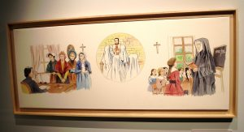
In response to the advice of Mother Saint Francis de Sales, on January 9th, 1900, I began a Novena to Our Venerable Father de la Mennais. Five of Our Sisters and my younger brother, a Junior Priest in Guingamp, joined their prayers with mine. Each day we recited Three Our Fathers, Hail Marys, and Glory Be to the Fathers, followed by the Invocation, “Venerable Father de la Mennais, pray for us.”
I felt no improvement during that Novena; on the contrary, towards the end my Sore Throat worsened, and at night I had Frightening Episodes of suffocation. Mother Superior, concerned about my condition, informed me that I should see the Doctor on Thursday, January 24th. Then, full of confidence, I began again to address the good Father on Tuesday the 22nd; the Sisters who had prayed with me since January 9th and the Students of the Boarding School kindly redoubled their fervor and joined me in prayer. “My good Father,” I said to myself, “you still have two days to cure me; it was absolutely essential to do so, so that the Doctor could declare me completely well.”
On Thursday the 24th, early in the Morning, I prayed fervently and with hope. Around 10 o'clock, I went with Mother Superior to see Dr. Boulai. As soon as he examined my Throat, he said, “Sister, you are cured; you don't need to come back here.” My confidence in the power and goodness of Our Venerated Father de la Mennais was so great that the Doctor's words did not surprise me; I had expected them.
Upon returning to the Community, I went to the Chapel to thank Our Lord and the good Father for the grace I had just received, and I began a Novena of Thanksgiving. However, my Ears were still not accustomed to the noise. I turned again to the good Father and began another Novena. On the last day, wanting to see if my prayers had been answered, I went into the Middle of a Recreation Session where more than fifty children were jumping and talking; I suffered nothing from it. Since then, I have done it every day without being bothered by it, and I hear very clearly.
Sister Saint Margaret, Daughter of Providence

- THE APPARITIONS OF OUR LADY OF KERIO (Brittany, France) TO THE YOUNG JEAN-PIERRE LE BOTERFF (Br. Florien) AND TO THE LITTLE PIERRE BOULARD (Br. Pierre-Édouard) (second part)

CREDIBILITY
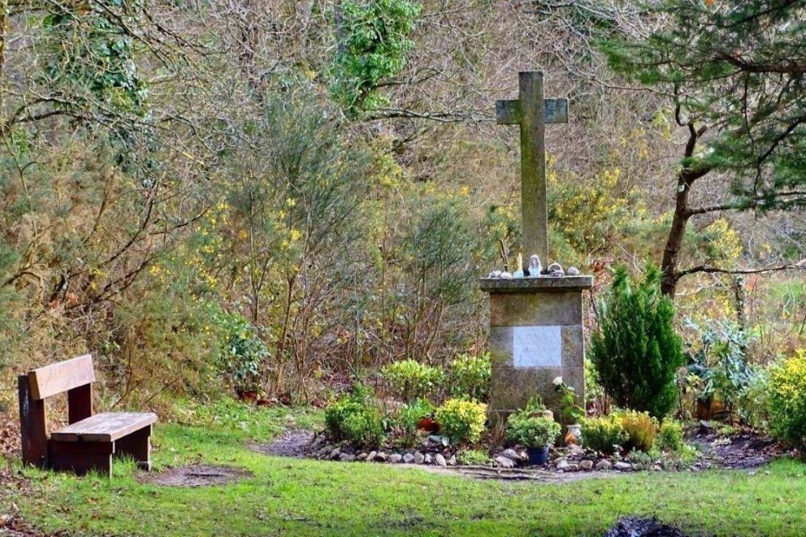
“What credibility could we give to those Apparitions? We have only one witness, supported by a very young child, not yet a year old. At the First Apparition, the “Seer” pointed out to the Two Women with him the presence of a Beautiful Lady in the Valley, near the Large Oak Tree. They looked and saw nothing. They teased him a little: “He’s Crazy!” On Wednesday, his Companion was too young to remember it. On Wednesday Evening, he was alone. “However, it seemed that no one doubted the Seer’s Statements, not even his Parents, neither his Teachers, nor those who knew his Great Devotion to the Virgin, his simplicity and his horror of lying.”(V) But we knew that the Virgin, like her Son Jesus, had a Predilection for the little ones and the simple: “Father, I praise you, because you have hidden the Mysteries of the Kingdom of Heaven from the Wise and the Learned, and revealed them to the Little Ones!” All his life the Farm Boy remained simple and was shown as a “little brother.” When he met the “Intelligent People” who teased him and made Ironic Comments about his “supposed” Apparitions, he simply replied: “I saw the Mother of God. She spoke to me, I’m not lying. I have nothing more to tell you. I knew they would laugh at me, but that didn’t scare me.” (VY)
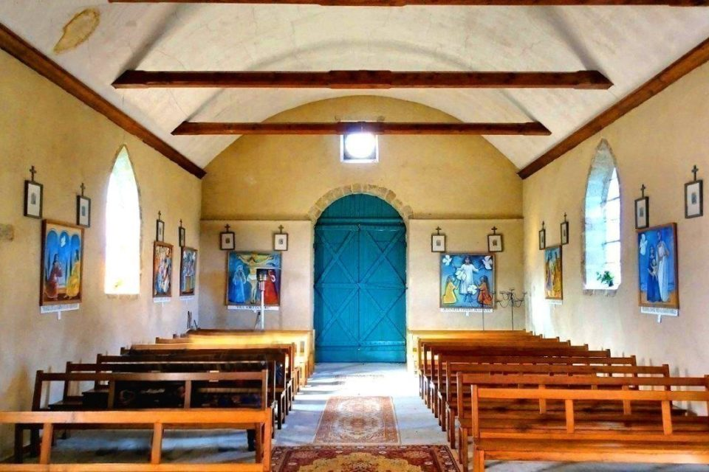Let's also look at the Testimony of some Colleagues.
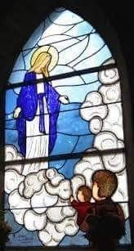
“Brother Armand-Joseph Rouault, Master of Novices in Ploërmel for several years, clearly expressed his conviction that the young man had not been the Victim of an Illusion and that he had truly experienced the Apparition of the Blessed Virgin. Jean-Pierre Le Boterff was too good-natured to concoct such a story. Nor did it seem that he was the Victim of an Illusion.” Brother Armand concluded: “Could the young man have been a Victim of the Devil? That seemed highly unlikely. Everything about the Lady's attitude and words was perfectly normal. And above all, only good came of it: Two Religious Vocations, Pilgrimages, and Daily Prayers.” (Y) His fellow Novices also held Jean-Pierre, who would become Brother Florien-Marie, in high esteem: “He was a Model Novice—a holy young man—the best and most pious of us all.” (Brothers Alpinien Gillet and Enéas Le Serre) (FICP Menologion, pp. 636–7)
Among Ecclesiastical Figures, Jean-Pierre Le Boterff received little encouragement. The Parish Priest paid no attention to the Event. He did not communicate, at least not at the time, to the Bishop either the “Apparitions” or the “Alleged Message from the Virgin.” He probably discouraged his Vicar from attaching any importance to those “Phenomena.” That Distrust from the Parish Priests further increased the credibility of the Young Servant's Account, as he had no one to support him in announcing the Apparitions: Events in which, however, the Blessed Virgin herself had involved him. Moreover, she had given him a Mission to fulfill and a Message to deliver to the Pastor of the Church. Like “a Child, to whom belongs the Kingdom of Heaven,” he had become a Humble Instrument in the hand of the Mother of God: Distrust, Mockery, and Contempt—"that didn't frightened me." (That was also what happened in Several Apparitions recognized by the Church: Guadeloupe, Lourdes, La Salette, Fatima…)
“It was regrettable that the Parish Priest did not request an Official Investigation. It must be acknowledged that he did not prevent people from going to pray in the Valley.” (Y)Most people understood that Events from God had unfolded in the Valley and in the Young Boy's Life. Slowly, through Word of Mouth, ever-increasing numbers of people came to pray to Our Lady of Kério. They asked for Graces, but above all, they came to pray as if in a Family Home to the Mother who calmed, soothed, changed hearts, and restored hope. Kério was a Sanctuary built on Simplicity, Small Conversions, Familial Graces, and the Desire to Remain in the House of Mary, which was also the House of the Trinity.
It was rather unusual that René Laurentin, the Great Theologian of Mary and Marian Shrines, cited in his “Encyclopedic Dictionary of Apparitions of the Virgin, (R. Laurentin-P. Sbalchiero) the Account of the Apparitions at the place called Kério, September 10th, 1874 to Jean-Pierre Le Boterff.” The Knowledge of God and the Wisdom of the Lowly meet in the Heart of Mary.
Finally, even though there was no Official Investigation or Ecclesiastical Approval, “The Bishops’ Attitude was to let it happen, even to encourage it. Thus, the Cross erected on the Site of the Apparition was granted a 50-Day Indulgence by Bishop Gouraud in 1919.” Today, the Chapel built on the Site belongs to the Diocesan Association.” (Father Jean-Eudes Fresneau, Parish Priest of the Muzillac Deanery, 2015 Ouest-France)

DEVOTION TO THE VIRGIN OF KÉRIO
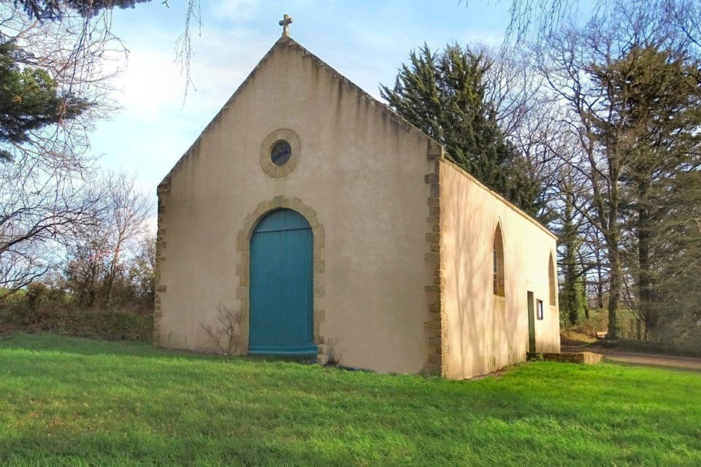
The Sites of the Apparitions are places where the Virgin Mary has manifested her Maternal Presence. Often, they become a Small or Large “Sanctuary,” a “Holy” place, where God’s people could concretely express their Devotion to God, the Virgin Mary, and the Saints. Jean-Pierre would accompany the First Steps of that Humble Devotion to “his” Virgin Mary. Above all, he prepared himself to follow her call. He relearned to read and write, perhaps with the help of the Brother from Ploërmel who ran the School in Noyal-Muzillac. The Encounter with the Virgin Mary made the Young Man even more Devout, Obedient, and ready to follow his Vocation as a future Brother. Some ignored him or mocked him, but many believed in him and remained amazed by his Spiritual Growth. Every Evening, Jean-Pierre went to the Valley to pray. He was not alone; people from the Village and the Surrounding Areas awaited him to recite the Rosary and Sing Hymns. People began bringing Images and a Small Statue of the Virgin Mary. Jean-Pierre built a Small Shelter to protect them. Later, he improved it: using Branches and Bent Broom, he erected a Hut. In 1876, obeying the Virgin's Invitation, he went to Ploërmel to enter the Novitiate and prepare to become a Brother. But people continued to go to Kério. A Chapel was built of Fir Planks, which were unfortunately destroyed by fire in 1881. Finally, in 1882, the Friends of Our Lady of Kério decided to build a Chapel on the Site of the Oratory. Donations and Offerings from Pilgrims made it possible to pay for the Chapel's Construction. “It was very simple. It had a Beautiful Granite Altar surmounted by a Large Statue of the Virgin… Later, a Former Mayor of Noyal had a Granite Cross erected on the Spot where the Virgin Mary Statue had stood. On the Base, a Marble Plaque bore that Inscription:
“MIRACLES WOULD BE PROOF THAT I DESCENDED INTO THOSE PLACES IN 1874” (V)
We could also note the presence of a Spring, linked to that Tradition: “A man from Noyal, seeing that Pilgrims were asking for Water, offered that Prayer: ‘Good Mother, you could see that your Devotees are thirsty: make Water spring forth so that they may quench their thirst.’ Trusting, he dug a Hole at the edge of the path. Water began to spring forth.” Here, in very small print, we could see the allusion to Lourdes.
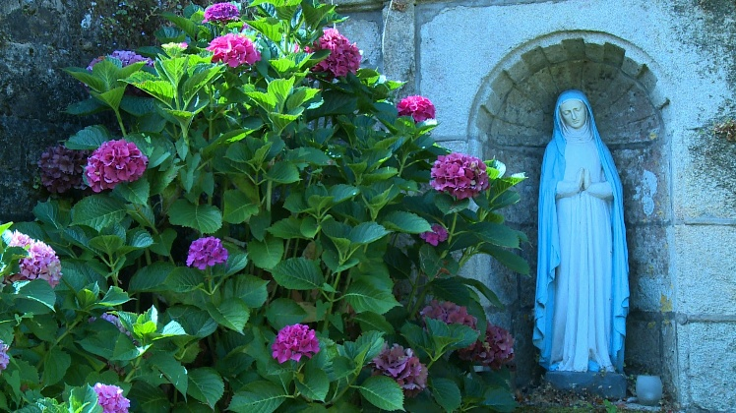
Today, Devotion to Our Lady of Kério remained very much alive. That Small Sanctuary has become a place of Well-Attended Celebrations. “Notably on Easter Monday and August 15th with a Procession, but also on the Second Tuesday of each Month at 6:30 p.m., and a time of Eucharistic Adoration was offered every First Friday of the Month from 10:00 a.m. to 5:00 p.m. The Deanery was organizing, as requested by the “Lady,” a Pilgrimage on Foot in September to Sainte-Anne-d'Auray, with Kério as the starting point.” (Father Fresneau). Another characteristic of Kério was a Spontaneous and Continuous Presence of the Faithful who came to pray in the Chapel: they are alone or in Small Groups, they stay for a Long Time or for a Short Prayer, they stop in front of the Cross or kneel in the silence of the Chapel, they have the Rosary in their Hand or they enjoy a moment of peace, favored by the middle of the Countryside… Silent Witnesses of that Presence are the Candles continually lit, Prayer of Praise, of Petition, of Conversion, to the Mother who simply welcomed her Children into her House.

FRUITS
The Virgin Mary is “Full of Grace”: she is the mother who provides for her Children’s Needs. People go to her House to ask for Material Graces, for help in times of need, and—understandably—that was the attitude of sons; but gently, the Mother educates them to turn toward the Graces of the Heart, of Faith, of Love; she encouraged them to imitate her and, above all, to follow her Son Jesus. “The Church was not very interested, in fact, in the Miraculous, but rather, quite rightly, in the Imitation of Christian Virtues. That was why I tried to show how the Virgin Mary, through the Virtues she inspired,and could be a Model and a Teacher of those Virtues” (Father Fresneau).

- SPIRITUAL RENEWAL
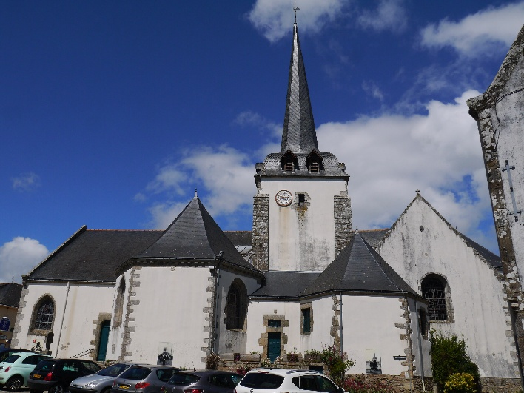
Father Michelot, the Parish Priest and Successor to Father Corric, witnessed a Great Movement around the Land of Kério. He observed the Piety of the Faithful, a Current of Faith and Conversion of Hearts, a filial trust in the Virgin Mary, and the various favors that were being bestowed upon them. He realized that a Heavenly Event had occurred in his Parish. He recorded the Story of the Apparitions in the Parish Register, gathering Information from his Parishioners and the Boulard and Le Boterff Families. He also recorded the Favors that the Pilgrims to Kério shared with him. Naturally, Material Graces, particularly those related to Health, were highlighted. Inner Healings were also numerous, but often remained a Secret of the Heart.
Father Michelot could also thank the Virgin Mary for the Renewal of his Parish and those surrounding it: a Discreet, Simple Renewal, entirely in line with the Direction Indicated by the Beautiful Lady, Mother of God. In that Land of Brittany, the Christian Faith of the Great Tradition was the precious resource for building a Civilization that was Fully Human and Divine together. For that reason, Kério was linked to Saint Anne of Auray, Patron Saint of Brittany. She was the Symbol of Faith lived in Everyday Life: Family, Life, Home, Work, Fields, Community…
- THE RELIGIOUS VOCATIONS OF THE BROTHERS OF PLOERMEL
The Fruits of the Apparitions at Kério also include the Splendid Religious Vocations of the "Visionaries": the young Jean-Pierre Le Boterff and the very young Pierre Boulard, a Child of the Boulard Farm. The Brothers of Ploërmel have recorded their Memories in the Menologion of the FICP. We add their Short Biographies to their Stories, which we already knew.
Brother Florien-Marie 1857-88 (Jean-Pierre Le Boterff)
“On June 12th, 1876, the Young Le Boterff, aged 19, entered the Postulancy in Ploërmel. What was striking about the Newcomer, despite his relatively advanced age, was a Charming Simplicity. He hid deep in his heart a Great Secret, which he would one day confide to Brother Armand-Joseph, Director of Postulants and later Master of Novices, and which the latter would later recount.” (The Menologion followed with an Account of the Apparitions, highlighting the Virgin's Invitation: “to return as soon as possible to the Novitiate in Ploërmel”).
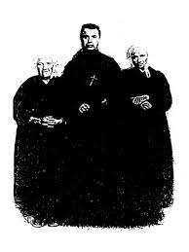
According to the Testimony of Brothers Alpinien Gilet and Enéas Le Serre, both his fellow Novices, Jean-Pierre Le Boterff, who became Brother Florien-Marie, was in every way a Model Novice… After professing his Vows, Brother Florien-Marie was the Devoted Assistant to Brother Ernest-Marie Lamiré in the Infirmary. Brother Bruno Cloarec, who was cared for by him, testified that the Young Nurse was simplicity itself, speaking little, effacing himself as much as possible, and gentle in his Dealings with the Sick. He was never heard to make an Allusion to the Extraordinary Favor bestowed upon him; but all who knew him unanimously noted his Filial Devotion to the Blessed Virgin and the Fervor with which he recited the Rosary. Brother Amand Joseph clearly expressed his Conviction that he had truly experienced the Apparition of the Blessed Virgin. The circumstances seem to support that conclusion. The Integrity, Humility, and Discretion of the Visionary; the fact that everything in the Lady's Attitude and Words were equally Dignified, Simple and Pure; finally the Supernatural Good that resulted from the Apparition: the Religious Vocation and Holy Life of the Visionary, then the Vocation of a Child of the Boulard Family, Pierre-Marie, who under the name of Br. Pierre-Edouard, was to render Great Services to the Missions of the Institute, all bear the mark of the Good Spirit and contribute to establishing that Jean-Pierre Le Boterff was the object of a Great Favor from the Blessed Virgin.
Upon the death of Brother Florien-Marie on June 1st , 1888, the Chronicle of the FICP did not deem it appropriate to report that Extraordinary Event; however, Brother Amand had carefully recorded all the circumstances in writing, and he shared them with Each New Group of Novices. His account must have been lost at the time of the dispersal in 1903. A Small Statuette and a Rosary, placed at the top of the Cross surmounting Brother Florien-Marie's Tomb, often prompted that question from those who visited the Cemetery: "Why that Statuette of the Virgin and that Rosary?" And the answer was always: "He was a Little Brother to whom the Blessed Virgin appeared." (Menologion, Vol. II, pp. 636-8)
Brother Pierre-Edouard, 1874-1908 (Pierre-Marie Boulard)

“As a child, Pierre-Marie often heard his parents recount the Apparitions of the Blessed Virgin to their Former Servant, Jean-Pierre, who later became Brother Florien-Marie. He himself frequently went to pray in the Rustic Chapel erected on the Site of the Apparitions. Those Stories and Pilgrimages undoubtedly contributed to awakening in him the desire to dedicate himself to God. By a twist of Providence, he entered Ploërmel in February 1888, just long enough to take over from Brother Florien, who died at the age of 31 on June 1st of the same year. Pierre-Marie became Brother Pierre-Edouard. Three years later, he embarked for Haiti.” (Menologium, vol. IV, pp. 1368-70). He arrived during the Heroic Period of the Brothers' Mission, which began in 1864, the First after the Founder's Death. The early days were dramatic: the Brothers began opening Small Schools in Extreme Poverty; their growth was hampered by Fires, Political Uprisings, Destitution, and Disease. In 1878, Yellow Fever claimed the lives of Seven Brothers, and many others had to return to France due to failing Health. Despite those obstacles, by 1897, there were 106 Brothers in Haiti, working in 25 Schools and serving 4,800 Students. Brother Pierre was sent to Port-au-Prince, where the Country's First High School, the Institution St-Louis de Gonzague, had just opened. It was precisely to that School that Brother Pierre Boulard was assigned. After receiving thorough preparation, he taught for Eight Consecutive Years with the same Students he had taught in Elementary School, achieving Excellent Results. “Rarely had Students been seen more devoted to their Teacher, and a Teacher more attentive to the needs of his Students. The dwindling number of Brothers, due to Deaths and Failing Health, forced Brother Pierre to assume the Roles of Assistant Director, Prefect of Discipline, and Teacher.” A Former Student testified: “The Students of St. Louis de Gonzague would not forget the Wise Censor who combined the severity of his Title with the Justice of a Teacher and the kindness of a Great Friend; he was the Astute Teacher who, well-versed in youth and its failings, strove to equip us with the Convictions necessary for a Life Guided by Duty.”
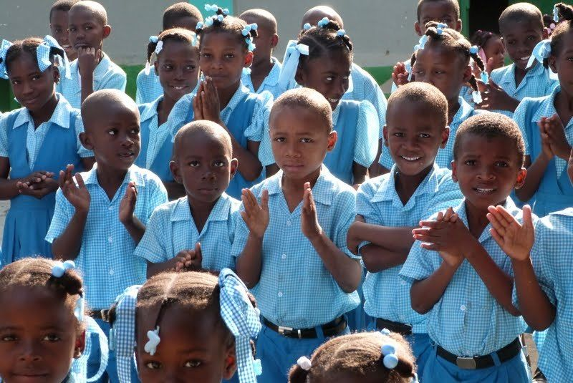
On June 7th, 1908, after a brief return to France, he came back to Haiti full of strength and determined to dedicate himself fully. He asked, as a favor, that he not be spared in the allocation of Jobs: “I am strong, I could work harder than many others!” But on October 2nd, a Bilious Fever seized him and, despite the most enlightened and devoted care, carried him off in Three Weeks. [“Between 1903 and 1909, Twelve Brothers died of Tuberculosis and about thirty had to Return Permanently to France. The Situation of the Brothers in Haiti was Catastrophic: Seven Schools were closed and the Entire Mission was threatened with closure. (150th Mission of the FIC)]. Seeing, during his Illness, the eagerness of Families, Clergy, and Friends to come and inquire about him; seeing, on the day of the Funeral, the Coffin disappearing under the Flowers, the Tears in everyone's eyes, and the Sobs in the Cemetery, one could appreciate the sympathy that Brother Pierre-Edouard had earned and the deep regret caused by his premature death at the age of 34. (Menologion) The Virgin, whom he had contemplated as a Small Child in Kério, in the Arms of Jean-Pierre, came to take him and lead him into the Joy of Paradise.

End of the Account of those Apparitions in Kerio, in February

Volant Frère Théodore (V), Notre-Dame de Kerio en Noyal-Muzillac, Muzillac 1992
Y of Menga. Apparitions of the Virgin in Brittany, Rostrenen – quotes to come: Y

