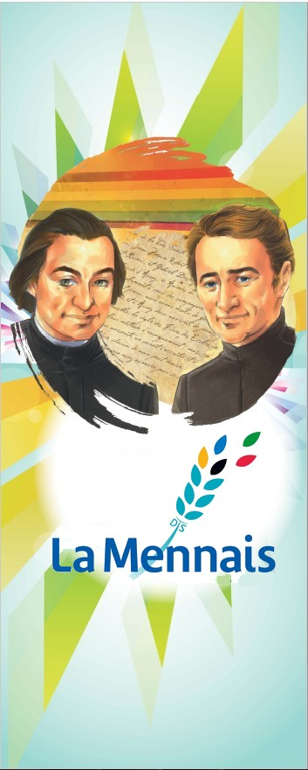
MENNAISIAN NOVENA JANUARY 2024
- POSTULATION NEWS
- RESUMPTION OF ENZO CAROLLO'S HEALING AND INFORMAL PRESENTATION OF OTHER CAUSES
Currently, there are four Doctors who are studying the Medical File concerning Enzo Carollo, following the Indications of the Dicastery for the Causes of Saints. We also had a conversation with the French-speaking Officer, Father Rémy Bazin, on the opportunity to present the possible causes of some Brothers who have left a reputation for Holiness (in particular Brother Zoël Hamon, Brother François Cardinal, Brother Arthur Registrar, Brother Hyacinthe Fichou). He encouraged us and gave us Indications on the Canonical Procedure.
- FOR ANIMATORS:
I see with pleasure that the Mennaisian Animators are very active: Novena, Intentions, Mennaisian Home, Images, Reports… I offer two Suggestions :
- Send a story about the favors received by invoking the Father: Healings, Punctual Grace, help with Studies and Work, Reconciliation, Support for the Family, Dangers Avoided, Return to God, Growth in Faith, even in a Group...
It would be good and encouraging to receive News of your “Mennaisian Activities”: Prayers, Celebrations, Days, Songs, Small Dramatizations, Games… We could make them known to everyone and give Ideas to other parts of the Congregation. These don't have to be Extraordinary Activities. It is the Hearts of Mennaisian Children that count. You can also send Photos by email (frateldino@tiscali.it ) or by WhatsApp.

- INTENTIONS
- For the GENERAL CHAPTER: may it bring Hope for the World, the Church, the Mennaisian Family.
- For PEACE, especially in countries plagued by War and Disorder, where the Institute is present.
- We continue to pray for ourSsick, especially those in your Region, to whom we can add:
- UGANDA: Carolina Tibindimunda and Palma de Nebbi
- ST FRANÇOIS-XAVIER DISTRICT : Corazon Modragon, Yukari Holme, Lise Beaudouin, Robert Scripko, Katarina Eda Botha
- SENEGAL: Mathilde Kayoungua; CONGO: Student with Anemia
- DISTRITO DIVINA PROVIDENCIA: Nerina Zavatarelli, MariLuz Perez Callaù, Nicole Perez, Lorenzo (3 years), Doris Cuellar
- ITALIA: Giuseppe, Claudio (Ophthalmia), Massimo, Irene.

- REPORTED FAVORS (in the collection by Bro Jean-Charles Bertrand)
- SACO, MAINE, USA
“I had been ill for several years. Severe Headache, Back Pain and all the Muscles at once. When I got sick, I had to be taken to the Hospital. The further I went, the worse it got. So, they decided to Operate on me to better understand the nature of my problem. I was scared and worried a lot.
One of my Aunts, a person very attached to the Cause of Father de la Mennais, then gave me a Relic Image of the good Father and told me not to fear and that everything would be fine. And the Operation was very successful. Since then I have kept his Image in my wallet and always keep it with me. I recommend myself to the good Father every day and regularly recite the Prayer for his Beatification. Please send me other Relic Images so that I can make it known to other people around me.” (Mother Saint-André, FdlP Missions, December 1985).

- STORY OF BRO ALLAIN-JOSEPH GUITTON (MISSIONARY IN TAHITI)
“A few years ago, I had Appendicitis. I suffered a lot from it. I was treated by Dr. Violle. In the midst of the Crisis, he was asked for a Mission to the dangerous Tuamotus Archipelago and left me alone with my illness. Devoured by fever, broken with suffering, I cast my eyes on an Image of the Father invoking him and, suddenly, the evil ceased. It was over, I was cured, without remedy and without an Operation. Returning, a few months later, the Doctor asked the first people he met: “And Brother Allain, is he dead, no doubt?” “Brother Allain!... He runs the Streets of Tahiti as if he had never been sick!” I should have asked the Doctor to give me a Certificate stating that I had Appendicitis. In all cases, the recovery was complete and, to this day, I have not suffered from this disease again.” (Missions, June 1986)

- HISTORY OF MENNAISIAN DEVOTION:
12- IN THE SOCIETY CRISIS
After the years of Enthusiasm and Momentum of Mennaisian Devotion in line with the two great events (Centenary of the Death of the Father and Proclamation of the Heroicity of the Virtues) we expected a period of Development and Stability. But the years after the Second Vatican Council were very difficult for the Entire Church, which also participated in the Largest Cultural and Social Crisis in Society, especially in the West. “We expected a Spring, but we witnessed a Winter frost” (Paul VI). Indeed, the Council had brought a new flowering in the people of God: Biblical and Liturgical Renewal, return to the sources, Spiritual Movements, participation of the Laity, Dialogue with the World... But, at the same time, a Crisis broke out throughout the Church: the first sign was the Drastic and Unexpected Reduction of Institutes of Consecrated Life, with a Dramatic Reduction in Numbers and Works. “The Events of 1968, in Europe and elsewhere, mark a tormented time in the Western World and in the Post-Council Church. They are characterized by the questioning of Institutions, Systematic Contestation and a Search for the Development of the Human Person that is difficult to balance: choices are revised profoundly and, for some, radically. These events will have a lasting influence.” (Bro Célestin-Paul, Two Mennaisian Congregations)
Faced with this situation which was becoming ever more difficult, the Institute, following the Indications of the Church, had a good reaction of Faith and Missionary zeal. “Among the Brothers, the Second Chapter Session (January 30th -March 26th, 1970) saw the development of a desire to maintain the essential and to build, in order to bring to a successful conclusion, the drafting of the Rule of Life, mindful of the deep motivations, suitably demanding, adapted to an evolution which is intended to be positive.” (Bro Célestin-Paul…)
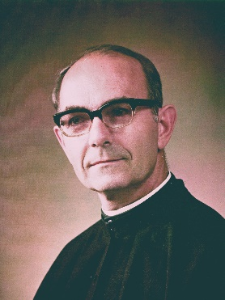
The Special Chapters had been requested by the Vatican Council, to engage the Institutes of Consecrated Life in the path of updating to New Times, in Renewal and Adaptation. The Brothers of Christian Instruction experienced two Chapters in this regard: in 1968 and in 1970. The Rule was updated to respond to New Times and the challenges of the “New Society” according to Conciliar Indications. Each Region of the Congregation had applied these Guidelines to its own Environment. Thus, concluded the Chapter of the French Region: “In the current circumstances, the National Chapter considers it essential to affirm its attachment to the Fundamental Values of Religious Life, as they were recently described by the Council” (Chronicle 1970). In the 1970 Chapter, a non-French Superior General was elected for the first time, Canadian Brother Albert Tremblay. He accompanied the Congregation during these difficult years, having as his Guide the Spirit of the Second Vatican Council. He gave a very strong impetus to Missionary Work, especially in Africa: Canadian Missions in Congo, Rwanda, Burundi; resumption of the Missions of the French Province in West Africa; Development of Communities in South America… During the 1970s and 80s, there were also times of difficulty and confusion, with a Serious Hemorrhage of Religious, moreover shared by most Religious Congregations. In this period of disorientation, Mennaisian devotion also seemed to suffer: one of the signs was the Closure of the Magazine “Le Courrier du Vénérable” in 1969, continued in part in the Magazine “Missions”, still Directed by Brother Jean -Charles Bertrand, great Mennaisian Devotee.
RV Bro Albert TREMBLAY
Despite these difficulties, awakening symptoms immediately appeared. The Council, in the Document on Religious Life “Perfectae Caritatis” had urged the Institutes of Consecrated Life to return to the sources of the Charism and, consequently, to highlight the Person and Inspiration of the Founders. “It is to the advantage of the Church that the Institutes have their own Physiognomy and their own Mission. To this end, the Spirit and the Specific Purpose of the Founders, as well as Sound Traditions, must be observed, because all of this constitutes the Heritage of each Institute.”
To give strong impetus to this Exhortation, two events occurred providentially: The Second Centenary of the Birth of the co-Founder, Father Gabriel Deshayes in 1967-68 and the Second Centenary of the Birth of Father de la Mennais in 1980-81. In the year 1967-68 there was a flowering of initiatives dedicated to Father Deshayes: Articles, Meetings, Celebrations in Beignon: Country of Birth, in Auray: where he worked so much, in Saint-Laurent-sur- Sèvre: where he directed the Montfortian Works. These events made us rediscover our oldest Founder, a Passionate Apostle of the little ones and the poor, Fruitful Initiator of Numerous Works of Charity, Trainer with Deep and Solid Spiritual Foundations. The figure of Father Deshayes, often remaining in the shadows, also because of his great humility, began to regain his place and give New Light to the Spirituality and Mission of the Institutes founded by him.
In 1980, it was the turn of Father de la Mennais. The Celebrations in all parts of the World formed a “Holy Year” of the Mennaisian Congregations. We made the person and work of Jean-Marie de la Mennais known, in a capillary way: New Edition of Merlaud's Biography, Comic Books, Documentaries, Postal Broadcasts, Meetings and Conferences, Prayer Celebrations... The Daughters of Providence also participated in the Bicentenary Initiatives in France, Canada, England. A new enthusiasm spread throughout the Mennaisian family: after years of difficulties and purification gave a sign of recovery and hope for the Spiritual Sons and Daughters of the two great Founders.SOURCES:
DOCUMENTS OF THE II VATICAN COUNCIL
Two Mennaisian Congregations (Bro Paul Cueff)
Chronicles: years 1968-80

- TRACES OF HOLINESS IN THE MENNAISIAN CONGREGATIONS:
BROTHER MARIE- FRANÇOIS HAMON: A LITTLE CHARLES DE FOUCAULD FROM OUR INSTITUTE (1892-1922)
There are “Saints” who carry out Grandiose Works and who leave a reputation for Formidable Companies. There are others who achieve a humble and hidden path of Holiness, but no less heroic. We can see an example of this in our little Brother Marie-François Hamon.

A CHILDHOOD WITH SOME LIGHTS AND MANY SHADOWS
Mary-François Hamon was born in Pleurtuit (Ille-et-Vilaine, France) in 1892. His father ran a well-stocked Fitting Workshop. His mother was a person of great Faith and Deep Piety. But Mary-François was barely ten months old when he suffered a terrible accident. While playing, he had escaped from his mother's hand to go onto the road, when a heavy truck passed, which knocked him down and crushed his wrist. The little child's right hand had to be amputated. How many times later he will reflect on this misfortune, for a long time to curse it and, afterwards, to recognize in it the hand of Providence. At the age of six, he began attending

the Brothers' School in Pleurtuit. These were years of Great Serenity, lived in an Atmosphere of Faith and Prayer, Work and Cheerfulness. But another ordeal awaited him, even more serious. He was 14 years old and had finished Primary School when his mother fell ill. She was taken away in a short time, on July 30th , 1906. She was the soul of the family: Mary-François was linked to her in a special way. Unfortunately, the father too could not resist this grief and, on November 30th , he too passed away.

A YOUTH IN THE DRIFT
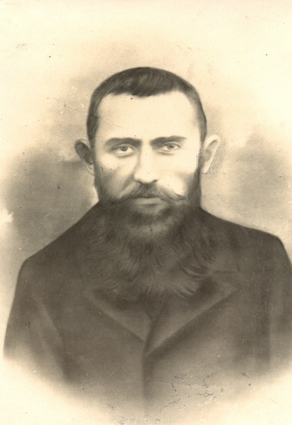
After these bereavements, the teenager is entrusted to his uncle's family. He was a brave man, but quite indifferent when it came to matters of Faith. He did not hesitate to put his nephew, as a Boarder, in a Public Upper Primary School. The Boarding School had no Religious References; on the contrary, there reigned an Atmosphere of contempt for the Faith, lack of respect for the Commandments and Immoral Conduct. Mary-François tried to resist this unhealthy drift, to remain consistent with the Education received in Family and at School, but he was dragged away by bad examples, by the Atheist Mentality of his comrades, by the General Vulgar Atmosphere. and Immoral. Little by little he became like the others, taken by the same vices. “Lamentable shipwreck, from which he will never console himself and whose sadness he will denounce later, denouncing the bad examples he had experienced. When in 1908, with his Certificate of Competence, he left the Boarding School, there remained, apparently, nothing of the Faith inherited by his Pious Mother. He began his working life as a Clerk for a Notary. But he had no interest, the heart was empty, the soul was bored. He filled his anguish by running to places where people had fun, he travelled, he rans after all kinds of pleasures, but his heart remained restless, until he became disgusted with life. To continue his life of pleasure, he needed more money. He believed he found the solution by entering Teaching. He responded to a Newspaper ad by going to take up a Teaching Position in Bréal-sous-Montfort. The Director of the School welcomed him kindly: Mary-François discovered that he had arrived in a Christian School and that he was also responsible for Teaching Religion. He immediately thought about retiring at the end of the first month. But Providence was waiting for him. In the Parish he met a Young Priest who noticed this young man's discomfort: he listened to him, encouraged him, responded to his doubts and his prejudices, pacified his soul. Likewise, at School the Director helped him to overcome his difficulties. From the Younger Class, which he was unable to master, he moved to the Older Class, where there were fewer students and already trained in responsibility. The Young Apprentice Teacher tried teaching in the New Class and found himself much better. He finally began to calm down and his Class was more Peaceful and Orderly. At the same time, Grace did its work: one morning in the small Church of Bréal, Mary-François received God's forgiveness and he approached the Holy Table to receive the Eucharist. It was the end of his error and the return of the Prodigal Son to the Father's House. From there on his life would be in the service of God and Children: he wanted to repair his faults and gave himself Ardently to the Lord: “Never too much for God, nor for Souls. Never too many Sacrifices! Never too much Love!” He would now be a Faithful Disciple of Jesus and an Ardent Apostle for children in Bréal,
Mary-François HAMON
A NEW LIFE
He gave himself to the Apostolate without sparing himself: he created an Elite among his Young Students. Without neglecting the Masses, he enlivened them with Christian Sap, with the Gospel, with examples of Saints; He trained him in the Apostolate of Testimony in Class and during recess; He exhorted him to Additional Prayer, to visits to Church. “Mr. Hamon” was experiencing a moment of Great Serenity, was at ease in the Community, but he would like to see more clearly about his future. He was determined to repair his past life in sin: he would like to join a Penitential Religious Order. But his Spiritual father and the Director of the School, “The Good Superior”, F. Lucidas, reassured him that his Vocation was indeed that of a Brother-Teacher. He went to the Novitiate in England: there he met the “Saint” Brother Constantin-Marie, Legendary Missionary from Alaska and man of Solid Spirituality. He kept the name of Marie-François (these were the times of Secularization and it was necessary to Eliminate the Signs of Religious Consecration), demonstrating his Devotion to the Virgin.
He found Cancale again, this time as a Brother and embarked on the Project of Apostle in the Christian School. He was happy to teach children who had the ocean in front of them and dreamt of great adventures. The heart of its Educational Action was Faith. All knowledge was inspired by the Christian Religion: in it the Brother formed thought, Heart, Feelings, Relationships, that was to say the Integral Man. To achieve this Program, Our Apostle began with himself. There were demanding Regulations for the Schedule, the Exercises of Prayers, the Use 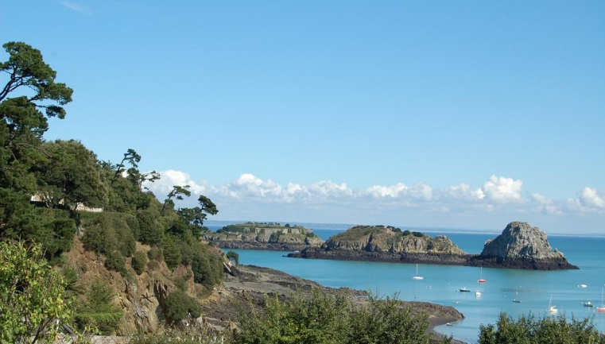of Time, the Apostolate, Study, and Free Time. He prayed long and hard: Eucharist, Rosary, Spiritual Reading. He worked “all the time that the Good Lord gave him”. With his students he became the Soul of their journey of Faith. He created Groups linked to the Apostolate of Prayer: Brotherhood of the Apostolate, Volunteers of the Sacred Heart, Knights of the Sacred Heart, the Slaves of the Sacred Heart, the Convicts of the Sacred Heart. Each of these Groups had a Specific Regulation. Let us give an example from the Group of Knights: “No human respect/ accept all Penances, even undeserved/ avoid Bad Company/ do service to your fellow students, especially those who displease us/ Never complain about Thirst while walking/ offer One’s Labors to the Sacred Heart through the Immaculate Heart of Mary/ at least Weekly Communion.” The Meetings of these Groups were held in Br. Marie-François’ Class. The Associates prepared a small, Well-Decorated Altar with an Image of the Sacred Heart or the Virgin. The Celebrations had this tone: “The Candles are lit: let us salute the Sacred Heart which brings us together - Let us salute Mary: Ave, Maris Stella - She is our Mother: Monstra te esse Matrem - Mary will Pray for us. Let us sing: I will go see her one day - Let us say a Prayer for poor sinners - Let us turn our hearts towards Jesus, present at the Tabernacle: O Salutaris Hostia - Let us make a Spiritual Communion” Then the fiery words of the master ignited the hearts of the young students. They left the Meeting, ever more determined to follow their master’s beautiful motto: “Never too much for God! Never too many Sacrifices! Never too much Love!”
From time to time all the Congregants were mobilized for a General Ceremony. Here are the impressions of a witness: “What a Beautiful Phalanx crowded that day at the foot of the Altar! Everyone carefully followed the Prayers of the Mass in their collection. This memory still moves us to tears today: what Meditation, what fervor among the children! And what Joy, when, leaving the Church, they came to give Mr. Hamon a confident handshake, thanking their master for having made their Souls so good, so all to God!”
The Educational Action of Brother Marie-François was not limited to the Strict School Timetable, but extended throughout the Week. In Cancale, the Population was completely occupied by Activities linked to the Sea and Fishing. Also, on days off the children were left to their own devices, exposed to all kinds of dangers. After discussing it with the Priest and the Good Superior, Mr. Hamon would make himself available to the students on Thursdays and Sundays. “In the morning at School you can come freely, do Free Reading, Play Dominoes, Cards, Checkers. In the afternoon we will take a nice walk!” With great Joy the kids rushed to School. Then, at two o'clock, a short visit to the Chapel. We left with the Ball to play on the meadows (the nielles), we entered the undergrowth, we ran on the Sandy Beaches or we took the Wild Coast to play the Ball, Leapfrog, or even had fun Fishing. When it has calmed down, a few students erected a small Altar on a mossy mound or the hollow of a rock. A whistle and the gang gathered near the Altar decorated with Wildflowers. Hymns, Prayers, Exhortations, Little Religious History. These Meetings could take place in a quiet or wild corner, or at crossroads or in the middle of the strike to give a living testimony of Faith. We finished the walk under the gaze of Jesus at the Church.
Faced with this initiative, someone found fault: “the students leave the School areas, there can be dangers, the Brother must be in his Class, these are not Educational Activities…” But Bro Marie - Francis only followed the intuition of the Great Educators: Don Bosco, St. Filippo Neri, St. François de Sales, St. Jean-Baptiste de La Salle, P. de la Mennais, P. Flanagan... He wanted offer children an Integral Education: Study and Play, Authority and Love, Teaching and Animation, Faith and Life... In this way, the Brother had the full confidence of the students, who listened to him and follow him because they knew that the master desired their good. Brother Marie-François had a moment of hesitation in these initiatives because of the contrary paths. But it was the very children who persuaded him to walk this road: “If you abandon us, you condemn us to spend our days off in the middle of the road, abandoned to ourselves and perhaps victims of bad company and dangers of all kinds. Do you want to make us lose our Innocence?” The master, also remembering his sad past experiences, immediately resumed his luminous initiatives with more enthusiasm. What were the fruits of this intense Apostolate? From these Apostolic Groups were born numerous Vocations of Priests, Religious and Missionaries. For this purpose, he organized strong moments of Prayer: the “Spiritual Assaults” which had their summit in the Eucharistic Communion. In the years 1918-21 we find 117 names of little Apostles of the Sacred Heart, which would lead to a large number of Consecrated Vocations.
MORE ACTIVITIES
Six hours of Class per day. Well-filled holidays. Spiritual path of great fervor. Fraternal Community life. All this was not enough for our Brother. Cancale was an important Fishing Port. During the Winter the Good Superior, Bro Lucidas, offered Sailors the opportunity to learn in the Sciences of Navigation. Mr. Hamon gave Lessons to Sailors returning from Cod Fishing in Newfoundland. They improved and also rediscovered the welcoming and Christian Atmosphere of their childhood. Our master was very present in the Parish. He was friendily with the Priests and helped them in a surprising way: he, who had an Artificial hand, was the Official Organist of the Ceremonies. He fixed a Prosthesis on his right hand, he became familiar with the Pedal Keyboard and the Parishioners believed that more Melodious Chords had never been heard in Church. It was also said that, during a Celebration, he managed to repair the Keyboard, while continuing to play with the Pedals and the Prosthesis.
THE TESTAMENT OF A LITTLE “SAINT”
In the years 1914-18 the Brothers were mobilized for the “Great War”. In Cancale too, the mobilization had left large gaps. Brother Lucidas remained because of his age and the Primary School operated with very young lay people of all dedication, led by Brother Marie-François. In 1916 they also resumed Naval Courses. However, this exhausting activity undermined Mr. Hamon's health. At the start of the School Year in 1920, he felt very weak. He wouldn't want to part with his little pupils, but the Doctor forced him to take a period of rest. He was sorry to burden his colleagues with additional work. He wrote to his little ones a letter for each one. He encouraged them to be docile to their Teachers, to be friends of Jesus, to follow their Vocation, to return to the Brothers. The patient's situation became more serious: Breathing Difficulties, Dry and Stubborn Cough, Tuberculosis, did not leave him and exhausted him. In August 1921 he entered the St-Martin Clinic in Josselin. “We found him charmingly reserved, holyly detached from himself, careful not to be sullen or cumbersome, simple and candid in his Obedience.” His heart as always addressed to God and to his children: for them he offered his sufferings. He participated in the prayers for his healing, but he abandoned himself to Providence and the thought of Paradise relieved him, where he could contemplate God, the Angels and the Saints. He was born in Heaven on April 8th, the Saturday Eve of Holy Week. He said to the Nun who was assisting him: “The Blessed Virgin will come and take me to Heaven. You go to Mass. I will unite myself with the Holy Sacrifice of my Savior. Bring the Crucifix to me.” We found him with his gaze turned towards Jesus on the Cross: he went to Heaven to celebrate the Passover of his Lord.
Two comparisons for our little Brother: St-Charles de Foucauld: like him, he had a radical and total conversion; Saint Thérèse of the Child Jesus: he too did small things with immense love and in Heaven he continues to do good, especially to children and their Educators.

SOURCES:
COLLECTION “Serving Youth” n.1, 1940 LAPRAIRIE, CANADA
MENOLOGE FIC pp 427-434
IN THE SERVICE OF CHILDREN AND YOUTH: T. IV pp. 205- 236 “Marie-François Hamon, Vannes 1932
CHRONICLES 1928, nn. 85, 86, 87

