Brothers of Christian Instruction
Mennaisian Family

General Secretary / Directorate of Information
Via della Divina Provvidenza, 44
00166 ROMA (Italia)
secretariat@lamennais.org

Rome - May 2017
Tools to celebrate the Bicentenary
Order form to be returned before the 1st July 2017 by email to :secretariat@lamennais.org

Letter from the Superior General,

To:
The Teaching Staffs of Mennaisian Schools and Educational Centres,
The Parents’ Associations
The Management Committees and the Solidarity Associations, etc.
The Students and Former Students,
The Brothers of Christian Instruction and the Mennaisian Family.

Rome, 10th May 2017

Dear Brothers,
Dear friends,
Dear young people,

This year, we enter into the celebration of the Bicentenary of the Congregation of the Brothers of Christian Instruction of Ploërmel. Thus, we begin a journey, which will last three years with effect from June, 2017 until September, 2020. During these three years we shall give thanks to God for the gift of the Mennaisian Charism which we received through our founders. We shall also try to discern together the calls of the world and of the Church that we shall be invited to answer. We shall finally decide, with the same dynamism and the same inventiveness as our founders to meet the current challenges of education and evangelisation.
The General Council of the Congregation, as well as your own Province or District, will propose to you some initiatives for the animation of these three years.
In connection with the General Council, the General Secretary and the Director of Information of the Congregation have already proposed to you some tools which you can find at the following address: http://www.lamennais.org/logo/ . I invite you to acquaint yourself with the attached Order Form concerning some of these tools. Among them, I would like in particular to draw your attention to the last special issue of La Mennais Magazine which you received recently. It is a good introduction to the celebration of this Bicentenary which can be used for young people as well as adults.
I count on your collaboration and I wish you a good beginning of the celebration of this important anniversary.
Brother Yannick Houssay, Superior General
VERY IMPORTANT.
The order form below presents different tools proposed for the Bicentenary of the Congregation.
These proposals were adopted by the general Conference of last October in connection with the General Council on October 2016.

Specifications
+ Costs. The more we order the cheaper it is for everyone! The prices quoted are the most interesting cost prices, after having interviewed several suppliers.
+Total quantity. The presented prices take into account the editions estimated for the entire Congregation. If at the end, the indicated quantity is not reached, prices will be higher and you will be informed about it.
+Three years. Think of the numerous possibilities during these three years: meetings of parents and families, with children and young people, assemblies of the Mennaisian Family, meetings of teachers and non teaching staff, relations with religious authorities, feasts, anniversaries … It is interesting to build up a stock.

Contacts for more information
Secretary General : Bro Hervé Asse secretariat@lamennais.org
Director of Information : Michel Tanguy m.tanguy@lamennais.org

+ The order form below must be returned before the 1st July 2017 by email to : secretariat@lamennais.org

+ Your order will be delivered by the General Secretary or your Province/District who will transmit it to you.

+ Payment and invoicing: the follow-up will be carried out by the General Secretariat with the corresponding invoices according to the orders placed. You will be told the best way to pay, according to the different countries

OTHER TOOLS FOR THE BICENTENARY:
They are already available on the Website : www.lamennais.org
This order form and other tools as:
- The hymn of the Bicentenary
- A poster of the Bicentenary
- Frame-Posters of the two Founders
- Digital files of the Union Treaty signed by the two Founders

Other Tools :
- Videos are in preparation and in progress:
    - A first video message of Bro Superior General will present the theme of this first year of the Bicentenary on 6th June 2017.
    - A cartoon on JMDLM’s life (15’) : FR-ENG-SP.
    - A documentary about the « Mennaisian places »
    - A film (26’) whose scenario would include the modules of the Mennaisian Educative Project.

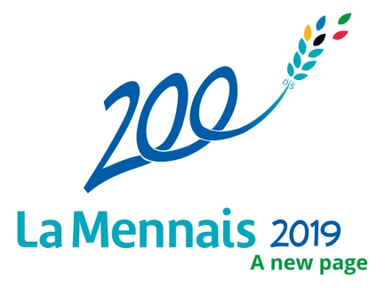  Brothers of Christian Instruction  General Secretariat / Directorate of Information  Complete the box “quantity” | ORDER FORM  To Schools, Educationnal Centres and various assocations of the Congregation

Quantity | FORMAT | DESCRIPTION |  | UNIT PRICE
 | 21cms wide  X 28 cms high  48 pages quadri  200 photos | SPECIAL BICENTENNIAL N° La Mennais Magazine  « Discern together » April 2017 |  | 1, 4 Euros one copy TTC
 |  | Additional edition to spread widely besides the usual addressees  Three languages : FR, ENG, SP | 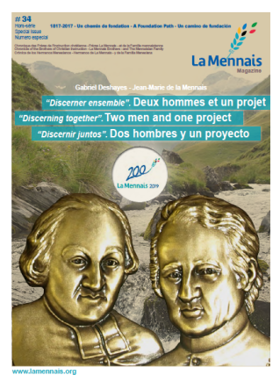

 |  | 8 cms wide  x  12, 5 cms high  150 g | 3 pictures of John-Mary de la Mennais  Versions in FR, ENG, SP  Front: portrait of JMLM  reverse: presentation of JMLM and prayer for the beatification |  |  | 0, 12 Euros one picture  TTC  (for an edition of  15 000 cc.)
 |  |  | Picture 1 |  | 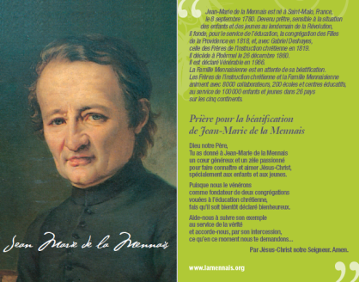
 |  | 8 cms wide  x 12, 5 cms high  150 g | Picture 2 |  | 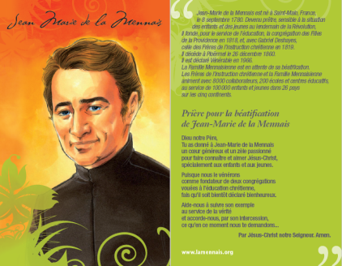 | 0, 12 Euros one picture  TTC  (for an edition of  15 000 cc.)
 | 8 cms wide  x 12, 5 cms high  150 g |  |  | Picture 3 | 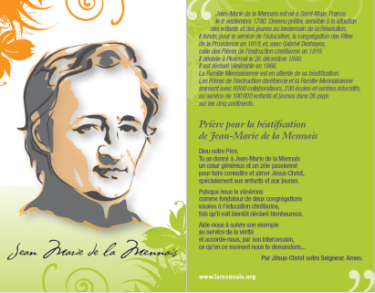 | 0, 12 Euros one picture  TTC  (for an edition of  15 000 cc.)

 | 8 cms wide  x  12, 5 cms high  150 g | 3 pictures of Gabriel Deshayes  Versions in FR, ENG, ESP  Front : portait of GD  Reverse : presentation of GD and prayer to GD |  | 0, 12 Euros one picture  TTC  (for an edition of  15 000 cc.)
 |  | Picture 1 | 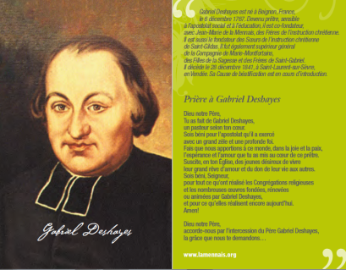
 | 8 cms Wide  x  12, 5 cms high  150 g | Picture 2 | 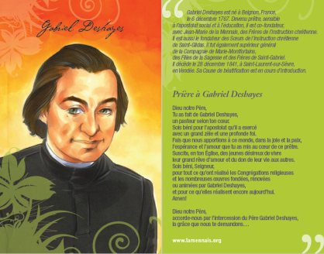 | 0, 12 Euros one picture  TTC  (for an edition of  15 000 cc.)
 | Wide 8 cms  x high  12, 5 cms  150 g | Picture 3 | 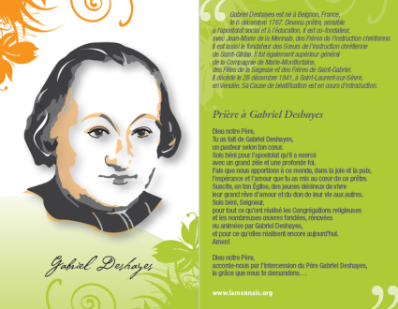 | 0, 12 Euros one picture  TTC  (for an edition of  15 000 cc.)

 | Wide  8 cms  x high  12, 5 cms  150 g | 1 picture of the Bicentenary / A new page  John-Mary de la Mennais and Gabriel Deshayes  Version FR/ Version ENG / Version SP  Front : Prayer of the Bicentenary - Reverse : Visuals of JMLM and GD | 0, 12 Euros one picture  TTC  (for an edition of  15 000 cc.)
 |  | 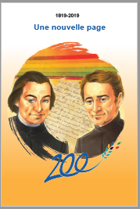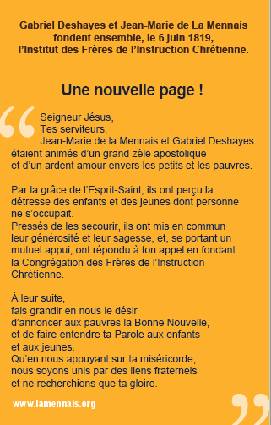
 | Wide  5 cms  x high 14 cms  250 g | 1 bookmark Bicentenary / A new page  John-Mary de la Mennais and Gabriel Deshayes  Version en FR/ Version ENG/ Version ESP  Front : Visuals of JMLM and GD- Reverse : Prayer of the Bicentenary | 0, 14 Euros one picture  TTC  (for an edition of  15 000 cc.)

Order made by :
(Write the person who has made the order)

In the name of:
(Write the name and address of the School or Association)

At : Date : /2017

Order to be sent to the following address:

