The Rule of Life
In the light
of the Word of God

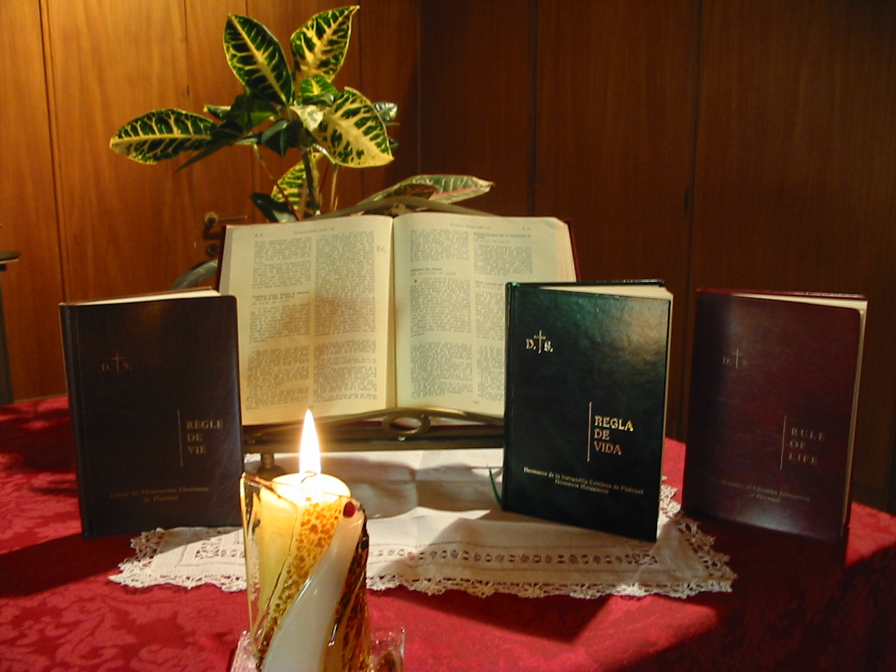

Brothers of Christian Instruction
On-gooing formation 2007-2008

Booklet 6

Mission

MISSION

How to use this booklet

1 – The Superior distributes the booklet to each Brother. He presents the document asking each one to question how our mission is lived: as a basis for holiness, as a place where his experience of God is nourished, as a profession or as a task, as broadening out…

2 – Individual time.
Time is allowed for individual Brothers to read the chapters in the Rule of Life (Constitutions and Directory) devoted to mission.
Reply to personal questions that might be asked.
Prepare the community approach to this task.

3 – Community meetings
Exchange in community the aspects relating to community in the questions that arise.

AIMS
- To live and develop our mission of education faithful to our own charism, as indicated by the Rule.
- Discover what is meant by: the school is “ church concern”, and live our mission in school in agreement with the reality proclaimed by the Church.
- To live out ever more deeply our mission as community mission and help one another to fulfil “the work of God”.
- To look in our schools to see that priority is given to evangelising in its threefold dimension – catechism, vocation ministry and youth groups.
- To make progress in the relationship between consecration and mission.
- To pursue the relationship that exists between the two ends of our educational mission: evangelisation and the contribution of doing all within God’s plan.

TO BEGIN WITH
At a personal level
- I see mission in the context of Christ’s mission, I feel embraced by the sweetness of the Spirit, I am convinced that He renders mission fruitful.
- I see mission as community mission or, on the contrary as an individual.
- What part does Mary play in my way of living out mission.
- Mission for me is a way of communion with the Lord and the food of my experience of God.
- I hold the conviction that I am sent by the Father to bring life to the children and to the youth.
- I take part in catechism, vocation ministry and working with youth.
At community level
- For our community, what assertions are we making about: “ the school is Church centred”.
- Mission always has a community dimension. This is how we live it and feel about it, giving mutual support; or , on the contrary we live out mission as individuals as a task to share out.
- How is the gospel dimension of the school lived out in the community and work place in the dual dimension of announcing the gospel and contributing to ordering God’s plan.
- How is the community engages in catechism, vocations and working with youth.
- How does the community show concern for young people, their education, their evangelisation, as much in its prayer as in its action ?

MISSION IN OUR RULE OF LIFE

The Constitutions has only two numbers on the Brother’s mission. No. 48 which says that the human and Christian education of youth is our special charism and No.49 where the missionary dimension is stressed as our Founders willed it.
These two dimensions were underlined by the Chapter of 2006 when it was stated “the call of the Congregation to proceed with our mission in line with our charism and to revive the missionary flame in each Brother and in each community”.
In speaking of the mission of the Brother, the Rule is very explicit in No.48 of the Constitutions. In reality, as we shall see, the Directory develops and explains this.
“Christ applied to himself the word of the prophet Isaiah: ‘The spirit of the Lord has been given to me, for he has anointed me. He has sent me to bring the good new2s to the poor’” (Luke 4:18)
“The congregation shares this mission .It arose in the Church for the human and Christian education of youth. This is its special charism: the school is its privileged field of activity. Outside the academic framework and taking into account the special aptitudes of some Brothers, it undertakes other apostolates, especially in the broad area of education.
“All the Brothers, regardless of their age or health, share the common mission of the Congregation through their prayer, their work, their sufferings and their holiness” (C. 48)
We will develop this number of the Constitutions through what the Directory says about the mission of the Brother.
Sharing in the mission of Christ
“The Congregation shares this mission ( Christ’s mission)” (C.48).
No. 48 of the Constitutions presents first of all the mission of the Brother as sharing the mission of Christ. The Brother, like Christ, receives the anointing by the Spirit to announce the Good News to the poor and to free the oppressed. As Jean-Marie de La Mennais would say, you will give sight to the blind, make the lame walk, and you will raise the dead. The Brother acquits himself of this mission and shares in it by the spreading of the gospel and by his contribution to shaping the world according to God’s plan.
“ Their baptismal and their religious consecrations associate the Brothers closely to the redemptive mission of Christ to announce the Gospel: “ Go out to the whole world; proclaim the Good News, teaching them to observe all I have commanded you “ and by their contribution to shaping the world according to the divine plan.” (D.104)
The root and source of mission, according to Luke, is the anointing by the Spirit who spreads faith, hope and love in our hearts. This demands of the brother to maintain a deep spiritual life and a deep conviction that all increase comes from the Spirit. It is well to note that the Rule speaks of increase rather than success; these are two distinct realities although they do not necessarily clash. The Brother ought to seek the human means that are most appropriate to fulfil his mission, while at the same time remaining convinced that fruitfulness comes from God, since it comes from Him. As St Paul says: one sows, another waters but it is God who gives the increase.
“The apostolate is carried on through faith, hope and charity which the Holy Spirit diffuses in the hearts”. Are not the Brothers also, conscious of fulfilling their mission as ‘co-workers’ of God”, constantly at work in men. They maintain an intense spiritual life, the source of holiness for them and others. They use all human means without forgetting that our apostolate depends on God alone for its fruitfulness.” (D.104)

Sharing in the mission of the Church
This mission is at the same time a participation in the mission of the Church which has already acknowledged the approval of the Institute.
“The Brothers’ work is essentially ecclesial and therefore integrated into the comprehensive pastoral effort of the Church on behalf of God’s people2 (D. 104)
“The approbation of the Congregation by the Holy See gives the Brothers’ mission an official status. In fidelity to their calling and in loyalty to its Founders, the Brothers eagerly respond to the pastoral directives of the Pope and of the bishops in whom is invested prime responsibility for the apostolate”. (D. 105)
Education – our true charism
Human and Christian education of youth is defined as the particular charism of the Congregation.
“It arose in the Church for the human and Christian education of youth. This is its special charism” (C. 48)
“The Congregation fulfils its apostolic mission primarily by the human and Christian education and instruction of youth, especially of the lowly and the poor. This specialisation increases efficiency, prevents the dispersal of efforts and provides the Brothers with the benefit of an ever-growing experience”. (D. 105)
A specific apostolate – education
As Directory No.104 says, this apostolate carries a double dimension:
“to participate closely in the redemptive work of Christ through proclaiming the Gospel: ‘Proclaim the Good News to all creation, making disciples of them…..teaching them to observe all I have commanded you’ and by their contribution to the divine plan for the world” (D104)

Working towards the realisation of God’s plan for the world.
The document “The Catholic School” treats “ the school as a place in which young people learn to progress steadily in awareness in understanding life.”
All teaching gives a view of the world, and the school is a place where a sense of purpose is given with Gospel values.
“The Brother respects the autonomy of the secular subjects which he teaches. Yet, he knows how to relate profane knowledge to man’s call to salvation, so that faith ‘illumines the understanding which students gradually acquire about life, mankind and the world”. (D.119)
“The Brother prepares his students for their future roles by an appropriate social and civic formation. He prepares them to work towards the gradual elimination of unjust social and economic structures and of all forms of discrimination in basic human rights ,thus disposing them to carry out God’s plan for mankind.
He sensitizes them to the major problems of the world and to the great aspirations of his fellowmen for peace, justice, freedom and truth” (D 120)
Education comes through contacts, the style of relationships that we put in place within the school system. Respect for the dignity of the person and love are central to relations, dialogue and a welcoming spirit and these are the essential links.
“The Brother’s educational apostolate depends on the love and respect for his students in whom he recognises the dignity of man, created in God’s image and destined to live in union with him. Personal development requires interaction marked by sympathetic understanding and mutual trust”. (D. 112)
As the publication “Éduquer ensemble dans l’école catholique” says,
«Based on the diversity of people and vocations, but given life through the same spirit of communion, the Catholic School aims to create relationships which are themselves educational and increasing in depth. It is precisely this that “explains the variety and beauty of different vocations as well as their richness on the educational and pedagogical level in the life of a school”.
“The success of human and spiritual formation requires collaboration complementary witness of all educators: parents, religious and lay colleagues, priests etc. The Brothers strive to elicit the active participation of students, whom they progressively prepare to assume responsibility for their own lives and for the society in which we live. (D.113)

Education in the faith – a major concern for the Brother
The other goal in Mennaisian education is evangelization through spreading the Gospel. This is insisted upon in the Rule.
What relation is there between a world ordered according to God’s plan and evangelization? To evangelize means to learn how to discover the sacramental dimension of life.
To discover the Good News that God is present in life and in history and orders all things within his plan of salvation as revealed in Jesus Christ. As you can see, there is a narrow link between these two ends: to discover the presence of God, and thus, order all things to realizing his plan of salvation.
The Chapter 2006 also gives this double relationship: “ Mennaisian lay people and Brothers of all ages commit themselves resolutely to a Gospel inspired education, particularly regarding issues such as the right to life, peace, justice, solidarity and dialogue among religions, in a spirit of charity and of self-giving.”
“The Chapter encourages the deepening of the meaning of Mennaisian education so that our educational establishments become centres of evangelization.” (Capitular Document pp17-18)
“Education in the faith must be a major concern of the Brothers. To the witness of their own lives and to the climate of freedom which they help create in the school, they add special attention to catechesis, the awakening of vocations and the promotion of youth movements”. (D. 114)
Thus, according to the Rule, education in the faith carries three fundamental elements:
Catechesis
To make Jesus Christ known and loved is the first aim of the Mennaisian school.
“Catechesis is a participation in the ministry of the Word. To be fruitful, it should correspond to the deep personal convictions of the teacher and be reflected in his lifestyle. The Brother works to improve his doctrinal and catechetical formation and is careful to work closely with other teachers of the faith at the heart of the Christian community.”(D.115)
Vocation ministry
The Chapter 2006 reminds us that vocation ministry is an essential element of Mennaisian education. In this, the appeal of the Brother’ vocation takes on a character of urgency for the fulfillment of mission.
“The Brother willingly listens to his students in order to understand and help them. Attentive to the special vocation of each person, he prepares the laity within the Church by promoting all vocations, but nurtures with special care vocations to the priesthood and to the religious life.”(D.116)
Youth groups
With a congregation of young people, John de La Mennais envisaged, in his own way, creating a battalion of apostles who would transform their field of education.
“In his thinking – and this is how he always understood it – groups should be a sacred battalion made up of subjects without any human respect who would, cost what may, exercise the apostolate of good example.”
He himself founded groups of young people and invited the Brothers to do the same.
“Each day our college improves. Do not affect piety, zeal, fervour of my groups. These are angels. Oh no! I will not leave these children who are so dear to me”
It is this sensitivity that he passed on to his Brothers.
“I fully approve of the small association you have set up in honour of the Blessed Virgin Mary, and I hope God will take the glory for it. Carry on with your work with zeal and Our Lord will continue to bless your work to increase the number of the faithful servants of his Mother”.
“Religious education finds an essential complement in sodalities and other movements of spiritual development and Catholic action. Brothers readily collaborate with those who animate and direct such movements.” (D-117)
Mary and the mission of the Brother
Mary is presented as a model of evangelization. Evangelization has for its goal to create children of God. Mary brought forth the Son and helped in the birth of others, his brothers.
“Having been called to work at the growth of divine life in souls, the Brothers seek Mary’s help in their ministry of evangelization and try to promote her devotion among their students. The Virgin Mary indeed gave birth to a Son, whom God made ‘the first born of many brothers,’ whom she surrounds with her love as she participates in their birth and development. (D.118)
The school – a special means
The school as a special place to ensure our mission.
As the document “The Catholic School” puts it, “the catholic school is set up as a ‘Church entity’ a place of specific pastoral activity. It shares in the evangelizing mission of the Church, and it is a privileged place for Christian education. It is a ‘real Church experience’ because of the teaching where faith, culture and life are combined closely.”
“The Congregation chooses the school as a special field of action. Today, as much as in the time of our Founders, the school gives a vital service to individuals and to society by the formation of free and responsible persons. The Christian school does even more: integrating the acquisition of knowledge, the preparation to responsible freedom and education in the faith. To accomplish this, the Brothers devote themselves to teaching, catechesis, pastoral care as well as other activities deemed necessary or useful in special circumstances. (D.106)
It is interesting to state the insistence of the Rule on the evangelizing aspect of education and the school. It is one of its points of emphasis.
Unity of life
Another great emphasis of the Rule is the unity of life of the Brothers. This comes through strongly in the chapter on prayer, as well as that on mission. The Rule shows us the close relation between mission and consecration, between mission and the spiritual life.
Mission and consecration
This is how Jean Marie de La Mennais explains the relationship between mission and consecration: “What a beautiful moment for you, my dear children…. You are going to devote yourselves to the Christian education of youth and take the vow of obedience. Glory to God for inspiring you to such a resolution and may he give you the strength to fulfill such! Peace be to you for you are men of good will to whom the angels have announced and promised, when Jesus appeared in the world, and gave to us all, the example of poverty, humility and total abnegation of self. You have the desire to walk in his steps, to be meek and humble of heart, following his example, to be like him, obedient unto death to the will of the heavenly Father”
Lord, all powerful God send forth your spirit upon your servant who consecrates himself to your service in this congregation; grant that, helped by your grace, he may merit to reach eternal life with the children who will be confided to him.”
“Between the Brother’s religious state and his educational mission, there is harmony and interaction: his religious consecration finds specific expression in apostolic action, which, in turn, sustain his Christian and religious life. This reciprocity of influence permeates all aspects of the Brother’s life.” (D.107)
“The vows of the religious educator favour his greater availability:
- Consecrated celibacy helps him to be a Brother to all, in a simple and genuine relationship which expresses Christ’s universal love;
- Evangelical poverty is expressed by the pooling of resources for apostolic work. The spirit of detachment facilitates true dialogue and moves the Brother to share the benefits of his cultural achievements with others, especially the less fortunate.;
- Religious obedience makes the Brother more attentive to the designs of God on him and makes him more available for apostolic responsibilities proposed by his superiors and his community.” (D.108)
“The religious life of the Brother, apostolic by its very nature, offers witness to the transcendence of God and to the restoration of mankind in the risen Christ.”
“Having centred his life on God’s Kingdom, which is even now a reality of history, and yet engaged in temporal activities, the Brother gives priority to eternal values as he pursues his educational work;
“He strives to make his message convincing to men of good will, to hearts that are straightforward and receptive. He does this mainly by the quality of his relationship and by his obvious happiness in the service of God and of men.” (D. 109)
Mission and community
“The Brothers fulfill this mission “ as fellow workers with God” (D. 104)
“In his community, the brother develops a spirit of understanding and collaboration which disposes him to co-operate with his colleagues in the school and in the parish. In turn, the Brother’s apostolate enhances the unity and dynamism of the fraternal community.”(D.110)
Mission and prayer
“The apostle’s relationship with others will be genuine if it reflects a deep union with God and leads back to him. Hence, the brother often prays for those who depend on him or with whom he lives and works. Occasionally, he invites them to participate in the prayer of the community and he, in turn, joins the parish community for prayer.” (D.111)
THE MISSIONS
Another number in the Constitutions speaks about the missionary spirit; it is developed in the Directory when he speaks of the missions.
“The Congregation also has a missionary vocation bequeathed to it by its Founders. In response to the needs of the local churches, it sends forth Brothers to spread the Gospel outside their native lands.
“Superiors carefully select Brothers in whom they discern a special call from God, manifested by a serious desire and necessary aptitudes for missionary work, and provide them with an adequate preparation.” (C.49)
The Congregation is missionary through the express will of the Founders. Every Brother should live and cultivate this missionary dimension, even if he is never sent to a mission country by his Superiors. The spirit which has a specific highlight is the evangelizing one.

THE WORD OF GOD
Lk 4, 16-21
“He came to Nazara, where he had been brought up, and went into the synagogue on the Sabbath day as he usually did. He stood up to read, and they handed him the scroll of the prophet Isaiah. Unrolling the scroll he found the place where it is written;
“The spirit of the Lord has been given to me, for he has anointed me. He has sent me to bring the good news to the poor, to proclaim liberty to captives and to the blind new sight, to set the downtrodden free, to proclaim the Lord’s year of favour.”
“He then rolled up the scroll, gave it back to the assistant and sat down. And all eyes in the synagogue were fixed on him. Then he began to speak to them ‘This text is being fulfilled today even as you listen”.
This text has two parts. Verses 14-15 are a resumé. They present the mission of Jesus in Galilee. In Lk 4,1 we read “Jesus, with the power of the Spirit, returned from the Jordan and he was led by the Spirit across the desert.” Exactly as in the text that we are commenting upon; in fact, the text gives two fundamental aspects, the fact of being filled with the Holy Spirit and the fact of being led by Him. Jesus experiences the Spirit and it is from this experience that he lets himself be led. Jesus’ teaching in the Jewish synagogues is follows the lead of the Spirit.
In verses 16-21 Luke applies the general plan of the summary to the particular case of Nazareth. The Spirit leads Jesus to Nazareth and makes him enter the synagogue. Jesus gets up to read, takes the scroll offered to him, from the prophet Isaiah, the messianic prophet, unfolds it and searches for the precise place. Jesus seeks the passage which describes his experience of God and the way to live out his mission. In the chosen passage he sees a reflection of himself.
What does Jesus tell us in the passage he has chosen?
That he feels filled with the Holy Spirit, blessed by gentleness, covered with the light and strength of the Spirit. It is same Spirit who reveals the hopes of his father which he readily accepts. It is the Spirit who pushes him to fulfill them. Through the mediation of the spirit, Jesus brings to life the Father’s wishes; he is the outward face of the invisible Father. In Jesus is revealed the person of the Father, his heart.
It is a heart that wants to be the good news for the poor, a heart that loves, which frees, which saves and which, above all, is the gift of God.
The people will be surprised by this image of God which does not agree with what they think. They will also be surprised that Jesus takes from the prophet Isaiah announcing vengeance. Initially the text is not an invitation to involvement as one would have expected. What he sees is the revelation of the experience of God that Jesus reflects and to make us see how this is the source of mission. Mission arises from knowing the heart of the Father; it is born of this knowledge; it urges us to know the Father even more and to trust oneself to his heart.
“Today, this word of Scripture is accomplished before you.” It is this attitude that should push all believers towards hearing Scriptures and he should be able to say” Today The Word is fulfilled”.
To be born in the life of the Word of God, to deepen one’s knowledge of the heart of the Father through the Word.
Matthew 28, 18-20
“Jesus came up and spoke to them.” All authority in heaven and on earth has been given to me. Go, therefore, make disciples of all the nation; baptize them in the name of the Father and of the Son and of the Holy Spirit”, and teach them to observe all the commands I gave you. And know that I am with you always; yes, to the end of time.”
Jesus received all power on earth, as is says in Matthew 9,6. After his resurrection he sat at the right of the Father (Mt. 26,64)
It is through this universal authority that Jesus sent his disciples on mission in the whole world. Mission consisted in making disciples through announcing the Gospel and baptism.
The disciples should proclaim the message of Jesus so that these new disciples know and practice this message. This means to live the message, as contained in the beatitudes, the new Law of the Kingdom.
The community, by the way it acts and through its fidelity to the message of Jesus, is the school for beginners
In this mission we are not alone. The risen Christ continues to be Emmanuel. Jesus stays with us. We have the certainty of Jesus’ presence in the community; a dynamic presence given our mission. Jesus has promised he will be in the middle of the community where two or three are united in his name. Here Matthew reminds us that He is also present at the centre of the community to give life to mission.
1 Corinthians 3, 6-9
“ I did the planting, Apollos did the watering but God made things grow. Neither the planter nor the waterer matters: only God, who makes things grow. It is all one who does the planting and who does the watering, and each will duly be paid according to his share in the work. We are fellow workers with God; you are God’s farm, God’s building.”
In God’s field each one has his mission; one plants, another waters. We must never forget that the increase comes from God. It is his grace that brings fruit. It is He who, within, gives life and brings forth fruit.
We are called to work within the same field, we are collaborators of God. Those who work for the same cause, not in competition, have not got reserved responsibilities. We are co-operators with God. We all work in the one field.
Romans 8, 29
“They are the ones he chose specially long ago and intended to become true images of his Son, so that his Son might be the eldest of many brothers.”
Mary gave birth to Jesus, the first born Son among many brothers. Mary, too, collaborated in the birth of the Body of Christ, of the Church

The Catholic School, n°.31
Educate together in the Catholic School, n°. 37
LAVEILLE: Jean de La Mennais (1780-1860) vol 1 p106
LAVEILLE: Jean de La Mennais (1780-1860) vol 1 p221
À travers la Correspondance, vol 3 p226 (lettre du 08-06-1843 au frère Hyacinthe
S. VII p 2375
Rule of 1825, Prayer of profession

