The Rule of Life
In the light
of the Word of God

Brothers of Christian Instruction
On-going formation 2006-2007

Booklet 3
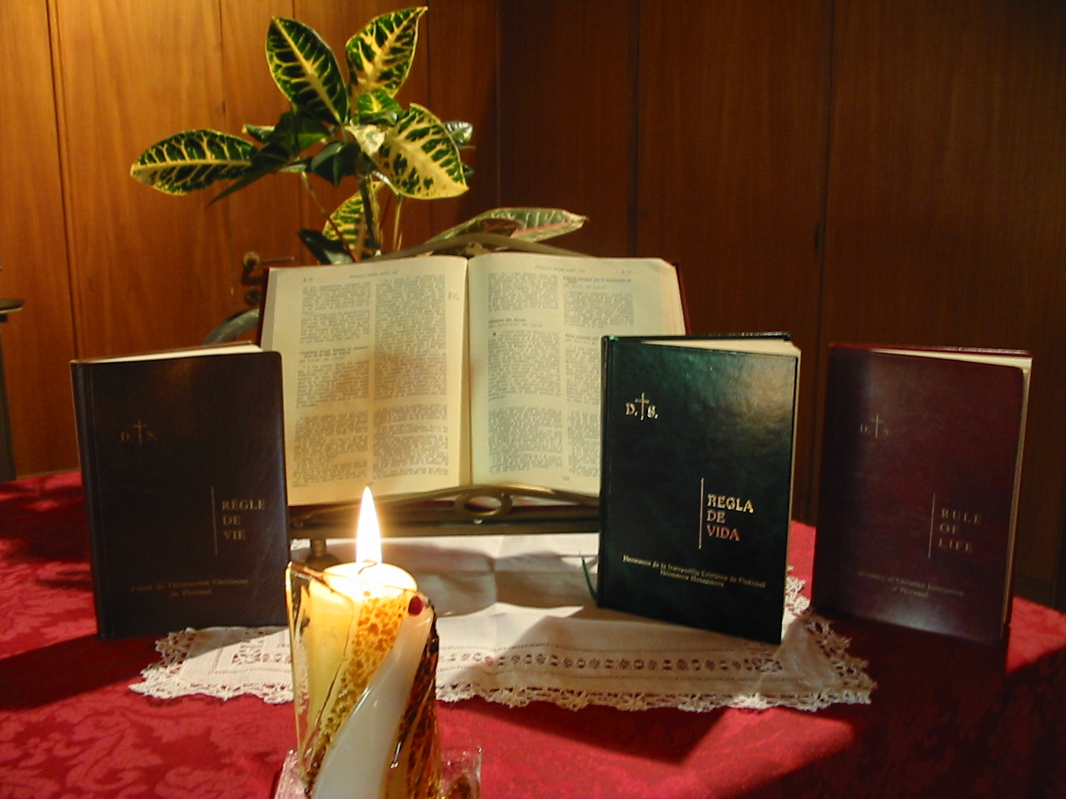

How to use this booklet

- The superior distributes the booklet to each Brother. He presents it, suggesting that each one asks himself how he understands the vows first and foremost: as moral requirements, as ascesis, as a way to link to God and others. Then, he considers with the Brothers the objectives to aim for.

- Time alone.
Allow some personal time for the Brothers to read what the Rule of Life (Constitutions and Directory) says about the evangelical counsels.
Respond to the individual questions that each suggests
Do the work proposed in community.

- Community meeting
We can share together the responses to questions 2, 3, 4, 6 and 8 in the individual questionnaire. Share the community aspect together.

THE EVANGELICAL COUNSELS

AIMS

Place the evangelical counsels in the context of the Trinity, of Jesus Christ – The Son, the One sent – and of the Kingdom of God.
To discover and savour the relationships within the evan-gelical counsels.
To study the evangelical counsels as the best way to fulfil and free the person.
To consider the necessary ascetic dimension as a means and not an end in itself.

TO START WITH
Individually

- My relation with the Lord: is it with “You” at a personal level, living and present, or is it just a question of ideas? Do I find loving peace in the Lord or am I looking for a place of refuge from my frustrations, in Him?
- What is the link between my way of relating to others and to the Lord?
- How does the fraternal life lived in community support my practice of the vow of chastity?
- If someone witnessed over a period of a month our personal and community life would they discover that “ God alone suffices?”
- Do I feel that I am becoming more and more a poor person (I accept my limitations, I am aware I am a creature, I acknowledge all I receive and I am not demanding)? In difficult moments do I turn to the Lord?
- Why, in your opinion, do community problems relating to poverty become difficult?
- How do I personally view the vow of obedience? As following Jesus “who learned obedience through suffering” or in trying to keep one’s independence?
- How do I seek the will of God in daily events? Do I identify it with my own point of view or do I turn with faith to the many intermediaries to avoid self delusion?

In Community

Three relational attitudes considered as indicators that your community is

▪ Chaste

▪ Poor

▪ Obedient

Give some examples of each attitude.

1 - The evangelical counsels – Confessing the Trinity, serving the Kingdom of God, becoming Christ like

a)The evangelical counsels and the Trinity

“Vita Consecrata” invites us to relate our vows with the mystery of the Trinity to discover a deep meaning.
“ To relate the evangelical counsels to the Holy Trinity is to reveal their deepest meaning” (V.C. n°. 21)
After this reference to the Trinity we see that the vows are essentially a gift of God’s love.
“ The evangelical counsels are, above all, a gift of the Most Holy Trinity. The consecrated life proclaims what the Father , through the Son and in the Spirit, brings about by his love, goodness, his beauty.”(V.C. n°. 20 )
The evangelical counsels thus proclaim the Trinity, a sign of God in history.
“ The consecrated life becomes one of the tangible seals which the Trinity impresses on history so that people can sense with longing the attraction of divine beauty”. (V.C n°. 20)
By referring the document on the evangelical counsels to the mystery of the Trinity, Vita Consecrata shows the narrow link of these counsels to the kind of life we are called to live. The vows aim to deepen the way we ought to live out our relation with the Father and, in Him mission and community.
“ Fraternal life in itself …. is a clear manifestation of the life of the Trinity” (V.C. n°.25)
The required ascetical dimension of the vows has for object to make of our life style a proclaiming of the Trinity.
b) The evangelical Counsels and the Kingdom of God
We read in Vita Consecrata:
“ The evangelical basis of consecrated life is to be sought in the special relationship which Jesus, in his earthly life, established with some of his disciples, whom He called not only to welcome the Kingdom of God into their own lives, but also to put their lives at its service, leaving everything behind and closely imitating his own way of life.” (V.C. n°.14)
The Kingdom of God is the incarnation of relations with the Trinity across history. It is the story of sonship and fraternity within our lives. The evangelical counsels, as signs of the Kingdom, aim to deepen in our lives both sonship and fraternal life. The evangelical counsels represent the way in which we welcome and serve God’s Kingdom in our lives.

c) Evangelical Counsels and modelling on Christ
Vita Consecrata says:
“By the profession of the evangelical counsels, the characteristic features of Jesus – the chaste, poor and obedient one – are made constantly visible in the midst of the world.” (V.C n°.1)
The evangelical counsels seek to make visible and to incarnate the relationship of Jesus as Son, sent to set up the Kingdom of God.
This triple reference shows us the close link between the evangelical counsels and the types of relations we are called to live out.
The vows are the incarnation of these three relations down through history. They are a deepening of relationships with the Kingdom, an expression and practice of the relationship of sons, sent as we are also.

2 - CHASTITY

“The chastity of celibates and virgins, as a manifestation of dedication to God, with an undivided heart, is a reflection of the infinite love which links the three Divine Persons in the mysterious depths of the life of the Trinity” (V.C. n°.21)

a) Relationship with God.

Constitutions n°.11 establishes a relation between chastity and bonding with Christ “ to follow Christ more closely,” and between chastity and the Kingdom of God “ celibate for the Kingdom of Heaven”.
Constitutions n°. 14 tells us that chastity is a gift from God, the source of intimacy with Him. Chastity deepens our intimacy with the Lord.
“ Chastity, fruit of our intimacy with God, is a remarkable grace.”
Chastity leads us to belong more faithfully to God, without any sharing: it frees the human heart in order to make it more ardent in the love of God and all people.
Directory n°. 36 also speaks of chastity as a preference for Christ. Chastity changes the human being in depth and creates in him a mysterious resemblance with Christ.
Chastity is a sign of the preferential love for the Lord. It puts into perspective the bond uniting us to the Father, by putting other bonds into their place, and thereby becomes a profession of our sonship.

b) Missionary dimension

Directory n°. 39 tells us that the Brother is happy to be able to offer to others the resources of his unfettered heart.
“ Perfect continence is a sign and a spur of charity and a particular source of spiritual fruitfulness.”
Chastity renders the Brother “ more open in his professional and apostolic undertakings .” (D 62)
Directory n°. 35 speaks of celibacy for the sake of God’s Kingdom. The celibate is a sign and instrument of the Kingdom.

c) Community Dimension
Chastity is equally reflected in community relations. As Directory n°. 40 states: “ The brothers live together in genuine fraternal love in the joyful gift of self, in mutual trust and a caring attention to others.”
Chastity like chastity for the Kingdom, carries a community dimension which is essential. In community, relations of the Kingdom, sonship and fraternity, should find a real birth.

d) Ascetic dimension
The preferential love for the Lord, the freedom from sensitivity, the joyous gift of self, suppose an education of the heart and ascetical demands.
Constitutions n°.13 stipulates:
“Besides the renunciations demanded of all Christians, consecrated celibacy requires others, which prudent religious discover by a kind of spiritual instinct”.
The expression “ by a kind of spiritual instinct” means that it is not simply a question of voluntariness but an opening up to the Spirit; it is He who engraves the law in our hearts.
Directory n°. 37 and 38 give details of such renouncements to be lived by the Brother: the acceptance of solitude, of one’s sexuality and one’s temperament, mastery of the heart, personal equilibrium, vigilance….

e) The Word of God
Mk 10,29-31
“ Jesus said, ‘ I tell you solemnly, there is no one who has left house, brothers, sisters, father, children or land for my sake and for the sake of the gospel who will not be repaid a hundred times over, houses, brothers, sisters, mother, children and land – not without persecutions – now in this present time and, in the world to come, eternal life. Many who are first will be last, and the last first.’

To give and take is expressed in relationships. If we list what we leave behind and what we receive we will notice we receive a hundred times more except in fatherhood! About the Father, there is only one and He is in Heaven. Jesus calls us to form a new family which will be made up of those who do the will of the Father (Mk 3,34-35). In this new family relationships do not impoverish; on the contrary, they enrich. Aside from the unique paternity of God we are all called to be mothers, sons, daughters, sisters and brothers.

Lk 20, 34-38
“Jesus replied, ‘ The children of this world take wives and husbands, but those who are judged worthy of a place in the other world and in the resurrection from the dead do not marry because they can no longer die, for they are the same as the angels, and being children of the resurrection they are sons of God. And Moses himself implies that the dead rise again, in the passage about the bush where he calls the Lord the God of Abraham, the God of Isaac and the God of Jacob. Now he is God, not of the dead, but of the living; for to him all men are in fact alive.”
This text contrasts two phases, two ‘worlds’.
The children of this world marry and have children. The children of “ the world to come” do not marry and have children. They are under the sign of the gift and of life. They do not marry because they cannot die.
“Marriage gives life to those who die after. The resurrection, to those who should die, gives a new life, free from death and child bearing. Man can renounce marriage because he is a person who is on a par in his relation with God. He is not obliged to continue the species because he is the same species as God.”
Christian marriage, as a sacrament, proclaims that the true source of life and love is in God. Our God is the God of the living. If God is the God of Abraham, Isaac and Jacob, it is a sign of resurrection..
“ He (Jesus) saw the state of virginity as a way of living entirely for the Kingdom, by creating a universal fraternity, as a way of interpersonal relations which will continue to be valid in the next world, such that they will transcend what might be based on distinctive features.”

Mt 19,12
“ There are eunuchs born that way from their mother’s womb, there are eunuchs made so by men and there are eunuchs who have made themselves that way for the sake of the kingdom of heaven. ‘ Let anyone accept this who can’.”

Renouncing marriage is not a question of ascesis or of voluntarism. One can only make such a renouncement on condition that one has found the treasure of the Kingdom, and this is a gift. This gift is the desire, written in our hearts by the Lord, to consecrate ourselves for the Kingdom, struck by urgency of his coming which will show the fullness of our blossoming. . The sole reason for abstaining from marriage is for the Kingdom as an expression of a new universal family. That is what Jesus lived and felt; it is on the basis of this experience that he calls others to follow him.

2 Timothy 1,2
“ It is only on account of this that I am experiencing fresh hardships here now, but I have not lost confidence, because I know who it is that I have put my trust in, and I have no doubt at all that he is able to take care of all that I have entrusted to him until that Day.”
Paul is in prison for the second time. He says he has not lost confidence over his hardships, that is to say, he doubts neither his mission nor his preaching, in spite of his trials. Paul adopts such an attitude in the light of his full confidence in the Lord and the hope within him.

3 - POVERTY

“ Poverty proclaims that God is man’s only real treasure…. It becomes an expression of that total gift of self which the three Divine Persons make to one another.” (V.C. n°. 21)

a) Relation with God
Constitutions n°. 15 tells us that Brothers make the vow of poverty to imitate Christ so as to “ to detach themselves from who they are and what they have…..Thus, they become more readily available to God and others”.
Like the three Persons of the Trinity, the Brother lives the total detachment and the unconditional giving. He lives such by reason of his total confidence in the Lord who becomes his whole wealth.
Constitutions n°. 27 says: “ Religious poverty and Christian charity are inseparable”. It is love for the Father and full confidence in Him that pushes the Brother to become enriched with this love. Through the example of Jesus Christ he receives his identity in welcoming all that the Father offers him.

b) Missionary dimension

Poverty brings the Brothers “ to free their hearts from the grip of temporal values” (C 24). It breaks the instinct in them to appropriate, which can be a source of division and of violence.
This interior freedom alongside temporal goods creates in the Brother “ a cheerful availability to others and the readiness to share”. (D 43)
Share his temporal goods, place his talents in the service of others
The spirit of sharing invites him to a real communion with the poor (D 48) and to live his mission as the greatest service that he can offer them (D 30)

c) Community dimension
Directory n°. 46 says:
“ The community of goods is an essential element of religious poverty.” Communion expresses the solidarity among the Brothers and strengthens the bonds which unite members of the Institute together. Communion which shows the pooling of resources that characterizes what belongs to God.
This communion which has become life in the community “anticipates eternal life when God will fulfil every aspiration.” (D49)

d) Ascetic dimension
To free the heart from the spirit of possession and to live such insecurity in entire confidence in the Lord (D 47) concrete requirements in the life of the Brother are needed.
The Brother renounces the free disposal of his goods (C 16): he frees himself from comforts, commodities, posts and functions, seeking success and recognition, including cultural fulfilment (C24). He lives like a person of modest means (C 26). He knows how to deprive himself of superfluous goods (D 44) in submission to the universal law of work (D 62).

e) Word of God
Acts 4, 32-35
“ The whole group of believers was united, heart and soul; no one claimed for his own use anything that he had, as everything they owned was held in common. The apostles continued to testify to the resurrection of the Lord Jesus with great power, and they were all given great respect. None of their members was ever in want, as all those who owned land or houses would sell them, and bring the money from them, to present it to the apostles; it was then distributed to any members who might be in need.”

Luke gives an ideal description of the Christian community. The ideal situation Luke places before our eyes should awaken in us hope and an eschatological tension. Such utopia will not be realized now but it is what we are called to live out.
Luke speaks of goods held in common. That means a world without the barriers of private property. But in this freedom and taking account of the needs of our brothers, they freely dispose of their goods.
All this happened in faithfulness to Jesus who warns us against riches (Lk 6,24) and who, in Luke’s gospel, adopts a critical attitude towards earthly goods .

2 Corinthians 8, 8-9
“ It is not an order that I am giving you; I am just testing the genuineness of your love against the keenness of others. Remember how generous the Lord Jesus was: he was rich, but he became poor for your sake, to make you rich out of his poverty.”
In vv 1-6 Paul places before the Corinthians the example of Christians from Macedonia in order to encourage them to be generous for the funding destined for the Christians of Jerusalem.
But he told them that such generosity should not be seen as an obligation. It should be born of a desire to imitate Christ, in his incarnation, who made himself poor, was stripped of everything, as the letter to the Philippians tells us in order to enrich us. Through mercy he became poor freely. For our part we should share what we have in a spirit freedom and of mercy.
4 - OBEDIENCE

“ Obedience, practiced to imitate Christ, whose very food was to do the will of the Father, shows the liberating beauty of a dependence which is not servile but filial”. (V.C. n°. 21).

a) Relation with God
The spirit of obedience leads the Brother to “ enter totally into the designs of God for him and to transform him to his own will”. (D 54)
As the letter to the Hebrews says, obedience makes of the Brother a son.
“ It introduces him intimately into that surge of love which led Christ to state, just before his Passion: ‘ The world must be brought to know that I love the Father and that I do exactly what the Father told me”. (D 54)

The Brother offers himself to God as a holocaust (D 55) by which he offers to God not just the fruits of his life but down to the depths of his being.
This obedience enhances his freedom as a child of God. (D57)

“To enter more completely into the obedient attitude of Christ, the Saviour, to become more receptive to the will of God, to discern it more readily, to protect them against illusions of self-seeking, the Brother makes the vow of obedience”. (C 28)

b) Missionary dimension
Obedience frees the Brother from any illusions and from his own will in the exercise of his apostolate. It “ protects him against illusions of self-seeking, and makes his apostolic action more fruitful.” (C 28)
It is through obedience that the Brother deepens in his own person the spirit of a son – sent. “ It is not my own will that I seek, but the will of him who sent me”. (D 53)
Through obedience, in searching to realize in everything the salvific designs of God, the Brother shares in the work of salvation.
“ The Brother’s obedience makes him participate more closely in the Church’s work of salvation, strengthening the Mystical Body of Christ”. (D 58)
Obedience is the expression of the fruitfulness of the Brother’s life as in Mary. “ Just as Mary, through her obedience, gave birth to the Son of God, the Brother contributes to the birth and growth of Christ”. (D 58)
c) Community dimension
The community is the privileged place for the Brother to seek and find the will of God.
“ Enlightened by the insights and the reflections of its members in which the Spirit speaks and acts in an ideal place for discerning God’s will” (C 31)
“ Together, they (the Brothers) give priority to the common good, they adjust individual opinions in the light of other people’s views, study situations and devise responses suited to the needs of the Church, and of the world. Thus, religious obedience and fraternal understanding reinforce each other.” (D 60)
It is obedience that creates the “us” community. Obedience brings to birth communion with the will of God and creates the community.
d) Ascetic dimension
Real pursuit of the will of God requires that one frees himself from his own false ideas. Accepting mediation in one’s life proves to be indispensable. The Rule, the superior, the community are essential intermediaries in order to live obedience.
“ The Brothers bind themselves to obey the orders of the legitimate authorities of the Congregation in all that conforms to the Rule of Life” (C 29).
“ They find in the Rule of Life, rooted in the Gospel and approved by the Church, as well as in the authority of their superiors, authentic manifestations of God’s will”. (C 30)
“ The Brother’s obedience is motivated by faith and charity which prompt him to want to obey and to seek a Rule to guide his behaviour”. (D 56)

e) Word of God
Philippians 2, 1-11
“ If our life in Christ means anything to you, if love can persuade at all, or the Spirit that we have in common, or any tenderness and sympathy, then be united in your convictions and united in your love, with a common purpose and a common mind. That is the one thing which would make me completely happy. There must be no competition among you, no conceit; but everybody is to be self-effacing. Always consider the other person to be better than yourself, so that nobody thinks of his own interests first but everybody thinks of other people’s interests instead. In your minds you must be the same as Christ Jesus:
His state was divine, yet he did not cling to his equality with God but emptied himself to assume the condition of a slave, and became as men are; and being as all men are, he was humbler yet, even to accepting death, death on a cross. But God raised him on high and gave him the name which is above all other names so that all beings in the heavens, on earth and in the underworld, should bend the knee at the name of Jesus and that every tongue should acclaim Jesus Christ as Lord, to the glory of God the Father.”
In vv 1-5 Paul throws out a challenge to the Philippians to live in harmony with others. He exhorts them to be of one heart and mind, sharing the same feelings. That is to say, place yourself wholly at the service of others. He encourages them not to have rivalries or be vain but rather to seek the common good.
Paul invites them to have the same feelings as Jesus Christ.
Then, he points out what are the deep attitudes to take to live in the way of Christ and to be a source of communion to others
There are three such attitudes:
- Do not be attached to status. Do not live by appearances, seeking one’s own prestige.
- Humility, knowing how to throw off all that we own in order to take on everything that the Father gives us. Not wishing to build ourselves on our own person, but to leave the Father in charge.
- Obedience up to death on the Cross. It is union with the will of god which creates unity among the Brothers. Obedience is the way to unity.

John 5, 30
“ I can do nothing of myself; I can only judge as I am told to judge, and my judging is just because my aim is not to do my own will, but the will of him who sent me.”
The Son, the One sent, never acts in his own name. The Son, the One sent, thinks continually of the Father, proclaims what he understands of Him and does what he sees the father doing. The Son has no will of his own: his will, it is that of the Father.
John 19, 30
“ After He had taken the vinegar Jesus said: ‘ It is accomplished’, and bowing his head he gave up his spirit.”
To accomplish to the full the designs of God in our lives, right up to the last.

S. Fausti: A community reads the Gospel of Luke. EDB. Bologne 1994, p. 675 (Italian edition)
Severino M. Alonso ; The great love, Claret editions, Madrid 2006, p. 150 ( Spanish edition)

